Paper 1: The effect of incomplete and non-random sampling on transmission network characteristics inferred from phylogenetic analysis
Phylogenetic tree analysis has been used to investigate time trends in HIV incidence [17,19], as well as the age-mixing pattern in HIV transmission clusters, i.e. who acquires infection from whom, with respect to the age groups of infectors (“source”) and newly infected individuals (“sink”) [16]. In addition, Colless imbalance and “ladder length” are properties of the topology of the phylogenetic tree that have been identified as tree shape measures that can distinguish between different transmission patterns [20]. In a “super-spreader” pattern, most infected people produce no or one onward transmission, while a small fraction produces a high number of onward transmission. In chain-like transmission, the vast majority of infected people produce exactly one onward transmission, while a few exceptions produce two or three onward transmissions. In a homogeneous transmission pattern, onward transmissions are Poisson-distributed.
Time trends in HIV incidence, the age-mixing pattern and the distribution of onward transmissions are all important features to understand, because they would inform the design of more effective HIV prevention and linkage-to-care programmes. This paper will address the question what the effects of incomplete and non-random sampling are on these three transmission network characteristics as inferred from phylogenetic analysis. The results of the analysis will likely act as a note of caution for phylodynamics studies conducted in the context of low sequence coverage and unknown biases in sequence sampling. They will also inform recommendations of minimum sequence coverage levels and additional analyses to quantify and adjust for biases in sequence sampling.

How does the time trends in HIV incidence, the age-mixing pattern and the distribution of onward transmissions change with sequence coverage?

How does sequence coverage vary: with time (it is easy now to get HIV testing than in past 20 years), gender (femals are more likely to get HIV test than males), and age (young men/women have high likelihood of being tested than old men/women).

Paper 2: Improving the estimation of temporal trends in HIV incidence by calibrating individual-based simulation models to multiple data sources
This paper will investigate if and by how much the precision and accuracy of estimated temporal trends in HIV incidence can be improved if the models used to infer HIV incidence are not only calibrated to currently used data but also to phylogenetic tree data. Importantly, this study will be conducted in the context of a concentrated HIV epidemic among men who have sex with men (MSM) in Western Europe, where sequence coverage is very high. Currently used annual data from which models infer time trends in HIV incidence, include the number of new HIV diagnoses, the percentage of new HIV diagnoses that tested HIV negative in past year, the number of people on antiretroviral treatment (ART), the median CD4 count at diagnosis and at ART initiation, total number of AIDS cases, and number of HIV diagnoses with a concurrent AIDS diagnosis [18]. An example of a summary statistic of the phylogeny that may have the ability to improve inference of time trends in HIV incidence is the number of internal branching points that fall within one-year intervals in the time-stamped phylogenetic tree (Figure 1, below). For this analysis, a model will be used in which only sexual relationships between MSM are considered.

A.
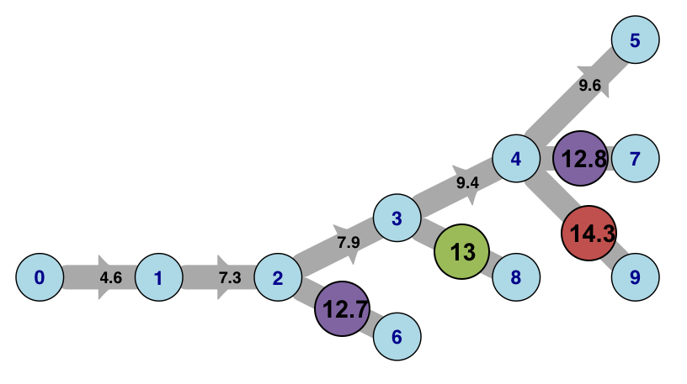

B.
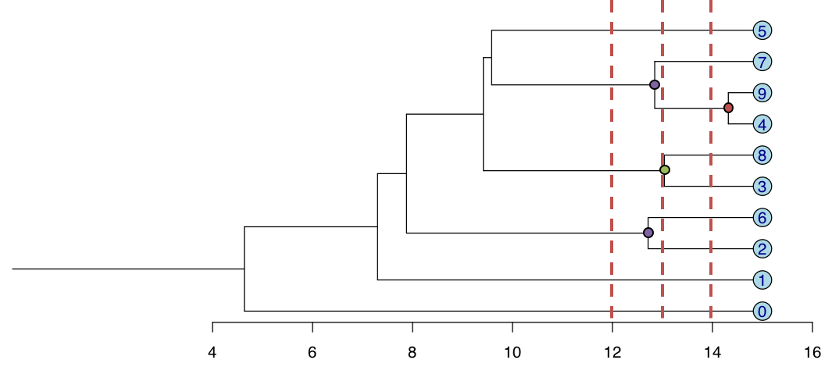
Figure 1. A. Network of HIV transmission. Blue circles represent HIV-infected individuals, and numbers on the arrows represent the timing of the transmission event. B. Time-stamped phylogenetic tree, reconstructed from HIV sequences that were evolved over the network shown in A. Red, green and purple internal branching points correspond to transmission events that occurred in the three years preceding the time of HIV sequencing.

Comparing time trends incidence obtained by ECDC tool, Simpact calibrated without phylogenetic features, and Simpact calibrated with phylogenetic features.

Background:
Time trends in HIV incidence are typically not measured directly, but estimated indirectly by mathematical models.
- Age and time-specific data on sexual behaviour and HIV status can be used to calibrate individual-based simulation models for HIV incidence estimation.
- Phylogenetic tree analysis, using HIV sequence data has also been used to infer temporal trends in HIV incidence.
- Existing modelling frameworks have limited ability to take detailed demographic, epidemiological and phylogenetic data into account when inferring HIV incidence.
Objectives:
- To develop an individual-based model (IBM) for estimating time trends in HIV incidence.
- To develop a method that enables the IBM to be calibrated to a array of summary statistics of self-reported sexual behaviour, HIV prevalence, population growth and the phylogenetic tree
Study design:
- Simpact, an individual-based modelling tool, was used to build a “Master” IBM of HIV transmission in a dynamic sexual network.
- The Master model produced 17 summary statistics of the age-mixing pattern, degree distribution, age-specific HIV prevalence and population growth rate in a model population of 2000 individuals (initially).
- Molecular evolution of a sequence of 1000 DNA nucleotide bases was simulated across the simulated transmission networks under an F81 model with a mutation rate = 0.005 per nucleotide base per year.
- Only sequences of individuals alive 10 years after the introduction of HIV into the population were included in the time-scaled phylogenetic tree reconstruction, and the number of internal nodes within the last year before the simulated sequence study was used as an additional summary statistic.
- Simpact was again used to explore a 15-dimensional parameter space, in a feature-matching calibration scheme. After the model was calibrated, its projected five-year time-trends of HIV incidence were compared to those from the Master model.

Paper 3: Assessing the uncertainty of inferred age-mixing features of the HIV sexual transmission networks in KwaZulu-Natal via an individual-based simulation approach
This paper will investigate the strength of evidence for the claim that “Sexual partnering between young women and older men, who might have acquired HIV from women of similar age, is a key feature of the sexual networks driving transmission”. This claim was made in a recent paper [16] that describes the results of a community-wide phylogenetic study. However, only 4% of the census-defined population was included in the study, and among HIV-infected study participants, sequence coverage was rather low (37.3% for women and 48.0% for men). Together, this means that there appears to be a high likelihood of a participant’s connections in the transmission network not being included in the analysis. As a result, it becomes very difficult to give a precise and valid meaning to “phylogenetically linked pairings”. Building on the work from Work Package 2, we plan to conduct a simulation study that aims to identify the range of age-mixing patterns that are compatible with the empirical results of the community-wide phylogenetic study under the reported fraction of the census-defined community that took part in the study and the observed levels of sequence coverage and phylogenetic linking. Our study may find that the range of compatible age-mixing patterns is much wider than the age-mixing pattern hypothesised in [16]. If that turns out to be the case, our study would point to a much larger uncertainty around the suggested age-mixing pattern than acknowledged in [16].

Data for Calibration

The analyses proposed in the section above require the following empirical data:
  - Number of new HIV diagnoses (annually), fraction of new HIV diagnoses testing HIV negative in past year (annually), annual update of the number of people on ART, annual update of the median CD4 count at diagnosis, and annual update of the median CD4 count at ART initiation: These summary statistics, which we will extract from the most recent report by the Belgian Scientific Institute for Public Health [Sasse A. et al. Epidemiologie van AIDS en HIV-infectie in België – Toestand op 31 december 2016. Available at: https://www.wiv-isp.be/sites/www.wiv-isp.be/files/jaarrapport_hiv_aids_2016_web.pdf Last accessed on 5 December 2017] are needed for the calibration of parameters of HIV diagnosis and ART initiation among MSM in Belgium. This calibration will be part of the HIV incidence component of the sensitivity analysis in paper 1, as well as part of the analysis in paper 2.
  - For at least one point in time, the degree distribution of new partners in past year: To calibrate sexual network parameters for heterosexual networks in South Africa, we will use the data collected by Delva et al. [6]. This calibration will be part of the transmission pattern component of the sensitivity analysis in paper 1. To calibrate sexual network parameters for homosexual networks in Belgium, we will use summary statistics reported in the Sialon II Project [18]. This calibration will be part of the HIV incidence component of the sensitivity analysis in paper 1, as well as part of the analysis in paper 2.
  - Number of internal branching points / year: To calibrate parameters of HIV diagnosis and ART initiation among MSM in Belgium, we will use published phylogenetic trees from Belgium [check for appropriate papers by Van Damme and Verhofstede]
  - Ages of putative transmission pairs, percentage of census-defined population included in the study, and sequence coverage as reported in [16]: To calibrate parameters of sexual age-mixing and age-specific HIV transmission hazard among women we will use the summary statistics published in [16]. This calibration will be part of the age-mixing component of the sensitivity analysis in paper 2, as well as the analysis in paper 3.

And these data will be complemented with simulated data from “master models” that have been calibrated to the above listed empirical data:

  - Number of new HIV infections (annually) ➔ Time trends in HIV incidence
  - Number of onward HIV transmissions per infected person over his or her lifetime ➔ Distribution of onward transmissions
Ages of infector and newly infected person in transmission pairs ➔ Age-mixing pattern in transmission clusters

