新建　－＞输入job名称 –>　选择 构建一个maven项目 -> OK

配置源码管理：

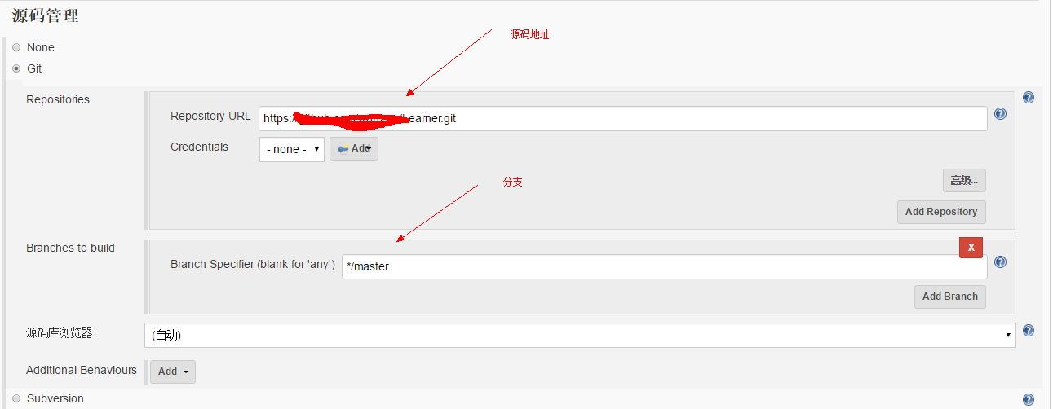

Maven 执行命令：

clean install -Dmaven.test.skip=true

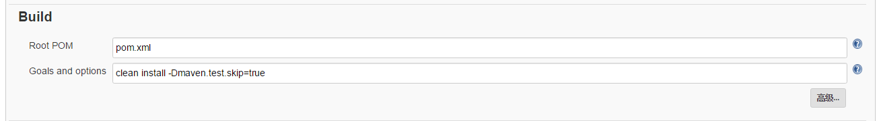

构建前执行脚本

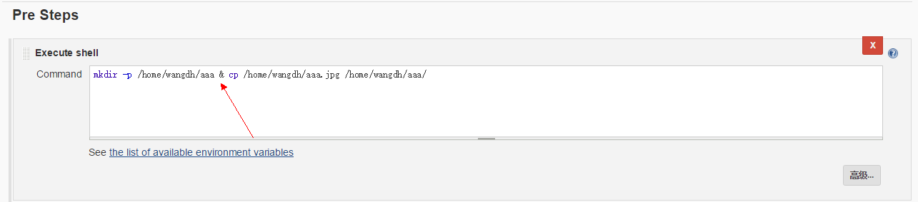

配合ansible进行远程发布

安装python pip工具：<https://pip.pypa.io/en/stable/installing/>

yum –y install python-devel

yum groupinstall "Development Tools"

pip install ansible

配置ansible playbook

mkdir –p /opot/ansible

cd /opt/ansible

git clone <https://github.com/hengyunabc/jenkins-ansible-supervisor-deploy>

Ubuntu安装ansible

<http://blog.csdn.net/hao930826/article/details/52734844>

修改hosts(这里配置的服务器可能需要免密登录)

[linux] -- 组

127.0.0.1 -- 服务器列表

或者

[linux]

127.0.0.1 ansible_ssh_user= ansible_ssh_paa=

修改site.yml(这是个yaml格式的文件，格式需要对，被坑过)

---

# This playbook deploys a simple standalone Tomcat 7 server.

- hosts: 127.0.0.1

remote_user: root

vars:

- destdir: /data/apps/jenkins/test

- tcdocbasedir: /data/apps/aaa/ROOT

tasks:

- name: 1.create dir {{destdir}}

file: path={{destdir}} state=directory owner=wangdh group=wangdh

- name: 1.sync file to dest host

synchronize: src=/root/.jenkins/workspace/learner.springmvc/wangdh.learner.springmvc/target/wangdh.learner.springmvc dest={{destdir}}

- name: 3.move old version link

file: path={{tcdocbasedir}} state=absent

- name: 4.create new version link

file: src={{destdir}}/wangdh.learner.springmvc dest={{tcdocbasedir}} state=link

- name: 5.copy file

shell: cp -rp /home/wangdh/*.jpg {{tcdocbasedir}}/

ignore_errors: yes

配置 post steps

/usr/bin/ansible-playbook -i /opt/ansible/jenkins-ansible-supervisor-deploy/hosts /opt/ansible/jenkins-ansible-supervisor-deploy/site.yml

---

- hosts: 10.1.21.16

remote_user: dazhanghao

vars:

- destdir: /apps/web/oas-biz

- tcdocbasedir: /data/apps/oasbiz/ROOT

tasks:

- name: 1.create dir {{destdir}}

file: path={{destdir}} state=directory owner=dazhanghao group=dazhanghao

- name: 1.sync file to dest {{destdir}}

synchronize: src=/home/frontpayops/.jenkins/workspace/test_oas-biz/oas-biz-web/target/oas-biz-web dest={{destdir}} rsync_opts="--exclude=.git" delete=yes recursive=yes

- name: 3.stop tomcat service

service: name=tomcat8080 state=stopped

become_user: root

become: yes

ignore_errors: yes

- name: 4. move old version link

file: path={{tcdocbasedir}} state=absent

- name: 5. create new version link

file: src={{destdir}}/oas-biz dest={{tcdocbasedir}} state=link

- name: 7. copy conf to project

shell: cp -rp /data/apps/oasbiz_config/* {{tcdocbasedir}}/

ignore_errors: yes

- name: 8. start tomcat service

service: name=tomcat8080 state=restarted sleep=5

become_user: root

become: yes