## 异常处理体系

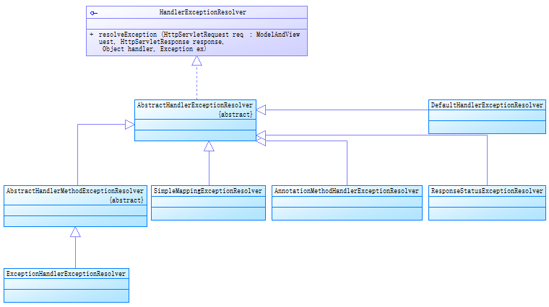

org.springframework.web.servlet. HandlerExceptionResolver

org.springframework.web.servlet.handler. AbstractHandlerExceptionResolver

org.springframework.web.servlet.handler. AbstractHandlerMethodExceptionResolver

org.springframework.web.servlet.mvc.method.annotation. ExceptionHandlerExceptionResolver

org.springframework.web.servlet.handler. SimpleMappingExceptionResolver

org.springframework.web.servlet.mvc.annotation. ~~AnnotationMethodHandlerExceptionResolver~~(已弃用)

org.springframework.web.servlet.mvc.annotation. ResponseStatusExceptionResolver

org.springframework.web.servlet.mvc.support. DefaultHandlerExceptionResolver

**概述一：**

AbstractHandlerMethodExceptionResolver及子类ExceptionHandlerExceptionResolver一起完成使用@ExceptionHandler注解的方法进行异常解析的功能；

DefaultHandlerExceptionResolver：按不同类型分别对异常进行解析；

ResponseStatusExceptionResolver：解析具有@ResponseStatus注解类型的异常；

SimpleMappingExceptionResolver：通过配置异常类和View的对应关系来解析异常

**概述二：**

mvc:annotation-driven会自动将ExceptionHandlerExceptionResolver、ResponseStatus-

ExceptionResolver、ResponseStatusExceptionResolver配置到SpringMVC中

## SimpleMappingExceptionResolver