Bank Connect

Programming Guide
for Developers

Content
Introduction 2
Architecture 3
Available webservices 3
Quick start 4
Getting started 4
Things to be aware of 4
XSLT 4

Introduction
The main purpose of this document is to ease the implementation of the web services in Bank Connect, for ERP (client) and bank central (server) developers.
Bank Connect certificate knowledge is available in the certificate-policy document.
In Bank Connect, we will make it easy to implement the code.

Architecture
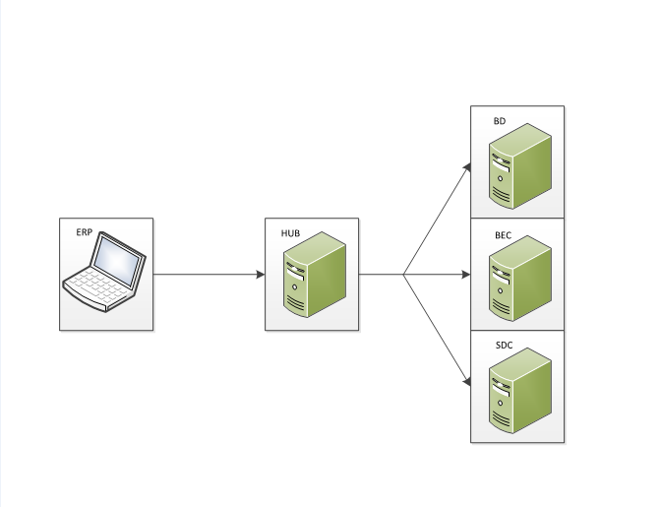
The diagram above is a rough illustration of the architecture. To the left are the ERP customers.
The HUB is responsible for determining to which of the data centrals, to forward the received SOAP requests. When SOAP requests are sent to the HUB, the HUB extracts the necessary information from the SOAP header, in order to determine where to forward the request. As such the HUB is merely a routing central.

Web service
The BankConnect web service are available at our test environment at:
Test | stest.bankconnect.dk | https://stest.bankconnect.dk/2019/04/04/services/CorporateService

The CorporateService operations are
- ActivateServiceAgreement
- GetAlternate
- GetBankCertificate
- GetCustomerStatement
- GetDebitCreditNotification
- GetCustomerAccountReport
- GetStatus
- RenewCustomerCertificate
- TransferPayments

A more detailed description of the CorporateService web service and operations can be found in Bank Connect API document.

Quick start
Call the test environment, with getBankCertifikate, and get a correct answer back.

Test environment:
https://stest.bankconnect.dk/2019/04/04/services/CorporateService

When this is ok, order a customer for system testing, send mail to:
Bankconnect@bankconnect,dk with required info:
Name, e-mail, firm and, Mobil number “you will receive an activation code”.

Getting started
The developer package is available at www.bankconnect.dk the basic parts are:

- Docs/Step by step guides/ for information about the requests with examples.
  - We get a lot of questions about troubleshooting calls to ActivateServiceAgreement in particular. If you have any issues calling it, then please start by reading though the step by step guide a second time and compare your request XML with the examples in the guide.
- Docs/Bankconnect-API.docx for wsdl documentation
- Docs/Certificate-policy.docx for certificate policy

Things to be aware of
- The bankconnect.wsdl uses the camelCase notation.
- Notice that there is a message/payment/ISO20022 limit size of 30 megabytes compressed.
- The encoding format is UTF-8.
- If you are C# developer we recommend you to use .Net crypto.
- We are using TLS v1.2.
- The timeout server side is 3 minutes (180000ms)
- The bank certificates (there is one per bank central) gets renewed every few years, so make sure your application calls getBankCertificate, but cache it. As an example, you could call it the first time each mainRegistrationNumber is used per day and cache it. You could also call it for all the mainRegistrationsNumbers that you use when you boot up the application. Just make sure it’s not a manual task to update the bank certificate when the time comes.
- EndToEndMessageId may not exceed 35 characters. We recommend using a UUID but without the dashes.

XSLT
There is XSLT for the PAIN001 format. The file is named PAIN001XsltViewer.xsl, and is easily set up to view the xml in a much more readable way.

PAIN001XsltViewer.xsl is located in the developer package under the resources/xsl folder.
A prefabricated PAIN001.xml can be found in the developer package under the resources/xml folder.

Add the xml line below, to the PAIN001.xml and fix the path to the PAIN001XsltViewer.xsl.
<?xml-stylesheet type="text/xsl" href="C:\PAIN001XsltViewer.xsl"?>

Open your PAIN001.xml with the added xml line, in a browser and you can see the output in a more readable way.

Besides PAIN.001, there are also constructed xml and xsl for payment types PAIN.002, CAMT.052, CAMT.053 and CAMT.054, which is located in the same folder.



