**The Earliest Handbook of OBI: A Shamanic Code of the Gospel**

No scholars would deny the assumption that, besides of OBI, there must have other forms of linguistic writings, like silk document, bamboo book, stone inscription, etc.

1. Any civilization must have its language. The language is one of the important symbol of any civilization. The degree of maturity of a language represent how advance its civilization is. Anyang campus represent a highly advanced civilization and highly integrated social system with high density population. Without human language, without cooperation, such high degree civilization or harmony society cannot be possible.
2. Evidence inside OBI, Dian, Ce and Shu, pen etc.
3. Physical Condition show that it is possible to have bamboo books, cloth documents. Evidence of brush painting writings.

However, all unearthed material and published archeological reports disappointed not only scholars but also discouraged the archeologists’ enthusiasm.

Some scholars explain that the documents exist but are erupted.

This paper suggests that the book, what archeologists long time sought for, cannot be found outside of OBI but inside; the pictogram ce and all its inherited characters refer to one identical book, that is what all Chinese are familiar with, what is called for today the numerals, heavenly-stems, earthly-branches and sexagenary cycle, which are the oldest four rules predefined before OBI in Chinese history.

1. Physical Evidence of the Handbook of OBI   
   The numeral system, heavenly-stem, earthly-branch and sexagenary cycle are the only four magic principles that can be found easily among 1,000,000 characters from 53,834 pieces of collected oracle bones with naked eyes without professional technique. Among the four parts of the handbook, numeral system is the easiest one to remember, and sexagenary cycle is the most complicated that is beyond normal human memory capability.

Adam Smith found that there are many pieces of OBI that were not used for divination but for scribal training. [1] Most writing materials used as model for training come from the handbook, particularly the lengthy sexagenary cycle. A typical sample inscription with high quality is the bone (HJ 37986) with the full 60 symbols of sexagenary cycle. If ignoring the missing part, there are more than thirty pieces of similar model bones in the collection (Jia-GuWenHeJI). By comparison of the standard inscription, Adam found that some bones contains errors, which Adam believes it was made by the trainees. [2] Such phenomenon is unique in OBI. Obviously, the model inscriptions have two purposes: one is for trainee to mimic and practice; another is used as a handbook for references to prevent from forgetting or mistakes.   
 The handbook has only 31 distinct characters, all of which are among the top 200 most frequently used among the five thousands distinct characters, and takes up 50% of all about 1,000,000 characters collected characters from total about 53,834 pieces of OBs. Making every ten inscribed bones would need at least one character from handbook. The high frequency statistic also shows how useful and important the handbook is in OBI practice.

1. The Name of the Handbook in OBI.   
    The importance of handbook can be found in OBI the character Ce, which mean manual for today. Through visual thinking, from a top view, the circle can mean a nail or turtle. When the circle represents a nail, it can refer to ‘something nailed down’ or ‘something precisely’ or ‘fixed’ or ‘unchangeable.’   
    When the circle represents a turtle, it refer to the turtle bones used for oracle inscription. The evidence of such usage is the character , which can be confirmed by unearthed bronze material. As the circle is a little bit ovel, it is more likely a turtle.   
    It is a kind of absurd to link the four bars to the four gospels of the NT right now. However, it is not hard to link the four vertical lines to the four pre-defined principles (numeral, heavenly-stems, earthly-branches and sexagenary circle). In OBI, a vertical line represents an authoritative stuff from heaven.  
    In OBI, there is another character Dian, which is a character Ce over two holding hands. OBI, anything with two hands holding it means it is divine or sacred. There are more characters can be found in OBI. They all are lost today. Since there is no other book in OBI. So all of characters refers to one entity.   
    Today, the character Ce (simplified 册, traditional 冊) means scroll, book, volume, register, list, or banboo strips with words written on them. Usage example: 手册 or 冊子 cè zǐ (book). Dian (simplified 典 ) means law, canon; documentation; classic, scripture. Usage example: 字典 zì diǎn (dictionary), 法典 or 典章 (law).   
    It can be seen that both the original meanings and the relationship between the Ce and Dian are lost today. However, from the difference in usage that Ce refers to small book, Dian is more related to law and institution, it can tell how much it is left for today.
2. The Influence of the Handbook of OBI.   
   The oldest and most stringent rules in the world  
   [3]
3. The Gospel oriented.
4. OBI is a non-linguistic symbol system.   
   All languages have a grammar that internalizes rules of syntax to regulate sentences and phrases with types of words to compose an idea or meaning accurately.
5. Shamanic code.

Chinese Shamanism Theory is proposed by Taiwanese-American scholar K. C. Zhang (Kwang-chih Chang, 張光直, 1931–2001), which is a milestone of sinology. It holds that the Chinese culture in essence is based upon shamanism that can be found globally. Being different from the western world that shamanism pervades only in pre-Christian times, Chinese shamanism keeps unchanged from its origin until today. From shamanism perspective, the so-called main streams of Chinese Buddhism, Confucianism, and Daoism (BCD) are nothing mysterious but the forms of shamanism. When characterizing the difference between the Chinese civilization and the western from shamanism view, Zhang calls the Chinese form the "continuity" form, and the Western form the "disruptive" form[4].

Zhang’s Shamanism theory has been supported by more and more evidence from the Chinese archeological study and the historical classic corpus as well as various aspects of the society today (e.g. Chinese herbs, acupunctures, qigong, psychic divination, etc.) More and more Chinese scholars also began to accept it.[5]  Chinese scholar Cheng Meng-Jia (陈梦家) was the first one who found the shamanism and its role in Chinese culture. Although China changed significantly after May Fourth Movement in 1919 under the western influence and experienced the painful cultural revolution (1966—76), the essential Chinese shamanism culture remains unchanged. While the western capitalism, science and technology significantly improved the Chinese people’s life in past decades, the Chinese shamanism became stronger than ever at the same time. The confliction between the East and West is essentially the confliction between the ‘continuity’ and ‘rupture’ or between shamanism and scientism.

**Shamanism**

The term shamanism derives from *shaman* (from the Siberian Tungus language, means “one who knows”) a title for those who can enter the ghost realm to interfere human life. Dutch [Nicolaes Witsen](https://en.wikipedia.org/wiki/Nicolaes_Witsen) (1641 –1717) defined *shaman* as ‘priest of the Devil’ in 17th century. The term shamanism became popular after Mircea Eliade (1907–1986) published his work, *Shamanism: Archaic Techniques of Ecstasy* (1951), where Eliade views the mysterious and fascinating phenomenon in native cultures as absolute true account of a creation in primordial time rather than fake or foolish superstitions.

Depending on the purpose and functionality, shaman can be various types, e.g. a medium, necromancer, wizard, magician, magus, sorcerer, witch, wizard, enchanter, medicine man, witchdoctor, sorcerer, exorcist, soothsayer, necromancer, and spirit walker, etc. The female medium(witch) at Endor (1Sam28) who can summon the spirits of the dead by magic is a typical shaman.

Shamanism do not have a certain unified descriptive doctrine (like sacred text, scripture). Many native shamans are illiterate. They use oral storytelling and practices to keep their tradition alive. For example, in China, many mystical practices, like Qigong, a particular acupuncture, a specific herb, etc. are usually passed down generation by generation inside a close family only; they never spill the beans outside. Shamans usually do not make public propaganda; they prefer to operate secretly and usually illegally and unwittingly. Shamans only know that their legacy shamanic practices can work, and they depend on it to live but they cannot explain how and why.

**Animism**

The conceptualization of the worldview of shamans contributes to the formation of animism in anthropology. [Sir Edward Tylor](https://en.wikipedia.org/wiki/Edward_Burnett_Tylor) (1832—1917) is a major contributor of animism research. Tylor asserts that although each culture has its own different expression style, mythologies, rituals and society's development stage, the human mind and its capabilities are the same globally. The goal of animism study is to find out the most common, foundational thread of indigenous peoples' "spiritual" or "supernatural" worldviews.According to Tylor, animism is a study that explores ‘the general doctrine of souls and other spiritual beings in general.’  Animism often includes "an idea of pervading life and will in nature;"[[19]](https://en.wikipedia.org/wiki/Animism#cite_note-19) a belief that natural objects other than humans have souls. David Cashin suggested in his lecture that the animism is a study in the overlap area between spiritual and material worlds.

**Religion**

Animism plays a critical role to assist shamanists to abstract its own ideological theory from various folk religious phenomenon. The constructed shamanism can be studied as a type of religion since it contains identical elements of religion: doctrine, rituals and mass. However, it is over-band to presume that shamanism represents the earliest transitive form of religion. Tylor’s (1929) use of the term ‘animism’ referring to a theory of religion rather than a type of religion is untenable.

In history, the term *religion* initially was used by Tertullian (150--220 AD) to refers to the Christianity faith and became popular after St. Augustine of Hippo (354--430 AD) wrote his paper, *of the true religion* (*de vera religione*)[6]. The English word *religion* came from Latin *religio,* which is derived from *religare*: *re* (again) + *ligare* (bind or connect). Augustine uses the term *religion* as a tool to expound how his Christianity faith is essentially different from all kinds of heresies and syncretism (like Manichaeism) -- the religious Christianity or Christian’s religion is purely built upon Christ the triune of the Son and the Father and the Spirit.

From shamanic perspective, the primitive ineffable concept of spirits of shamanism in primordial times is in essence identical to the Heraclitus’ *logos* and Laozi’s *Dao*, which can be considered as an evolutionary progress for religion. However, human acknowledgement of the Holy Spirit from spirits cannot happened naturally without the reborn process through Christ. From a particular perspective, Zhang’s Chinese shamanism continuity theory shows that, without the missionaries in China, the spirit of the good and bad, auspicious and inauspicious, just and unjust in its culture will remain determined by man rather than the trinity God. There is no historical and archeological evidence that can explicitly show a natural evolutionary relationship between animism and Augustine’s true religion.

**Shamanic OBI**

**Supernatural**   
 One of the most significant features of animism is the supernatural that encompasses phenomena that do not follow to the common sense of human society or principles of nature.  The puzzles or mysteries found in Chinese OBI are essentially the supernatural features of shamanic practice, which can be listed as followings:

1. Magic Origin:   
   The OBI does not follow the common natural evolution principle that anything has a development process from simplicity to complexity. The unearthed Chinese archeological materials shows that the complicated matured OBI (characters on bones) eruptively emerged within a clear boundary of a small area of about 30 km2 in a village about 2 km away north-east of the modern city of Anyang city of Henan province today[7]. Although nearly a hundred of symbols earlier than OBI are found similar to Chinese characters, they cannot be concluded attributing to earliest Chinese writing as precursor of OBI since its quality, quantity and archeological features cannot match OBI linguistic characteristics. Some suggests that the sudden appearance of OBI attributes to stimulus diffusion theory that OBI was inspired from foreign culture. However, the worldwide archeological evidence shows that OBI is unique globally even though many similarities can be extracted between OBI and Egyptian hieroglyphics or Sumerian cuneiforms. It is hard to deny that OBI was designed and created by someone rather than through natural evolution.
2. Mysteriously Sudden Disappearance  
   The archeological evidence shows that OBI suddenly disappeared in history without leaving any historical notes in details after existing about hundreds of years period. Although some pieces of burned turtle bones later than OBI are found elsewhere in couple of archeological sites in the same region in west of China, there has no linguistic characters on them. The overview of archeological evidence shows that what was replaced after OBI in Anyang was the wide spread bronze inscription. OBI culture had been lost for thousands of years in history until 1898 discovery.
3. Incredible Power of Influence   
   Although OBI originated in a small place, and never spread during only about hundreds of years of period, and was forgotten in history for more than three thousands of years, its symbol system and OBI handbook remained in use until today and became the only pictorial language in the world covering the far east main Asia continent and influencing the world. Among five points of continuity from ancestral OBI cult (divination) concluded by Paul R. Goldin,[8] the status of Chinese in sole writing system is the solid evidence for Zhang’s Chinese shamanism continuity theory.

**non-linguistic**

OBI cannot be considered as human linguistic language. Although some patterns can be found in some bones, the types of words (e.g. verb, noun, adjective, pronouns, preposition, etc.) cannot be distinguished, and they do not follow the structure of basic linguistic typology (SVO, SOV, etc.) OBI has order from top to bottom, right to left. However, in many whole plastrons, the characters are found arranged in a vertical symmetrical way, or repeated in parallel vertically. There are cases that a few characters are scattered randomly without order. The bronzes scripts found at the same time period usually have only one and less than three characters.

There are no punctuation marks found used in the OBI. It is untenable that some scholars add modern period, comma or question mark to interpret OBI for divination. OBI is a grouping sensitive system. The quotation marks applied into OBI leads to regrouping and perverting of the original messages.

The discovery of the handbook of OBI also demonstrates that OBI was not designed for human linguistic but for a specific purpose related to a certain calculation. At least, OBI practitioners or people at that times did not speak in a way of OBI showed.

The highly developed civilization (the unearthed bronze vessels, handcraft of jades, the royal cemetery and many tombs, the chariots and horses, etc.) suggests that, at OBI times, local people have another independent matured language that has nothing to do with OBI, at least, the complicated OBI system was designed and created by another well-developed oral language. Such theory can be supported by the fact that, in long Chinese history, the oral language and written language were not consistent until the ‘new culture movement’ (also called plain text movement) of May-fourth in 1911. Multiple distinct dialects in China today also prove a theory that the writing and speaking are two independent systems--an antecedent oral language created OBI; in return, OBI influenced its oral language and speakers’ worldview. It is the power of writing system rather than spoken language that keeps Chinese as sole language to continue until today.

**Grave** Simply speaking shamanism is a spiritual practice as distinct to human worldly activities. A common spirit that shamans dealt with is the spirit of the dead. Chinese Archeological evidence shows that along the OBI unearthed in the ash ditches, was the large amounts of graves including the royal cemetery nearby. Although these cannot confirm the OBI practice is a type of necromancer, they can be certain that OBI practice is related to death or resurrection of life rather than divination for near future of personal daily life. The discovery of the bronze inscription in the tomb undergird the assertion that characters are used for a shamanic practice related to dead and spirit. It could be a type of prayer for personal eternal life or a type of blessing in the world.

The supernatural features also shows that OBI is not a language used for native people’s communication in their daily life but is a sacred code for shamanic practice only. Types of shamanic practice can be three types:

1. Pray for the dead: The graves field unearthed nearby demonstrates that OBI shamanic practice is related to death and life, which is consistent to the meaning of characters themselves. The discovered seven grand tombs likely belongs to the shamans rather than kings. Pray for personal eternal life and blessing.
2. Divination:
3. The handbook of OBI
4. The usage of Turtle shells
5. Ash ditches and grand graves  
   Archeological evidence shows that the writing system in OBI times was only used for ancestral cult[9], moreover, along the OBI unearthed in the ash ditches, was the large areas of grand tombs nearby. Although these cannot confirm the OBI practice is a type of necromancer, they can be certain that OBI practice is related to death or resurrection of life rather than divination for near future of personal daily life. The discovery of the bronze inscription in the tomb undergird the assertion that characters are used for a shamanic practice related to dead and spirit. It could be a type of prayer for personal eternal life or a type of blessing in the world.

**Ash Pit**

The Evidence for Scribal Training at Anyang

Adam Smith

2011, Writing and Literacy in Early China, edited by Li Feng and David Prager Branner, University of Washington Press

401 Views

35 Pages

1 File ▾

History of Reading and Writing,

Shang Dynasty (Archaeology),

Early China,

Shang Dynasty Bronzes and Oracle Bones,

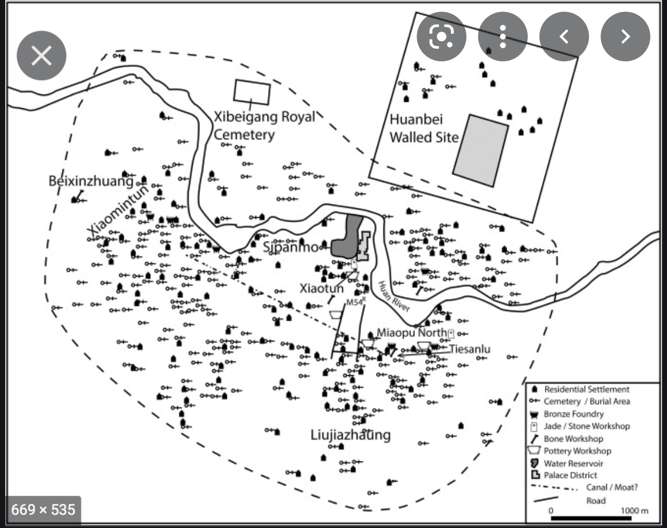

Rowan Flad, Urbanism as technology in early China, Archaeological Research in Asia Publisher: Elsevier, 2018 Archaeological Research in Asia Volume 14, June 2018, Pages 121-134, <https://www.sciencedirect.com/science/article/abs/pii/S2352226716300770>

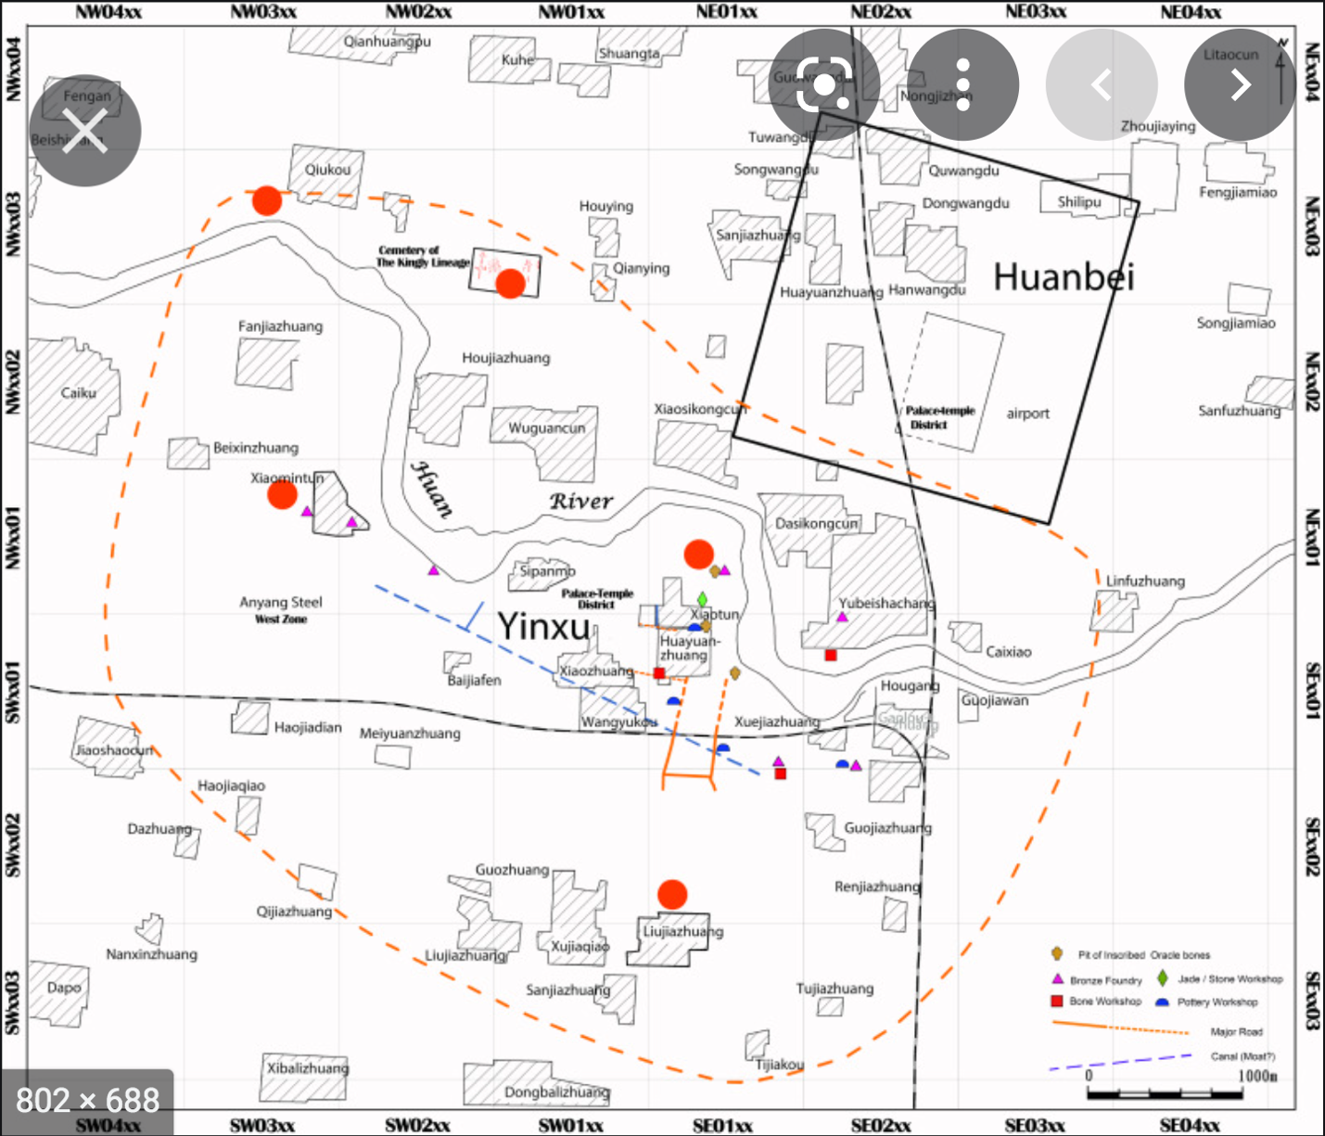

<https://www.sciencedirect.com/science/article/abs/pii/S2352226717300491>

Annihilation or decline: The fall of Anyang as an urban center

Author links open overlay panel Yung-ti(a), Lia ZhanweiYue(b), YulingHe(b)

a

East Asian Languages and Civilizations, University of Chicago, United States

b

Anyang Archaeological Team, Institute of Archaeology, Chinese Academy of Social Sciences, China

Received 20 April 2016, Revised 17 June 2017, Accepted 20 June 2017, Available online 20 September 2017.

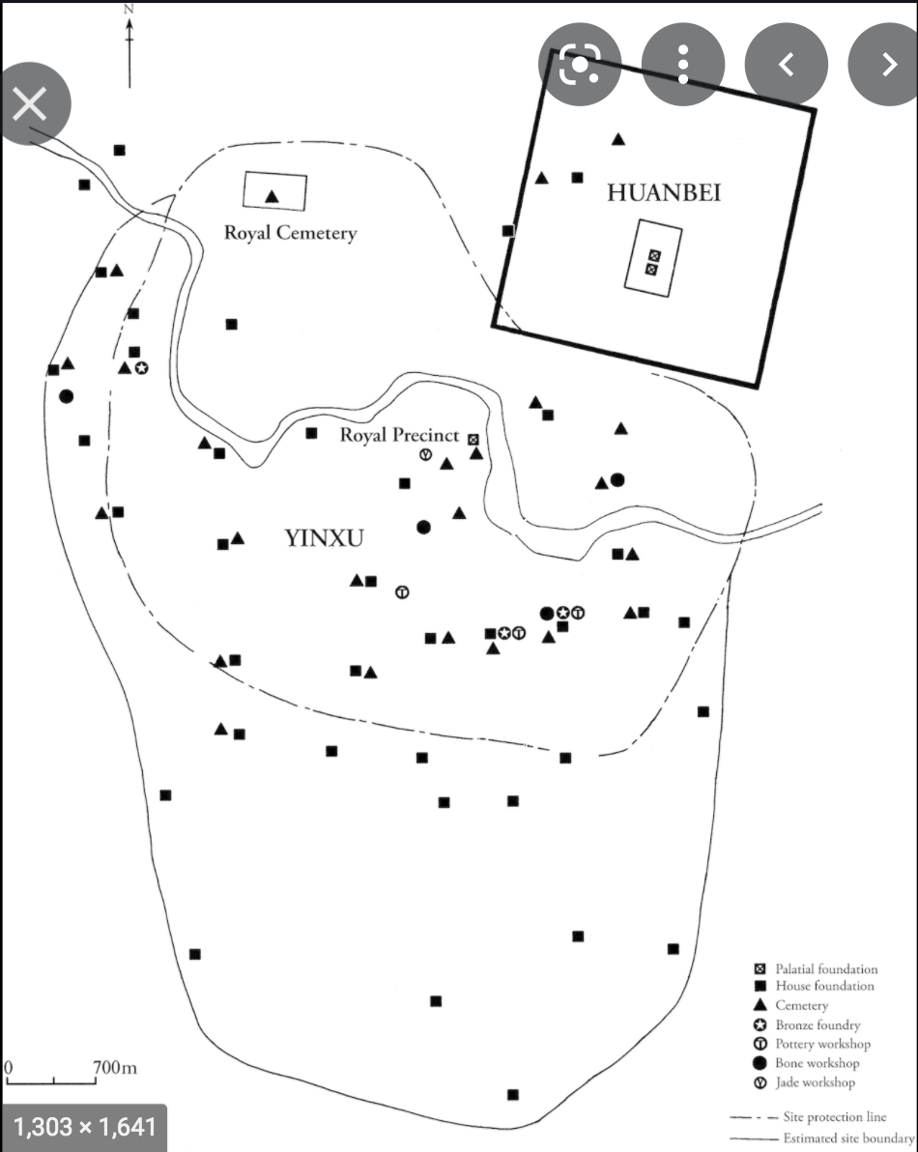

Part II - Early cities and information technologies

Published online by Cambridge University Press: 05 March 2015

Edited by

Norman Yoffee

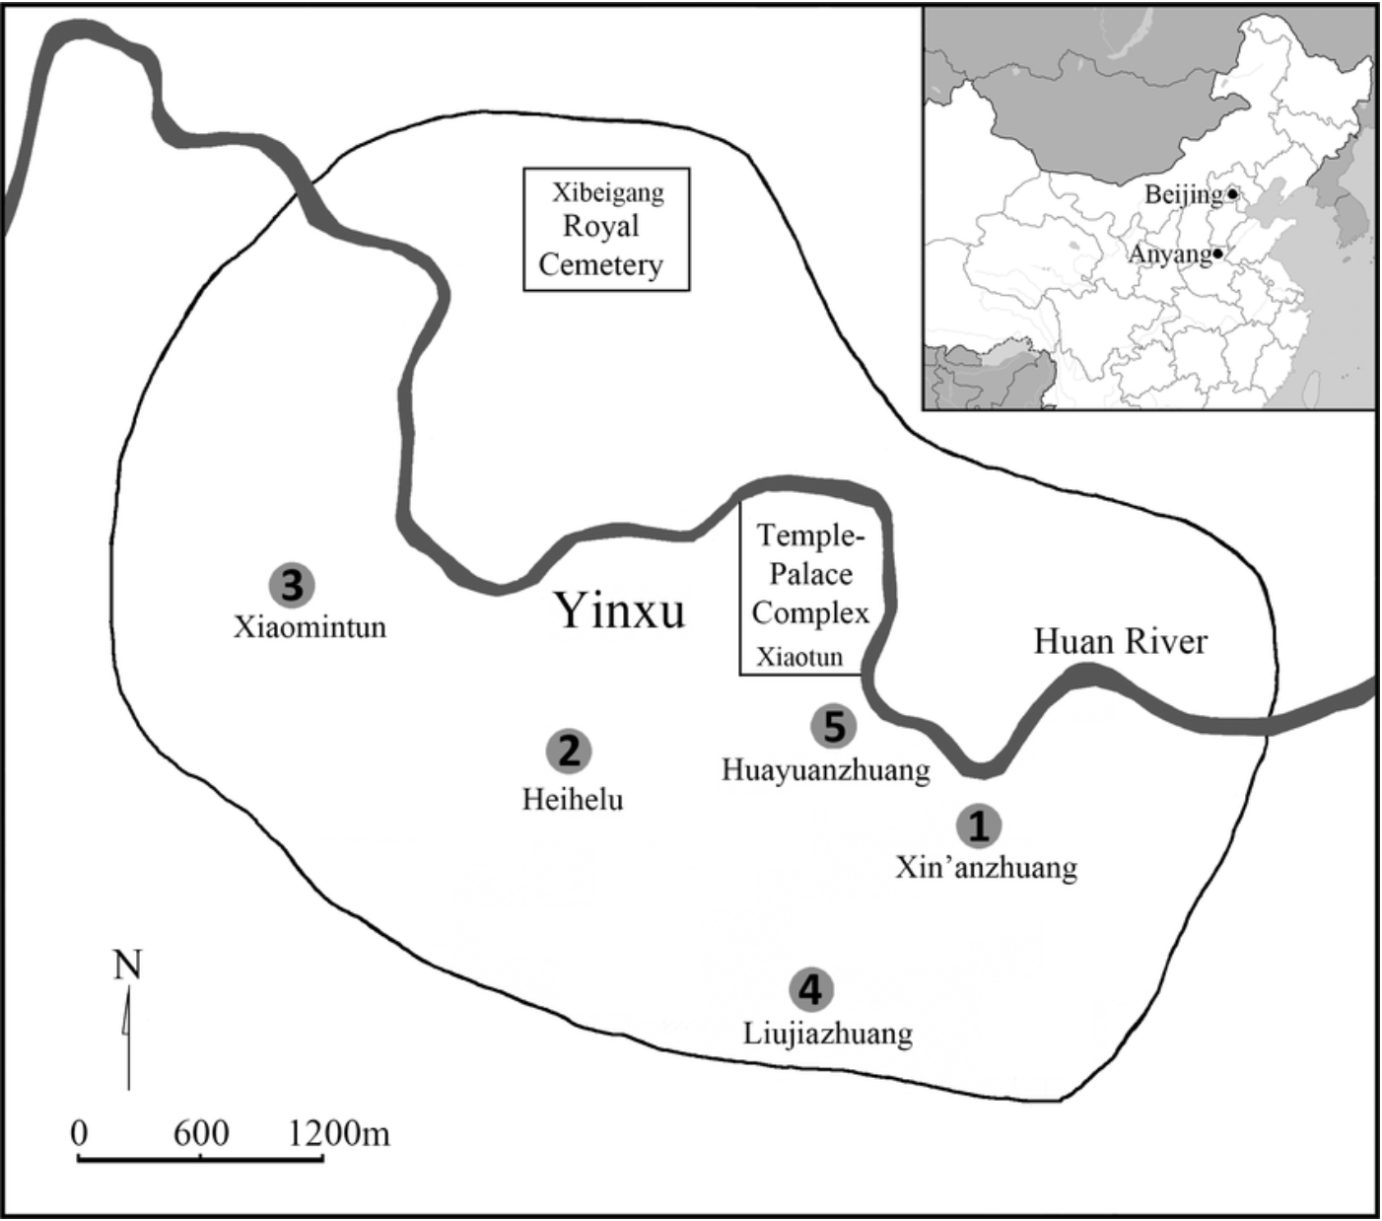

Fig 1.

Map of Yin and the locations of the sites: (1) Xin’anzhuang, (2) Xiaomintun, (3) Heihelu, (4) Liujiazhuang North, and (5) Huayuanzhuang East.

Fig 1 - Osteoarchaeological Studies of Human Systemic Stress of Early Urbanization in Late Shang at Anyang, China

1. Adam Smith, *The Evidence for Scribal Training at Anyang*, Writing and Literacy in Early China: Studies from Columbia Early China Seminar, Editor Li Feng and David Prager Branner, 2011, University of Washington Press, p185
2. Adam Smith, *The Evidence for Scribal Training at Anyang*, Writing and Literacy in Early China: Studies from Columbia Early China Seminar, Editor Li Feng and David Prager Branner, 2011, University of Washington Press, p185
3. Adam Smith, *The Evidence for Scribal Training at Anyang*, Writing and Literacy in Early China: Studies from Columbia Early China Seminar, Editor Li Feng and David Prager Branner, 2011, University of Washington Press, p185
4. K.C. Chang, Continuity and Rupture: Ancient China and the Rise of Civilizations, Manuscript being prepared for publication. https://min.news/en/culture/59a6f27153177a16b35cd6a71b0ac432.html
5. <http://ntupoli.s3.amazonaws.com/wp-content/uploads/2011/03/7.%E4%B8%AD%E5%9C%8B%E5%8F%A4%E4%BB%A3%E7%9A%84%E5%B7%AB.pdf>
6. THE WORKS OF SAINT AUGUSTINE:A Translation for the 21st Century. New City Press. 2005. p17. <https://wesleyscholar.com/wp-content/uploads/2019/04/Augustine-On-Christian-Belief.pdf>
7. Rowan Flad, Urbanism as technology in early China, Archaeological Research in Asia Publisher: Elsevier, 2018 Archaeological Research in Asia Volume 14, June 2018, Pages 121-134, https://www.sciencedirect.com/science/article/abs/pii/S2352226716300770
8. Paul R. Goldin, and University of Pennsylvania. “Some Shang Antecedents of Later Chinese Ideology and Culture.” *Journal of the American Oriental Society*, vol. 137, no. 1, American Oriental Society, 2017, pp. 121–27, https://doi.org/10.7817/jameroriesoci.137.1.0121.
9. Paul R. Goldin, and University of Pennsylvania. “Some Shang Antecedents of Later Chinese Ideology and Culture.” *Journal of the American Oriental Society*, vol. 137, no. 1, American Oriental Society, 2017, pp. 121–27, https://doi.org/10.7817/jameroriesoci.137.1.0121.