**How To Decipher OBI**

**Chinese Shamanism Theory**

Chinese Shamanism Theory is first introduced and advocated by Taiwanese-American scholar K. C. Zhang (Kwang-chih Chang, 張光直, 1931–2001) who is inspired by research on comparative mythology by Joseph Campbell and on comparative shamanism by Peter Furst and others.[1] It holds that the Chinese culture in essence is based upon shamanism that can be found globally. Being different from the western world that shamanism pervades only in pre-Christian times, Chinese shamanism keeps unchanged from its origin until today. From shamanism perspective, the so-called main streams of Chinese Buddhism, Confucianism, and Daoism (BCD) are nothing deserved to study but the various forms of shamanism.[2] When characterizing the difference between the Chinese civilization and the western from shamanism view, Zhang calls the Chinese form the "continuity" form[3], and the Western form the "disruptive" form.[4] The continuity of Chinese character is an evidence of the continuity of the original Chinese shamanism.

Zhang’s shamanism theory has been supported by more and more evidence from the Chinese archeological study and the historical classic corpus as well as various aspects of the society for today (e.g. Chinese herbs, acupunctures, qigong, psychic divination, etc. can be seen in China today)  The earliest shaman *Guan Shefu* (觀射父, 515-489 BC) found in Chinese classic documents shed some light about the Chinese shamanism.[5] More and more Chinese scholars also began to accept Chinese shamanism theory.[6]  Chinese scholar Cheng Meng-Jia (陈梦家) was the first one who realized the shamanism and its role in Chinese culture and history. Although China changed significantly after Chinese Union Version (CUV) was first published in Hongkong in 1919 with onset of May Fourth Movement and New Culture Movement in Beijing under the western influence, the essential Chinese shamanism eventually won back to its future again after the Marxism communism domain in China, which is a repeated bloody history of Peace Heaven Kingdom Movement (TaiPinTianGuo, 太平天国, 1851-1864). While the western capitalism, science and technology significantly improved the Chinese people’s life in past decades, the Chinese shamanism became stronger than ever at the same time. The confliction between the East and West is essentially the confliction between the ‘continuity’ and ‘rupture’ or between shamanism and the true religion. Since the earliest Christianity (大秦景教 DaQingJinJiao, 635AD) found in China, its history demonstrates that, Chinese shamanism cannot be rooted out like some disappeared culture in the world no matter how evil it is, because, while you are pulling the weeds, you may uproot the wheat with them (Mat13:29). It’s worthy to observer if Chinese shamanism will remain strongly until the end of the day.

**Shamanism**

The term shamanism derives from *shaman* (from the Siberian Tungus language, means “one who knows”) a title for those who can enter the ghost realm to interfere human life. Dutch [Nicolaes Witsen](https://en.wikipedia.org/wiki/Nicolaes_Witsen) (1641 –1717) defined *shaman* as ‘priest of the Devil’ in 17th century. The term shamanism became popular after Mircea Eliade (1907–1986) published his work, *Shamanism: Archaic Techniques of Ecstasy* (1951), where Eliade views the mysterious and fascinating phenomenon in native cultures as absolute true account of a creation in primordial time rather than fake or foolish superstitions.

Depending on the purpose and functionality, shaman can be various types, e.g. a medium, necromancer, wizard, magician, magus, sorcerer, witch, wizard, enchanter, medicine man, witchdoctor, sorcerer, exorcist, soothsayer, necromancer, and spirit walker, etc. The female medium(witch) at Endor (1Sam28) who can summon the spirits of the dead by magic is a typical shaman.

Shamanism do not have a certain unified descriptive doctrine (like sacred text, scripture). Many native shamans are illiterate. They use oral storytelling and practices to keep their tradition alive. For example, in China, many mystical practices, like Qigong, a particular acupuncture, a specific herb, etc. are usually passed down generation by generation inside a close family only; they never spill the beans outside. Shamans usually do not make public propaganda; they prefer to operate secretly and usually illegally and unwittingly. Shamans only know that their legacy shamanic practices can work, and they depend on it to live but they cannot explain how and why.

**Animism**

The conceptualization of the worldview of shamans contributes to the formation of animism in anthropology. [Sir Edward Tylor](https://en.wikipedia.org/wiki/Edward_Burnett_Tylor) (1832—1917) is a major contributor of animism research. Tylor asserts that although each culture has its own different expression style, mythologies, rituals and society's development stage, the human mind and its capabilities are the same globally. The goal of animism study is to find out the most common, foundational thread of indigenous peoples' "spiritual" or "supernatural" worldviews.According to Tylor, animism is a study that explores ‘the general doctrine of souls and other spiritual beings in general.’  Animism often includes "an idea of pervading life and will in nature;"[[19]](https://en.wikipedia.org/wiki/Animism#cite_note-19) a belief that natural objects other than humans have souls. David Cashin suggested in his lecture that the animism is a study in the overlap area between spiritual and material worlds.   
 The study of animism can demonstrate that the Chinese culture is nothing mysterious but based on a type of animism. Stone sculptures from royal grave 1001 unearthed at Anyang[7] with the animal head human body shed the light of how Chinese shamanists viewed human beings and themselves when their souls entered into animal spiritual world.

**Religion**

Animism plays a critical role to assist shamanists to abstract its own ideological theory from various folk religious phenomenon. The constructed shamanism can be studied as a type of religion since it contains identical elements of religion: doctrine, rituals and mass. However, it is over-band to presume that shamanism represents the earliest transitive form of religion. Tylor’s (1929) use of the term ‘animism’ referring to a theory of religion rather than a type of religion is untenable.

In history, the term *religion* initially was used by Tertullian (150--220 AD) to refers to the Christianity faith and became popular after St. Augustine of Hippo (354--430 AD) wrote his paper, *of the true religion* (*de vera religione*)[8]. The English word *religion* came from Latin *religio,* which is derived from *religare*: *re* (again) + *ligare* (bind or connect). Augustine uses the term *religion* as a tool to expound how his Christianity faith is essentially different from all kinds of heresies and syncretism (like Manichaeism) -- the religious Christianity or Christian’s religion is purely built upon Christ the triune of the Son and the Father and the Spirit.

From shamanic perspective, the primitive ineffable concept of spirits of shamanism in primordial times is in essence identical to the Heraclitus’ *logos* and Laozi’s *Dao*, which can be considered as an evolutionary progress for religion. When apostle John contextualized *Logos* into the Word, indeed he also sowed a gospel seed for the Chinese Dao which can be seen through the Chinese Union Version(CUV) in 1911. Human acknowledgement of the Holy Spirit from spirits cannot happened naturally without the reborn process through Christ. From a particular perspective, Zhang’s Chinese shamanism continuity theory shows that, without the missionaries in China, the spirit of the good and evil, auspicious and inauspicious, just and unjust in its culture will remain determined by man rather than the trinity God. There is no historical and archeological evidence that can explicitly show a natural evolutionary relationship between animism and Augustine’s true religion.

**OBI is Shamanic Code**

**Supernatural**   
 One of the most significant features of animism is the supernatural that encompasses phenomena that do not follow to the common sense of human society or principles of nature.  The puzzles or mysteries found in Chinese OBI are essentially the supernatural features of shamanic practice, which can be listed as followings:

1. Magic Origin:   
   The OBI does not follow the common natural evolution principle that anything has a development process from simplicity to complexity. The unearthed Chinese archeological materials shows that the complicated matured OBI (characters on bones) eruptively emerged within a clear boundary of a small area of about 30 km2 in a village about 2 km away north-east of the modern city of Anyang city of Henan province today[9]. Although nearly a hundred of symbols earlier than OBI are found similar to Chinese characters, they cannot be concluded attributing to earliest Chinese writing as precursor of OBI since its quality, quantity and archeological features cannot match OBI linguistic characteristics. Some suggests that the sudden appearance of OBI attributes to stimulus diffusion theory that OBI was inspired from foreign culture. However, the worldwide archeological evidence shows that OBI is unique globally even though many similarities can be extracted between OBI and Egyptian hieroglyphics or Sumerian cuneiforms. It is hard to deny that OBI was designed and created by someone rather than through natural evolution.
2. Mysteriously Sudden Disappearance  
   The archeological evidence shows that OBI suddenly disappeared in history without leaving any historical notes in details after existing about hundreds of years period. Although some pieces of burned turtle bones later than OBI are found elsewhere in couple of archeological sites in the same region in west of China, there has no linguistic characters on them. The overview of archeological evidence shows that what was replaced after OBI in Anyang was the wide spread bronze inscription. OBI culture had been lost for thousands of years in history until 1898 discovery.
3. Super Powerful Influence   
   Although OBI originated in a small place, and never spread during only about hundreds of years of period, and was forgotten in history for more than three thousands of years, its symbol system and OBI handbook remained in use until today and became the only pictorial language in the world covering the far east main Asia continent and influencing the world. Among five points of continuity from ancestral OBI cult (divination) concluded by Paul R. Goldin,[10] the status of Chinese in sole writing system is a solid evidence for Zhang’s Chinese shamanism continuity theory.

**Non-human Language**

OBI cannot be considered as human linguistic language. Although some patterns can be found in some bones, the types of words (e.g. verb, noun, adjective, pronouns, preposition, etc.), the basic linguistic typology (SVO, SOV, etc.) or phrases[11] cannot be found in OBI.

OBI has order from top to bottom, right to left. However, in many whole plastrons, the characters are found arranged in a vertical symmetrical way, or repeated in parallel vertically. There are cases that a few characters are scattered randomly without order. The bronzes scripts found at the same time period usually have only one and less than three characters.

There are no punctuation marks found used in the OBI. It is untenable that some scholars add modern period, comma or question mark to interpret OBI for divination. OBI is a grouping sensitive system. The quotation marks applied into OBI leads to regrouping and perverting of the original messages.

The discovery of the handbook of OBI also demonstrates that OBI was not designed for human language but for a specific purpose related to a shamanic ritual configuration. At least, OBI was not a language used for practitioners or people in their daily life at that time.

**Super-Human Languages**

If OBI is considered as a special media language, then the OBI practitioners have to be bilingual for both the human and the ghost. Shaman who practice OBI must speak a human language. The highly developed civilization (the unearthed bronze vessels, handcraft of jades, the royal cemetery and many tombs, the chariots and horses, etc.) suggests that, at OBI time, local people have another independent matured language that has nothing to do with OBI. At least, the complicated OBI system was designed and created by people through another well-developed human oral language.   
 Such theory can be supported by the evidence that the spoken and the written languages are isolated for long time in history until the ‘plain text movement’ (or ‘new culture movement’ that advocates the consistency between the speaking and writing) of May-fourth in 1919. The widely existence of multiple distinct dialects in China today also prove that the oral and the writing can be developed independently. Chinese writing system is developed from OBI whereas its spoken language is developed from some tribes.   
 The study of the skulls have indicated that Shang community is a mixture of racially divergent groups (Mongoloid, Negroid, Caucasoid, Eskimoid and unknown types). It infers that OBI was created among multiple lingual environment. However, history proves that OBI possesses a super power over human languages. OBI has successfully overcome the influence from all types of cultures, survived from the beginning until today, and have become the domain of the world most population for today, and showed the tendency from history to exist until the end of the day.

**Disruptive Discrepancy Theory**

**1. OBI Inventor and User (Ancestor and Descendant)**

**2. OBI and Oral Language**

**3.**

**Chinese Ancestors are Shamanists**

**Not-divination but oracle about living for death. Grave** Simply speaking shamanism is a spiritual practice as distinct to human worldly activities. A common spirit that shamans dealt with is the spirit of the dead. Chinese Archeological evidence shows that along the OBI unearthed in the ash ditches, was the large amounts of graves including the royal cemetery nearby. Although these cannot confirm the OBI practice is a type of necromancer, they can be certain that OBI practice is related to death or resurrection of life rather than divination for near future of personal daily life. The discovery of the bronze inscription in the tomb undergird the assertion that characters are used for a shamanic practice related to dead and spirit. It could be a type of prayer for personal eternal life or a type of blessing in the world.

From the connections between groups of living and dead and the huge investment in death ritual, the dead seem to have played a central role in Shang life. Given the vast disparity between the resources devoted to the royal tombs and sacrifices compared to those of ordinary folk, Shang mortuary ritual seems to have been hierarchy-enacting and, to some degree, ordered by sumptuary rules (Campbell 2007; Tang 2004). It was also community forming, bringing together groups of living with their dead and, based on the evidence of captive sacrifice, it was political. If we can draw the further conclusion that these hierarchical communities of the living and dead were kin-based, then the Late Shang socio-political landscape was fundamentally an ancestral one. [12]

The supernatural features also shows that OBI is not a language used for native people’s communication in their daily life but is a sacred code for shamanic practice only. Types of shamanic practice can be three types:

1. Pray for the dead: The graves field unearthed nearby demonstrates that OBI shamanic practice is related to death and life, which is consistent to the meaning of characters themselves. The discovered seven grand tombs likely belongs to the shamans rather than kings. Pray for personal eternal life and blessing.
2. Divination:
3. The handbook of OBI
4. The usage of Turtle shells
5. Ash ditches and grand graves  
   Archeological evidence shows that the writing system in OBI times was only used for ancestral cult[13], moreover, along the OBI unearthed in the ash ditches, was the large areas of grand tombs nearby. Although these cannot confirm the OBI practice is a type of necromancer, they can be certain that OBI practice is related to death or resurrection of life rather than divination for near future of personal daily life. The discovery of the bronze inscription in the tomb undergird the assertion that characters are used for a shamanic practice related to dead and spirit. It could be a type of prayer for personal eternal life or a type of blessing in the world.

**Ash Pit**

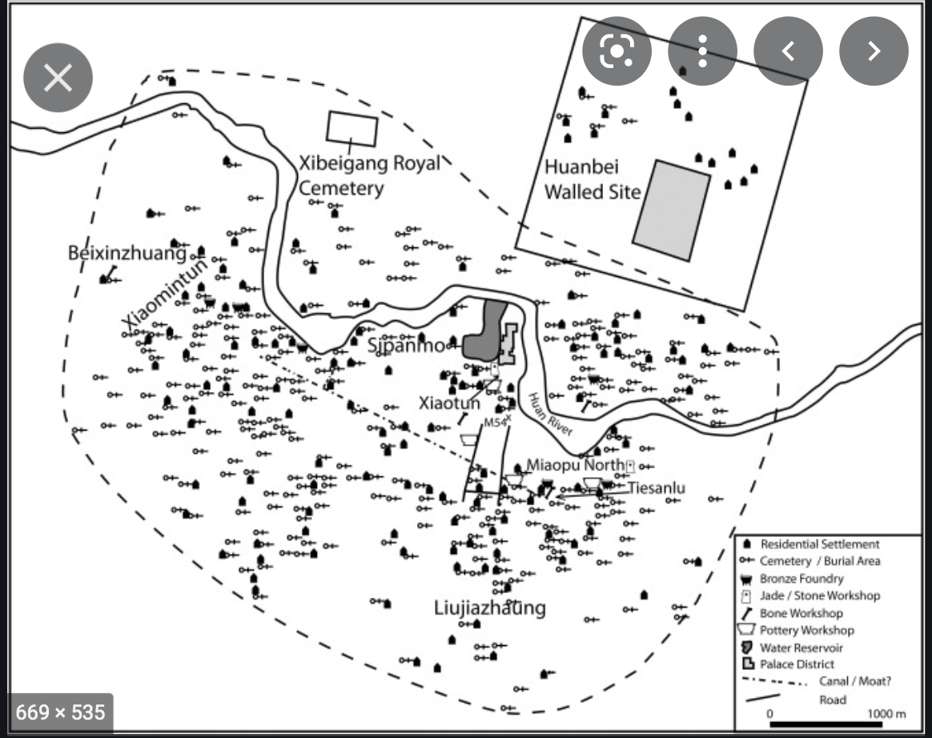

Rowan Flad, Urbanism as technology in early China, Archaeological Research in Asia Publisher: Elsevier, 2018 Archaeological Research in Asia Volume 14, June 2018, Pages 121-134, <https://www.sciencedirect.com/science/article/abs/pii/S2352226716300770>

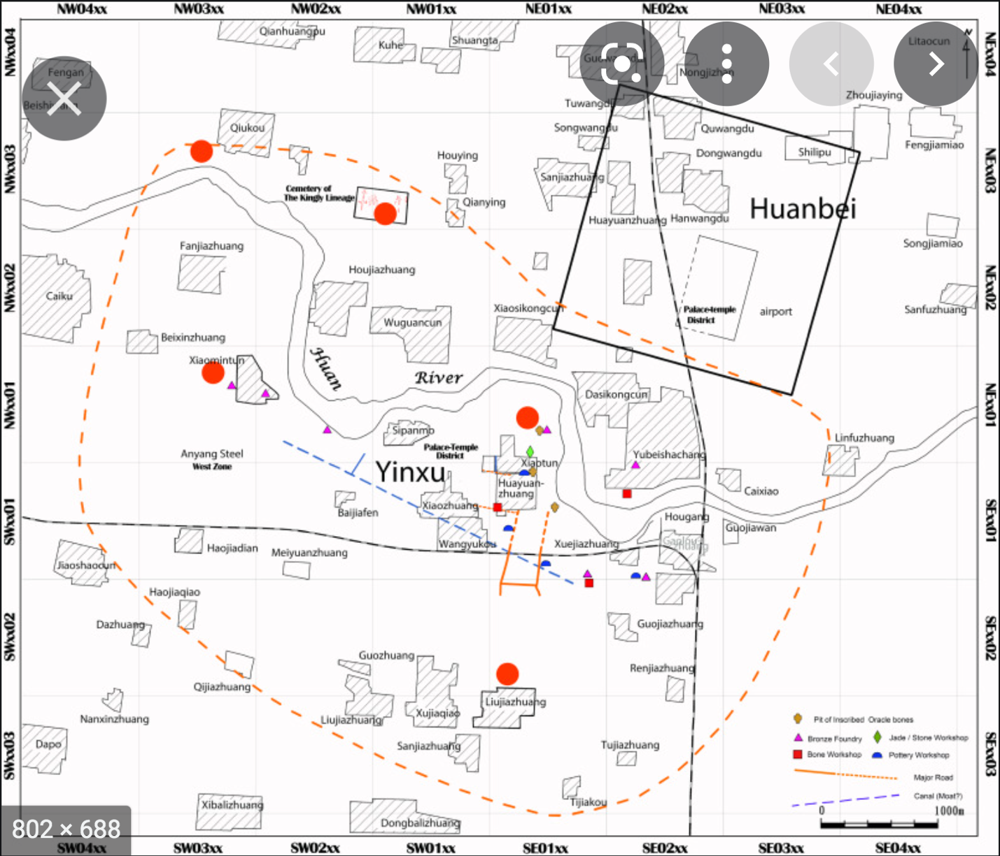

<https://www.sciencedirect.com/science/article/abs/pii/S2352226717300491>

Annihilation or decline: The fall of Anyang as an urban center

Author links open overlay panel Yung-ti(a), Lia ZhanweiYue(b), YulingHe(b)

a

East Asian Languages and Civilizations, University of Chicago, United States

b

Anyang Archaeological Team, Institute of Archaeology, Chinese Academy of Social Sciences, China

Received 20 April 2016, Revised 17 June 2017, Accepted 20 June 2017, Available online 20 September 2017.

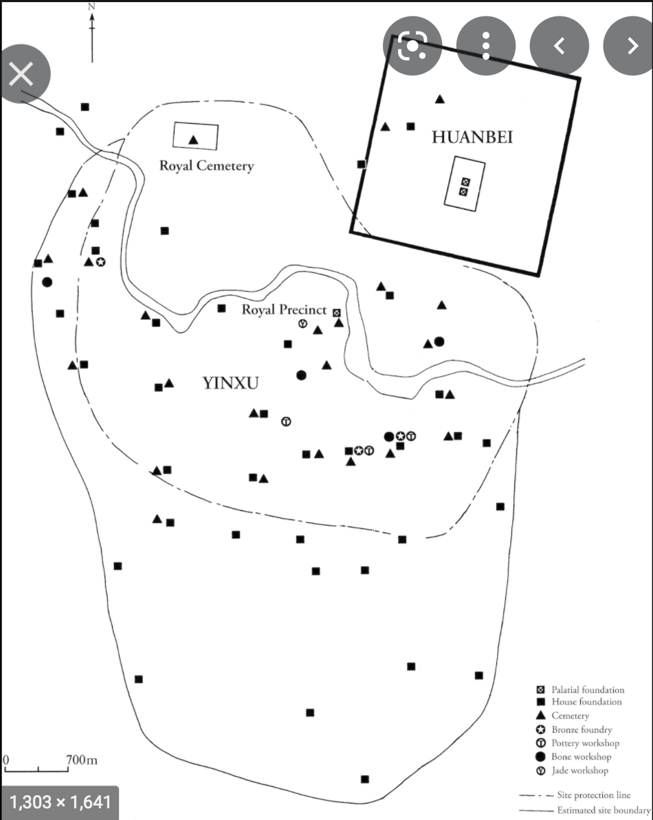

Part II - Early cities and information technologies

Published online by Cambridge University Press: 05 March 2015

Edited by

Norman Yoffee

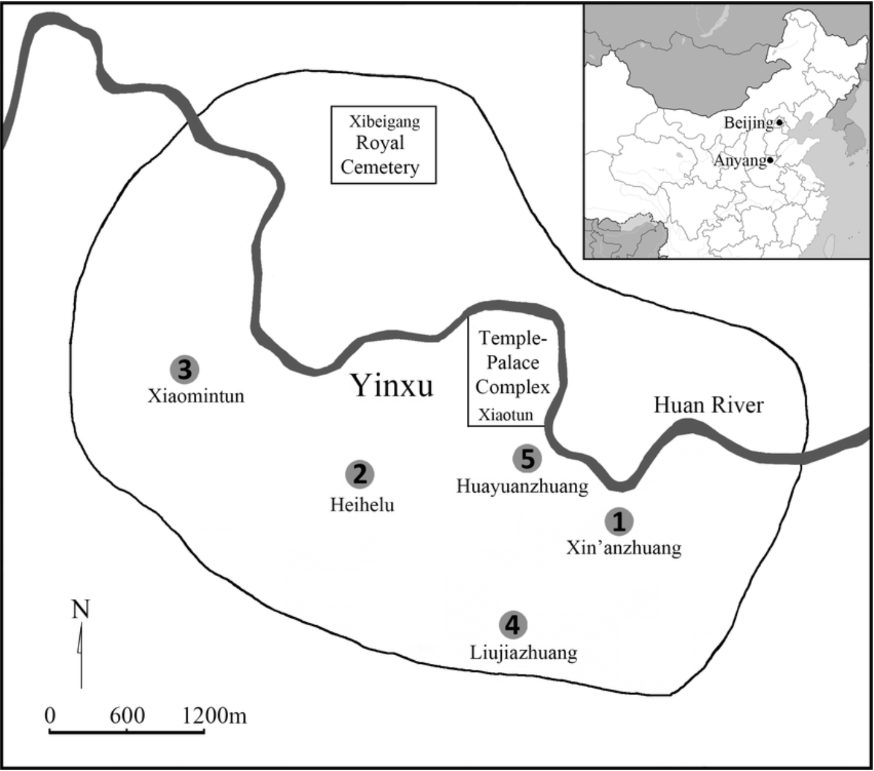

Fig 1.

Map of Yin and the locations of the sites: (1) Xin’anzhuang, (2) Xiaomintun, (3) Heihelu, (4) Liujiazhuang North, and (5) Huayuanzhuang East.

Fig 1 - Osteoarchaeological Studies of Human Systemic Stress of Early Urbanization in Late Shang at Anyang, China

<https://www.google.com/books/edition/Early_Chinese_Religion/q2nWdWbN3MQC?hl=en&gbpv=1&dq=Shang+shamans&pg=PA275&printsec=frontcover>

### **[Early Chinese Religion: The Period of Division (220-589 Ad) - Page 275](https://books.google.com/books?id=q2nWdWbN3MQC&pg=PA275&dq=Shang+shamans&hl=en&newbks=1&newbks_redir=1&sa=X&ved=2ahUKEwjQvLau-OT1AhWpmGoFHWm0DXIQ6AF6BAgLEAI)**

[books.google.com › books](https://books.google.com/books?id=q2nWdWbN3MQC&pg=PA275&dq=Shang+shamans&hl=en&newbks=1&newbks_redir=1&sa=X&ved=2ahUKEwjQvLau-OT1AhWpmGoFHWm0DXIQ6AF6BAgLEAI)

1. Robert E. Murowchick, National Academy of Sciences: Kwang-Chi Change (1931-2001), 2012, p30-31.
2. Fushin Lin, *Shamans and Politics*, in Early Chinese Religion: The Period of Division (220-589 AD),Ed John Lagerwey, Pengshi Lu 200)9, p254.
3. Kwang-chih Chang, The Archaeology of Ancient China, 3rd edition, New Haven and London Yale University Press, 1977. p481. He stated that “despite many cultural exchanges with outside world, the Chinese culture has for thousands of years not only persisted but also proved to be self-contained. Both phenomenon—continuity and self-contained—are, as far as I know, unprecedented in world history, when the size of China is taken into account.”
4. K.C. Chang, Continuity and Rupture: Ancient China and the Rise of Civilizations, Manuscript being prepared for publication. https://min.news/en/culture/59a6f27153177a16b35cd6a71b0ac432.html
5. Fushin Lin, *Shamans and Politics*, in Early Chinese Religion: The Period of Division (220-589 AD),Ed John Lagerwey, Pengshi Lu 200)9, p254.
6. <http://ntupoli.s3.amazonaws.com/wp-content/uploads/2011/03/7.%E4%B8%AD%E5%9C%8B%E5%8F%A4%E4%BB%A3%E7%9A%84%E5%B7%AB.pdf>  
   
7. Kwang-Chih Chang, Shang Civilization, New Haven and London Yale University Press, 1980, p115,116,206.
8. THE WORKS OF SAINT AUGUSTINE:A Translation for the 21st Century. New City Press. 2005. p17. <https://wesleyscholar.com/wp-content/uploads/2019/04/Augustine-On-Christian-Belief.pdf>
9. Rowan Flad, Urbanism as technology in early China, Archaeological Research in Asia Publisher: Elsevier, 2018 Archaeological Research in Asia Volume 14, June 2018, Pages 121-134, https://www.sciencedirect.com/science/article/abs/pii/S2352226716300770
10. Paul R. Goldin, and University of Pennsylvania. “Some Shang Antecedents of Later Chinese Ideology and Culture.” *Journal of the American Oriental Society*, vol. 137, no. 1, American Oriental Society, 2017, pp. 121–27, https://doi.org/10.7817/jameroriesoci.137.1.0121.
11. Takashima, K. “NOUN PHRASES IN THE ORACLE-BONE INSCRIPTIONS.” *Monumenta Serica*, vol. 36, Maney Publishing, 1984, pp. 229–302, http://www.jstor.org/stable/40702983.
12. Campbell, R. (2018). Violence, Kinship and the Early Chinese State. In Violence, Kinship and the Early Chinese State: The Shang and their World (pp. I-Ii). Cambridge: Cambridge University Press. chapter2 p15.
13. Paul R. Goldin, and University of Pennsylvania. “Some Shang Antecedents of Later Chinese Ideology and Culture.” *Journal of the American Oriental Society*, vol. 137, no. 1, American Oriental Society, 2017, pp. 121–27, https://doi.org/10.7817/jameroriesoci.137.1.0121.