**Plan**

1. How to decipher OBI
2. The Earliest Chinese Handbook: an evidence of shamanic code for Gospels (Ancient/precursor)
3. The One in OBI: an evidence of shamanic code for Jesus the Savior
4. The Purpose of OBI: divination, oracle, shamanic spell or prayer

Optical illusion

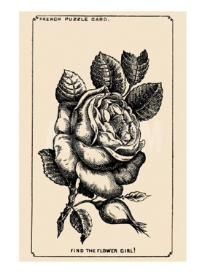

the Girl’s face hidden in the Rose

<https://www.jagranjosh.com/general-knowledge/1880s-optical-illusion-to-test-your-brain-can-you-spot-girls-face-hidden-in-rose-1661513162-1>

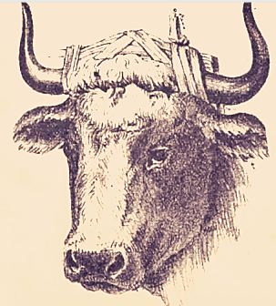

Bull Master’s Hidden Face

<https://www.jagranjosh.com/general-knowledge/optical-illusion-iq-test-only-a-genius-can-spot-bull-masters-hidden-face-1662461885-1>

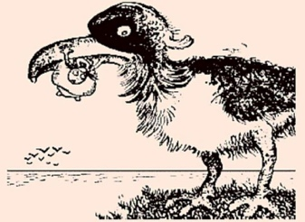

a Man catching Fish inside Giant Bird

<https://www.jagranjosh.com/general-knowledge/century-old-optical-illusion-people-with-high-iq-can-spot-man-catching-fish-inside-giant-bird-1662719345-1>

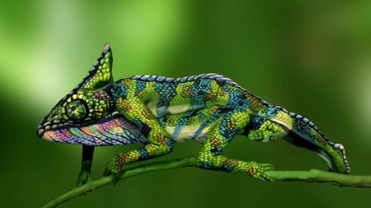

Find Two Hidden Women in 9 seconds

<https://www.jagranjosh.com/general-knowledge/can-you-spot-the-two-hidden-women-in-this-optical-illusion-within-9-seconds-1661524548-1>

 Circus Master’s Elephant Hidden in Picture

<https://www.jagranjosh.com/general-knowledge/iq-test-optical-illusion-can-you-spot-circus-masters-elephant-hidden-in-picture-1662374911-1>

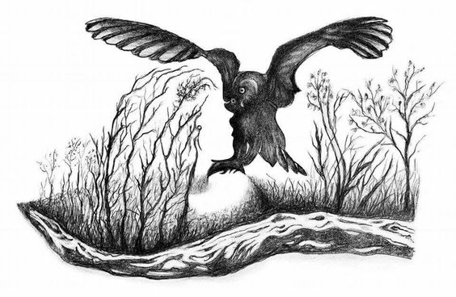

Optical Illusion for IQ Test: Spot hidden face of a Beautiful Woman inside forest with an Owl in 7 Secs!

<https://www.jagranjosh.com/general-knowledge/optical-illusion-iq-test-spot-hidden-face-of-beautiful-women-inside-forest-with-owl-1663670848-1>

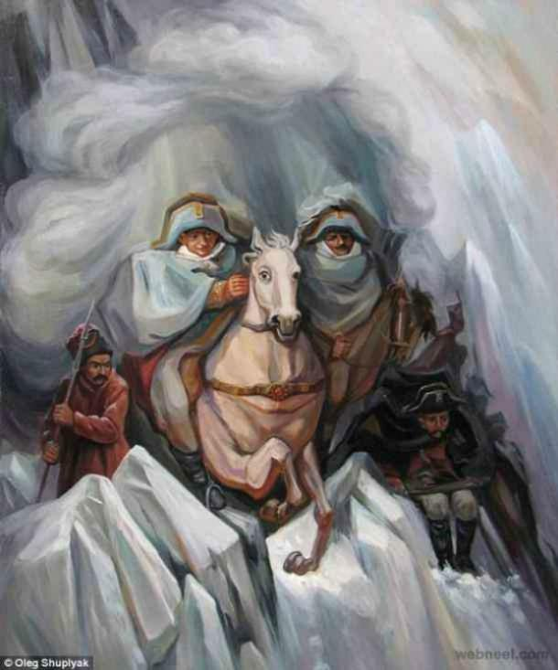

What you see first reveals your secret fear in Romantic Relationship

<https://www.jagranjosh.com/general-knowledge/optical-illusion-love-test-what-you-see-first-reveals-your-secret-fear-in-romantic-relationship-1663339314-1>

**Optical Illusion to Test Your Love Life:**An optical illusion is a mind-bending illustration of an object or a drawing or a picture that has different appearances and can be perceived differently. There are many types of optical illusions like physical, physiological, and cognitive illusions. These optical illusions are sometimes also helpful in testing helpful as our innermost desires and things we don’t usually reveal about ourselves. These are also a part of the field of psychoanalysis as they throw some light on your personality traits. Many optical illusion images can reveal hidden aspects of our personality and our deepest desires based on what we see.  One such fine illustration can be seen in an old optical illusion painting created by artist Oleg Shupliak.

## **What do you see first in this Optical Illusion?**

This optical illusion is kind of a personality test that helps in revealing your secret fear in love. The faces that you can see in this optical illusion are:

1. **A Woman** **- Fear of Losing Sleep in Love**
2. **The Mounted Soldiers** **- Fear to keep up the Appearances in Love**
3. **A Horse** **- Fear of Rejection in Love**
4. **The Soldiers in the Background** **- Fear of Playing Games in Love**

Visual Thinking Logically

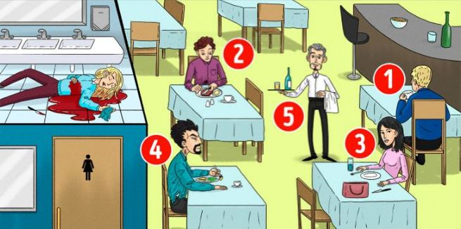

who is the Killer of the woman in the restaurant

<https://www.jagranjosh.com/general-knowledge/brain-teaser-iq-test-who-is-the-killer-of-woman-in-restaurant-picture-1662977945-1>

This IQ test is a fun way to know your Intelligence Quotient.

This brain teaser will help in testing your intelligence level based on the decision you make while looking at the problem. While solving these brain teasers, you need to scan the problem and arrive at the answer by using analytical reasoning skills. Brain puzzles make a simple riddle more interesting, as these fun games are solved with creative thinking. You need to think a little differently for coming on to the solution as the answer won’t be right in front of you. So, we have come up with an interesting brain teaser where you have to identify the Killer among the five people suspected to be the murderer of the woman in the restaurant in the image.

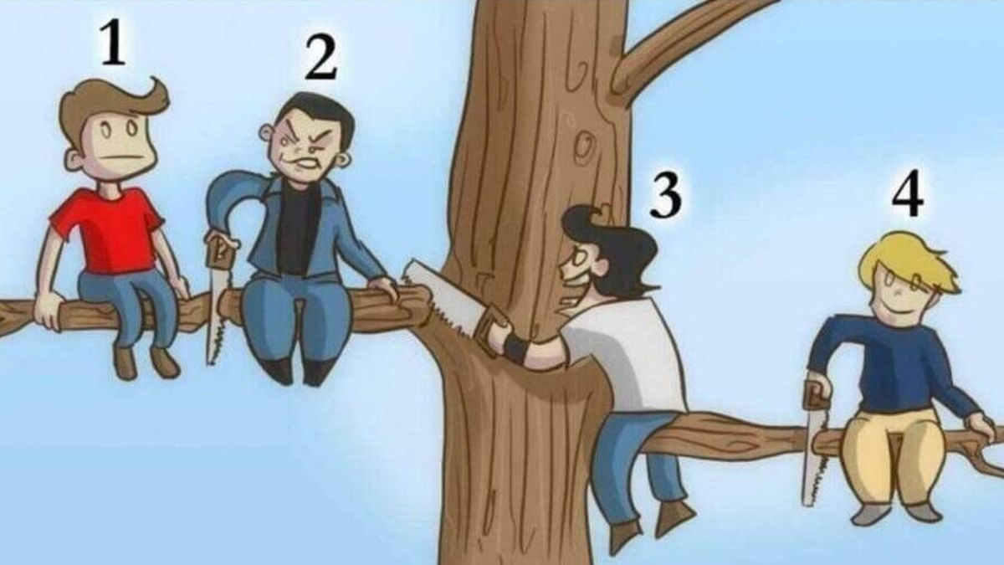

<https://www.jagranjosh.com/general-knowledge/brain-teaser-iq-test-who-is-the-most-stupid-person-in-picture-1662446335-1>

This brain teaser will help in testing your intelligence level based on the decision you make while looking at the problem. This IQ test is also a fun way to know your Intelligence Quotient. Brain puzzles make a simple riddle more interesting, as these fun games are solved with creative thinking. While solving these brain teasers, you need to scan the problem and arrive at the answer by using analytical reasoning skills. You need to use a little different approach for coming on to the solution as the answer won’t be right in front of you. So, we have come up with an interesting brain teaser where you have to identify the most stupid person among the four people sitting on a tree branch in the image.

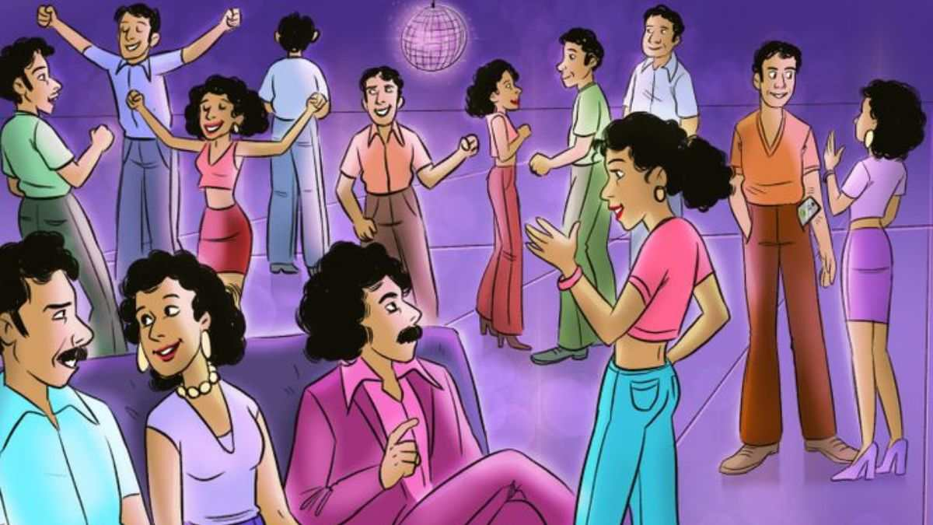

Identify who is from future in 1970s picture

<https://www.jagranjosh.com/general-knowledge/brain-teaser-iq-test-identify-who-is-from-future-in-1970s-picture-1663328461-1>

This IQ test is a fun way to check your Intelligence Level. Some brain teasers will help in assessing your intelligence level based on the decision you make while looking at the problem. The important task in these puzzles is to scan the problem quickly and arrive at the answer by using your logical reasoning skills. Brain teasers make a simple puzzle more interesting, as these fun IQ Tests are solved with creative thinking. You need to out of the box for coming on to the solution as the answer would be hiding somewhere in the picture. So, we have come up with an interesting brain teaser where you have to identify in who is from the future in the 1970s image.