https://www.gotquestions.org/bind-the-strongman.html

The phrase bind the strong man (or strongman) is a reference to a passage in the book of Mark, where Jesus is responding to some Jewish scribes who were accusing Him of being possessed by Beelzebul. Their argument was that “by the prince of demons he is driving out demons” (Mark 3:22). In other words, the reason the demons listened to Jesus was that they were in league with Him and recognized Him as their commanding officer, so to speak.
Jesus refuted their blasphemous argument with plain logic: “How can Satan cast out Satan?” (Mark 3:23) and then gave them a parable. First, Jesus spoke of the principle of a divided kingdom, which cannot stand (verses 24–26). Then He told them, “No one can enter a strong man’s house without first tying him up. Then he can plunder the strong man’s house” (Mark 3:27). Jesus refers to Satan as the “strong man” and to Himself as the One who enters the house and plunders the place. Of course, before Satan allows his domain to be “plundered,” he must be incapacitated. Jesus was not in league with Satan, as the scribes suggested, but had come to the earth, to what is essentially Satan’s “house” (1 John 5:19), "We know that we are children of God, and that the whole world is under the control of the evil one." (1Jn5:19 NIV) in order to bind Satan and plunder his “goods,” which are the souls of men (John 17:15; Luke 4:18; Ephesians 4:8).
My prayer is not that you take them out of the world but that you protect them from the evil one. John 17:15;

8 This is why it says:

“When he ascended on high,

he took many captives

and gave gifts to his people.” Ephesians 4:8.

A parallel passage says this: “When a strong man, fully armed, guards his own house, his possessions are safe. But when someone stronger attacks and overpowers him, he takes away the armor in which the man trusted and divides up his plunder” (Luke 11:21–22). Satan is strong, and he holds possessions that he guards jealously. But Jesus is the One who was and is stronger than the strong man. He is the only One who can bind the strong man and rescue us from his clutches (see John 12:31).
Some Christians, usually in the Charismatic or Pentecostal movements, apply Jesus’ parable to the spiritual warfare that believers must wage. They teach that Christians are the ones who must “bind the strong man” in their lives or in their cities and then win the victory in Jesus’ name. Some Charismatic preachers even name the “strong men” and attempt to identify the cities or geographical areas over which they hold power. Such doctrines go far beyond what Jesus said. The Lord’s parable was simply to impress upon the scribes that He was not in league with Satan. Never does Jesus instruct us to “bind the strong man” or tell us how to do it. We do not have warrant to interpret the parable as a spiritual reality over geographical regions.

https://epicpew.com/11-time-jesus-took-demons-seriously-and-why-you-should-too/

There is a growing trend among youth in America called “Charlie, Charlie.” The “game” supposedly attempts to make contact with a demon named Charlie and ask him questions–a kind of simplified Ouija board. But wait, you say. Isn’t belief in demons just superstitious hogwash? Not at all. In fact, according to many bishops and those involved in exorcism, the incidences of occult activity and requests for exorcism are on the rise worldwide. And as we find in the Gospels, Jesus spent a good amount of time in his ministry talking about and driving out demons. Here are 11 times Jesus took demons seriously–and why you should too!

1. Temptation in the Desert

(Matthew 4:1-11; Mark 1:12-13; Luke 4:1-13)
Jesus went out into the desert and fasted for 40 days. During these 40 days, Satan tempted Him. Jesus resisted all of the temptations, and Satan departed. Matthew adds that angels came and ministered to Him following the temptations.

2. Demon in the Synagogue

(Mark 1:21-28; Luke 4:31-37)
While teaching in a synagogue in Capernaum, Jesus was interrupted by a man possessed by a demon. He cried out, “What have you to do with us, Jesus of Nazareth? Have you come to destroy us? I know who you are—the Holy One of God!”
Jesus ordered the spirit to be quiet and to come out of the man. The man convulsed, and with a loud cry, the spirit left the man.

3. The Possessed Swine

(Matthew 8:28-34; Mark 5:1-20; Luke 8:26-39)
Jesus and His disciples were traveling in the region of the Gerasenes. When they arrived there, a man (Matthew reports two men), who had been living among the tombs because of demonic possession, approached Jesus and fell prostrate before him, calling out, “Jesus, Son of the Most High God, what have you to do with us?” The demons begged him, “Do not torment us.”
“What is your name?” Jesus asked.
They answered, “Legion is my name. There are many of us.” They begged Him not to drive them away from that territory and requested, “If you drive us out, send us into the herd of swine.”
He allowed them to enter the nearby herd of swine. The pigs ran down a steep bank into the sea and drowned. The man who had been freed of Legion proclaimed to all the people what the Lord had for him.

4. Driving Out Demons by the Power of Demons?

(Matthew 12:22-32; Mark 3:20-30; Luke 11:14-26)
After Jesus drove a demon out of a person who was mute, restoring their speech, He was accused of driving out demons by the power of the Beelzebul (the devil). Jesus responded to the accusations:
“Every kingdom divided against itself will be laid waste and house will fall against house. And if Satan is divided against himself, how will his kingdom stand? For you say that it is by Beelzebul that I drive out demons. If I, then, drive out demons by Beelzebul, by whom do your own people* drive them out? Therefore they will be your judges. But if it is by the finger of God that drive out demons, then the kingdom of God has come upon you. When a strong man fully armed guards his palace, his possessions are safe. But when one stronger than he attacks and overcomes him, he takes away the armor on which he relied and distributes the spoils. Whoever is not with me is against me, and whoever does not gather with me scatters.When an unclean spirit goes out of someone, it roams through arid regions searching for rest but, finding none, it says, ‘I shall return to my home from which I came.’ But upon returning, it finds it swept clean and put in order. Then it goes and brings back seven other spirits more wicked than itself who move in and dwell there, and the last condition of that person is worse than the first.”

5. Jesus Rebukes Demons

(Luke 4:41)
While curing the sick, Jesus was approached by demons, who called out, “You are the Son of God!” Jesus rebuked them and ordered them not to speak because they knew He was the Messiah.

6. The Disciples Are Unable to Drive Out a Demon

(Matthew 17:14-20; Mark 9:14-29; Luke 9:37-43)
A man came to Jesus and told him his disciples were unable to cast out a demon from his son. Jesus asked that the boy be brought to Him. Upon approaching Jesus, the demon caused the boy to convulse. The man told Jesus that the demon had forced the boy into fire and water in an attempt to kill the boy. The father asked Him to help “if you can.”
Jesus replied, “‘If you can!’ Everything is possible to one who has faith.”
“I do believe,” the man responded. “Help my unbelief.”
Jesus order the spirit to leave the boy. Once again, the demon made the boy convulse, and with a cry, the demon left. The boy laid on the ground motionless. His father thought he was dead, but Jesus took the boy by the hand and helped him up. Later, the disciples asked why they were unable to drive out the demon. Jesus told them (from Mark’s account), “This kind can only come out through prayer.” In the Gospel of Matthew, He says, “Because of your little faith. Amen, I say to you, if you have faith the size of a mustard seed, you will say to this mountain, ‘Move from here to there,’ and it will move. Nothing will be impossible for you.”

7. Greek Woman’s Daughter

(Matthew 15:21-28; Mark 7:24-30)
A Greek woman went to Jesus and asked him to drive out a demon from her daughter. He replied, “Let the children be fed first. For it is not right to take the food of the children and throw it to the dogs.”
To which the woman responded, “Lord, even the dogs under the table eat the children’s scraps.”
Jesus then said, “O woman, great is your faith! Let it be done for you as you wish.”
When she returned home, the demon had, in fact, left her daughter.

8. Mary Magdalene

(Mark 16:9; Luke 8:2)
Both the Gospels of Mark and Luke describes Mary Magdalene as someone out of whom Jesus had driven seven demons.

9. Jesus Warns About Satan

(Luke 22:31)
Jesus warns Peter about his denial of Jesus and the great desire of Satan to cause division among the disciples of Jesus:
“Simon, Simon, behold Satan has demanded to sift all of you like wheat…”

10. Jesus Sends Disciples out with Authority Over Demons

(Mark 6:7; Matthew 10:1, 8; Luke 9:1)
In the Gospel of Matthew, Jesus sends His Apostles out to spread the Gospel. One of the directives He gives them is to drive out demons, and He gives them the power to do so.
“Then he summoned his twelve disciples and gave them authority over unclean spirits to drive them out and to cure every disease and every illness.”

11. Jesus Predicts Exorcisms

(Mark 16:17)
Jesus, after the Resurrection, told the Apostles to go out and evangelize. Among the signs He said they could expect to see was the ability to drive out demons.
“These signs will accompany those who believe: in my name they will drive out demons, they will speak new languages…”

Bottom Line
This list is not at all exhaustive, but should serve to illustrate that Jesus saw the great torment that resulted from demonic activity. He did not play games with demons; He rebuked them and drove them out. Demons and the occult are not fun; they are dangerous. But the Gospels also reveal that Jesus is stronger. Demons flee at His very name. Rather than invoke “Charlie”, invoke the Holy Name of Jesus. And pray the Prayer to St. Michael the Archangel.

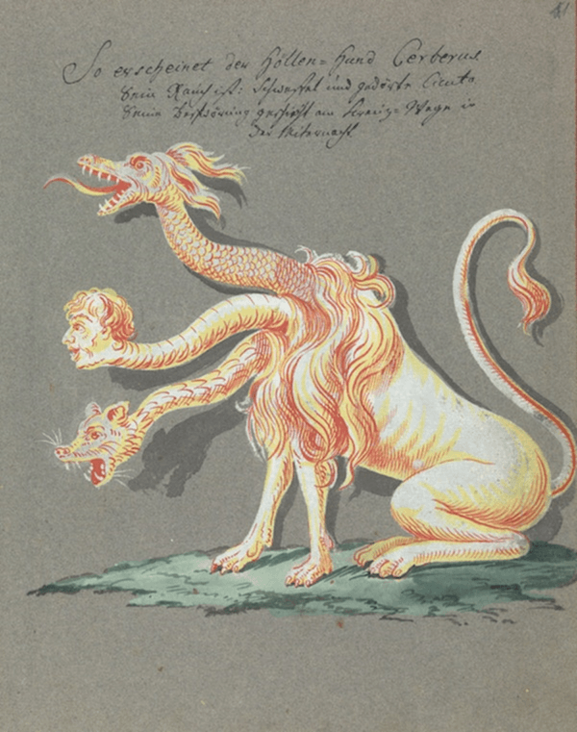
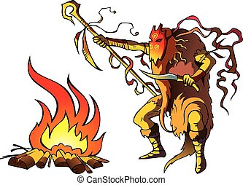



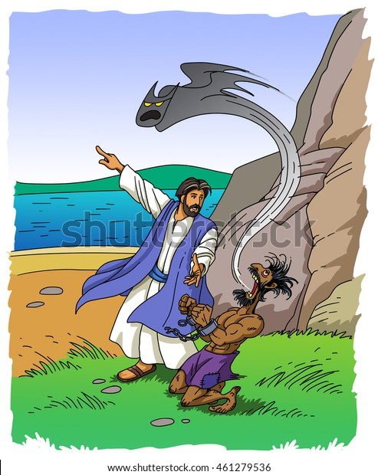

https://epicpew.com/11-time-jesus-took-demons-seriously-and-why-you-should-too/









