**Plan**

1. How to decipher OBI
2. The Earliest Chinese Handbook: an evidence of shamanic code for Gospels (Ancient/precursor)
3. The One in OBI: an evidence of shamanic code for Jesus the Savior
4. The Purpose of OBI: divination, oracle, shamanic spell or prayer

Optical illusion

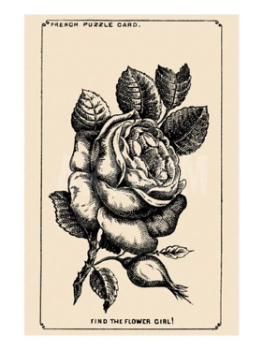

the Girl’s face hidden in the Rose

<https://www.jagranjosh.com/general-knowledge/1880s-optical-illusion-to-test-your-brain-can-you-spot-girls-face-hidden-in-rose-1661513162-1>

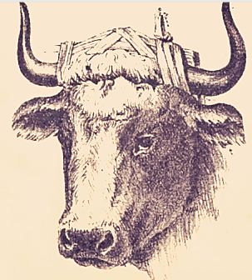

Bull Master’s Hidden Face

<https://www.jagranjosh.com/general-knowledge/optical-illusion-iq-test-only-a-genius-can-spot-bull-masters-hidden-face-1662461885-1>

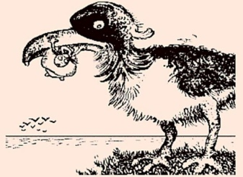

a Man catching Fish inside Giant Bird

<https://www.jagranjosh.com/general-knowledge/century-old-optical-illusion-people-with-high-iq-can-spot-man-catching-fish-inside-giant-bird-1662719345-1>