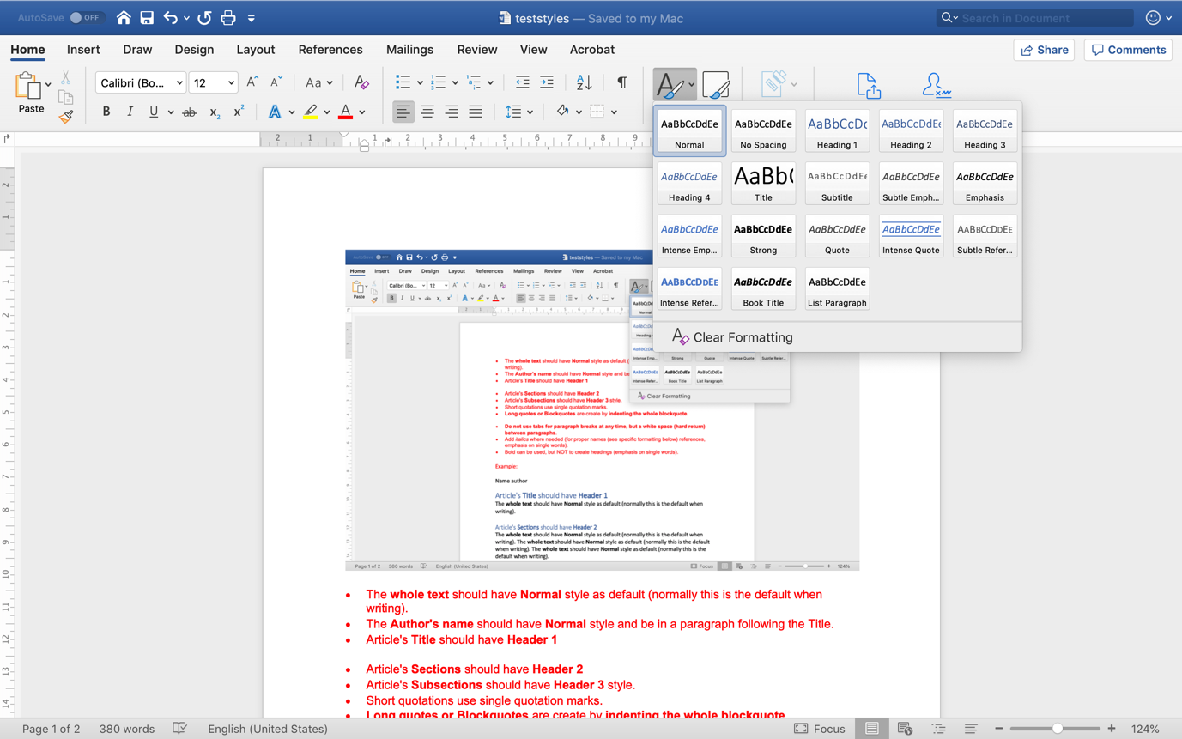

* The **whole text** should have **Normal** style as default (normally this is the default when writing).
* The **Author's name** should have **Normal** style and be in a paragraph following the Title.
* Article's **Title** should have **Header 1**
* Article's **Sections** should have **Header 2**
* Article's **Subsections** should have **Header 3** style.
* Short quotations use single quotation marks.
* **Long quotes or Blockquotes** are create by **indenting the whole blockquote**.
* **Do not use tabs for paragraph breaks at any time, but a white space (hard return) between paragraphs**.
* Add *italics* where needed (for proper names (see specific formatting below) references, emphasis on single words).
* Bold can be used, but NOT to create headings (emphasis on single words).

Example:

Name author

# Article's **Title** should have **Header 1**

The **whole text** should have **Normal** style as default (normally this is the default when writing).

## Article's **Sections** should have **Header 2**

The **whole text** should have **Normal** style as default (normally this is the default when writing). The **whole text** should have **Normal** style as default (normally this is the default when writing). The **whole text** should have **Normal** style as default (normally this is the default when writing).

### Article's **Subsections** should have **Header 3** style.

The **whole text** should have **Normal** style as default (normally this is the default when writing). The **whole text** should have **Normal** style as default (normally this is the default when writing). ‘Short quotations use single quotation marks.’ The **whole text** should have **Normal** style as default (normally this is the default when writing). The **whole text** should have **Normal** style as default (normally this is the default when writing).

**Long quotes or Blockquotes** are create by **indenting the whole blockquote.**

### Article's **Subsections** should have **Header 3** style.

The **whole text** should have **Normal** style as default (normally this is the default when writing).

**Long quotes or Blockquotes** are create by **indenting the whole blockquote. Long quotes or Blockquotes** are create by **indenting the whole blockquote.**

## Article's **Sections** should have **Header 2**

The **whole text** should have **Normal** style as default (normally this is the default when writing). The **whole text** should have **Normal** style as default (normally this is the default when writing). The **whole text** should have **Normal** style as default (normally this is the default when writing).