About Emittance Grow in SIMULINAC Simulations

To understand the influence of non-linearities from different cavity-models in SIMULINAC on transverse and longitudinal emittances, simulations with identical lattices but different cavity-mappings have been done.
All simulations have been done with git repository version v11.0.2.3 and input file TT29.yml from that repository.

Cavity-Model with Mapping t3d.
Mapping t3d is a linear model. It uses the matrices defined in the code Trace 3-D. The cavities are modeled as Drift-Kick-Drift (DKD) triplets. It does not use any field distribution table. This simulation is the fastest one.

Cavity-Model with mapping oxal.
Mapping oxal is a linear model. It uses matrices defined in the article by A.Shishlo and Jeff Holmes section 4.6 OpenXAL RF Gap Model. It does need a table (from SuperFish) for the field distribution E0z on axis. The cavities are modeled as DKD triplets. This simulation is a bit slower than the t3d simulation.

Cavity-Model with mapping base.
Mapping base is a non-linear model. It uses mappings defined in the article by A.Shishlo and Jeff Holmes section 4.2 Base RF Gap Model. It does need a table (from SuperFish) for the field distribution E0z on axis. The cavities are modeled as DKD triplets. Comparing the results from this model with those from t3d allows to estimate the contributions of non-linearities arising from this more realistic approach. This simulation is the fastes non-linear simulation.

Cavity-Model with mapping ttf.
Mapping ttf is a non-linear model. It uses mappings defined in the article by A.Shishlo and Jeff Holmes section 4.4 Three Point TTF Model. It does need a table (from SuperFish) for the field distribution E0z on axis. The cavities are modeled as DKD triplets. This model is the most realistic one of all but very compute intensive and thus the slowest one.

Results for t3d

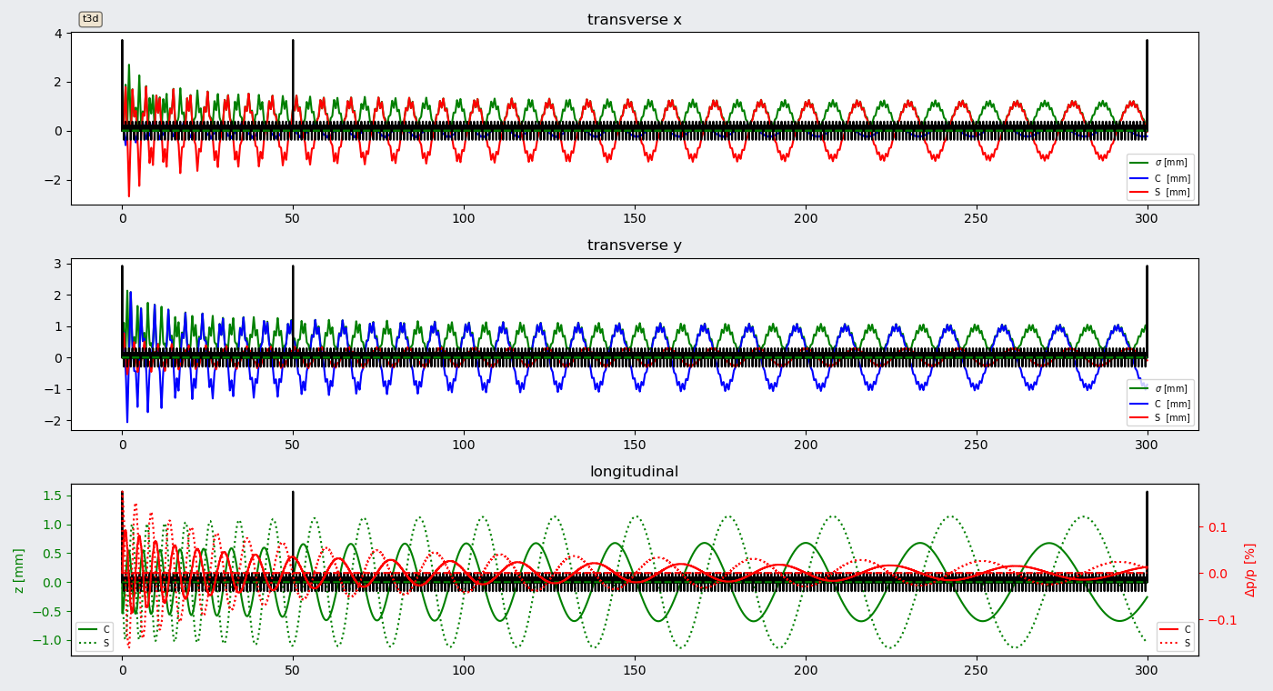
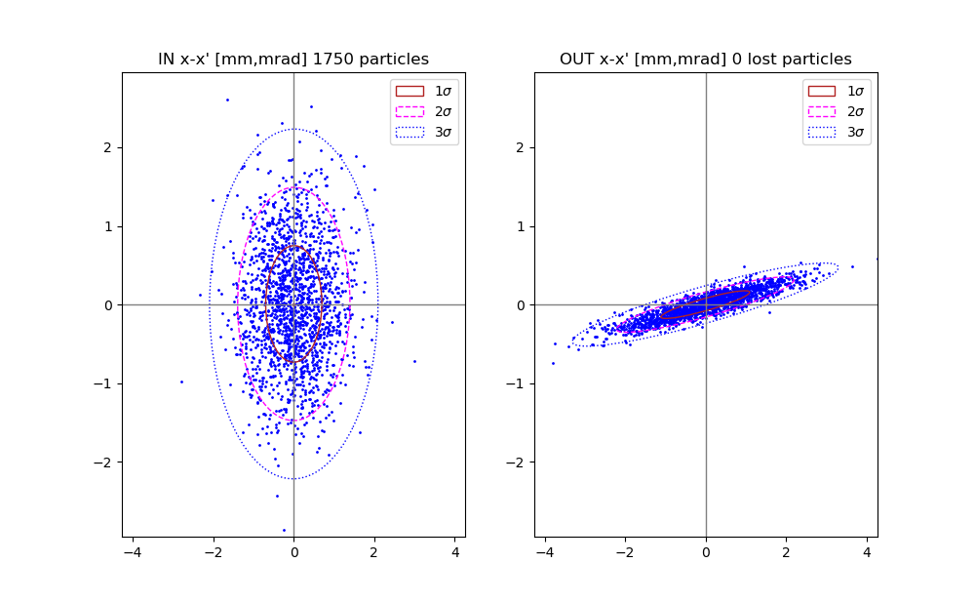
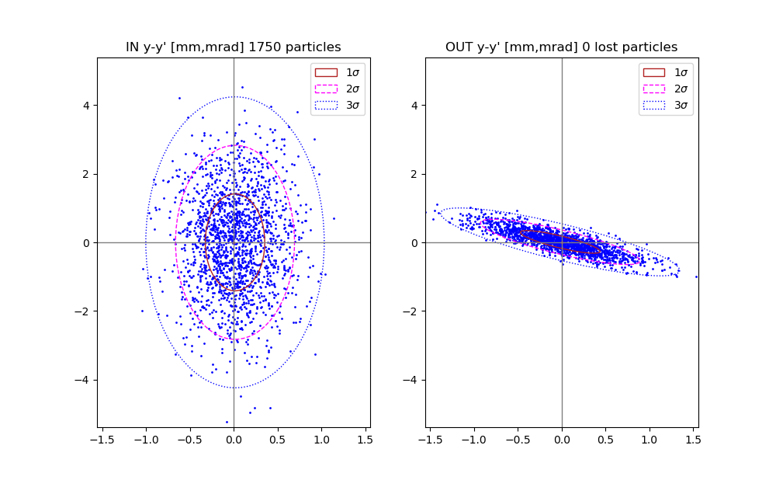
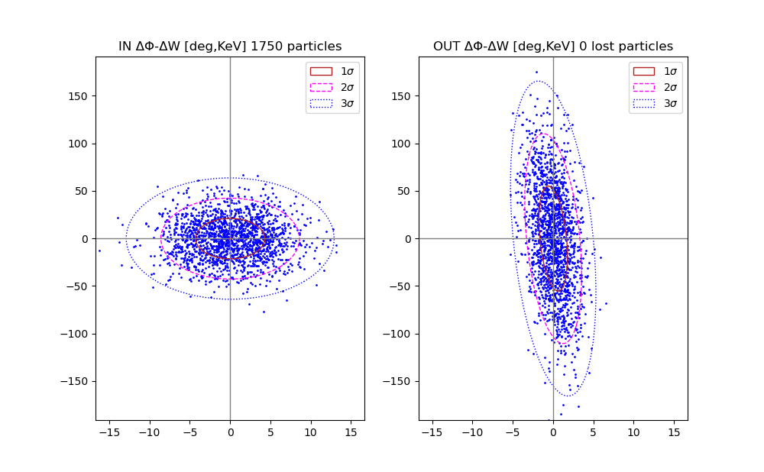
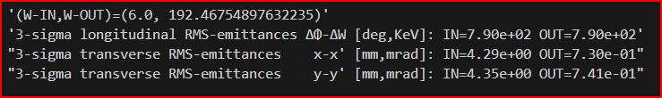

Results for oxal

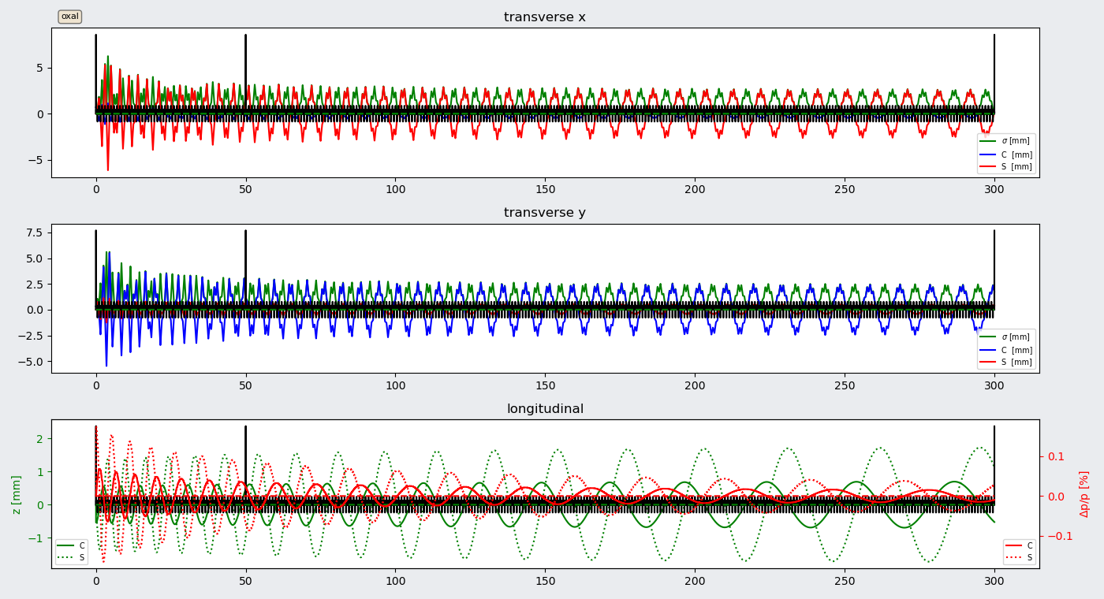
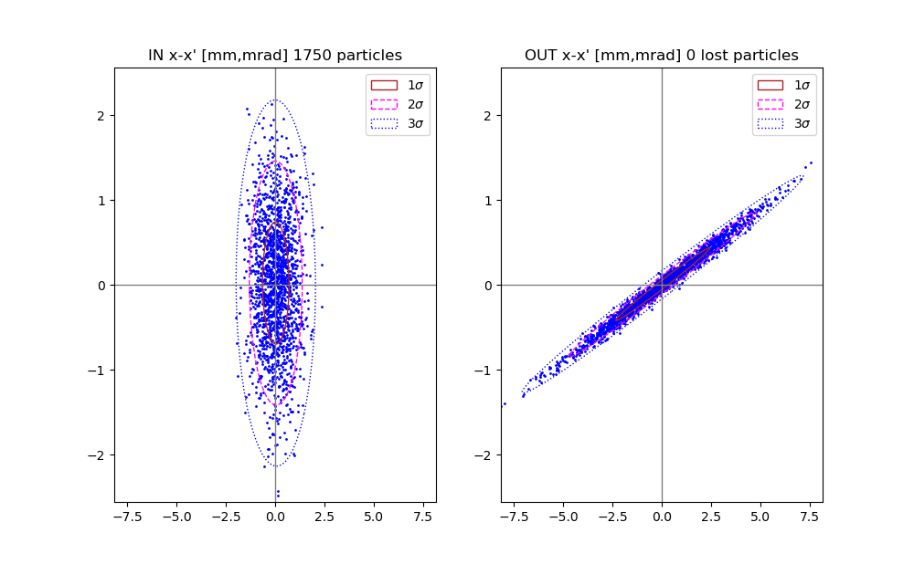
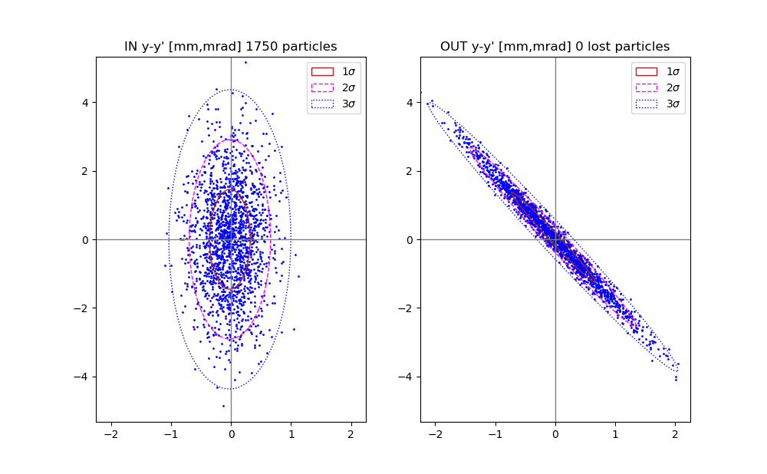
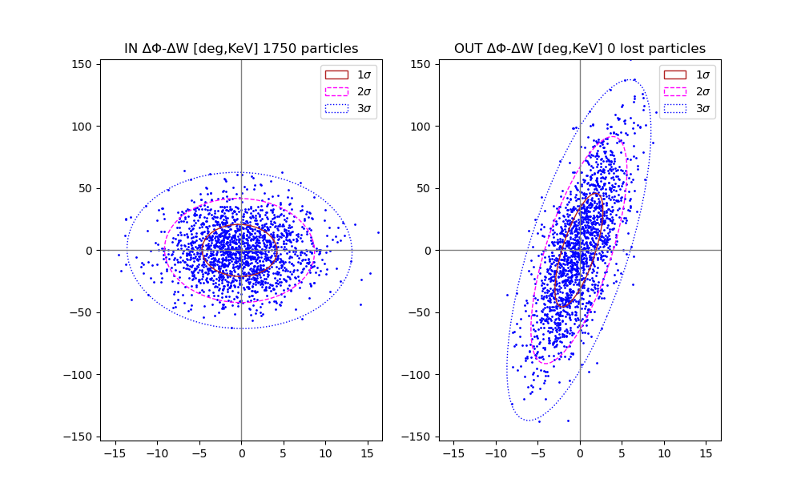

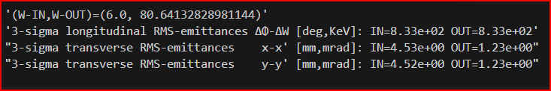

Results for base

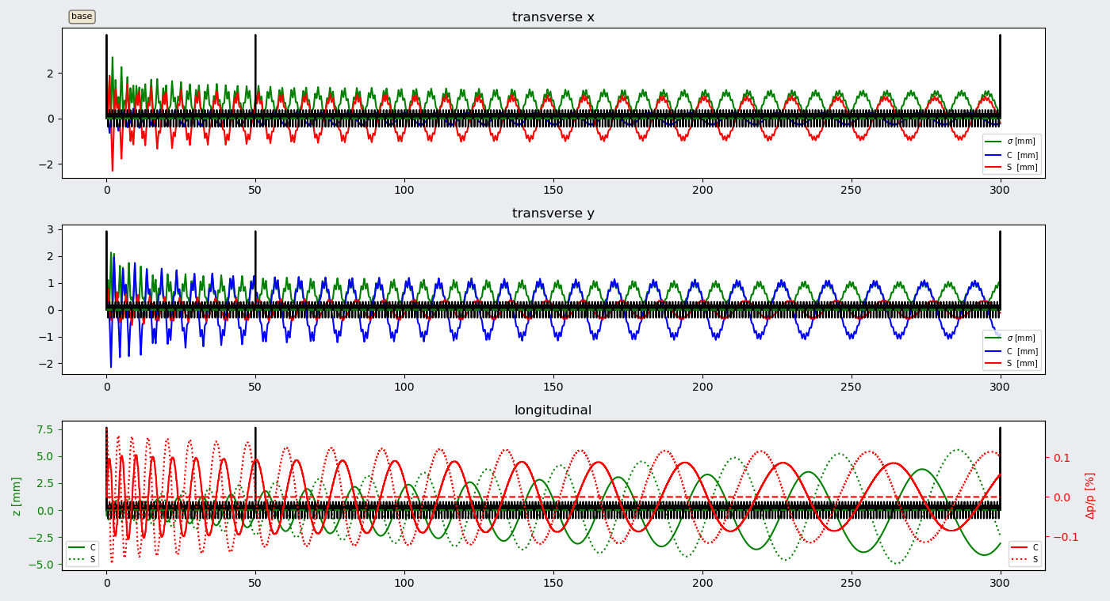
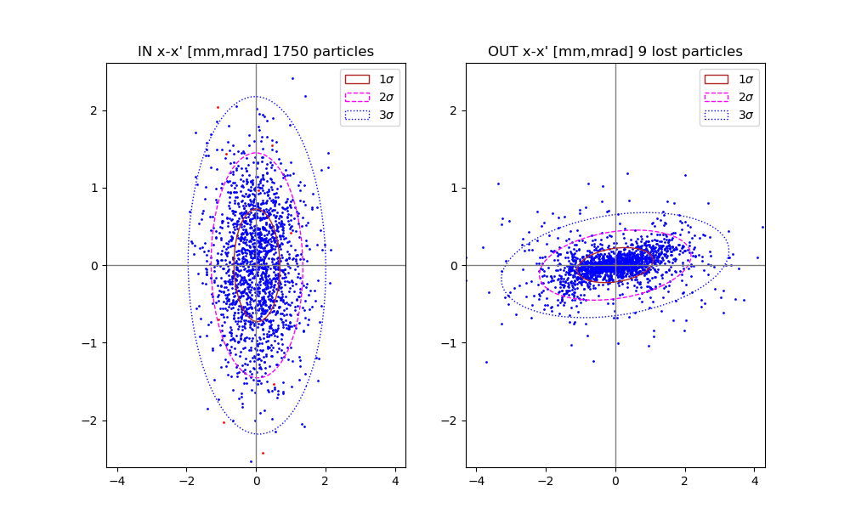
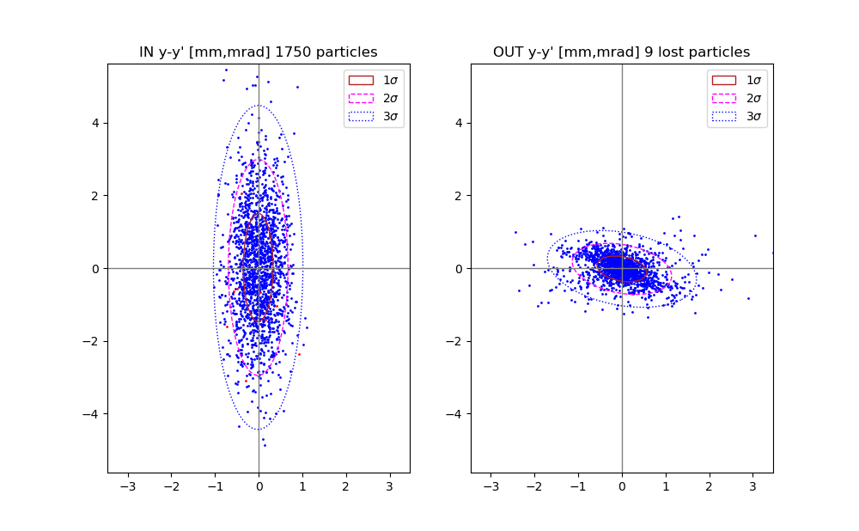
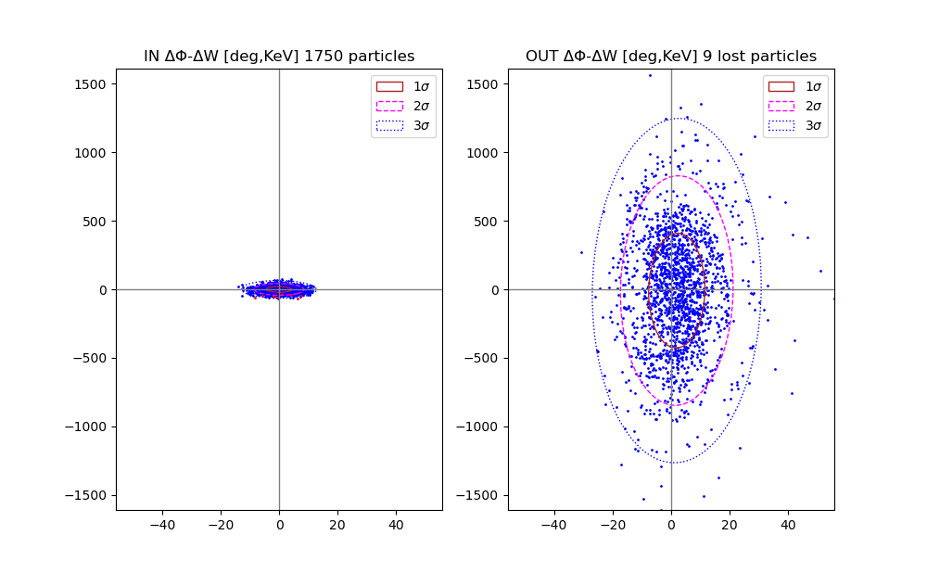

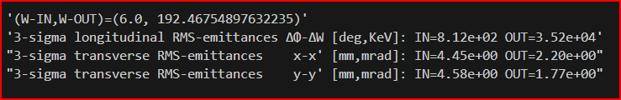

Results for ttf

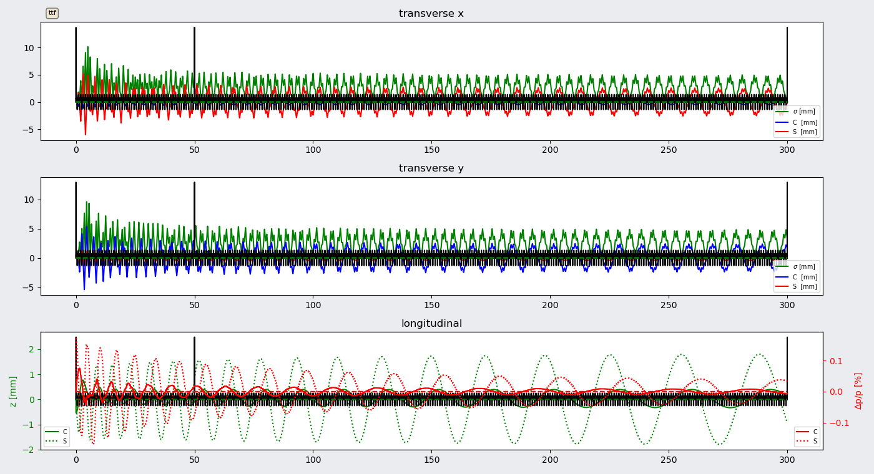
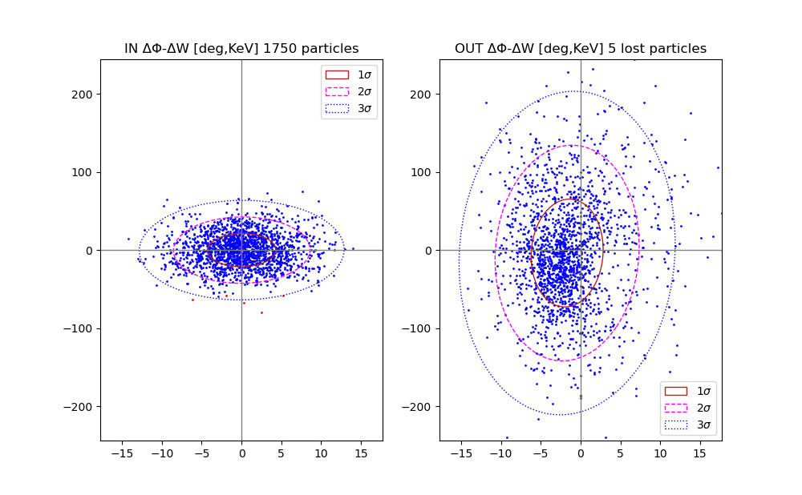
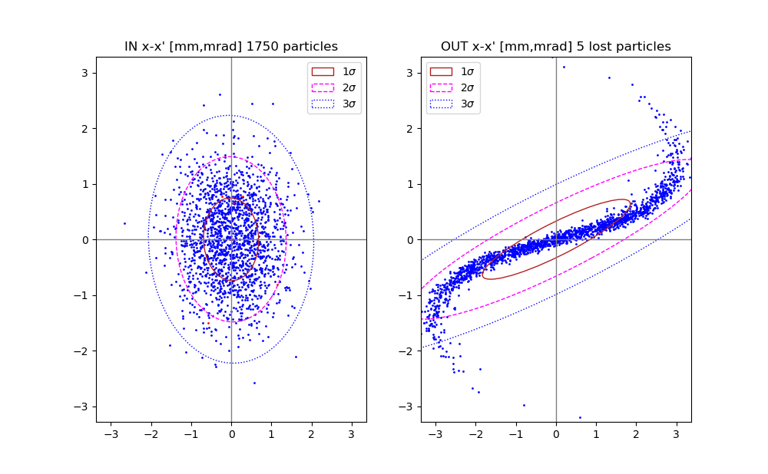
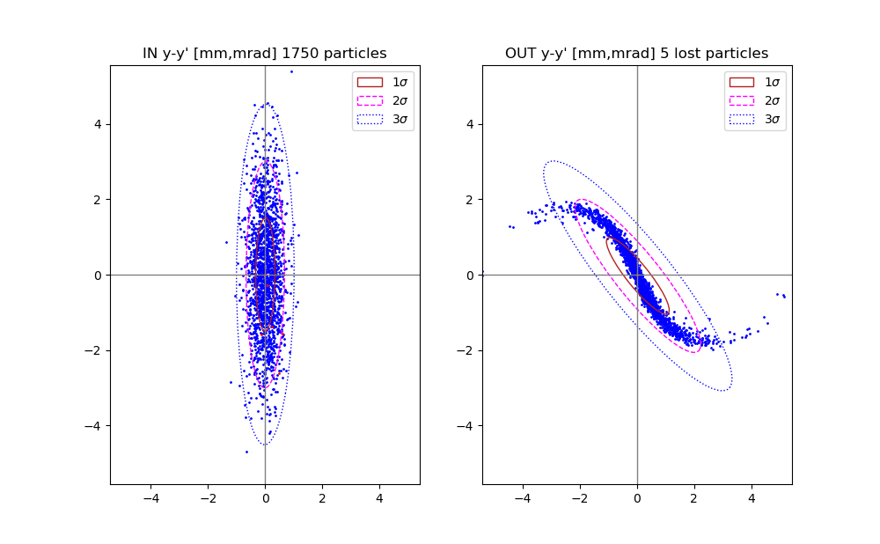

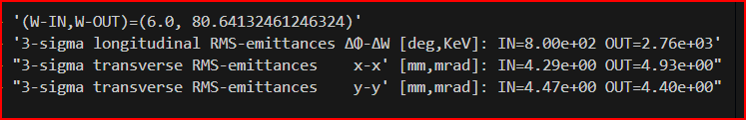

Discussion
For linear mappings the longitudinal rms-emittances stay constant and the transverse rms-emittances get smaller by a factor ~5.9 for t3d and ~3.7 for oxal.
For non-linear mappings the longitudinal rms-emittances increase by about a factor ~43 (strange?) for base and 3.4 for ttf. The horizontal scatterplots show filamentation for non-linear mappings. Not very much for base but very strong for ttf.
For the base mapping for instance the longitudinal kick ΔW in kinetic energy and the transverse angles x’ and y’ have a radial depency as can be seen by the formulae from Shishlo’s article :

