PAYTM PAYMENT INTAGRATION IN REACT JS

Sign up for a Paytm Merchant Account: Visit the Paytm for Business website (<https://business.paytm.com/>) and sign up for a merchant account. Provide the required details and complete the registration process.

Verify Your Account: Once you've signed up, you need to verify your account. Paytm will guide you through the verification process, which typically involves providing necessary documents to establish your business identity and ownership.

After your account is verified, log in to the Paytm Dashboard (<https://dashboard.paytm.com/>) using your registered credentials. This dashboard is where you'll find the required information for integration.

Generate API Keys: In the Paytm Dashboard, navigate to the "API Keys" section. Here, you can generate the necessary API keys for integration. Paytm uses different environments for testing and production, namely the Sandbox and the Production environment. Generate separate API keys for each environment.

The above steps are following below.

* **I refer the web Sites**

If you get the merchant key and merchant id then see this web site for your example

https://www.bacancytechnology.com/blog/integrate-paytm-payment-gateway-using-reactjs

**https://github.com/neelkhamar/react-paytm-checkout**

**PAYTM MERCHANT CREDENTIALS**

* https://dashboard.paytm.com/login/

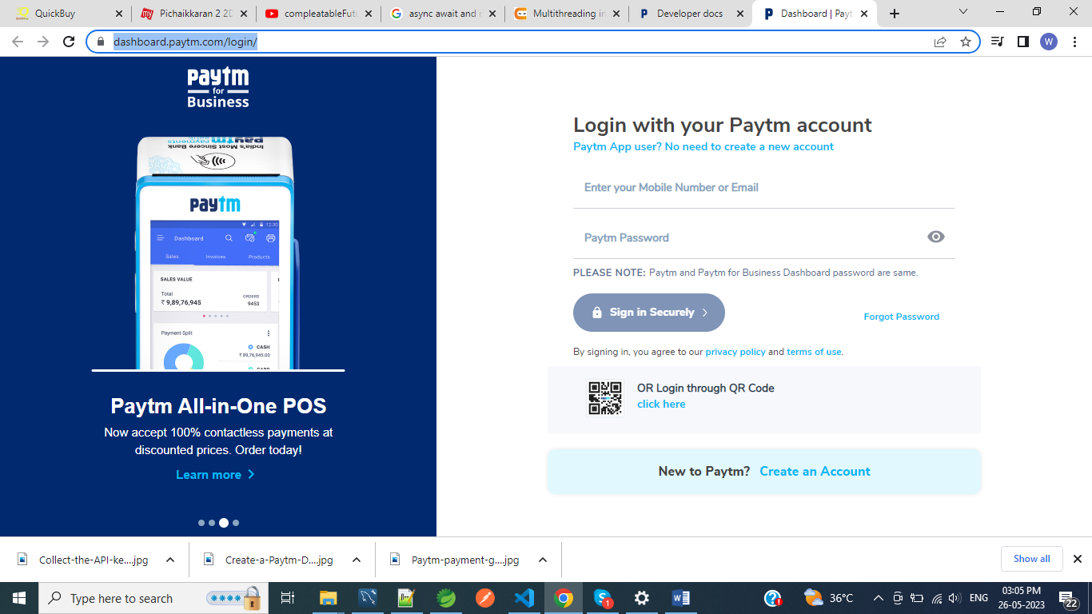

**STEP I : To open sign in tab or else create new account**

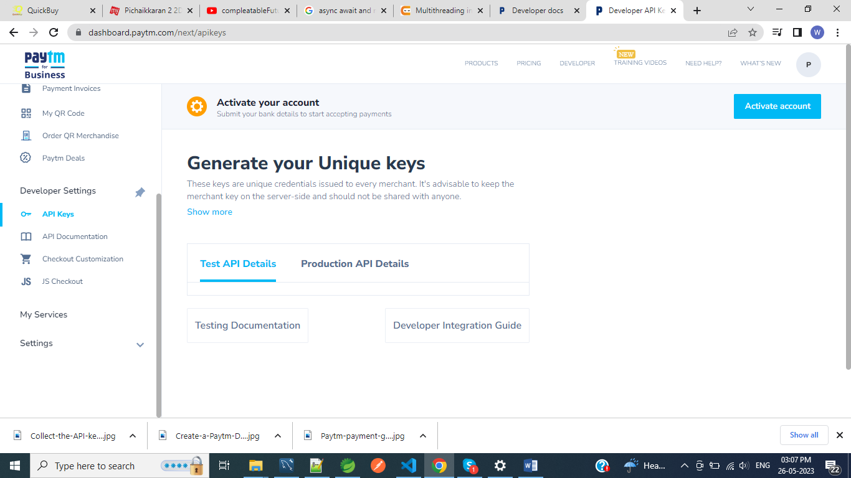

**STEP 2 : To click the developer header**

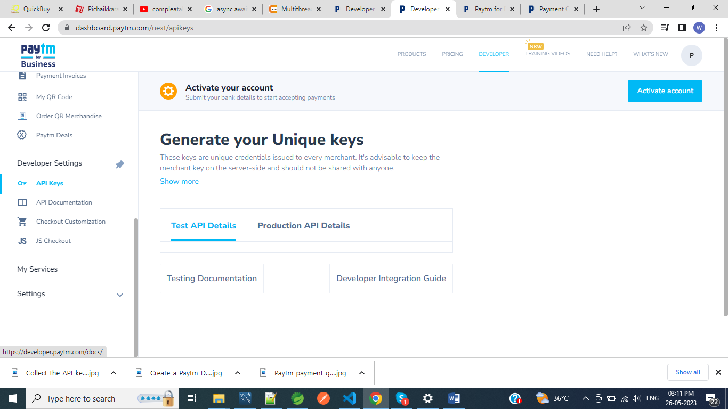

**Click the Developer settings and api keys in side bar**

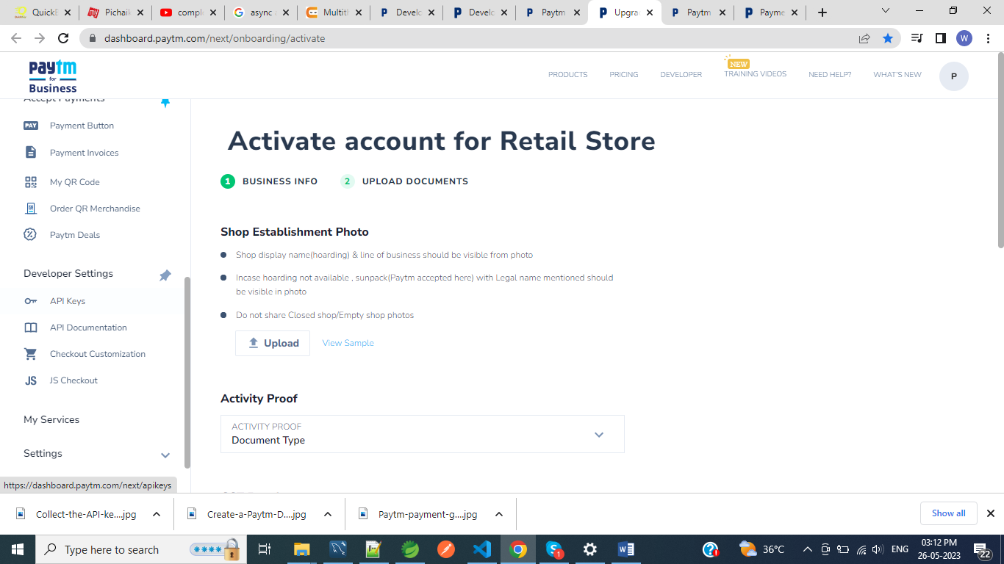

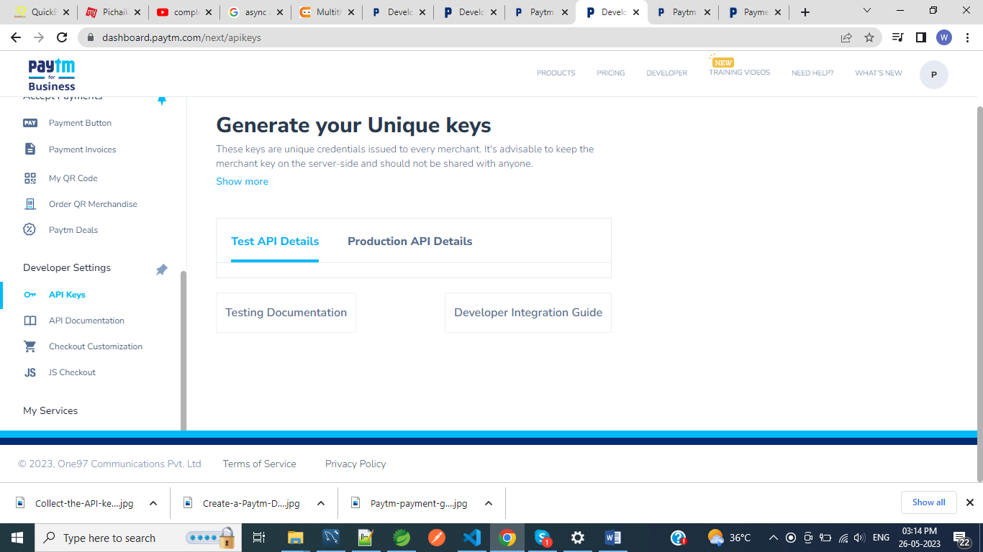

**To see merchant id and merchant key**

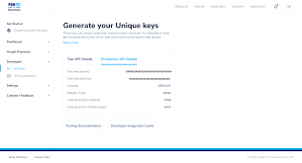

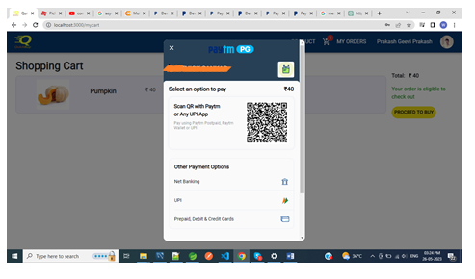

**Click the payment type upi card and net banking. The payment will completed the response data is show in your paytm button make payment files**