1. Un-archive/Archive Message has been done.

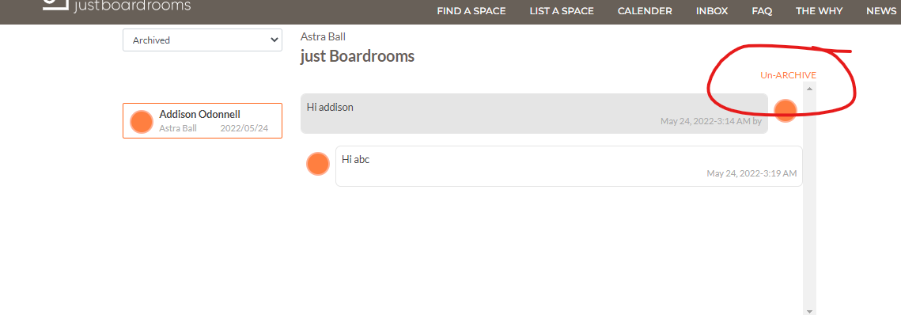

1. Boardroom details on Dashboard has been done.

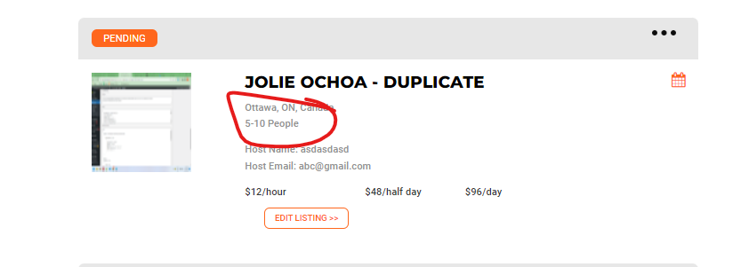

1. Inbox message drop down has been updated

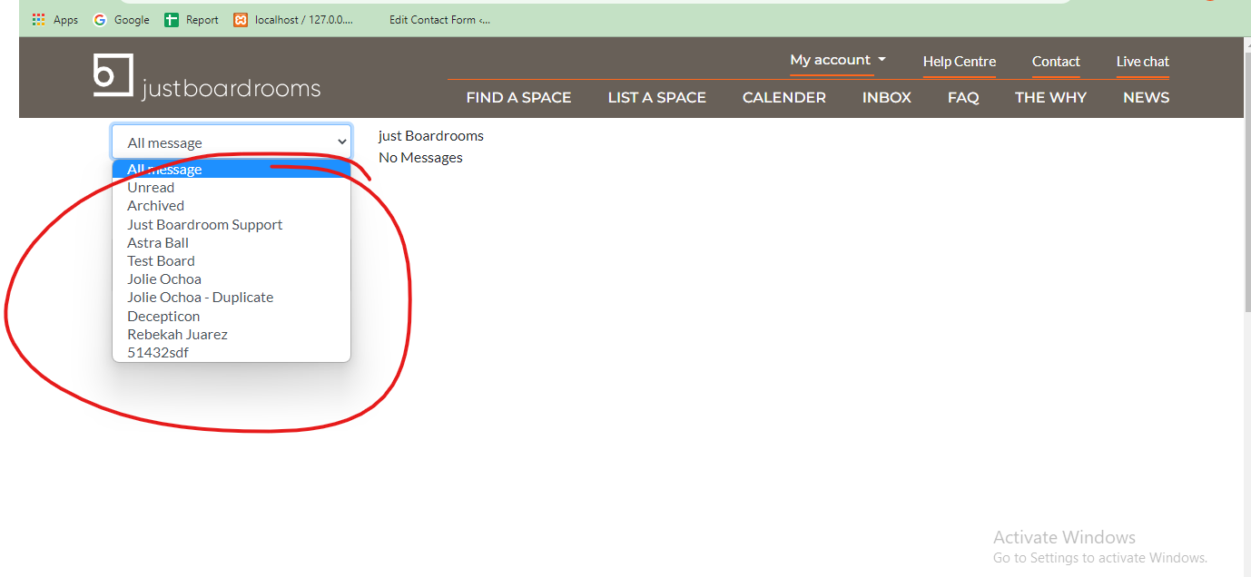

1. Sidebar has been updated

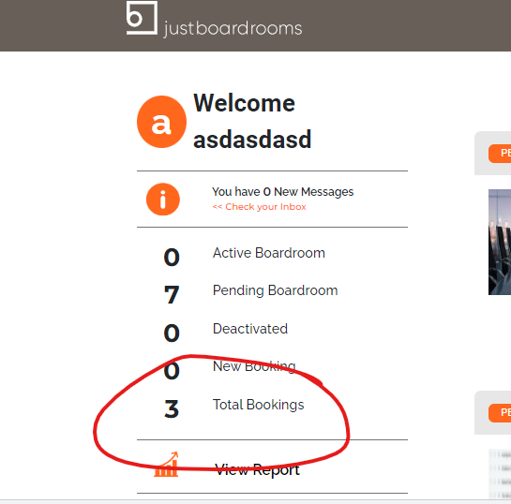

1. Booking calender has been done.

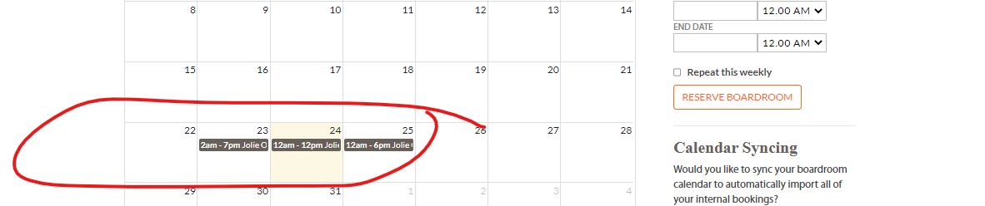

1. Terms and conditions has been added

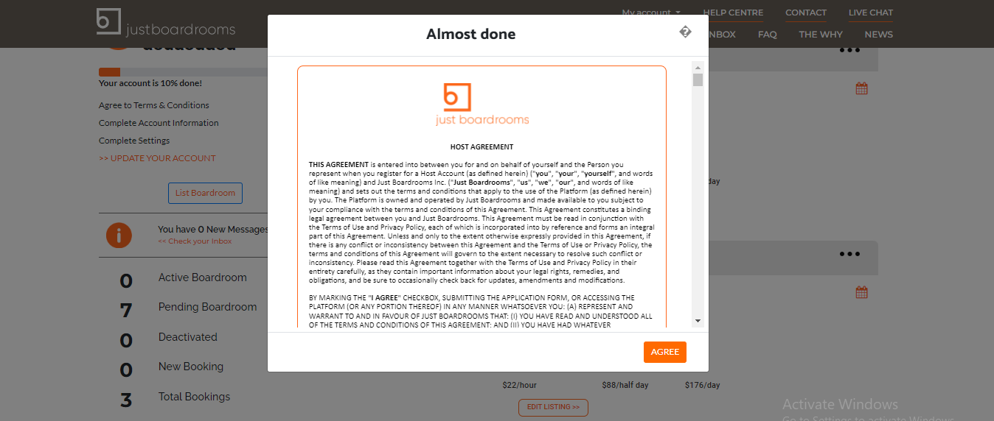

1. Sidebar Account status has been done .

