Message Maker
National Institute of Standards and Technology

Robert Snelick
Len Gebase
Sydney Henrard

Version 1.4
January 2006



Table of Contents

1 Background 3
2 Installation 4
2.1 Download 4
2.2 System Requirements 5
2.3 Installing Message Maker 5
2.4 Running Message Maker 6
3 Overview of Message Creation 6
4 Initialization 7
4.1 Selecting a Profile 7
4.2 Test Options 8
4.2.1 Predetermined Message Generation Sets 8
4.2.2 Select the Number of Messages to Create 9
4.2.3 Customize Message Creation 9
4.2.4 Customized Message Creation at the Element Level 11
4.2.5 Message Generation Characteristics 14
4.3 Data File and Configuration 14
4.3.1 Data Files 14
4.3.2 MSH Segment Data Initialization 17
4.3.3 Table Data Initialization 18
4.3.4 Data Configuration Panel 18
4.4 Data for Z Segments 21
4.5 Identifying Elements with Missing Data Values 23
5 Message Generation 23
5.1 How Message Elements are Populated with Data 23
6 Message Browsing and Editing 25
6.1 Viewing Previously Generated Messages 27
7 Message Management: Creating HL7 Batch Files 27
8 General Configuration Options 29
9 Appendix A: Message Maker Version 1.4 Limitations 30
10 Appendix B: Trouble Shooting 30
11 Glossary 31

Message Maker User’s Guide

Message Maker Version 1.4

Robert Snelick
Len Gebase
Sydney Henrard
National Institute of Standards and Technology
messagemaker@nist.gov

Preface
The Message Maker Project is a collaborative effort between the National Institute of Standards and Technology (NIST) and the Health Level 7 (HL7) Standards Consortium. NIST is directing its efforts towards the development of a conformance-testing tool that automatically generates test messages for HL7 message profile specifications. The messages can be used to test systems for conformance to a given profile. Message Maker is public domain software and is freely available. Message Maker is a work-in-progress, as such, not all planned functionality is implemented. This release is intended as a prototype; feedback on its design, feature set, and usefulness is welcomed. This User’s Guide provides an introduction on how to install and use the tool. Send comments and questions to messagemaker@nist.gov.

Background
HL7 is an application-level messaging standard for the healthcare industry and defines the interfaces that allow centrally located and distributed information systems to communicate. HL7 establishes the rules for building interfaces and provides many optional features to accommodate the disparate needs of the health care industry. However, for interfaces to be implemented, a precise and unambiguous specification must be defined. Message profiles define processing rules and, by defining exactly which of the optional elements allowed by the standard that a message might include, provide an unambiguous XML description of HL7 messages. Tools, such as the Messaging Workbench (MWB), have been developed to help in the construction of message profiles. Interfaces modeled by a message profile need to be tested to ensure that they have been implemented correctly. Current practice involves meticulous by hand debugging of implementations as problems arise. Test message suites and the tools to create them are needed. Message Maker is a tool that is designed to automatically generate test messages.

Message Maker dynamically constructs HL7 messages while parsing a message profile. Data values for the primitive elements (i.e., Field, Component, and SubComponent) defined in the profile are obtained from a number of data sources. These include the NIST developed database of HL7 primitive data items, HL7 tables, user tables, external tables, local tables, example values from the profile, and default values. Alternatively, data can be extracted from a site-specific database (this feature is not yet implemented).

Data Sources
HL7 Reference Database
Table Data
External Data
Example Values
Default Values

HL7 Test
Messages
Profile based
Structurally correct
Validated
Varied
Injected errors
Suitable for conformance testing

Message
Maker

HL7 Profile
(XML)

Test Options
Usage
Cardinality
Volume
Data Content
Value Sets
Length
etc.

Figure 1. Overview of Message Maker Process

Message Maker creates test messages for a given HL7 profile. The messages can be valid or invalid and contain variation from message to message. An example of an invalid message is a missing data item for a required field. A number of test parameters control the variation in the construction of a message. These may include segment and field cardinality, the usage of certain primitive fields, value sets, data content, and more. Data content variation is achieved by randomly selecting items from the HL7 items database.

The core engine of Message Maker generates messages in XML. These messages can be subsequently transformed into the HL7 ER7 format. Figure 1 depicts a functional overview of Message Maker. Processing is XML based. Profile generation tools, such as MWB, export message specifications as XML documents. Data sources, converted into XML files, along with the profile are used by the XSL transformation generation engine to create the test messages. Metadata is recorded for each message. The metadata provides information on the purpose of the test messages. Later stages of this project will include a testing framework that will utilize these messages to examine the behavior of HL7 implementations.

Installation

Download
Message Maker can be downloaded at http://www.nist.gov/messagemaker.

You can download either a self-installing executable jar or the entire software bundle that includes the source code. Choose the self-installing executable if you just plan on using the tool. The generic file name of the installer is maker_install_n.n.jar, where n.n represents the version number.

System Requirements
Message Maker uses Java and XML technologies. The following software is required:

- Java 2 SDK (Version 1.4.2 or later)

Note that the self-installing executable is a jar file, so the Java 2 SDK needs to be installed in order to run it.

Message Maker has been tested on Windows, Linux, and MAC platforms. The following operating systems are supported:

- Windows XP
- Windows 2000
- Linux Redhat 9.0
- MAC OS 10

Since Message Maker is Java based, it is likely that the software will run on other system configurations, however they have not been tested.

Installing Message Maker
Double-click on the installer’s icon to run the self-installing executable to unpack and install the Message Maker software. Then follow the instructions the installer provides—they are self-explanatory. Upon successful completion, you should see the MessageMaker.exe (in the maker bin directory under your chosen install directory) and the desktop short-cut icon if you requested one. Note that the file to run on Unix based systems is MessageMaker.sh. When done with the installation, you can delete the download file to recover disk space.

Windows Troubleshooting: Installer won’t execute.
The installer may not execute if the jar file does not have the proper file type association. One instance where this may occur is when you upgrade your java SDK version. First check to see that the installer is an executable jar file by examining its properties. If it is and still doesn’t work, ensure that the proper execution instructions are associated with the file type. Below gives the steps for Windows 2000. Similar steps apply for other versions of Windows, including Windows XP.

In the Window’s File Explorer, select the “Folders Option …” item from the “Tools” menu. Then select the “File Types” tab. Check to see if there is a “JAR” extension with an “Executable Jar File” File Type in this list.

If it is not present:
- Select “New” and enter “Jar” for the file extension.
- Select the “Advanced” button and enter “Executable Jar File” in the text field at the top of the dialog
- Select “New”. Enter “Open” under Action: and enter
“C:\j2sdk1.4.2_06\bin\javaw.exe” -jar "%1" %* (substitute the location of the javaw executable on your system) under “Application used to perform action”
- check the “Use DDE” box and enter the following in the text fields:
DDE Message:
Application: javaw
DDE Application:
Topic: System

If it is present:
- Confirm that it “Opens with” javaw. If not, select the Change button to launch the “Open With” dialog. Choose “Other” and navigate to the location of your Java installation (e.g., C:\j2sdk1.4.2_06\bin) and then select “javaw”.
- Select “Advanced” and enter the string “Executable Jar File” in the text field at the top of the dialog.
- Under the “Actions” box, enter “Open” and make sure the “Confirm open after download box” is checked.
- Select “Edit” and enter the following test for these fields:

Action: Open
Application used to perform action: C:\j2sdk1.4.2_06\bin\javaw.exe -jar "%1" %*
Use DDE: (confirm this box is checked)
DDE Message:
Application: javaw
DDE Application:
Topic: System

Note that in some cases it is easier to remove an existing Jar file type association and start with a new one.

Running Message Maker
To run Message Maker double-click on the desktop short-cut icon or run the MessageMaker.exe or MessageMaker.sh file in the directory where Message Maker was installed.

Overview of Message Creation
Below the basic steps to create messages for a given profile are listed. The user can specify the number of messages to generate and give Message Maker complete control over the set of messages that are generated. Or, alternatively, the user can select specific options for controlling the types of messages that are generated.

Overview of the Message Creation Process:

Initialization- In this step the user selects the Profile that the messages will be based upon. It can be used to later recall settings. The message path indicates the location where messages are to be stored. A session name attaches a name to the current message generation setup. A session can be saved and recalled using the File menu options.

Options- The user can choose from a number of options when generating messages. By default Message Maker will create a set of valid messages. The user can keep the default settings or customize the process. The volume parameter sets the number of messages that will be created. Additionally, various tests can be selected for specific locations in the profile by selecting the Manual Test Selection panel.

Data Initialization- The user can set the values in the configuration file and the data repository as needed. Values set in the configuration file become the default value for a particular data element. A typical element that might be set in the configuration file is the Sending Application (MSH-3.1). Also, values in the data repository can be modified. Various utilities are provided by Message Maker to customize the data files. The MSH Segment utility can be used to modify and saved configuration data.

Message Generation- After initialization is complete messages can be generated. Message Maker provides a utility that monitors the progress of the generation process. Messages are optionally validated against the profile to ensure correctness (not yet implemented). Although post validation is not done, Message Maker is designed to created valid messages. A trace of the process is provided in a log file.

View/Modify/Validate Messages- After successful completion of message generation, the test messages can be viewed and/or edited. Message Maker provides four views: XML, ER7, Enhanced ER7, and Validation (forthcoming). Messages in the Enhanced ER7 view are presented in a tree structure where element values can be modified and saved. The Validation view shows a message validation report. All of these features can be used on current and previously created messages.

Message Management- Message Management provides a utility that allows the user to create “File” (FHS) and “Batch” (BHS) message structures.

Initialization

Selecting a Profile
The message generation process is driven by a message profile. The profile provides the template that guides message creation. To begin the process, select the profile you want to create messages for. The profile can be selected from the Initialization Panel (the default panel upon startup, Figure 2). Click on the “Browse” button to locate a particular profile or enter the path and file name directly in the text field. Once a profile is loaded the message path directory is automatically selected. This location is provided for convenience that can be modified. The message path indicates the location where the message files are created and stored.
The session provides persistence that saves the settings for the message generation process. This allows for repeating of message generation and partial setup. A session name can be selected using the utility under the File Menu.

Test Files: Message Maker provides an option to load an example profile (“NIST_SampleADT_Z.xml”) upon initial startup. It is a good idea to load this profile to get familiar with Message Maker’s functionality. The profile is used in many of the examples provided in this User’s Guide. In addition to the XML profile, the native MWB profile along with tables files are located in the maker/testing directory under the your chosen install directory.

Test Options
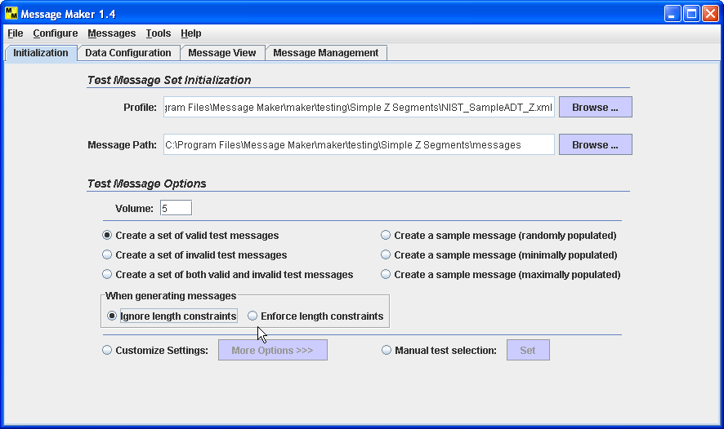

Figure 2. Initialization Panel

Message Maker supports various message generation options. The options include the number of messages that are created, the message validity, constraints on usage, segment and field cardinality, and more.

Predetermined Message Generation Sets
Message Maker by default provides testing variation. When selecting one of the three general test options message variation is provided. You can choose to create messages that are valid, invalid, or a mixture of both. By choosing one of these options, you are allowing Message Maker to control which data items and test options are varied. By default all messages are valid. There are also options to choose a sample message. Sample messages may be minimally populated, maximally populated, or randomly populated. See the glossary for definitions of these terms.

Select the Number of Messages to Create
The Volume field allows you to select the number of messages to create. The default number is 10. Volume can be set when the predetermined message generation sets and customize message creation options are selected. The Volume for manual test selection is determined by the tests that the user selects.

Customize Message Creation
You can have finer control of the testing options by selecting Customize and the More Options button. This will expand the Initialization Panel (Figure 3). This group of testing options allows you to select the type of messages you want to create.

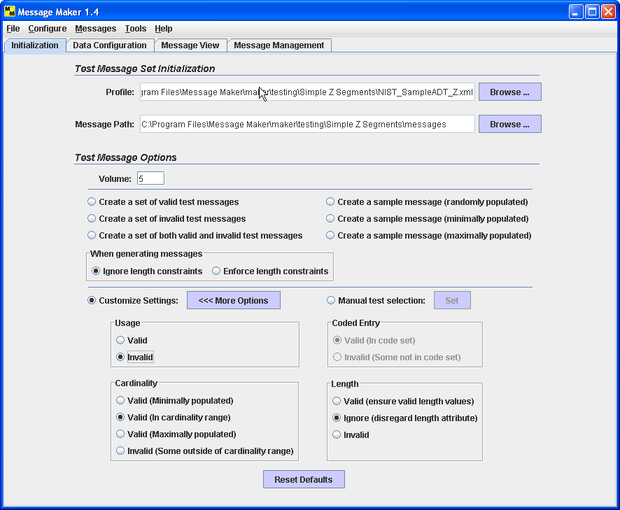

Figure 3 Expanded Initialization Panel

The options set by the user in combination with the number of messages to be generated, determine the types (variation) of messages that are generated. The types of messages generated are divided roughly evenly based on which options are selected. For example, if 10 messages are to be generated and Cardinality and Usage are selected, then 5 messages for testing cardinality and 5 messages for testing usage will be generated.

A base message is a minimally populated message. It serves as the reference message where deviations from it can be identified and recorded as message variants. In selecting the customized options in Figure 3, the user is selecting a given variant or variances, for example, cardinality, from the base message. The “Valid (In cardinality range)” option instructs the message generation engine to create messages that vary the cardinality of segments and fields. The cardinality value and location of the variation is random. Table 1 gives a summary of options meanings.

Category | Option | Interpretation
Usage | Valid | In the case of RE usage the element is populated with data. The location is random.
Usage | Invalid | An element with X usage may get populated with data or an element with R usage may not get populated with data.
Cardinality | Minimally | All elements with cardinality are set to the minimum.
Cardinality | In range | All elements with cardinality will fall within the cardinality range.
Cardinality | Maximally | All elements with cardinality are set to the maximum.
Cardinality | Invalid | An Element with cardinality will be set to values that fall outside the valid cardinality range.
Code Set | Valid | The value is a valid value taken from the requested code set.
Code Set | Invalid | Not Yet Implemented. When implemented it will be a value not contained in the requested code set. Note: You can request a specific Code Set test location by using the manual test selection utility (See section 4.2.4).
Length | Valid | All elements have valid lengths.
Length | Ignore | Disregard the length attribute during message creation and validation.
Length | Invalid | Message will contain an element with an invalid length.
Table 1. Meaning of Customized Option Settings.

The variations in the data used for populating the messages is largely a function of the size of the set of data values available for each primitive element, Field, Component, and Subcomponent. These data values are maintained in a set of XML files that are accessed by the message generation software. The software uses a random number generator to determine the location it will use as its starting point for selecting values from the files. The frequency with which the same location will be selected will then largely be determined by the number of possible values. Subsequent values are selected from the files using a scheme that will increment the starting location by a number that depends on the hierarchical structure of the profile. This scheme should result in relatively little repetition of data values, provided a sufficient number of possible data values are available.

Cardinality and Usage options result in messages being generated in an analogous manner. The length options work somewhat differently. Length constraints can either be enforced or ignored, but the option's setting doesn’t otherwise impact the messages that are generated. When length constraints are being enforced for primitive elements, repeated attempts will be made to find suitable values satisfying the constraint; generally if such a value is present in the XML data files, it will be used. When the composite length option is set, its only impact is to produce a warning in those cases where a composite element might violate its length constraint, even though none of its component elements violates any length constraint.

When an option for generating a length error is set, a single element in the message will be instantiated with a value that violates the length constraint for some numeric (NM) or string (ST) type only.

Customized Message Creation at the Element Level
Selective element locations and test type can be identified for testing when generating messages. Choose the “Manual Test Selection” radio button and select the “Set” button to launch the selection panel. This panel depicts the profile in a tree structure and shows the available options that can be selected for generating messages for particular elements. These options vary depending on the validity of the message. By default the options are given for valid messages. Use the drop-down list to change this to create invalid messages.

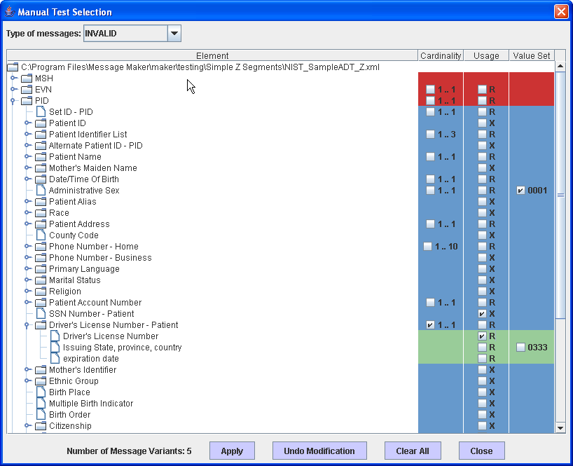

Figure 4. Manual Test Selection Panel

As a reference point, all modifications made to a message variant is made with regards to the base message. The base message is a minimally populated message. See the glossary for a precise definition of both.

Choosing a test category at a selected location indicates to Message Maker that you want to create test messages that vary the constraints at this element. More then one message can be created for a given selection. A running total of message variants are given at the bottom of the panel.

Table 2 (Valid) and Table 3 (Invalid) give the interpretation of the options for cardinality as a function of the usage attribute. Table 4 summarizes the options for the usage constraint. Recall that message variants are in reference to the base message, so instances that include the base message settings are not listed here.

Usage | Cardinality | Message Variants
R | 1…1 | None
R | 1…N | 3 message variants possible:  - Cardinality = 2 (minimum + 1)  - Cardinality = N (if N = * then cardinality is set to the minimum + 3, where 3 is an arbitrary value that can be configured, see the Options utility).  - Cardinality = floor (minimum + N)/2. If this value equals one of the values in 1 or 2 above, then only 2 message variants are created in this instance.
R | M...N | 3 message variants possible:  - Cardinality = M+1 (minimum + 1)  - Cardinality = N (if N = * then cardinality is set to the minimum + 3, where 3 is an arbitrary value that can be configured).  - Cardinality = floor (M + N)/2. If this value equals one of the values in 1 or 2 above, then only 2 message variants are created in this instance.
RE | 0…1 | Cardinality = 1
RE | 0…N | 3 message variants possible:  - Cardinality = 1 (minimum + 1)  - Cardinality = N (if N = * then cardinality is set to the minimum + 3, where 3 is an arbitrary value that can be configured).  - Cardinality = floor (minimum + N)/2. If this value equals one of the values in 1 or 2 above, then only 2 message variants are created in this instance.
X | Don’t care | None
Table 2. Valid Message Variants for Cardinality

Usage | Cardinality | Message Variants
R | 1…1 | Element not included
R | 1…N | 2 message variants possible:  - Element not included  - Cardinality = N +1 (if N = * then there are no variants)
R | M...N | 2 message variants possible:  - Element not included  - Cardinality = N +1 (if N = * then there are no variants)
RE | 0…1 | None
RE | 0…N | Cardinality = N+1 (if N = * then there are no variants)
X | Don’t care | Element included
Table 3. Invalid Message Variants for Cardinality

Validity | Usage | Message Variants
Valid | R | None
Valid | RE | Element included
Valid | X | None
Invalid | R | Element not included
Invalid | RE | None
Invalid | X | Element included
Table 4. Message Variants for Usage

Note that the “Manual Selection Panel” displays only check boxes for the tests that are possible given the validity of the message. For example, for valid messages with elements that have R usage, no tests can be created. If, however, Invalid message type is selected, then an element with R usage can be selected. In this case, an element that has R usage and is selected will instruct the message generation engine not to populate the element with data, thus creating and invalid message.

Consider the following examples as selected in Figure 4--these four cases will generate five test messages:

Case1: Invalid Value Set at PID.8 Administrative Sex
The type of message selected is invalid and the Administrative Sex table 0001 is selected. This instructs the message generation engine to implant an error at this location. The message generation engine will search table 0001 and then populate this element with a value that is not in table 0001.

Case 2: Invalid Usage X PID.19 SSN Number – Patient
The type of test selected is invalid usage (X) for the SSN Number – Patient. In this case the element is not supported (indicated by the X usage). By selecting this test the message generation engine is instructed to populate this element with a data value thus creating an invalid message.

Case 3: Invalid Cardinality PID.20 Driver’s License Number - Patient
The type of test selected is invalid cardinality for the Driver’s License Number – Patient element. In this case the profile supports exactly one instance of this element (indicated by the cardinality of 1..1). By selecting the test the message generation engine is instructed to create messages where this element with have instances that fall outside of the cardinality range; therefore two messages will be generated:

- The Driver’s License Number – Patient element is not present
- The Driver’s License Number – Patient element appears twice

Case 4: Invalid Cardinality PID.20.1 Driver’s License Number
The type of test selected is invalid usage (R) for the Driver’s License Number. In this case the element is supported (indicated by the R usage). By selecting this test the message generation engine is instructed not to populate this element with a data value thus creating an invalid message

Analogous test cases can also be created for valid messages. For example, consider an element with an RE usage. The base message does not populate elements that have a usage of RE, so the selection at this point indicates to the message generator to populate this element. The selection of an element with a cardinality attribute of 1..3 indicates that messages will be generated that contains 2 and 3 instances of that element. The base message covers the case of 1 instance.

Message Generation Characteristics
Each generated message is different in terms of both structure and content. Below is a list of message characteristics that should be considered when choosing options for message generation:

- data content is randomly selected from a database
- multiple variations maybe introduced for any given message
- at most one error is introduce for a given message.

Data File and Configuration
Message Maker provides various ways to input and modify the data that is used in message generation. Configuration, Table, and Reference data can be defined and modified. Configuration data are values that will always be used in a primitive data element. Any item in the reference database can be modified with the use of the “Data Configuration” panel (including MSH segment and table data). MSH configuration data can be set with the MSH Segment convenience dialog. Table data can be set or modified with the Table Viewer dialog.

Data Files
Message Maker maintains a number of XML data files for use in message generation. A brief description for each is given below:

ConfigData: This is a special file that contains data items that are always used for an element. Typical configuration data might include the HL7 version number or the name of the sending application used in the MSH segment. If a data item is present in this file, the message generation software will always use the item’s value when generating messages.

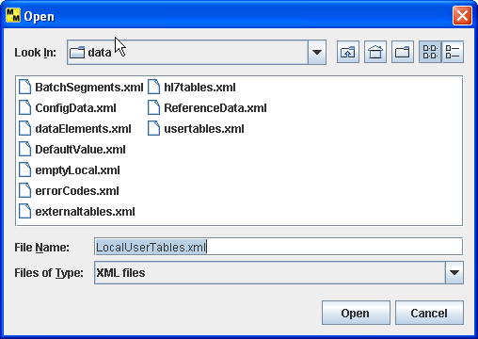

Figure 4. Saving Data Files

hl7tables: This file contains the list of tables defined by HL7. These include HL7 and HL7User table types. The file contains the table id, name, type, and code/value pair. The initial values for the tables are those defined or suggested by the HL7 standard. Values for the HL7 tables cannot be modified. Values for HL7User tables can be modified.

usertables: This file contains the list of tables defined by HL7 to be of type “User”. There are no suggested values in the standard—the values are site specific (e.g., a hospital room number). These values are typically unique to a particular installation and are defined locally. NIST provides values for these tables (i.e., NIST creates sample values). The NIST created values may be sufficient for many testing scenarios. In cases where they are not, the tables can be modified with the Table Viewer or by selecting the table from the Data Configuration Panel.

externaltables: This file contains the list of tables defined by HL7 to be of type “User” with suggested values coming from an external source such as ISO. For example, HL7 Table 0399 for Country Codes are taken from the 3-character codes defined by ISO 3166 table.

localtables: This contains the list of tables that are local to a particular site. These files are provided by the users and imported into Message Maker. The local tables can be directly imported into Message Maker or can be transformed into a format that Message Maker can read.

ReferenceData: The NIST HL7 Reference Database contains example data values for HL7 data elements that are not found in other data sources such as HL7 tables. The database contains items for the HL7 primitive data elements (i.e., fields, components, and sub-components). The data items are contained in an Microsoft Access database and are transformed into an XML file for processing by Message Maker.

Together, these data sources are used in the message generation process. Each of the data sources can be modified. When values from a data source are modified, Message Maker will request the name of the file to save (Figure 4) the new data source. By default Message Maker suggests the “Local” prefix. Message Maker will maintain any number of local versions of the file.

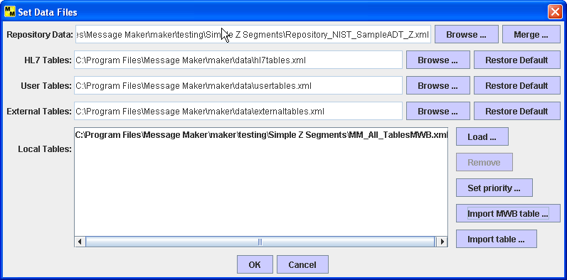

Figure 5. Set Data Files

The user can select which data files they want to use when generating messages. This can be accomplished with the “Data Files” dialog under the “Configure” menu (See Figure 5). Once set, the Local data files can be used for any message generation session.

Local table data files can be added to the data lookup sequence using the “Data Files” dialog. Use the “Load” button to browse the file system to locate the file you want to add. Local tables are used when the profile contains references to a local set of table definitions. [Currently, only one local table can be added. In addition the priority feature that allows the user to set the sequence that the data files are searched is not yet implemented.]

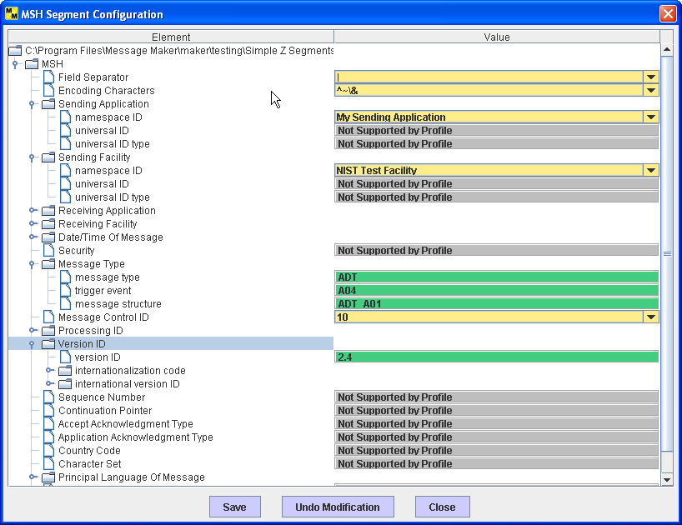

Figure 6. MSH Segment Initialization

Local table files can be imported directly into Message Maker as long as they adhere to the format that is consistent with the data files provided with Message Maker. Use the “Load” button. See the hl7tables.xml file provided in the distribution for an example of the table format. Also, tables produced by the MWB can be imported into Message Maker directly. Message Maker will automatically convert the MWB table file into its internal format. Use the “Import MWB table” button. A third method of importing table data is via a generic mapping feature. Click on the “Import Table” button and provide the mappings of the local table to the format required by message maker. Again, see the hl7tables.xml file for an example.

MSH Segment Data Initialization
To set configuration data in the MSH Segment, select “MSH Segment” under the “Configure” Menubar. This dialog displays the profile represented as a tree structure. Data items colored in yellow can be modified. Items that are not supported in the profile are colored in gray and contain the text “Not supported by Profile”. Items colored in green, cannot be modified (e.g., the message type MSH.9).

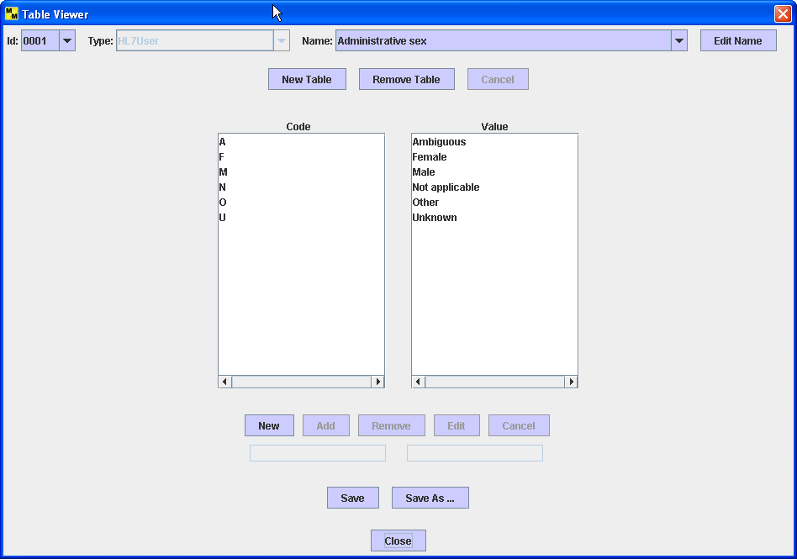

Figure 7. Table Viewer

Items set on this dialog are written to the ConfigData file and as such will be used as the default value in message creation. Change the “Message Control ID” (MSH.10) element to set the beginning sequence number for identifying messages.

Table Data Initialization
Tables can be modified, created, or removed using the “Table Viewer” dialog (See Figure 7). To create a new table select the “New” button and then provide the Name, Number, Type, and code/value pairs. To remove a table, select the table and click-on the “Remove” button.

When a table is selected, its code/value pairs are shown. Using the utilities provided, the table code/value pairs can be modified. To modify an entry, select the code/value pair of interest. This will copy the entry to the text field provided below. Make the modifications and select the edit button to make the changes permanent. New items can be added to the table by using the “New” and “Add” buttons. Select “New”, enter the code/value pair in the text fields, and select “Add” to include the item into the table. To remove an item, select an entry and click-on the “Remove” button.

Data Configuration Panel
The Data Configuration panel is a general-purpose utility that allows the users to modify the data elements in the database, including MSH segment and table data. The Data Configuration panel allows the user to set various site-specific values that they want to include in messages or allows them to provide customized variation of the data values for particular elements. The view that is presented is a reflection of the profile. All data elements can be modified including table values. The user may add, edit, or delete values from the repository. Depending on the type of data value, an appropriate data modification panel on the right side of the Data Configuration panel will appear. To view and/or modify a particular data element browse the tree structure and select the desired element.

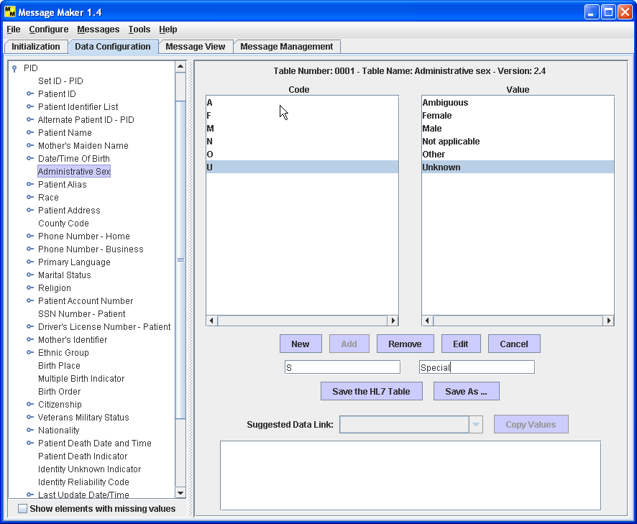

Figure 8. Data Configuration Panel (Table Data Modifications)

Figure 8 shows the panel for table data (HL7 Table 0001 Administrative Sex). To add an entry into the table select the New and Add buttons. Select New. This activates the two text fields where the Code and Value pair can be entered. Select the Add button to commit the values to the table. To delete an entry from the table, select (highlight) Code and Value pair and select the Remove button. To modify an existing entry select (highlight) the Code and Value pair. This entry will now appear in the Code and Value pair text fields. Perform the modifications and select the Edit button to commit the changes to the table.

Data values for primitive elements can also be modified. Figure 9 depicts such a panel. Again use the tree structure to navigate to the element you want to modify. In this case we selected the PID segment, the Phone Number – Home field and the [(999)]999-9999[X999][C any text] component. The [(999)]999-9999[X999][C any text] component is highlighted. On the right side of the panel the values in the database for this element are given. You can add, modify, or delete values from this list. Also, for each value you can set the associated attributes (e.g., Complexity). Currently, Message Maker does not yet make use of these attributes; hence changing the attribute values will have no affect on message construction in this release.

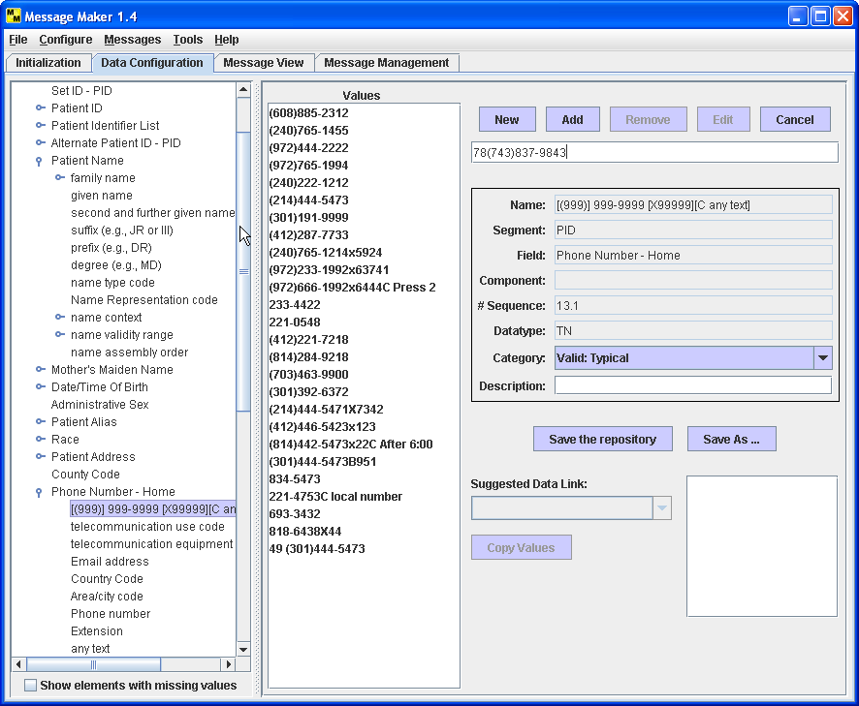

Figure 9. Data Configuration Panel (Reference Data Modification)

To add an entry into the element list select the New and Add buttons. Select the New button; this activates the text field where a Value can be entered. Select the Add button to commit the value to the list. To delete an entry from the list, select (highlight) a Value and click-on the Remove button. To modify an existing entry select (highlight) the Value. This entry will now appear in the Value text field. Perform the modifications and select the Edit button to commit the changes to the list.

Data for Z Segments
Because Z Segments are local extensions, they inherently present a problem for populating message elements with data. We can provide data values for standard HL7 elements because they are known and given in the HL7 database. Z segments contain elements that support their local implementations and therefore have their own nomenclature. However, there are a number of methods to provide data values for Z segment elements.

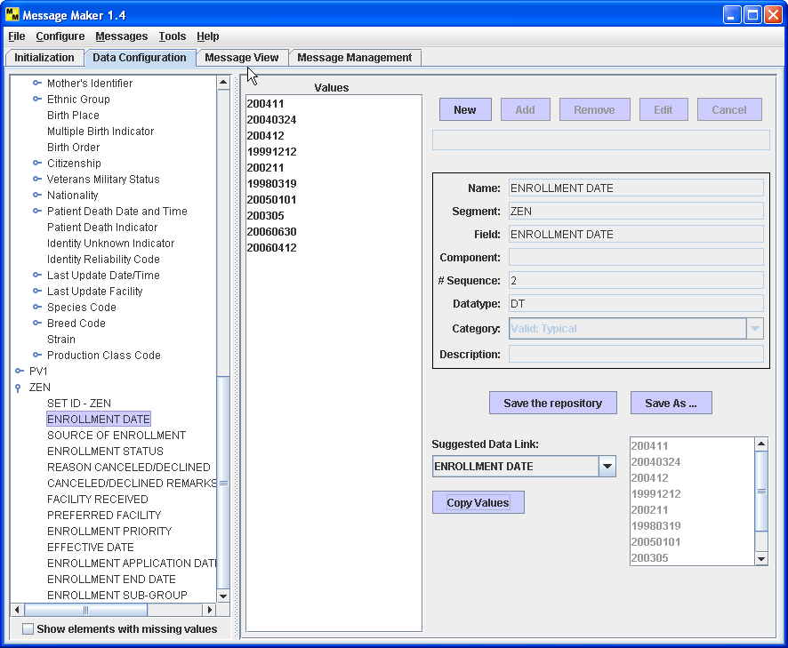

Figure 10. Data Configuration Z-Segments Data Copy

A link to a database can be established and the mappings to it can be defined. This would be the optimal solution and will be provided in future versions of Message Maker.

A second solution is to map data values provided by the repository to Z segment elements. The repository can be search for similar element names where by the user can review to determine if the data maps. If it does, they can choose to copy this data to create a new element field in the repository (Figure 10). To link data values in the repository to elements defined in Z Segments browse through the values of the “Suggested Data Links” and use the “Copy Values” button when appropriate values are found.

A third method is to use the Configuration Panel to add values directory to the repository. These values can be saved and use for subsequent use in Message Maker. In this case follow the instructions given in the previous section for adding new values for primitive elements.

A fourth method is to use the example data value given in the profile, if one is provided. The downside to this is that the same data for Z segment elements will be used for every message created.

The fifth method is to use the default values. In this case, if a data value can’t be found for a particular message element, a default data value is assigned based on the data type of the element. Although aesthetically unpleasing, functionally it provides the same utility as data obtained from health care information databases.

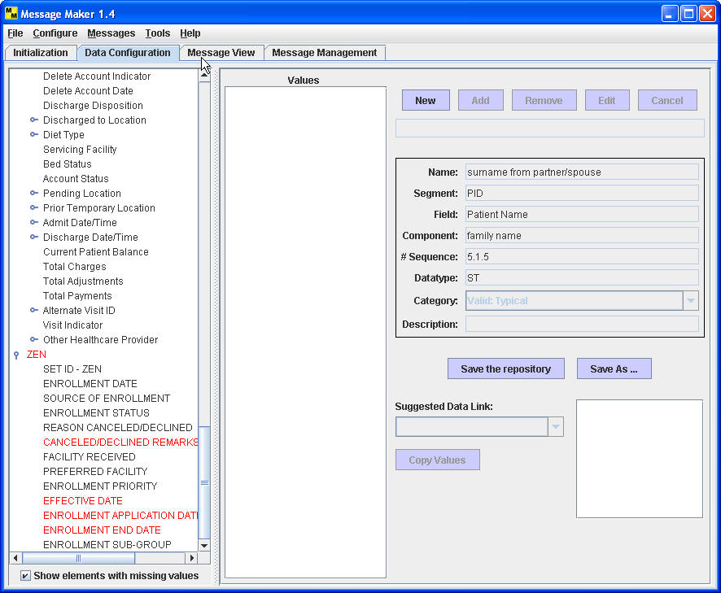

Figure 11. Identifying Elements with Missing Data Values

Identifying Elements with Missing Data Values
Figure 11 illustrates a utility that allows the user to determine the elements that are missing data values. Knowing which values are not present allows the user to populate the repository with data for these elements. In the event that these elements are not populated, before message generation, default values will be put into the repository based on the data type of the element.

Message Generation
Once initialization is complete messages can be generated. The minimum initialization requirement is providing a valid message profile. To start the message generator select the “Generate…” item under the “Messages” menu. This will launch the Generate Messages Dialog, See Figure 12. Click-on the Start button to begin the process.

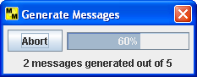

Figure 12. Generate Message Dialog

Upon completion messages are saved in the “Message Path” directory specified during initialization. The messages are stored as XML files. Internally, Message Maker processes messages as XML representations. Message can be transformed into the ER7 encoding and can be saved in XML or ER7 format. To save messages select the Save item from the Messages menu. If you wish to subsequently edit messages, the XML version must be saved. Messages that are not explicitly saved will be removed when Message Maker exits. Messages can be deleted by selecting the Delete item from the Messages menu.

How Message Elements are Populated with Data
Message Maker has a predefined sequence for populating primitive message elements with data. The precedence order is given below:

- Values predetermine by the HL7 specification and present in the profile, for example, MSH.9, the Message Type.
- Constant Values defined in the profile (i.e, the ConstantValue attribute)
- Configuration Values set by the user either through the MSH Segment Configuration Panel or the Data Configuration Panel. Here the data that is explicitly saved as configuration data. The “namespace ID” for the “Sending Application, MSH.3, is a typical example. It may be the case where the user wants to set this value so that it appears in every message with the same value. Most MSH segment elements are considered Configuration Values.
- If an element indicates that a value should come from a Table, a data value is randomly selected from the specified table. Tables are search by default in the following order:
  - HL7 Tables
  - Local Tables (either imported or created in Message Maker)
  - User Tables
  - External Tables

The priority of how tables are searched can be set using the “Data Files” dialog’s “Set Priority” utility (not yet implemented). Local Tables that are provided by the user can be imported into Message Maker. See section 4.3.1 for details.

- Reference Database
- Example value given in the profile
- Default Values. These values are chosen based on the data type of the primitive element. Default values can be modified by using the Options utility. See section 8 for details.

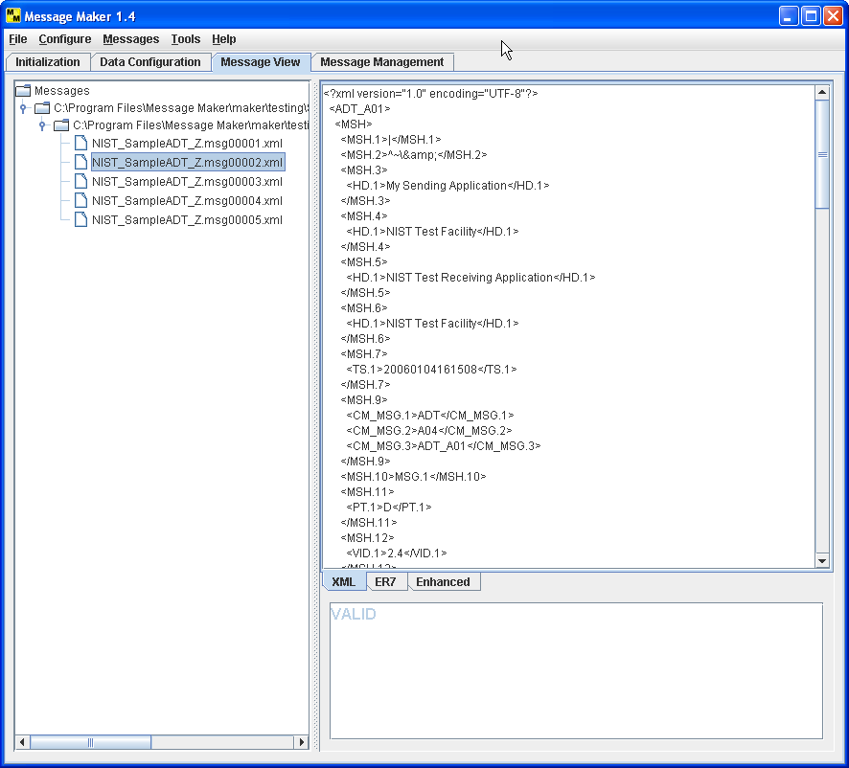

Figure 13. Message View Panel (XML View)
Note that before message generation a data repository is created from the configuration values, reference database, example values, and the default values. The table data is contained in separate resources.

Message Browsing and Editing
Select the Message View tab to review and edit the messages. The Message Path directory selected during initialization is automatically mounted. Open this folder and select the Test Description file associated with the message test suite. By default the name of this file is the name of the profile with a “TD_” prefix. Selecting this file gives a summary of the messages in the display panel on the right.

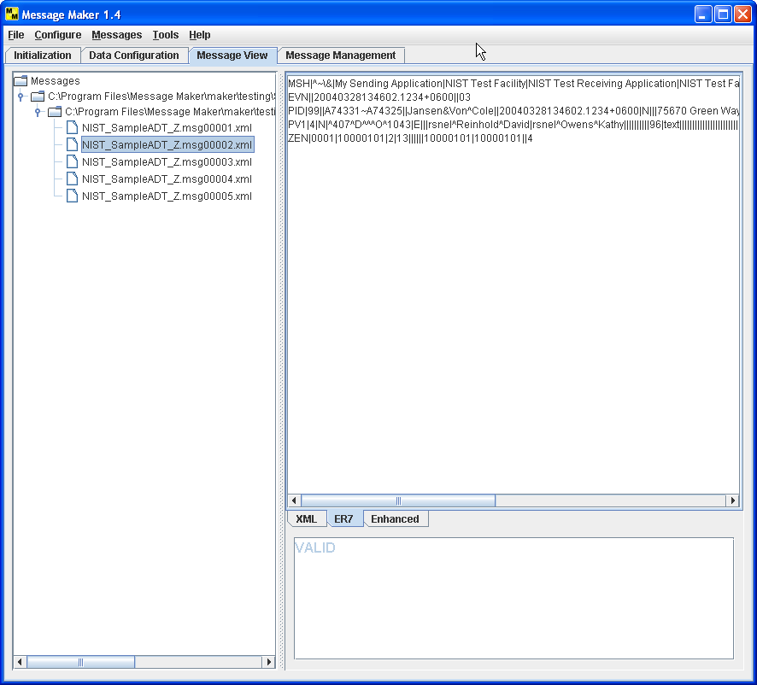

Figure 14. Message View Panel (ER7 View)

Expanding this folder displays the list of messages. By default the name of the message files is the profile name with the string “.msg00000.xml” appended. The “00000” string represents the message sequence number. By default it starts as 0. Select a message to view its contents. Messages can be rendered in XML, ER7, or Enhanced ER7 formats. By default messages are displayed in XML (Figure 13). Select the ER7 tab at the bottom to display the message in the ER7 format (Figure 14). Select Enhanced ER7 to view and navigate messages in a tree-structure. The Enhanced ER7 view also allows the user to edit the content of the data values in the message. To change the value of a data element, select the value, make the changes, and hit enter (Figure 15).

Modifications made to messages can be saved. Messages saved with the same name will still be associated with the originating metadata file. Messages saved under a different name will not be associated with a metadata file.

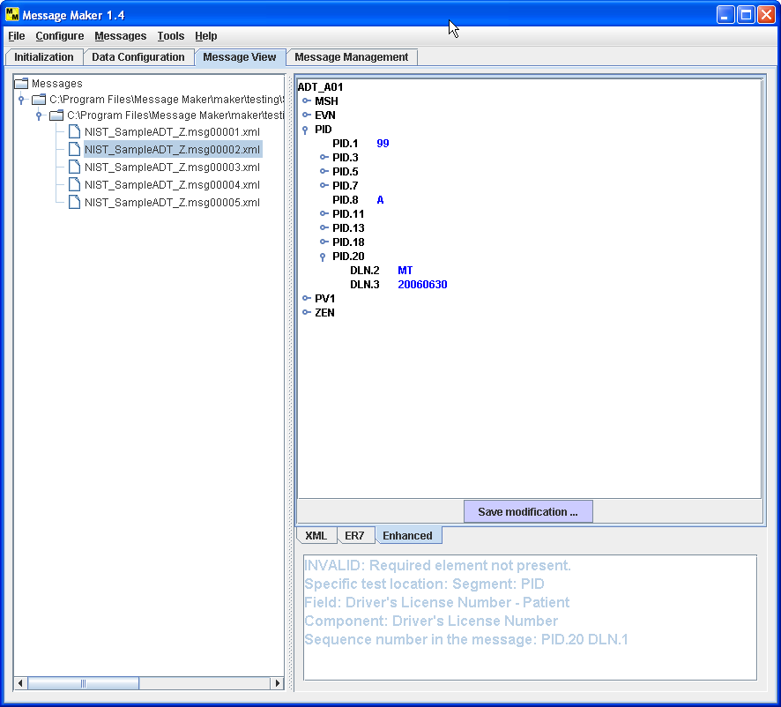

Figure 15. Message View Panel (Enhanced ER7 View-Edit)

At the lower right hand quadrant of the Message View windows a test description describes the purpose of the test message. When specific test types and locations are requested, a detailed description is given. The test type (Valid or Invalid), test category (e.g., usage, cardinality), and the location is given. The example in Figure 14 indicates that a required element is not present in element PID.20.DLN.1.

Viewing Previously Generated Messages
Messages that were previously generated can be view by mounting the directory where the messages were saved. Choose the Mount Directory dialog from the Messages menu.

Message Management: Creating HL7 Batch Files
The Message Management Panel provides functionality to create HL7 batch files. Batch files are used when there are instances when it is convenient to transfer a batch of HL7 messages.

The following steps can be followed to create an HL7 Batch File:

- Enter the structure of the batch file. Enter the segment names in the Structure text field (Figure 16). The table below gives a summary of the allowed values and their meanings. Once the structure has been completed, select the compile button to build the batch file structure. A typical structure is FHS, BHS, MSG, BTS, FTS. This represents a set of messages wrapped in a batch segment wrapped in a file segment.

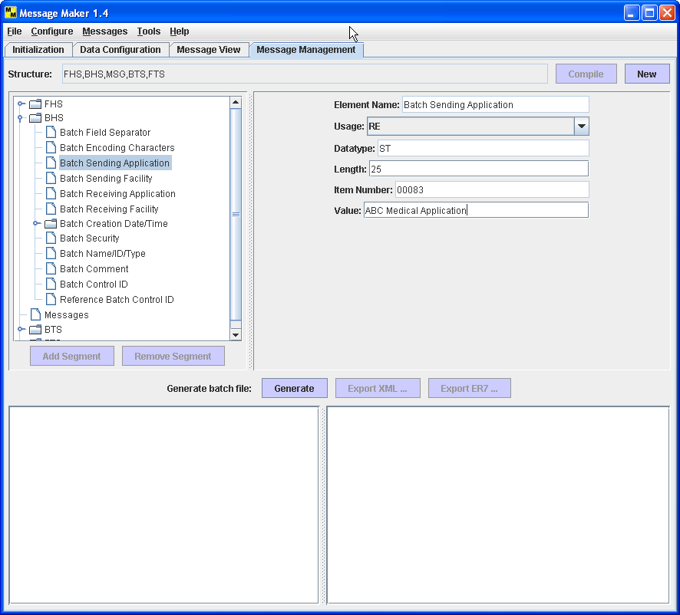

Figure 16. Message Management: Setting Field Values
The structure can be modified with the use of “Add Segment” and “Remove Segment” buttons. To add a segment, select a location where you want to add a segment and click-on the “Add Segment” button. This brings up a dialog requesting what segment to add and where. To remove a segment, select the segment and click-on the “Remove Segment” button.

Segment | Name | Description
FHS | File Header Segment | HL7 defined header segment containing File header information.
BHS | Batch Header Segment | HL7 defined header segment containing Batch header information.
MSG | Messages Placeholder | Message Maker defines the MSG placeholder to represent 0 or more HL7 messages.
BTS | Batch Trailer Segment | HL7 defined trailer segment containing Batch trailer information.
FTS | File Trailer Segment | HL7 defined trailer segment containing Batch trailer information.

- Once the structure is defined, each field in the FHS, BHS, BTS, and FTS segments can be set by selecting the item in the tree structure. A set of attributes for each field appears on the right hand side of the panel. The values set in these text fields will be copied to the batch file when it is generated. Figure 16 illustrates the Batch Sending Application field being set to “ABD Medical Application”.
- The MSG segment is a placeholder for messages. To add messages to the batch file, click-on the MSG segment. This brings up a navigation utility to mount message directories. Select the messages and click-on the Add button to add them to the batch file (See Figure 17).
- After setup is complete, select the Generate button to create the batch file. The batch file is displayed in both XML encoding and ER7 encoding (See Figure 17).
- The batch file can be saved using the “Export XML” or “Export ER7” buttons.

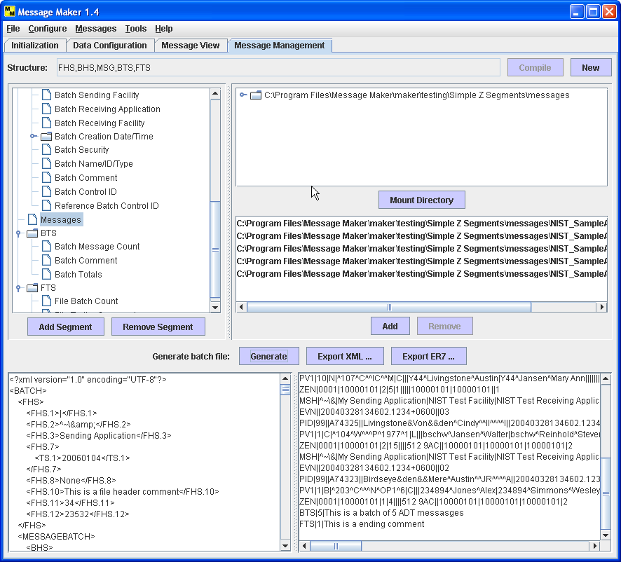

Figure 17. Message Management: Adding Messages and Generating the Batch File

General Configuration Options
Figure 18 depicts the Options panel for setting various configuration parameters. The HL7 version (currently 2.4 only), message and profile validation preferences, cardinality upper bound and default value preferences can be set.

When data is not available for a particular element, the message generation engine will use a default value based on the data type of a primitive element. For each primitive data type default values can be set. However, Message Maker provides an initial set of defaults that should be sufficient in most cases.

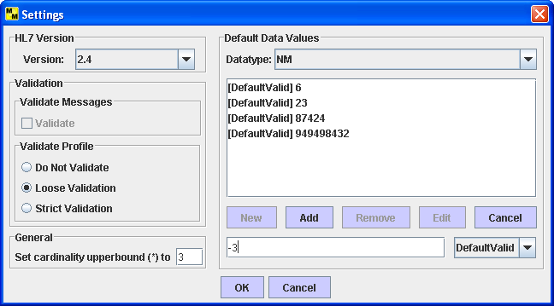

Figure 18. Setting General Configuration Options

Appendix A: Message Maker Version 1.4 Limitations
The following list gives the current known limitations of this version of Message Maker.

- The reference data is limited to version 2.4 elements.
- The reference database is not yet fully populated. It is partially populated for ADT message types. Any message type can be processed; however, example data from the profile and/or default data values will be used. User’s can add their data to the reference database.
- Message Maker has limited support for importing site-specific data.
- Message Maker has limited validation and reporting functionality.
- There is no support for the C and CE usage types.
- Not all complex data types are handled (e.g., the HD data type) according to their semantic meaning defined in the standard. The elements are populated with data however the relationship of the data implied by the data type is not maintained. For example, in the case of an HD the values of the first component may not be identified by the second and third components. If this is critical to a particular message instance, the user can set these values by using the editing features of the enhanced ER7 view.

Appendix B: Trouble Shooting

- Profile fails to load.
Check to see if the profile (or table file if loading a table) is a valid XML file. In some cases the XML files created by profile generation tools, such as the MWB, contained illegal characters. Try and view the profile with Internet Explorer.
- Non-standard HL7 profiles (e.g., field repetitions created by the MWB).
Unpredictable messages may occur if the profile is a non-standard HL7 profile. For example, the MWB has an option to produce profiles with field repetitions explicitly defined and represented with the “_rep” string appended to the field (e.g., Patient Address_rep).

Glossary

Base message. A base message is a minimally populated message. It serves as the reference message where deviations from it can be identified and recorded as message variants.

Maximally populated message. A maximally populated message will follow the usage rules at each level as stated. In the case of an RE the element will be populated. For cardinality, all maximums are selected. In cases where the maximum is unbounded (*), the maximum is set to the minimum + N (N is configurable; default is 3). All lengths fall within the specified limits at each level. If the option to ignore lengths is chosen then the length constraint attribute is eliminated. All coded values are taken from the specified value set.

Minimally populated message. A minimally populated message will follow the usage rules at each level as stated (e.g., in the case of R usage, the element is populated). In the case of an RE the element will not be populated. For cardinality, all minimums are selected. All lengths fall within the specified limits at each level. If the option to ignore lengths is chosen then the length constraint attribute is eliminated. All coded values are taken from the specified value set.

Sample message. A sample message will follow the usage rules at each level as stated. In the case of an RE the element is randomly populated. For cardinality, a value within the specified limits including the edges is randomly selected. In cases where the maximum is unbounded (*), the maximum is set to the minimum + N (N is configurable; default is 3). All lengths fall within the specified limits at each level. If the option to ignore lengths is chosen then the length constraint attribute is eliminated. All coded values are taken from the specified value set.

