**BDS Graphical Catalogue**

**Title Glossary of graphical terms**

**Category Introduction**

**Author Peter Lane**

**Date 21 June 2005, latest revision 14 November 2007**

This is an alphabetical list of graphical terms, providing brief explanations of names commonly used to refer to graphs. Each item includes a brief description of the term, links to internal and external resources, and:

* a thumbnail graph,
* references to any entries in the Catalogue that illustrate that type of graph,
* information about availability of the graph in SAS and S-Plus,
* availability in the BDS Graphical Workbench Environment (GWE) of S-Plus, and
* references to any HARP macros that have been developed.

Please contact [R&D_BDS-Graphics-Catalogue](mailto:R&D_BDS-Graphics-Catalogue) with suggestions for improvement.

**Latest changes**

* New entry for Waterfall plot, example for Radial plot, revision of Barchart and Response-surface plot (14 Nov 07)
* Links to GWE and HARP macros updated throughout the document (27 Jun 07)
* New entries for Galbraith diagram, Interval plot, L’Abbé plot, Radial plot, Skyline plot (20 Jun 07)

Notes.

* Each thumbnail is constructed to be as clear as possible in a small area, but using a maximum of 10 KB to avoid the size of this index becoming too large.
* Click on the thumbnail to see a full-size version.
* The external links should open a new browser window rather than replace this document in the current window; however, the BDS Library does not allow this, so use the Back button in Internet Explorer to return to this document.
* The internal links move your view around the document; however, the Back button will return you to the top of the document, so navigation may be easier using the lines of links provided below and after each letter of the alphabet.

A B C D E F G H I J K L M N O P Q R S T U V W X Y Z

**A**

**AE dotplot**

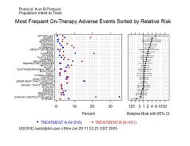

This is a panel display consisting of two associated dot-plots showing the incidence rate of adverse events in a comparative clinical trial. The right-hand panel shows the values of a statistic comparing two treatments, such as relative risk, odds ratio or risk difference, with bars for the standard errors or confidence intervals.

*GWE* Item in menu can draw simple dotplot only;

DOUBLEDOTPLOT ClinPack macro (Unix)

*S-Plus GUI* None

*S-Plus script* [Entry in Catalogue](http://iwha.gsk.com/bdsvd/files/Graphics%20Catalogue/10.%20Panel%20display/AE%20dotplot.doc) Jun 05

*HARP* IDSL standard AE10; macro td_ae10 using SAS graphics released Sep 06;

macro td_ae10splus using S-Plus graphics released Q2 07

*SAS script* [Entry in Catalogue](http://iwha.gsk.com/bdsvd/files/Graphics%20Catalogue/10.%20Panel%20display/PGx%20dotplot.doc) Jul 06 (though for a PGx display rather than an AE display)

**AE onset time CDF**

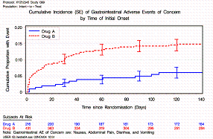

This is a multiple lineplot showing the cumulative incidence of adverse events in a clinical trial. It is similar to a Kaplan-Meier plot, but showing incidence rather than survival.

*GWE* Item in menu for Kaplan-Meier Plot

*S-Plus GUI* See Kaplan-Meier plot

*S-Plus script* See Kaplan-Meier plot

*HARP* IDSL standard AE11 (like TTE11); macro td_tte11 using SAS graphics March 07

*SAS script* See Kaplan-Meier plot

**AE onset time hazard**

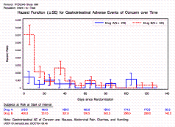

This is a multiple lineplot of the hazard function of two or more arms in a clinical trial, from a life-table analysis of a time-to-event response variable.

*GWE* None

*S-Plus GUI* None

*S-Plus script* [Entry in Catalogue](http://iwha.gsk.com/bdsvd/files/Graphics%20Catalogue/05.%20Comparison%20of%20relationships/AEhazard.doc) May 06

*HARP* IDSL standards AE12 and TTE13; macro td_ae12 using SAS Graphics Dec 06

*SAS script* [Entry in Catalogue](http://iwha.gsk.com/bdsvd/files/Graphics%20Catalogue/05.%20Comparison%20of%20relationships/AEhazard.doc) May 06

A B C D E F G H I J K L M N O P Q R S T U V W X Y Z

**B**

**Barchart**

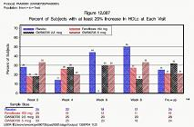

A barchart is a display of a distribution over discrete categories, with the height of parallel bars indicating frequency. A similar display of grouped continuous data is usually referred to as a histogram. Most barcharts, particularly when the height of the bars represents a continuous variable, are better displayed as a dotplot, particularly when displaying a series of summaries of a variable (such as means). When variability ranges are also to be included, a forest plot is appropriate. When the categories are values on a continuous scale, the display is usually better shown as a lineplot.

*GWE* Item in menu for Bar Chart

*S-Plus GUI* Graphics – 2D Plot – Bar: options for simple, grouped, or stacked,

and vertical or horizontal

*S-Plus script* Function barchart

*HARP* None

*SAS script* Proc GCHART

**Biplot**

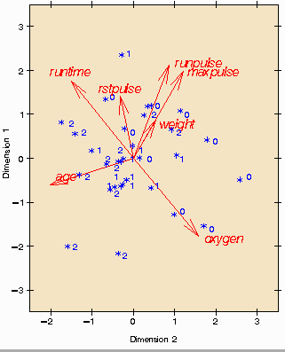

A biplot is a scatterplot that simultaneously displays the observations (rows) and the relative positions of the variables (columns) of a multivariate dataset. Symbols are displayed for observations and arrows for variables. Observations are projected to two dimensions, approximately preserving the distance between the observations. The cosine of the angle between arrows approximates the correlation between the variables. For more information, see the [MathWorks website](http://www.mathworks.com/access/helpdesk/help/toolbox/stats/index.html?/access/helpdesk/help/toolbox/stats/f72143.html).

*GWE* None

*S-Plus GUI* Statistics – Multivariate – Principal Components or Factor Analysis, Plot tab

*S-Plus script* None

*HARP* None

*SAS script* Macro BIPLOT available from <http://www.math.yorku.ca/SCS/sssg/biplot.html>;

menu facilities available in Analyst: Statistics – Multivariate – Principal Components

and click on Plots

**Bland-Altman plot**

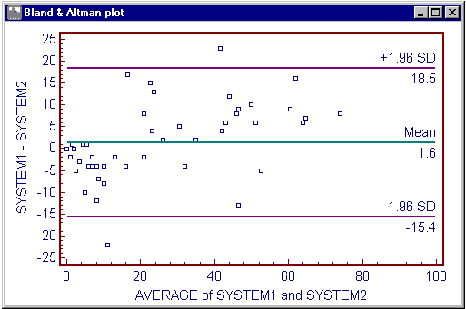

A Bland-Altman plot is a scatterplot of treatment differences against treatment means for the result of a clinical trial. Reference lines are usually added at the mean difference, and at the mean difference plus and minus 1.96 times the standard deviation of the differences.

*GWE* Item in menu for Scatter Plot

*S-Plus GUI* As for scatterplot

*S-Plus script* As for scatterplot

*HARP* None

*SAS script* As for scatterplot

**Boxplot**

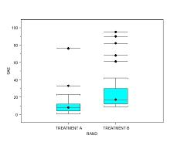

A boxplot displays the distribution of a set of values, representing the interquartile range as a box with a line at the median (introduced by Tukey in the 1970s). Whiskers extend either to the extremes (simple boxplot) or to “fences”, with “outliers” marked individually (schematic diagram). It is usually presented in grouped form, comparing distributions in subsets of the data, or in parallel form comparing distributions of several variables. See the [entry in Wikipedia](http://en.wikipedia.org/wiki/Box_plot).

*GWE* Item in menu for Box Plot

*S-Plus GUI* Graphics – 2D Plot – Box Plot (vertical or horizontal, grouped)

*S-Plus script* boxplot and bwplot functions, including boxplot profiles; [entry in Catalogue](http://iwha.gsk.com/bdsvd/files/Graphics%20Catalogue/03.%20Comparison%20of%20distributions/ParBoxplot.doc) Aug 06

*HARP* None (but see QTc time boxplots, Boxplot profile and LFT time boxplots)

*SAS script* Proc BOXPLOT, and Proc SHEWHART for boxplot profiles;

[entry in Catalogue](http://iwha.gsk.com/bdsvd/files/Graphics%20Catalogue/03.%20Comparison%20of%20distributions/ParBoxplot.doc) Aug 06

**Boxplot profile**

A boxplot profile is a multiple boxplot displaying the distribution of a variable at a series of time-points; see QTc time boxplots and LFT time boxplots for specific examples.

**Bubble plot**

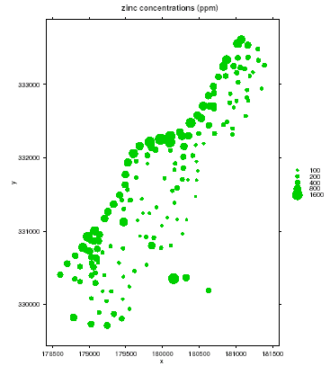

A bubble plot is a scatterplot with circular symbols whose size and colour vary according to other variables. There is known bias in visual recognition of areas, so these plots should be used with care.

*GWE* None

*S-Plus GUI* Graph – 2D Plot – Bubble Plot or Bubble Color Plot

*S-Plus script* As for Scatterplot; function bubble in [gstat](http://www.gstat.org/) library

*HARP* None

*SAS script* Proc GPLOT, statement BUBBLE; example [D0324U01](http://ftp.sas.com/techsup/download/sample/samp_lib/grphsampProducing_a_Bubble_Plot__D0324u0.html) in SAS Sample Library

A B C D E F G H I J K L M N O P Q R S T U V W X Y Z

**C**

**CDF plot** (Cumulative Distribution Function)

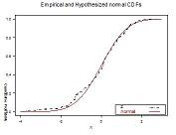

A theoretical CDF for a continuous distribution is a lineplot of cumulative probability against the abscissa; for a discrete distribution, is it usually displayed as a barchart of the cumulative probabilities at each value. An empirical CDF may be shown as a step function, or a smoothed version, and may have added bars to indicate variability. Multiple plots can compare empirical with theoretical CDFs, for example. See also QTc CDF plot. See also Kaplan-Meier plot.

*GWE* Item in menu for CDF Plot

*S-Plus GUI* None

*S-Plus script* [Entry in Catalogue](http://iwha.gsk.com/bdsvd/files/Graphics%20Catalogue/03.%20Comparison%20of%20distributions/CDFplot.SPlus.doc) Aug 05; cdf.compare compares empirical against theoretical

*HARP* IDSL Standard EG7; macro td_ae10 using SAS graphics released Q1 07

*SAS script* [Entry in Catalogue](http://iwha.gsk.com/bdsvd/files/Graphics%20Catalogue/03.%20Comparison%20of%20distributions/CDFplot.SAS.doc) Aug 05; Proc UNIVARIATE and Proc CAPABILITY

**Choropleth map**

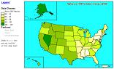

A choropleth map is a geographical density display, showing the change in a variable across regions. (The word was constructed from two Greek words for “place” and “multiply”.) See <http://www.geoplace.com/gw/2003/0301/0301crit.asp> for an introduction.

*GWE* None

*S-Plus GUI* None

*S-Plus script* None

*HARP* None

*SAS script* None

**Clustering tree**: see dendrogram

**Constellation diagram**

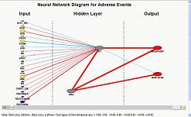

A constellation diagram is a display of the nodes and linkages in a neural network. It may include interactive features such as a slider to determine a level below which linkages are not displayed.

*GWE* None

*S-Plus GUI* None

*S-Plus script* None

*HARP* None

*SAS script* [Entry in Catalogue](http://iwha.gsk.com/bdsvd/files/Graphics%20Catalogue/06.%20Map%20and%20density%20display/Constellation.doc) Apr 06, using SAS 9.1 and Enterprise Miner

**Contour plot**

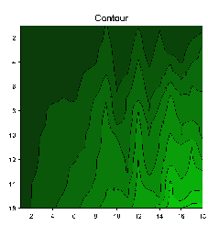

A contour plot is a two-dimensional representation of the variation of one variable as two other variables change, as in a cartographical map showing contour lines of elevation across a piece of land.

*GWE* Item in menu for Contour Plot

*S-Plus GUI* Graph – 2D Plot – Contour Plot

*S-Plus script* Functions contour and contourPlot

*HARP* None

*SAS script* Proc GCONTOUR

**Co-plot** or **Conditioning plot**: see trellis display

A B C D E F G H I J K L M N O P Q R S T U V W X Y Z

**D**

**Dendrogram**

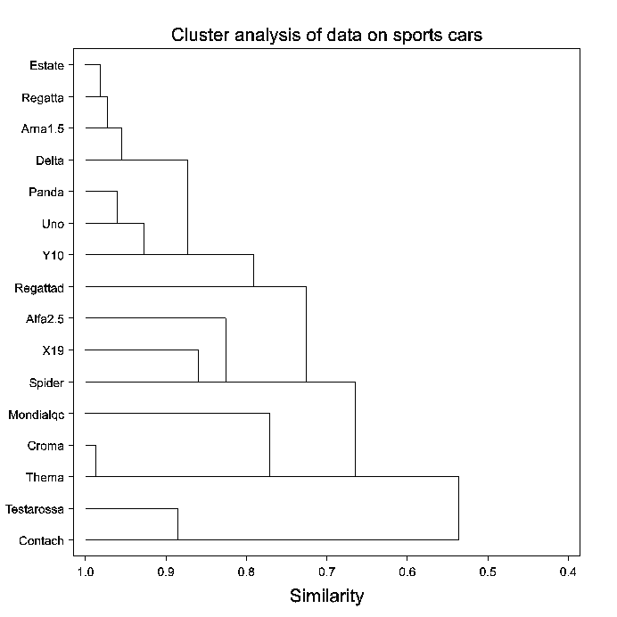

A dendrogram is a display of the results of a hierarchical clustering procedure on a set of multivariate data. It consists of a tree-like set of linked lines showing how individual cases combine into clusters as the measure of similarity decreases.

*GWE* None

*S-Plus GUI* Statistics – Cluster Analysis – Agglomerative Hierarchical Clustering, Plot tab,

Clustering Tree

*S-Plus script* None

*HARP* None

*SAS script* None

**Dot chart** (two dimensional): see scatterplot

**Dotplot** (one dimensional)

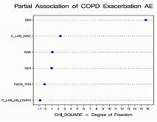

A dotplot is a display of a set of numerical values indexed by their labels. It was introduced by Cleveland (1984) to replace the too-pervasive piechart and barchart. Another common application is to display a series of summary statistics, sometimes with information on variation (see forest plot for one example). The values are usually ordered in some way to help interpretation. See also AE dotplot. A two-dimensional dotplot is usually called a scatterplot.

*GWE* Item in menu for Dot Plot

*S-Plus GUI* Graph – 2D Plot – Dot Plot

*S-Plus script* Function dotplot; see also [scripts at UCLA](http://www.ats.ucla.edu/STAT/examples/vizdata/) for Cleveland’s “Visualizing data”

*HARP* None

*SAS script* None; entry for Catalogue in preparation

A B C D E F G H I J K L M N O P Q R S T U V W X Y Z

**E**

A B C D E F G H I J K L M N O P Q R S T U V W X Y Z

**F**

**Forest plot**

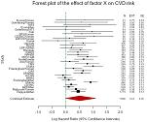

A forest plot is a display of the results of individual studies in a meta-analysis and the resulting pooled estimate. It consists of a range plot of the individual estimates and confidence intervals, with symbol area proportional to weight (e.g. inverse of variance), with the overall estimate and confidence interval shown as a diamond shape. Numerical values are often displayed at the side of the ranges. See [article in BMJ](http://www.bmj.com/cgi/content/full/322/7300/1479).

*GWE* Item in menu for Forest Plot

*S-Plus GUI* None

*S-Plus script* [Entry in Catalogue](http://iwha.gsk.com/bdsvd/files/Graphics%20Catalogue/01.%20Comparison%20of%20summary%20statistics/Forest%20plot.doc) March 06

*HARP* IDSL standards TTE 11 & 12; macro td_tte11 using SAS graphics March 07

*SAS script* [Entry in Catalogue](http://iwha.gsk.com/bdsvd/files/Graphics%20Catalogue/01.%20Comparison%20of%20summary%20statistics/Forest%20plot.doc) June 05

**Funnel plot**

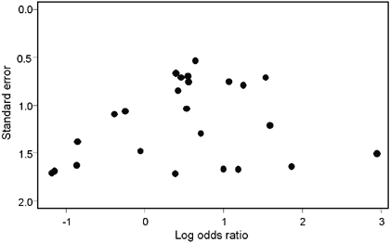

A funnel plot is a scatterplot of standard errors plotted against estimated effects, used to summarize the component studies in a meta-analysis. See the [Cochrane website](http://www.cochrane-net.org/openlearning/HTML/mod15-3.htm) for interpretation.

*GWE* Item in menu for Scatter Plot

*S-Plus GUI* As for scatterplot

*S-Plus script* As for scatterplot

*HARP* None

*SAS script* As for scatterplot

A B C D E F G H I J K L M N O P Q R S T U V W X Y Z

**G**

**Galbraith diagram**: see radial plot.

**Grouped boxplot, barchart, etc**: modification to display data in groups; see boxplot, barchart, etc

A B C D E F G H I J K L M N O P Q R S T U V W X Y Z

**H**

**Half-Normal plot**: see Q-Q plot

**Hazard plot**

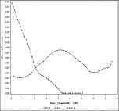

A hazard plot is a lineplot displaying the change in hazard or risk over time. See AE onset time hazard for an example with adverse events.

*GWE* None

*S-Plus GUI* None

*S-Plus script* [Entry in Catalogue](http://iwha.gsk.com/bdsvd/files/Graphics%20Catalogue/05.%20Comparison%20of%20relationships/AEhazard.doc) May 06

*HARP* IDSL standard AE 12 and TTE13; macro td_ae12 using SAS graphics Dec 06

*SAS script* [Entry in Catalogue](http://iwha.gsk.com/bdsvd/files/Graphics%20Catalogue/05.%20Comparison%20of%20relationships/AEhazard.doc) May 06

**Heat map**

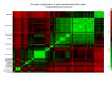

A heat map is a two-dimensional array of coloured areas, indicating potential association between two sets of variables or subjects represented as rows and columns of the array. Developed for the analysis of data from microarrays; see the [entry in Wikepedia](http://en.wikipedia.org/wiki/Heat_map).

*GWE* None

*S-Plus GUI* None

*S-Plus script* None

*HARP* None

*SAS script* None

**Histogram**

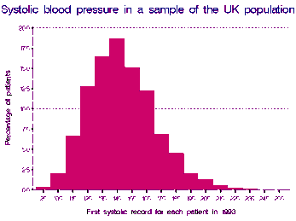

A histogram is a display of the distribution of a continuous variable, shown as a series of bars whose lengths correspond to the frequency of the variable lying in successive intervals. Several distributions can be compared in a parallel histogram. The display can be enhanced with an overlaid density curve (see PDF plot). The display for a series of categories is usually called a barchart.

*GWE* Item in menu for Frequency Histogram

*S-Plus GUI* Graph – 2D Plots – Histogram and Histogram with Density Line

*S-Plus script* [Entry in Catalogue](http://iwha.gsk.com/bdsvd/files/Graphics%20Catalogue/02.%20Distribution%20of%20one%20variable/Histogram.doc) Mar 06; Functions hist and hist.factor

*HARP* none

*SAS script* [Entry in Catalogue](http://iwha.gsk.com/bdsvd/files/Graphics%20Catalogue/02.%20Distribution%20of%20one%20variable/Histogram.doc) Aug 05; second entry in preparation with overlaid density;

Procs UNIVARIATE and CAPABILITY

A B C D E F G H I J K L M N O P Q R S T U V W X Y Z

**I**

**Index plot**

An index plot is a scatterplot showing values of one variable plotted against, and hence ordered by, the values of another (often time).

**Interaction plot**

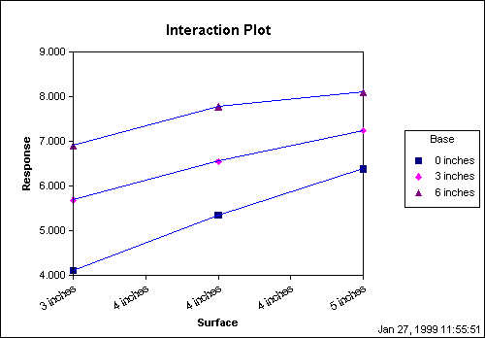

An interaction plot is a multiple lineplot of the means of a response variable against the levels of an explanatory variable, with separate lines for each level of a second explanatory variable (usually categorical). The display can be enhanced with bars representing SEs of the means, or a single bar at the edge when SEMs are equal or close.

*GWE* Items in menu for Line Plot

*S-Plus GUI* As for lineplot

*S-Plus script* Function interaction.plot; otherwise as for lineplot

*HARP* None

*SAS script* As for lineplot

**Interval plot**: an alternative name for a forest plot.

A B C D E F G H I J K L M N O P Q R S T U V W X Y Z

**J**

A B C D E F G H I J K L M N O P Q R S T U V W X Y Z

**K**

**Kaplan-Meier plot**

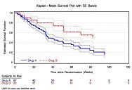

A Kaplan-Meier plot is a cumulative distribution function of survival plotted against time, estimated from a time-to-event response variable. It can be enhanced with standard-error envelopes or bars, and with numbers at risk along the x-axis. Alternative forms include plotting the CDF of the recorded event, i.e. (1-survival), on the y-axis. See also: CDF plot.

*GWE* Item in menu for Kaplan-Meier Plot

*S-Plus GUI* Statistics – Survival – Cox provides dialogue to display function only

*S-Plus script* [Entry in Catalogue](http://iwha.gsk.com/bdsvd/files/Graphics%20Catalogue/03.%20Comparison%20of%20distributions/Kaplan-Meier.doc) Sep 06; function plot.kaplanMeier

*HARP* IDSL standard TTE10; macro td_tte10 using SAS Graphics Mar 07  
 macro td_tte10splus using S-Plus graphics March 07

*SAS script* [Entry in Catalogue](http://iwha.gsk.com/bdsvd/files/Graphics%20Catalogue/03.%20Comparison%20of%20distributions/Kaplan-Meier.doc) May 05; PLOTS option of Proc LIFETEST displays function only

A B C D E F G H I J K L M N O P Q R S T U V W X Y Z

**L**

**L’Abbé plot**:

A L’Abbé plot is used in meta-analysis, and is a scatterplot of treatment group risk against control group risk estimated from a collection of studies of a binary outcome. It is often shown as a bubble plot with the area of each bubble proportional to the precision of estimation.

**Ladder plot** for meta-analysis: see forest plot

**Lattice display**: see trellis display

**Levels plot**: an alternative name for a contour plot.

**LFT matrix plot by parameter**

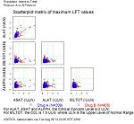

This is a matrix display of the variables assessed in liver function tests, showing scatterplots for each pair of variables of the maximum (worst-case) on-therapy results for each subject.

*GWE* Macro MATRIXOFCSP using SAS–S-Plus link (Unix)

*S-Plus GUI* None

*S-Plus script* [Entry in Catalogue](http://iwha.gsk.com/bdsvd/files/Graphics%20Catalogue/09.%20Matrix%20display/Matrix%20scatter.doc) Aug 06

*HARP* IDSL standard LB8; macro td_lb8 using SAS Graphics March 07;

Macro using S-Plus graphics to be released Q3 07

*SAS script* [Entry in Catalogue](http://iwha.gsk.com/bdsvd/files/Graphics%20Catalogue/09.%20Matrix%20display/Matrix%20scatter.doc) Dec 06

**LFT max boxplots** of maximum LFT values for each LFT

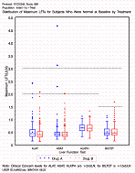

This is a parallel boxplot showing the distributions of the maximum (worst-case) on-therapy results for each subject for the variables assessed in a liver function test.

*GWE* Item in menu for Box Plot

*S-Plus GUI* As for boxplot

*S-Plus script* [Entry in Catalogue](http://iwha.gsk.com/bdsvd/files/Graphics%20Catalogue/03.%20Comparison%20of%20distributions/ParBoxplot.doc) Aug 06

*HARP* IDSL standard LB10; macro td_lb10 using SAS Graphics March 07

*SAS script* [Entry in Catalogue](http://iwha.gsk.com/bdsvd/files/Graphics%20Catalogue/03.%20Comparison%20of%20distributions/ParBoxplot.doc) Aug 06

**LFT patient profile**

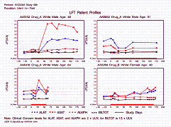

This is a trellis display for each patient of concern in a clinical trial, showing a multiple lineplot of liver function test results over time.

*GWE* Item in menu for Line Plot, using conditioning (a.k.a. trellis) option

*S-Plus GUI* None

*S-Plus script* None

*HARP* IDSL standard LB11; macro td_lb11 using SAS graphics March 07

*SAS script* [Entry in Catalogue](http://iwha.gsk.com/bdsvd/files/Graphics%20Catalogue/08.%20Trellis%20display/LFTprofile.doc) Mar 06

**LFT time boxplots**

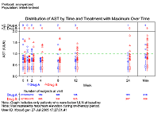

This is a boxplot profile of one variable assessed in a liver function test during the course of a clinical trial. It is similar to the QTc time boxplots, but illustrates the use of an upper margin for extreme data.

*GWE* Item in menu for Box Plot, using dependent numeric X and Y variables

*S-Plus GUI* As for boxplot profile

*S-Plus script* As for boxplot profile

*HARP* IDSL standard LB9 (similar to EG8); macro td_eg8 using SAS graphics March 07

*SAS script* [Entry in Catalogue](http://iwha.gsk.com/bdsvd/files/Graphics%20Catalogue/03.%20Comparison%20of%20distributions/boxplotprofile.doc) Dec 05 (actually for QTc rather than LFT)

**LFT trellis plots by baseline**

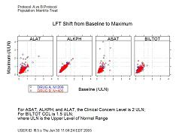

This is a trellis display of the results from liver function tests in a clinical trial, showing maximum (worst-case) on-therapy results by the baseline value for each subject.

*GWE* Item in menu for Scatter Plot, using trellis option;

macro TRELLISOFCSP using SAS–S-Plus link (Unix)

*S-Plus GUI* As for trellis display

*S-Plus script* As for trellis display; [entry in Catalogue](http://iwha.gsk.com/bdsvd/files/Graphics%20Catalogue/08.%20Trellis%20display/LFTtrellis.doc) Jan 06

*HARP* IDSL standard LB7; macro td_lb7 using SAS graphics March 07;

macro using S-Plus graphics to be released Q3 07

*SAS script* As for trellis display; [entry in Catalogue](http://iwha.gsk.com/bdsvd/files/Graphics%20Catalogue/08.%20Trellis%20display/LFTtrellis.doc) Nov 06

**Lineplot**

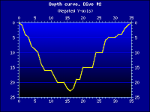

A lineplot is a display of the association between two variables, representing corresponding observations as points in two dimensions joined by lines. The points may additionally be marked with symbols. The attributes of lines (e.g. colour, thickness and dashed or dotted style) and symbols (e.g. colour, size and shape) may be varied to represent categories of the observations. Bars may be added at each point, selected points, or at the edge of the graph, to indicate variability (usually SD, SEM or CI), particularly when the points represent observed or fitted summaries (such as means) of one variable plotted against another. Multiple lines are often plotted in a single display for comparison, and a scatterplot may be overlaid, particularly of raw data when the lines represent summaries. There are many examples in this index.

*GWE* Items in menu for Line Plot

*S-Plus GUI* Graph – 2D Plots – Line Plot

*S-Plus script* Function lines

*HARP* Several macros available including td_eg9, td_ae13, td_lb11:

see under AE, LFT and QTc

*SAS script* Proc GPLOT, statement PLOT

**Loadings plot**: see principal-components plot

A B C D E F G H I J K L M N O P Q R S T U V W X Y Z

**M**

**Matrix display**

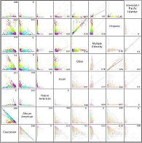

A matrix display is a panel display consisting of one type of graph in a two-dimensional array. Usually, rows and columns correspond to a set of variables whose cross-relationships are displayed in the graphs; but separate sets of variables may be used in each dimension. Rows or columns can also correspond to values of other variables (particularly factors) that may be associated with those displayed in the graphs. The display may be triangular, to avoid repeating information when the array is symmetric. The graphs on the diagonal may be of a different to those off the diagonal. For an example, see LFT matrix plot by parameter.

*GWE* Item in menu for Scatterplot Matrix

*S-Plus GUI* Graph – 2D Plot with Axes Type: Vary X, Vary Y or Vary XY

*S-Plus script* Functions such as splom; see LFT Matrix plot by parameter

*HARP* See LFT matrix plot by parameter

*SAS script* Can be constructed using Proc GREPLAY; [entry in Catalogue](http://iwha.gsk.com/bdsvd/files/Graphics%20Catalogue/09.%20Matrix%20display/CompareRegs.doc) Aug 05

**Mean plot**: see summary plot

**Mean profile plot**: see summary profile plot

**Mosaic plot**

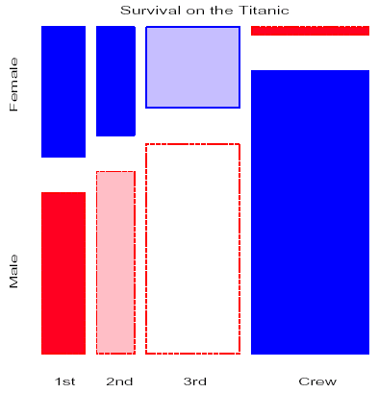

A mosaic plot is a display of potential associations in multi-dimensional categorical data, representing frequencies as areas in a sub-divided rectangular framework. For more information, see [Michael Friendly’s website](http://www.math.yorku.ca/SCS/friendly.html).

*GWE* None

*S-Plus GUI* None

*S-Plus script* Function mosaic

*HARP* None

*SAS script* None

A B C D E F G H I J K L M N O P Q R S T U V W X Y Z

**N**

**Needle plot**

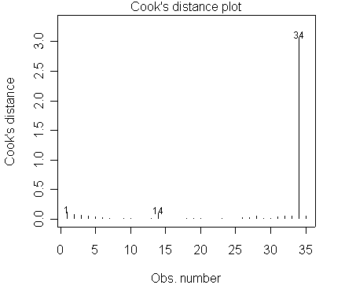

A needle plot is a barchart using lines rather than bars. This can be used as an alternative to an index plot to display an ordered series of values. The term is also used for a two-dimensional display showing gradient information as small directional compass-like needles at many points in an area.

*GWE* As for barchart

*S-Plus GUI* As for barchart

*S-Plus script* As for barchart

*HARP* None

*SAS script* As for barchart

**Normal plot**: see Q-Q plot

**Normal probability plot**: see probability plot

A B C D E F G H I J K L M N O P Q R S T U V W X Y Z

**O**

A B C D E F G H I J K L M N O P Q R S T U V W X Y Z

**P**

**Panel display**

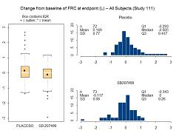

A panel display is a general term for a graphical display made up of more than one graph. It allows pictures to be grouped together so that related information can be viewed at the same time. Special examples are trellis displays and matrix displays, where the multiple graphs are all of the same type.

*GWE* No facilities for general panel displays, but many for trellis and matrix displays

*S-Plus GUI* No facilities for general panel displays, but many for trellis and matrix displays

*S-Plus script* For an example, see AE Dotplot; [entry in Catalogue](http://iwha.gsk.com/bdsvd/files/Graphics%20Catalogue/10.%20Panel%20display/Box&Hists.doc) Aug 05

*HARP* See AE Dotplot

*SAS script* Proc GREPLAY allows multiple graphs to be brought together in a single display

**Parallel boxplot, barchart, etc**: modification to display data in groups; see boxplot, barchart, etc

**Parallel coordinate plot**

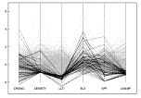

*A parallel coordinate plot is a display of relationships in multidimensional data. See* [*Oklahoma State University*](http://catt.okstate.edu/jones98/parallel.html) *website.*

*GWE* PARALELLTRELLIS ClinPack Macro (Unix)

*S-Plus GUI* None

*S-Plus script* None

*HARP* None

*SAS script* None

**Pareto chart**

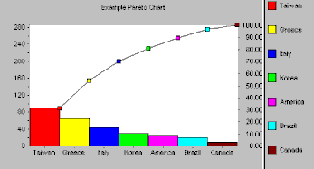

A Pareto chart is a barchart showing the relative importance of groups in a dataset; e.g. frequencies of failures due to different causes. The display shows descending percentages of each category; optionally, it can be plotted with a line plot displaying cumulative percentages.

*GWE* Item in menu for Bar Chart

*S-Plus GUI* Graph – 2D Plots – Pareto Plot

*S-Plus script* As for barchart

*HARP* As for barchart

*SAS script* As for barchart

**Partial-residual plot**

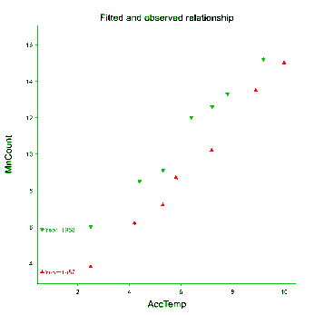

A partial-residual plot is a lineplot with an overlaid scatterplot, displaying the modelled relationship of the response variable with one explanatory variable, adjusted for effects of other explanatory covariables, with residual scatter. Multiple lines can be used to represent different relationships for groups of the data, with both points and lines colour-coded.

*GWE* None

*S-Plus GUI* None

*S-Plus script* None

*HARP* None

*SAS script* None

**PDF plot** (Probability Density Function)

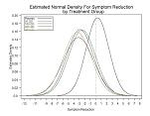

A PDF for a continuous distribution is a lineplot of probability density against the abscissa; for a discrete distribution, is it usually displayed as a barchart of the probabilities at each value. A theoretical PDF can be useful for illustrating assumptions, while a fitted PDF displays the form of a distribution whose parameters have been estimated from data. An empirical PDF shows the actual distributions of observed data, and is usually shown as a histogram for a continuous distribution, and as a barchart for a discrete one; various forms of smoothing can be applied before display. Multiple plots can compare empirical with theoretical PDFs, for example.

*GWE* DENSITYPLOTTRELLIS Clinpack macro (Unix)

*S-Plus GUI* None

*S-Plus script* Function densityplot; [entry in Catalogue](http://iwha.gsk.com/bdsvd/files/Graphics%20Catalogue/03.%20Comparison%20of%20distributions/PDFestimate.doc) (fitted PDF) Mar 06

*HARP* None

*SAS script* [Entry in Catalogue](http://iwha.gsk.com/bdsvd/files/Graphics%20Catalogue/03.%20Comparison%20of%20distributions/PDFestimate.doc) (fitted PDF) Aug 05; [entry in Catalogue](http://iwha.gsk.com/bdsvd/files/Graphics%20Catalogue/03.%20Comparison%20of%20distributions/KDEplot.doc) (empirical PDF) Dec 05;

Proc UNIVARIATE for observed PDF

**Peto diagram** for meta-analysis: see forest plot

**Piechart**

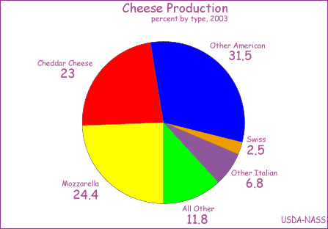

A piechart displays a set of proportions using segments of a circle. This is not recommended for conveying information: a dotplot is usually more informative. Edward Tufte said “Given their low data-density and failure to order numbers along a visual dimension, pie charts should never be used.” So-called “three-dimensional” pie-charts, in particular, should not be used because they distort the information.

*GWE* Item in menu for Pie Chart

*S-Plus GUI* Graph – 2D Plots – Axes type: Pie

*S-Plus script* Function piechart

*HARP* None

*SAS script* Proc GCHART, statements PIE (and PIE3D: certainly not recommended)

**Power curve**

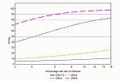

A power curve is a lineplot showing the change in power of a planned test as some aspect of the expected data varies, such as sample size or effect size. Multiple lines are often displayed in a single graph to compare the power curves as a second aspect of the data varies. Note that the program PASS produces power curves.

*GWE* Items in menu for Line Plot

*S-Plus GUI* As for lineplot

*S-Plus script* As for lineplot

*HARP* IDSL standard ESI7; macro td_eg9 using SAS graphics can be used to create this

plot

*SAS script* As for lineplot

**P-P plot** (Probability-probability plot)

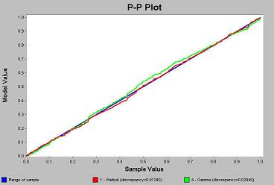

A P-P plot is a scatterplot of an observed against a theoretical cumulative distribution function.

*GWE* Item in menu for Scatter Plot

*S-Plus GUI* Graph – 2D Plots – Probability-Probability or PP Normal

*S-Plus script* As for scatterplot

*HARP* None

*SAS script* As for scatterplot

**Principal-components plot**

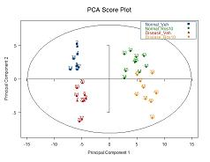

Two types of scatterplot are commonly referred to as principal-components plots, displaying either the scores or the loadings for one component against those for another in a principal-components analysis.

*GWE* None

*S-Plus GUI* None

*S-Plus script* [Entry in Catalogue](http://iwha.gsk.com/bdsvd/files/Graphics%20Catalogue/04.%20Relationship%20between%20two%20variables/PCAplot.doc) Nov 05

*HARP* None

*SAS script* [Entry in Catalogue](http://iwha.gsk.com/bdsvd/files/Graphics%20Catalogue/Macro%20files/pca.plot.ssc) Nov 05

**Probability plot**

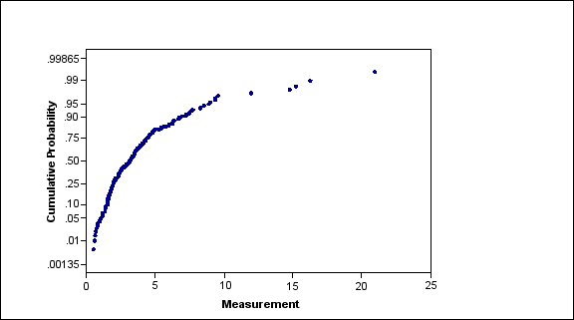

A probability plot is a scatterplot of the observed cumulative distribution of a set of values plotted on a probability scale against the values themselves. Sometimes this term is used to refer to other types of graphs that use a probability scale, particularly a P-P plot, or quantiles from a probability distribution, particularly a Q-Q plot.

*GWE* Item in menu for Scatter Plot

*S-Plus GUI* As for scatterplot

*S-Plus script* As for scatterplot

*HARP* None

*SAS script* As for scatterplot

**Profile plot**: A lineplot of observations of a variable against time.

A B C D E F G H I J K L M N O P Q R S T U V W X Y Z

**Q**

**Q-Q plot** (Quantile-quantile plot)

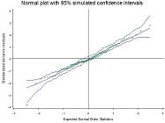

A Q-Q plot is a scatterplot comparing quantiles of an observed distribution against a theoretical one (often the Normal). A common application is to compare the quantiles of the standardized residuals from a fitted linear model with those of the Normal distribution; this can be extended to generalized linear models. The plot can be enhanced with a simulation envelope.

*GWE* Item in menu for QQ Plot

*S-Plus GUI* Graph – 2D Plot – “QQ Normal with Line”;

Statistics – Regression – “Residuals Normal QQ” on Plots tab,

and similarly for other models

*S-Plus script* plot function applied to the output from lm and glm functions; qqplot and qq functions

*HARP* None

*SAS script* [Entry in Catalogue](http://iwha.gsk.com/bdsvd/files/Graphics%20Catalogue/02.%20Distribution%20of%20one%20variable/Normal%20plot%20with%20envelope.doc) May 05; Proc REG has keyword NQQ in PLOTS statement

**QTc CDF plot**

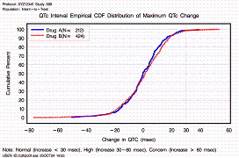

This is a CDF plot of the cumulative distribution function of the change from baseline in the QTc interval at some time-point during a clinical trial.

*GWE* Item in menu for CDF Plot

*S-Plus GUI* As for CDF plot

*S-Plus script* As for CDF plot

*HARP* As for CDF plot

*HARP* IDSL standard EG7; macro td_eg7 using SAS graphics March 07

*SAS script* As for CDF plot

**QTc means plot**

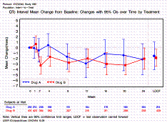

This is a summary profile plot of the mean change from baseline in the QTc interval during the course of a clinical trial.

*GWE* Item in menu for Line Plot

*S-Plus GUI* As for summary profile plot

*S-Plus script* As for summary profile plot

*HARP* IDSL standard EG9; macro td_eg9 using SAS graphics Dec 06

*SAS script* As for summary profile plot

**QTc time boxplots**

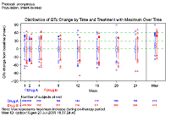

This is a boxplot profile of the change from baseline in the QTc interval during the course of a clinical trial. It is similar to the LFT time boxplots.

*GWE* Item in menu for Box Plot, using dependent numeric X and Y variables

*S-Plus GUI* As for boxplot profile

*S-Plus script* As for boxplot profile

*HARP* IDSL standard EG8; macro td_eg8 using SAS graphics March 07

*SAS script* As for boxplot profile; [entry in Catalogue](http://iwha.gsk.com/bdsvd/files/Graphics%20Catalogue/03.%20Comparison%20of%20distributions/boxplotprofile.doc) Dec 05

A B C D E F G H I J K L M N O P Q R S T U V W X Y Z

**R**

**Radar plot**

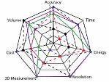

A radar plot gives a visual comparison of several items, usually without regard to a specific numeric scale. It can be useful for comparing observations on a subject against a norm or target.

*GWE* None

*S-Plus GUI* None

*S-Plus script* None

*HARP* None

*SAS script* Procedure GRADAR

**Radial plot**

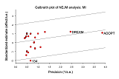

A radial plot is a display proposed by Rex Galbraith for meta-analysis, sometimes referred to as a Galbraith diagram. It is a scatterplot of standardized treatment effect (effect/s.e.) against precision (1/s.e.) from a collection of studies. It is usually enhanced with an unweighted regression line through the origin (representing the combined estimate) and a confidence band, and may include radial axes to help interpret individual study estimates.

*GWE* None

*S-Plus GUI* None

*S-Plus script* None

*HARP* None

*SAS script* None

**Range plot**

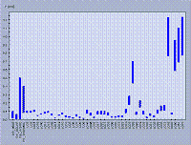

A range plot is a comparative display of the range of a variable, with bars representing the ranges for a series of groups of observations. When the groups are ordered, particularly associated with time, the minima and maxima may be joined by two lines with the area between being shaded rather than displaying discrete bars. See summary plot for a similar display with bars representing variability estimates such as standard errors or confidence intervals, and forest plot for an example..

*GWE* Item in menu for Forest Plot

*S-Plus GUI* None

*S-Plus script* [Entry in Catalogue](http://iwha.gsk.com/bdsvd/files/Graphics%20Catalogue/01.%20Comparison%20of%20summary%20statistics/Forest%20plot.doc) March 06

*HARP* IDSL standards TTE 11 & 12; macro td_tte11 using SAS graphics March 07

*SAS script* [Entry in Catalogue](http://iwha.gsk.com/bdsvd/files/Graphics%20Catalogue/01.%20Comparison%20of%20summary%20statistics/Forest%20plot.doc) June 05

**Residual plot**

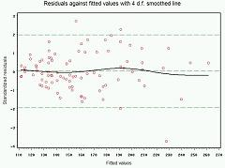

The term “residual plot” usually refers to a scatterplot of the residuals against the fitted values from a linear or generalized linear model (e.g. logistic, log-linear or Poisson). It may be enhanced with reference lines and a smoothed line to highlight any trends. Residuals are usually standardized to aid interpretation of the size of outliers.

*GWE* Item in menu for Scatter Plot

*S-Plus GUI* Statistics – Regression – “Residuals vs Fit” on Plot tab, and option for smooth line

*S-Plus script* plot function applied to output from lm and glm functions; [entry in Catalogue](http://iwha.gsk.com/bdsvd/files/Graphics%20Catalogue/04.%20Relationship%20between%20two%20variables/Residuals%20vs%20Fitted%20values.doc) Dec 04

*HARP* A standard macro would be useful, but none has been proposed yet

*SAS script* simple version (no lines) from ODS option of Proc GLM; [entry in Catalogue](http://iwha.gsk.com/bdsvd/files/Graphics%20Catalogue/04.%20Relationship%20between%20two%20variables/Residuals%20vs%20Fitted%20values.doc) Dec 04

**Response-surface plot**

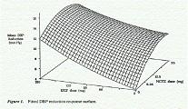

A response-surface plot represents a three-dimensional surface, showing the change in a modelled response variable with respect to two explanatory variables. It is often used in factorial designs with quantitative treatments that may interact.

*GWE* Item for Response-Surface Plot

*S-Plus GUI* Graph – 3D Plots – Surface (9 different entries)

*S-Plus script* The dox library (released with S-Plus 6.2) provides functions for generating and

displaying response-surface designs

*HARP* None

*SAS script* [Entry in Catalogue](http://iwha.gsk.com/bdsvd/files/Graphics%20Catalogue/07.%20Three-dimensional%20display/Surface%20Plot.doc) Apr 06; [Entry for animated version](http://iwha.gsk.com/bdsvd/files/Graphics%20Catalogue/07.%20Three-dimensional%20display/Animated%20Surface%20Plot.doc) Apr 06;

[Entry for “colour draped” version](http://iwha.gsk.com/bdsvd/files/Graphics%20Catalogue/07.%20Three-dimensional%20display/DrapedResponse.doc) Dec 06

Proc GMAP, statement SURFACE

**ROC plot** (Receiver-Operating Characteristic plot)

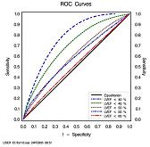

An ROC plot is a lineplot of sensitivity, or the “true-positive rate”, against (1–specificity), or “false-positive rate”, over all possible values of the criterion used in a decision process to divide subjects into two classes (such as healthy vs diseased). Multiple lines can represent alternative criteria, or one criterion applied to separate datasets. The lines may be smoothed to show the main trend without the expected random fluctuation as a criterion changes. See the [entry in Wikipedia](http://en.wikipedia.org/wiki/Receiver_operating_characteristic).

*GWE* Item in menu for Line Plot

*S-Plus GUI* As for lineplot

*S-Plus script* As for lineplot

*HARP* As for lineplot

*SAS script* [Entry in Catalogue](http://iwha.gsk.com/bdsvd/files/Graphics%20Catalogue/04.%20Relationship%20between%20two%20variables/ROC%20Curves.doc) Aug 05

**Rugplot**

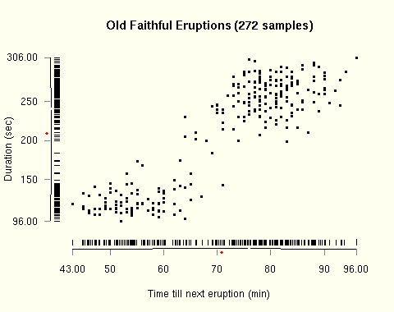

A rugplot displays the distribution of observed values, usually in the form of short vertical lines added along the x-axis of a more complex graph.

*GWE* Could use Scatter Plot item in menu if dataset in correct format (i.e. extra observations with appropriate values to draw the rug)

*S-Plus GUI* Option Include rugplot in dialogue for plots, e.g. Statistics – Regression – Linear

*S-Plus script* Function rug adds a rug to an existing plot

*HARP* None

*SAS script* Could use PROC GPLOT, statement PLOT, if dataset in correct format (i.e. extra observations to draw the rug)

A B C D E F G H I J K L M N O P Q R S T U V W X Y Z

**S**

**Scatterplot**

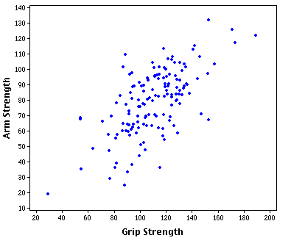

A scatterplot displays the association between two variables, representing corresponding observations as points in two dimensions marked with graphical symbols. The symbol shape, colour and fill-status can be varied to represent categories of the observations. Envelopes or density contours can be added to emphasize the range and shape of the observed or a hypothesized distribution. Scatterplots can also display observed or fitted summaries (such as means) of one variable against summaries of another. There are many examples in the Catalogue; see also: bubble plot.

*GWE* Item in menu for Scatter Plot

*S-Plus GUI* Graph – 2D Plots – Scatter Plot

*S-Plus script* Functions plot and xyplot

*HARP* None

*SAS script* Proc GPLOT, statement PLOT

**Scatterplot matrix**: see matrix display

**Scatterplot, one-dimensional**: see strip plot, rugplot

**Schematic diagram**: see boxplot

**Screeplot**

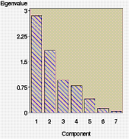

A Screeplot is a scatterplot or barchart showing how the percentage of variation in a multivariate dataset is associated with increasing numbers of principal components.

*GWE* Items in menu for Scatter Plot and Bar Chart

*S-Plus GUI* As for scatterplot or barchart

*S-Plus script* As for scatterplot or barchart

*HARP* None

*SAS script* As for scatterplot or barchart; menu facilities available in Analyst:

Statistics – Multivariate – Principal Components and click on Plots

**Skyline plot**: another name for a step plot, particularly when the steps can be large both up and down, giving the effect of a silhouette of high-rise buildings.

**Spaghetti plot**: another term for a profile plot.

**Sparkline**

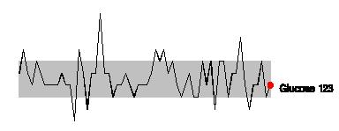

A sparkline is a miniature graphic intended for displaying within text in a document, or as part of a larger display. For more information, see <http://sparkline.org/>.

*GWE* None

*S-Plus GUI* None

*S-Plus script* None

*HARP* None

*SAS script* [Entry in Catalogue](http://iwha.gsk.com/bdsvd/files/Graphics%20Catalogue/04.%20Relationship%20between%20two%20variables/Sparkline.doc) Aug 05

**Spider plot**: a simple form of radar plot

**Splom**: a term used in S-Plus for a matrix display of scatterplots

**Stacked barchart**

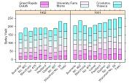

A stacked barchart is a barchart in which each bar is subdivided to show the proportion of the frequency attributable to several categories. The subdivisions are usually differentiated by fill-style or colour or both. When the display needs to allow visual comparison of the relative sizes of components across the graph, a parallel barchart or dotplot are clearer representations because they facilitate comparison from a common baseline.

*GWE* None

*S-Plus GUI* Graph – 2D Plots – Bar-stacked

*S-Plus script* As for barchart

*HARP* None

*SAS script* As for barchart

**Star plot**

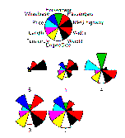

A star plot is a series of small iconic charts, each in the form of a radial lineplot or barchart, used to display multivariate data. Each star represents an individual in a dataset, with the “spokes” of the stars showing the size of each of the variables measured on the individuals. The spokes can simply be points, which are joined up to give a polygonal shape characterizing the relative sizes of the variable for that individual, or can be drawn as radial coloured “bars”.

*GWE* None

*S-Plus GUI* None

*S-Plus script* None

*HARP* None

*SAS script* None

**Step plot**: a type of lineplot in which the lines are all horizontal or vertical, giving a stepped effect; for examples, see AE onset time hazard, CDF plot and Kaplan-Meier plot

**Stick plot**: another term for a lineplot

**Strip plot**

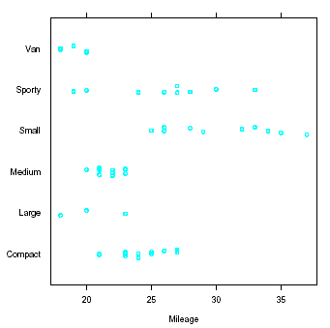

A strip plot is a one-dimensional scatterplot, showing the distribution of a set of values. It can be enhanced by showing the mean as a solid line, median as a dotted line, and quartiles as dashed lines; alternatively, means and confidence intervals may be drawn in parallel to the strips. The individual values can be jittered, in either or both dimensions, to avoid hiding points; alternatively, symbols can be modified e.g. in size) to represent superposition.

*GWE* Could be conceived as a dot plot (Dot Plot item in menu)

STRIPPLOTTRELLIS Clinpack macro (UNIX)

*S-Plus GUI* None

*S-Plus script* None

*HARP* None

*SAS script* [Entry in Catalogue](http://iwha.gsk.com/bdsvd/files/Graphics%20Catalogue/03.%20Comparison%20of%20distributions/StripPlot.doc) Sep 06; [trellis version](http://iwha.gsk.com/bdsvd/files/Graphics%20Catalogue/08.%20Trellis%20display/TrellisStrip.doc) Nov 06

**Summary plot**

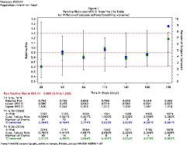

A summary plot is a scatterplot of a set of summary statistics, such as means or variances, plotted against a continuous variable such as time, or against a categorical variable with several groups. The statistics are usually presented with added bars indicating variability, such as standard deviations, standard errors or confidence intervals. The statistics are sometimes displayed numerically alongside the graphical representation. See forest plot for a specific display for meta-analysis. If the bars indicate the ranges, the display is also referred to as a range plot.

*GWE* Item in menu for Line Plot (would need to set line colours to white)

*S-Plus GUI* None

*S-Plus script* None

*HARP* IDSL standard TTE11; macro td_tte11 using SAS graphics March 07

*SAS script* [Entry in Catalogue](http://iwha.gsk.com/bdsvd/files/Graphics%20Catalogue/04.%20Relationship%20between%20two%20variables/Lifetable.doc) Aug 05

**Summary profile plot**

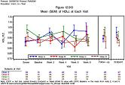

A summary profile plot is a lineplot of a summary statistic (such as the mean) over time, with bars indicating variability. Multiple lines compare the profile between groups in the data. The display can be enhanced with numbers of individuals at each time-point, and with margins showing maxima or other derived statistics. See also QTc means plot.

*GWE* Items in menu for Line Plot

*S-Plus GUI* None

*S-Plus script* None

*HARP* IDSL standard EG9; macro td_eg9 using SAS graphics Dec 06

*SAS script* [Entry in Catalogue](http://iwha.gsk.com/bdsvd/files/Graphics%20Catalogue/05.%20Comparison%20of%20relationships/SummaryStats.doc) July 05

**Surface plot**: see response-surface plot

A B C D E F G H I J K L M N O P Q R S T U V W X Y Z

**T**

**Three-dimensional histogram or barchart**

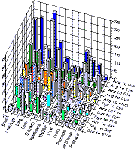

This is a three-dimensional representation of a continuous or discrete distribution in two dimensions. This form of display is sometimes also used to display the values of one variable in relation to corresponding values of two other variables, but this is usually best shown as a contour plot.

*GWE* None

*S-Plus GUI* Graph – 3D Plots – Bar Chart

*S-Plus script* None

*HARP* None

*SAS script* None

**Time-line plot**

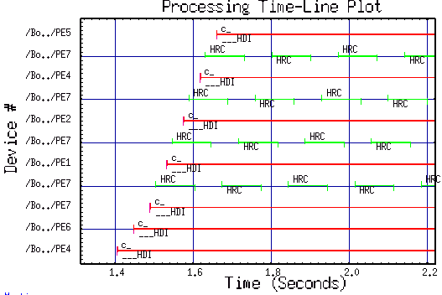

A time-line plot is a comparative display of time-periods, using time as the x-axis (or y-axis) and a series of horizontal (or vertical) lines, with explanatory labels, representing periods. The term is also sometimes used to refer to a lineplot with time on the x-axis, which is referred to here as a profile plot.

*GWE* None

*S-Plus GUI* None

*S-Plus script* None

*HARP* None

*SAS script* None

**Tornado diagram**: see forest plot

**Treemap**

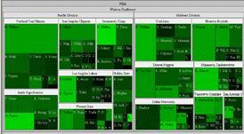

A Treemap is an enhanced mosaic plot displaying the frequencies of multi-dimensional categorical data, with interactive facilities to drill down into chosen sub-classifications. It was developed specifically for the investigation of microarray data. See examples at [Uni. of Maryland](http://www.cs.umd.edu/hcil/treemap/) and the [Hive Group](http://www.hivegroup.com/technology.html).

*GWE* None

*S-Plus GUI* None

*S-Plus script* None

*HARP* None

*SAS script* None

**Trellis display**

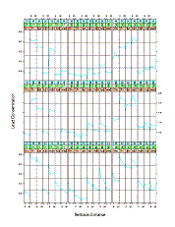

A trellis display is a panel display in which panels are laid out into rows, columns, and pages indexed by the values of one or more “conditioning” variables in a multivariable dataset. On each panel of the trellis, a subset of the data is graphed by a display method such as a scatterplot or boxplot, showing the relationship between other variables conditional on the values of the conditioning variables. The name “trellis” was coined by Bill Cleveland, and the concept is fully integrated into the S and S-Plus languages; in R, it is called a “lattice display” to avoid copyright restrictions. For examples, see LFT patient profile and LFT trellis plot by baseline.

*GWE* Use trellis option of many of the menu items

*S-Plus GUI* Graph – Multipanel Graph;

also available via interactive amendment of a simple graph

*S-Plus script* Trellis is a defined class in the language, with many supporting functions

such as coplot; see also [scripts at UCLA](http://www.ats.ucla.edu/STAT/examples/vizdata/) for Cleveland’s “Visualizing data”

*HARP* None

*SAS script* Can be constructed using Proc GREPLAY;

some procedures such as UNIVARIATE provide types of trellis

**Triangle plot**

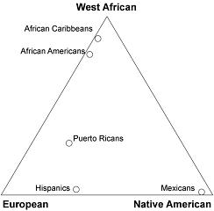

A triangle plot is a scatterplot of three-component proportions within a triangular framework. See the [Wikipedia entry](http://en.wikipedia.org/wiki/Image:Admixture_triangle_plot.png), for example,

*GWE* None

*S-Plus GUI* None

*S-Plus script* None

*HARP* None

*SAS script* None

A B C D E F G H I J K L M N O P Q R S T U V W X Y Z

**U**

A B C D E F G H I J K L M N O P Q R S T U V W X Y Z

**V**

**Volcano plot**

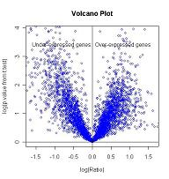

A volcano plot is a scatterplot, developed in the analysis of microarrays, of log P-value against log fold-change. See, for example, the [NIH website](http://discover.nci.nih.gov/microarrayAnalysis/Statistical.Tests.jsp). When displayed horizontally, confidence intervals can be added (preferably to selected points only).

*GWE* None

*S-Plus GUI* None

*S-Plus script* None

*HARP* None

*SAS script* [Entry in Catalogue](http://iwha.gsk.com/bdsvd/files/Graphics%20Catalogue/04.%20Relationship%20between%20two%20variables/Volcanoplot.doc) May 06

A B C D E F G H I J K L M N O P Q R S T U V W X Y Z

**W**

**Waterfall plot**

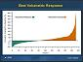

The term “Waterfall plot” is used for several different displays. This example is in oncology, where it is used for a CDF plot constructed with bars for each subject, ordered by the value of some measured variable, and transposed so that the variable is on the y-axis. In Excel, a waterfall chart is constructed from “floating-columns”, showing how an initial value is increased and decreased by a series of intermediate values, leading to a final value. Wikipedia has an entry for a [Waterfall plot](http://en.wikipedia.org/wiki/Waterfall_plot) that is three-dimensional, showing how two-dimensional information changes over time or some other variable. *GWE* None

*S-Plus GUI* None

*S-Plus script* None

*HARP* None

*SAS script* None

**Wire frame**: a response-surface plot with grid-lines drawn on the surface

A B C D E F G H I J K L M N O P Q R S T U V W X Y Z

**X**

**XY-plot**: another name for a scatterplot

A B C D E F G H I J K L M N O P Q R S T U V W X Y Z

**Y**

A B C D E F G H I J K L M N O P Q R S T U V W X Y Z

**Z**

A B C D E F G H I J K L M N O P Q R S T U V W X Y Z