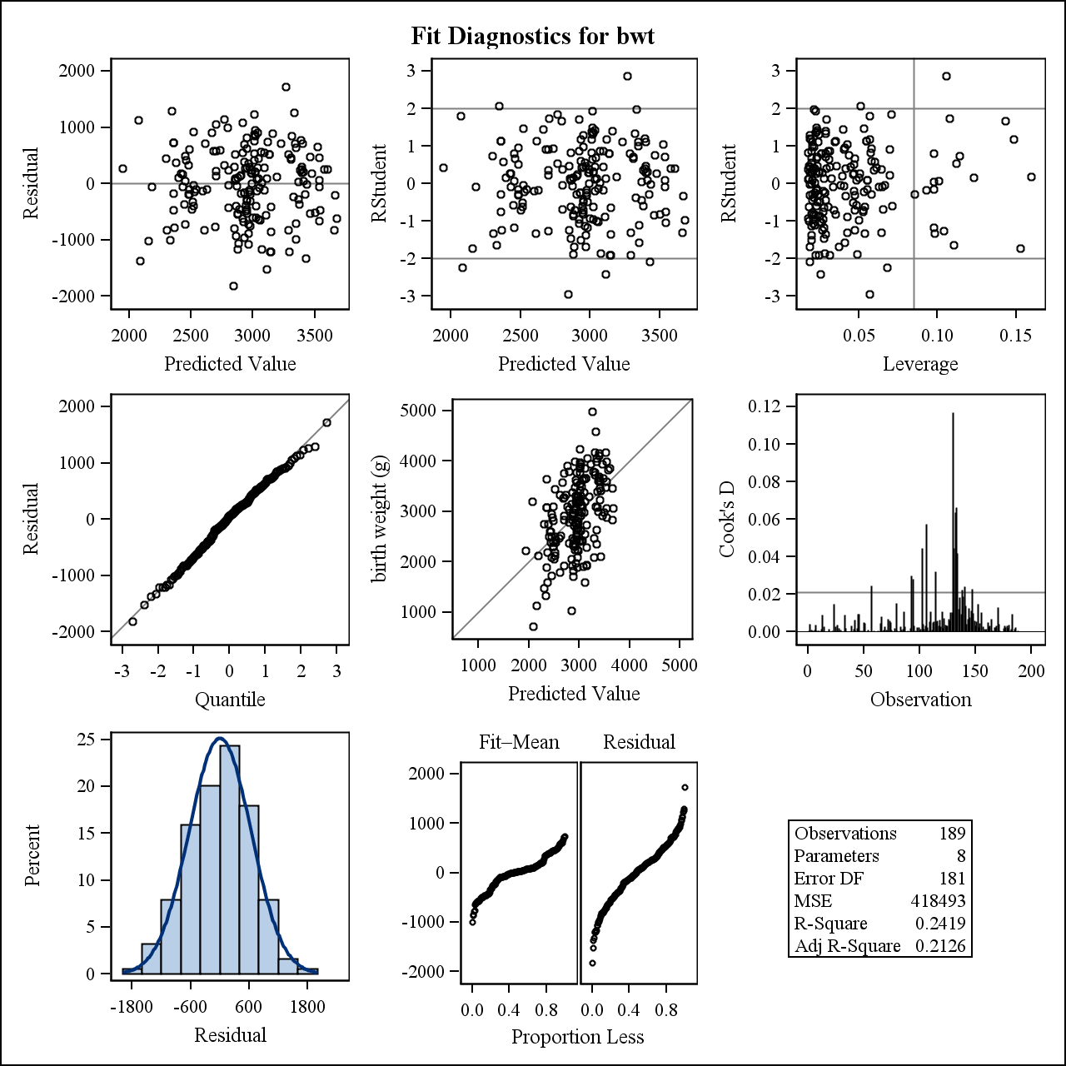
Analysis Variable : _residsqr (Squared Studentized Residual)
Range_of_Percentile | N Obs | N | Mean | Std Dev | Minimum | Maximum
0-10th percentile | 18 | 18 | 1.4274752 | 1.5424108 | 0.0080935 | 4.8631413
10-20th percentile | 20 | 20 | 0.4707818 | 0.6250137 | 0.0018279 | 2.1490880
20-30th percentile | 19 | 19 | 1.4654382 | 1.9840568 | 0.0014726 | 8.4038896
30-40th percentile | 18 | 18 | 0.8597801 | 1.1438599 | 0.0032374 | 3.4654545
40-50th percentile | 20 | 20 | 0.7965907 | 0.7533036 | 0.0625001 | 2.8003781
50-60th percentile | 18 | 18 | 0.8284207 | 0.9907777 | 3.0592951E-6 | 3.6711840
60-70th percentile | 21 | 21 | 0.7359894 | 0.9177190 | 0.0011539 | 3.3907482
70-80th percentile | 17 | 17 | 2.1042813 | 2.1595641 | 0.0211613 | 7.9466246
80-90th percentile | 20 | 20 | 0.8320928 | 0.9965283 | 0.0030813 | 3.8871685
90-100th percentile | 18 | 18 | 0.7080947 | 1.0156711 | 0.000676424 | 4.2975421

Categorized birth weight | Age of mother | Weight at last menstrual period | Race (3 categories) | Smoking status during pregnancy | History of hypertension | Uterine irritability | # of physician visits first trimestor | History of premature labor
>= 2500 g | 45 | 123 | white | NonSmoker | No | No | 1 | No

birth weight (g) | smoke NonSmoker | race other | race white | ht Yes | ui No | Predicted Value of bwt | Residual | Studentized Residual | Cook's D Influence Statistic | Leverage
4990 | 1 | 0 | 1 | 0 | 1 | 3265.11 | 1724.89 | 2.81898 | 0.11697 | 0.10535
Categorized birth weight | Age of mother | Weight at last menstrual period | Race (3 categories) | Smoking status during pregnancy | History of hypertension | Uterine irritability | # of physician visits first trimestor | History of premature labor
>= 2500 g | 28 | 250 | other | Smoker | No | No | 1 | No

birth weight (g) | smoke NonSmoker | race other | race white | ht Yes | ui No | Predicted Value of bwt | Residual | Studentized Residual | Cook's D Influence Statistic | Leverage
3303 | 0 | 1 | 0 | 0 | 1 | 3189.44 | 113.563 | 0.19151 | .000871445 | 0.15973
Smoking status during pregnancy
smoke | Frequency | Percent | Cumulative  Frequency | Cumulative  Percent
NonSmoker | 115 | 60.85 | 115 | 60.85
Smoker | 74 | 39.15 | 189 | 100.00

Race (3 categories)
race | Frequency | Percent | Cumulative  Frequency | Cumulative  Percent
black | 26 | 13.76 | 26 | 13.76
other | 67 | 35.45 | 93 | 49.21
white | 96 | 50.79 | 189 | 100.00

History of hypertension
ht | Frequency | Percent | Cumulative  Frequency | Cumulative  Percent
No | 177 | 93.65 | 177 | 93.65
Yes | 12 | 6.35 | 189 | 100.00

Uterine irritability
ui | Frequency | Percent | Cumulative  Frequency | Cumulative  Percent
No | 161 | 85.19 | 161 | 85.19
Yes | 28 | 14.81 | 189 | 100.00
Variable | Label | N | Mean | Std Dev | Minimum | Maximum
age  lwt | Age of mother  Weight at last menstrual period | 189  189 | 23.2380952  129.6878307 | 5.2986779  30.6471496 | 14.0000000  80.0000000 | 45.0000000  250.0000000

Number of Observations Read | 189
Number of Observations Used | 189

Variable | Values | Parameter Estimate | Standard Error | P-Value | Lower 95% CI | Upper 95% CI | VIF | Type 3 P-Value
INTERCEPT |  | 1550.14836 | 321.33774 | <.0001 | 916.09855 | 2184.19818 | 0 | .
AGE |  | -4.61616 | 9.31942 | 0.6210 | -23.00484 | 13.77253 | 1.09542 | .
HT | Yes | -591.54917 | 200.20696 | 0.0035 | -986.58894 | -196.50939 | 1.07637 | .
HT | No | . | . | . | . | . | . | .
LWT |  | 4.42562 | 1.70029 | 0.0100 | 1.07067 | 7.78056 | 1.21983 | .
RACE | other | 134.27309 | 158.47330 | 0.3980 | -178.41963 | 446.96581 | 2.59536 | .
RACE | white | 490.96743 | 149.01809 | 0.0012 | 196.93134 | 785.00352 | 2.50658 | .
RACE | black | . | . | . | . | . | . | .000480057
SMOKE | NonSmoker | 359.50523 | 103.95415 | 0.0007 | 154.38736 | 564.62310 | 1.16269 | .
SMOKE | Smoker | . | . | . | . | . | . | .
UI | No | 527.86441 | 134.98454 | 0.0001 | 261.51872 | 794.21011 | 1.03849 | .
UI | Yes | . | . | . | . | . | . | .

