Correlation

Measures of correlation are not statistical tests of inference, but are actually descriptive statistical measures which represent the degree to which two or more variables are related to one another. After calculating a measure of correlation, such as the Pearson product-moment correlation coefficient or the Spearman’s rank correlation, an inferential statistical test is often used to evaluate hypotheses regarding the correlation coefficient. E.g., we may wish to test the null hypothesis that a correlation between two variables equals 0.
Correlation is concerned with trends: if X increases, does Y tend to increase or decrease? How much? How strong is this tendency?

Notation
The following notation will be used to define the correlation coefficient:
Sxx = 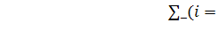
Syy = 
Sxy =  with Sxy = Syx

The sample variances of the X’s and Y’s can be defined, respectively, as follows:
 and 
and the sample covariance is defined as:
S_{xy} =

The Pearson Correlation Coefficient
If we had data in the form of pairs of observations for individuals, such as SAT score and freshman GPA, we could plot each individual’s pair of values on a scatter diagram, with the X variable on the horizontal axis and the Y variable on the vertical axis. Plotting these points for all individuals would yield a scatter diagram that would help illustrate the relationship between the two variables. If a straight line drawn through the points provides the best approximation to the observed relationship, we say that the relationship is linear. The Pearson product moment correlation coefficient measures how close the observations fall to the line.
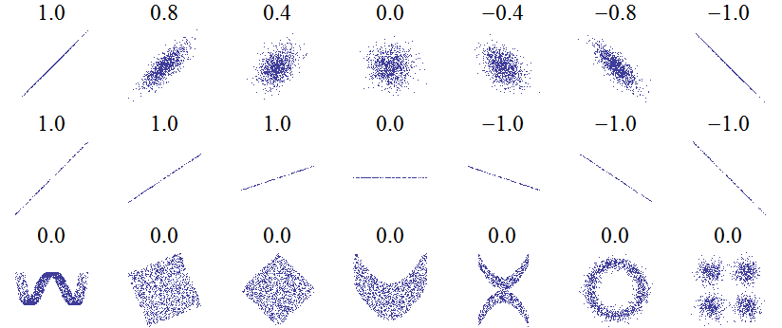
Sample scatter diagrams and corresponding correlation coefficients. (Wikipedia)
The true value of the correlation coefficient in the population, ρ, is estimated by the sample correlation coefficient, r, which measures the strength and direction of a linear relationship between the X and Y variables.
The formula for the sample correlation coefficient is
 =
and is interpreted as “the correlation between X and Y '' .

Properties of Pearson's Correlation
- The value of r falls between -1 and +1.
- A positive value of r indicates that as one variable increases, the other variable increases. A negative value of r indicates that as one variable increases, the other variable decreases. If r = 0, then there is no linear relationship between the two variables.
- r = 1 or r = -1 only when all the points lie exactly on a straight line.
- The magnitude of r indicates the strength of the association between the two variables. As r gets closer to either -1 or +1, the strength of the association becomes greater.
- Because X and Y have been converted to standard units, the value of r has no units of measurement.
- The value of r does not depend upon which variable is labeled X and which variable is labeled Y.
- The value of r is only valid within the range of values of X and Y in the sample from which r has been calculated.
- r measures only the linear relationship between X and Y.

Interpretation of the size of a correlation
Several authors have offered guidelines for the interpretation of a correlation coefficient. e.g.:
Small correlation: 0.1 < |r| ≤ 0.3
Medium correlation: 0.3 < |r| ≤ 0.5
Large correlation: 0.5 < |r| ≤ 1.0

Cohen (1988)*, has observed, however, that all such criteria are in some ways arbitrary and should not be observed too strictly. This is because the interpretation of a correlation coefficient depends on the context and purposes. A correlation of 0.9 may be very low if one is verifying a physical law using high-quality instruments, but may be regarded as very high in the social sciences where there may be a greater contribution from complicating factors.
It is also useful to remember that the square of the correlation coefficient (r²) gives the proportion of variance in Y explained by X. E.g., a correlation of 0.7 explains less than half of the variance (49%).
*Cohen, J. (1988). Statistical power analysis for the behavioral sciences (Lawrence Erlbaum; January 15, 1988; 2nd edition.

Correlation and Causation

It is frequently stated that correlation does not imply causation. An association, even a highly significant one, between two variables does not imply a cause-and-effect relationship between them. Correlation coefficients therefore should be interpreted cautiously.

Spearman's Rank Correlation
Spearman’s rank correlation coefficient is the non-parametric equivalent of the Pearson’s correlation coefficient. Whereas Pearson’ correlation measures linear relationships between variables, Spearman’s rank correlation can be used when the relationship between two variables is not linear because:
at least one of the variables is measured on an ordinal scale
neither x nor y is normally distributed
the sample size is small
The Spearman correlation is calculated by
separately ranking the variables for each data point with the two groups to be compared. Tied absolute values each get the average rank of those two values had they not been tied;
computing the differences between the ranks (d) for the two variables for each data point;
squaring the difference;
summing the square of the differences (∑d²).
applying the following formula:
r (Spearman) = 1 - 
where d² = the square of the differences between the ranks for the two variables that establish each point, and n = the number of individual points.
Actually, this is just Pearson's formula applied to the ranks.
http://en.wikipedia.org/wiki/Spearman%27s_rank_correlation_coefficient

