Histograms
Last updated by Richard Forshee on September 16, 2010
Disclaimer: The opinions expressed in this document are those of the author and may not represent the opinions of the U.S. Food and Drug Administration.

Type of data: continuous
Type of analysis: univariate

Description and purpose:
Histograms are used to represent the distribution of a single continuous variable. A histogram groups individual observations into bins (mouseover to define) of a specified (usually equal) width and counts the number of observations in each bin. Rectangles are drawn so that the height (or width for a horizontal histogram) represents the frequency, percentage, or density of the number of observations in each bin. By convention, the rectangles in a histogram touch one another.

Histograms are distinct from bar charts (link). Bar charts are for categorical data and by convention the rectangles in a bar chart do not touch.

Examples:
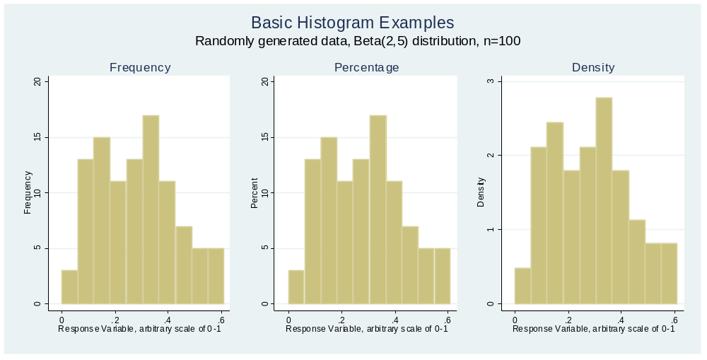

Complementary graphs:
Kernel density overlays
Theoretical distribution overlays
Rug plots

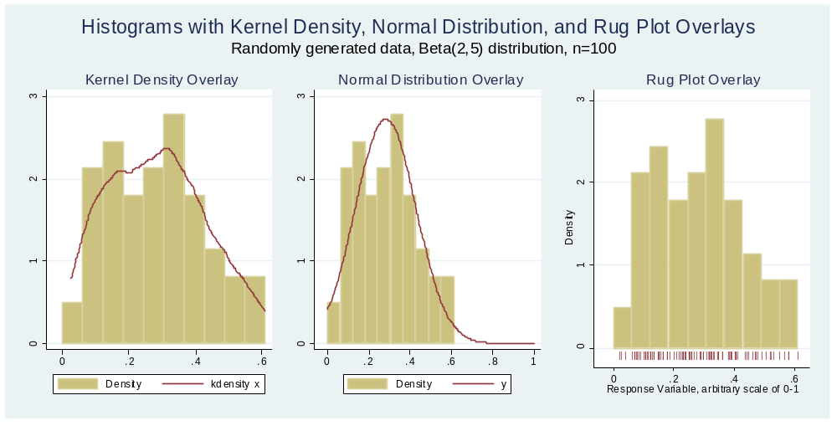

Potential pitfalls
Visual representation is very sensitive to the choice of bin size

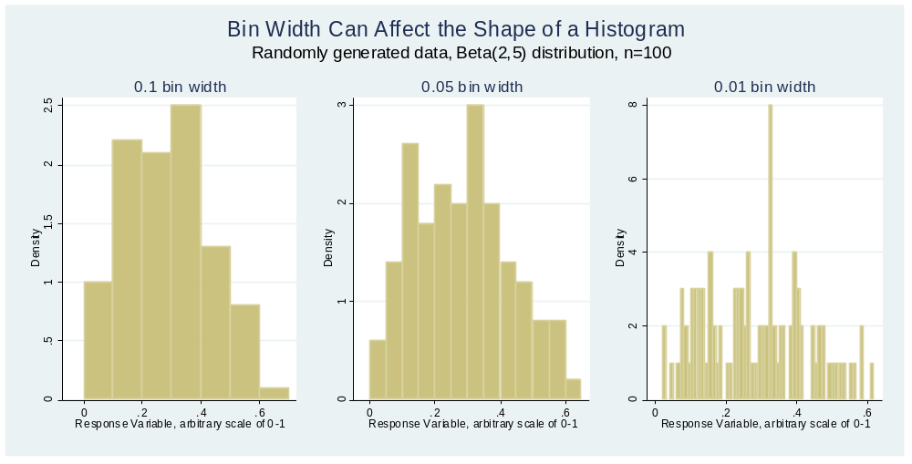

Reference: These concepts have been discussed by many authors, but Cox NJ, Speaking Stata: Graphing distributions, The Stata Journal (2004) 4, Number 1, pp. 66–88 was particularly helpful as I prepared this description.

Code (Stata 11):
**********************************************************
**
** Histogram Examples for Clinical Safety Graphics WG
** Richard Forshee, FDA/CBER/OBE
**
** Last updated September 16, 2010
**
** This file benefited from Cox NJ, Speaking Stata:
** Graphing Distributions. Stata Journal 2004.
**
**********************************************************

** Generate random data from a beta distribution alpha=2, beta=5
** This set of parameters generates highly skewed data between 0 and 1

clear
set seed 85360497 // serial number from the first dollar bill in my wallet
set obs 100
gen x = rbeta(2,5)

label var x "Response Variable, arbitrary scale of 0-1"

** Basic histograms
twoway histogram x, title("Frequency") freq start(0) saving(basic_freq, replace)
twoway histogram x, title("Percentage") percent start(0) saving(basic_perc, replace)
twoway histogram x, title("Density") start(0) saving(basic_dens, replace)

graph combine basic_freq.gph basic_perc.gph basic_dens.gph, ///
row(1) xsize(6) ysize(3) title("Basic Histogram Examples") ///
subtitle("Randomly generated data, Beta(2,5) distribution")

** Histograms with overlays

** Kernel Density
twoway (histogram x, start(0)) (kdensity x), ///
title("Histogram with Kernel Density Overlay") ///
saving(over_kd, replace)

** Normal
summ x // Generate summary statistics
local m=`r(mean)' // Place mean into a local macro
local sd=`r(sd)' // Place standard deviation into a local macro

twoway (histogram x, start(0)) (function y=normalden(x,`m',`sd'), range(0 1)), ///
title("Histogram with Normal Distribution Overlay") ///
saving(over_normal, replace)

** Rug Plot
gen pipe = "|" // Create a vertical line symbol
gen where=-0.1 // Create a variable for vertical placement of the rug plot

** Histogram with a scatter plot underneath to produce rug plot

histogram x, start(0) ///
title("Histogram with Rug Plot Overlay") ///
saving(over_rug, replace) ///
plot(scatter where x, ms(none) mlabel(pipe) mlabpos(0)) ///
legend(off) plotregion(margin(medium))

graph combine over_kd.gph over_normal.gph over_rug.gph, ///
row(1) xsize(6) ysize(3) ///
title("Histograms with Kernel Density, Normal Distribution, and Rug Plot Overlays")

** Pitfalls
** Bin width

histogram x, start(0) width(0.1) ///
title("Histogram with 0.1 bin width") saving(width_10, replace)
histogram x, start(0) width(0.05) ///
title("Histogram with 0.05 bin width") saving(width_05, replace)
histogram x, start(0) width(0.01) ///
title("Histogram with 0.01 bin width") saving(width_01, replace)

graph combine width_10.gph width_05.gph width_01.gph, ///
title("Bin Width Can Affect the Shape of a Histogram") ///
row(1) xsize(6) ysize(3)

