EDITS NOTED FORM

Image: 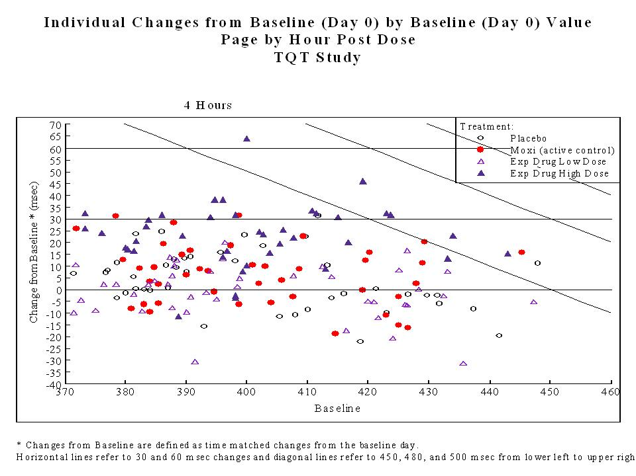

Proposed Edits:
Annotate the diagonal lines with 450msec, 480msec, and 500msec.
Use dashed lines for all but the origin.
Left Justify the hour post dose such that it lines up with the upper left of the graph frame.
Modify Title and Axes to indicate QTc and the type of correction imparted (eg. Bazett, Fridericia)

Title: Categorical QTc Relationship of Changes from Baseline to Baseline in Time-Matched Values
Graph Subgroup: Scatter plot

Description: This figure plots the change from baseline by the baseline value and is useful in examination of 'categorical' QTc changes. By plotting the changes against the baseline one can view the changes in the context of the raw QTc values. Large changes toward the left hand side of the plot are most likely due to regression to the mean and a low baseline whereas large changes to the upper right-hand side of the plot have large raw QTc values as well as large changes and are potentially more worrisome. The plot presented here is produced by hour post dose in a thorough QT design and the 4 hour timepoint was presented as that represented tmax of the experimental drug.

Submitter Name and Email: R.J. Anziano, Richard.J.Anziano@Pfizer.com

Background: Additional background information on the graphic

Date Sent for Peer Review: 17Oct2011

Code Available: No code available

Key words: QTc, Categorical, Scatter plot,

References: http://www.fda.gov/downloads/RegulatoryInformation/Guidances/ucm129357.pdf

Data:
Data is saved as both a SAS transport dataset and a comma delimited ascii file. A dataset description file with more detail on the trial design and dataset structure can be found in the following descriptor file:
http://www.ctspedia.org/wiki/pub/StatisticalGraphics/ECGVitalSubteam/tQT_Dataset_Description.doc
Comma delimited dataset:
http://www.ctspedia.org/wiki/pub/CTSpedia/StatGraphTopic017/tqt.dat

Classifications: Please specify for each bulleted item below.
- Graph Type: scatterplot
- Variable Relationship: continuous vs. continuous
- Data Type: continuous

Special Considerations: The graphic was purposefully used at tmax of the experimental drug. If you wish to use across timepoints you will want to select the maximum change or raw value to represent each subject otherwise there will be multiple obs per subject which would be difficult to interpret. A potential solution would be to produce this plot for each time post dose.

