EDITS NOTED FORM

Image:
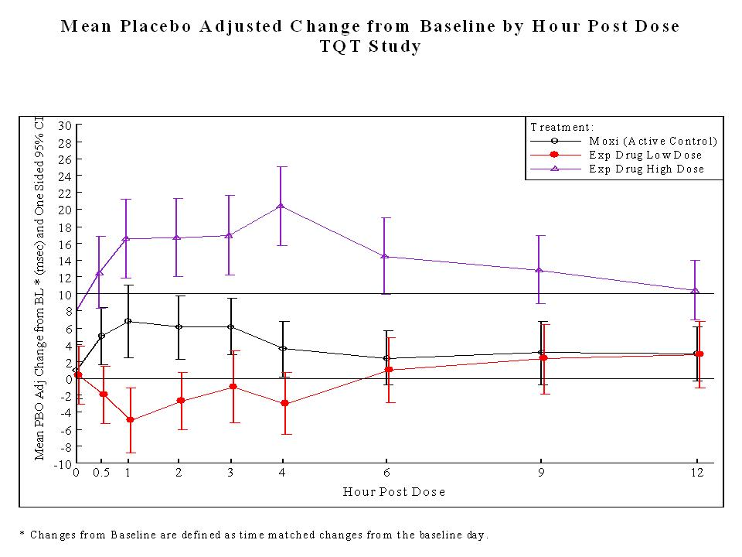

Proposed Edits:
Label the two horizontal lines to indicate a possible normal range.
Use different types of line pattern to indicate dosages and Moxi.
Possibly add sample size at each time point.
Modify Title to be more generic (i.e., hours to some other time units). Also indicate a type of adjustment (eg. QTCF, QTCB and etc..)

Title: Adjusted Time Matched Change Across Different Time Points

Graph Subgroup: Profile Plot

Description: This plot reflects time matched changes by adjusting for placebo. In other words, it compares how much changes, if we compare with placebo at a certain time point, were observed. If a change above the horizontal line initiated at vertical axis with value as 10, it indicates a potential worrisome. The unit of the x-axis is hour and can be modified accordingly based on requirements.

Submitter Name and Email: R.J. Anziano, Richard.J.Anziano@Pfizer.com

Background: Additional background information on the graphic

Date Sent for Peer Review: 18Oct2011

Code Available: No code available

Key words: Adjusted change, Profile plot, Time-matched change

References: http://www.fda.gov/downloads/RegulatoryInformation/Guidances/ucm129357.pdf

Data:
Data is saved as both a SAS transport dataset and a comma delimited ascii file. A dataset description file with more detail on the trial design and dataset structure can be found in the following descriptor file:
http://www.ctspedia.org/wiki/pub/StatisticalGraphics/ECGVitalSubteam/tQT_Dataset_Description.doc
Comma delimited dataset:
http://www.ctspedia.org/wiki/pub/CTSpedia/StatGraphTopic017/tqt.dat

Classifications: Please specify for each bulleted item below.
- Graph Type: profile plot
- Variable Relationship: continuous vs. continuous
- Data Type: continuous

Special Considerations:

