EDITS NOTED FORM

Image:

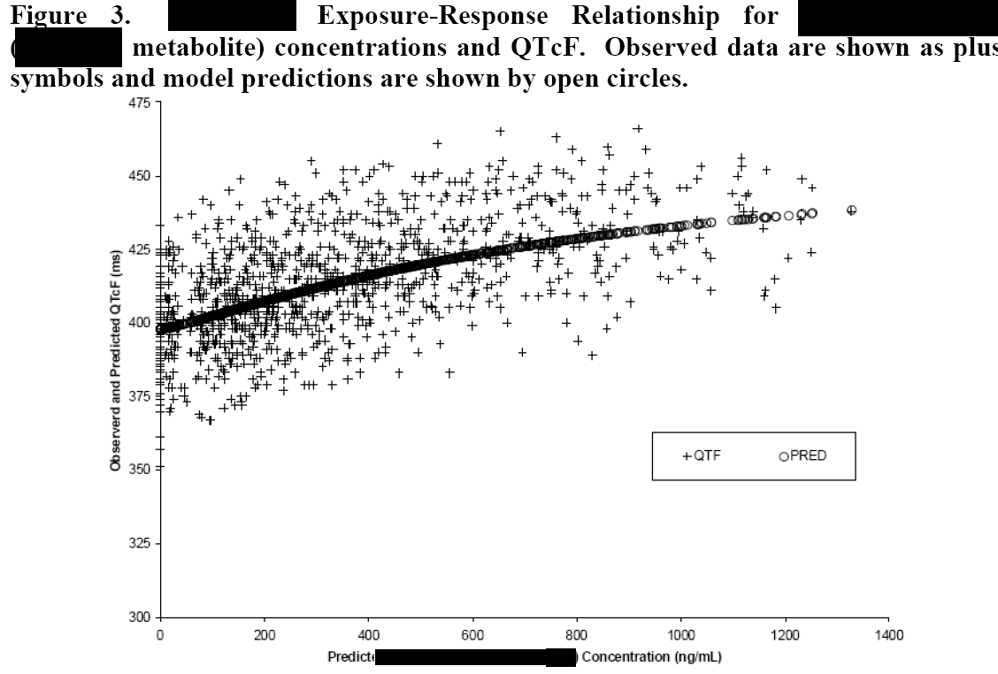
Proposed Edits:
May add notes regarding how the predictive values were obtained.
Make symbols more distinguishable.
Make labels for x-axis and y-axis clearer and also add a label for the trend line.
Add line instead of predicted values and create label for this non-linear regression line form either as annotation or in footnote
Allow for confidence bands in code
Footnote QTcF is Fridericia corrected QT

Title: Observed and Predicted QT Intervals and Relationships with Drug Exposure

Graph Subgroup: Scatter plot

Description: The x-axis of this plot is the drug concentration; y-axis is the observed QT interval; and the line in the plot is based on predicted values. This plot illustrates a trend of how concentrations of a drug exposure were associated with changes of observed and predicted values of QT interval.

Submitter Name and Email: R.J. Anziano, Richard.J.Anziano@Pfizer.com

Background: Additional background information on the graphic

Date Sent for Peer Review: 18Oct2011

Code Available: No code available

Key words: QT Interval, Exposure, Scatter plot, Change, Concentration

References: http://www.fda.gov/downloads/RegulatoryInformation/Guidances/ucm129357.pdf

Data:
Data is a one observation per subject dataset for a large p2/p3 program. Sample data is not provided for this plot. It is important that the data be one observation per subject for a SLR to maintain i.i.d. If not, the statistical model should take into account the within subject correlations.

Classifications: Please specify for each bulleted item below.
- Graph Type: scatter plot
- Variable Relationship: continuous vs. continuous
- Data Type: continuous

Special Considerations: If more than 1 QTc concentration for a subject the within subject component should be modeled appropriately.

