Model Information
Data Set | WORK.MYDATA
Response Variable | outcome
Number of Response Levels | 2
Model | binary logit
Optimization Technique | Fisher's scoring

Number of Observations Read | 124
Number of Observations Used | 118

Response Profile
Ordered  Value | outcome | Total  Frequency
1 | no | 70
2 | yes | 48

Probability modeled is outcome='no'.

Note: | 6 observations were deleted due to missing values for the response or explanatory variables.

Model Convergence Status
Convergence criterion (GCONV=1E-8) satisfied.

Model Fit Statistics
Criterion | Intercept  Only | Intercept  and  Covariates
AIC | 161.457 | 116.384
SC | 164.228 | 121.925
-2 Log L | 159.457 | 112.384

R-Square | 0.3290 | Max-rescaled R-Square | 0.4439

Testing Global Null Hypothesis: BETA=0
Test | Chi-Square | DF | Pr > ChiSq
Likelihood Ratio | 47.0730 | 1 | <.0001
Score | 26.1402 | 1 | <.0001
Wald | 20.1538 | 1 | <.0001

Analysis of Maximum Likelihood Estimates
Parameter | DF | Estimate | Standard  Error | Wald  Chi-Square | Pr > ChiSq
Intercept | 1 | 2.1943 | 0.4180 | 27.5625 | <.0001
predictor | 1 | -0.0362 | 0.00806 | 20.1538 | <.0001

Odds Ratio Estimates
Effect | Point Estimate | 95% Wald  Confidence Limits
predictor | 0.964 | 0.949 | 0.980

Association of Predicted Probabilities and Observed Responses
Percent Concordant | 84.4 | Somers' D | 0.689
Percent Discordant | 15.5 | Gamma | 0.689
Percent Tied | 0.1 | Tau-a | 0.335
Pairs | 3360 | c | 0.844

Wald Confidence Interval for Parameters
Parameter | Estimate | 95% Confidence Limits
Intercept | 2.1943 | 1.3751 | 3.0135
predictor | -0.0362 | -0.0520 | -0.0204

Profile Likelihood Confidence Interval for Odds Ratios
Effect | Unit | Estimate | 95% Confidence Limits
predictor | 1.0000 | 0.964 | 0.948 | 0.978

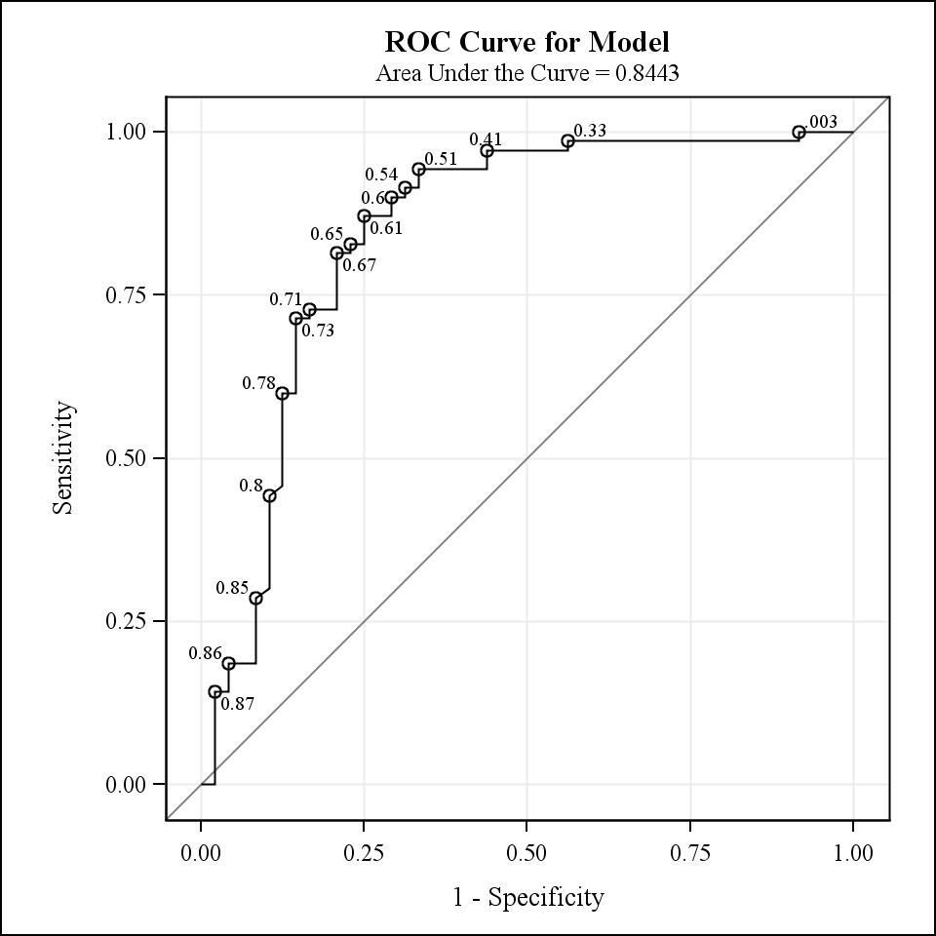
Obs | id | predictor_cutoff
1 | 33 | 48.3

Model Information
Data Set | WORK.MYDATA
Response Variable | outcome
Number of Response Levels | 2
Model | binary logit
Optimization Technique | Fisher's scoring

Number of Observations Read | 124
Number of Observations Used | 118

Response Profile
Ordered  Value | outcome | Total  Frequency
1 | no | 70
2 | yes | 48

Probability modeled is outcome='yes'.

Note: | 6 observations were deleted due to missing values for the response or explanatory variables.

Class Level Information
Class | Value | Design Variables
PredictNumcut | 0 | 1
 | 1 | -1

Model Convergence Status
Convergence criterion (GCONV=1E-8) satisfied.

Model Fit Statistics
Criterion | Intercept  Only | Intercept  and  Covariates
AIC | 161.457 | 117.051
SC | 164.228 | 122.592
-2 Log L | 159.457 | 113.051

Testing Global Null Hypothesis: BETA=0
Test | Chi-Square | DF | Pr > ChiSq
Likelihood Ratio | 46.4062 | 1 | <.0001
Score | 44.1278 | 1 | <.0001
Wald | 36.6758 | 1 | <.0001

Type 3 Analysis of Effects
Effect | DF | Wald  Chi-Square | Pr > ChiSq
PredictNumcut | 1 | 36.6758 | <.0001

Analysis of Maximum Likelihood Estimates
Parameter |  | DF | Estimate | Standard  Error | Wald  Chi-Square | Pr > ChiSq
Intercept |  | 1 | -0.1642 | 0.2386 | 0.4735 | 0.4914
PredictNumcut | 0 | 1 | -1.4451 | 0.2386 | 36.6758 | <.0001

Odds Ratio Estimates
Effect | Point Estimate | 95% Wald  Confidence Limits
PredictNumcut 0 vs 1 | 0.056 | 0.022 | 0.142

Association of Predicted Probabilities and Observed Responses
Percent Concordant | 64.3 | Somers' D | 0.607
Percent Discordant | 3.6 | Gamma | 0.895
Percent Tied | 32.1 | Tau-a | 0.296
Pairs | 3360 | c | 0.804

