EDITS NOTED FORM

Image:
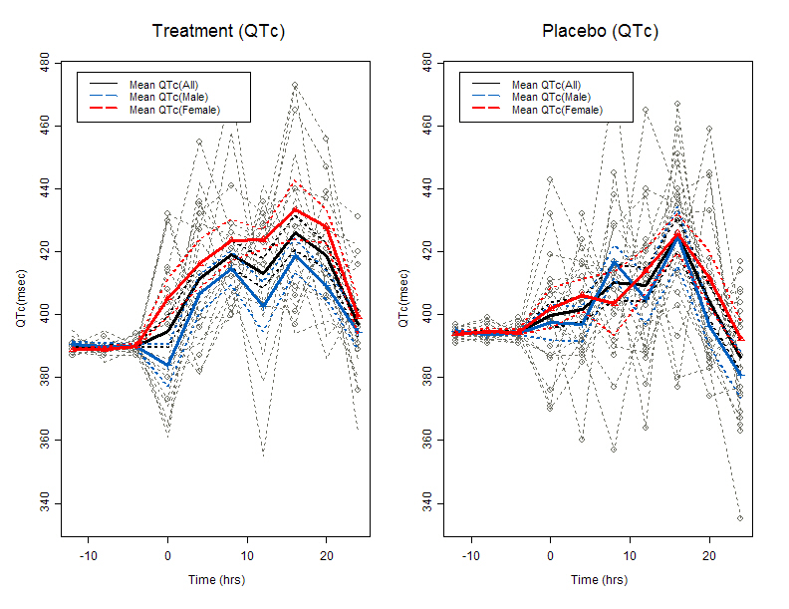
Proposed Edits:
Create whiskers for the confident intervals at the aggregated QTc values or a background shade for the CIs.
Remove separate legend and create a common
Use different line styles compatible with printing in B&W

Title: Individual QTc with Aggregate overlay

Graph Subgroup: Aggregate plot

Description: This figure shows the individual QTc with aggregated QTc values over time. The aggregated QTc values and its CIs are overlaid on the individual plots.

Submitter Name and Email: E.Y. Frimpong, Eric.Frimpong@fda.hhs.gov

Background: Additional background information on the graphic

Date Sent for Peer Review: 19Oct2011

Code Available: Code may be available

Key words: QTc, Individual profile plot, Aggregate plot

References: http://www.fda.gov/downloads/RegulatoryInformation/Guidances/ucm129357.pdf

Data:
Data is simulated from a hypothetical design/algorithm

Classifications: Please specify for each bulleted item below.
- Graph Type: Aggregate Profile plot
- Variable Relationship: continuous vs. continuous
- Data Type: continuous

Special Considerations: Similar graphics such as QTC, QTCB, etc. may be created for any categorical variable such as Gender.

