How to install the Windows driver for the Ricoh MP C4503 printer

Download the printer driver from the Ricoh web site - <http://www.ricoh-usa.com/downloads/downloads.aspx>. Enter the printer model number (“MP C4503”) in the search box. Make sure the “Driver/Software” box is checked. Then click the search button.

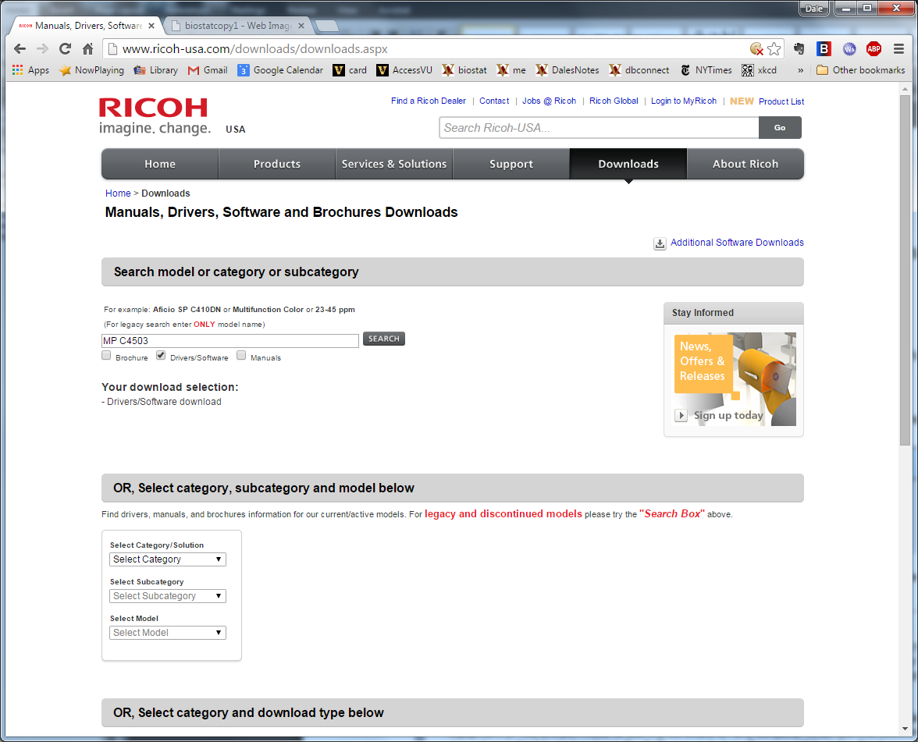

Scroll down to the Drivers links and click on the “MP C4503” link. On the next screen click “I agree” to agree to the software license terms.

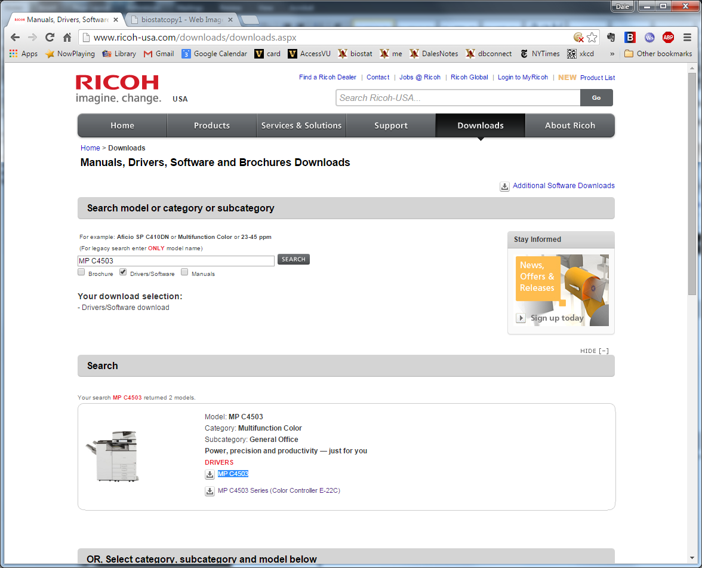

Click on the appropriate operating system (e.g. Microsoft Windows 7 (x64))

Click on the download icon for the PCL 6 Driver.

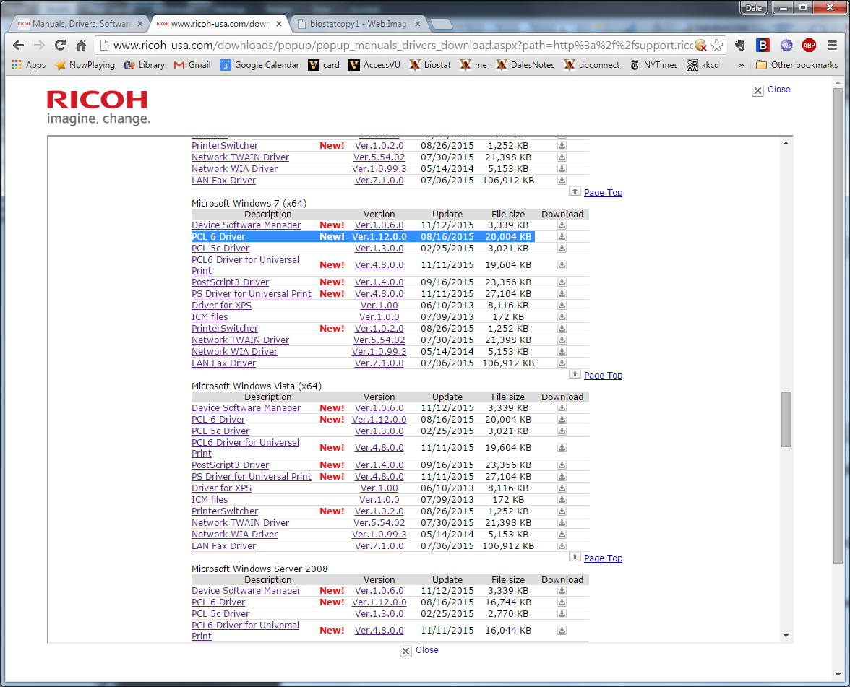

Double click on the downloaded file (in this case “z72088L16.exe”) to expand the installer. Take note of where the installation materials are stored.

Run the downloaded installer (in this case “RP_SETUP64.EXE”). It takes the program quite a while to get started. Be patient.

The first screen to appear is the license agreement. Accept the agreement and click Next.

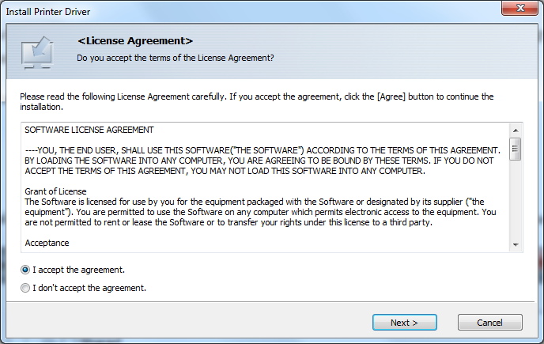

Next choose “Add a new printer” and click Next.

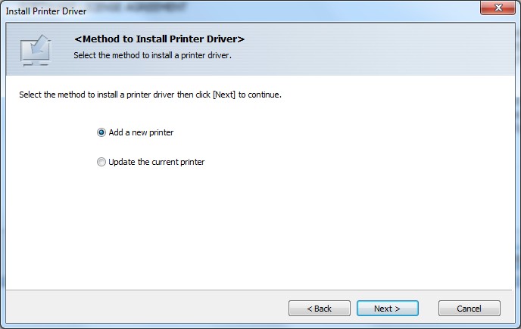

The printer is connected via the network. Select “Search for printers by specified IP Address” and click Next.

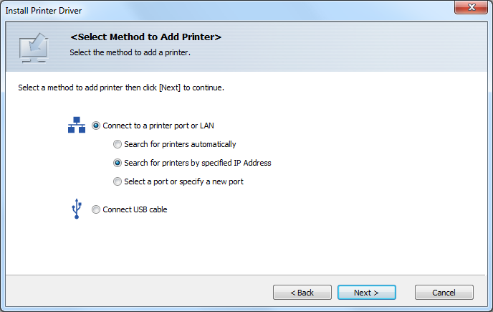

This screen will appear. Click Next.

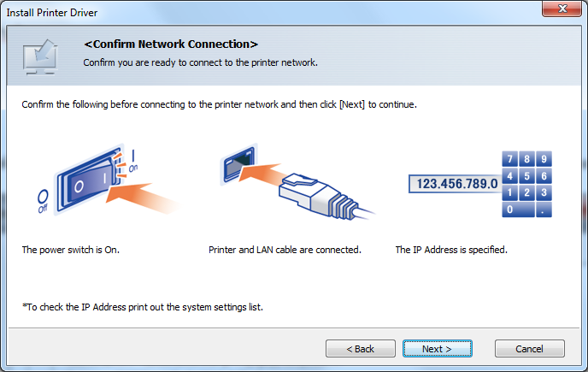

The installer will prompt for the printer’s IP address. The address is 10.151.20.250. Click OK when the address is entered.

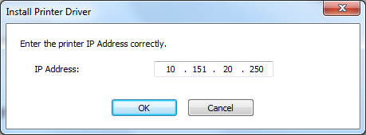

There will be another longish wait. Be patient.

Select the “RICOH MP C4503 PCL 6” item on the “Set and select Printer” window.

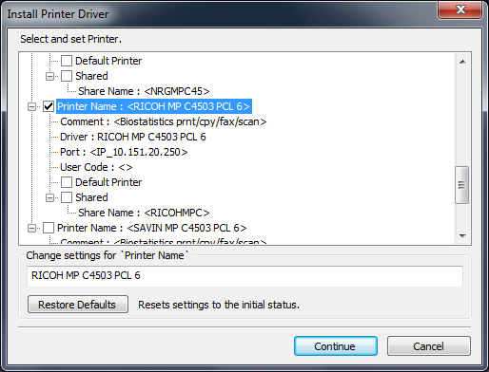

Enter the printer’s common name (biostatcopy1) in the “Change settings for `Printer Name`” box. Click the Continue button.

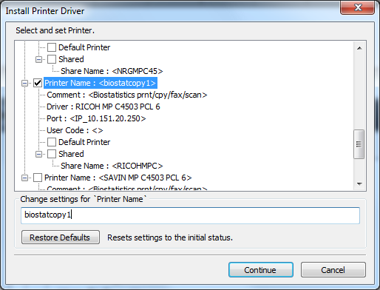

Eventually, this screen will appear. You will need to reboot your computer to complete the process. Once that is done, the installation should be complete.

