**ICEGATE**

1. Home page

* Home page created
* The header section is implemented – design of header section is implemented
* Latest news on header is implemented
* Menu section is also created except child menus and menus pages – Design of menu section is implemented except child menus and its functionality



* Banner section functionality is also created except design – Design implemented



* National Portal for Indian Customs section functionality is created except design – Design implemented

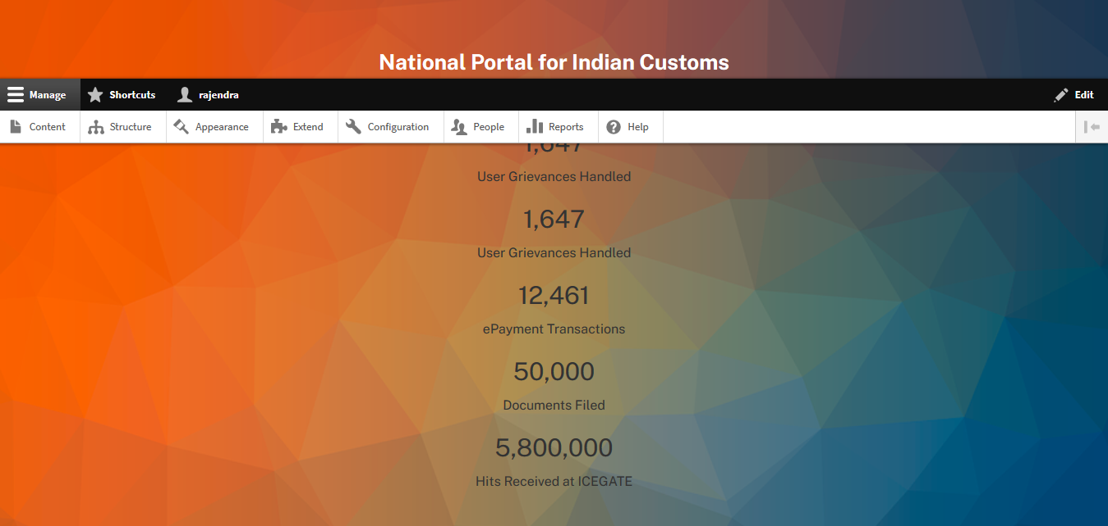

* Our Services section functionality is created except design – Design implemented partially (Some part of it is still pending for design)

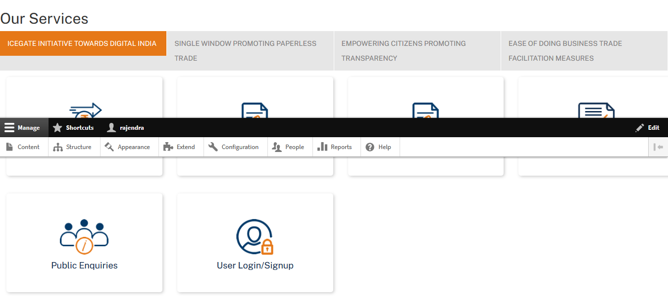

* Awards and Recognitions section functionality is created except design – Design implemented

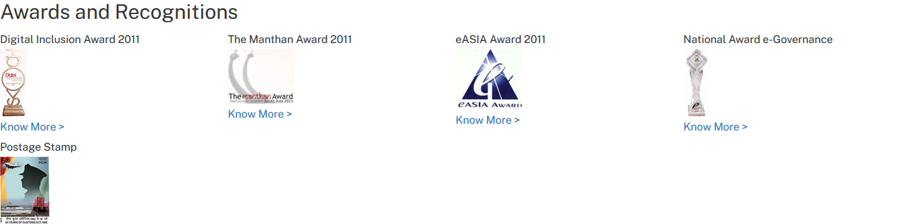

* footer section Get in touch with us, some icons list and menus are listed and design is also implemented – Design implemented

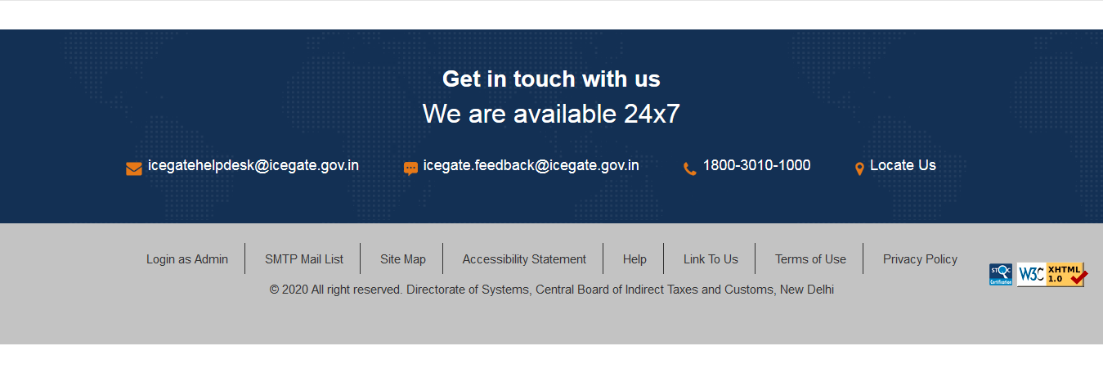

**Note: The design is implemented for firefox and chrome only. Mobile design is still in progress. The design and other detail still not getting so creating replica of “https://icegate.gov.in”**

**Next week plan**

* Implement design for all the section and test on bowser and test on all the bowser with mobile. - Work in progress
* Create Sub-menu pages – Work in progress
* Creating user registration
* Creating User Dashboard

**Questions: How will we verify the IceGate ID licence? Are we verify with any third party tool or from our database?**

