1、<https://github.com/AlloyTeam/Rosin/tree/fiddler4-trunk>

参考enable-all实现

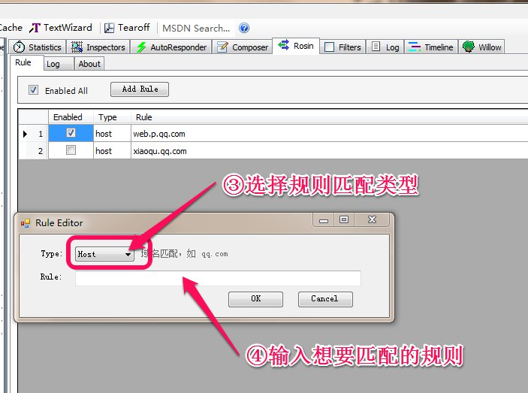

2、参考类方法

<https://github.com/vcsjones/FiddlerScriptCSharp>

3、内容安全

https://github.com/david-risney/CSP-Fiddler-Extension