**一、设备激活**

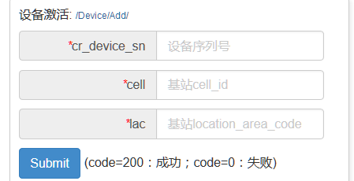

[http://*.*.*.*:8020/api/iphone/Device/Add/?auth_code=mHealth365_qTbmSvaL5c365d3z&cr_device_sn=987654&cell=38630&lac=1067](http://101.201.39.122:8020/api/iphone/Device/Add/?auth_code=mHealth365_qTbmSvaL5c365d3z&cr_device_sn=987654&cell=38630&lac=1067)



已激活的状态

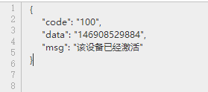

二、固件版本升级



[http://*.*.*.*:8020/api/iphone/Device/GetAppVersion/?auth_code=mHealth365_qTbmSvaL5c365d3z&cr_firm_version=1.6.3](http://101.201.39.122:8020/api/iphone/Device/GetAppVersion/?auth_code=mHealth365_qTbmSvaL5c365d3z?cr_firm_version=1.6.3)

有新版本

{

"code" : "200",

"data" :

{

"cr_firm_version" : "1.6.4",

"cr_update_desc" : "版本更新",

"cr_firm_url" : "http://127.0.0.1:3000/static/images/20160513/5735b7ef7ef8e.zip",

"cr_file_o_name" : "408_132621_1.jpg",

"cr_file_n_name" : "5735b7ef7ef8e.zip",

"cr_create_time" : 1463138287,

"cr_online_time" : 1463138287,

"id" : "146313828712"

}}

没有新版本

{

"code" : "0",

"data" : ""}

升级新：

{

"code":"200",

"data":

{

"cr_firm_version":"1.7.17",

"cr_update_desc":"jtj-arm.zip",

"cr_file_n_name":"5763b717c601c.zip",

"cr_firm_url":

"http:\/\/*.*.*.*:8060\/static\/images\/20160617\/5763b717c601c.zip",

"cr_create_time":1466152727,

"cr_online_time":1466152727,

"id":"146615272742"

}

}

1. 下载批号

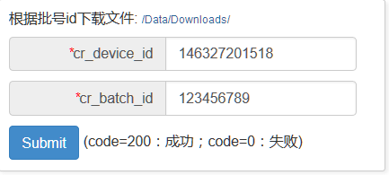

cr_device_id 设备id

cr_batch_id 批号id

[http://*.*.*.*:8020/api/iphone/Data/Downloads/?auth_code=mHealth365_qTbmSvaL5c365d3z&cr_device_id=146327201518&cr_batch_id=123456789](http://101.201.39.122:8020/api/iphone/Data/Downloads/?auth_code=mHealth365_qTbmSvaL5c365d3z&cr_device_id=146327201518&cr_batch_id=123456789)

获取的数据

{

"code" : "200",

"data" :

{

"cr_item_name" : "poct",

"cr_item_id" : "146336303408",

"cr_file_path" : "http://127.0.0.1:3000/static/images/20160519/573d2e172e33f.zip",

"cr_batch_id" : "123456789"

}

}

cr_item_name 项目名称

cr_item_id 项目id

cr_file_path 文件下载路径

cr_batch_id 批号id

下载曲线

曲线下载链接 "cr_file_path" : "http://127.0.0.1:3000/static/images/20160519/573d2e172e33f.zip"

1. 上传数据

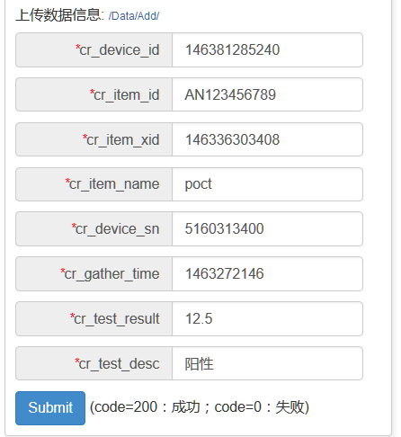

cr_device_id 设备id

cr_item_id 项目批号

cr_item_xid 项目id

cr_item_name 项目名称

cr_device_sn 设备序列号

cr_gather_time 采集时间(时间戳)

cr_test_result=73.5 测量结果

cr_test_desc 结果描述

[http://*.*.*.*:8020/api/iphone/Data/Add/?auth_code=mHealth365_qTbmSvaL5c365d3z&cr_device_id=](http://101.201.39.122:8020/api/iphone/Data/Add/?auth_code=mHealth365_qTbmSvaL5c365d3z&cr_device_id=)146381285240&cr_item_id=AN123456789&cr_item_xid=146336303408&cr_item_name=poct&cr_device_sn=5160313400&cr_gather_time=1451622559&cr_test_result=88.8&cr_test_desc=阳性

上传成功 获取的结果(正确)

{"code": "200",

"data": {"id": "146397310922" }

}

上传失败 获取的结果值

{ "code" : "0","data" : "xxxxxx 错误信息"}

升级新：

"code":

"200",

"data":{

"cr_firm_version":"1.6.61",

"cr_update_desc":"fffffff",

"cr_file_n_name":"5742de6839d9a.zip",

"cr_firm_url":"http:\/\/*.*.*.*:8060\/static\/images\/20160523\/5742de6839d9a.zip",

"cr_create_time":1464000104,

"cr_online_time":1464000104,

1. 开机广告

http://*.*.*.*:8020/api/iphone/Device/GetAdvert/?auth_code=mHealth365_qTbmSvaL5c365d3z

{"code" : "200",

"data" :

{

"img_site" : "http://*.*.*.*:8060/static/images/20160621/5768d0508ca76.png",

"url_site" : "www.baidu.com",

"state" : "1"

}}

state 1表示广告是开启的可以弹出 0 表示广告关闭

1. 位置改变信息

[http://*.*.*.*:8020/api/iphone/Device/DeviceLbs/?auth_code=mHealth365_qTbmSvaL5c365d3z](http://101.201.39.122:8020/api/iphone/Device/DeviceLbs/?auth_code=mHealth365_qTbmSvaL5c365d3z)&device_id=146666516946&cell=38630&lac=1067

device_id 设备激活后返回的设备的Id

Cell 与 lac 与设备激活相同

位置信息修改请求成功

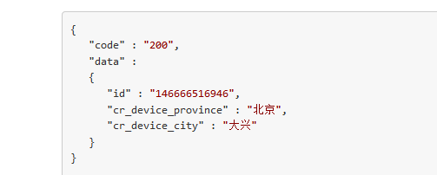

位置信息修改请求失败



1. 新的版本升级

[http://*.*.*.*:8020/api/iphone/Device/GetAppVersion/?auth_code=mHealth365_qTbmSvaL5c365d3z&cr_firm_version=1.8.0](http://101.201.39.122:8020/api/iphone/Device/GetAppVersion/?auth_code=mHealth365_qTbmSvaL5c365d3z&cr_firm_version=1.8.0)

1、需要更新(机器版本小于服务器版本)

{

"code" : "200",

"data" :

{

"id" : "146699667852",

"cr_firm_version" : "1.81",

"cr_firm_url" :

{

"num" : 3,

"urlList" :

[

"http://*.*.*.*:8031/static/images/20160627/577097c630da3.zip_1.part",

"http://*.*.*.*:8031/static/images/20160627/577097c630da3.zip_2.part",

"http://*.*.*.*:8031/static/images/20160627/577097c630da3.zip_3.part"

]

},

"cr_online_time" : 1466996678,

"cr_offline_time" : null

}}

Code 200表示需要更新

cr_firm_version 最新的版本号

Num 固件被分为多少个部分

urlList 固件下载的连接组

1. 不需要更新

{

"code" : "0",

"data" : ""

}

Code 0表示不需要更新

文件曲线下载修改

1. 曲线下载

第一次下载曲线

[http://*.*.*.*:8020/api/iphone/Data/Downloads/?auth_code=mHealth365_qTbmSvaL5c365d3z&cr_device_id=146381285240&cr_batch_id=123456789&cr_create_time=0](http://101.201.39.122:8020/api/iphone/Data/Downloads/?auth_code=mHealth365_qTbmSvaL5c365d3z&cr_device_id=146381285240&cr_batch_id=123456789&cr_create_time=0)

传递参数

cr_device_id 与旧版本相同

cr_batch_id 与旧版本相同

cr_create_time 第一次下载曲线的时候传0 如上述url

返回结果值

{

"code" : "200",

"data" :

{

"cr_item_name" : "234",

"cr_item_id" : "146336303408",

"cr_batch_id" : "123456789",

"cr_file_path" : "http://127.0.0.1:3000/static/images/20160519/573d2e172e33f.zip",

"cr_create_time" : "1463627287"

}

}

第二次下载曲线

[http://*.*.*.*:8020/api/iphone/Data/Downloads/?auth_code=mHealth365_qTbmSvaL5c365d3z&cr_device_id=146381285240&cr_batch_id=123456789&cr_create_time=](http://101.201.39.122:8020/api/iphone/Data/Downloads/?auth_code=mHealth365_qTbmSvaL5c365d3z&cr_device_id=146381285240&cr_batch_id=123456789&cr_create_time=0)[1463627287](http://101.201.39.122:8020/api/iphone/Data/Downloads/?auth_code=mHealth365_qTbmSvaL5c365d3z&cr_device_id=146381285240&cr_batch_id=123456789&cr_create_time=0)

传递参数

cr_device_id 与旧版本相同

cr_batch_id 与旧版本相同

cr_create_time 第二次下载曲线的时候传时间戳(如 1463627287十位数) 如上述url

若曲线文件替换了返回值为

{

"code" : "300",

"data" :

{

"cr_create_time" : "1463627287",

"cr_file_path" : "http://127.0.0.1:3000/static/images/20160519/573d2e172e33f.zip"

},

"msg" : "批号文件有更新"

}

上传数据

[http://*.*.*.*:8020/api/iphone/Data/Add/?auth_code=mHealth365_qTbmSvaL5c365d3z&cr_device_id=](http://101.201.39.122:8020/api/iphone/Data/Add/?auth_code=mHealth365_qTbmSvaL5c365d3z&cr_device_id=)146381285240&cr_item_id=AN123456789&cr_item_xid=146336303408&cr_item_name=poct&cr_device_sn=5160313400&cr_gather_time=1451622559&cr_test_result=88.8&cr_test_desc=阳性&cr_create_time=1463272146

cr_create_time 是下载曲线保存下来的时间戳

返回的数据(下面表示有曲线文件更新)

{

"code" : "300",

"data" :

{

"cr_item_id" : "146526726416",

"cr_item_name" : "心梗三联",

"cr_batch_id" : "20AMI015132"

},

"msg" : "批号文件需更新"

}

返回数据上传成功

{

"code" : "200",

"data" :

{

"id" : "146856226354"

}

}