Module-level agreement is not replication: a reporting and reproducibility gate for public human intervertebral disc transcriptomes
Article type: Special Communication

Structured Abstract
Objective. To determine whether module-level significance or direction agreement establishes gene-level cross-cohort replication in public human intervertebral disc transcriptomes.
Methods. We audited six public human IVD transcriptome cohorts and used GSE70362 and GSE23130 for a matched annulus fibrosus grade I-IV comparison. Effects were estimated with gene-wise linear models, then assessed using exact sign tests, stratified permutation, empirical null models, split-half reliability, donor-level resampling and expression-matched sensitivity analyses. We introduced a five-level claim ladder ranging from exploratory module signals to FDR-controlled gene-level replication and tested it on seven prespecified mechanisms plus 1,554 Hallmark, KEGG and Reactome modules.
Results. The ECM remodelling module was significant in GSE23130 (77.4% positive, p=0.0017) but not in GSE70362 (46.7%, p=0.7077). Gene-level concordance was 23.3% (two-sided p=0.0052); probe and scale sensitivity preserved concordance below 50% but did not preserve below-chance significance. The ECM module did not exceed chance in cross-cohort gene-level agreement. Across 1,554 modules, 673 were significant in one cohort and 31 in both; 14 reached the nominal gene-level gate but no module survived strict FDR. An alias-aware sensitivity and collection-local FDR analysis preserved the qualitative result.
Conclusion. Module-level significance does not establish replication. Public-data IVD claims should report module direction, gene-level sign concordance, internal reliability, matched comparability and multiplicity control before using replication language.
Keywords: reproducibility; transcriptomics; bioinformatics; gene-sets; intervertebral-disc

1 Introduction
Intervertebral disc degeneration is studied with many small human transcriptome cohorts that differ in tissue compartment, RNA processing, platform, degeneration scale, and clinical endpoint. In a scoping corpus of 95 open-access IVD transcriptome articles, 79 used more than one GSE and 62 combined multi-cohort use with consistency language. None described gene-level concordance using the prespecified text criteria. Reanalyses therefore may use public cohorts to support a module by citing a significant enrichment in one dataset and a directionally similar result in another without showing that the same genes replicate. Comparable cross-omic and prognostic-signature audits have shown that nominal gene-set recurrence and apparently good discrimination can coexist with limited gene-level overlap or performance indistinguishable from suitable null models [1,2]. These concerns align with long-standing analyses of research validity [3] and systematic replication projects, where most replication effect sizes were smaller than the original estimates [4]. The Open Science Collaboration similarly found replication effects about half the magnitude of original effects [5].
That argument has a blind spot. A module may be enriched because 80% of its genes move in one direction in cohort A and 55% move in the same direction in cohort B, even while the individual genes that drive the signal differ. Module membership is not evidence that the same biological programme is active. Gene-level sign concordance is the missing check. This concern is reinforced by transcriptomic benchmarking showing that marginal gene-by-gene selection can be biased by coexpression structure, so aggregation may not represent the gene-level behaviour required for replication [6].
We therefore built a reproducibility audit around public human IVD transcriptomes (Figure 1). The audit asks four questions. First, are the compared samples measuring the same tissue and endpoint? Second, could a global shift, processing confound, or detection-depth difference explain the apparent effect? Third, is the module internally reproducible? Fourth, do the same genes move in the same direction in an independent cohort?
The audit is not a new pathway discovery study. It is a negative-control and reporting framework for public-data claims, using gene sets that were fixed before the cross-cohort comparison. It contributes three elements: a matched IVD case study, a reusable gene-level reproducibility gate, and a claim ladder that separates exploratory, internally stable, contextually concordant, candidate-replicated and FDR-controlled claims. The contribution is not a new statistical test or algorithm. It is the integration of domain-matched evidence, operational claim gates, and sensitivity analyses spanning donor dependence, probe selection, gene identity, scale and FDR-family structure.

Statement of Significance
Problem or Issue | What is Already Known | What this Paper Adds | Who would Benefit
Module-level significance and direction agreement are often presented as evidence of replication in public-data transcriptomics. | Random signatures may be significant, batch and platform effects can distort cross-cohort comparisons, and gene-set aggregation can hide gene-level disagreement. | A matched IVD audit separates module significance, internal reliability, contextual consistency, gene-level concordance and FDR-controlled replication, with sensitivity analyses across the full analysis chain. | Authors, reviewers, editors and methodologists evaluating public transcriptome claims.

2 Related Work
Reproducibility studies have shown that original effect sizes often shrink on replication [3,4,5], and random or weakly related gene signatures can be significantly associated with clinical outcomes [19]. Marginal gene selection can also be biased by coexpression patterns [6]. At the assay level, batch and latent variation affect high-throughput measurements [15,16], and cross-platform concordance depends on analysis and probe choices [18]. Reporting frameworks address adjacent problems of transparent study description and reusable data and code [20,21]. The contribution of this audit is not a new statistic or algorithm. It integrates a matched IVD comparison, a gene-level reproducibility gate and sensitivity analyses for donor dependence, probe selection, gene identity, scale and FDR-family structure.

3 Methods

3.1 Data sources
We used the public human IVD tissue cohorts already present in the analysis workspace. The primary graded comparison used GSE70362 (annulus fibrosus and nucleus pulposus; Thompson grades I-V) and GSE23130 (annulus fibrosus; histological grades I-V). Additional tissue cohorts were GSE186542, GSE167199, GSE146904 and GSE207176. The reproducibility analysis did not use the blood cohorts because the question concerned tissue programme transferability, not blood-versus-tissue generality. GEO is an international public repository that archives raw data, processed data and metadata for high-throughput functional genomic datasets [7]. GSE70362 was originally reported by Kazezian et al. [8], GSE23130 by Gruber et al. [9], and GSE167199 by Li et al. [10].
The strict primary analysis used 20 GSE70362 annulus fibrosus samples of Thompson grade I-IV and 15 GSE23130 laser-capture samples of grade I-IV. The all-sample comparison used 24 GSE70362 annulus fibrosus samples and all 23 GSE23130 samples.

3.2 Analysis timing and prespecification
An internal analysis plan was frozen on 2026-09-16 before the final permutation run. It is available as `Frozen Analysis Plan.md` and `docs/analysis_plan_v2.md`. It was not publicly preregistered. In this manuscript, "prespecified" therefore means that the final sensitivity analyses and claim language were fixed before that run, not that the whole investigation was prospective, blinded or registered in advance. Earlier exploratory work informed cohort and endpoint selection. The audit should therefore be read as a transparent retrospective analysis with an internal freeze rather than a publicly registered prospective study.

3.3 Harmonisation and effect estimation
GEO series matrices were parsed directly. Probes were mapped to Entrez or gene symbols using the supplied platform annotations and the human gene_info table. When multiple probes mapped to one symbol, the probe with the highest mean expression was retained as the primary rule. Sensitivity analyses also used the first probe, the median across probes, and repeated random-probe selection. The primary gene-identity rule retained supplied platform symbols; an alias-aware sensitivity additionally mapped historical symbols through current synonyms and nomenclature-authority symbols.
For each cohort we fitted gene-wise linear models to the normalized expression matrix. Direction was defined as increasing with degeneration grade. The strict GSE70362 model included grade and batch; the strict GSE23130 model included grade and tissue source. The all-sample GSE23130 model also included processing method. The all-sample GSE70362 model used the annulus fibrosus subset to reduce tissue heterogeneity. We used an in-house ordinary least-squares implementation rather than the limma package itself; limma provides the reference framework for gene-wise linear models of high-throughput expression data [11].
Grade was used only as a strictly increasing ordinal score: I = 1, I-II = 1.5, II = 2, III = 3 and IV = 4. The reported direction is the sign of a gene-wise monotone trend. Any strictly increasing recoding of the same grade order preserves that sign; coefficient magnitudes are scale-dependent and are not interpreted as equal-step dose responses. The analysis does not test arbitrary non-monotonic differences among grades.

3.4 Reproducibility gates
Gene-set analysis was introduced to interpret genome-wide profiles through coordinated gene sets rather than isolated genes [12]. For each gene set we calculated the fraction of measured genes with positive effects in each cohort, the median effect, and exact sign-test p-values. A nominal module gate required same-direction significance in both cohorts and gene-level sign concordance greater than 50% at p < 0.05. We then added a strict gate: exact two-sided sign tests with Benjamini-Hochberg FDR across the 1,554 modules [13]. Cohort-specific direction was also evaluated with stratified label permutation, Freedman-Lane residual permutation and rotation-based residual nulls [14]. Gene concordance was evaluated with size-matched and expression-matched empirical nulls. A module was called replicated only if the exact FDR gate passed. This does not require every gene to agree; it asks whether module membership carries information across cohorts.
We applied the gate to seven prespecified mechanism modules and to 1,554 Hallmark, KEGG and Reactome modules with at least 10 measured genes.
The claim ladder was operationalised as follows. Level 2 required nominal same-direction significance in both matched cohorts. Level 3 (candidate gene-level replication) additionally required greater than 50% shared-gene sign concordance, a one-sided exact sign-test p < 0.05, and a one-sided size-matched empirical-null p < 0.05. Level 4 (strong cross-cohort replication) required both the cohort-direction tests and the gene-level concordance test, both based on two-sided exact sign tests, to survive Benjamini-Hochberg FDR across the prespecified module family. No module was written as replicated unless Level 4 was reached.

3.5 Technical diagnostics
We calculated the fraction of genes moving in each direction and the median gene effect within each cohort. A directional fraction outside 30-70% or an absolute median effect above 0.2 was flagged as a possible global shift. We cross-tabulated grade against tissue, batch, processing method and source. We did not use sva directly; known batch or source variables were included in the design. The sva framework highlights the broader concern that latent variation can bias high-throughput experiments [15]. Empirical-Bayes batch adjustment methods such as ComBat address a related class of problems [16]. The GSE23130 grade V samples occurred only in homogenized tissue; the strict analysis therefore restricted GSE23130 to laser-capture samples.
Internal reproducibility was measured by 100 repeated grade-stratified split-half analyses. Within each repeat, gene effects were estimated independently in the two halves, and the Spearman correlation of the two effect vectors was recorded. The median split-half correlation was reported for all genes and for the ECM module.
To address within-donor dependence in GSE70362, we repeated the ECM analysis using one randomly selected sample per donor and using donor-level cluster bootstrap. Split-half reliability was also repeated by splitting donors rather than samples. We estimated the effective number of independent ECM genes from the correlation spectrum and used expression-matched random gene sets in addition to size-matched nulls. GSE23130 metadata did not include donor identifiers, so donor-level resampling was not possible for that cohort; residual within-donor dependence cannot be excluded. The effective-test adjustment follows the eigenvalue-based approach of Li and Ji [17].
Finally, we estimated full-sample reliability from split-half correlations with the Spearman-Brown formula and simulated expected sign concordance under latent correlations from 0 to 0.8. This tests whether the observed 23.3% concordance can be explained by reliability attenuation alone.

3.6 Pair comparability and interpretive ceiling
Cohort pairs were classified by how closely their measurement context was matched. Class A pairs shared tissue compartment, endpoint, processing method and platform family. Class B pairs shared tissue compartment and endpoint but differed in processing method or platform family. Class C pairs differed in tissue compartment or endpoint and were retained as contextual comparisons only.
The primary GSE70362-GSE23130 comparison is Class B: tissue compartment and degeneration-grade endpoint are matched, but platform and processing method are not. Platform identity is structurally confounded with cohort identity, because each platform is represented by one cohort. No statistical model can therefore separate platform-specific effects from cohort biology. The audit can test transfer of a prespecified module signal across the observed cohorts, but it cannot establish platform-independent biology. This ceiling applies even if a module passes Level 4. The MAQC project showed that microarray platforms can be concordant at the differential-expression level, but that result does not resolve the present cohort-platform identifiability problem [18].
Grade was also partially non-identifiable within cohorts: source or batch cells were empty for some grade levels. Adjustment therefore reduces obvious technical confounding but cannot establish a causal grade effect or remove all residual confounding.

3.7 Software and code availability
The audit is implemented as a standalone Python project. All tables and figures are regenerated by `run_audit.py`; statistical tests use exact binomial tails and do not depend on additional statistical libraries beyond NumPy and pandas. The code is available in the project repository.

4 Results

4.1 Cohort diagnostics
None of the four primary analysis sets showed a global shift (Table 1). The strict GSE70362 and GSE23130 sets had fractions up of 43.6% and 55.0%, with median effects within 0.01 log units. The remaining between-cohort differences were therefore not explained by a matrix-wide loading difference.
The donor count for GSE23130 is shown as not available because donor identifiers were not provided in the series metadata. Its 15 strict samples are therefore sample-level measurements, not validated independent donors.
The grade-processing crosstab showed why the unrestricted GSE23130 analysis is not sufficient for a replication claim: grade V occurred only in homogenized samples. Restricting to laser capture removed that specific confound and left a grade I-IV comparison.
The remaining crosstabs showed partial non-identifiability rather than a clean crossed design. In the strict GSE23130 subset, grade I occurred only in CHTN specimens and grade IV only in surgical specimens. In GSE70362, grade II occurred only in batch 1 and batch 2 did not contain grades III-IV. Adjusted models are therefore interpreted as nuisance-adjusted associations, not as fully identified causal grade effects. Grade-only sensitivity models retained the primary ECM cross-cohort concordance at 23.3% (Table S2) and produced similar directional estimates, so the principal audit conclusion did not depend on the adjustment choice.

4.2 ECM module significance does not imply gene-level replication
In the all-sample comparison (Table 2), the ECM module was strongly positive in GSE23130 (87.1% up, p = 1.70 x 10^-5) and absent in GSE70362 (46.7% up, p = 0.7077). Gene-level concordance was 40.0%, without evidence of concordance above chance.
The strict grade I-IV laser-capture comparison preserved the contradiction. GSE23130 remained positive (77.4% up, p = 0.0017), while GSE70362 remained non-reproducible at the gene level. The cross-cohort concordance was 23.3% (two-sided exact sign p = 0.0052). The same module was therefore a strong result in one cohort and a non-concordant direction match in the other (Figure 2).
The prespecified highest-mean-probe rule gave 23.3% ECM concordance (two-sided exact p = 0.0052). Probe-collapsing sensitivity analyses gave 30.0% for the first probe, 33.3% for the median probe, and a median of 36.7% (2.5-97.5%: 23.3-48.4%) across 100 random-probe selections. No rule exceeded 50%, but the below-chance significance was not robust to probe selection (Table 2, Table S23). The defensible conclusion is therefore failure to exceed chance, not evidence of statistically significant anti-concordance.
Scale-invariant rank-trend analyses also failed to support cross-cohort concordance. Unadjusted gene-wise Spearman trends gave 33.3% ECM concordance (p = 0.0987), and averaging trends within batch or source strata gave 36.7% (p = 0.2005). In the stratified rank-trend analysis, GSE23130 retained a positive ECM signal (74.2% up, p = 0.0053), whereas GSE70362 remained non-directional (53.3% up, p = 0.4278). The result therefore remains below 50% without providing significant evidence of anti-concordance (Table S25).
Internal split-half analyses showed that both strict datasets contained moderate gene-level reliability (median Spearman rho 0.37 and 0.41 for the ECM module; Table S3). This rules out the simplest explanation that GSE23130 was pure noise. The evidence supports failure to establish cross-cohort gene-level replication, not a claim that biological programmes in the two patient populations are categorically different.
Donor-level sensitivity analyses preserved the negative result (Table S7, Figure 5).
The effective number of independent ECM genes was low: 6.8 in GSE70362 and 5.9 in GSE23130 (Table S9). We therefore did not treat the binomial sign test as the final test. An expression-matched null gave an empirical lower-tail probability of 0.0046 for the primary ECM comparison (Table S10).
Reliability attenuation did not explain the result (Table S8, Figure 5). With the observed split-half reliabilities, simulated concordance under zero latent correlation remained near 50%, whereas the observed concordance was 23.3%. The observed ECM effect-size correlation was -0.495; after disattenuation it was -0.884.
The result was not limited to the unweighted sign metric (Table S12).
Within-cohort cross-half analyses provided a positive control (Table S11, Figure S1). Two independent halves of the same cohort were analyzed with the same models and compared with the same concordance metric.
The donor-level ECM module score also changed in opposite directions (Table S14):
Power calibration showed the expected resolution of the gene-level sign test (Table S13, Figure S1). With the observed reliabilities, the nominal 30-gene test had limited power, and the effective-n sensitivity analysis was deliberately conservative.
The three permutation schemes agreed on the direction of the ECM result (Table S15). No method made GSE70362 nominally directional, while GSE23130 ranged from borderline to nominally positive.

4.3 A broad module audit produces the same pattern
Of 1,554 modules, 673 were significant in only one cohort (Figure 3; the full module-level results are provided in Table S4). Thirty-one were significant in both cohorts; 14 of those also passed the gene-level concordance gate at nominal p-values. After exact sign-test FDR control, with permutation and size-matched empirical nulls as sensitivity checks, 0 modules passed the strict gate. No module was nominally significant in opposite directions in both cohorts, which is expected for modest correlation: discordance appears as chance-level gene concordance rather than as a clean sign reversal. In the terms of Box 1, 14 modules reached Level 3 (candidate gene-level replication) and 0 reached Level 4 (strong cross-cohort replication).
Gene-identity sensitivity gave the same qualitative result (Table S24). Mapping 1,098 alias-only platform symbols to current canonical symbols expanded the tested set from 1,554 to 1,572 modules and increased nominal Level 3 results from 14 to 15. The number significant in both cohorts remained 31, and 0 modules survived the strict FDR gate.
FDR-family sensitivity also preserved the strict null (Table S26). Applying Benjamini-Hochberg separately within Hallmark, KEGG and Reactome yielded 0 collection-local FDR results under both primary and alias-aware mappings. Nominal gene-level results were 0, 3 and 11 in the primary mapping and 0, 3 and 12 after alias mapping. The module sets were not independent: 1,636 pairs had Jaccard similarity above 0.5 and 94 above 0.8. The strict result is therefore not caused only by pooling overlapping collections into one large FDR family, but the overlap structure limits any interpretation of FDR as independent evidence across modules.
The module-level directional imbalance and gene-level concordance were essentially uncorrelated (Spearman rho approximately -0.05). A stronger module direction in one or both cohorts therefore did not predict that the same genes would agree in the other cohort.
The nominally replicated modules were not interpreted as mechanisms (Table S27). Their names clustered around protein targeting, chaperones, glycosylation, ER-Golgi transport, autophagy and interferon-related processes, but most did not survive multiple-testing control. The nominal list is therefore a hypothesis-generating shortlist, not a biological conclusion.

4.4 Pairwise tissue cohorts remain close to chance
Across 15 tissue cohort pairs, the median gene-level sign concordance was 49.4% (Figure 4, Table S5). This broad summary is contextual only because the pairs differ in tissue compartment and endpoint. Large gene counts can make even modest deviations from 50% statistically significant, which is why effect size is reported alongside the p-value.
Exact tissue-and-endpoint matches were rare. The complete exact-contrast set contained 1 pair (Table S16):
Relaxing the requirement to the same compartment and endpoint class added 3 further pairs (Table S17):
The full 15-pair table is retained in the supplement as exploratory context. The exact-contrast result is not pooled with the broader set.

4.5 No comparable third AF severity cohort was identified
We maintained a third-cohort registry with explicit eligibility tiers (Table S20). The current public-data landscape does not contain a Tier A cohort matching the primary AF I-IV comparison.
`GSE176205` is an NP bulk RNA-seq cohort (3 controls and 6 degeneration samples), but its raw group contrast shows a severe global shift: only 25.6% of genes move upward, with median effect -1.038. Per-sample median centering removes the global shift, after which the ECM direction has only 16.7% positive genes and concordance with the GSE70362 NP effect of 44.8% (Table S18). This is retained as a contrast-specific sensitivity analysis, not a third severity cohort.
`GSE17077` was corrected from a secondary-paper label of normal versus degenerated AF to its official design: senescent versus non-senescent laser-capture annulus cells. Eight donors had paired senescent and non-senescent samples. The global paired effect showed no shift, but the ECM module was not enriched in senescent cells (41.9% positive; Table S19).

4.6 Scoping audit of multi-cohort language
To test whether the reporting issue is plausible in the accessible IVD literature, we performed a language-level scoping audit of the open-access full-text corpus (Table S21). This is not a systematic review and cannot establish prevalence.
The strongest defensible interpretation is that multi-cohort analyses and consistency language are common in the scoping corpus, while explicit gene-level concordance language was not detected. The absence of a phrase is not proof that an analysis was absent, but it identifies a reporting gap.

4.7 Blood cohorts were reproduced but excluded from the tissue claim
The two external blood cohorts were successfully reconstructed from raw archives (Table S22). They are retained as exploratory cross-compartment context only.
Table 1. Cohort diagnostics.
Analysis set | Samples | Donors | Genes | Up | Median effect | Shift
GSE70362 AF, all grades | 24 | 18 | 18,479 | 47.6% | -0.0027 | No
GSE70362 AF, I-IV | 20 | 16 | 18,479 | 43.6% | -0.0089 | No
GSE23130, all processing | 23 | NA | 22,107 | 49.7% | -0.0002 | No
GSE23130 LCM, I-IV | 15 | NA | 22,107 | 55.0% | +0.0075 | No

Table 2. Primary ECM comparison and probe-collapsing sensitivity.
Comparison | GSE70362 up | GSE23130 up | Concordance | Two-sided p
All available AF/LCM | 46.7% | 87.1% | 40.0% | 0.3616
Strict I-IV, adjusted (primary) | 46.7% | 77.4% | 23.3% | 0.0052
Strict I-IV, grade only | 50.0% | 74.2% | 23.3% | 0.0052
First-probe collapsing | 46.7% | 83.9% | 30.0% | 0.0428
Median-probe collapsing | 46.7% | 74.2% | 33.3% | 0.0987
Random-probe, median (2.5-97.5%) | 46.7% | 71.0% (61.3-80.6%) | 36.7% (23.3-48.4%) | 0.2005

5 Discussion

5.1 Novelty and relationship to prior work
Several components of this audit are established. Random-signature studies show that biologically unrelated gene sets can appear significant [19], marginal selection can be biased by coexpression [6], batch and latent variation can distort high-throughput data [15,16], and cross-platform concordance depends strongly on analysis choices [18]. Reporting frameworks such as STROBE and FAIR address adjacent transparency and reuse problems [20,21]. The novel contribution of this paper is therefore not a new statistic or algorithm. It is the integrated, domain-matched IVD audit that combines gene-level sign concordance, an operational claim ladder and a sensitivity battery spanning donor dependence, probe selection, gene identity, scale and FDR-family structure.

5.2 Principal finding
Module-level agreement is not replication. In the clearest matched comparison, the same ECM module was significant and moderately internally reliable in GSE23130 but its gene-level direction was not supported in GSE70362. The result persisted under donor-level resampling and did not arise from reliability attenuation. Alternative probe-collapsing rules remained below 50% concordance but showed that the exact below-chance magnitude was not robust. The broad audit found hundreds of one-cohort module signals; no module survived the strict exact-sign FDR gate. This pattern aligns with a cross-omic sCJD analysis, where FDR-controlled gene-set overlap was absent and nominal overlap remained exploratory [1], and with a glioma audit in which a well-calibrated signature was indistinguishable from random-signature and clinical-reference benchmarks in external validation [2]. Random-signature studies further show that gene sets unrelated to the clinical outcome can appear significant [19].

5.3 Why this matters
Public IVD transcriptomes are heterogeneous. They differ in tissue compartment, dissection or digestion, platform, grade scale, sample size and clinical context. A module score integrates those differences into a single direction, which can make two cohorts look more similar than their underlying genes. Gene-level concordance is a direct check on that aggregation. Benchmarking studies also show that gene-gene dependencies can bias marginal selection, so aggregation should be explicitly validated rather than assumed to preserve gene-level signal [6].
The audit also shows why technical checks alone are insufficient. The primary cohorts passed the global-shift screen, and the strict comparison removed the known grade-processing confound. The failure occurred after those checks, at the cross-cohort gene level. The comparison is nevertheless Class B rather than Class A: cohort and platform remain structurally confounded, so even a positive result could support only statistical transfer across the observed cohorts, not platform-independent biology.
Context dependence is not unique to IVD. A compact sepsis blood signature discriminated in one clinically distinct validation contrast but was near-null for infection source and short-term survival in other Day 1 settings [22], whereas an exploratory ICU sepsis transcriptomic score was sensitive to cell-composition adjustment and was explicitly framed as an observational state rather than target engagement [23]. These examples support matching each reproducibility claim to the tissue, endpoint, processing method and clinical context in which it is made.
Recent IVD single-cell and spatial studies provide biological context for fibrotic NP cell states and matrix-integrin programmes, including WNT/FN1-CD44 and integrin/N-glycosylation axes [24,25]. Such findings support plausibility but do not imply that the bulk ECM module investigated here is replicated across cohorts; biological relevance and reproducibility are separate claims.
Box 1. Claim ladder for public-data module reproducibility.
Level | Claim | Minimum evidence | Permitted language
0 | Exploratory module signal | Significant module in one cohort | exploratory or hypothesis-generating
1 | Internally reproducible module | Repeated split-half or permutation supports within-cohort direction | internally stable, not independently replicated
2 | Contextually concordant module | Same prespecified module direction in matched independent cohorts | consistency in this matched context
3 | Candidate gene-level replication | Same-direction significance in both cohorts; >50% shared-gene sign concordance; one-sided exact and size-matched empirical-null p < 0.05 | candidate replication requiring confirmation
4 | Strong cross-cohort replication | Both two-sided exact module-direction tests and gene-level concordance survive FDR across the prespecified family | statistically replicated across the observed cohorts in the matched tissue and endpoint context, not platform-independent

Claim level does not override pair comparability. A Level 4 finding in a Class B pair supports statistical transfer across the observed cohorts only; platform-independent or mechanistic replication requires Class A data, additional independent cohorts or experimental validation.

5.4 Reporting recommendation
The recommendation below follows the claim ladder in Box 1. For public-data IVD studies, we recommend a four-line reproducibility statement for every claimed module:
1. Report the module direction and exact sign-test p-value in each cohort.
2. Report the proportion of shared genes moving in the same direction and its exact and empirical p-value.
3. Report an internal reliability estimate and state whether the comparison is matched by tissue, endpoint and processing.
4. For multiple modules, report multiplicity control and state whether the result survives FDR.
Words such as "replicated" or "consistent" should be reserved for findings that pass all four layers. A one-cohort module is exploratory even when its p-value is small.
Where cell-resolved data are available, the same reporting logic should be applied at donor and cell-state level. Annotation should be independently validated or consensus-based [26], and cross-cohort classification should be evaluated on held-out donors using pseudobulk or comparable aggregation rather than treating individual cells as independent samples [27]. Machine-readable metadata and executable workflow descriptions should accompany the analysis to make provenance and parameter choices traceable [28]. When cell-resolved designs use hashtag-assisted pooling, the trade-off between batch-effect mitigation and demultiplexing cell loss should be reported explicitly, because pooled designs can remove cells required for downstream pseudobulk comparisons [29]. Established reporting statements such as STROBE provide a broader framework for transparent observational research reporting [20].

5.5 Limitations
The audit is retrospective and uses public cohorts with different platforms and processing methods. The strict comparison has 20 and 15 samples, limited power for small gene sets, and cannot eliminate all platform-specific effects. This limitation defines the claim: the observed data do not establish cross-cohort gene-level replication. They do not prove that the underlying biology is absent or opposite.
No Tier A third AF severity cohort was identified, so the strongest domain statement is that the current public-data landscape does not provide the independent evidence needed for such a claim. The literature component is a scoping language audit rather than a systematic review. The results therefore identify a reporting and data gap, not a prevalence estimate across all IVD studies.
Because the primary cohorts differ in platform and processing method, cohort and platform effects are not identifiable separately. The negative primary result is therefore a failure to establish cross-cohort gene-level transferability, not proof that a shared biological programme is absent. A future positive result would require the same qualification.
The analysis was not publicly preregistered. The internal freeze limits, but does not eliminate, concern that the primary comparison or sensitivity analyses were selected after exploratory inspection.
Donor identifiers were available only for GSE70362. GSE23130 was analysed at the sample level because its GEO metadata did not identify donors, so residual within-donor dependence in that cohort remains unresolved.
Grade, batch, source and processing method were not fully crossed. Some grade levels occurred in only one nuisance stratum, so the adjusted grade coefficients are not fully identified causal effects. The grade-only sensitivity analysis reproduced the primary ECM concordance, but residual confounding remains a limitation.
Grade was modelled as an ordinal trend rather than as a categorical exposure. This choice preserves the sign of monotonic gene-level associations under any strictly increasing coding, but it does not capture non-monotonic differences among grades and does not justify interpreting coefficient magnitudes as linear dose-response effects.
The primary probe rule retained the highest-mean probe per gene. Alternative first-probe, median-probe and random-probe rules remained below 50% ECM concordance, but the exact below-chance magnitude depended on probe selection. The study therefore does not claim statistically significant anti-concordance.
Gene identity was also imperfect. Of 22,107 platform symbols, 1,098 were mapped only through historical aliases, 3,305 remained unresolved, and 4,434 ambiguous alias keys were removed to avoid conflicting mappings. The alias-aware sensitivity did not change the primary ECM comparison or the FDR conclusion, but broad module counts were mapping-sensitive.
The scale-invariant rank-trend analysis preserved direction in GSE23130 but gave only 33.3-36.7% cross-cohort ECM concordance, with two-sided p-values between 0.0987 and 0.2005. The primary below-chance p-value is therefore not treated as robust evidence of anti-concordance.
The module family was operationally defined as one global Hallmark/KEGG/Reactome family. Collection-local FDR analyses also produced zero strict results, but module overlap was substantial: 1,636 pairs exceeded Jaccard 0.5 and 94 exceeded 0.8. FDR therefore should not be interpreted as evidence from thousands of independent hypotheses.
The nominally replicated modules require independent cohorts and, where possible, experimental validation. Recent single-cell evidence for fibrotic NP states and matrix-integrin programmes [24,25] does not remove the need for an independent bulk severity cohort or experimental validation, and it does not establish causality for the present module result. No result in this study establishes a causal mechanism.

6 Conclusion
Public human IVD transcriptomes can support strong module-level signals even when the same genes do not replicate across matched cohorts. The claim ladder and sensitivity workflow provide a practical reporting standard for distinguishing exploratory module findings from gene-level replication. The approach is directly applicable to other public human transcriptome audits with ordered severity or clinical endpoints.

Data Availability
All source cohorts are public GEO series: GSE70362, GSE23130, GSE186542, GSE167199, GSE146904 and GSE207176. MSigDB 2024.1 files were used for the module audit. The derived effect tables, audit results, figures and manuscript are generated by the code in this project. Machine-readable metadata and executable workflow descriptions would make the analysis easier to reuse and audit [28]. The FAIR principles provide the underlying standard for findable, accessible, interoperable and reusable data and metadata [21].

Figure Legends
Figure 1. A reproducibility gate for cross-cohort omics claims. The workflow moves from cohort inventory to harmonisation, technical diagnostics, independent-unit re-estimation, module and gene-level testing, and reporting. Each gate can stop a claim before it is written as replication.
Figure 2. ECM module significance does not reproduce at the gene level. (A) Fraction of ECM genes increasing with degeneration in GSE23130 and GSE70362 under all-sample and strict grade I-IV analyses. (B) Gene-level sign concordance between the two cohorts. The dashed reference is 50%. The strict comparison is below 50%, but the exact below-chance magnitude depends on the probe-collapsing rule. Internal split-half correlations show that both cohorts contain moderate ECM reliability, so the failure is not explained by the absence of within-cohort signal.
Figure 3. Broad MSigDB module audit. Each point is a Hallmark, KEGG or Reactome module with at least 10 measured genes. The x-axis is the maximum absolute deviation from 50% directional balance in either cohort; the y-axis is gene-level sign concordance. The bar panel summarises the audit funnel.
Figure 4. Pairwise tissue cohort concordance. Gene-level sign concordance for 15 pairs of public human IVD tissue cohorts. The vertical reference at 50% denotes chance. Most pairs cluster near chance, and the highest pair remains below 60%.
Figure 5. Donor-level sensitivity and reliability attenuation. (A) One-sample-per-donor and donor cluster-bootstrap distributions for the GSE70362 ECM directional fraction. (B) The corresponding cross-cohort gene-level concordance. (C) Simulated sign concordance under latent correlations from 0 to 0.8 using the observed split-half reliabilities. The red line is the observed ECM concordance.
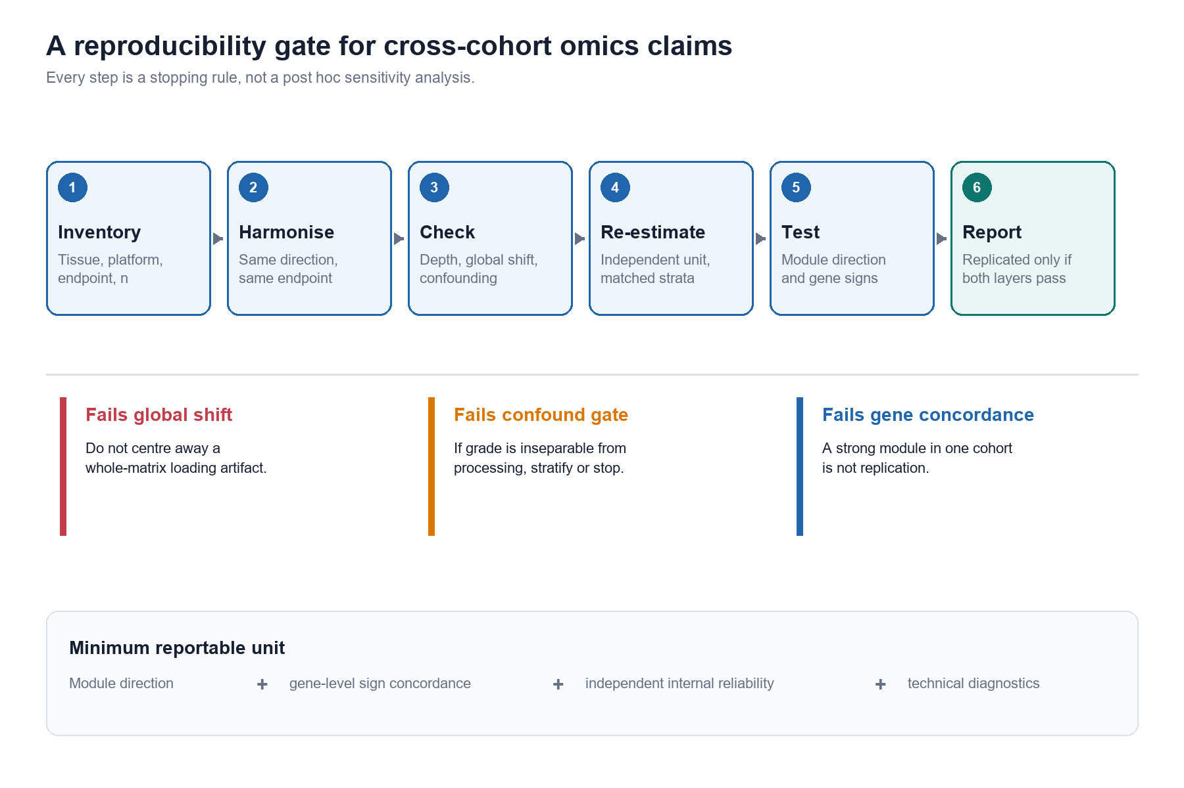
Figure 1.
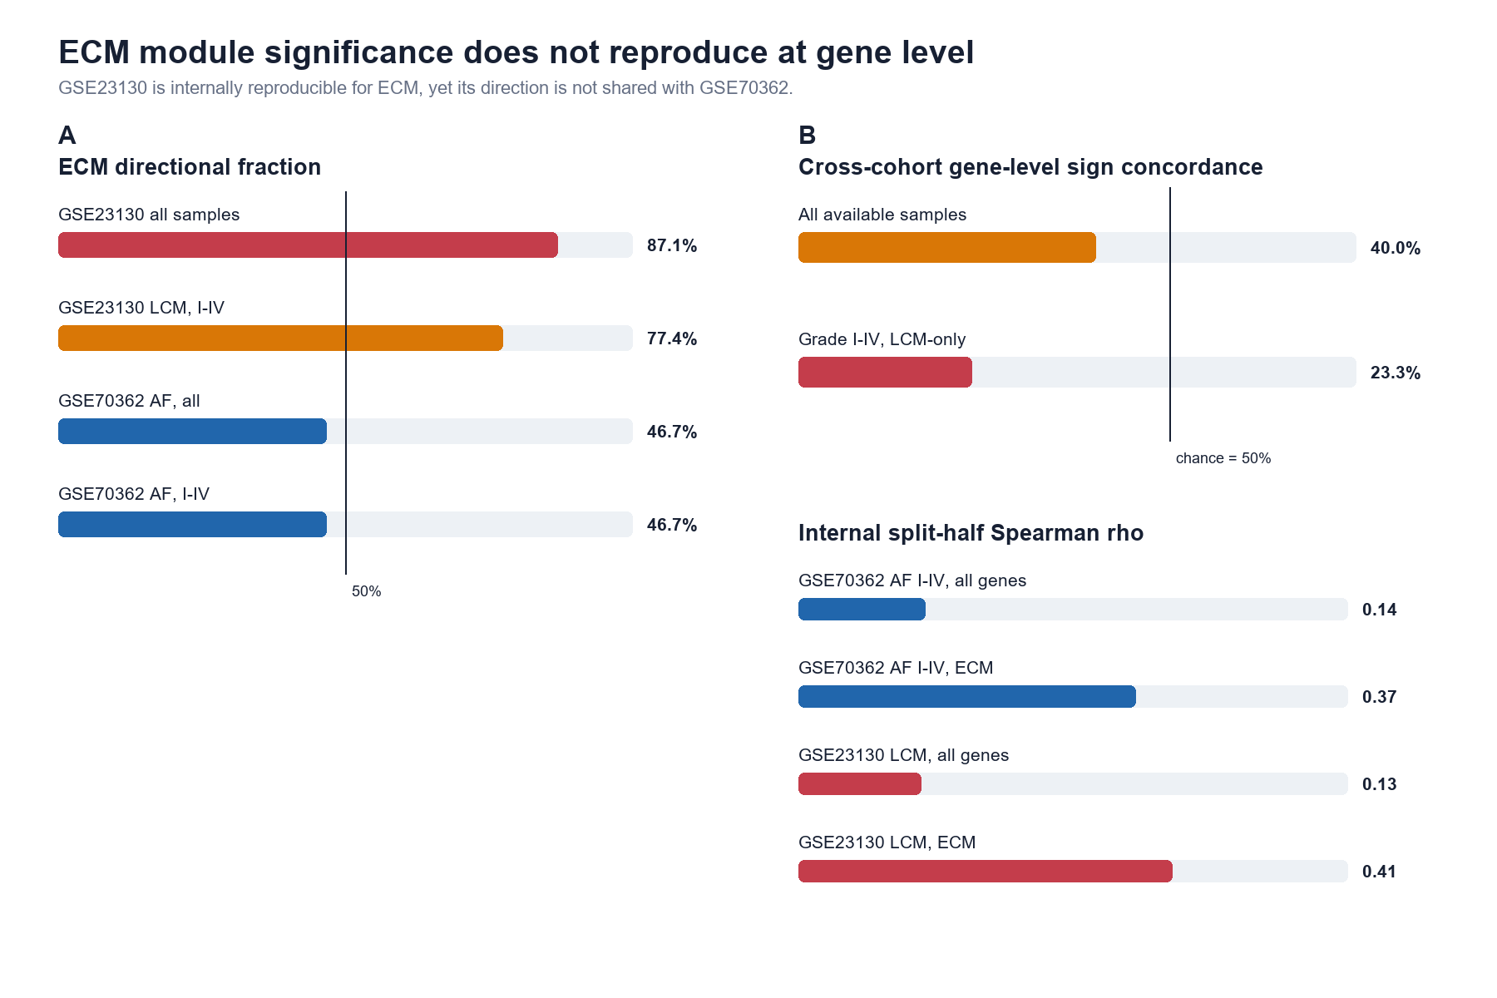
Figure 2.
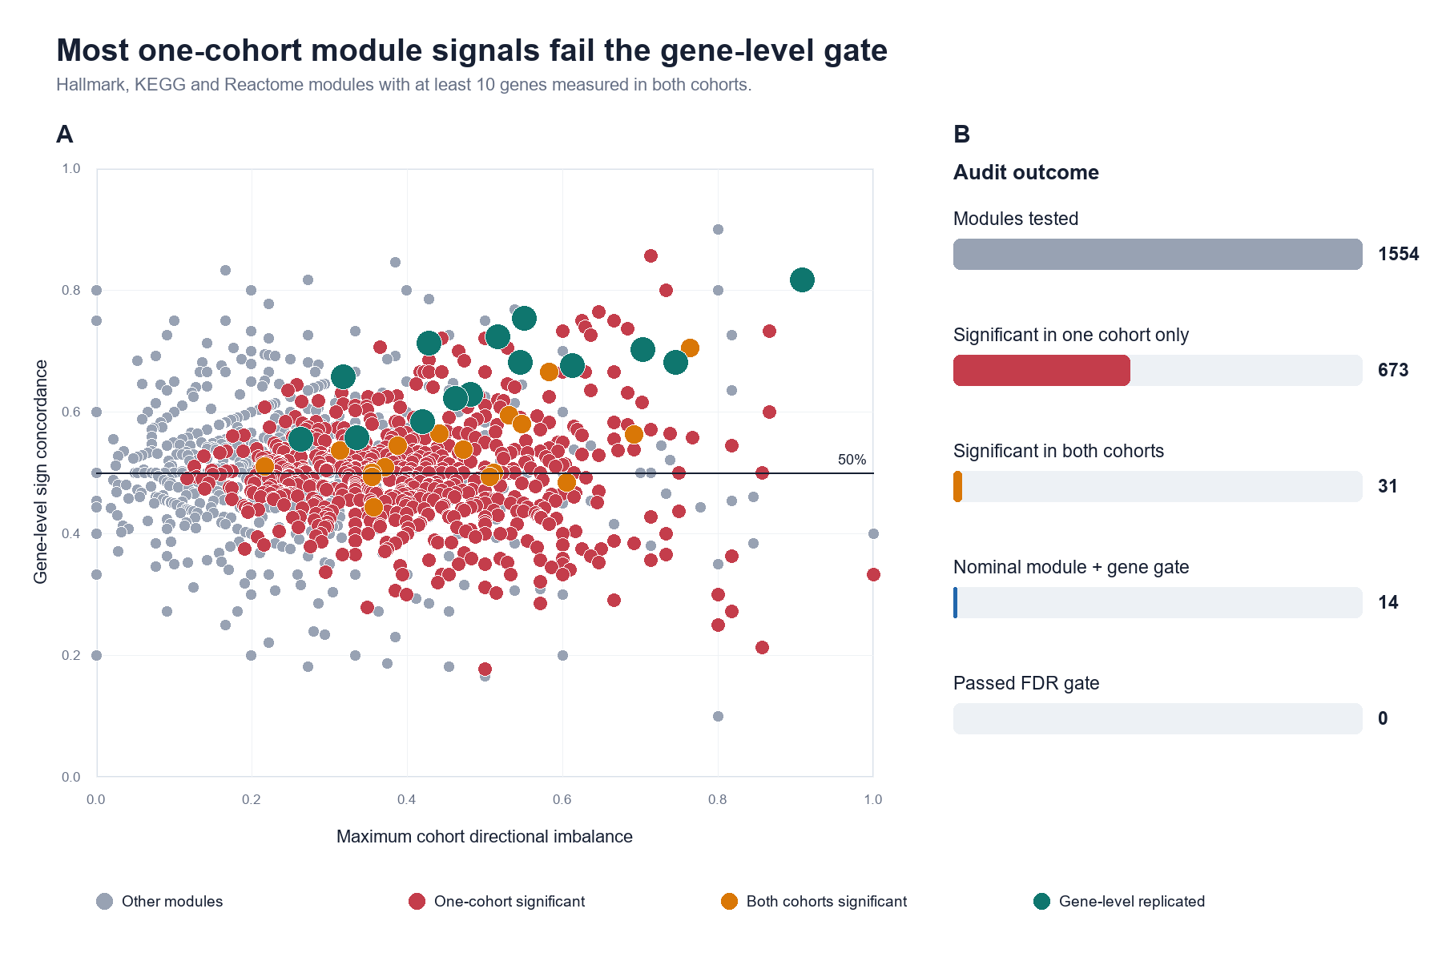
Figure 3.
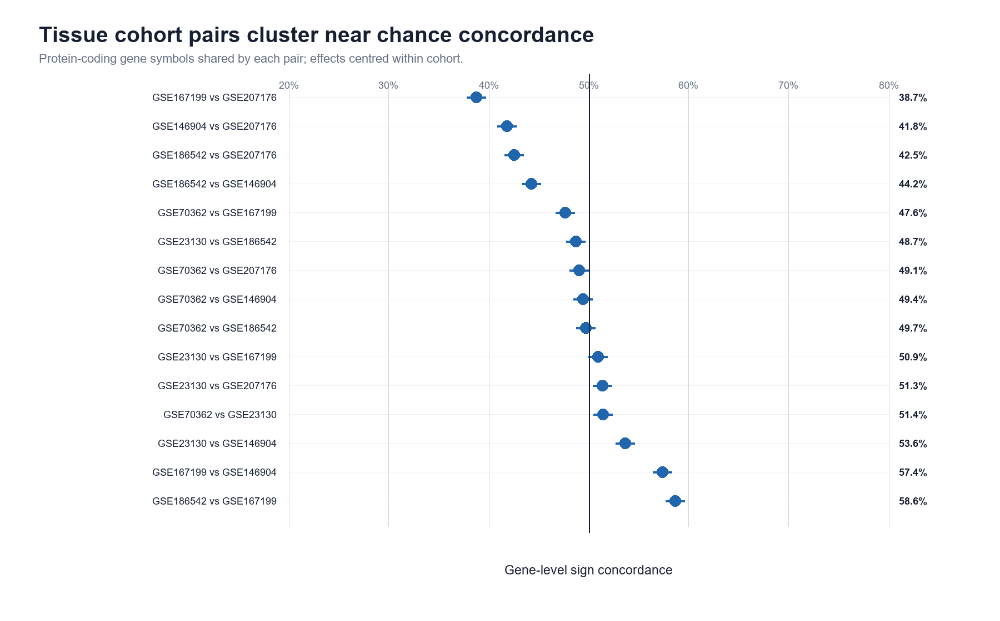
Figure 4.
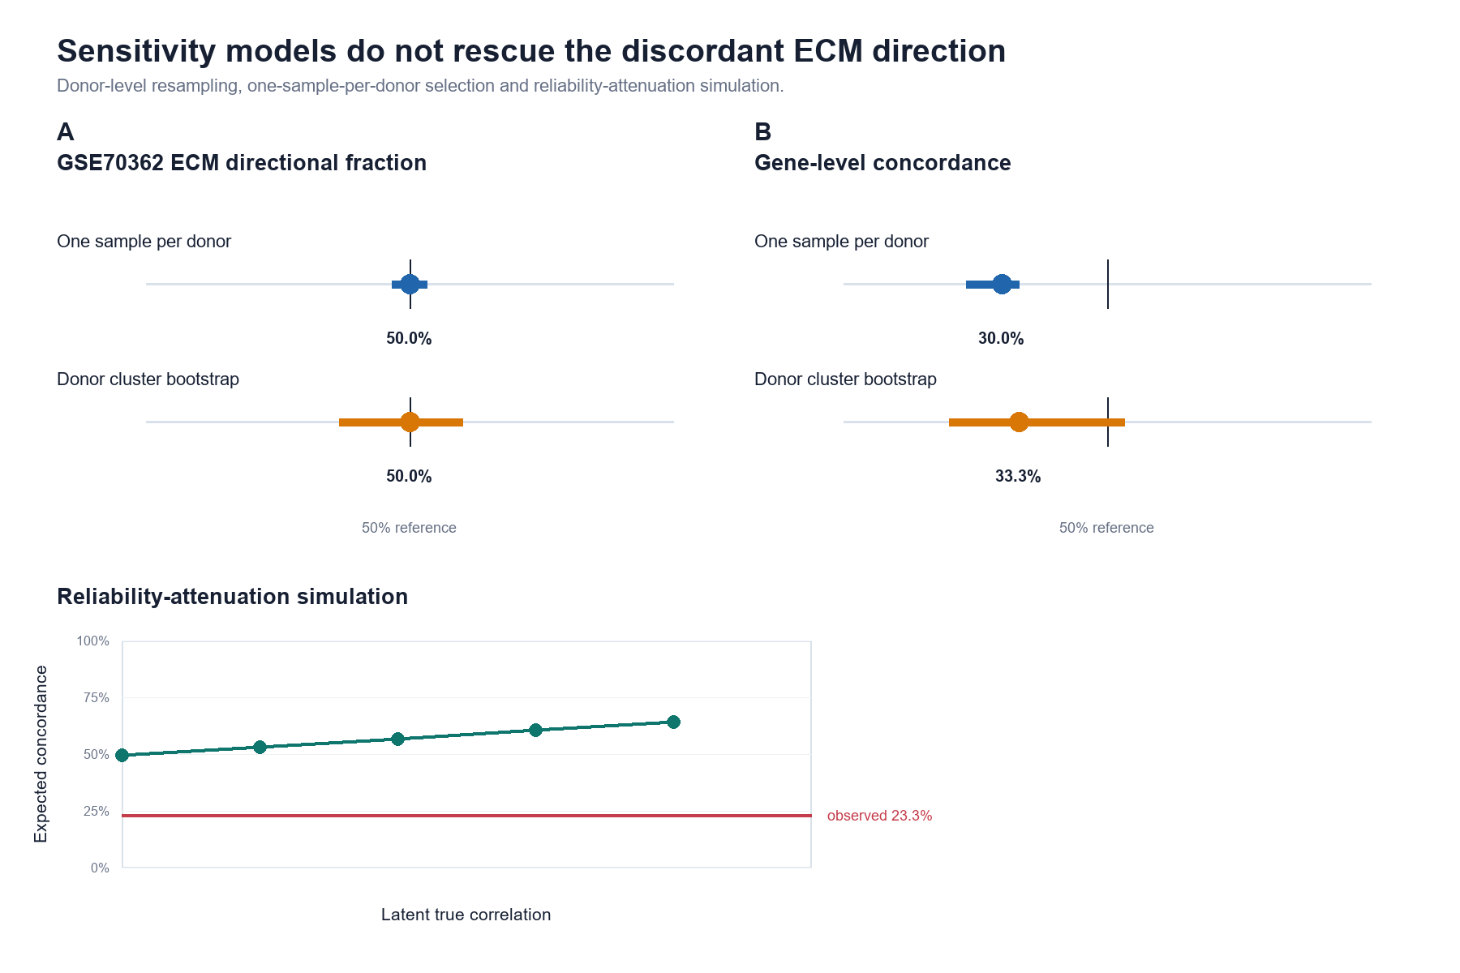
Figure 5.

References
1. Oberoi RK, Gurung D, Harris LK. Cross-Omic Comparative Analysis Identifies Transcriptomic Signatures and Exploratory Gene Set-Level Signals in Sporadic Creutzfeldt-Jakob Disease. International Journal of Molecular Sciences. 2026;27:6560. doi:10.3390/ijms27156560
2. Yasar S, Yagin B, Alzakari SA, et al. Evaluating a Glioma Transcriptomic Signature Against a Clinical Reference Model and a Random-Signature Null Distribution: A Leakage-Controlled Internal Audit and a Survey of the Field. Diagnostics. 2026;16:2803. doi:10.3390/diagnostics16172803
3. Ioannidis JPA. Why most published research findings are false. PLoS Medicine. 2005;2:e124. doi:10.1371/journal.pmed.0020124
4. Errington TM, et al. Investigating the replicability of preclinical cancer biology. eLife. 2021;10:e71601. doi:10.7554/eLife.71601
5. Open Science Collaboration. Estimating the reproducibility of psychological science. Science. 2015;349:aac4716. doi:10.1126/science.aac4716
6. Yu D, Li C, Yan S, et al. Comparative evaluation of gene selection approaches in transcriptomics: bias correction and visualization with TransPro. GigaScience. 2026;15:giag057. doi:10.1093/gigascience/giag057
7. Barrett T, et al. NCBI GEO: archive for functional genomics data sets: update. Nucleic Acids Research. 2013;41:D991-D995. doi:10.1093/nar/gks1193
8. Kazezian Z, Gawri R, Haglund L, et al. Gene Expression Profiling Identifies Interferon Signalling Molecules and IGFBP3 in Human Degenerative Annulus Fibrosus. Scientific Reports. 2015;5:15662. doi:10.1038/srep15662
9. Gruber HE, Hoelscher GL, Ingram JA, Hanley EN. Genome-wide analysis of pain-, nerve- and neurotrophin-related gene expression in the degenerating human annulus. Molecular Pain. 2012;8:63. doi:10.1186/1744-8069-8-63
10. Li Z, Sun Y, He M, Liu J. Differentially-expressed mRNAs, microRNAs and long noncoding RNAs in intervertebral disc degeneration identified by RNA-sequencing. Bioengineered. 2021;12:1026-1039. doi:10.1080/21655979.2021.1899533
11. Ritchie ME, et al. limma powers differential expression analyses for RNA-sequencing and microarray studies. Nucleic Acids Research. 2015;43:e47. doi:10.1093/nar/gkv007
12. Subramanian A, et al. Gene set enrichment analysis: a knowledge-based approach for interpreting genome-wide expression profiles. PNAS. 2005;102:15545-15550. doi:10.1073/pnas.0506580102
13. Benjamini Y, Hochberg Y. Controlling the false discovery rate: a practical and powerful approach to multiple testing. Journal of the Royal Statistical Society Series B. 1995;57:289-300. doi:10.1111/j.2517-6161.1995.tb02031.x
14. Freedman D, Lane D. A nonstochastic interpretation of reported significance levels. Journal of Business & Economic Statistics. 1983;1:292-298. doi:10.1080/07350015.1983.10509354
15. Leek JT, et al. The sva package for removing batch effects and other unwanted variation in high-throughput experiments. Bioinformatics. 2012;28:882-883. doi:10.1093/bioinformatics/bts034
16. Johnson WE, Li C, Rabinovic A. Adjusting batch effects in microarray expression data using empirical Bayes methods. Biostatistics. 2007;8:118-127. doi:10.1093/biostatistics/kxj037
17. Li J, Ji L. Adjusting multiple testing in multilocus analyses using the eigenvalues of a correlation matrix. Heredity. 2005;95:221-227. doi:10.1038/sj.hdy.6800717
18. MAQC Consortium. The MicroArray Quality Control (MAQC) project shows inter- and intraplatform reproducibility of gene expression measurements. Nature Biotechnology. 2006;24:1151-1161. doi:10.1038/nbt1239
19. Venet D, Dumont JE, Detours V. Most random gene expression signatures are significantly associated with breast cancer outcome. PLoS Computational Biology. 2011;7:e1002240. doi:10.1371/journal.pcbi.1002240
20. von Elm E, Altman DG, Egger M, et al. The Strengthening the Reporting of Observational Studies in Epidemiology (STROBE) statement: guidelines for reporting observational studies. Lancet. 2007;370:1453-1457. doi:10.1016/S0140-6736(07)61602-X
21. Wilkinson MD, Dumontier M, Aalbersberg IJ, et al. The FAIR Guiding Principles for scientific data management and stewardship. Scientific Data. 2016;3:160018. doi:10.1038/sdata.2016.18
22. Qin C, Wang W, Du Q, et al. An 11-gene blood transcriptomic signature reflects a sepsis-associated host-response pattern across public cohorts. Frontiers in Medicine. 2026;13:1844619. doi:10.3389/fmed.2026.1844619
23. Yang X, Hu T, Wang J, et al. An NLRP3 inflammasome-anchored Astragalus mechanistic prior yields a mortality-associated transcriptomic signal in ICU sepsis: a secondary analysis with exploratory cross-cohort assessment. Inflammation Research. 2026;75:201. doi:10.1007/s00011-026-02352-0
24. Li Q, Liang G, Bo K, et al. Single-cell and spatial transcriptomics characterisation of RSPO2+ nucleus pulposus cells reveals a WNT/FN1-CD44 degenerative axis and therapeutic targets in IVDD. Journal of Orthopaedic Translation. 2026;60:101203. doi:10.1016/j.jot.2026.101203
25. Qiang S, Liu Y, Dong Y, et al. ITGBL1 and RPN1 Mark a Fibrotic NP Subpopulation with Coupled Integrin Signaling and N-Glycosylation Programs in IVDD. Journal of Inflammation Research. 2026;19. doi:10.2147/JIR.S629922
26. Sun L, Ma L, Chen L, et al. Annotation of cell types in single-cell sequencing for cardiovascular disease: concepts, workflows, challenges, and best practices. International Journal of Biochemistry and Cell Biology. 2026;201:107027. doi:10.1016/j.biocel.2026.107027
27. Marchi A, Anwer D, Kerkhoven E, et al. Cell-Type-Resolved Pseudobulk Classification Across Independent Cohorts Identifies Microglial PTPRG as a Transcriptional Hub in Alzheimer's Disease. bioRxiv. 2026. Preprint. doi:10.64898/2026.04.07.717029
28. Dörpholz H, Simon R, Usadel B, Kranz A. Integrating cross-omics research through FAIR Digital Objects with DataPLANT. Journal of Integrative Bioinformatics. 2025;22(4):20250056. doi:10.1515/jib-2025-0056
29. Chatterjee B, Gorga K, Blair C, et al. Moderated designs can balance between batch-effect mitigation and cell loss due to hashtag-assisted pooling in single-cell experiments. Genome Research. 2026;36:2027-2036. doi:10.1101/gr.281624.125

