William Dubbs

ECE 2310.01

Dr. Mei Klein

9/6/20

Homework 1 Question 1

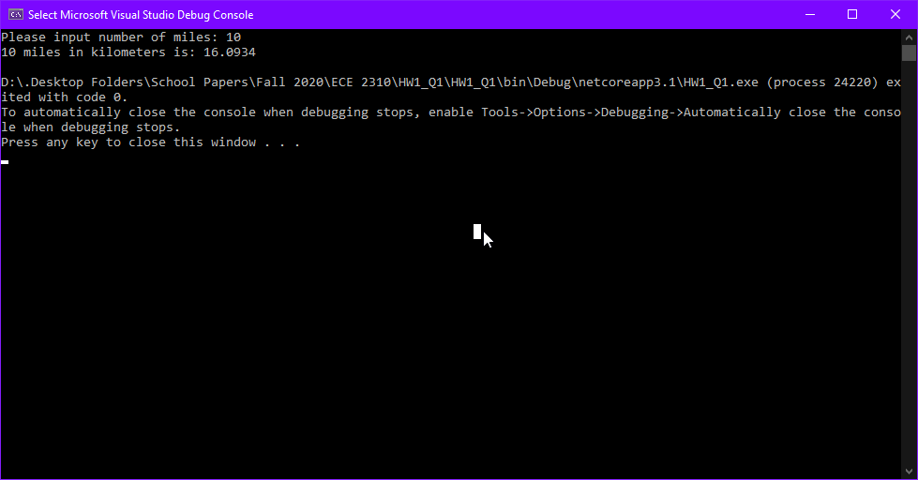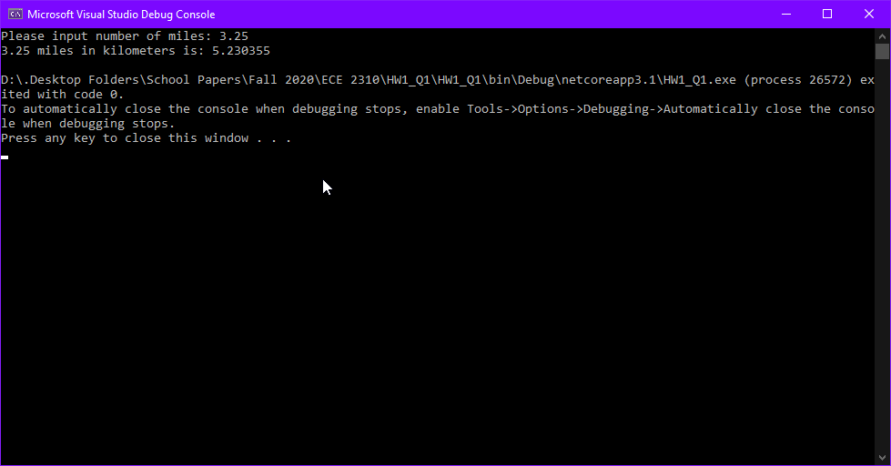

using System;

namespace HW1_Q1

{

class Program

{

static void Main(string[] args)

{

Console.Write("Please input number of miles: ");

double mi = Convert.ToDouble(Console.ReadLine());

double km = mi * 1.60934;

Console.WriteLine($"{mi} miles in kilometers is: {km}");

}

}

}