William Dubbs

ECE 2310.01

Dr. Mei Klein

9/6/20

Homework 1 Question 2

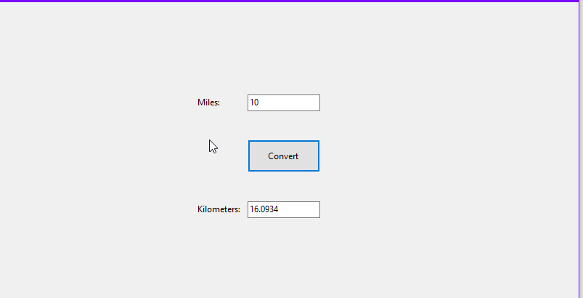

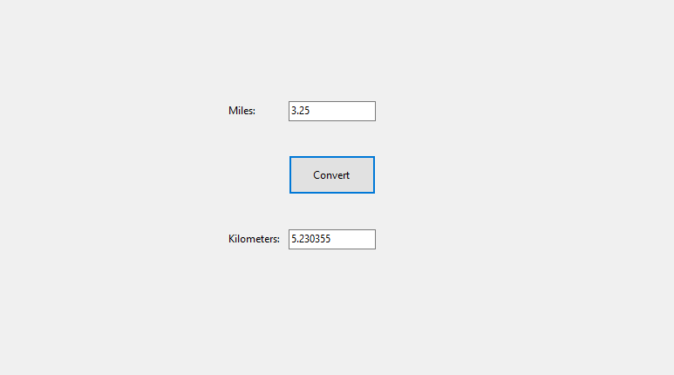

‘

using System;

using System.Collections.Generic;

using System.ComponentModel;

using System.Data;

using System.Drawing;

using System.Linq;

using System.Text;

using System.Threading.Tasks;

using System.Windows.Forms;

namespace HW1_Q2

{

public partial class Form1 : Form

{

public Form1()

{

InitializeComponent();

}

private void button1_Click(object sender, EventArgs e)

{

double mi = Convert.ToDouble(textBox1.Text);

double km = mi * 1.60934;

textBox2.Text = Convert.ToString(km);

}

}

}