William Dubbs

ECE 2310.01

Dr. Mei Klein

9/6/20

Homework 1 Question 3

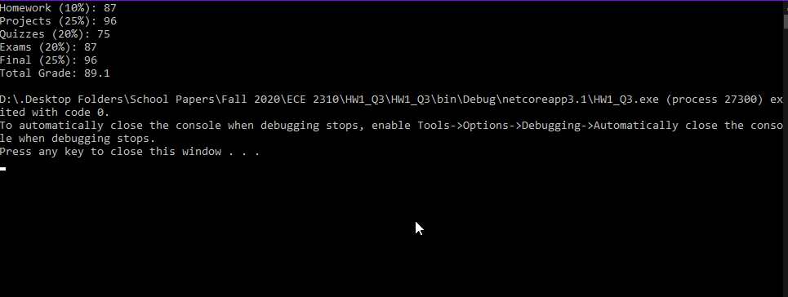

using System;

namespace HW1_Q3

{

class Program

{

static void Main(string[] args)

{

Console.Write("Homework (10%): ");

double HW = Convert.ToDouble(Console.ReadLine());

Console.Write("Projects (25%): ");

double Proj = Convert.ToDouble(Console.ReadLine());

Console.Write("Quizzes (20%): ");

double Quiz = Convert.ToDouble(Console.ReadLine());

Console.Write("Exams (20%): ");

double Exam= Convert.ToDouble(Console.ReadLine());

Console.Write("Final (25%): ");

double Final = Convert.ToDouble(Console.ReadLine());

double total = Math.Round( HW * .1 + Proj * .25 + Quiz * .2 + Exam * .2 + Final * .25,2);

Console.WriteLine("Total Grade: {0}", total);

}

}

}