William Dubbs

ECE 2310.01

Dr. Mei Klein

9/6/20

Homework 2 Question 1

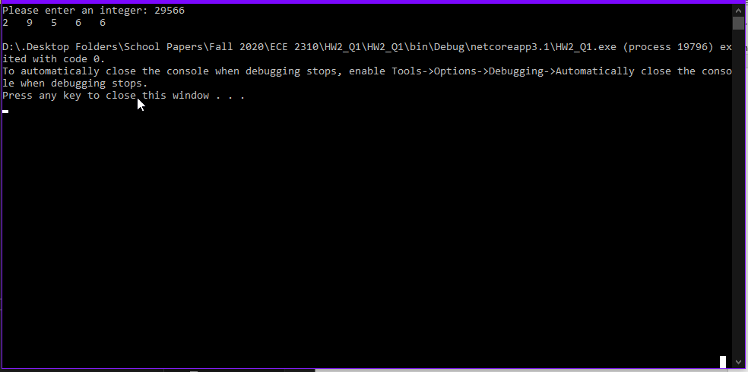

using System;

namespace HW2_Q1

{

class Program

{

static void Main(string[] args)

{

Console.Write("Please enter an integer: ");

int num = Convert.ToInt32(Console.ReadLine());

String N = "";

bool negative = false;

if (num < 0)

{

negative = true;

num *= -1;

}

while (num > 0)

{

N = Convert.ToString(num % 10) + " " + N;

num /= 10;

}

if (negative)

{

N = "- " + N;

}

Console.WriteLine(N);

}

}

}