William Dubbs

ECE 2310.01

Dr. Mei Klein

9/6/20

Homework 2 Question 2

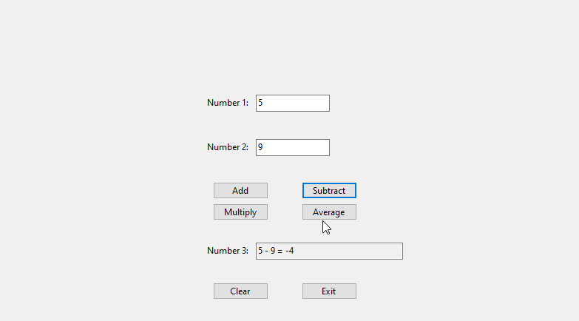

using System;

using System.Collections.Generic;

using System.ComponentModel;

using System.Data;

using System.Drawing;

using System.Linq;

using System.Text;

using System.Threading.Tasks;

using System.Windows.Forms;

namespace HW2_Q2

{

public partial class Form1 : Form

{

public Form1()

{

InitializeComponent();

textBox3.ReadOnly = true;

}

private void button1_Click(object sender, EventArgs e) //add

{

double num1 = Convert.ToDouble(textBox1.Text);

double num2 = Convert.ToDouble(textBox2.Text);

double sum = num1 + num2;

textBox3.Text = $"{num1} + {num2} = {sum}";

}

private void button2_Click(object sender, EventArgs e) //subtract

{

double num1 = Convert.ToDouble(textBox1.Text);

double num2 = Convert.ToDouble(textBox2.Text);

double sum = num1 - num2;

textBox3.Text = $"{num1} - {num2} = {sum}";

}

private void button3_Click(object sender, EventArgs e) //multiply

{

double num1 = Convert.ToDouble(textBox1.Text);

double num2 = Convert.ToDouble(textBox2.Text);

double sum = num1 * num2;

textBox3.Text = $"{num1} * {num2} = {sum}";

}

private void button4_Click(object sender, EventArgs e) //average

{

double num1 = Convert.ToDouble(textBox1.Text);

double num2 = Convert.ToDouble(textBox2.Text);

double sum = (num1 + num2)/2;

textBox3.Text = $"average of {num1} & {num2} is: {sum}";

}

private void button5_Click(object sender, EventArgs e) //clear

{

textBox1.Text = "";

textBox2.Text = "";

textBox3.Text = "";

}

private void button6_Click(object sender, EventArgs e) //exit

{

Application.Exit();

}

}

}