William Dubbs

ECE 2310.01

Dr. Mei Klein

9/20/20

Homework 3 Question 1

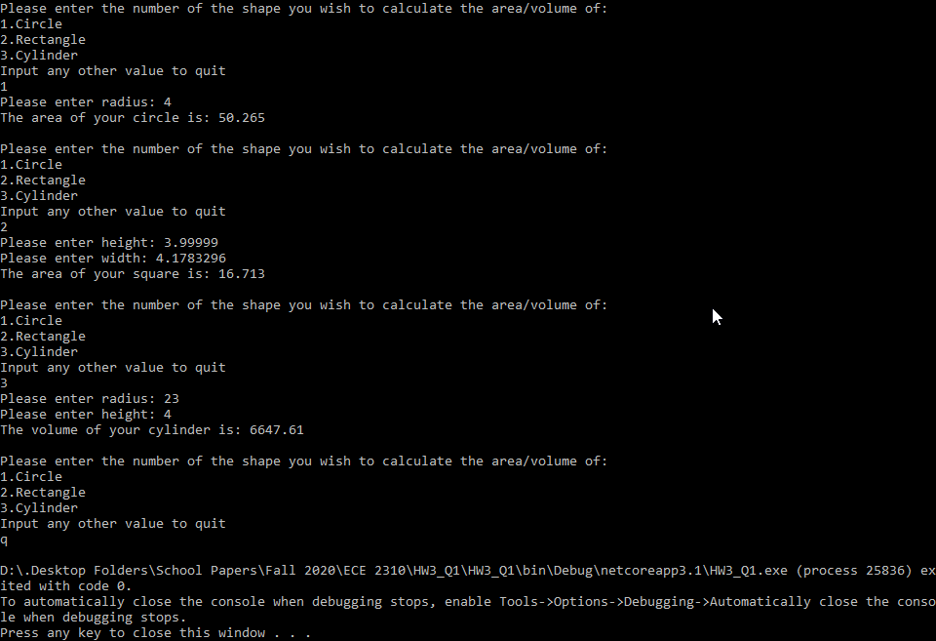

using System;

namespace HW3_Q1

{

class Program

{

static void Main(string[] args)

{

int selection = 1;

while (!(selection > 3) && !(selection < 1))

{

Console.WriteLine("Please enter the number of the shape you wish to calculate the area/volume of: \n1.Circle\n2.Rectangle\n3.Cylinder\nInput any other value to quit");

if(!Int32.TryParse(Console.ReadLine(),out selection))

{

selection = 0;

}

if (selection == 1)

{

Console.Write("Please enter radius: ");

Double radius = Convert.ToDouble(Console.ReadLine());

Console.WriteLine("The area of your circle is: " + Math.Round(Math.PI * Math.Pow(radius,2),3) + "\n");

}

else if (selection == 2)

{

Console.Write("Please enter height: ");

Double height = Convert.ToDouble(Console.ReadLine());

Console.Write("Please enter width: ");

Double width = Convert.ToDouble(Console.ReadLine());

Console.WriteLine("The area of your square is: " + Math.Round(height*width,3) + "\n");

}

else if (selection == 3)

{

Console.Write("Please enter radius: ");

Double radius = Convert.ToDouble(Console.ReadLine());

Console.Write("Please enter height: ");

Double height = Convert.ToDouble(Console.ReadLine());

Console.WriteLine("The volume of your cylinder is: " + Math.Round(Math.PI * Math.Pow(radius, 2)*height,3) +"\n");

}

}

}

}

}