William Dubbs

ECE 2310.01

Dr. Mei Klein

9/20/20

Homework 3 Question 2

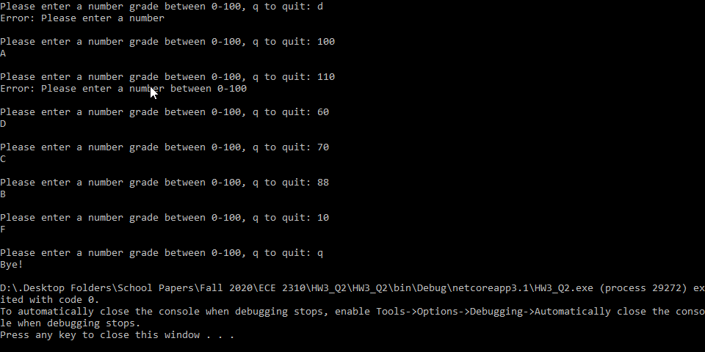

using System;

namespace HW3_Q2

{

class Program

{

static void Main(string[] args)

{

string input = "";

while (input != "q")

{

Console.Write("Please enter a number grade between 0-100, q to quit: ");

input = Console.ReadLine();

if (input == "q")

{

Console.WriteLine("Bye!");

}

else if(!Double.TryParse(input,out double num))

{

Console.WriteLine("Error: Please enter a number\n");

}

else if (num < 0 || num > 100)

{

Console.WriteLine("Error: Please enter a number between 0-100\n");

}

else

{

int n = (int)num;

n /= 10;

char grade;

switch (n)

{

case 10:

case 9:

grade = 'A';

break;

case 8:

grade = 'B';

break;

case 7:

grade = 'C';

break;

case 6:

grade = 'D';

break;

default:

grade = 'F';

break;

}

Console.WriteLine(grade+"\n");

}

}

}

}

}