William Dubbs

ECE 2310.01

Dr. Mei Klein

9/20/20

Homework 3 Question 3

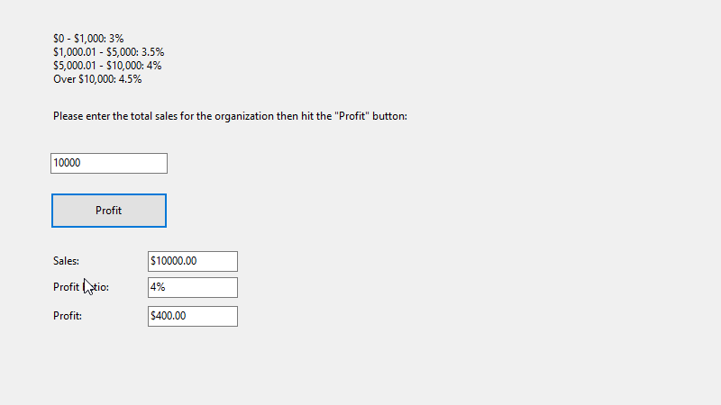

using System;

using System.Collections.Generic;

using System.ComponentModel;

using System.Data;

using System.Drawing;

using System.Linq;

using System.Text;

using System.Threading.Tasks;

using System.Windows.Forms;

namespace HW3_Q3

{

public partial class Form1 : Form

{

public Form1()

{

InitializeComponent();

}

private void button1_Click(object sender, EventArgs e)

{

double sale = Convert.ToDouble(saleIn.Text);

sales.Text = String.Format("${0:0.00}", sale);

double profitRate = .045;

if (sale < 1000.01)

{

profitRate = .03;

}

else if (sale < 5000.01)

{

profitRate = .035;

}

else if (sale < 10000.01)

{

profitRate = .04;

}

Ratio.Text = Convert.ToString(Math.Round(profitRate * 100,1)) + "%";

Profit.Text = String.Format("${0:0.00}", profitRate*sale);

}

}

}