Gemini Enterprise Admin Migration Platform
Installation, Environment Setup & Pre-Requisites Technical Guide
Document Version | v1.6.1 (Enterprise Release)
Classification | Google Cloud Enterprise / Administrative
Target Platform | Google Cloud Discovery Engine & Gemini Enterprise
Execution Profile | Headless CLI & Local Workstation Web Console (127.0.0.1:8080)
Auth Protocols | Google Workspace DWD (OAuth2) & Microsoft Entra ID WiF (STS)

1. Overview & Security Architecture
The Gemini Enterprise Admin Migration Platform (gemini-migrate) is a purpose-built, high-throughput enterprise migration solution designed to transfer Gemini Enterprise and Google Cloud Discovery Engine assets across Google Cloud projects, geographic regions, and Identity Providers on behalf of enterprise end users.
The platform migrates Research Notebooks, Granular Grounding Sources (PDFs, Web URLs, YouTube videos, Google Drive docs), Custom Agents (Low-Code and Workflow agents with dynamic _##### Connector Auto-Mapping & HITL validation), User-Created Skills in Agent Registry (Experimental — may not work for everyone), Multi-Turn Chat History, User Personalized Memories & Facts (Experimental — may not work for everyone), Studio Artifacts (Presentations, Infographics, Videos, Interactive Quizzes, and Flashcards), and Gemini Enterprise Projects (WIP).
🚨 CRITICAL: Workstation-Local Security Isolation Model
To satisfy strict enterprise security and InfoSec audit requirements, the migration tool operates entirely within the administrator workstation boundary. No user data, prompt history, or private keys are transmitted to any third-party SaaS servers. All network calls are strictly restricted to official Google Cloud APIs.
- Localhost-Only Network Binding: The Web Console binds exclusively to 127.0.0.1 (localhost), eliminating exposure to external network interfaces.
- SSRF Allowlist Protection: Outbound requests from the proxy layer are cryptographically constrained to official Google API hostnames (discoveryengine.googleapis.com, agentregistry.googleapis.com, gmail.googleapis.com, sts.googleapis.com, secretmanager.googleapis.com).
- Private Key Isolation: Service Account private keys (sa-dwd-key.json) and RSA keys (wif-migration-key.pem) remain securely on local disk and are never sent over the wire.
- Header-Only Token Injection: Authentication credentials are transmitted strictly within HTTP Authorization: Bearer headers, preventing URL logging in intermediate proxies.
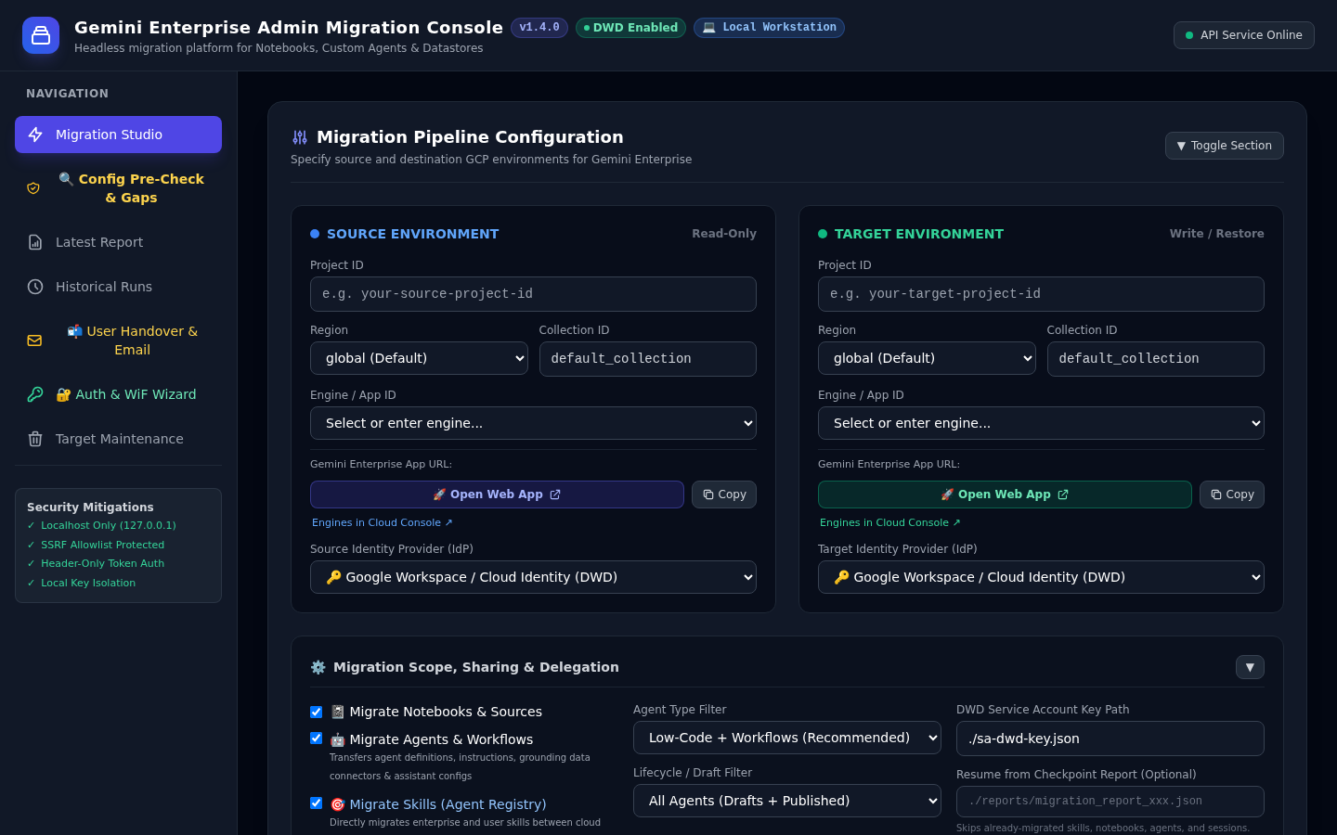
Figure 1.1: Local Administration Console running on Workstation (http://127.0.0.1:8080)

2. System & Workstation Prerequisites
Before deploying the migration tool, verify that the administrator workstation satisfies the minimum software dependencies:
Component | Minimum Version | Recommended Version | Purpose / Description
Node.js | v20.0.0 (LTS) | v22.x or v20.18+ (LTS) | Asynchronous runtime executing CLI pipeline and local Express server
npm | v10.0.0 | v10.8+ | Package manager for installing dependencies
Google Cloud SDK | v480.0.0 | Latest (gcloud components update) | CLI used for GCP authentication, IAM role binding, and ADC
Operating System | Linux / macOS / Windows WSL2 | Ubuntu 22.04 LTS / Debian 12 / macOS Sonoma | Host platform supported across Linux, macOS, and WSL2
ffmpeg (Optional) | v4.4+ | v6.0+ (apt install ffmpeg) | Enables automated compression of high-bitrate Explainer Videos (> 12 MB)

Verify your local workstation installation using the following terminal commands:
node --version # Expected: v20.0.0 or higher
npm --version # Expected: v10.0.0 or higher
gcloud --version # Expected: Google Cloud SDK 480.0.0 or higher
ffmpeg -version # Optional: Verifies video compression availability

3. Google Cloud Project Pre-Requisites & API Enablement
The migration platform interacts with Google Cloud Discovery Engine, Identity and Access Management, Google Agent Registry, and Gmail APIs. You must enable the following APIs in both the Source GCP Project and the Target GCP Project prior to migration.
API Service Name | Endpoint Identifier | Required On | Functional Purpose
Discovery Engine API | discoveryengine.googleapis.com | Source & Target | Read/write access to engines, collections, notebooks, custom agents, and sessions
Agent Registry API | agentregistry.googleapis.com | Source & Target | Discovers and migrates enterprise skills created by end users
Service Usage API | serviceusage.googleapis.com | Source & Target | Verifies consumer project quotas and passes infrastructure pre-flight checks
IAM Service Account API | iam.googleapis.com | Target Project | Required for Service Account token minting and DWD impersonation
Security Token Service | sts.googleapis.com | Source & Target | Required for Workforce Identity Federation (WiF) OIDC token exchanges
Gmail API (Optional) | gmail.googleapis.com | Target Project | Required for dispatching user handover notification emails with attached study guides
Secret Manager API | secretmanager.googleapis.com | Target Project | Optional for secure enterprise storage of Service Account keys

Run the following gcloud command to enable the APIs on both environments:
# Enable APIs on Source Project
gcloud services enable discoveryengine.googleapis.com \
agentregistry.googleapis.com \
serviceusage.googleapis.com \
sts.googleapis.com \
--project=<SOURCE_PROJECT_ID>
# Enable APIs on Target Project
gcloud services enable discoveryengine.googleapis.com \
agentregistry.googleapis.com \
serviceusage.googleapis.com \
iam.googleapis.com \
sts.googleapis.com \
gmail.googleapis.com \
secretmanager.googleapis.com \
--project=<TARGET_PROJECT_ID>

4. IAM Roles & Security Permissions Matrix
The migration administrator or execution identity requires distinct read and write privileges across the source and target environments to uphold the principle of least privilege.
Environment | Role Name / Identifier | Role Type | Justification / Purpose
Source Project | roles/discoveryengine.viewer | Predefined Role | Read-only discovery of custom agents, notebooks, datastores, and chat turns
Source Project | roles/serviceusage.serviceUsageConsumer | Predefined Role | Authorizes Discovery Engine API consumption checks on source project
Source Project | roles/iam.securityReviewer | Predefined Role | Allows enumerating project IAM bindings (resourcemanager.projects.getIamPolicy) during User Discovery
Target Project | roles/discoveryengine.admin | Predefined Role | Creation and configuration of target engines, datastores, agents, and notebooks
Target Project | roles/iam.serviceAccountTokenCreator | Predefined Role | Allows minting user-scoped impersonation tokens via Domain-Wide Delegation
Target Project | roles/serviceusage.serviceUsageConsumer | Predefined Role | Authorizes Discovery Engine API consumption checks on target project

💡 TIP: Resolution of 403 serviceusage.serviceUsageConsumer Errors
Granting roles/serviceusage.serviceUsageConsumer and roles/iam.securityReviewer on the Source Project is mandatory. Administrative pre-flight checks and project IAM discovery are isolated to the configured Service Account key, ensuring that user-scoped WiF tokens are never erroneously used for administrative engine validation.

4.1 Google Cloud Organization Policies & Security Constraints
Enterprise Google Cloud landing zones frequently enforce organizational constraints at the Organization or Folder hierarchy level. Before provisioning credentials, evaluate the following policies:
Organization Policy Constraint | Target Requirement | Impact on Migration Tool | Remediation / Alternative
constraints/iam.disableServiceAccountKeyCreation | Key creation permitted on target project | Blocks Pattern A Step 3: Prevents generating sa-dwd-key.json | Use 1-Click project override in Auth Wizard, or adopt Pattern B (WiF) which is keyless and exempt.
constraints/iam.disableCrossProjectServiceAccountUsage | Target SA created within target project | Blocks Cross-Project DWD: A service account from source project cannot access target Discovery Engine | Create and bind gemini-dwd-migrator directly within the Target GCP Project.
constraints/iam.allowedPolicyMemberDomains | Workforce & user domains allowed in IAM | Restricts Cross-Domain Sharing: Agent/Skill IAM sync fails if users belong to unauthorized domains | Map source identities to target domain via identityMapping, or verify workforce pool principalSet is permitted.
constraints/discoveryengine.managed.allowedDataSources | Connectors permitted | Restricts data store attachment | Ensure required data sources (e.g. custom_mcp, Drive, GCS) are permitted by policy.
constraints/storage.uniformBucketLevelAccess | Uniform bucket-level access | Enforces bucket IAM over object ACLs | The migration tool defaults to standard IAM bucket permissions; avoid object-level ACLs.

Live Organization Policy Inspection & 1-Click Remediation
The web console provides built-in pre-flight inspection in the Auth & WiF Wizard (http://127.0.0.1:8080):
1. Navigate to Auth & WiF Wizard -> Domain-Wide Delegation (DWD).
2. Enter your Target GCP Project ID and click Check Org Policies.
3. If iam.disableServiceAccountKeyCreation is active, click 1-Click Project Override to apply a project-scoped exemption without altering the parent organization.

5. Authentication Setup & Credential Provisioning
The migration tool supports three flexible enterprise authentication patterns depending on the Identity Providers in use:

Pattern A: Google Workspace / Cloud Identity via Domain-Wide Delegation (DWD)
Domain-Wide Delegation (DWD) enables the migration tool to restore chat history and personal research notebooks directly into each user's personal Google Workspace library.
1. Create the migration service account in the Target GCP Project:
gcloud iam service-accounts create gemini-dwd-migrator \
--display-name="Gemini Enterprise Migration Service Account" \
--project=<TARGET_PROJECT_ID>
2. Assign required IAM roles to the service account across BOTH Target and Source Projects:
# Grant roles on TARGET Project (Restore & Token Minting)
gcloud projects add-iam-policy-binding <TARGET_PROJECT_ID> \
--member="serviceAccount:gemini-dwd-migrator@<TARGET_PROJECT_ID>.iam.gserviceaccount.com" \
--role="roles/discoveryengine.admin"
gcloud projects add-iam-policy-binding <TARGET_PROJECT_ID> \
--member="serviceAccount:gemini-dwd-migrator@<TARGET_PROJECT_ID>.iam.gserviceaccount.com" \
--role="roles/iam.serviceAccountTokenCreator"
gcloud projects add-iam-policy-binding <TARGET_PROJECT_ID> \
--member="serviceAccount:gemini-dwd-migrator@<TARGET_PROJECT_ID>.iam.gserviceaccount.com" \
--role="roles/serviceusage.serviceUsageConsumer"
# Grant roles on SOURCE Project (MANDATORY for Cross-Project Discovery & Parity Audit)
gcloud projects add-iam-policy-binding <SOURCE_PROJECT_ID> \
--member="serviceAccount:gemini-dwd-migrator@<TARGET_PROJECT_ID>.iam.gserviceaccount.com" \
--role="roles/discoveryengine.admin"
gcloud projects add-iam-policy-binding <SOURCE_PROJECT_ID> \
--member="serviceAccount:gemini-dwd-migrator@<TARGET_PROJECT_ID>.iam.gserviceaccount.com" \
--role="roles/serviceusage.serviceUsageConsumer"
gcloud projects add-iam-policy-binding <SOURCE_PROJECT_ID> \
--member="serviceAccount:gemini-dwd-migrator@<TARGET_PROJECT_ID>.iam.gserviceaccount.com" \
--role="roles/iam.securityReviewer"
3. Export the service account JSON private key:
gcloud iam service-accounts keys create sa-dwd-key.json \
--iam-account="gemini-dwd-migrator@<TARGET_PROJECT_ID>.iam.gserviceaccount.com"
🚨 CRITICAL: Blocked by iam.disableServiceAccountKeyCreation?
If step 3 returns FAILED_PRECONDITION: Key creation is disabled by organization policy, you can: (1) In the web console Auth Wizard, click 1-Click Project Override (requires roles/orgpolicy.policyAdmin), or apply via gcloud org-policies set-policy; or (2) Switch to Pattern B (Workforce Identity Federation), which exchanges tokens with GCP STS dynamically and is 100% exempt from service account key policies.
4. Authorize the Client ID in Google Workspace Admin Console (admin.google.com):
- Sign in to admin.google.com as a Super Administrator.
- Navigate to Security &rarr; Access and data control &rarr; API controls.
- Under Domain-wide delegation, click Manage Domain Wide Delegation &rarr; Add new.
- Enter the OAuth2 Client ID of your service account (found in sa-dwd-key.json as client_id).
- In the OAuth Scopes field, paste the exact comma-delimited scope string:
https://www.googleapis.com/auth/cloud-platform,https://www.googleapis.com/auth/discoveryengine,https://www.googleapis.com/auth/gmail.send,https://www.googleapis.com/auth/userinfo.email
- Click Authorize.

Pattern B: Microsoft Entra ID / Okta via Workforce Identity Federation (WiF)
For organizations authenticating via external Identity Providers (Microsoft Entra ID, Okta, Ping Identity), the platform uses Google Cloud Workforce Identity Federation and Security Token Service (STS).
1. Place your Workforce Identity Federation pool configuration in workforce-identity-config.json.
2. Provide RSA signing keys (wif-migration-key.pem and wif-migration-jwks.json) to sign user subject token assertions.
3. When migrating from Entra ID to Google Cloud Identity, the tool mints WiF STS tokens for source discovery and switches to DWD tokens for target restoration.
💡 TIP: Keyless Architecture & Organization Policy Immunity
Workforce Identity Federation does not require Service Account keys (sa-dwd-key.json). STS token exchanges are entirely immune to iam.disableServiceAccountKeyCreation and iam.disableServiceAccountKeyUpload organization policies.
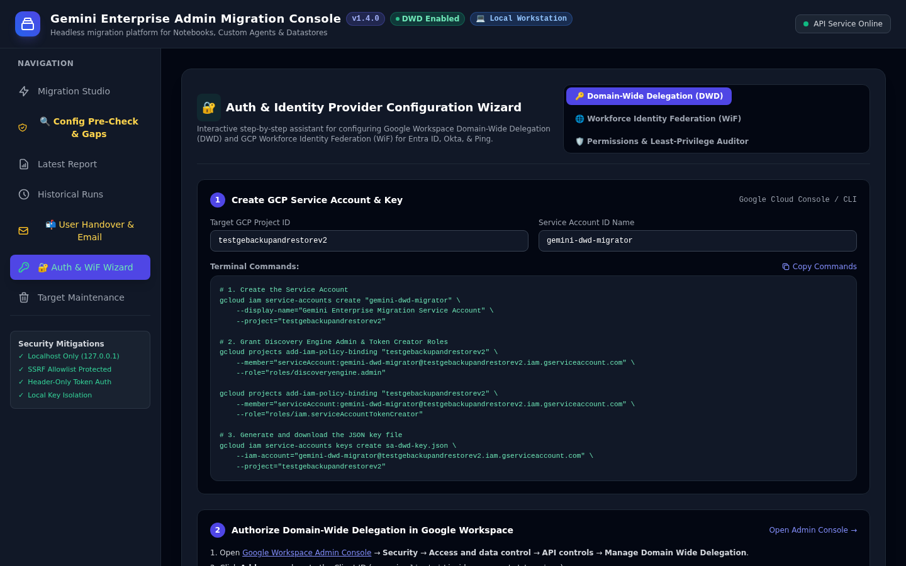
Figure 1.2: Interactive Authentication & Workforce Identity Federation (WiF) Setup Wizard

6. Installation, Local Build & Configuration
Follow these steps to clone, build, and configure the platform on your administrator workstation:
1. Clone the repository:
git clone https://github.com/your-org/gemini-enterprise-admin-migration-tool.git
cd gemini-enterprise-admin-migration-tool
2. Install Node.js dependencies:
npm install
3. Compile TypeScript to JavaScript production artifacts:
npm run build
4. Configure migration-config.json:
Copy config.example.json to migration-config.json and customize your source and target environments:
{
"source": {
"projectId": "source-gcp-project",
"appLocation": "global",
"collectionId": "default_collection",
"appId": "gemini-source-app",
"assistantId": "default_assistant"
},
"target": {
"projectId": "target-gcp-project",
"appLocation": "global",
"collectionId": "default_collection",
"appId": "gemini-target-app",
"assistantId": "default_assistant"
},
"options": {
"dryRun": false,
"migrateNotebooks": true,
"migrateAgents": true,
"migrateSkills": true,
"migrateSessions": true,
"migrateMemories": true,
"exportArtifacts": true,
"userFilter": ["*@company.com"],
"promptForAdminNotebookHitl": false,
"promptForConnectorHitl": true
},
"collectionMapping": {
"github_1773757636775": "github_1780931139999"
},
"auth": {
"authType": "SERVICE_ACCOUNT_KEY",
"serviceAccountKeyPath": "./sa-dwd-key.json"
}
}

7. Launching & Validating the Console
You can run the migration platform either via the interactive Web Console or directly as a headless CLI script:

Option 1: Launch Local Web Console
npm start
# Console listens on: http://127.0.0.1:8080
Open your web browser and navigate to http://127.0.0.1:8080. Verify that the status pill in the top-right reads API Service Online.

Option 2: Headless CLI Execution
# Run full migration in dry-run simulation mode
npx tsx src/cli.ts --config migration-config.json --dry-run
# Run full live migration
npx tsx src/cli.ts --config migration-config.json

Option 3: Run Automated Test Suite
npm test
# Executes 323 automated tests across 26 test suites covering auth, cross-project parity pre-checks, dynamic _##### connector Regex Pattern Matching, HITL validation, export, decommissioning, and rollback validation

Command-Line CLI Flag Reference
Flag | Argument | Description | Default
-c, --config | <path> | Path to JSON migration configuration file | migration-config.json
--dry-run | — | Simulate migration without applying changes to target | false
--no-notebooks | — | Skip notebook and source migration | Enabled
--no-agents | — | Skip custom agent migration | Enabled
--no-sessions | — | Skip chat conversation history migration | Enabled
--no-memories | — | Skip personalized memories and facts migration (Experimental — may not work for everyone) | Enabled (Exp)
--no-skills | — | Skip Agent Registry custom skills migration (Experimental — may not work for everyone) | Enabled (Exp)
--export-memories | — | Export JSON snapshot of user memories to local disk (Experimental) | false
--export-artifacts | — | Export studio presentations, quizzes, and flashcards | false
--agent-types | <types...> | Filter agent migration by type (LOW_CODE, WORKFLOW, ALL) | ALL
--publish-agents | — | Auto-publish migrated agents to organizational gallery | false
--no-preserve-sharing | — | Do not replicate sharing configurations (ALL_USERS/RESTRICTED) | Replicate
--prompt-admin-hitl | — | Pause migration for HITL confirmation when shared Admin notebooks are detected | false
--no-connector-hitl | — | Disable HITL validation prompts when unmapped agent connectors/datastores are detected | Prompts enabled
--users | <users...> | Filter migration to specific user email(s) or patterns | All users
--concurrency | <number> | Maximum parallel worker concurrency | 10
--token | <token> | Explicit Google OAuth Access Token (overrides ADC) | —
--service-account-key | <path> | Path to GCP Service Account JSON key for DWD | —
--output-dir | <dir> | Directory to output migration reports | ./reports
--resume | <reportPath> | Resume migration by skipping already-successful assets | —
--generate-user-reports | — | Generate post-migration handover bundles and checklists | false
--notify-users | [override] | Dispatch bulk handover emails to users (or test override) | —
--no-zip-attachments | — | Disable packaging user artifacts into .zip archive | ZIP enabled
--no-optimize-media | — | Disable automatic media optimization for slide decks | Optimized

8. Troubleshooting & Common Installation Gotchas
Symptom / Error Message | Root Cause | Actionable Resolution
403 Forbidden: Caller does not have required permission to use project | Service Usage API is disabled or caller lacks roles/serviceusage.serviceUsageConsumer | Run gcloud services enable serviceusage.googleapis.com --project=<PROJECT_ID> and grant roles/serviceusage.serviceUsageConsumer to caller.
invalid_grant: Invalid email or User ID | DWD impersonation targeted a user email that does not exist in Google Workspace directory | Verify target user exists in Google Workspace Admin Console (admin.google.com) and DWD scopes are authorized.
ENOENT: idp-subject-token.jwt does not exist | WiF auth selected but subject token file has not been minted or has expired | Generate a fresh subject token using wif-migration-key.pem or switch auth type to ADC / DWD.
EADDRINUSE: address already in use :::8080 | Another process is already bound to port 8080 on the workstation | Launch with custom port: PORT=8085 npm start or terminate the conflicting process (lsof -i :8080).
Puppeteer / Chrome launch failed | Missing Chrome executable on Linux workstation | Install Google Chrome: apt-get install -y google-chrome-stable or use pre-captured artifact assets.

9. Application Decommissioning & Cleanup (Full Teardown)
When migration waves are completed or during environment reset, the tool provides two distinct cleanup mechanisms in Tab 6 (Target Maintenance & Platform Decommission):

Button 1: Reset Target Project Assets (Test Iterations)
Resets migrated assets (notebooks, custom agents, chat history, user memories, reports, and local artifacts) between test iterations without modifying credentials or GCP IAM roles.

Button 2: Clean Up Install & Decommission Migration App (Full Teardown)
Completely uninstalls the migration application and restores both Google Cloud and your local workstation to their pre-setup baseline state:
- Reset Overwritten Org Policies: Resets iam.disableServiceAccountKeyCreation back to inherit from parent organization via gcloud org-policies reset.
- Revoke IAM Roles: Strips roles/discoveryengine.admin, roles/serviceusage.serviceUsageConsumer, and roles/iam.serviceAccountTokenCreator.
- Delete Service Account: Deletes gemini-dwd-migrator in Google Cloud IAM.
- Invalidate DWD: Permanently revokes token creation in Google Cloud IAM; manual console deletion in admin.google.com required due to Google Workspace API boundaries.
- Delete Local Credentials: Removes sa-dwd-key.json, workforce-identity-config.json, .pem, .jwt, and migration-config.json.
- Purge Output Directories: Empties reports/, exports/, and user_handover_reports/.
- Headless CLI Support: Supports "gemini-migrate decommission --project <ID> --confirm <ID> [--wipe-target-assets]".

Automated Rollback State Verification Engine
Provides an automated 7-dimension audit engine verifying that organization policies inherit parent defaults, service accounts are permanently deleted, IAM role bindings are removed, DWD tokens are invalidated, local private keys are deleted, output folders are empty, and state caches are cleared.
- Web Console: Click "Verify Rollback State" in Tab 6 (Card 2).
- Headless CLI: gemini-migrate verify-rollback --project <TARGET_PROJECT_ID>
- REST API: GET /api/maintenance/verify-rollback?targetProject=<PROJECT_ID>

