Gemini Enterprise Admin Migration Platform
Administrator Operations, Asset Restoration, Parity Audit & User Handover Guide
Document Version | v1.7.0 (Enterprise Release)
Classification | Google Cloud Enterprise / Administrative
Target Audience | Cloud Architects, Migration Operators & IT Administrators
Supported Assets | Notebooks, Sources, Custom Agents, Skills (Experimental), Chat Sessions, Memories (Experimental), Artifacts & Projects (WIP)
Handover Formats | Interactive Checklists, Single-ZIP Archives, Office PPTX/DOCX, Offline HTML5

1. Overview & Key Capabilities
The Gemini Enterprise Admin Migration Platform empowers Google Cloud administrators to execute frictionless, zero-data-loss migrations of Gemini Enterprise and Google Cloud Discovery Engine assets between environments.
- Research Notebooks & Granular Grounding Sources: Deep-clones notebooks and re-indexes all grounding sources (PDFs, URLs, YouTube videos, Google Drive docs, and text files) with adaptive source read concurrency (min(concurrency, 3)) and transparent per-source integrity auditing (MANUAL_REUPLOAD_REQUIRED / FAILED reporting with zero fake metadata stubs).
- Custom Agents, Draft Filtering & Dynamic Connector Auto-Mapping: Migrates Low-Code and Workflow agents, preserving system prompts, descriptions, author tags, and grounding DataStore connections as native editable drafts. Supports Ignore Draft Agents (`excludeDraftAgents`) to skip unsaved UI draft placeholders ("My Agent", "My Workflow") and migrate only Private (created/deployed) and Published/Shared agents. Automatically pairs timestamp-suffixed Connector Collections (<connector>_<timestamp>) and child entity DataStores (_issue, _pull_request, _repository) across projects using Regex Pattern Matching (_##### instance matching) to prevent 1-to-3 Connector source multiplication.
- Human-in-the-Loop (HITL) Connector & Notebook Validation: Interactive Step 2 mapping dropdowns and Step 3 runtime HITL modals so operators can verify, remap, or strip (__STRIP__) unmapped agent connectors and selectively filter colleague-shared Admin notebooks.
- User-Created Skills in Agent Registry (`Experimental`): Migrates custom skills from agentregistry.googleapis.com while intelligently ignoring built-in 1P Google templates (Experimental — may not work for everyone).
- Multi-Turn Chat History: Rehydrates conversational histories turn-by-turn into each user's left-hand Gemini Enterprise History sidebar.
- Personalized AI Memories & Facts (`Experimental`): Discovers and exports user preferences, role profiles, and learned memory facts (Experimental — may not work for everyone).
- Studio Artifacts Export (PPTX, DOCX, Video, Interactive Apps): Converts generated presentations into native widescreen PowerPoint (.pptx) decks, briefing docs into formatted Microsoft Word (.docx) files, explainer videos with automated ffmpeg compression, and quizzes/flashcards into 100% offline interactive HTML5 applications.
- Project Migrations (`WIP`): Gemini Enterprise Project workspace migrations (Work in Progress).
- Automated User Handover Delivery Engine: Dispatches personalized email notifications with interactive onboarding checklists (/checklist) and a consolidated NotebookLM_Artifacts.zip archive.

2. Pre-Migration Parity Audit & Gap Remediation (Step 2)
Before executing a migration run, administrators execute a Configuration Pre-Check in Step 2: Config & Parity Audit (#audit) to ensure that the target environment has all required feature toggles, security settings, and DataStores configured to support the migrated assets.
⚠️ WARNING: Why Configuration Parity Matters
Migrating custom agents or notebooks that reference missing DataStores or disabled platform features (such as user memories or skill sharing) can cause silent runtime errors for end users. The Parity Audit catches these gaps beforehand.

Interactive Step 2 Environment Selector & Bi-Directional Sync
- Direct Environment Configuration: Step 2 features interactive Source and Target environment cards allowing administrators to configure Source Project ID, Region, Collection, and Engine/App ID as well as Target Project ID, Region, Collection, and Engine/App ID directly.
- Real-Time Bi-Directional Synchronization: Any configuration changed in Step 2 automatically synchronizes to Step 3 (Migration Studio), and vice-versa.
- Guided Empty-State Guardrail: Prevents premature API calls when project IDs are unconfigured, guiding the operator with actionable instructions.
- Parity Readiness Score (0–100%): Analyzes more than 100 configuration points across engine feature flags and attached DataStores.
- Wizard Progression: Click Next: Proceed to Step 3: Migration Studio at the bottom of the audit report to carry configured environments and confirmed connector mappings forward.
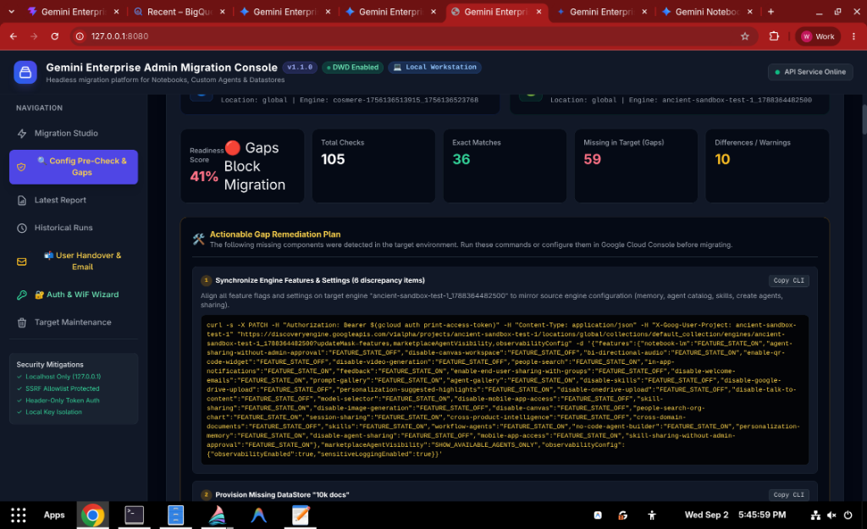
Figure 2.1: Configuration Pre-Check & Gap Audit Screen with Parity Readiness Score

Dynamic Connector & DataStore Auto-Mapping (_##### Instance Matching) & HITL Validation
In Google Cloud Discovery Engine, third-party workplace connectors (such as GitHub, Jira, Confluence, ServiceNow, and Slack) are provisioned as timestamp-suffixed Connector Collections (e.g. github_1773757636775) that manage multiple child entity DataStores (github_1773757636775_issue, github_1773757636775_pull_request, github_1773757636775_repository).
- Preventing 1-to-3 Connector Source Multiplication: A No-Code Agent connected to a GitHub Connector displays as 1 unified source ONLY when its parent collections/{id}/dataConnector and all 3 child entity dataStoreSpecs share the target project's exact <connector>_<timestamp> prefix. If those timestamps are not remapped together, Gemini Enterprise fails to group the child DataStores under the parent connector and displays 3 separate broken DataStore sources in the restored agent.
- Automated `_#####` Regex Pattern Matching: During Step 2 (Run Pre-Check), the audit engine uses Regex Pattern Matching (parseTimestampedResourceId) to inspect all source and target Connector Collections and DataStores, automatically pairing matching connector base names and entity suffixes across different _##### timestamps.
- Interactive Step 2 HITL Mapping Table: Displays every discovered source Connector Collection and DataStore with status badges (AUTO-MATCH (_#####), EXACT MATCH, HITL REQUIRED), dropdown selectors for live target connectors, custom ID inputs, and Strip / Remove Connector from Migrated Agents (__STRIP__).

Actionable Gap Remediation Plan
For any detected discrepancies, the console offers a 1-Click Sync Target Engine Settings button (PATCH API) and generates ready-to-run Google Cloud CLI commands. Administrators can copy these commands with a single click and execute them in Cloud Shell or a terminal.
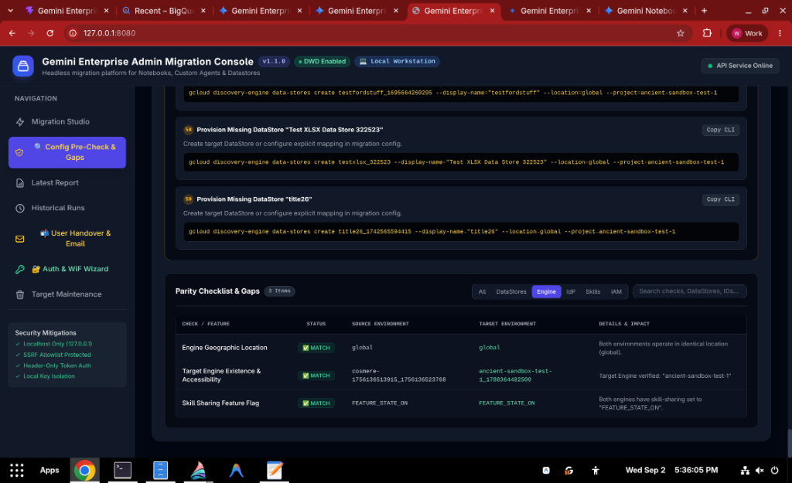
Figure 2.2: Actionable Gap Remediation Plan with 1-Click Copyable CLI Commands

3. Migration Pipeline Configuration (Step 3: Migration Studio)
On the Migration Studio (#studio) tab, review or adjust the synchronized Source and Target environment parameters:
- Source Project ID: The GCP project hosting current Gemini Enterprise assets (e.g. ancient-sandbox-322523).
- Source Region: Geographic location (global, eu, us-central1).
- Source Engine / App ID: Dropdown auto-populated with discovered engines.
- Source Identity Provider: Select between Google Workspace / Cloud Identity (DWD) or Microsoft Entra ID (Workforce Identity Federation).
- Target Project ID & Region: The destination environment (e.g. testgebackupandrestorev3).
- Target Identity Provider: Destination authentication provider.
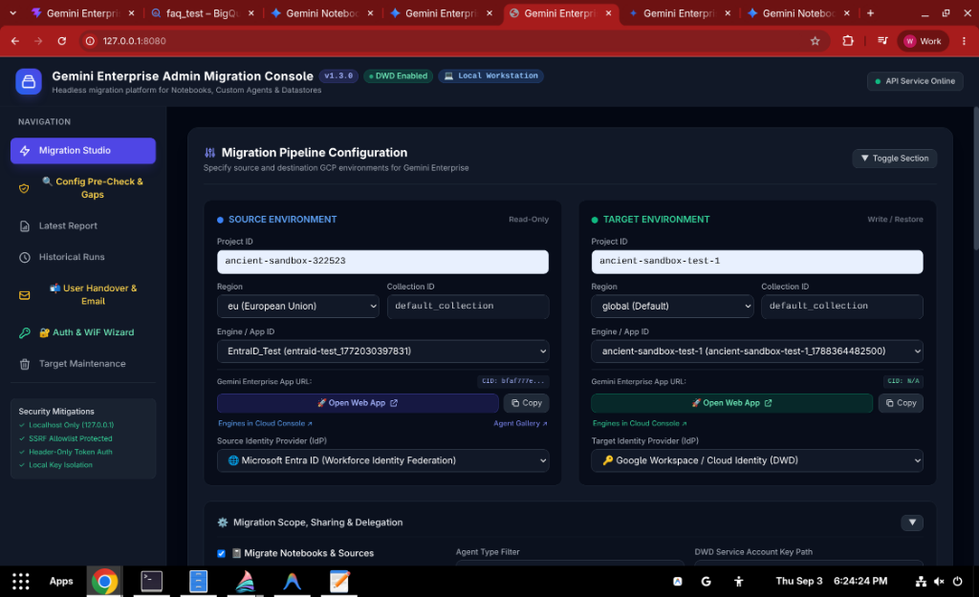
Figure 2.3: Migration Pipeline Configuration in Web Console

4. Scoping & Asset Selection
Administrators can selectively include or exclude specific asset categories and tune execution concurrency in Step 3:
Scope Control | Asset Category | Default State | Operational Effect
Migrate Notebooks & Sources | Research Notebooks & Grounding Docs | Enabled (Checked) | Restores notebooks and re-indexes attached PDFs, URLs, and YouTube videos; reports any unextractable binary files honestly as MANUAL_REUPLOAD_REQUIRED
Migrate Custom Agents | Low-Code & Workflow Agents | Enabled (Checked) | Deep-copies agent instructions, tools, and datastores as native editable drafts
↳ Ignore Draft Agents (Private & Published Only) | Custom Agent Sub-Option (#optExcludeDraftAgents) | Disabled (Unchecked) | When checked (--exclude-draft-agents), skips unsaved UI draft placeholders ("My Agent", "My Workflow") and migrates only Private (created/deployed) and Published/Shared agents
Migrate User Skills (Experimental) | User-Created Skills in Agent Registry | Enabled (Checked) | Migrates custom skills in agentregistry.googleapis.com while ignoring built-in 1P Google templates (Experimental — may not work for everyone)
Migrate Multi-User Chat History | Chat Conversation History | Enabled (Checked) | Rehydrates chronological chat sessions into the target Gemini sidebar
Migrate User Memories & Facts (Experimental) | Personalized Facts & Profiles | Enabled (Checked) | Discovers and exports memory facts to local JSON backup and target library (Experimental — may not work for everyone)
Export & Archive User Artifacts | Studio Outputs & Presentations | Enabled (Checked) | Generates .pptx decks, .docx study guides, .html apps, and .mp4 videos
Migrate Projects (WIP) | Gemini Enterprise Workspace Projects | Disabled (WIP) | Gemini Enterprise Project workspace migrations (Work in Progress)
Worker Concurrency (Parallel API Workers) | Pipeline Throttling (#optConcurrency) | 5 (Range 1–50) | Controls parallel API workers; automatically throttles Notebook source reads to min(concurrency, 3) (3–5 recommended for large PDFs/PPTX) to prevent HTTP 504 timeouts
Dry Run (Simulate Only) | Safety Simulation Mode | Disabled (Unchecked) | When checked, performs full discovery, payload validation, and source extractability auditing without writing to target

5. Targeted User Selection & Cross-IdP Transformation Rules
In enterprise migrations, you may want to migrate a pilot group of VIP users before rolling out to the entire organization. The platform provides granular user discovery and selection controls.
1. Click Discover App Users: The tool scans source DataStores and agents to discover all active user emails.
2. Select Specific Users: Check or uncheck individual users in the table.
3. Configure Cross-IdP Domain Mapping: When migrating between different IdPs (e.g. Microsoft Entra ID to Google Cloud Identity), configure the transformation rules:
💡 TIP: Cross-IdP Domain Translation Rules
When moving from Entra ID (user@tenant.onmicrosoft.com) to Google Cloud Identity (user@company.com), the tool automatically strips the source suffix and appends the target domain, completely preventing duplicate domain concatenation bugs.
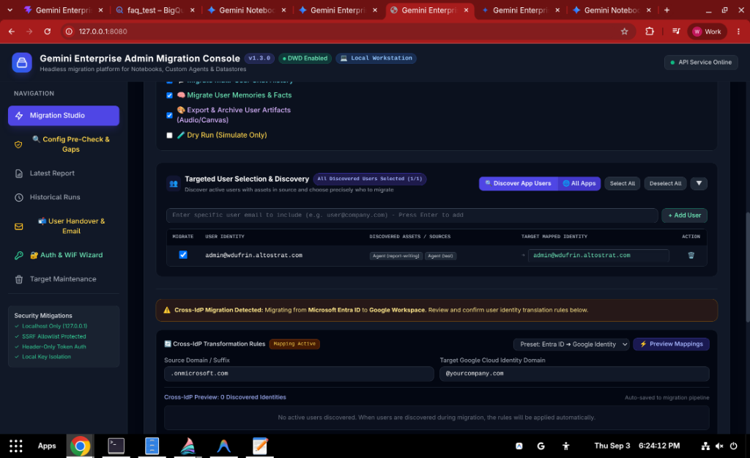
Figure 2.4: Targeted User Discovery and Cross-IdP Transformation Matrix

6. Executing the Migration Pipeline
Once configured, click 🚀 Execute Live Migration (or ⚡ Execute Pre-Flight Dry Run). The migration pipeline executes across 7 discrete stages:
1. Stage 1: Pre-Flight Infrastructure Checks — Verifies target engine existence, accessibility, and service usage quotas.
2. Stage 2: Notebooks & Granular Sources Restoration — Syncs research notebooks and restores individual grounding documents.
3. Stage 3: User Skills Discovery & Restoration (Experimental) — Migrates custom skills in agentregistry.googleapis.com (Experimental — may not work for everyone).
4. Stage 4: Custom Agents Restoration & Dynamic Connector Rewriting — Automatically runs _##### connector/datastore discovery, rewrites both full projects/.../collections/{id} paths and relative collections/{id}/dataConnector paths, expands parent collectionMapping rules to child entity DataStores, strips __STRIP__ connectors, and deduplicates dataStoreSpecs.
5. Stage 5: Multi-Turn Chat Conversation Rehydration — Recreates conversational turns chronologically for each user.
6. Stage 6: Personalized AI Memories & Facts Export (Experimental) — Backs up and migrates discovered user facts (Experimental — may not work for everyone).
7. Stage 7: Studio Artifacts Discovery, Office Generation & Compression — Synthesizes PPTX presentations, Word study guides, interactive HTML5 quiz/flashcard apps, and compresses Explainer Videos.

Runtime Human-in-the-Loop (HITL) Validation Modals
- Connector & DataStore Mapping Review Modal (`#connectorHitlModal`): Pauses before Stage 4 if any discovered Custom Agent references an unmapped Connector Collection or DataStore, allowing the operator to map it to a target connector from the dropdown, enter a custom ID, or select Strip / Remove Connector (__STRIP__).
- Shared Admin Notebook HITL Modal (`#adminHitlModal`): When promptForAdminNotebookHitl (--prompt-admin-hitl) is enabled and the impersonated user holds project-level discoveryengine.notebooks.delete permissions, pauses during Stage 2 so the operator can uncheck colleague-authored shared notebooks.

7. Migration Reports & Reconciliation Auditing (Step 4)
Upon pipeline completion, the platform generates comprehensive executive and machine-readable audit reports saved in reports/:
- Markdown Report (reports/migration-report-<ID>-<TIMESTAMP>.md): Human-readable executive summary with detailed asset breakdown.
- JSON Report (reports/migration-report-<ID>-<TIMESTAMP>.json): Structured telemetry schema for SIEM or enterprise database logging.
- User Reconciliation Matrix: Comprehensive table matching each source user identity with their target Google identity, listing restored vs. failed counts across all asset categories.
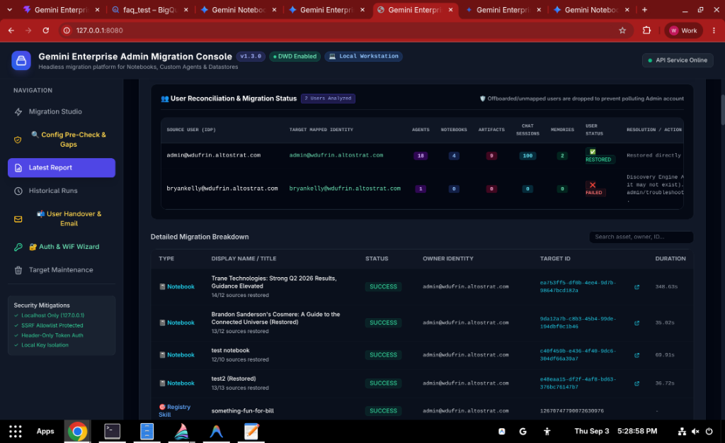
Figure 2.5: Migration Report and User Reconciliation Matrix in Web Console

8. User Handover Delivery & Notification Engine (Step 5)
To deliver a seamless day-one onboarding experience, the platform packages each user's assets into a single consolidated NotebookLM_Artifacts.zip archive and dispatches an onboarding email.
- Action-Oriented Checklists: The email features interactive checkboxes [ ] guiding users through initial sign-in, connector authorizations (Outlook, OneDrive, Google Drive, Jira), and agent publishing, along with explicit warnings if any asset types were skipped.
- Smart Deduplication: Static HTML document viewers are excluded when authentic Word documents are attached, but interactive quiz and flashcard apps are explicitly preserved alongside Word study guides.
- Multi-Part Email Threading: If user assets exceed Gmail's 14.5 MB unencoded per-message threshold, attachments are automatically bin-packed into sequential parts and delivered within a single threaded conversation (In-Reply-To).
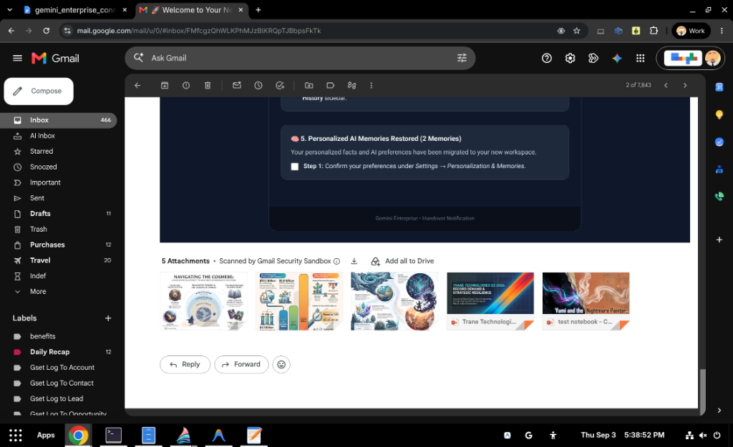
Figure 2.6: Migration Handover Notification Received in Gmail with Attachments
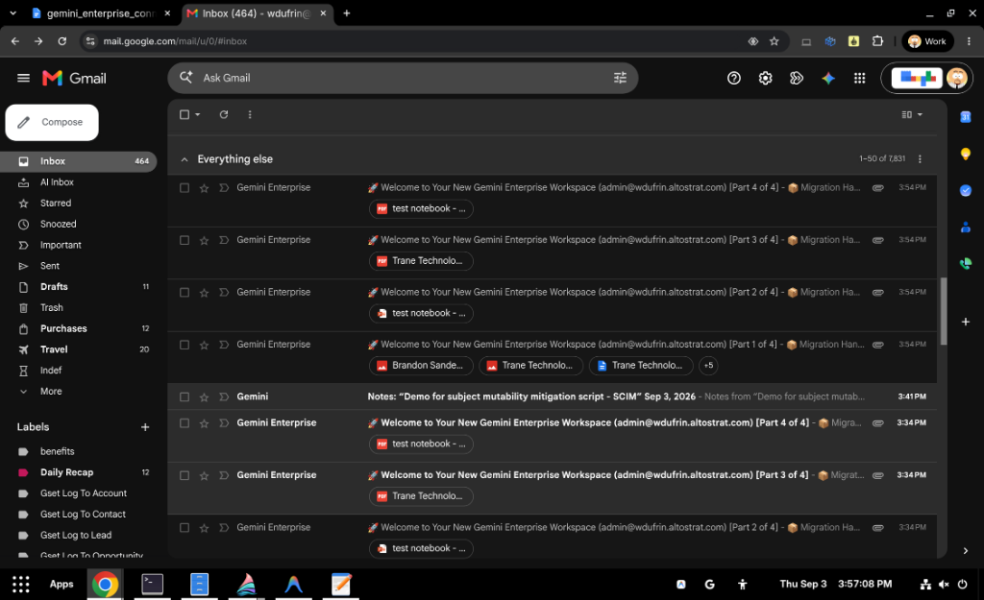
Figure 2.7: Multi-Part Handover Thread with Partitioned Attachments in Gmail
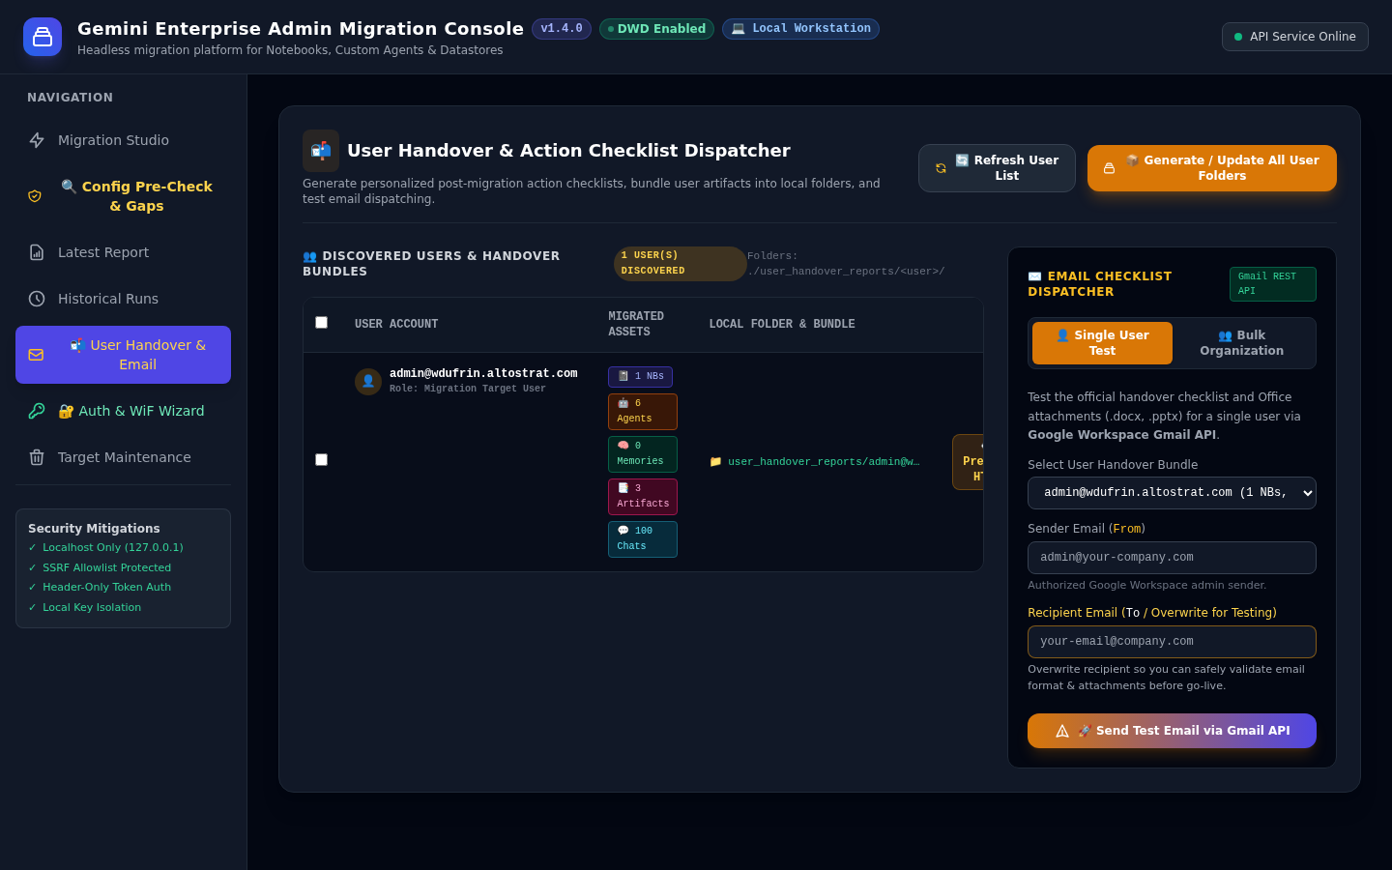
Figure 2.8: User Handover & Email Delivery Console Tab

9. Auth & Identity Provider Configuration Wizard (Step 1: DWD & WiF)
The Auth & WiF Wizard (#wizard) provides an interactive, guided interface to configure and test authentication protocols across Google Workspace and external Identity Providers (Microsoft Entra ID, Okta, Ping).

9.1 Domain-Wide Delegation (DWD) & Cross-Project IAM Generator
- Dual Project Topology Input: Accepts both Source GCP Project ID and Target GCP Project ID (wizDwdSrcProject and wizDwdProject), automatically synchronizing with Step 2 and Step 3.
- Cross-Project IAM Command Generator: Generates copy-paste ready gcloud CLI commands granting roles/discoveryengine.admin and roles/serviceusage.serviceUsageConsumer across both Source and Target environments, along with an Architecture Explainer clarifying user impersonation vs administrative pipeline permissions.
- Check Org Policies: Performs live inspection of target project organization policies (iam.disableServiceAccountKeyCreation, iam.disableCrossProjectServiceAccountUsage, and iam.allowedPolicyMemberDomains).
- Conflict Detection: If iam.disableServiceAccountKeyCreation is active, an alert banner warns the operator before executing CLI commands that creating sa-dwd-key.json will fail.
- 1-Click Project Override: Operators holding roles/orgpolicy.policyAdmin can click the 1-Click Project Override button to automatically apply a project-scoped exemption (enforce: false) without modifying parent organizational policies.
- Live DWD Impersonation Test: Validates that minted user-scoped OAuth2 tokens function against Discovery Engine APIs.

9.2 Workforce Identity Federation (WiF) — Keyless Enterprise Path & Architecture
- Keyless Architecture: WiF exchanges external OIDC/SAML tokens with Google Cloud Security Token Service (sts.googleapis.com) to mint short-lived tokens and is 100% exempt from `iam.disableServiceAccountKeyCreation` and key upload policies.
- The Headless Migration Provider Pattern (`migration-dwd-provider`): Standard Okta/Entra providers require interactive logins and MFA redirects. To enable automated bulk migration without passwords, the platform registers a dedicated OIDC provider (migration-dwd-provider) directly inside the customer's existing Workforce Identity Pool using a local RSA keypair (wif-migration-key.pem and wif-migration-jwks.json).
- Direct Workforce User Tokens vs. Service Account Impersonation: User-owned assets (NotebookLM notebooks, personalized memories, and chat sessions) cannot be accessed by a Service Account (gemini-dwd-migrator@...). The migration engine calls Discovery Engine APIs (notebooks:listRecentlyViewed) directly using the minted Workforce User STS token (principal://.../subject/<USER>). Service Account impersonation is optional and reserved for administrative infrastructure APIs.
- `google.subject` & `google.groups` Parity Architecture: The migration provider must construct the identical principal as the production provider (e.g. google.subject = assertion.email.lowerAscii()). If the provider lacks .lowerAscii() or misses google.groups = assertion.groups, user calls fail with HTTP 403: Permission discoveryengine.notebooks.list denied. SAML assertion.subject.lowerAscii() and OIDC assertion.email.lowerAscii() are semantically equivalent.
- Automated GE App Workforce Discovery: The Wizard automatically inspects Discovery Engine aclConfig and project IAM policies to detect production pools, discover group bindings, and auto-align the --attribute-mapping string via 1-click update-oidc.
- Stateless Federation & Wildcard IAM Pool Bindings: GCP STS validates the RSA JWKS locally without contacting Okta/Entra. In sandbox projects with pool-wide wildcard IAM bindings (workforcePools/<POOL>/*), any email returns 200 OK with 0 notebooks. Step 4 displays an amber warning when 0 notebooks are returned to remind operators to test a user who owns >= 1 notebook.
- 3-Stage End-to-End Live Verification: Step 4 tests (1) STS Token Minting, (2) Subject Mapping Parity, and (3) Live User Notebooks API Probe (discoveryengine.notebooks.list) as the target user.

9.3 Permissions & Least-Privilege Auditor
- Evaluates Discovery Engine read/write scopes, NotebookLM source access, and Gmail API dispatch scopes.
- Flags over-provisioned permissions or destructive deletion privileges.
- Runs automated organization policy compliance audits on the target project.
- Offers 1-click IAM policy bindings auto-fixes for missing roles.

9.4 Troubleshooting Guide & Enterprise Error Remediations
Error / Symptom | Root Cause | Actionable Resolution
No-Code Agent with 1 Connector source in source project displays 3 separate sources in target project | Third-party connectors (GitHub, Jira, Confluence, ServiceNow) create a parent Connector Collection (github_1773757636775) and 3+ child entity DataStores (_issue, _pull_request, _repository). If not mapped together to the target project <connector>_<timestamp>, Gemini Enterprise displays each child DataStore separately. | Run Step 2: Config & Parity Audit (Run Pre-Check) to trigger automatic _##### Regex Pattern Matching across collections and child DataStores, or configure collectionMapping in migration-config.json.
More notebooks discovered than expected (shared colleague notebooks marked as owned) | Impersonated user holds project-level discoveryengine.notebooks.delete (Admin permissions), causing NotebookLM to treat the user as PROJECT_ROLE_OWNER on all shared notebooks. | Replace roles/discoveryengine.admin with roles/discoveryengine.user on the Workforce Pool in Source project, or pass --prompt-admin-hitl to review and uncheck shared colleague notebooks interactively.
Permission discoveryengine.notebooks.list denied (HTTP 403) | Mismatched google.subject (missing .lowerAscii()), missing google.groups claim, or user lacks roles/discoveryengine.user | 1. Align provider: gcloud iam workforce-pools providers update-oidc migration-dwd-provider --attribute-mapping="google.subject=assertion.email.lowerAscii(),google.groups=assertion.groups,attribute.user_email=assertion.email". 2. Grant roles/discoveryengine.user and serviceusage.serviceUsageConsumer.
WorkforceSubjectMappingMismatch | Pool contains multiple providers with differing subject CEL expressions | Update migration-dwd-provider to match the canonical lowercase email format (assertion.email.lowerAscii()). The validator treats OIDC and SAML lowercase email mappings as semantically aligned.
The issuer in ID Token does not match... | Configuration points to an interactive production provider instead of headless migration-dwd-provider | Select Migration DWD preset in Auth Wizard, or set providerId to migration-dwd-provider and issuer to https://gemini-migration.internal.
USER_PROJECT_DENIED / serviceusage | Workforce principal or SA not authorized on quota project | Grant roles/serviceusage.serviceUsageConsumer to the workforce principal or pool.
invalid_grant: Invalid email or User ID | Target user does not exist in Google Workspace directory | Verify target user exists in admin.google.com, or configure Cross-IdP transformation rules in Step 3.

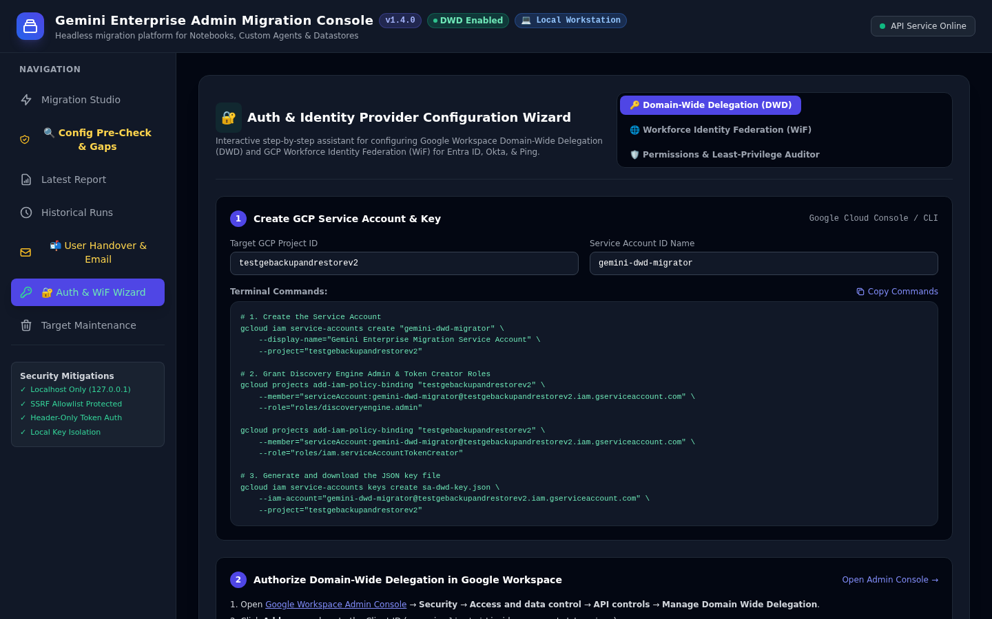
Figure 2.9: Auth & Identity Provider Configuration Wizard with Org Policy Pre-Flight

10. Target Maintenance & Selective Rollback
The Target Maintenance console provides two distinct operational flows: resetting assets between test iterations, or performing a complete teardown of the migration app:

Button 1: Reset Target Project Assets (Test Iterations)
Selectively cleans migrated assets in the target environment prior to fresh migration runs without disturbing authentication or GCP infrastructure:
Maintenance Option | Scope of Action | Risk Level | Recommendation
Clean Target Chats | Deletes migrated chat sessions for selected users | Low | Safe to run between test iterations to avoid duplicate session history
Clean Target Agents | Removes custom agents created by migration pipeline | Medium | Use when iterating on system prompt translations or tool bindings
Clean Target Notebooks | Deletes migrated research notebooks in target | Medium | Use when re-testing source ingestion or PDF uploads
Clean User Memories | Purges personalized user facts & memory profiles | Low | Cleans personalization state across all target user scopes
Clean Exported Artifacts | Clears exports/artifacts/ folder on local disk | Low | Frees local disk space without modifying cloud environments
Clean Migration Reports | Clears reports/ folder on local disk | Low | Archives old run logs and handover bundles

Button 2: Clean Up Install & Decommission Migration App (Full Teardown)
Performs a complete application uninstall and restores your Google Cloud project and workstation to their pre-setup baseline state:
- Reset Overwritten Org Policies: Resets iam.disableServiceAccountKeyCreation back to inherited parent default.
- Delete Service Account & Strip IAM Roles: Revokes discoveryengine.admin, serviceUsageConsumer, and deletes the service account.
- Invalidate Domain-Wide Delegation (DWD): Permanently revokes token minting in GCP IAM; manual console deletion in admin.google.com required due to Google Workspace API boundaries.
- Delete Local Credentials: Removes sa-dwd-key.json, workforce-identity-config.json, .pem, .jwt, and migration-config.json.
- Purge Local Folders: Empties reports/, exports/, and user_handover_reports/.
- Headless CLI Execution: gemini-migrate decommission --project <TARGET_PROJECT_ID> --confirm <TARGET_PROJECT_ID>

Automated Rollback State Verification Engine
Audits cloud and local baseline state across 7 security dimensions. Automatically runs after decommissioning or can be triggered on demand via Web Console ("Verify Rollback State"), Headless CLI (gemini-migrate verify-rollback --project <ID>), or REST API.
- Web Console: Tab 6 (Card 2) "Verify Rollback State" button with live audit checklist.
- Headless CLI: gemini-migrate verify-rollback --project <TARGET_PROJECT_ID>
- REST API: GET /api/maintenance/verify-rollback?targetProject=<PROJECT_ID>
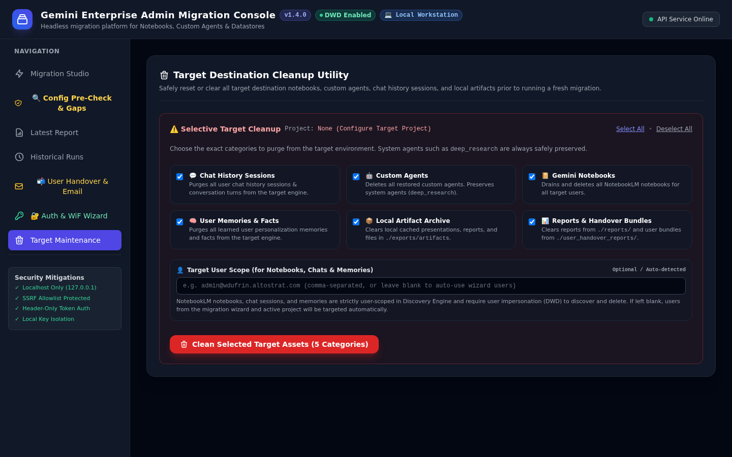
Figure 2.11: Target Maintenance & Platform Decommissioning Console

11. Enterprise Migration Playbook & Best Practices
Follow this recommended four-phase migration playbook for enterprise rollouts:

Phase 1: Pre-Flight Discovery & Parity Alignment
1. Open the Auth & WiF Wizard and run Check Org Policies to verify that target project policies permit credential provisioning or apply 1-click project overrides.
2. Run Configuration Pre-Check & Gap Audit against Source and Target engines.
3. Execute generated CLI commands to align DataStores and feature flags.
4. Confirm that caller identity has roles/serviceusage.serviceUsageConsumer on both projects.

Phase 2: Pilot Wave Execution (5–10 VIP Users)
5. Select 5–10 active power users with notebooks and agents.
6. Run a Dry Run simulation to verify identity mapping and asset discovery.
7. Execute Live Migration and review the resulting Markdown audit report.
8. Dispatch pilot handover emails and verify user receipt in Gmail.

Phase 3: Production Bulk Migration Wave
9. Execute migration for remaining organizational users.
10. Monitor streaming event logs for any network throttling or quota pauses.
11. Verify that 100% of discovered notebooks, sources, and agents migrated successfully.

Phase 4: Post-Migration Handover & Support
12. Dispatch bulk handover email packages with NotebookLM_Artifacts.zip.
13. Direct users to /checklist for guided day-one onboarding steps.
14. Archive final migration reports for compliance records.

