**Final semester project**

**Lu Wang**

**Background**

In this research, we will investigate the diagnose diseases using immunosignature, a customized non-natural peptide array development in the lab I am working at. On the peptide array, there are 330,000 non-natural peptides generated using program aimed at diversifying the peptide space coverage. And the way the technology works is to get a drop of blood from an individual and put it onto the array. The antibodies in the blood will then bind onto the array based on antibody-specific binding. And certain method can be used to illuminate the binding result and turn into intensity value. By investigating the binding result, we will be able to tell if the individual is healthy, or ill, and which disease does he/she have. And since the immune system is too complicated and we have too many features (each peptide serves as a feature), peptide selection is needed before the real diagnosis. In this research, we will test if a feature selection method is appropriate to select the features needed for diagnosing diseases.

**Question to be investigated**

In this research we want to test if using two tale T-Test comparing healthy samples and disease samples is a good feature selection method. Because by selecting peptides that are significantly different, it can either be the result of disease specific factor, or it can be the result of general inflammation that occurs in any disease. Which means in this research, we will test if there is unique factor underlying each set of feature selected from T-Test or there is a common factor underlying all of them.

**Data collection**

To test this, we will use three groups of samples, healthy people, dengue patients and malaria patients. Peripheral blood will be drawn from each individual. Same amount of blood will be put onto the array. Wait certain amount of time for the antibodies in the blood to bind to specific peptides and then wash the blood away. What are left are only the binded antibodies. Using secondary antibody attached with fluorescence, we can quantify the amount of antibody binded at each location. Signal intensity is gained for each peptide and used as a feature. So at last, for each sample, we will have a list of 330,000 features each with an intensity value. Then we will do a two tale T-Test between dengue and healthy, malaria and healthy samples. And select the top three features in each comparison based on p-value. Each feature is a variable, so we will have ten variables in total. The dataset will use will consist of the ten variables and the observations will consist of all the samples from healthy, dengue and malaria patients.

**Models to be tested**

In this research, we will test two models.

Two factor model

The first model will be that each set of peptides selected from the same comparison group will have unique underlying factor. And because we want the factor to be disease specific, we need to eliminate the covariance of the underlying variables. The path model is shown below.

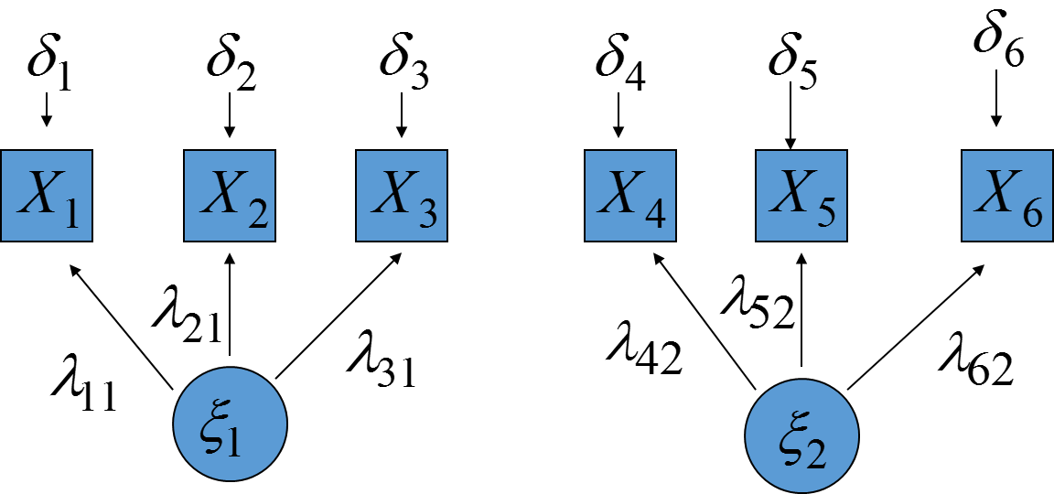

If this model holds, then we can conclude that the selection method is applicable to select disease specific peptides. And further analysis can be done using the peptides selected in this way.

Concerning identification, according to three-indicator rule

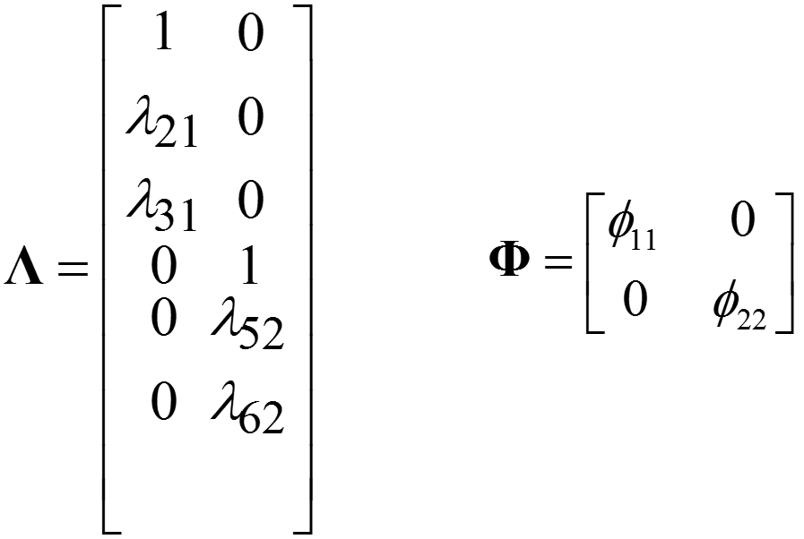

All the conditions hold, as a result, this model is identified.

One factor model

The second model I will test here is that there is one common factor loads onto all the variables. The path model is shown below.

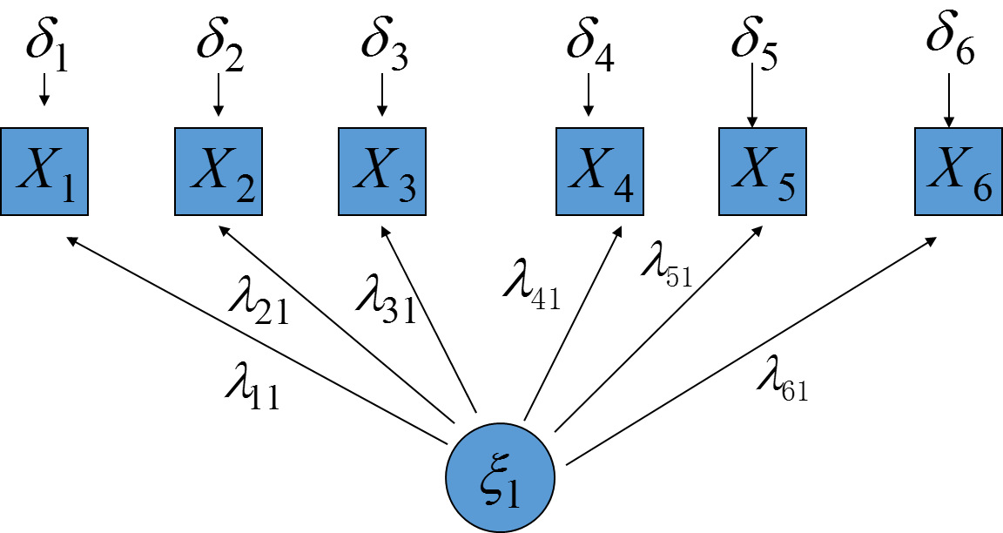

If this model holds, then it means that there is one common factor underlying all the peptides selected from different comparison, which indicates this T-Test selection method is not a good way to find disease specific peptides. Others methods are needed to find disease specific signatures.

Concerning the identification, according to the three-indicator rule, this model is also identified.

**Test of model fit**

Two factor model

To evaluate the fit for the two factor model. I used the following model script

MODEL: F1 BY x1 x2 x3;

F2 by x4 x5 x6;

F1 with F2@0;

When we look at the global fit indices below

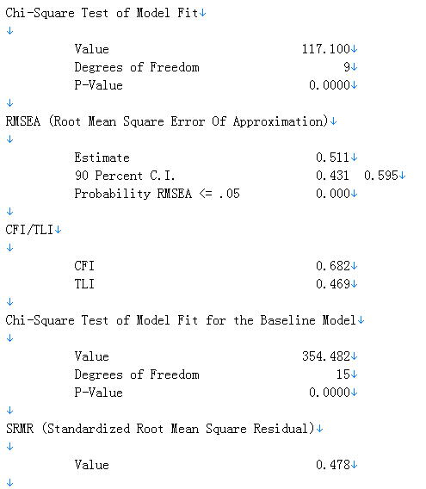

The chi-square value is 117, not too bad. However, when we look at the other indices, the fitting seems to be poor. RMSEA has a 90% C.I. of (0.431, 0.595), indicating bad fit. CFI value is 0.682, also means bad fit. And SRMR is 0.478, far larger than 0.05, which also means bad fit. So overall, all the global fit indices indicates the model fits poorly, which means the two factor model is not an appropriate model for the data.

When look into the local fit information to find the aspect responsible for the bad fit.

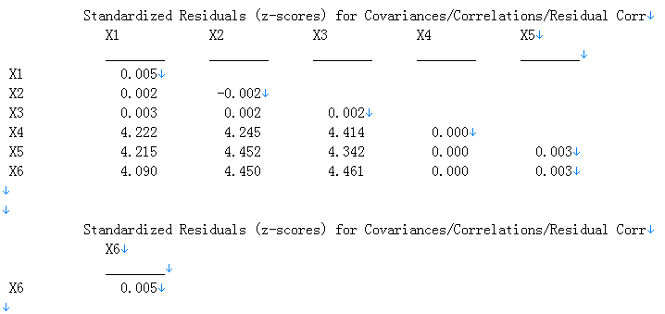

The z-score for the covariance between x1-x3 and x4-x6 are all over 4, indicates the residual covariance are too big. That should be the part responsible for the lack of fit.

And from the modification index output below

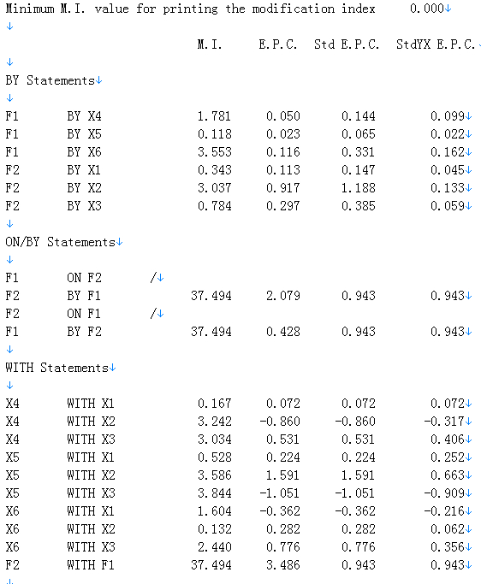

By allowing F1 and F2 to correlate, the model will improve a lot, with a M.I. value of 37.494 and an E.P.C value of 3.486, both significantly larger than to loose other constraints.

So when taking all the above discussions into consideration, the two factor model is a bad fit. And the bad fit is caused by constraining F1 not to correlate with F2 because the goal is to find disease specific peptides. And the constraint of F1 not correlating with F2 caused the residual covariance between x1-x3 and x4-x6 to be larger than normal, caused the bad fit.

One factor model

For the one factor model, the following model script in Mplus is used

MODEL: F1 BY x1 x2 x3 x4 x5 x6;

The global fit indices is followed:

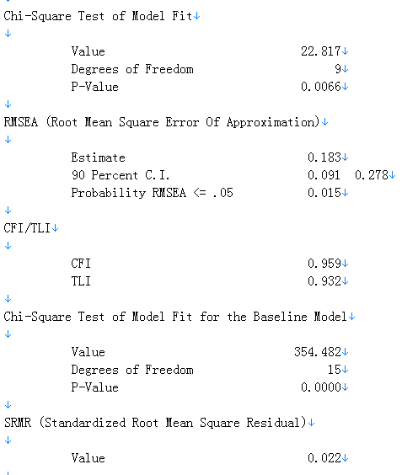

The chi-square value is 22.817, significantly smaller than the two factor model, and the p-value=0.0066, larger than the former model too, providing the first set of evidence that this model is a better fit than the last one. The RMSEA has a 90% C.I. of (0.091, 0.278), still larger than 0.05 to be compared a good fit. But the improvement is significant compared with the last model. And the CFI is 0.959, indicating good fit. And SRMR value is 0.022, also indicates good fit. So all the global indices indicates the model is a good fit except the RMSEA indicates only a fair fit.

Up to this points, we can actually conclude that the one factor model is better fit and more logical than the two factors model.

And when looking at the local fit indices, we can see from the below output that all the residuals are fairly fitted

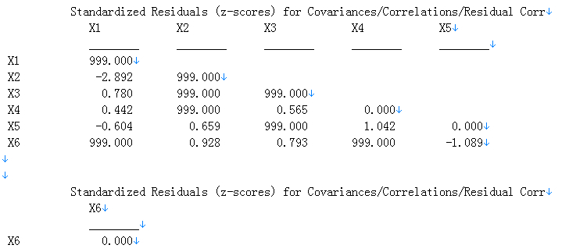

And then we can look at the modification indices to see how we can improve the model.

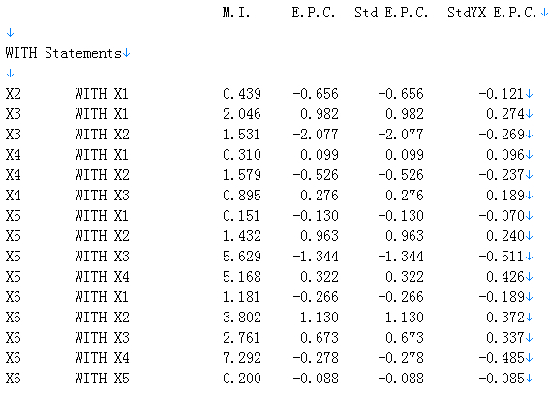

None of the M.I value is as significant as in the last model. However, if we use a common value of larger than 4 as a cutoff for needed modification, we need to lose the constraints between X3 with X5, X3 with X6 and X4 with X5. However, in factor analysis, that is usually not used, but can be considered as a factor.

And the parameter estimates for this model is listed as below

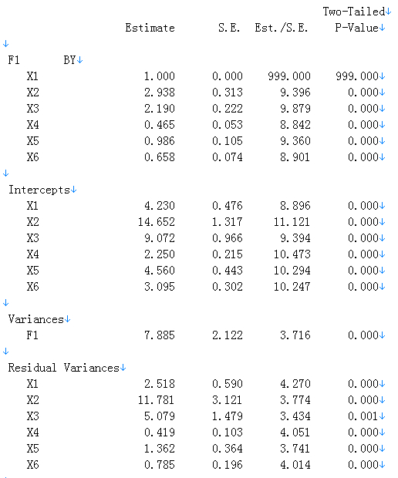

The loadings, intercepts, and residual variances for x1-x3 are all larger than x4-x6, probably because the raw data are larger. And the p-value for all parameters are significant, indicates the loading exist.

**Discussion**

Overall, after building the two models and analyzed the fitting result, I concluded that the one factor model is a much better fit than the two factor model. Since the two factors model implies that the T-Test can select disease specific peptides while the one factor model indicates that the T-Test can only found a general disease response that is not disease specific, we can actually conclude that this T-Test selection method is not a good way to find disease specific peptides.

The reason we want to use T-Test as a selection method is because it is widely used and our data meets all the assumption. And this method only need to take the disease of interest and normal and don’t need to care of other disease group samples. However, we are worried that the most significant peptides found in the T-Test is not the disease specific ones, but instead, they are telling information that the person is ill or not. So if that is the case, there will only be one factor underlying the selected peptides across several disease-normal comparisons, which means the one factor model. And if the selected ones are really disease specific, we can find a unique factor underlying the peptides selected each comparison, which in this case I only used two disease groups to start with.

And using the peptides selected from dengue-healthy and malaria-healthy comparison to fit the models, we have found that there is actually one common factor underlying all the peptides from both groups. This is actually a disappointing result because this indicates that the most significantly different peptides are not even close to disease specific. And if we want to really find disease specific peptides for dengue and malaria, maybe further selection is needed, like performing a T-Test between dengue and malaria. If that is the case, when it will make the future analysis very difficult. Because if by comparing healthy and specific disease, we can find the specific peptides, then for any disease, we only need to reference the healthy samples. So the comparison needed to differentiate diseases increase linearly with the number of diseases. However, since the find found that this method could not find the needed peptides, and disease-disease comparison is possibly needed, then the number of comparisons needed increase quadratically with the number of diseases needed to differentiate.

And a by-product of the modelling result is the fact that the most significant peptides are not disease specific. Because from prior knowledge, most academic researchers would assume when you get ill, the dominant antibodies in your blood will be the ones against the disease directly, which would make them easily stand out from the T-Test selection. However, from my result, that seems not to be the case. The most dominate antibodies reflected through the peptides are the ones that indicates a general response to illness while not disease specific. The disease specific information seems to be deeply imbedded in the immune system than previously thought. This is actually a first tentative experiment for an ongoing research I am currently working on in the lab, which is to redefine the way that antibody immune system works.

Mplus VERSION 7

MUTHEN & MUTHEN

05/05/2014 2:18 PM

INPUT INSTRUCTIONS

TITLE: Lu Wang final project one common factor model

DATA: FILE = "F:\Dropbox\class\Spring 2014\PSY533\final\data.txt";

VARIABLE: NAMES ARE x1-x6;

USEVARIABLES ARE x1-x6;

ANALYSIS: TYPE = GENERAL;

ITERATIONS=3000;

ESTIMATOR=ML;

MODEL: F1 BY x1 x2 x3 x4 x5 x6;

OUTPUT: sampstat standardized residual mod(0);

INPUT READING TERMINATED NORMALLY

Lu Wang final project one common factor model

SUMMARY OF ANALYSIS

Number of groups 1

Number of observations 46

Number of dependent variables 6

Number of independent variables 0

Number of continuous latent variables 1

Observed dependent variables

Continuous

X1 X2 X3 X4 X5 X6

Continuous latent variables

F1

Estimator ML

Information matrix OBSERVED

Maximum number of iterations 3000

Convergence criterion 0.500D-04

Maximum number of steepest descent iterations 20

Input data file(s)

F:\Dropbox\class\Spring 2014\PSY533\final\data.txt

Input data format FREE

SAMPLE STATISTICS

SAMPLE STATISTICS

Means

X1 X2 X3 X4 X5

________ ________ ________ ________ ________

1 4.230 14.652 9.072 2.250 4.560

Means

X6

________

1 3.095

Covariances

X1 X2 X3 X4 X5

________ ________ ________ ________ ________

X1 10.403

X2 22.735 79.847

X3 17.848 49.780 42.900

X4 3.739 10.452 8.181 2.124

X5 7.687 23.357 16.395 3.814 9.025

X6 4.996 15.915 11.715 2.225 5.060

Covariances

X6

________

X6 4.197

Correlations

X1 X2 X3 X4 X5

________ ________ ________ ________ ________

X1 1.000

X2 0.789 1.000

X3 0.845 0.851 1.000

X4 0.795 0.803 0.857 1.000

X5 0.793 0.870 0.833 0.871 1.000

X6 0.756 0.869 0.873 0.745 0.822

Correlations

X6

________

X6 1.000

THE MODEL ESTIMATION TERMINATED NORMALLY

MODEL FIT INFORMATION

Number of Free Parameters 18

Loglikelihood

H0 Value -567.775

H1 Value -556.367

Information Criteria

Akaike (AIC) 1171.550

Bayesian (BIC) 1204.466

Sample-Size Adjusted BIC 1148.027

(n* = (n + 2) / 24)

Chi-Square Test of Model Fit

Value 22.817

Degrees of Freedom 9

P-Value 0.0066

RMSEA (Root Mean Square Error Of Approximation)

Estimate 0.183

90 Percent C.I. 0.091 0.278

Probability RMSEA <= .05 0.015

CFI/TLI

CFI 0.959

TLI 0.932

Chi-Square Test of Model Fit for the Baseline Model

Value 354.482

Degrees of Freedom 15

P-Value 0.0000

SRMR (Standardized Root Mean Square Residual)

Value 0.022

MODEL RESULTS

Two-Tailed

Estimate S.E. Est./S.E. P-Value

F1 BY

X1 1.000 0.000 999.000 999.000

X2 2.938 0.313 9.396 0.000

X3 2.190 0.222 9.879 0.000

X4 0.465 0.053 8.842 0.000

X5 0.986 0.105 9.360 0.000

X6 0.658 0.074 8.901 0.000

Intercepts

X1 4.230 0.476 8.896 0.000

X2 14.652 1.317 11.121 0.000

X3 9.072 0.966 9.394 0.000

X4 2.250 0.215 10.473 0.000

X5 4.560 0.443 10.294 0.000

X6 3.095 0.302 10.247 0.000

Variances

F1 7.885 2.122 3.716 0.000

Residual Variances

X1 2.518 0.590 4.270 0.000

X2 11.781 3.121 3.774 0.000

X3 5.079 1.479 3.434 0.001

X4 0.419 0.103 4.051 0.000

X5 1.362 0.364 3.741 0.000

X6 0.785 0.196 4.014 0.000

STANDARDIZED MODEL RESULTS

STDYX Standardization

Two-Tailed

Estimate S.E. Est./S.E. P-Value

F1 BY

X1 0.871 0.039 22.529 0.000

X2 0.923 0.025 36.388 0.000

X3 0.939 0.022 43.358 0.000

X4 0.896 0.032 27.578 0.000

X5 0.921 0.026 35.265 0.000

X6 0.902 0.031 29.077 0.000

Intercepts

X1 1.312 0.201 6.522 0.000

X2 1.640 0.226 7.263 0.000

X3 1.385 0.206 6.711 0.000

X4 1.544 0.218 7.073 0.000

X5 1.518 0.216 7.018 0.000

X6 1.511 0.216 7.003 0.000

Variances

F1 1.000 0.000 999.000 999.000

Residual Variances

X1 0.242 0.067 3.598 0.000

X2 0.148 0.047 3.149 0.002

X3 0.118 0.041 2.911 0.004

X4 0.197 0.058 3.385 0.001

X5 0.151 0.048 3.134 0.002

X6 0.187 0.056 3.347 0.001

STDY Standardization

Two-Tailed

Estimate S.E. Est./S.E. P-Value

F1 BY

X1 0.871 0.039 22.529 0.000

X2 0.923 0.025 36.388 0.000

X3 0.939 0.022 43.358 0.000

X4 0.896 0.032 27.578 0.000

X5 0.921 0.026 35.265 0.000

X6 0.902 0.031 29.077 0.000

Intercepts

X1 1.312 0.201 6.522 0.000

X2 1.640 0.226 7.263 0.000

X3 1.385 0.206 6.711 0.000

X4 1.544 0.218 7.073 0.000

X5 1.518 0.216 7.018 0.000

X6 1.511 0.216 7.003 0.000

Variances

F1 1.000 0.000 999.000 999.000

Residual Variances

X1 0.242 0.067 3.598 0.000

X2 0.148 0.047 3.149 0.002

X3 0.118 0.041 2.911 0.004

X4 0.197 0.058 3.385 0.001

X5 0.151 0.048 3.134 0.002

X6 0.187 0.056 3.347 0.001

STD Standardization

Two-Tailed

Estimate S.E. Est./S.E. P-Value

F1 BY

X1 2.808 0.378 7.432 0.000

X2 8.250 1.005 8.211 0.000

X3 6.150 0.727 8.459 0.000

X4 1.306 0.168 7.792 0.000

X5 2.768 0.339 8.177 0.000

X6 1.847 0.235 7.876 0.000

Intercepts

X1 4.230 0.476 8.896 0.000

X2 14.652 1.317 11.121 0.000

X3 9.072 0.966 9.394 0.000

X4 2.250 0.215 10.473 0.000

X5 4.560 0.443 10.294 0.000

X6 3.095 0.302 10.247 0.000

Variances

F1 1.000 0.000 999.000 999.000

Residual Variances

X1 2.518 0.590 4.270 0.000

X2 11.781 3.121 3.774 0.000

X3 5.079 1.479 3.434 0.001

X4 0.419 0.103 4.051 0.000

X5 1.362 0.364 3.741 0.000

X6 0.785 0.196 4.014 0.000

R-SQUARE

Observed Two-Tailed

Variable Estimate S.E. Est./S.E. P-Value

X1 0.758 0.067 11.264 0.000

X2 0.852 0.047 18.194 0.000

X3 0.882 0.041 21.679 0.000

X4 0.803 0.058 13.789 0.000

X5 0.849 0.048 17.632 0.000

X6 0.813 0.056 14.539 0.000

QUALITY OF NUMERICAL RESULTS

Condition Number for the Information Matrix 0.338E-02

(ratio of smallest to largest eigenvalue)

RESIDUAL OUTPUT

ESTIMATED MODEL AND RESIDUALS (OBSERVED - ESTIMATED)

Model Estimated Means/Intercepts/Thresholds

X1 X2 X3 X4 X5

________ ________ ________ ________ ________

1 4.230 14.652 9.072 2.250 4.560

Model Estimated Means/Intercepts/Thresholds

X6

________

1 3.095

Residuals for Means/Intercepts/Thresholds

X1 X2 X3 X4 X5

________ ________ ________ ________ ________

1 0.000 0.000 0.000 0.000 0.000

Residuals for Means/Intercepts/Thresholds

X6

________

1 0.000

Standardized Residuals (z-scores) for Means/Intercepts/Thresholds

X1 X2 X3 X4 X5

________ ________ ________ ________ ________

1 0.000 0.000 0.000 0.000 0.000

Standardized Residuals (z-scores) for Means/Intercepts/Thresholds

X6

________

1 0.000

Normalized Residuals for Means/Intercepts/Thresholds

X1 X2 X3 X4 X5

________ ________ ________ ________ ________

1 0.000 0.000 0.000 0.000 0.000

Normalized Residuals for Means/Intercepts/Thresholds

X6

________

1 0.000

Model Estimated Covariances/Correlations/Residual Correlations

X1 X2 X3 X4 X5

________ ________ ________ ________ ________

X1 10.403

X2 23.167 79.847

X3 17.269 50.738 42.900

X4 3.667 10.774 8.031 2.124

X5 7.773 22.838 17.024 3.615 9.025

X6 5.187 15.239 11.359 2.412 5.113

Model Estimated Covariances/Correlations/Residual Correlations

X6

________

X6 4.197

Residuals for Covariances/Correlations/Residual Correlations

X1 X2 X3 X4 X5

________ ________ ________ ________ ________

X1 0.000

X2 -0.431 0.000

X3 0.579 -0.959 0.000

X4 0.072 -0.322 0.150 0.000

X5 -0.086 0.519 -0.630 0.199 0.000

X6 -0.191 0.676 0.356 -0.187 -0.053

Residuals for Covariances/Correlations/Residual Correlations

X6

________

X6 0.000

Standardized Residuals (z-scores) for Covariances/Correlations/Residual Corr

X1 X2 X3 X4 X5

________ ________ ________ ________ ________

X1 999.000

X2 -2.892 999.000

X3 0.780 999.000 999.000

X4 0.442 999.000 0.565 0.000

X5 -0.604 0.659 999.000 1.042 0.000

X6 999.000 0.928 0.793 999.000 -1.089

Standardized Residuals (z-scores) for Covariances/Correlations/Residual Corr

X6

________

X6 0.000

Normalized Residuals for Covariances/Correlations/Residual Correlations

X1 X2 X3 X4 X5

________ ________ ________ ________ ________

X1 0.000

X2 -0.080 0.000

X3 0.142 -0.085 0.000

X4 0.081 -0.131 0.081 0.000

X5 -0.047 0.099 -0.167 0.232 0.000

X6 -0.156 0.189 0.136 -0.341 -0.045

Normalized Residuals for Covariances/Correlations/Residual Correlations

X6

________

X6 0.000

MODEL MODIFICATION INDICES

NOTE: Modification indices for direct effects of observed dependent variables

regressed on covariates may not be included. To include these, request

MODINDICES (ALL).

Minimum M.I. value for printing the modification index 0.000

M.I. E.P.C. Std E.P.C. StdYX E.P.C.

WITH Statements

X2 WITH X1 0.439 -0.656 -0.656 -0.121

X3 WITH X1 2.046 0.982 0.982 0.274

X3 WITH X2 1.531 -2.077 -2.077 -0.269

X4 WITH X1 0.310 0.099 0.099 0.096

X4 WITH X2 1.579 -0.526 -0.526 -0.237

X4 WITH X3 0.895 0.276 0.276 0.189

X5 WITH X1 0.151 -0.130 -0.130 -0.070

X5 WITH X2 1.432 0.963 0.963 0.240

X5 WITH X3 5.629 -1.344 -1.344 -0.511

X5 WITH X4 5.168 0.322 0.322 0.426

X6 WITH X1 1.181 -0.266 -0.266 -0.189

X6 WITH X2 3.802 1.130 1.130 0.372

X6 WITH X3 2.761 0.673 0.673 0.337

X6 WITH X4 7.292 -0.278 -0.278 -0.485

X6 WITH X5 0.200 -0.088 -0.088 -0.085

Mplus VERSION 7

MUTHEN & MUTHEN

05/05/2014 11:40 AM

INPUT INSTRUCTIONS

TITLE: Lu Wang final project two factor model

DATA: FILE = "F:\Dropbox\class\Spring 2014\PSY533\final\data.txt";

VARIABLE: NAMES ARE x1-x6;

USEVARIABLES ARE x1-x6;

ANALYSIS: TYPE = GENERAL;

ITERATIONS=3000;

ESTIMATOR=ML;

MODEL: F1 BY x1 x2 x3;

F2 by x4 x5 x6;

F1 with F2@0;

OUTPUT: sampstat standardized residual mod(0);

INPUT READING TERMINATED NORMALLY

Lu Wang final project two factor model

SUMMARY OF ANALYSIS

Number of groups 1

Number of observations 46

Number of dependent variables 6

Number of independent variables 0

Number of continuous latent variables 2

Observed dependent variables

Continuous

X1 X2 X3 X4 X5 X6

Continuous latent variables

F1 F2

Estimator ML

Information matrix OBSERVED

Maximum number of iterations 3000

Convergence criterion 0.500D-04

Maximum number of steepest descent iterations 20

Input data file(s)

F:\Dropbox\class\Spring 2014\PSY533\final\data.txt

Input data format FREE

SAMPLE STATISTICS

SAMPLE STATISTICS

Means

X1 X2 X3 X4 X5

________ ________ ________ ________ ________

1 4.230 14.652 9.072 2.250 4.560

Means

X6

________

1 3.095

Covariances

X1 X2 X3 X4 X5

________ ________ ________ ________ ________

X1 10.403

X2 22.735 79.847

X3 17.848 49.780 42.900

X4 3.739 10.452 8.181 2.124

X5 7.687 23.357 16.395 3.814 9.025

X6 4.996 15.915 11.715 2.225 5.060

Covariances

X6

________

X6 4.197

Correlations

X1 X2 X3 X4 X5

________ ________ ________ ________ ________

X1 1.000

X2 0.789 1.000

X3 0.845 0.851 1.000

X4 0.795 0.803 0.857 1.000

X5 0.793 0.870 0.833 0.871 1.000

X6 0.756 0.869 0.873 0.745 0.822

Correlations

X6

________

X6 1.000

THE MODEL ESTIMATION TERMINATED NORMALLY

MODEL FIT INFORMATION

Number of Free Parameters 18

Loglikelihood

H0 Value -614.917

H1 Value -556.367

Information Criteria

Akaike (AIC) 1265.834

Bayesian (BIC) 1298.749

Sample-Size Adjusted BIC 1242.310

(n* = (n + 2) / 24)

Chi-Square Test of Model Fit

Value 117.100

Degrees of Freedom 9

P-Value 0.0000

RMSEA (Root Mean Square Error Of Approximation)

Estimate 0.511

90 Percent C.I. 0.431 0.595

Probability RMSEA <= .05 0.000

CFI/TLI

CFI 0.682

TLI 0.469

Chi-Square Test of Model Fit for the Baseline Model

Value 354.482

Degrees of Freedom 15

P-Value 0.0000

SRMR (Standardized Root Mean Square Residual)

Value 0.478

MODEL RESULTS

Two-Tailed

Estimate S.E. Est./S.E. P-Value

F1 BY

X1 1.000 0.000 999.000 999.000

X2 2.789 0.315 8.847 0.000

X3 2.190 0.222 9.884 0.000

F2 BY

X4 1.000 0.000 999.000 999.000

X5 2.275 0.222 10.264 0.000

X6 1.327 0.166 8.013 0.000

F1 WITH

F2 0.000 0.000 999.000 999.000

Intercepts

X1 4.230 0.476 8.896 0.000

X2 14.652 1.317 11.121 0.000

X3 9.072 0.966 9.394 0.000

X4 2.250 0.215 10.473 0.000

X5 4.560 0.443 10.294 0.000

X6 3.095 0.302 10.247 0.000

Variances

F1 8.152 2.160 3.775 0.000

F2 1.677 0.443 3.787 0.000

Residual Variances

X1 2.251 0.632 3.562 0.000

X2 16.437 4.752 3.459 0.001

X3 3.821 2.179 1.753 0.080

X4 0.447 0.131 3.403 0.001

X5 0.350 0.485 0.722 0.470

X6 1.246 0.307 4.062 0.000

STANDARDIZED MODEL RESULTS

STDYX Standardization

Two-Tailed

Estimate S.E. Est./S.E. P-Value

F1 BY

X1 0.885 0.039 22.513 0.000

X2 0.891 0.038 23.353 0.000

X3 0.954 0.028 34.042 0.000

F2 BY

X4 0.889 0.040 22.454 0.000

X5 0.980 0.028 35.426 0.000

X6 0.839 0.050 16.939 0.000

F1 WITH

F2 0.000 0.000 999.000 999.000

Intercepts

X1 1.312 0.201 6.522 0.000

X2 1.640 0.226 7.263 0.000

X3 1.385 0.206 6.711 0.000

X4 1.544 0.218 7.073 0.000

X5 1.518 0.216 7.018 0.000

X6 1.511 0.216 7.003 0.000

Variances

F1 1.000 0.000 999.000 999.000

F2 1.000 0.000 999.000 999.000

Residual Variances

X1 0.216 0.070 3.109 0.002

X2 0.206 0.068 3.027 0.002

X3 0.089 0.054 1.664 0.096

X4 0.211 0.070 2.994 0.003

X5 0.039 0.054 0.715 0.475

X6 0.297 0.083 3.574 0.000

STDY Standardization

Two-Tailed

Estimate S.E. Est./S.E. P-Value

F1 BY

X1 0.885 0.039 22.513 0.000

X2 0.891 0.038 23.353 0.000

X3 0.954 0.028 34.042 0.000

F2 BY

X4 0.889 0.040 22.454 0.000

X5 0.980 0.028 35.426 0.000

X6 0.839 0.050 16.939 0.000

F1 WITH

F2 0.000 0.000 999.000 999.000

Intercepts

X1 1.312 0.201 6.522 0.000

X2 1.640 0.226 7.263 0.000

X3 1.385 0.206 6.711 0.000

X4 1.544 0.218 7.073 0.000

X5 1.518 0.216 7.018 0.000

X6 1.511 0.216 7.003 0.000

Variances

F1 1.000 0.000 999.000 999.000

F2 1.000 0.000 999.000 999.000

Residual Variances

X1 0.216 0.070 3.109 0.002

X2 0.206 0.068 3.027 0.002

X3 0.089 0.054 1.664 0.096

X4 0.211 0.070 2.994 0.003

X5 0.039 0.054 0.715 0.475

X6 0.297 0.083 3.574 0.000

STD Standardization

Two-Tailed

Estimate S.E. Est./S.E. P-Value

F1 BY

X1 2.855 0.378 7.549 0.000

X2 7.963 1.044 7.630 0.000

X3 6.251 0.731 8.553 0.000

F2 BY

X4 1.295 0.171 7.574 0.000

X5 2.945 0.329 8.941 0.000

X6 1.718 0.248 6.933 0.000

F1 WITH

F2 0.000 0.000 999.000 999.000

Intercepts

X1 4.230 0.476 8.896 0.000

X2 14.652 1.317 11.121 0.000

X3 9.072 0.966 9.394 0.000

X4 2.250 0.215 10.473 0.000

X5 4.560 0.443 10.294 0.000

X6 3.095 0.302 10.247 0.000

Variances

F1 1.000 0.000 999.000 999.000

F2 1.000 0.000 999.000 999.000

Residual Variances

X1 2.251 0.632 3.562 0.000

X2 16.437 4.752 3.459 0.001

X3 3.821 2.179 1.753 0.080

X4 0.447 0.131 3.403 0.001

X5 0.350 0.485 0.722 0.470

X6 1.246 0.307 4.062 0.000

R-SQUARE

Observed Two-Tailed

Variable Estimate S.E. Est./S.E. P-Value

X1 0.784 0.070 11.257 0.000

X2 0.794 0.068 11.676 0.000

X3 0.911 0.054 17.021 0.000

X4 0.789 0.070 11.227 0.000

X5 0.961 0.054 17.713 0.000

X6 0.703 0.083 8.469 0.000

QUALITY OF NUMERICAL RESULTS

Condition Number for the Information Matrix 0.298E-02

(ratio of smallest to largest eigenvalue)

RESIDUAL OUTPUT

ESTIMATED MODEL AND RESIDUALS (OBSERVED - ESTIMATED)

Model Estimated Means/Intercepts/Thresholds

X1 X2 X3 X4 X5

________ ________ ________ ________ ________

1 4.230 14.652 9.072 2.250 4.560

Model Estimated Means/Intercepts/Thresholds

X6

________

1 3.095

Residuals for Means/Intercepts/Thresholds

X1 X2 X3 X4 X5

________ ________ ________ ________ ________

1 0.000 0.000 0.000 0.000 0.000

Residuals for Means/Intercepts/Thresholds

X6

________

1 0.000

Standardized Residuals (z-scores) for Means/Intercepts/Thresholds

X1 X2 X3 X4 X5

________ ________ ________ ________ ________

1 0.000 0.000 0.000 0.000 0.000

Standardized Residuals (z-scores) for Means/Intercepts/Thresholds

X6

________

1 0.000

Normalized Residuals for Means/Intercepts/Thresholds

X1 X2 X3 X4 X5

________ ________ ________ ________ ________

1 0.000 0.000 0.000 0.000 0.000

Normalized Residuals for Means/Intercepts/Thresholds

X6

________

1 0.000

Model Estimated Covariances/Correlations/Residual Correlations

X1 X2 X3 X4 X5

________ ________ ________ ________ ________

X1 10.403

X2 22.735 79.847

X3 17.848 49.780 42.900

X4 0.000 0.000 0.000 2.124

X5 0.000 0.000 0.000 3.814 9.025

X6 0.000 0.000 0.000 2.225 5.060

Model Estimated Covariances/Correlations/Residual Correlations

X6

________

X6 4.197

Residuals for Covariances/Correlations/Residual Correlations

X1 X2 X3 X4 X5

________ ________ ________ ________ ________

X1 0.000

X2 0.000 0.000

X3 0.000 0.000 0.000

X4 3.739 10.452 8.181 0.000

X5 7.687 23.357 16.395 0.000 0.000

X6 4.996 15.915 11.715 0.000 0.000

Residuals for Covariances/Correlations/Residual Correlations

X6

________

X6 0.000

Standardized Residuals (z-scores) for Covariances/Correlations/Residual Corr

X1 X2 X3 X4 X5

________ ________ ________ ________ ________

X1 0.005

X2 0.002 -0.002

X3 0.003 0.002 0.002

X4 4.222 4.245 4.414 0.000

X5 4.215 4.452 4.342 0.000 0.003

X6 4.090 4.450 4.461 0.000 0.003

Standardized Residuals (z-scores) for Covariances/Correlations/Residual Corr

X6

________

X6 0.005

Normalized Residuals for Covariances/Correlations/Residual Correlations

X1 X2 X3 X4 X5

________ ________ ________ ________ ________

X1 0.000

X2 0.000 0.000

X3 0.000 0.000 0.000

X4 4.222 4.245 4.414 0.000

X5 4.215 4.452 4.342 0.000 0.000

X6 4.090 4.450 4.461 0.000 0.000

Normalized Residuals for Covariances/Correlations/Residual Correlations

X6

________

X6 0.000

MODEL MODIFICATION INDICES

NOTE: Modification indices for direct effects of observed dependent variables

regressed on covariates may not be included. To include these, request

MODINDICES (ALL).

Minimum M.I. value for printing the modification index 0.000

M.I. E.P.C. Std E.P.C. StdYX E.P.C.

BY Statements

F1 BY X4 1.781 0.050 0.144 0.099

F1 BY X5 0.118 0.023 0.065 0.022

F1 BY X6 3.553 0.116 0.331 0.162

F2 BY X1 0.343 0.113 0.147 0.045

F2 BY X2 3.037 0.917 1.188 0.133

F2 BY X3 0.784 0.297 0.385 0.059

ON/BY Statements

F1 ON F2 /

F2 BY F1 37.494 2.079 0.943 0.943

F2 ON F1 /

F1 BY F2 37.494 0.428 0.943 0.943

WITH Statements

X4 WITH X1 0.167 0.072 0.072 0.072

X4 WITH X2 3.242 -0.860 -0.860 -0.317

X4 WITH X3 3.034 0.531 0.531 0.406

X5 WITH X1 0.528 0.224 0.224 0.252

X5 WITH X2 3.586 1.591 1.591 0.663

X5 WITH X3 3.844 -1.051 -1.051 -0.909

X6 WITH X1 1.604 -0.362 -0.362 -0.216

X6 WITH X2 0.132 0.282 0.282 0.062

X6 WITH X3 2.440 0.776 0.776 0.356

F2 WITH F1 37.494 3.486 0.943 0.943