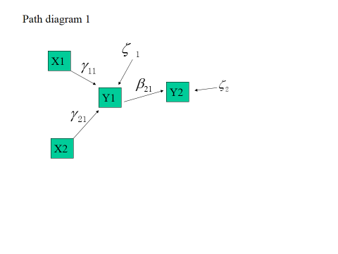









It is non-recursive. Because B matrix can be rearranged into lower triangle and  is a diagonal matrix

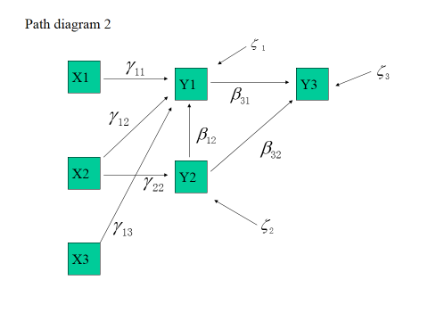















It is non-recursive. Because B matrix can be rearranged into lower triangle and  is a diagonal matrix

 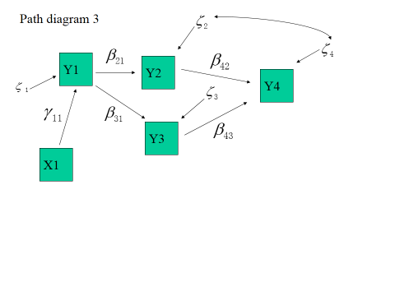







It is recursive. Because B matrix can be rearranged into lower triangle but  is not a diagonal matrix

 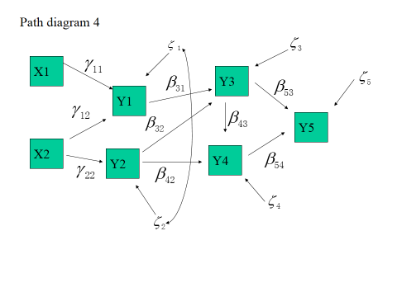















It is recursive. Because B matrix can be rearranged into lower triangle but  is not a diagonal matrix

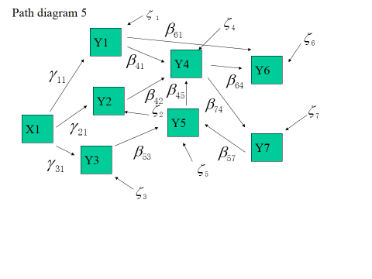













It is recursive. Because B matrix can’t be rearranged into lower triangle but  is a diagonal matrix