1)

a)

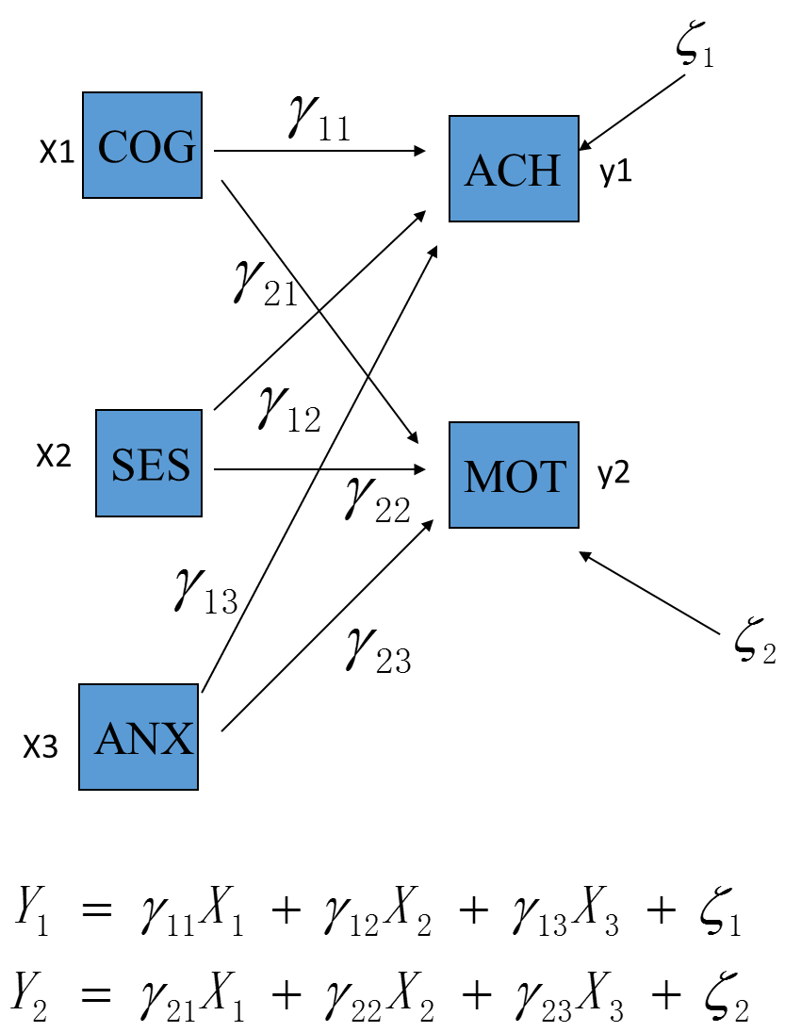

b)

p+q=5,



Number of =6









T=6+2+3=11<15

Thus, t-rule is fulfilled, the model is identified.

c)

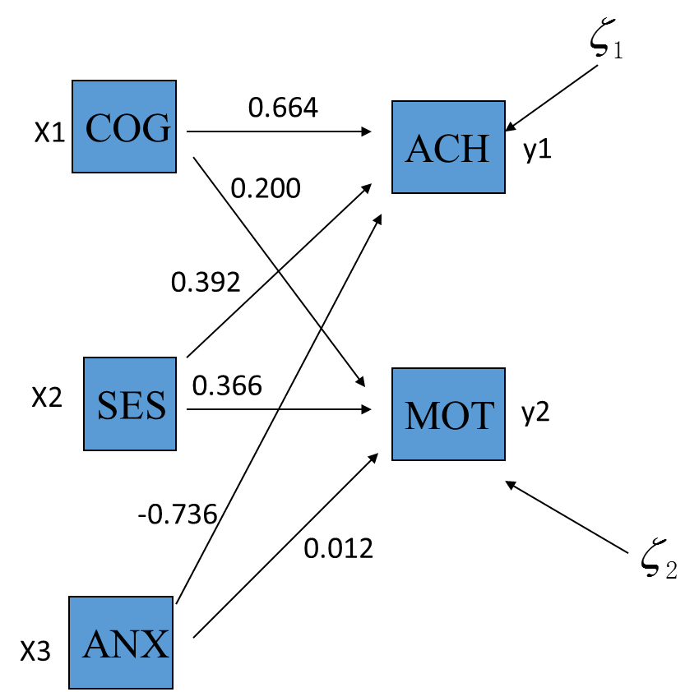

d) According to chi-square test of fit, the p-value =~0.000, indicating this is not a good fit.

Residual Variances

ACH 0.150 0.012 12.247 0.000

MOT 0.760 0.062 12.247 0.000

From the residual variance, we can see MOT is fitted badly.

e) ACH is more related to the causal agents. Because from the covariance table, ACH has better correlation with them.

R-SQUARE

Observed Two-Tailed

Variable Estimate S.E. Est./S.E. P-Value

ACH 0.850 0.016 53.188 0.000

MOT 0.237 0.043 5.526 0.000

2)

Whether adding ACH and MOT or disturbance residuals, free parameters will add 2, making it 13<15, so the model is still identified.

3)

a)

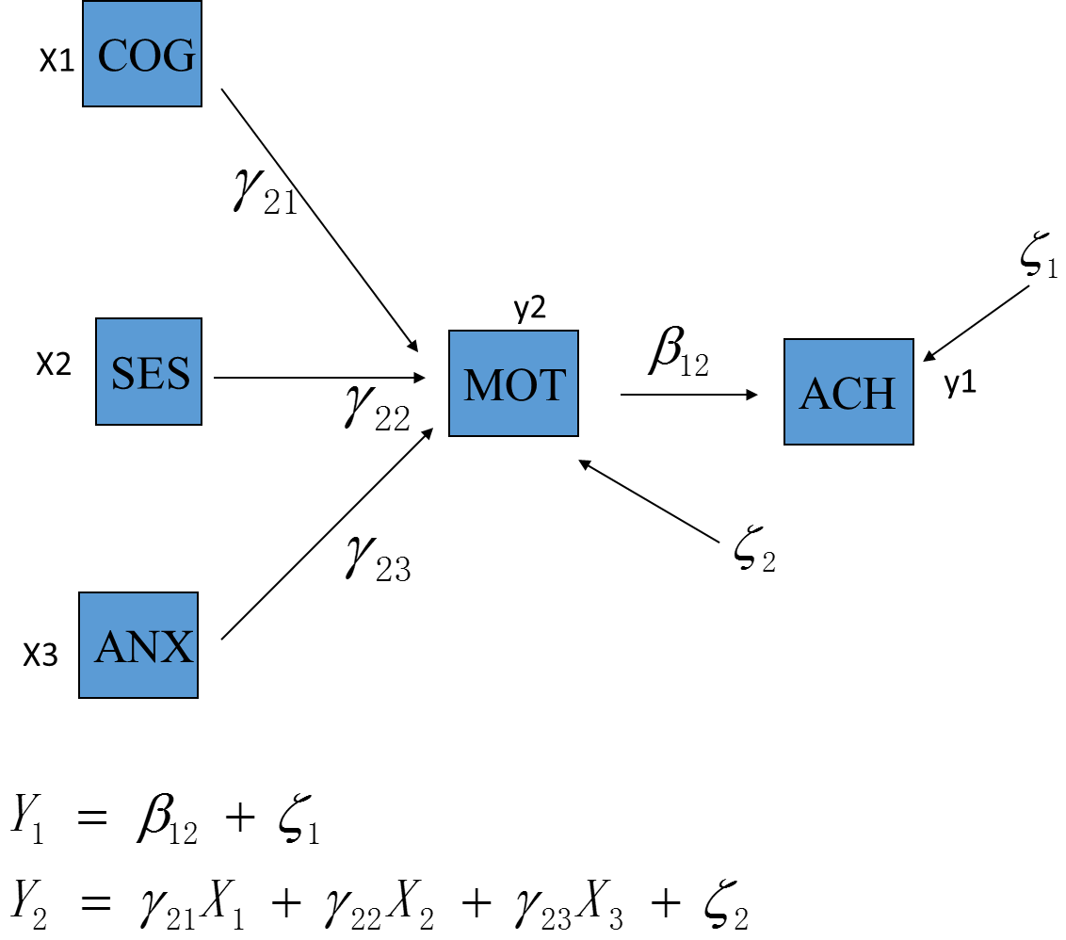

b)

p+q=4,



Number of =3









T=3+1+2+3=9<10

Thus, t-rule is fulfilled, the model is identified.

c)

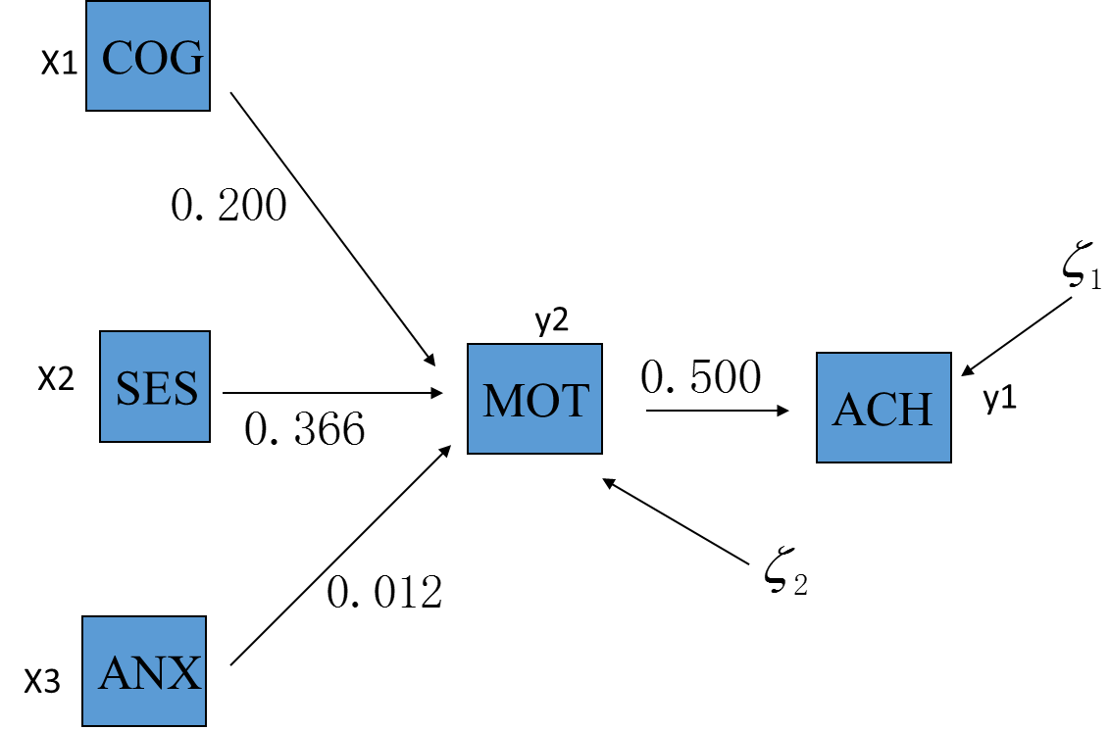

d) According to chi-square test of fit, the p-value =~0.000, indicating this is not a good fit.

Residual Variances

ACH 0.748 0.061 12.247 0.000

MOT 0.760 0.062 12.247 0.000

From the residual variance table, ACH and MOT are fitted poorly. Indicating the model itself is wrong.