1) Below is the outlet from Mplus concerning single-factor model.

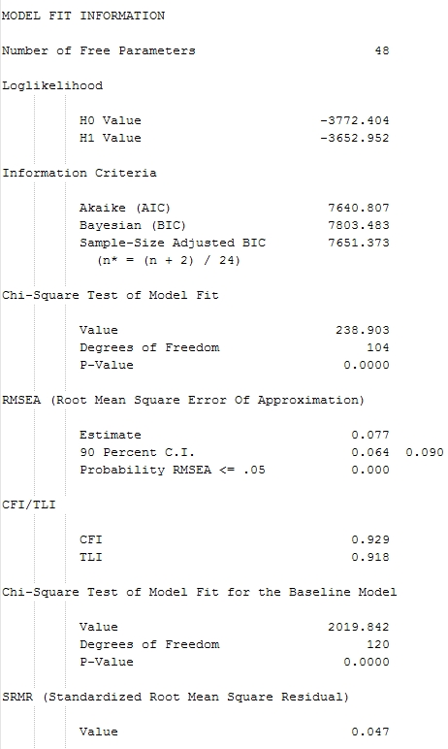

CFI=0.929<0.95, indicates the model is poorly fit. RMSEA =0.077, indicates the model is fairly fit. SRMR =0.047<0.5, is considered good. So overall, the model is not a good fit. A fair fit at most. There should be some variables that do not fit well.

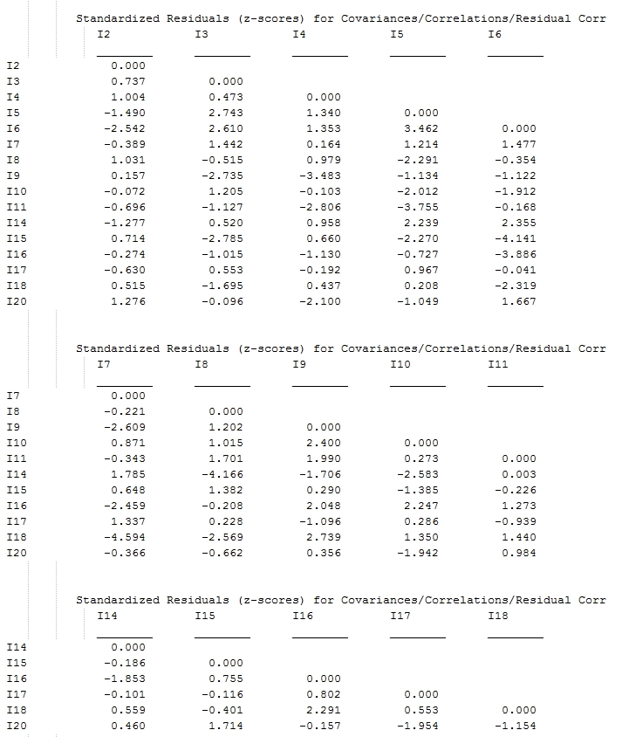

From the Standardized Residuals (z-scores) for Covariances/Correlations/Residual Corr table, we can find there are three instances that have high z-score. i6~i15, i7~i18, i8~i14, all have z-score larger than 4, indicating those are the ones that are responsible for lack of fit.

2)

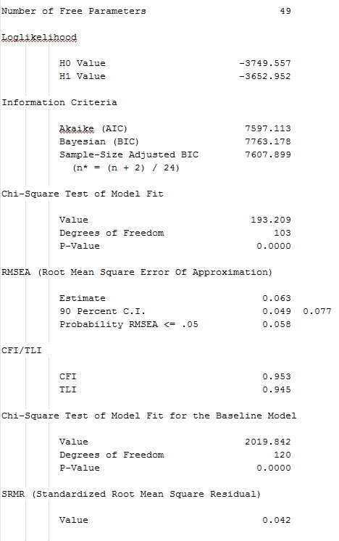

CFI=0.953>0.95, indicates the model is a good fit. RMSEA =0.063, indicates the model is fairly fit. SRMR =0.042<0.5, is considered good. So overall, the model is a good fit. But there should be improvements be made to better fit the model.

3)

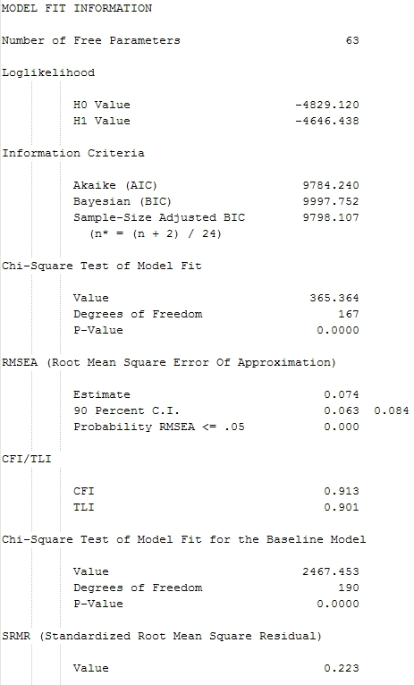

CFI=0.913<0.95, indicates the model is not a good fit. RMSEA =0.074, indicates the model is fairly fit. SRMR =0.223>0.05, is considered bad fit. So overall, the model is not a good fit.

Mplus Syntax

TITLE: Homework 3 Single-Factor model

DATA: FILE = "B:\dropbox\class\ANXM.DAT";

VARIABLE: NAMES ARE i1-i20;

USEVARIABLES ARE i2 i3 i4 i5 i6 i7 i8 i9 i10 i11 i14 i15 i16 i17 i18 i20 ;

ANALYSIS: TYPE = GENERAL;

ITERATIONS=3000;

ESTIMATOR=ML;

MODEL: F1 BY i3 i4 i5 i6 i7 i14 i17 i20 i2 i8 i9 i10 i11 i15 i16 i18;

OUTPUT: standardized residual ;

TITLE: Homework 3 two factor indep cluster (congeneric)

DATA: FILE = "B:\dropbox\class\ANXM.DAT";

VARIABLE: NAMES ARE i1-i20;

USEVARIABLES ARE i2 i3 i4 i5 i6 i7 i8 i9 i10 i11 i14 i15 i16 i17 i18 i20 ;

ANALYSIS: TYPE = GENERAL;

ITERATIONS=3000;

ESTIMATOR=ML;

MODEL: F1 BY i3 i4 i5 i6 i7 i14 i17 i20;

F2 BY i2 i8 i9 i10 i11 i15 i16 i18;

OUTPUT: standardized residual;

TITLE: Homework 3 EFA

DATA: FILE = "B:\dropbox\class\ANXM.DAT";

VARIABLE: NAMES ARE i1-i20;

USEVARIABLES ARE i1-i20;

ANALYSIS: TYPE = GENERAL;

ITERATIONS=3000;

ESTIMATOR=ML;

MODEL: F1 BY i3 i4 i5 i6 i7 i14 i17 i20 i1\*.5 i12\*.5 i13\*.5 i19\*.5;

F2 BY i2 i8 i9 i10 i11 i15 i16 i18 i1\*.5 i12\*.5 i13\*.5 i19\*.5;

F1@1 F2@1;

OUTPUT: standardized residual ;