1. Configural invariance model:

For this model**:** Same number of common factors across groups, with the nonzero loadings in the same locations in the loading matrix across groups

So in this model, we specify one common factor to load onto the five variables, and controlling the loading of CESD1 to be 1 for model identification purpose.

The following Mplus model is used:

MODEL: F1 BY CESD1@1 CESD2 CESD7 CESD11 CESD20;

[CESD1 CESD2@0 CESD7 CESD11 CESD20];

MODEL G1: [F1];

MODEL G2: F1 BY CESD1@1 CESD2 CESD7 CESD11 CESD20;

[CESD1 CESD2@0 CESD7 CESD11 CESD20];

[F1];

From the Mplus output,

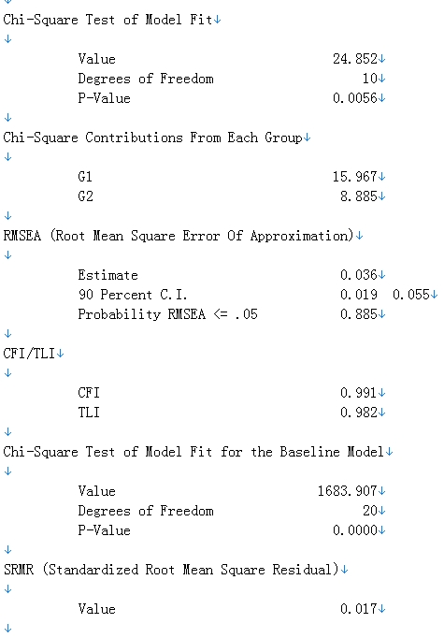

Chi-square=24.852, with pvalue=0.0056, which means a good fit of the model. RMSEA=0.036, CFI=0.991, SRMR=0.017 all means good fit of the model.

1. Metric invariance model

In this model, we force the loadings to have the same values across groups. Thus, the following Mplus model script is used.

MODEL: F1 BY CESD1@1 CESD2 CESD7 CESD11 CESD20;

[CESD1 CESD2@0 CESD7 CESD11 CESD20];

MODEL G1: [F1];

MODEL G2: [CESD1 CESD2@0 CESD7 CESD11 CESD20];

[F1];

From the Mplus output,

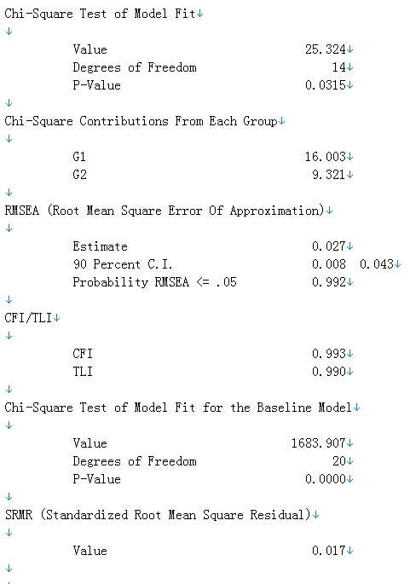

Chi-square= 25.324, with pvalue= 0.0315, which means a good fit of the model. RMSEA= 0.027, CFI=0.993, SRMR=0.017 all means good fit of the model. And actually the model seems to be improved a little bit. So no modification needed.

1. Strong invariance model:

For this model, we need to hold when both the loadings and the latent intercepts are invariant across groups. The following Mplus script is used.

MODEL: F1 BY CESD1@1 CESD2 CESD7 CESD11 CESD20;

[CESD1 CESD2@0 CESD7 CESD11 CESD20];

MODEL G1: [F1];

MODEL G2: [F1];

The output is followed:

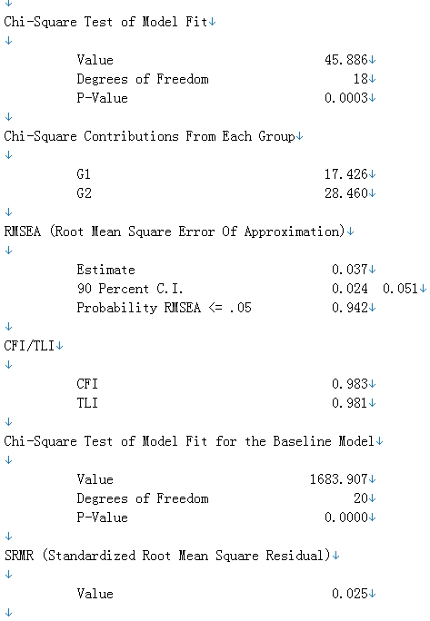

Chi-square= 45.886, with pvalue= 0.0003, which still means a good fit of the model, but since the Chi-square value increased a lot, it means the model is not as well fitted. RMSEA= 0.037, CFI=0.983, SRMR=0.025 all means good fit of the model. So overall, the model is still a good fit.

1. Strict invariance model

For this model, in addition to the above constraints, we will also constrain the unique variances.

So the following Mplus model script is used:

MODEL: F1 BY CESD1@1 CESD2 CESD7 CESD11 CESD20;

[CESD1 CESD2@0 CESD7 CESD11 CESD20];

CESD1 (1);

CESD2 (2);

CESD7 (3);

CESD11 (4);

CESD20 (5);

MODEL G1: [F1];

MODEL G2: [F1];

CESD1 (1);

CESD2 (2);

CESD7 (3);

CESD11 (4);

CESD20 (5);

The output is followed:

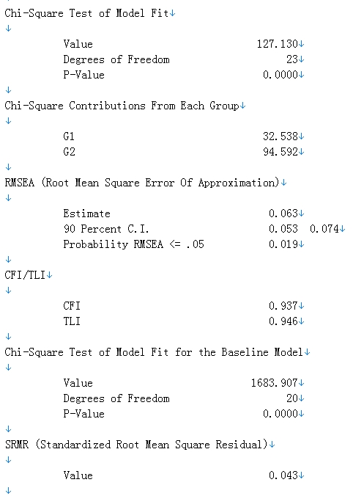

Chi-square= 127.130, with pvalue<0.0001, it means the model is not as well fitted because the Chi-square value increased a lot. RMSEA= 0.063, CFI=0.937, SRMR=0.043 still means a fair fit. But compared with the above model, the fit is clearly bad. And modifications needed.

From the following output, we can know that the residual variance of CESD2 and CESD7 should not be constraint, because they have the biggest s in the residual analysis.

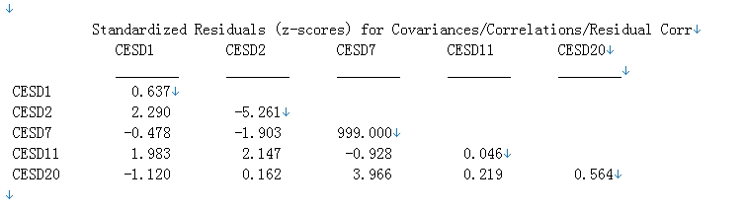

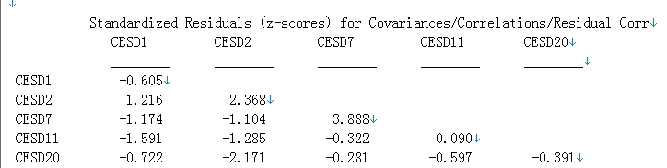

So modify the model using the following script:

MODEL: F1 BY CESD1@1 CESD2 CESD7 CESD11 CESD20;

[CESD1 CESD2@0 CESD7 CESD11 CESD20];

CESD1 (1);

CESD11 (2);

CESD20 (3);

MODEL G1: [F1];

MODEL G2: [F1];

CESD1 (1);

CESD11 (2);

CESD20 (3);

The output:

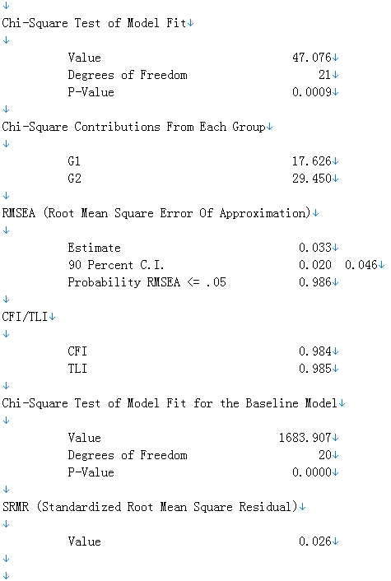

The global fit indices improved a lot. However, one of the local fit information below still shows not fit well.

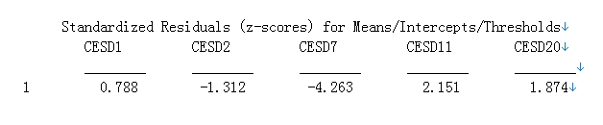

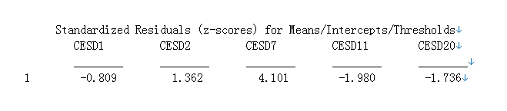

So we will lose the constraint on the intercept for CESD7 using the following model:

MODEL: F1 BY CESD1@1 CESD2 CESD7 CESD11 CESD20;

[CESD1 CESD2@0 CESD7 CESD11 CESD20];

CESD1 (1);

CESD11 (2);

CESD20 (3);

MODEL G1: [F1];

MODEL G2: [F1];[CESD7];

CESD1 (1);

CESD11 (2);

CESD20 (3);

Output attached:

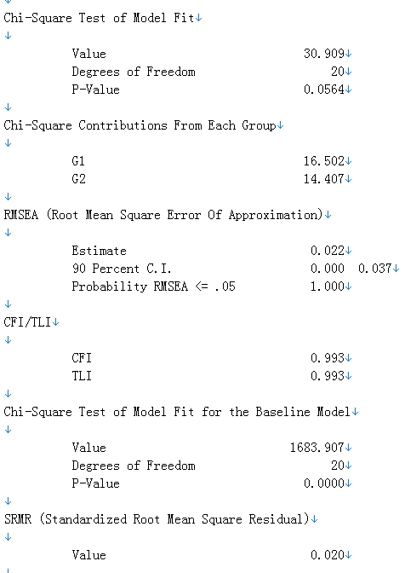

Chi-square= 30.909, with pvalue=0.0564, the Chi-square value is good and from the p-value, we could not reject the model at alpha=0.05 level, indicating perfect fit. RMSEA= 0.022, CFI=0.993, SRMR=0.02 all means good fit. So overall, this model is the final model.

And since this equal factor means and equal factor variances models offers almost good fit, thus, we can conclude that the groups do not differ in their factor means. And since the intercept of CESD7 freely estimated among the groups, it shows the intercept is different. And the variance of CESD2 and CESD7 are not constraint, their unique variance are different.

Mplus VERSION 6.12

MUTHEN & MUTHEN

04/20/2014 12:00 AM

INPUT INSTRUCTIONS

TITLE: CESD data from Gregorich(2006) Configural

DATA: FILE = "B:\dropbox\class\CESD_WBdata.dat";

TYPE IS means cova;

NGROUPS = 2;

NOBSERVATIONS = 2004 248;

VARIABLE: NAMES ARE CESD1 CESD2 CESD7 CESD11 CESD20;

ANALYSIS: TYPE = MGROUP;

ITERATIONS=3000;

ESTIMATOR=ML;

MODEL: F1 BY CESD1@1 CESD2 CESD7 CESD11 CESD20;

[CESD1 CESD2@0 CESD7 CESD11 CESD20];

MODEL G1: [F1];

MODEL G2: F1 BY CESD1@1 CESD2 CESD7 CESD11 CESD20;

[CESD1 CESD2@0 CESD7 CESD11 CESD20];

[F1];

OUTPUT: sampstat residual;

INPUT READING TERMINATED NORMALLY

CESD data from Gregorich(2006) Configural

SUMMARY OF ANALYSIS

Number of groups 2

Number of observations

Group G1 2004

Group G2 248

Number of dependent variables 5

Number of independent variables 0

Number of continuous latent variables 1

Observed dependent variables

Continuous

CESD1 CESD2 CESD7 CESD11 CESD20

Continuous latent variables

F1

Estimator ML

Information matrix EXPECTED

Maximum number of iterations 3000

Convergence criterion 0.500D-04

Maximum number of steepest descent iterations 20

Input data file(s)

B:\dropbox\class\CESD_WBdata.dat

Input data format FREE

SAMPLE STATISTICS

SAMPLE STATISTICS FOR G1

Means/Intercepts/Thresholds

CESD1 CESD2 CESD7 CESD11 CESD20

________ ________ ________ ________ ________

1 0.328 0.240 0.486 0.612 0.437

Covariances/Correlations/Residual Correlations

CESD1 CESD2 CESD7 CESD11 CESD20

________ ________ ________ ________ ________

CESD1 0.498

CESD2 0.126 0.427

CESD7 0.200 0.178 0.765

CESD11 0.182 0.170 0.273 0.823

CESD20 0.166 0.162 0.318 0.241 0.631

SAMPLE STATISTICS FOR G2

Means/Intercepts/Thresholds

CESD1 CESD2 CESD7 CESD11 CESD20

________ ________ ________ ________ ________

1 0.351 0.347 0.806 0.589 0.456

Covariances/Correlations/Residual Correlations

CESD1 CESD2 CESD7 CESD11 CESD20

________ ________ ________ ________ ________

CESD1 0.496

CESD2 0.169 0.576

CESD7 0.194 0.173 1.290

CESD11 0.141 0.131 0.317 0.875

CESD20 0.188 0.125 0.344 0.265 0.662

THE MODEL ESTIMATION TERMINATED NORMALLY

MODEL FIT INFORMATION

Number of Free Parameters 30

Loglikelihood

H0 Value -12475.037

H1 Value -12462.610

Information Criteria

Akaike (AIC) 25010.073

Bayesian (BIC) 25181.660

Sample-Size Adjusted BIC 25086.345

(n* = (n + 2) / 24)

Chi-Square Test of Model Fit

Value 24.852

Degrees of Freedom 10

P-Value 0.0056

Chi-Square Contributions From Each Group

G1 15.967

G2 8.885

RMSEA (Root Mean Square Error Of Approximation)

Estimate 0.036

90 Percent C.I. 0.019 0.055

Probability RMSEA <= .05 0.885

CFI/TLI

CFI 0.991

TLI 0.982

Chi-Square Test of Model Fit for the Baseline Model

Value 1683.907

Degrees of Freedom 20

P-Value 0.0000

SRMR (Standardized Root Mean Square Residual)

Value 0.017

MODEL RESULTS

Two-Tailed

Estimate S.E. Est./S.E. P-Value

Group G1

F1 BY

CESD1 1.000 0.000 999.000 999.000

CESD2 0.930 0.064 14.635 0.000

CESD7 1.679 0.100 16.761 0.000

CESD11 1.389 0.091 15.245 0.000

CESD20 1.476 0.089 16.609 0.000

Means

F1 0.258 0.024 10.933 0.000

Intercepts

CESD1 0.070 0.026 2.675 0.007

CESD2 0.000 0.000 999.000 999.000

CESD7 0.053 0.037 1.410 0.158

CESD11 0.254 0.035 7.316 0.000

CESD20 0.056 0.033 1.688 0.091

Variances

F1 0.121 0.012 9.897 0.000

Residual Variances

CESD1 0.376 0.014 27.601 0.000

CESD2 0.322 0.012 27.552 0.000

CESD7 0.422 0.020 21.241 0.000

CESD11 0.588 0.022 26.622 0.000

CESD20 0.366 0.016 22.353 0.000

Group G2

F1 BY

CESD1 1.000 0.000 999.000 999.000

CESD2 0.838 0.199 4.219 0.000

CESD7 1.760 0.343 5.137 0.000

CESD11 1.340 0.271 4.947 0.000

CESD20 1.492 0.277 5.383 0.000

Means

F1 0.414 0.114 3.642 0.000

Intercepts

CESD1 -0.063 0.118 -0.535 0.593

CESD2 0.000 0.000 999.000 999.000

CESD7 0.077 0.201 0.385 0.700

CESD11 0.034 0.157 0.216 0.829

CESD20 -0.162 0.163 -0.994 0.320

Variances

F1 0.125 0.037 3.373 0.001

Residual Variances

CESD1 0.369 0.040 9.206 0.000

CESD2 0.486 0.048 10.126 0.000

CESD7 0.897 0.104 8.652 0.000

CESD11 0.646 0.071 9.157 0.000

CESD20 0.380 0.055 6.954 0.000

QUALITY OF NUMERICAL RESULTS

Condition Number for the Information Matrix 0.132E-03

(ratio of smallest to largest eigenvalue)

RESIDUAL OUTPUT

ESTIMATED MODEL AND RESIDUALS (OBSERVED - ESTIMATED) FOR G1

Model Estimated Means/Intercepts/Thresholds

CESD1 CESD2 CESD7 CESD11 CESD20

________ ________ ________ ________ ________

1 0.328 0.240 0.486 0.612 0.437

Residuals for Means/Intercepts/Thresholds

CESD1 CESD2 CESD7 CESD11 CESD20

________ ________ ________ ________ ________

1 0.000 0.000 0.000 0.000 0.000

Standardized Residuals (z-scores) for Means/Intercepts/Thresholds

CESD1 CESD2 CESD7 CESD11 CESD20

________ ________ ________ ________ ________

1 0.000 0.000 0.000 0.000 0.000

Normalized Residuals for Means/Intercepts/Thresholds

CESD1 CESD2 CESD7 CESD11 CESD20

________ ________ ________ ________ ________

1 0.000 0.000 0.000 0.000 0.000

Model Estimated Covariances/Correlations/Residual Correlations

CESD1 CESD2 CESD7 CESD11 CESD20

________ ________ ________ ________ ________

CESD1 0.498

CESD2 0.113 0.427

CESD7 0.204 0.190 0.765

CESD11 0.169 0.157 0.283 0.823

CESD20 0.179 0.167 0.301 0.249 0.631

Residuals for Covariances/Correlations/Residual Correlations

CESD1 CESD2 CESD7 CESD11 CESD20

________ ________ ________ ________ ________

CESD1 0.000

CESD2 0.013 0.000

CESD7 -0.004 -0.012 0.000

CESD11 0.013 0.013 -0.010 0.000

CESD20 -0.013 -0.005 0.017 -0.008 0.000

Standardized Residuals (z-scores) for Covariances/Correlations/Residual Corr

CESD1 CESD2 CESD7 CESD11 CESD20

________ ________ ________ ________ ________

CESD1 999.000

CESD2 1.965 0.000

CESD7 -0.665 -2.191 0.000

CESD11 1.528 1.627 -1.499 0.000

CESD20 -2.355 -0.891 3.459 -1.183 0.000

Normalized Residuals for Covariances/Correlations/Residual Correlations

CESD1 CESD2 CESD7 CESD11 CESD20

________ ________ ________ ________ ________

CESD1 0.000

CESD2 1.220 0.000

CESD7 -0.272 -0.874 0.000

CESD11 0.894 0.949 -0.549 0.000

CESD20 -1.014 -0.388 0.997 -0.470 0.000

ESTIMATED MODEL AND RESIDUALS (OBSERVED - ESTIMATED) FOR G2

Model Estimated Means/Intercepts/Thresholds

CESD1 CESD2 CESD7 CESD11 CESD20

________ ________ ________ ________ ________

1 0.351 0.347 0.806 0.589 0.456

Residuals for Means/Intercepts/Thresholds

CESD1 CESD2 CESD7 CESD11 CESD20

________ ________ ________ ________ ________

1 0.000 0.000 0.000 0.000 0.000

Standardized Residuals (z-scores) for Means/Intercepts/Thresholds

CESD1 CESD2 CESD7 CESD11 CESD20

________ ________ ________ ________ ________

1 999.000 999.000 0.000 0.000 -0.009

Normalized Residuals for Means/Intercepts/Thresholds

CESD1 CESD2 CESD7 CESD11 CESD20

________ ________ ________ ________ ________

1 0.000 0.000 0.000 0.000 0.000

Model Estimated Covariances/Correlations/Residual Correlations

CESD1 CESD2 CESD7 CESD11 CESD20

________ ________ ________ ________ ________

CESD1 0.494

CESD2 0.105 0.574

CESD7 0.220 0.185 1.285

CESD11 0.168 0.141 0.296 0.871

CESD20 0.187 0.157 0.329 0.251 0.659

Residuals for Covariances/Correlations/Residual Correlations

CESD1 CESD2 CESD7 CESD11 CESD20

________ ________ ________ ________ ________

CESD1 0.000

CESD2 0.063 0.000

CESD7 -0.027 -0.012 0.000

CESD11 -0.027 -0.010 0.020 0.000

CESD20 0.000 -0.032 0.014 0.013 0.000

Standardized Residuals (z-scores) for Covariances/Correlations/Residual Corr

CESD1 CESD2 CESD7 CESD11 CESD20

________ ________ ________ ________ ________

CESD1 0.000

CESD2 2.646 999.000

CESD7 -1.090 -0.376 999.000

CESD11 -1.214 -0.348 0.581 999.000

CESD20 0.023 -1.819 0.672 0.713 0.025

Normalized Residuals for Covariances/Correlations/Residual Correlations

CESD1 CESD2 CESD7 CESD11 CESD20

________ ________ ________ ________ ________

CESD1 0.000

CESD2 1.786 0.000

CESD7 -0.524 -0.224 0.000

CESD11 -0.645 -0.224 0.288 0.000

CESD20 0.008 -0.807 0.219 0.263 0.000

Beginning Time: 00:00:33

Ending Time: 00:00:33

Elapsed Time: 00:00:00

MUTHEN & MUTHEN

TITLE: CESD data from Gregorich(2006) Metric

DATA: FILE = "B:\dropbox\class\CESD_WBdata.dat";

TYPE IS means cova;

NGROUPS = 2;

NOBSERVATIONS = 2004 248;

VARIABLE: NAMES ARE CESD1 CESD2 CESD7 CESD11 CESD20;

ANALYSIS: TYPE = MGROUP;

ITERATIONS=3000;

ESTIMATOR=ML;

MODEL: F1 BY CESD1@1 CESD2 CESD7 CESD11 CESD20;

[CESD1 CESD2@0 CESD7 CESD11 CESD20];

MODEL G1: [F1];

MODEL G2: [CESD1 CESD2@0 CESD7 CESD11 CESD20];

[F1];

OUTPUT: sampstat residual;

INPUT READING TERMINATED NORMALLY

CESD data from Gregorich(2006) Metric

SUMMARY OF ANALYSIS

Number of groups 2

Number of observations

Group G1 2004

Group G2 248

Number of dependent variables 5

Number of independent variables 0

Number of continuous latent variables 1

Observed dependent variables

Continuous

CESD1 CESD2 CESD7 CESD11 CESD20

Continuous latent variables

F1

Estimator ML

Information matrix EXPECTED

Maximum number of iterations 3000

Convergence criterion 0.500D-04

Maximum number of steepest descent iterations 20

Input data file(s)

B:\dropbox\class\CESD_WBdata.dat

Input data format FREE

SAMPLE STATISTICS

SAMPLE STATISTICS FOR G1

Means/Intercepts/Thresholds

CESD1 CESD2 CESD7 CESD11 CESD20

________ ________ ________ ________ ________

1 0.328 0.240 0.486 0.612 0.437

Covariances/Correlations/Residual Correlations

CESD1 CESD2 CESD7 CESD11 CESD20

________ ________ ________ ________ ________

CESD1 0.498

CESD2 0.126 0.427

CESD7 0.200 0.178 0.765

CESD11 0.182 0.170 0.273 0.823

CESD20 0.166 0.162 0.318 0.241 0.631

SAMPLE STATISTICS FOR G2

Means/Intercepts/Thresholds

CESD1 CESD2 CESD7 CESD11 CESD20

________ ________ ________ ________ ________

1 0.351 0.347 0.806 0.589 0.456

Covariances/Correlations/Residual Correlations

CESD1 CESD2 CESD7 CESD11 CESD20

________ ________ ________ ________ ________

CESD1 0.496

CESD2 0.169 0.576

CESD7 0.194 0.173 1.290

CESD11 0.141 0.131 0.317 0.875

CESD20 0.188 0.125 0.344 0.265 0.662

THE MODEL ESTIMATION TERMINATED NORMALLY

MODEL FIT INFORMATION

Number of Free Parameters 26

Loglikelihood

H0 Value -12475.272

H1 Value -12462.610

Information Criteria

Akaike (AIC) 25002.545

Bayesian (BIC) 25151.254

Sample-Size Adjusted BIC 25068.647

(n* = (n + 2) / 24)

Chi-Square Test of Model Fit

Value 25.324

Degrees of Freedom 14

P-Value 0.0315

Chi-Square Contributions From Each Group

G1 16.003

G2 9.321

RMSEA (Root Mean Square Error Of Approximation)

Estimate 0.027

90 Percent C.I. 0.008 0.043

Probability RMSEA <= .05 0.992

CFI/TLI

CFI 0.993

TLI 0.990

Chi-Square Test of Model Fit for the Baseline Model

Value 1683.907

Degrees of Freedom 20

P-Value 0.0000

SRMR (Standardized Root Mean Square Residual)

Value 0.017

MODEL RESULTS

Two-Tailed

Estimate S.E. Est./S.E. P-Value

Group G1

F1 BY

CESD1 1.000 0.000 999.000 999.000

CESD2 0.922 0.060 15.269 0.000

CESD7 1.682 0.096 17.551 0.000

CESD11 1.383 0.086 16.031 0.000

CESD20 1.475 0.084 17.473 0.000

Means

F1 0.260 0.023 11.195 0.000

Intercepts

CESD1 0.068 0.026 2.625 0.009

CESD2 0.000 0.000 999.000 999.000

CESD7 0.048 0.037 1.298 0.194

CESD11 0.252 0.034 7.377 0.000

CESD20 0.053 0.033 1.611 0.107

Variances

F1 0.122 0.012 10.316 0.000

Residual Variances

CESD1 0.376 0.014 27.698 0.000

CESD2 0.322 0.012 27.701 0.000

CESD7 0.421 0.020 21.315 0.000

CESD11 0.589 0.022 26.783 0.000

CESD20 0.366 0.016 22.515 0.000

Group G2

F1 BY

CESD1 1.000 0.000 999.000 999.000

CESD2 0.922 0.060 15.269 0.000

CESD7 1.682 0.096 17.551 0.000

CESD11 1.383 0.086 16.031 0.000

CESD20 1.475 0.084 17.473 0.000

Means

F1 0.376 0.058 6.473 0.000

Intercepts

CESD1 -0.025 0.066 -0.382 0.703

CESD2 0.000 0.000 999.000 999.000

CESD7 0.173 0.107 1.618 0.106

CESD11 0.069 0.089 0.770 0.441

CESD20 -0.099 0.087 -1.141 0.254

Variances

F1 0.124 0.020 6.267 0.000

Residual Variances

CESD1 0.367 0.038 9.791 0.000

CESD2 0.479 0.047 10.276 0.000

CESD7 0.913 0.095 9.623 0.000

CESD11 0.641 0.066 9.665 0.000

CESD20 0.386 0.047 8.300 0.000

QUALITY OF NUMERICAL RESULTS

Condition Number for the Information Matrix 0.106E-02

(ratio of smallest to largest eigenvalue)

RESIDUAL OUTPUT

ESTIMATED MODEL AND RESIDUALS (OBSERVED - ESTIMATED) FOR G1

Model Estimated Means/Intercepts/Thresholds

CESD1 CESD2 CESD7 CESD11 CESD20

________ ________ ________ ________ ________

1 0.328 0.240 0.486 0.612 0.437

Residuals for Means/Intercepts/Thresholds

CESD1 CESD2 CESD7 CESD11 CESD20

________ ________ ________ ________ ________

1 0.000 0.000 0.000 0.000 0.000

Standardized Residuals (z-scores) for Means/Intercepts/Thresholds

CESD1 CESD2 CESD7 CESD11 CESD20

________ ________ ________ ________ ________

1 0.000 0.000 0.000 0.000 0.000

Normalized Residuals for Means/Intercepts/Thresholds

CESD1 CESD2 CESD7 CESD11 CESD20

________ ________ ________ ________ ________

1 0.000 0.000 0.000 0.000 0.000

Model Estimated Covariances/Correlations/Residual Correlations

CESD1 CESD2 CESD7 CESD11 CESD20

________ ________ ________ ________ ________

CESD1 0.498

CESD2 0.112 0.426

CESD7 0.205 0.189 0.766

CESD11 0.168 0.155 0.283 0.822

CESD20 0.180 0.166 0.302 0.248 0.631

Residuals for Covariances/Correlations/Residual Correlations

CESD1 CESD2 CESD7 CESD11 CESD20

________ ________ ________ ________ ________

CESD1 0.000

CESD2 0.014 0.001

CESD7 -0.005 -0.011 -0.001

CESD11 0.014 0.015 -0.010 0.001

CESD20 -0.014 -0.004 0.016 -0.007 0.000

Standardized Residuals (z-scores) for Covariances/Correlations/Residual Corr

CESD1 CESD2 CESD7 CESD11 CESD20

________ ________ ________ ________ ________

CESD1 -0.138

CESD2 1.971 0.479

CESD7 -0.749 -1.863 -0.495

CESD11 1.488 1.730 -1.338 0.225

CESD20 -2.222 -0.644 2.863 -0.994 -0.118

Normalized Residuals for Covariances/Correlations/Residual Correlations

CESD1 CESD2 CESD7 CESD11 CESD20

________ ________ ________ ________ ________

CESD1 -0.019

CESD2 1.280 0.067

CESD7 -0.338 -0.822 -0.047

CESD11 0.916 1.066 -0.550 0.033

CESD20 -1.047 -0.307 0.920 -0.438 -0.014

ESTIMATED MODEL AND RESIDUALS (OBSERVED - ESTIMATED) FOR G2

Model Estimated Means/Intercepts/Thresholds

CESD1 CESD2 CESD7 CESD11 CESD20

________ ________ ________ ________ ________

1 0.351 0.347 0.806 0.589 0.456

Residuals for Means/Intercepts/Thresholds

CESD1 CESD2 CESD7 CESD11 CESD20

________ ________ ________ ________ ________

1 0.000 0.000 0.000 0.000 0.000

Standardized Residuals (z-scores) for Means/Intercepts/Thresholds

CESD1 CESD2 CESD7 CESD11 CESD20

________ ________ ________ ________ ________

1 0.000 0.000 0.000 0.000 0.000

Normalized Residuals for Means/Intercepts/Thresholds

CESD1 CESD2 CESD7 CESD11 CESD20

________ ________ ________ ________ ________

1 0.000 0.000 0.000 0.000 0.000

Model Estimated Covariances/Correlations/Residual Correlations

CESD1 CESD2 CESD7 CESD11 CESD20

________ ________ ________ ________ ________

CESD1 0.492

CESD2 0.115 0.585

CESD7 0.209 0.193 1.265

CESD11 0.172 0.158 0.289 0.879

CESD20 0.183 0.169 0.308 0.253 0.657

Residuals for Covariances/Correlations/Residual Correlations

CESD1 CESD2 CESD7 CESD11 CESD20

________ ________ ________ ________ ________

CESD1 0.002

CESD2 0.054 -0.011

CESD7 -0.016 -0.020 0.020

CESD11 -0.031 -0.028 0.027 -0.008

CESD20 0.004 -0.045 0.034 0.011 0.002

Standardized Residuals (z-scores) for Covariances/Correlations/Residual Corr

CESD1 CESD2 CESD7 CESD11 CESD20

________ ________ ________ ________ ________

CESD1 0.130

CESD2 1.724 -0.625

CESD7 -0.372 -0.427 0.393

CESD11 -0.906 -0.712 0.474 -0.251

CESD20 0.143 -1.415 0.767 0.291 0.112

Normalized Residuals for Covariances/Correlations/Residual Correlations

CESD1 CESD2 CESD7 CESD11 CESD20

________ ________ ________ ________ ________

CESD1 0.053

CESD2 1.516 -0.211

CESD7 -0.303 -0.368 0.171

CESD11 -0.735 -0.612 0.381 -0.096

CESD20 0.104 -1.118 0.549 0.207 0.041

Beginning Time: 00:00:34

Ending Time: 00:00:34

Elapsed Time: 00:00:00

Mplus VERSION 6.12

MUTHEN & MUTHEN

04/20/2014 12:00 AM

INPUT INSTRUCTIONS

TITLE: CESD data from Gregorich(2006) Strong

DATA: FILE = "B:\dropbox\class\CESD_WBdata.dat";

TYPE IS means cova;

NGROUPS = 2;

NOBSERVATIONS = 2004 248;

VARIABLE: NAMES ARE CESD1 CESD2 CESD7 CESD11 CESD20;

ANALYSIS: TYPE = MGROUP;

ITERATIONS=3000;

ESTIMATOR=ML;

MODEL: F1 BY CESD1@1 CESD2 CESD7 CESD11 CESD20;

[CESD1 CESD2@0 CESD7 CESD11 CESD20];

MODEL G1: [F1];

MODEL G2: [F1];

OUTPUT: sampstat residual;

INPUT READING TERMINATED NORMALLY

CESD data from Gregorich(2006) Strong

SUMMARY OF ANALYSIS

Number of groups 2

Number of observations

Group G1 2004

Group G2 248

Number of dependent variables 5

Number of independent variables 0

Number of continuous latent variables 1

Observed dependent variables

Continuous

CESD1 CESD2 CESD7 CESD11 CESD20

Continuous latent variables

F1

Estimator ML

Information matrix EXPECTED

Maximum number of iterations 3000

Convergence criterion 0.500D-04

Maximum number of steepest descent iterations 20

Input data file(s)

B:\dropbox\class\CESD_WBdata.dat

Input data format FREE

SAMPLE STATISTICS

SAMPLE STATISTICS FOR G1

Means/Intercepts/Thresholds

CESD1 CESD2 CESD7 CESD11 CESD20

________ ________ ________ ________ ________

1 0.328 0.240 0.486 0.612 0.437

Covariances/Correlations/Residual Correlations

CESD1 CESD2 CESD7 CESD11 CESD20

________ ________ ________ ________ ________

CESD1 0.498

CESD2 0.126 0.427

CESD7 0.200 0.178 0.765

CESD11 0.182 0.170 0.273 0.823

CESD20 0.166 0.162 0.318 0.241 0.631

SAMPLE STATISTICS FOR G2

Means/Intercepts/Thresholds

CESD1 CESD2 CESD7 CESD11 CESD20

________ ________ ________ ________ ________

1 0.351 0.347 0.806 0.589 0.456

Covariances/Correlations/Residual Correlations

CESD1 CESD2 CESD7 CESD11 CESD20

________ ________ ________ ________ ________

CESD1 0.496

CESD2 0.169 0.576

CESD7 0.194 0.173 1.290

CESD11 0.141 0.131 0.317 0.875

CESD20 0.188 0.125 0.344 0.265 0.662

THE MODEL ESTIMATION TERMINATED NORMALLY

MODEL FIT INFORMATION

Number of Free Parameters 22

Loglikelihood

H0 Value -12485.553

H1 Value -12462.610

Information Criteria

Akaike (AIC) 25015.107

Bayesian (BIC) 25140.937

Sample-Size Adjusted BIC 25071.040

(n* = (n + 2) / 24)

Chi-Square Test of Model Fit

Value 45.886

Degrees of Freedom 18

P-Value 0.0003

Chi-Square Contributions From Each Group

G1 17.426

G2 28.460

RMSEA (Root Mean Square Error Of Approximation)

Estimate 0.037

90 Percent C.I. 0.024 0.051

Probability RMSEA <= .05 0.942

CFI/TLI

CFI 0.983

TLI 0.981

Chi-Square Test of Model Fit for the Baseline Model

Value 1683.907

Degrees of Freedom 20

P-Value 0.0000

SRMR (Standardized Root Mean Square Residual)

Value 0.025

MODEL RESULTS

Two-Tailed

Estimate S.E. Est./S.E. P-Value

Group G1

F1 BY

CESD1 1.000 0.000 999.000 999.000

CESD2 0.926 0.061 15.295 0.000

CESD7 1.690 0.096 17.550 0.000

CESD11 1.378 0.086 15.995 0.000

CESD20 1.472 0.084 17.458 0.000

Means

F1 0.264 0.023 11.373 0.000

Intercepts

CESD1 0.061 0.025 2.383 0.017

CESD2 0.000 0.000 999.000 999.000

CESD7 0.052 0.037 1.402 0.161

CESD11 0.239 0.034 7.085 0.000

CESD20 0.042 0.033 1.300 0.194

Variances

F1 0.122 0.012 10.311 0.000

Residual Variances

CESD1 0.376 0.014 27.706 0.000

CESD2 0.322 0.012 27.670 0.000

CESD7 0.420 0.020 21.210 0.000

CESD11 0.590 0.022 26.836 0.000

CESD20 0.367 0.016 22.583 0.000

Group G2

F1 BY

CESD1 1.000 0.000 999.000 999.000

CESD2 0.926 0.061 15.295 0.000

CESD7 1.690 0.096 17.550 0.000

CESD11 1.378 0.086 15.995 0.000

CESD20 1.472 0.084 17.458 0.000

Means

F1 0.319 0.036 8.935 0.000

Intercepts

CESD1 0.061 0.025 2.383 0.017

CESD2 0.000 0.000 999.000 999.000

CESD7 0.052 0.037 1.402 0.161

CESD11 0.239 0.034 7.085 0.000

CESD20 0.042 0.033 1.300 0.194

Variances

F1 0.123 0.020 6.221 0.000

Residual Variances

CESD1 0.368 0.038 9.777 0.000

CESD2 0.481 0.047 10.263 0.000

CESD7 0.972 0.100 9.690 0.000

CESD11 0.652 0.067 9.685 0.000

CESD20 0.392 0.047 8.322 0.000

QUALITY OF NUMERICAL RESULTS

Condition Number for the Information Matrix 0.139E-02

(ratio of smallest to largest eigenvalue)

RESIDUAL OUTPUT

ESTIMATED MODEL AND RESIDUALS (OBSERVED - ESTIMATED) FOR G1

Model Estimated Means/Intercepts/Thresholds

CESD1 CESD2 CESD7 CESD11 CESD20

________ ________ ________ ________ ________

1 0.324 0.244 0.498 0.602 0.431

Residuals for Means/Intercepts/Thresholds

CESD1 CESD2 CESD7 CESD11 CESD20

________ ________ ________ ________ ________

1 0.004 -0.004 -0.012 0.010 0.006

Standardized Residuals (z-scores) for Means/Intercepts/Thresholds

CESD1 CESD2 CESD7 CESD11 CESD20

________ ________ ________ ________ ________

1 0.864 -1.289 -4.288 1.982 1.808

Normalized Residuals for Means/Intercepts/Thresholds

CESD1 CESD2 CESD7 CESD11 CESD20

________ ________ ________ ________ ________

1 0.229 -0.294 -0.590 0.491 0.363

Model Estimated Covariances/Correlations/Residual Correlations

CESD1 CESD2 CESD7 CESD11 CESD20

________ ________ ________ ________ ________

CESD1 0.498

CESD2 0.113 0.426

CESD7 0.205 0.190 0.767

CESD11 0.167 0.155 0.283 0.821

CESD20 0.179 0.166 0.302 0.246 0.630

Residuals for Covariances/Correlations/Residual Correlations

CESD1 CESD2 CESD7 CESD11 CESD20

________ ________ ________ ________ ________

CESD1 0.000

CESD2 0.013 0.000

CESD7 -0.005 -0.012 -0.003

CESD11 0.015 0.015 -0.010 0.002

CESD20 -0.013 -0.004 0.015 -0.006 0.001

Standardized Residuals (z-scores) for Covariances/Correlations/Residual Corr

CESD1 CESD2 CESD7 CESD11 CESD20

________ ________ ________ ________ ________

CESD1 -0.076

CESD2 1.932 0.208

CESD7 -0.845 -2.133 -1.661

CESD11 1.580 1.747 -1.308 0.516

CESD20 -2.095 -0.660 2.835 -0.733 0.207

Normalized Residuals for Covariances/Correlations/Residual Correlations

CESD1 CESD2 CESD7 CESD11 CESD20

________ ________ ________ ________ ________

CESD1 -0.011

CESD2 1.252 0.027

CESD7 -0.378 -0.925 -0.112

CESD11 0.977 1.078 -0.537 0.080

CESD20 -0.995 -0.315 0.906 -0.328 0.028

ESTIMATED MODEL AND RESIDUALS (OBSERVED - ESTIMATED) FOR G2

Model Estimated Means/Intercepts/Thresholds

CESD1 CESD2 CESD7 CESD11 CESD20

________ ________ ________ ________ ________

1 0.379 0.295 0.591 0.678 0.512

Residuals for Means/Intercepts/Thresholds

CESD1 CESD2 CESD7 CESD11 CESD20

________ ________ ________ ________ ________

1 -0.028 0.052 0.215 -0.089 -0.056

Standardized Residuals (z-scores) for Means/Intercepts/Thresholds

CESD1 CESD2 CESD7 CESD11 CESD20

________ ________ ________ ________ ________

1 -0.856 1.322 4.043 -2.054 -1.824

Normalized Residuals for Means/Intercepts/Thresholds

CESD1 CESD2 CESD7 CESD11 CESD20

________ ________ ________ ________ ________

1 -0.638 1.075 2.993 -1.500 -1.079

Model Estimated Covariances/Correlations/Residual Correlations

CESD1 CESD2 CESD7 CESD11 CESD20

________ ________ ________ ________ ________

CESD1 0.490

CESD2 0.114 0.586

CESD7 0.208 0.192 1.323

CESD11 0.169 0.157 0.286 0.885

CESD20 0.181 0.168 0.306 0.249 0.658

Residuals for Covariances/Correlations/Residual Correlations

CESD1 CESD2 CESD7 CESD11 CESD20

________ ________ ________ ________ ________

CESD1 0.004

CESD2 0.054 -0.013

CESD7 -0.014 -0.020 -0.039

CESD11 -0.029 -0.026 0.030 -0.014

CESD20 0.006 -0.043 0.037 0.015 0.001

Standardized Residuals (z-scores) for Covariances/Correlations/Residual Corr

CESD1 CESD2 CESD7 CESD11 CESD20

________ ________ ________ ________ ________

CESD1 0.194

CESD2 1.749 -0.754

CESD7 -0.343 -0.421 -1.012

CESD11 -0.833 -0.671 0.524 -0.492

CESD20 0.226 -1.370 0.826 0.404 0.040

Normalized Residuals for Covariances/Correlations/Residual Correlations

CESD1 CESD2 CESD7 CESD11 CESD20

________ ________ ________ ________ ________

CESD1 0.079

CESD2 1.536 -0.245

CESD7 -0.278 -0.362 -0.335

CESD11 -0.677 -0.578 0.422 -0.177

CESD20 0.165 -1.082 0.590 0.288 0.014

Beginning Time: 00:00:35

Ending Time: 00:00:35

Elapsed Time: 00:00:00

Mplus VERSION 6.12

MUTHEN & MUTHEN

04/20/2014 12:00 AM

INPUT INSTRUCTIONS

TITLE: CESD data from Gregorich(2006) Strict

DATA: FILE = "B:\dropbox\class\CESD_WBdata.dat";

TYPE IS means cova;

NGROUPS = 2;

NOBSERVATIONS = 2004 248;

VARIABLE: NAMES ARE CESD1 CESD2 CESD7 CESD11 CESD20;

ANALYSIS: TYPE = MGROUP;

ITERATIONS=3000;

ESTIMATOR=ML;

MODEL: F1 BY CESD1@1 CESD2 CESD7 CESD11 CESD20;

[CESD1 CESD2@0 CESD7 CESD11 CESD20];

CESD1 (1);

CESD2 (2);

CESD7 (3);

CESD11 (4);

CESD20 (5);

MODEL G1: [F1];

MODEL G2: [F1];

CESD1 (1);

CESD2 (2);

CESD7 (3);

CESD11 (4);

CESD20 (5);

OUTPUT: sampstat residual;

INPUT READING TERMINATED NORMALLY

CESD data from Gregorich(2006) Strict

SUMMARY OF ANALYSIS

Number of groups 2

Number of observations

Group G1 2004

Group G2 248

Number of dependent variables 5

Number of independent variables 0

Number of continuous latent variables 1

Observed dependent variables

Continuous

CESD1 CESD2 CESD7 CESD11 CESD20

Continuous latent variables

F1

Estimator ML

Information matrix EXPECTED

Maximum number of iterations 3000

Convergence criterion 0.500D-04

Maximum number of steepest descent iterations 20

Input data file(s)

B:\dropbox\class\CESD_WBdata.dat

Input data format FREE

SAMPLE STATISTICS

SAMPLE STATISTICS FOR G1

Means/Intercepts/Thresholds

CESD1 CESD2 CESD7 CESD11 CESD20

________ ________ ________ ________ ________

1 0.328 0.240 0.486 0.612 0.437

Covariances/Correlations/Residual Correlations

CESD1 CESD2 CESD7 CESD11 CESD20

________ ________ ________ ________ ________

CESD1 0.498

CESD2 0.126 0.427

CESD7 0.200 0.178 0.765

CESD11 0.182 0.170 0.273 0.823

CESD20 0.166 0.162 0.318 0.241 0.631

SAMPLE STATISTICS FOR G2

Means/Intercepts/Thresholds

CESD1 CESD2 CESD7 CESD11 CESD20

________ ________ ________ ________ ________

1 0.351 0.347 0.806 0.589 0.456

Covariances/Correlations/Residual Correlations

CESD1 CESD2 CESD7 CESD11 CESD20

________ ________ ________ ________ ________

CESD1 0.496

CESD2 0.169 0.576

CESD7 0.194 0.173 1.290

CESD11 0.141 0.131 0.317 0.875

CESD20 0.188 0.125 0.344 0.265 0.662

THE MODEL ESTIMATION TERMINATED NORMALLY

MODEL FIT INFORMATION

Number of Free Parameters 17

Loglikelihood

H0 Value -12526.176

H1 Value -12462.610

Information Criteria

Akaike (AIC) 25086.351

Bayesian (BIC) 25183.584

Sample-Size Adjusted BIC 25129.572

(n* = (n + 2) / 24)

Chi-Square Test of Model Fit

Value 127.130

Degrees of Freedom 23

P-Value 0.0000

Chi-Square Contributions From Each Group

G1 32.538

G2 94.592

RMSEA (Root Mean Square Error Of Approximation)

Estimate 0.063

90 Percent C.I. 0.053 0.074

Probability RMSEA <= .05 0.019

CFI/TLI

CFI 0.937

TLI 0.946

Chi-Square Test of Model Fit for the Baseline Model

Value 1683.907

Degrees of Freedom 20

P-Value 0.0000

SRMR (Standardized Root Mean Square Residual)

Value 0.043

MODEL RESULTS

Two-Tailed

Estimate S.E. Est./S.E. P-Value

Group G1

F1 BY

CESD1 1.000 0.000 999.000 999.000

CESD2 0.928 0.061 15.166 0.000

CESD7 1.716 0.098 17.430 0.000

CESD11 1.378 0.087 15.903 0.000

CESD20 1.466 0.085 17.326 0.000

Means

F1 0.263 0.023 11.242 0.000

Intercepts

CESD1 0.059 0.026 2.300 0.021

CESD2 0.000 0.000 999.000 999.000

CESD7 0.056 0.038 1.455 0.146

CESD11 0.235 0.034 6.900 0.000

CESD20 0.041 0.033 1.251 0.211

Variances

F1 0.118 0.012 10.276 0.000

Residual Variances

CESD1 0.376 0.013 29.077 0.000

CESD2 0.340 0.012 29.290 0.000

CESD7 0.475 0.021 22.881 0.000

CESD11 0.597 0.021 28.172 0.000

CESD20 0.373 0.016 23.621 0.000

Group G2

F1 BY

CESD1 1.000 0.000 999.000 999.000

CESD2 0.928 0.061 15.166 0.000

CESD7 1.716 0.098 17.430 0.000

CESD11 1.378 0.087 15.903 0.000

CESD20 1.466 0.085 17.326 0.000

Means

F1 0.338 0.036 9.291 0.000

Intercepts

CESD1 0.059 0.026 2.300 0.021

CESD2 0.000 0.000 999.000 999.000

CESD7 0.056 0.038 1.455 0.146

CESD11 0.235 0.034 6.900 0.000

CESD20 0.041 0.033 1.251 0.211

Variances

F1 0.141 0.021 6.721 0.000

Residual Variances

CESD1 0.376 0.013 29.077 0.000

CESD2 0.340 0.012 29.290 0.000

CESD7 0.475 0.021 22.881 0.000

CESD11 0.597 0.021 28.172 0.000

CESD20 0.373 0.016 23.621 0.000

QUALITY OF NUMERICAL RESULTS

Condition Number for the Information Matrix 0.134E-02

(ratio of smallest to largest eigenvalue)

RESIDUAL OUTPUT

ESTIMATED MODEL AND RESIDUALS (OBSERVED - ESTIMATED) FOR G1

Model Estimated Means/Intercepts/Thresholds

CESD1 CESD2 CESD7 CESD11 CESD20

________ ________ ________ ________ ________

1 0.322 0.244 0.507 0.598 0.427

Residuals for Means/Intercepts/Thresholds

CESD1 CESD2 CESD7 CESD11 CESD20

________ ________ ________ ________ ________

1 0.006 -0.004 -0.021 0.014 0.010

Standardized Residuals (z-scores) for Means/Intercepts/Thresholds

CESD1 CESD2 CESD7 CESD11 CESD20

________ ________ ________ ________ ________

1 1.303 -1.370 999.000 2.654 2.497

Normalized Residuals for Means/Intercepts/Thresholds

CESD1 CESD2 CESD7 CESD11 CESD20

________ ________ ________ ________ ________

1 0.365 -0.280 -1.075 0.689 0.568

Model Estimated Covariances/Correlations/Residual Correlations

CESD1 CESD2 CESD7 CESD11 CESD20

________ ________ ________ ________ ________

CESD1 0.494

CESD2 0.110 0.441

CESD7 0.203 0.188 0.823

CESD11 0.163 0.151 0.280 0.822

CESD20 0.173 0.161 0.298 0.239 0.627

Residuals for Covariances/Correlations/Residual Correlations

CESD1 CESD2 CESD7 CESD11 CESD20

________ ________ ________ ________ ________

CESD1 0.003

CESD2 0.016 -0.015

CESD7 -0.003 -0.010 -0.058

CESD11 0.019 0.019 -0.007 0.000

CESD20 -0.008 0.001 0.020 0.002 0.003

Standardized Residuals (z-scores) for Covariances/Correlations/Residual Corr

CESD1 CESD2 CESD7 CESD11 CESD20

________ ________ ________ ________ ________

CESD1 0.637

CESD2 2.290 -5.261

CESD7 -0.478 -1.903 999.000

CESD11 1.983 2.147 -0.928 0.046

CESD20 -1.120 0.162 3.966 0.219 0.564

Normalized Residuals for Covariances/Correlations/Residual Correlations

CESD1 CESD2 CESD7 CESD11 CESD20

________ ________ ________ ________ ________

CESD1 0.218

CESD2 1.517 -1.087

CESD7 -0.212 -0.780 -2.413

CESD11 1.270 1.353 -0.369 0.015

CESD20 -0.576 0.081 1.184 0.106 0.170

ESTIMATED MODEL AND RESIDUALS (OBSERVED - ESTIMATED) FOR G2

Model Estimated Means/Intercepts/Thresholds

CESD1 CESD2 CESD7 CESD11 CESD20

________ ________ ________ ________ ________

1 0.398 0.314 0.636 0.702 0.537

Residuals for Means/Intercepts/Thresholds

CESD1 CESD2 CESD7 CESD11 CESD20

________ ________ ________ ________ ________

1 -0.047 0.033 0.170 -0.113 -0.081

Standardized Residuals (z-scores) for Means/Intercepts/Thresholds

CESD1 CESD2 CESD7 CESD11 CESD20

________ ________ ________ ________ ________

1 -1.422 0.849 3.228 -2.645 -2.739

Normalized Residuals for Means/Intercepts/Thresholds

CESD1 CESD2 CESD7 CESD11 CESD20

________ ________ ________ ________ ________

1 -1.043 0.687 2.358 -1.904 -1.578

Model Estimated Covariances/Correlations/Residual Correlations

CESD1 CESD2 CESD7 CESD11 CESD20

________ ________ ________ ________ ________

CESD1 0.517

CESD2 0.131 0.461

CESD7 0.242 0.225 0.890

CESD11 0.194 0.180 0.334 0.865

CESD20 0.207 0.192 0.355 0.285 0.676

Residuals for Covariances/Correlations/Residual Correlations

CESD1 CESD2 CESD7 CESD11 CESD20

________ ________ ________ ________ ________

CESD1 -0.023

CESD2 0.037 0.113

CESD7 -0.049 -0.052 0.395

CESD11 -0.054 -0.050 -0.018 0.006

CESD20 -0.020 -0.067 -0.012 -0.021 -0.017

Standardized Residuals (z-scores) for Covariances/Correlations/Residual Corr

CESD1 CESD2 CESD7 CESD11 CESD20

________ ________ ________ ________ ________

CESD1 -0.605

CESD2 1.216 2.368

CESD7 -1.174 -1.104 3.888

CESD11 -1.591 -1.285 -0.322 0.090

CESD20 -0.722 -2.171 -0.281 -0.597 -0.391

Normalized Residuals for Covariances/Correlations/Residual Correlations

CESD1 CESD2 CESD7 CESD11 CESD20

________ ________ ________ ________ ________

CESD1 -0.521

CESD2 1.056 2.186

CESD7 -0.938 -0.940 3.422

CESD11 -1.267 -1.094 -0.256 0.077

CESD20 -0.513 -1.692 -0.197 -0.415 -0.286

Beginning Time: 00:00:35

Ending Time: 00:00:36

Elapsed Time: 00:00:01

MUTHEN & MUTHEN

3463 Stoner Ave.

Los Angeles, CA 90066

Tel: (310) 391-9971

Fax: (310) 391-8971

Web: www.StatModel.com

Support: Support@StatModel.com

Copyright (c) 1998-2011 Muthen & Muthen

Mplus VERSION 6.12

MUTHEN & MUTHEN

04/20/2014 12:00 AM

INPUT INSTRUCTIONS

TITLE: CESD data from Gregorich(2006) partial strict

DATA: FILE = "B:\dropbox\class\CESD_WBdata.dat";

TYPE IS means cova;

NGROUPS = 2;

NOBSERVATIONS = 2004 248;

VARIABLE: NAMES ARE CESD1 CESD2 CESD7 CESD11 CESD20;

ANALYSIS: TYPE = MGROUP;

ITERATIONS=3000;

ESTIMATOR=ML;

MODEL: F1 BY CESD1@1 CESD2 CESD7 CESD11 CESD20;

[CESD1 CESD2@0 CESD7 CESD11 CESD20];

CESD1 (1);

CESD11 (2);

CESD20 (3);

MODEL G1: [F1];

MODEL G2: [F1];[CESD7];

CESD1 (1);

CESD11 (2);

CESD20 (3);

OUTPUT: sampstat residual;

INPUT READING TERMINATED NORMALLY

CESD data from Gregorich(2006) partial strict

SUMMARY OF ANALYSIS

Number of groups 2

Number of observations

Group G1 2004

Group G2 248

Number of dependent variables 5

Number of independent variables 0

Number of continuous latent variables 1

Observed dependent variables

Continuous

CESD1 CESD2 CESD7 CESD11 CESD20

Continuous latent variables

F1

Estimator ML

Information matrix EXPECTED

Maximum number of iterations 3000

Convergence criterion 0.500D-04

Maximum number of steepest descent iterations 20

Input data file(s)

B:\dropbox\class\CESD_WBdata.dat

Input data format FREE

SAMPLE STATISTICS

SAMPLE STATISTICS FOR G1

Means/Intercepts/Thresholds

CESD1 CESD2 CESD7 CESD11 CESD20

________ ________ ________ ________ ________

1 0.328 0.240 0.486 0.612 0.437

Covariances/Correlations/Residual Correlations

CESD1 CESD2 CESD7 CESD11 CESD20

________ ________ ________ ________ ________

CESD1 0.498

CESD2 0.126 0.427

CESD7 0.200 0.178 0.765

CESD11 0.182 0.170 0.273 0.823

CESD20 0.166 0.162 0.318 0.241 0.631

SAMPLE STATISTICS FOR G2

Means/Intercepts/Thresholds

CESD1 CESD2 CESD7 CESD11 CESD20

________ ________ ________ ________ ________

1 0.351 0.347 0.806 0.589 0.456

Covariances/Correlations/Residual Correlations

CESD1 CESD2 CESD7 CESD11 CESD20

________ ________ ________ ________ ________

CESD1 0.496

CESD2 0.169 0.576

CESD7 0.194 0.173 1.290

CESD11 0.141 0.131 0.317 0.875

CESD20 0.188 0.125 0.344 0.265 0.662

THE MODEL ESTIMATION TERMINATED NORMALLY

MODEL FIT INFORMATION

Number of Free Parameters 20

Loglikelihood

H0 Value -12478.065

H1 Value -12462.610

Information Criteria

Akaike (AIC) 24996.130

Bayesian (BIC) 25110.521

Sample-Size Adjusted BIC 25046.978

(n* = (n + 2) / 24)

Chi-Square Test of Model Fit

Value 30.909

Degrees of Freedom 20

P-Value 0.0564

Chi-Square Contributions From Each Group

G1 16.502

G2 14.407

RMSEA (Root Mean Square Error Of Approximation)

Estimate 0.022

90 Percent C.I. 0.000 0.037

Probability RMSEA <= .05 1.000

CFI/TLI

CFI 0.993

TLI 0.993

Chi-Square Test of Model Fit for the Baseline Model

Value 1683.907

Degrees of Freedom 20

P-Value 0.0000

SRMR (Standardized Root Mean Square Residual)

Value 0.020

MODEL RESULTS

Two-Tailed

Estimate S.E. Est./S.E. P-Value

Group G1

F1 BY

CESD1 1.000 0.000 999.000 999.000

CESD2 0.924 0.061 15.267 0.000

CESD7 1.686 0.096 17.555 0.000

CESD11 1.383 0.086 16.026 0.000

CESD20 1.478 0.085 17.486 0.000

Means

F1 0.267 0.023 11.440 0.000

Intercepts

CESD1 0.061 0.026 2.401 0.016

CESD2 0.000 0.000 999.000 999.000

CESD7 0.036 0.037 0.967 0.334

CESD11 0.237 0.034 6.996 0.000

CESD20 0.041 0.033 1.258 0.208

Variances

F1 0.121 0.012 10.322 0.000

Residual Variances

CESD1 0.376 0.013 29.122 0.000

CESD2 0.322 0.012 27.692 0.000

CESD7 0.421 0.020 21.280 0.000

CESD11 0.595 0.021 28.172 0.000

CESD20 0.368 0.016 23.440 0.000

Group G2

F1 BY

CESD1 1.000 0.000 999.000 999.000

CESD2 0.924 0.061 15.267 0.000

CESD7 1.686 0.096 17.555 0.000

CESD11 1.383 0.086 16.026 0.000

CESD20 1.478 0.085 17.486 0.000

Means

F1 0.288 0.036 8.014 0.000

Intercepts

CESD1 0.061 0.026 2.401 0.016

CESD2 0.000 0.000 999.000 999.000

CESD7 0.320 0.076 4.229 0.000

CESD11 0.237 0.034 6.996 0.000

CESD20 0.041 0.033 1.258 0.208

Variances

F1 0.126 0.020 6.362 0.000

Residual Variances

CESD1 0.376 0.013 29.122 0.000

CESD2 0.488 0.047 10.306 0.000

CESD7 0.913 0.095 9.647 0.000

CESD11 0.595 0.021 28.172 0.000

CESD20 0.368 0.016 23.440 0.000

QUALITY OF NUMERICAL RESULTS

Condition Number for the Information Matrix 0.139E-02

(ratio of smallest to largest eigenvalue)

RESIDUAL OUTPUT

ESTIMATED MODEL AND RESIDUALS (OBSERVED - ESTIMATED) FOR G1

Model Estimated Means/Intercepts/Thresholds

CESD1 CESD2 CESD7 CESD11 CESD20

________ ________ ________ ________ ________

1 0.328 0.247 0.486 0.606 0.436

Residuals for Means/Intercepts/Thresholds

CESD1 CESD2 CESD7 CESD11 CESD20

________ ________ ________ ________ ________

1 0.000 -0.007 0.000 0.006 0.001

Standardized Residuals (z-scores) for Means/Intercepts/Thresholds

CESD1 CESD2 CESD7 CESD11 CESD20

________ ________ ________ ________ ________

1 -0.037 -1.982 999.000 1.221 0.442

Normalized Residuals for Means/Intercepts/Thresholds

CESD1 CESD2 CESD7 CESD11 CESD20

________ ________ ________ ________ ________

1 -0.010 -0.450 0.000 0.288 0.080

Model Estimated Covariances/Correlations/Residual Correlations

CESD1 CESD2 CESD7 CESD11 CESD20

________ ________ ________ ________ ________

CESD1 0.497

CESD2 0.112 0.426

CESD7 0.204 0.189 0.765

CESD11 0.168 0.155 0.283 0.827

CESD20 0.179 0.166 0.302 0.248 0.633

Residuals for Covariances/Correlations/Residual Correlations

CESD1 CESD2 CESD7 CESD11 CESD20

________ ________ ________ ________ ________

CESD1 0.001

CESD2 0.014 0.001

CESD7 -0.005 -0.011 -0.001

CESD11 0.014 0.015 -0.010 -0.004

CESD20 -0.013 -0.004 0.016 -0.007 -0.002

Standardized Residuals (z-scores) for Covariances/Correlations/Residual Corr

CESD1 CESD2 CESD7 CESD11 CESD20

________ ________ ________ ________ ________

CESD1 0.177

CESD2 1.997 0.486

CESD7 -0.692 -1.862 -0.326

CESD11 1.543 1.758 -1.293 -0.596

CESD20 -2.143 -0.630 2.862 -0.938 -0.413

Normalized Residuals for Covariances/Correlations/Residual Correlations

CESD1 CESD2 CESD7 CESD11 CESD20

________ ________ ________ ________ ________

CESD1 0.056

CESD2 1.303 0.070

CESD7 -0.315 -0.823 -0.034

CESD11 0.954 1.085 -0.532 -0.171

CESD20 -1.017 -0.300 0.919 -0.412 -0.103

ESTIMATED MODEL AND RESIDUALS (OBSERVED - ESTIMATED) FOR G2

Model Estimated Means/Intercepts/Thresholds

CESD1 CESD2 CESD7 CESD11 CESD20

________ ________ ________ ________ ________

1 0.350 0.267 0.806 0.636 0.467

Residuals for Means/Intercepts/Thresholds

CESD1 CESD2 CESD7 CESD11 CESD20

________ ________ ________ ________ ________

1 0.001 0.080 0.000 -0.047 -0.011

Standardized Residuals (z-scores) for Means/Intercepts/Thresholds

CESD1 CESD2 CESD7 CESD11 CESD20

________ ________ ________ ________ ________

1 0.038 2.085 0.001 -1.116 -0.403

Normalized Residuals for Means/Intercepts/Thresholds

CESD1 CESD2 CESD7 CESD11 CESD20

________ ________ ________ ________ ________

1 0.028 1.673 0.000 -0.794 -0.223

Model Estimated Covariances/Correlations/Residual Correlations

CESD1 CESD2 CESD7 CESD11 CESD20

________ ________ ________ ________ ________

CESD1 0.501

CESD2 0.116 0.595

CESD7 0.212 0.196 1.270

CESD11 0.174 0.160 0.293 0.835

CESD20 0.186 0.171 0.313 0.257 0.642

Residuals for Covariances/Correlations/Residual Correlations

CESD1 CESD2 CESD7 CESD11 CESD20

________ ________ ________ ________ ________

CESD1 -0.007

CESD2 0.052 -0.022

CESD7 -0.018 -0.023 0.015

CESD11 -0.033 -0.030 0.023 0.036

CESD20 0.002 -0.047 0.030 0.007 0.017

Standardized Residuals (z-scores) for Covariances/Correlations/Residual Corr

CESD1 CESD2 CESD7 CESD11 CESD20

________ ________ ________ ________ ________

CESD1 -0.185

CESD2 1.676 -1.423

CESD7 -0.434 -0.485 0.283

CESD11 -0.956 -0.761 0.403 0.534

CESD20 0.061 -1.482 0.659 0.199 0.389

Normalized Residuals for Covariances/Correlations/Residual Correlations

CESD1 CESD2 CESD7 CESD11 CESD20

________ ________ ________ ________ ________

CESD1 -0.161

CESD2 1.476 -0.421

CESD7 -0.355 -0.419 0.126

CESD11 -0.780 -0.657 0.326 0.463

CESD20 0.045 -1.178 0.477 0.143 0.291