

**How to Graduate Doctoral Degree: PhD/DMA/EdD/AuD/DNP**

# Use a checklist to remember your deadlines:

* Keep yourself on track by filling out and printing the handy checklist on the next page.
* Deadline dates for each semester are at [Graduation Deadlines and Procedures](https://graduate.asu.edu/completing-your-degree) and also appear on [MyASU](http://my.asu.edu/).
* Check frequently with [MyASU](http://my.asu.edu/) for updates and next steps.

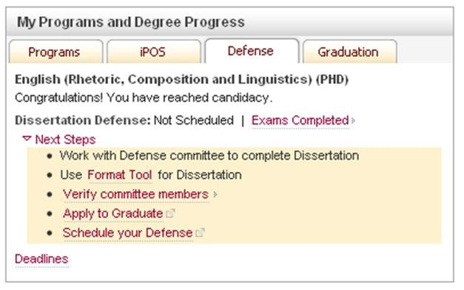

* Check with your academic unit for deadlines specific to your plan of study.
* See text following the checklist for a complete explanation of steps and procedures.

|  |  |
| --- | --- |
| **To-Do** | **Deadline** |
| 1. Check iPOS on [MyASU](http://my.asu.edu/) & verify Plan of Study is correct and complete | |
| 2. Verify that your committee is listed correctly on your iPOS | |
| 3. Have you met all requirements for graduation? | |
| 4. Does your iPOS show that you have reached candidacy? | |
| 5. Apply for graduation ***by deadline date*** *(late fee applies)* | |
| 6. Are any iPOS changes needed before graduation? ***(All courses on iPOS and Transcript must have final grades for your degree to be awarded)*** | |
| 7. Check committee members and roles on your iPOS. ***(If members listed are not correct, they will not be able to approve your dissertation)*** | |
| 8. Format your dissertation (see ***How to Format your Thesis/Dissertation***) | |
| 9. Schedule an oral defense on MyASU and upload a complete draft copy of your thesis to the Graduate Education [Dropbox](https://www.dropbox.com/request/NmUMYLhVchk1Y1vkKB2h) link | |
| **10. The following 4 steps can occur simultaneously or in any order:** | |
| * Submit revisions for dissertation format approval (and all additional revisions until you earn final format approval). | |
| * Defend your dissertation | |
| * Submit the *Survey of Earned Doctorates* (SED) | |
| * If you plan to attend commencement, RSVP via [MyASU](http://my.asu.edu/) | |
| 11. Submit dissertation to [UMI/ProQuest](http://www.etdadmin.com/asu) | |
| 12. Purchase academic regalia at [ASU’s Boo ksto re](http://bookstore.asu.edu/) | |
| 13. Attend commencement and/or convocation | |

# Steps 1 & 2: Check iPOS o[n MyASU](http://my.asu.edu/) & verify that your Plan of Study is correct and complete. Verify that your committee is listed correctly.

As you progress toward graduation, continue to check [MyASU](http://my.asu.edu/) for the latest updates and next steps you must take.

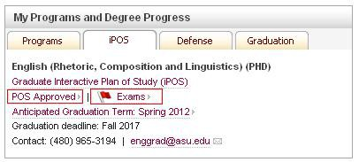



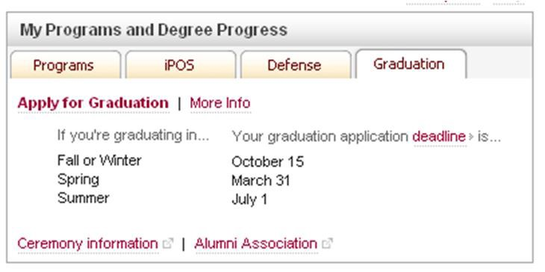

1. Prior to candidacy and defending your dissertation, all milestone events must be completed and the results reported by your department to Graduate Education, including any of the following events applicable to your Plan of Study:
   * Completion of all required courses
   * Foreign language exam, if applicable
   * Required comprehensive exams

* Dissertation prospectus defense as outlined by your department

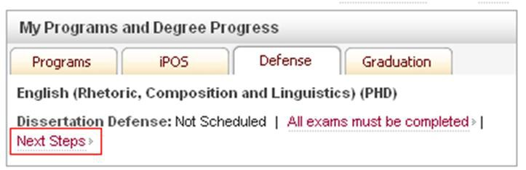

1. You must have maintained a minimum 3.00 grade point average (GPA) on both the Plan of Study (iPOS) GPA and the Graduate GPA (calculated on all courses that appear on the graduate transcript).

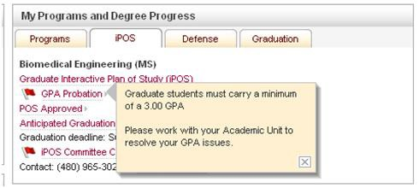

**Check your iPOS tab for your course list and grades.**

1. ***You must be registered for a minimum of one credit hour during all phases of your graduate education***, including the term in which you graduate. This includes periods when you are engaged in research, conducting a doctoral prospectus, working on or defending your dissertation, taking comprehensive examinations, taking Graduate Foreign Language Examinations, or in any other way utilizing university resources, facilities or faculty time.
2. For complete details on requirements to graduate, please see *Graduate Policies and Procedures*

at <https://graduate.asu.edu/key-policies>.

Once all required milestone events have been completed and reported by your department to Graduate Education, you will be notified you have achieved candidacy and are eligible to hold a defense.

Your candidacy letter can be viewed on the iPOS tab in [MyASU](http://my.asu.edu/), indicating your new graduation deadline and any relevant requirements. [MyASU](http://my.asu.edu/) will reflect your candidacy status with next steps you must take.

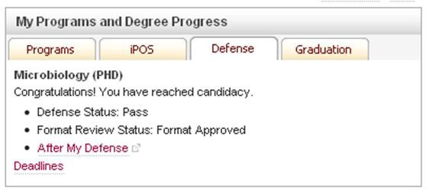

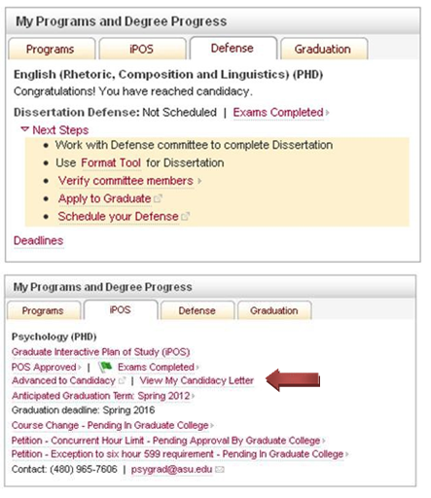

* + Deadline dates for each semester are at [Graduation Deadlines and Procedures](https://graduate.asu.edu/completing-your-degree) and also appear on [MyASU](http://my.asu.edu/).
  + Students must be registered for a minimum of one credit hour during all phases of their graduate education, including the term in which they graduate. This includes periods when students are engaged in research, conducting a doctoral prospectus, working on or defending theses or dissertations, taking comprehensive examinations, taking Graduate Foreign Language Examinations, or in any other way utilizing university resources, facilities or faculty time.
  + You may apply for graduation through the Graduation tab on [MyASU](http://my.asu.edu/), or through the

[Unive rsity Registrar’s Office](http://graduation.asu.edu/home) online, in person or by mail.

* + Information about the graduation application procedures and fees is available online: [students.asu.edu/graduation.](http://students.asu.edu/graduation)
  + **If you apply after the deadline for a semester, you will be assessed a late fee and your name will not appear in the commencement program.**



* If you have not done so already, please log into [MyASU](http://my.asu.edu/) to verify that your listed course work matches that of the courses you took. If you need to make corrections, please submit a Course Change through your iPOS, making any needed adjustments, before submitting it to your graduate support staff.
* All courses on iPOS and transcript must have final grades for your degree to be awarded
* Check committee members and roles on your iPOS tab. (If members listed are not correct, they will not be able to approve your dissertation)

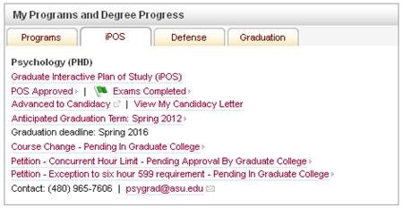

* See separate how to guides at <https://graduate.asu.edu/completing-your-degree>
  + *How to use the online formatting tool for your thesis or dissertation*
  + *How to submit your formatted dissertation or thesis for review*

# Step 9: Schedule an oral defense on MyASU and submit a complete draft copy of your dissertation via email t[o gradformat@asu.edu](mailto:gradformat@asu.edu)

* You are required to hold a public defense of your dissertation as part of your degree requirements. Defenses must be scheduled Monday through Friday between 8 am and 5 pm, on-campus in a publicly-accessible building/room.
* **The deadline for submitting a formatted version of your document is 10 days prior to your scheduled defense. Failure to do so may result in the cancelling of your defense.** For example, on August 1 you schedule a defense for August 29. You can submit your formatted document anytime between August 1 and August 19, *but no later than August 19*. See [MyASU](http://my.asu.edu/) for instructions on submitting your document.
* **You must submit your request to schedule a defense through MyASU at least 10 working days before your intended defense.** Please see [10-Working Day Calendar](https://graduate.asu.edu/file/10-working-day-calendar) for permissible defense dates. Your defense will be listed on the [Graduate Education Master’s/ Do cto ral Defense](http://graduate.asu.edu/defensecal)   [Schedule](http://graduate.asu.edu/defensecal) website which updates every Monday.
* Schedule the defense date, time, building and room number through your Committee AND your Support Staff in your academic unit before scheduling online through your [MyASU](http://my.asu.edu/). Your academic unit will need to approve the defense.
* If your title, building, room number or time of defense changes, or if you need to reschedule or cancel a defense, use the reschedule link in [MyASU](http://my.asu.edu/).

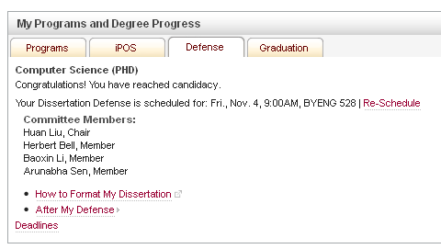

* You must have an approved iPOS, including committee composition.
* All required exams (Foreign Language Examination, oral/written comp exams, etc.) must be completed and your academic unit must have posted your final grades.
* You must have met all minimum 3.0 GPA requirements (iPOS and graduate GPA).
* You must be registered for at least 1 credit hour of graduate-level coursework in your department the semester in which you defend and plan to graduate.
* You must be physically present at the defense and enrolled during the term of the defense.
* Make certain all committee members can attend (required). If you have members that cannot be physically present at the defense because of extenuating circumstances, please refer to the [absent](http://graduate.asu.edu/progress/completing/defenses/preparing_your_defense)  [member policy.](https://graduate.asu.edu/file/absent-committee-member-procedures) Your chair or one of your co-chairs *must be present at your defense*.
  + Submit revisions for dissertation format approval (and all additional revisions until you earn final format approval). The format advisors will review your document and email you with results; you do not need to receive final format approval before your defense unless indicated by the format advisor, you simply need to meet the semester deadlines as listed on the [Graduation Deadlines and Procedures](https://graduate.asu.edu/completing-your-degree).
  + Defend your dissertation. A document called the Pass/Fail form will be emailed to your entire committee and your graduate support staff and it is their responsibility to bring the form to your defense. At your defense, your committee will sign your Pass/Fail form and indicate revisions as needed.

After your defense has received committee approval and all committee revisions have been made, you must submit the signed Pass/Fail form to Graduate Education. We recommend that you keep a copy for your records.



* + Submit the [Survey of Earned Doctorates (SED)](https://graduate.asu.edu/completing-your-degree#tabs-0-content_main-5)
  + If you plan on attending the university commencement ceremony, please RSVP online when Marching Orders appears on the [MyASU](http://my.asu.edu/) Graduation tab. Once your RSVP has been submitted, you will receive an email in your ASU email account with further information and instructions.
* Submit the final version of your document (that has been approved by your supervisory committee and the head of your academic unit) electronically to [UMI/ProQuest](http://www.etdadmin.com/asu).



**Ready to submit to Proquest**

* The approved document is then reviewed by the Graduate Education format advisors to ensure compliance with format regulations. Submission of the document may not be the last step; **additional formatting may be required**. Students will be contacted through their ASU email account regarding the status of their document in UMI/ProQuest.
* When ProQuest final format approval has been granted, Graduate Education notifies ProQuest that the document is ready for publication. ProQuest submits the dissertation to the ASU Library (and Library supported search engines) electronically.
* Once the document has been submitted to ProQuest and approved by ASU format advisors for publication, the document cannot be recalled; **no changes may be made to an approved document**. Always check to make sure you have submitted the correct version for publication.
* This is the last step in the graduation process. There are strict deadlines to for your submission to UMI/ProQuest. **If you miss the deadline, you will need to reapply for a future graduation date.** All graduation deadlines are available online:
  + [Graduation Deadlines and Procedures](https://graduate.asu.edu/completing-your-degree)
  + [UMI/ProQuest Submission](http://graduate.asu.edu/progress/completing/requirements/umi_proquest_submission)
* You will be required to create a new user account for the submission of your document and must use your ASU email address.
* Select the appropriate Publishing Option but do not select “Open Publishing” as Graduate Education does not allow open publishing. If you select the “Open Publishing” option your ETD submission will be returned to you.
* UMI/ProQuest requires all students to submit a PDF version of their final document. ASU Graduate Education requires that the PDF document is in compliance with the formatting standards. **You will receive final format approval only after the submitted PDF document has successfully passed a format review.**
* To create a PDF version of your dissertation, you can use the full Adobe suite for free by logging into [asu.edu/myapps,](http://www.asu.edu/myapps) or alternatively [UMI/ProQuest](http://www.etdadmin.com/asu) provides a free Word to PDF conversion.
* Students have an opportunity to order bound copies of their document through [UMI/ProQuest](http://www.etdadmin.com/asu). They can also go to any third party bindery to obtain bound copies of their document if desired.
* Doctoral students who intend to participate in commencement and/or an individual convocation must obtain academic regalia, which can be purchased at [**ASU’s Bookstore**.](http://bookstore.asu.edu/)can find additional information on dressing for graduation at  [**graduation.asu.edu/graduates/dressing**.](http://graduation.asu.edu/graduates/dressing)

You

* Information on the academic costume code, how to wear the Commencement regalia, and colors associated with different disciplines can be found at the **American Council on Education**.

# Step 13: Attend commencement and/or convocation

* ***Commencement*** is the university-wide celebration at which degrees are conferred upon graduating students by ASU President Michael Crow. Commencement is held each May and December in Wells Fargo Arena. Doctoral candidates (e.g. PhD, AUD, EDD, DBH, DNP, JD) will be individually recognized at the university graduate commencement ceremony. Participants will march in during the processional and will also cross the stage and shake the hand of President Crow or Provost Capaldi.
* If you plan on attending the university commencement ceremony, please RSVP online with Marching Orders via [MyASU](http://my.asu.edu/) no later than the due date on your Graduation tab on [MyASU](http://my.asu.edu/).
* It is your responsibility to notify your chair/hooder if you intend to participate in the commencement ceremony. Prior to commencement you and your hooder will receive an email with additional information you will need on the day of commencement.
* Once your RSVP has been submitted you will receive an auto response email with further information and instructions. Please look for this in your ASU email account to confirm your RSVP was properly submitted.
* ***College and cultural convocations*** are a time for smaller groups to gather and celebrate students’ graduation. The smaller setting provides the opportunity for individual recognition. Some convocations also require an RSVP in Marching Orders on [MyASU](http://my.asu.edu/). For more information about a particular convocation, please contact the dean's office of your college, or the  [University Ceremonies Office](http://graduation.asu.edu/home) for information and the schedule of special interest convocations.
* Graduates do not receive diplomas at University Commencement or at college convocations. Diplomas are mailed approximately 5-7 weeks after the degree conferral date to the home address on file with the University Registrar's Office. Change of diploma address must be submitted to the [Office o f Unive rsity Ceremo nies’ website](http://graduation.asu.edu/) or by signing in to [MyASU.](http://my.asu.edu/)