ThreadCare
A trusted bridge across every patient–clinician interaction
Technical Brief | Wang Yuyang | 27 August 2026 | Public synthetic-data prototype
Product thesis Medical history is not merely long; it mixes different writing styles, fragmented context, patient self-diagnosis, and information with unequal authority. ThreadCare lets AI compress that mess without becoming the source of truth: clinicians decide, and every AI claim remains traceable.

1. Problem, users, and design principles
The primary user is the care team. A clinician or staff member should efficiently understand the current concern, critical safety facts, and open actions, then move directly into the longitudinal evidence.
- The Top Card ranks a deliberately small set of actionable items; it does not present an AI suggestion as a confirmed fact.
- One shared longitudinal Care Note connects patient pre-consults, staff tasks/results, consultation outcomes, and patient-facing instructions. Additionally, clinicians can add an AI-generated summary of their conversation with the patient to the longitudinal timeline with a single click.
- The system provides a page where clinician can enter consultation outcomes and medication instructions, then simultaneously add them to the longitudinal timeline and send them to the patient.
- Role ownership is explicit: staff cannot overwrite clinician notes, clinicians cannot overwrite staff notes, and patients never receive internal comments or raw AI-scribed notes.
- After consultation, patients will be provided a form for rating and commenting. Thus the care team can get some feedback for further improvement.
- The prototype is a complete vertical slice at demo scale: one clinic, one clinician, two staff accounts, and multiple isolated patients rather than a feature-reduced mock-up.

2. Architecture
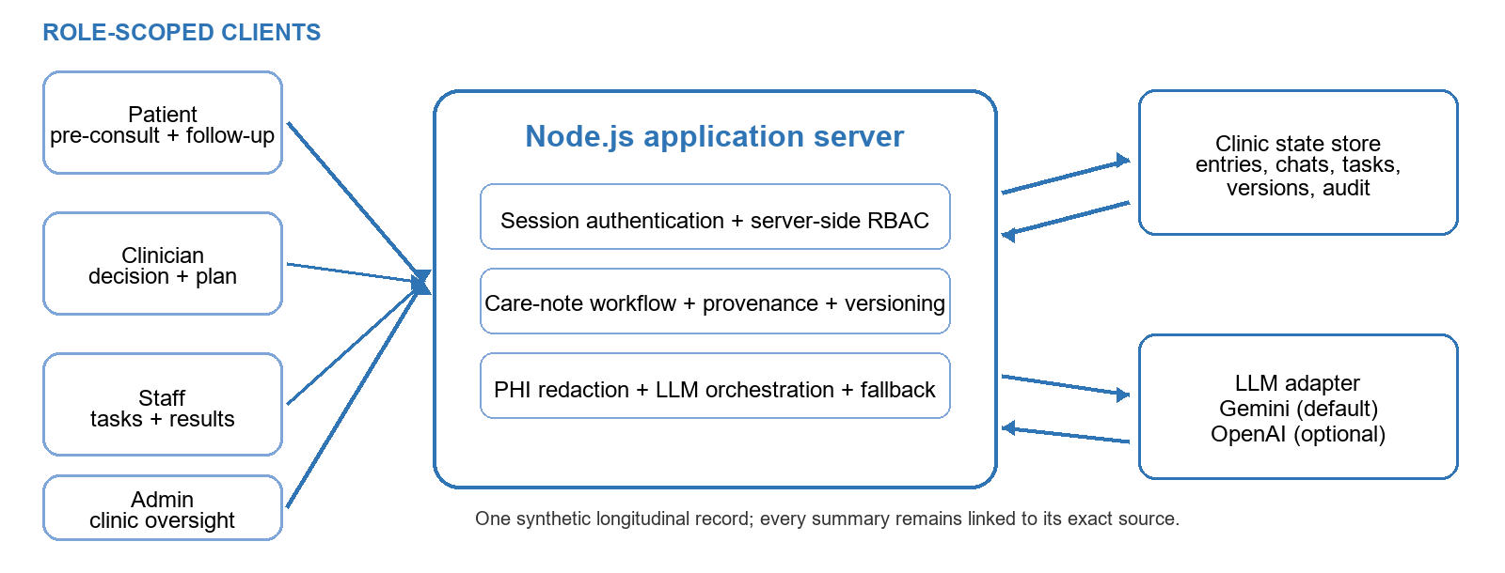
Figure 1. Browser clients share one server-enforced, clinic-scoped record; LLM providers never receive unredacted submitted text.
Request path. Authenticated sessions are checked by server middleware before the care-note service reads or mutates state. Names, phone numbers, and supported IC/ID patterns are redacted before downstream summarisation. Gemini is the default LLM adapter, with an optional OpenAI-compatible fallback and deterministic fallbacks for temporary provider failure.

3. Data model: one record, preserved sources
Entry is the longitudinal unit. Manual notes and three AI-scribe types are visually distinct but use the same versioned entry structure. AI-scribed notes point to a complete source conversation; Top Card highlights additionally resolve to an exact entry/span.
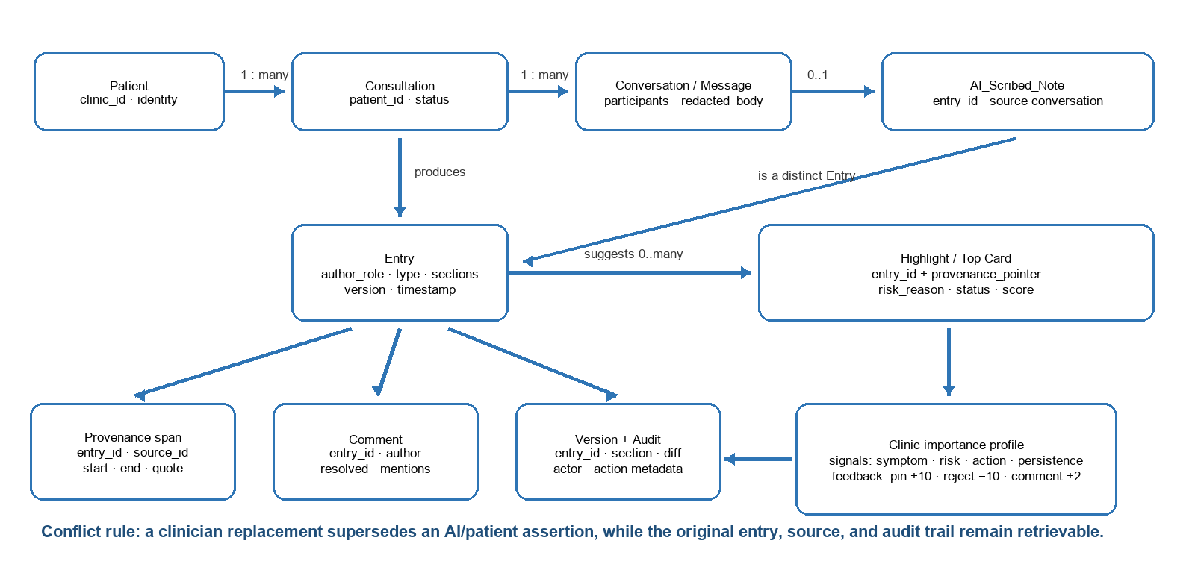
Figure 2. Logical schema and adaptive importance loop.
Concern | Implementation | Why it matters
Provenance | Source conversation/message + exact span pointers; original text remains retrievable. | A reviewer can inspect what the patient or team actually said, not only the AI’s paraphrase.
Revision | Section-level versions, actor/timestamp metadata, audit log, deterministic same-section conflict response, and revert. | Concurrent edits to different sections survive; ownership and change history remain visible.
Conflict | Clinician replacement supersedes an AI/patient assertion while preserving the earlier claim and source. | Clinical authority wins without silently rewriting history.
Data decay | Old low-priority entries become archive cards; allergies, confirmed diagnoses, review items, unresolved tasks, comments, versions, and sources stay protected. | The default timeline becomes quieter without deletion or loss of traceability.

4. Self-learning
Ranking, not truth. Each suggestion combines model confidence/base score with explicit risk, unresolved actions, and clinic-level learned signals such as symptom, hypothesis, urgency, and category. A pin adds +10, a rejection −10, and a first team comment +2 to matching future signals. The score breakdown is inspectable; feedback never confirms a diagnosis, edits a source, or crosses clinic boundaries.
Hard constraint Only a clinician can accept or reject an AI highlight. Rejection records a reason and replacement assessment; the previous claim remains visible as superseded evidence.

5. Safety, permissions, and evidence
SERVER-SIDE GUARANTEES  - Role- and clinic-scoped session checks on protected routes  - Patient response excludes internal comments and raw AI sources  - Note edit/revert ownership enforced by author role  - Synthetic data only; secrets excluded from Git  - Redaction before LLM: names, phones, supported IC/ID patterns | VERIFICATION  - 39 automated tests passing  - RBAC, revisions/revert, audit metadata, exact provenance  - Concurrent edits and deterministic same-section conflicts  - Multi-patient isolation and repeated consultations  - Self-learning transfer and non-destructive decay

Warm-path latency
Measured P95: 32.20 ms (requirement ≤ 300 ms). Measurement used 20 warm-up iterations followed by 200 sequential localhost samples of the authenticated Care Note and conversation-loading path. This is a reproducible prototype benchmark, not a production multi-region load test.

6. Assumptions and deliberate scope
Decision | Chosen scope | Trade-off / next production step
Voice | Reviewed speech-to-text input, maximum 30 seconds; raw audio is not retained. | Not full ambient capture: no diarisation, overlap/noisy-room handling, or continuous recording.
Storage | Local JSON logical store with complete relations and audit/version behavior. | Production needs a transactional encrypted database, migrations, backups, and tested recovery.
Privacy | Public demo and public GitHub use synthetic data only. | Real PHI requires legal authority, security review, encryption at rest, retention policy, monitoring, and compliance controls.
Learning | Transparent clinic-level weighted feedback signals. | A production model needs evaluation for bias, drift, misuse, and safe rollback before learning affects workflow.

7. First-principles reflection
The key learning was understanding why clinical records become “messy.” Different people document different visits in different styles; histories accumulate without a shared summary; and a patient’s sincere self-diagnosis can be useful context while also distracting from the underlying condition. Therefore the core problem is authority and trust. ThreadCare treats AI as the clinician’s assistant: it organises and prioritises, while human clinical judgment decides what becomes accepted care context.

