**Risk Profile For: ravindra gupta**

**Industry Selected: Cleaners**

**Prepared By: Test Broker of Test Brokerage**

Date: Mon, 18 Jul 2016, 16:55

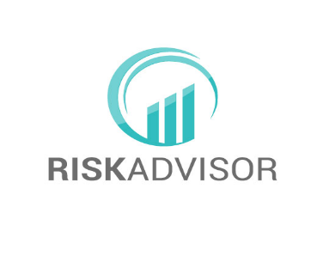



Contents

1. Purpose
2. Methodology
3. Outcomes
4. Care and Responsibility
5. Risk Benchmark Summary
6. Client Risk Rating Matrix
7. Action Report
8. Risk Area Details
9. Uninsured Risk Sample Checklist
10. Control Summary Report
11. Appendix 1 - Risk Profiling Process
12. Appendix 2 – Risk Management Methodology
13. Appendix 3 – Risk Likelihood and Consequence Table

1. Purpose

This Report has been generated using **Risk**Advisor, the web based interactive platform, that uses a structured process designed to help businesses and their risk professionals identify and consider business and/or insurable risk areas and their appropriate treatment.

Risk guidance content in the platform is provided by a number of risk specialists and organisations including AM Best, the world renowned ratings agency that analyses over 16,000 insurance companies globally to provide insurance professionals and consumers with critical information they need to make informed business decisions.

2. Methodology

The International Organization for Standardization otherwise known as ISO provides an approach to Risk Assessment (ISO 31000/AS4360) that **Risk**Advisorfollows.

That process involves:

1. Recognition or identification of risk
2. Ranking or evaluation of risk
3. Responding to said risks
4. Controlling and planning
5. Monitoring and re-evaluation

3. Outcomes

1. Self-assessment of risk through identification and understanding of risks areas and exposures relevant to a business.
2. Self-rating of these risk areas by likelihood and consequence and a comparison against the industry benchmark calculated by AM Best and other data analytics.
3. An Action Plan taking in to consideration a number of choices including insurance and other treatments to minimise or transfer risk.

4. Care and Responsibility

**Risk**Advisor is a web based, interactive tool developed by RiskAdvisor Pty Ltd. Every care has been taken to ensure the functionality and workflow of the application is correct. The risk assessment, treatment and outcomes if any, are the responsibility of the users whose data has been entered and captured by the system.

If you have any questions or feedback please “Contact Us” via our Website at www.riskadvisor.com.au or speak to your insurance and risk professional.

5. Risk Benchmark Summary

The benchmark graph provided below represents a combination of user provided data and information extracted from various sources including AM Best’s Hazard Index. The purpose is to compare and contrast results as part of an overall discussion on business and/or insurable risks and their treatment.

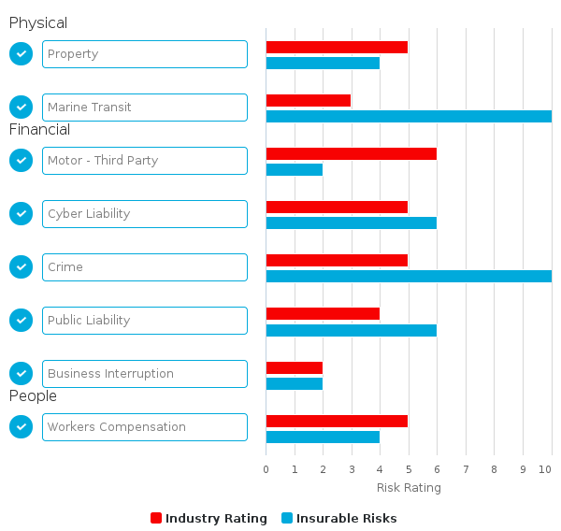

6. Client Risk Rating Matrix

|  |  |
| --- | --- |
|  |  |
| **Property** | **4** |
| **Crime** | **10** |
| **Cyber Liability** | **6** |
| **Business Interruption** | **2** |
| **Marine Transit** | **10** |
| **Motor - Third Party** | **2** |
| **Public Liability** | **6** |
| **Workers' Compensation** | **4** |
|  |  |

|  |  |  |  |  |  |
| --- | --- | --- | --- | --- | --- |
| Client Risk Rating Legend | Low |  | Medium |  | High |

7. Action Reports

**Risk Assessment AM Best v ravindra gupta**

|  |  |  |  |
| --- | --- | --- | --- |
| **RiskArea** | **AM Best Index** | **Client Index** | **Divergence** |
| Property | 5 | 4 | 1 |
| Crime | 5 | 10 | -5 |
| Cyber Liability | 5 | 6 | -1 |
| Business Interruption | 2 | 2 | 0 |
| Marine Transit | 3 | 10 | -7 |
| Motor - Third Party | 6 | 2 | 4 |
| Public Liability | 4 | 6 | -2 |
| Workers' Compensation | 5 | 4 | 1 |

*NOTE: Divergences of greater than +4, or greater than -4, will be highlighted*

Insurance Actions

|  |  |  |
| --- | --- | --- |
| **Risk Area:**  **Outcome** | **Assigned To** | **Due Date** |
| **No Insurance Actions** | | |

Risk Control Actions

|  |  |  |
| --- | --- | --- |
| **Risk Area:**  **Control Planned** | **Assigned To** | **Due Date** |
| **No Insurance Actions** | | |

8. Risk Area Details

|  |  |  |  |  |
| --- | --- | --- | --- | --- |
| **Physical/Insurable Risks** | | | | |
| **Property** | | **Insurance Action: Not Applicable** | | |
| **Client Index** | **4** | **AM Best Index** | **5** | |
| **Client Likelihood** | Possible | | | |
| **Notes** | - | | | |
| **Client Consequence** | Moderate | | | |
| **Notes** | - | | | |
| **Exposures** | No Exposures selected | | | |
| **Controls** | - All flammable and combustible liquids stored away from ignition sources in fire-resistant containers | | |  |
| - All rags tainted with flammable liquids kept in safety containers until they are disposed of safely | | |  |
| - Electrical wiring is regularly inspected and maintained by qualified electricians | | |  |
| - A sufficient number of annually tagged and inspected fire extinguishers are located throughout the premises | | |  |
| - Employees have been trained in the proper use of fire extinguishers | | |  |

|  |  |  |  |  |
| --- | --- | --- | --- | --- |
| **Financial/Insurable Risks** | | | | |
| **Crime** | | **Insurance Action: Not Applicable** | | |
| **Client Index** | **10** | **AM Best Index** | **5** | |
| **Client Likelihood** | Almost Certain | | | |
| **Notes** | - | | | |
| **Client Consequence** | Catastrophic | | | |
| **Notes** | - | | | |
| **Exposures** | No Exposures selected | | | |
| **Controls** | No Controls selected | | | |

|  |  |  |  |  |
| --- | --- | --- | --- | --- |
| **Financial/Insurable Risks** | | | | |
| **Cyber Liability** | | **Insurance Action: Not Applicable** | | |
| **Client Index** | **6** | **AM Best Index** | **5** | |
| **Client Likelihood** | Likely | | | |
| **Notes** | - | | | |
| **Client Consequence** | Major | | | |
| **Notes** | - | | | |
| **Exposures** | No Exposures selected | | | |
| **Controls** | No Controls selected | | | |

|  |  |  |  |  |
| --- | --- | --- | --- | --- |
| **Financial/Insurable Risks** | | | | |
| **Business Interruption** | | **Insurance Action: Not Applicable** | | |
| **Client Index** | **2** | **AM Best Index** | **2** | |
| **Client Likelihood** | Unlikely | | | |
| **Notes** | - | | | |
| **Client Consequence** | Minor | | | |
| **Notes** | - | | | |
| **Exposures** | No Exposures selected | | | |
| **Controls** | No Controls selected | | | |

|  |  |  |  |  |
| --- | --- | --- | --- | --- |
| **Physical/Insurable Risks** | | | | |
| **Marine Transit** | | **Insurance Action: Not Applicable** | | |
| **Client Index** | **10** | **AM Best Index** | **3** | |
| **Client Likelihood** | Almost Certain | | | |
| **Notes** | - | | | |
| **Client Consequence** | Catastrophic | | | |
| **Notes** | - | | | |
| **Exposures** | No Exposures selected | | | |
| **Controls** | No Controls selected | | | |

|  |  |  |  |  |
| --- | --- | --- | --- | --- |
| **Financial/Insurable Risks** | | | | |
| **Motor - Third Party** | | **Insurance Action: Not Applicable** | | |
| **Client Index** | **2** | **AM Best Index** | **6** | |
| **Client Likelihood** | Unlikely | | | |
| **Notes** | - | | | |
| **Client Consequence** | Minor | | | |
| **Notes** | - | | | |
| **Exposures** | No Exposures selected | | | |
| **Controls** | No Controls selected | | | |

|  |  |  |  |  |
| --- | --- | --- | --- | --- |
| **Financial/Insurable Risks** | | | | |
| **Public Liability** | | **Insurance Action: Not Applicable** | | |
| **Client Index** | **6** | **AM Best Index** | **4** | |
| **Client Likelihood** | Likely | | | |
| **Notes** | - | | | |
| **Client Consequence** | Major | | | |
| **Notes** | - | | | |
| **Exposures** | No Exposures selected | | | |
| **Controls** | No Controls selected | | | |

|  |  |  |  |  |
| --- | --- | --- | --- | --- |
| **People/Insurable Risks** | | | | |
| **Workers' Compensation** | | **Insurance Action: Not Applicable** | | |
| **Client Index** | **4** | **AM Best Index** | **5** | |
| **Client Likelihood** | Possible | | | |
| **Notes** | - | | | |
| **Client Consequence** | Moderate | | | |
| **Notes** | - | | | |
| **Exposures** | No Exposures selected | | | |
| **Controls** | No Controls selected | | | |

9. Uninsured Risk Checklist

|  |  |  |  |  |
| --- | --- | --- | --- | --- |
| **Risk Area** | **In Place** | **Obtain Quote** | **Retain Risk** | **N/A** |
| Motor - Own Damage |  |  |  | ✓ |
| Aircraft Liability |  |  |  | ✓ |
| Aircraft Hull |  |  |  | ✓ |
| Motor - Third Party |  |  |  | ✓ |
| Cyber Liability |  |  |  | ✓ |
| Crime |  |  |  | ✓ |
| Business Interruption |  |  |  | ✓ |
| Crop Damage |  |  |  | ✓ |
| Motor Trades |  |  |  | ✓ |
| Boiler Explosion and Machinery Breakdown |  |  |  | ✓ |
| Environmental Impairment Liability |  |  |  | ✓ |
| Property |  |  |  | ✓ |
| Employment Practices Liability |  |  |  | ✓ |
| Directors' and Officers' Liability |  |  |  | ✓ |
| Product Liability and Completed Operations |  |  |  | ✓ |
| Liquor Liability |  |  |  | ✓ |
| Marine Transit |  |  |  | ✓ |
| Marine Hull |  |  |  | ✓ |
| Public Liability |  |  |  | ✓ |
| Domestic Home and Contents |  |  |  | ✓ |
| Workers' Compensation |  |  |  | ✓ |
| Surety |  |  |  | ✓ |
| Contract Works |  |  |  | ✓ |
| Professional Indemnity |  |  |  | ✓ |
| Management Liability |  |  |  | ✓ |
| Personal Accident and Sickness |  |  |  | ✓ |
| Travel |  |  |  | ✓ |
| Trailer / Caravan |  |  |  | ✓ |
| Key Man and Group Life |  |  |  | ✓ |
| hlo insurable risk |  |  |  | ✓ |

10. Control Summary Report

|  |  |  |
| --- | --- | --- |
| **Property** | | |
| **Exposures** | No Exposures selected | |
| **Controls** | - All flammable and combustible liquids stored away from ignition sources in fire-resistant containers |  |
| - All rags tainted with flammable liquids kept in safety containers until they are disposed of safely |  |
| - Electrical wiring is regularly inspected and maintained by qualified electricians |  |
| - A sufficient number of annually tagged and inspected fire extinguishers are located throughout the premises |  |
| - Employees have been trained in the proper use of fire extinguishers |  |

|  |  |  |
| --- | --- | --- |
| **Crime** | | |
| **Exposures** | No Exposures selected | |
| **Controls** | No Controls selected | |

|  |  |  |
| --- | --- | --- |
| **Cyber Liability** | | |
| **Exposures** | No Exposures selected | |
| **Controls** | No Controls selected | |

|  |  |  |
| --- | --- | --- |
| **Business Interruption** | | |
| **Exposures** | No Exposures selected | |
| **Controls** | No Controls selected | |

|  |  |  |
| --- | --- | --- |
| **Marine Transit** | | |
| **Exposures** | No Exposures selected | |
| **Controls** | No Controls selected | |

|  |  |  |
| --- | --- | --- |
| **Motor - Third Party** | | |
| **Exposures** | No Exposures selected | |
| **Controls** | No Controls selected | |

|  |  |  |
| --- | --- | --- |
| **Public Liability** | | |
| **Exposures** | No Exposures selected | |
| **Controls** | No Controls selected | |

|  |  |  |
| --- | --- | --- |
| **Workers' Compensation** | | |
| **Exposures** | No Exposures selected | |
| **Controls** | No Controls selected | |

Appendix 1 – Risk Profiling Process

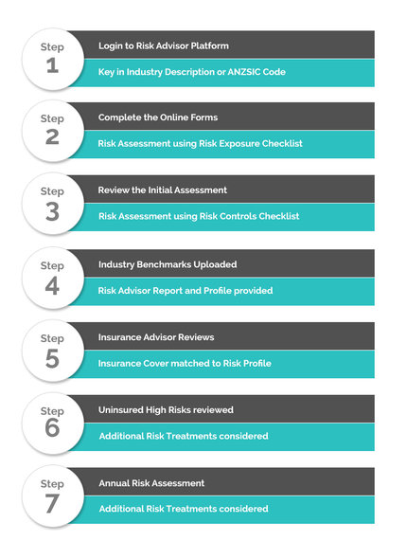

Appendix 2 –Risk Management Methodology

The assessment process involved ravindra gupta completing a business and/or insurable risk assessment questionnaire pre-populated with sample industry specific exposures and controls by **Risk**Advisor.

The findings were then benchmarked using data supplied by AM Best and others.

The methodology adopted is based on “ISO 31000 (AS/NZ: 4360) Risk Management – Principles and Guidelines"

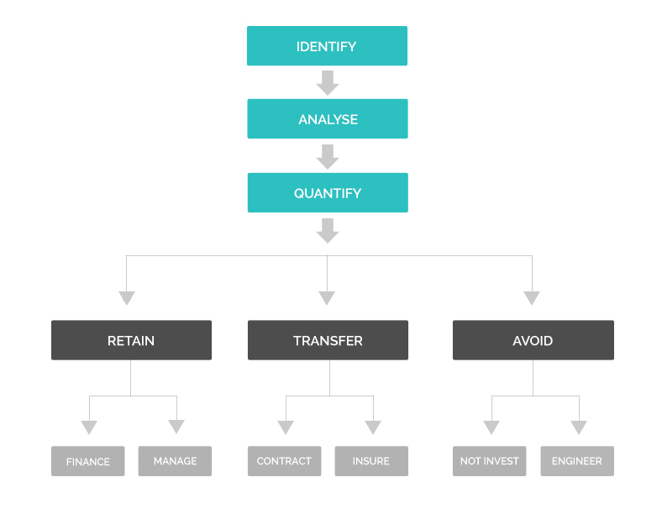

Appendix 3 –Risk Likelihood and Consequence Tables

|  |  |  |
| --- | --- | --- |
| **Descriptor** | **Likelihood Descriptor** | **Probability** |
| 5  Almost certain | The event and the associated consequences are expected to occur in most circumstances over a three year timeframe. | >95% |
| 4  Likely | The event and the associated consequences will probably occur in most circumstances over a three year timeframe. | 75-94% |
| 3  Possible | The event and the associated consequences may occur in some circumstances over a three year timeframe. | 50-74% |
| 2  Unlikely | The event and the associated consequences could occur in some circumstances over a three year timeframe, but it is unlikely. | 5-49% |
| 1  Rare | The event and the associated consequences may occur only in exceptional circumstances over a three year timeframe. | <5% |

|  |  |
| --- | --- |
| **Descriptor** | **Consequence Descriptor** |
| 5  Catastrophic | The event may stop achievement of Key Financial and Business Objectives (KBO’s) |
| 4  Major | The event may threaten achievement of KBO’s |
| 3  Moderate | The event may threaten may parts of the company |
| 2  Minor | The event may threaten a part of the company |
| 1  Insignificant | The event is of low consequence |