Subjective Evaluation of Perceived Effects in AI-Assisted Design Workflows: A Systematic Literature Review

Abstract
AI-Assisted Design Workflows are evaluated through diverse judgments about design outcomes, designers’ experiences, and interaction with AI. Yet selecting appropriate evidence for subjective evaluation of perceived effects requires more than identifying commonly used measures. We present a systematic literature review of 125 papers from 2022 to September 2026, organizing evaluation evidence through linked perceived effects, subjective indicators, and tools. The dataset contains 514 candidate records, including 460 mapped to perceived-effect dimensions and 454 to subjective indicators, together with 608 classified tool instances. Outcome quality accounts for 31.3% of mapped dimension records, while cognition, affect, interaction, and contextual value constitute substantial additional concerns. Bespoke structured ratings are the most frequent tool class. We examine reported support using seven standards adapted from the JCSEE Program Evaluation Standards and analyze contextual associations using repeated cross-validation grouped by paper. Contextual predictive contributions vary across evidence layers and scoring assumptions; stronger prediction does not consistently improve candidate shortlisting. We translate the findings into guidelines and a progressively disclosed recommender design that connects evaluation purposes and contexts to traceable evidence. The review contributes an evidence map, an assessment of reporting support, an analysis of contextual dependencies, and a practical framework for selecting and documenting subjective evaluation of perceived effects.
Keywords: subjective evaluation; perceived effects; AI-Assisted Design Workflows; systematic literature review; evaluation evidence; human–AI interaction.

1 Introduction
Perceived effects refer to the effects of a system, feature, or intervention as experienced, interpreted, and judged by people. Subjective evaluation provides access to these perceived effects through people's accounts and judgments. This formulation synthesizes descriptive uses of perceived effects in research on explanations, collaboration, and interactive systems [1] [2] [3]. In human-centered design, attention to people's needs, activities, and circumstances makes perceived effects relevant across different design domains [4]. For example, visual communication design may involve judgments about aesthetic appeal and the clarity of an intended message; industrial and product design may involve judgments about suitability, feasibility, and comfort; and fashion design may involve judgments about aesthetic expression, material qualities, and the anticipated experience of wearing a garment. Perceived effects also matter at different design stages. During research, subjective evaluation can establish the needs and value criteria against which perceived effects will subsequently be judged; during ideation, judgments about inspiration and novelty can direct exploration; during prototyping and testing, judgments about usability can guide revision; and during implementation, judgments about fit with everyday practices can inform continued adoption. Rigorous subjective evaluation of perceived effects is therefore fundamental for informing design decisions across the workflow and determining whether design outcomes meet the needs and expectations of the people they are intended to serve.
In human-computer interaction (HCI), perceived effects can encompass instrumental, affective, and situated aspects of interaction. Hassenzahl and Tractinsky's account of user experience emphasizes the interplay among the person, the system, and the circumstances of use [5]. In particular, AI-Assisted Design Workflows introduce perceived effects associated with AI's contribution to proposing, interpreting, and revising design material. A designer may experience generated suggestions as inspiring while also becoming concerned about fixation; perceive a reduction in effort while experiencing less control over a decision; or appreciate a finished outcome while questioning authorship and creative ownership. Research on AI-assisted ideation and human-AI co-creativity illustrates why the quality of a design outcome and the designer's experience require separate attention [6] [7]. The same intervention may also be judged differently by its operator, a domain expert, and an eventual user. Rigorous subjective evaluation of perceived effects in AI-Assisted Design Workflows consequently requires clear correspondence between the judgment being elicited, the person making it, the object of that judgment, and AI's role in the activity.
Credible evaluation evidence is central to this correspondence. The CDC Program Evaluation Framework connects an evaluation concept to an indicator and a measure, within a broader alignment of evaluation questions, study design, data sources, and expectations [8]. Utilization-focused evaluation further emphasizes that evidence should serve identified purposes and intended users in a particular situation [9]. Drawing on these accounts, we examine three connected components of evidence for subjective evaluation: perceived effects, subjective indicators, and tools. We organize perceived effects into broader dimensions, preserve the indicators through which they are operationalized, and document the tools used to elicit the relevant judgments. We examine seven contextual factors: evaluation purpose (G1), design domain (G2), design stage (G3), evaluation object (G4), evaluator (G5), target user (G6), and AI function (G7). These are this review's analytical categories rather than an official taxonomy supplied by either evaluation framework. Selecting appropriate evidence requires understanding how its components relate to each other and to the context in which subjective evaluation is conducted.
Existing reviews provide substantial accounts of creativity support tools and evaluation in human-AI co-creativity [10] [7] [6]. Reviews of individual instruments also reveal the consequences of inconsistent implementation and reporting [11]. A complementary problem remains: how to connect the diverse perceived effects examined across AI-Assisted Design Workflows to their subjective indicators and tools, assess the reported support for those connections, and use contextual information to guide subsequent evaluation choices. A list of frequently used indicators cannot establish that they were appropriately measured. A list of named tools cannot establish that their interpretation was justified in a new population or task. Without examining both the evidence chain and its contextual dependencies, findings are difficult to compare, and researchers have limited grounds for selecting evidence for a different workflow.
In this work, we systematically review a corpus of 125 papers published from 2022 to the search cutoff of September 25, 2026. We first map the reported perceived effects, subjective indicators, and tools across publication years, design domains, and design stages (RQ1). We then conduct a structured assessment of reported evaluation evidence using seven standards adapted from the third edition of the JCSEE Program Evaluation Standards (RQ2) [12]. We examine contextual associations and the relative predictive contribution of G1-G7 in strict and expanded analytical samples containing 63 and 183 records, respectively, defined by explicit operational eligibility rules (RQ3). This analysis includes sensitivity to how contextual categories were constructed. Finally, we translate the evidence and its limitations into guidelines and a progressive-disclosure recommender design for selecting perceived effects, subjective indicators, and tools (RQ4). Together, these analyses connect the evidence reported in prior studies to the contextual decisions involved in planning subjective evaluation.
We make the following contributions:
1. An evidence map connecting five dimensions of perceived effects, 35 observed subjective-indicator categories within a predefined taxonomy of 36 categories, and five tool categories across AI-Assisted Design Workflows, with explicit denominators for papers, evaluation cases, records, and tool instances.
2. A structured profile of reporting-support classifications across seven adapted evaluation standards, characterizing the distribution of recorded support and information gaps relevant to interpreting and reusing subjective evaluation evidence.
3. An analysis of contextual associations and predictive sensitivity that exposes the consequences of target-derived coding and demonstrates why stable descriptive distributions do not ensure stable recommendation rules.
4. A set of evidence-selection guidelines and a progressive-disclosure recommender specification that connect recommendations to traceable examples, contextual fit, and the limits of the available evidence.

2 Conceptual Background and Related Work

2.1 Perceived effects and subjective evaluation
Perceived effects identify the perspective from which the consequences of a system or intervention are understood. The term has been used in ACM research to describe users' interpretations and reactions to recommendation explanations [1], the implications of research networking systems for collaboration [2], and collaborators' judgments of shared gaze during drawing [3]. These uses establish a family of situated research questions rather than a single standardized instrument or a universally agreed set of dimensions. Our opening definition draws together their common emphasis on human experience and judgment. It does not imply that every paper in the corpus uses the exact phrase perceived effects.
Subjective evaluation denotes the activity through which these judgments are elicited, interpreted, and used as evidence. Its evidence can be quantitative or qualitative. A numerical rating of workload, a comparison of two designs, and an interview about creative ownership provide different forms of subjective evidence. Their interpretation depends on the referent, the task, the evaluator, and the conditions of elicitation. Self-reports concern a person's own experience; expert ratings concern an evaluator's judgment of an object. Both can contribute to subjective evaluation, but an expert rating of a generated artifact does not by itself establish how the designer experienced working with AI.
We distinguish perceived-effect claims from the broader activities through which their evaluation becomes possible. Eliciting needs can establish whose values should define an outcome; constructing preference criteria can identify what should count as an improvement; and human labels can calibrate a model that subsequently supports design decisions. These activities are retained when they form part of the evaluation of perceived effects. Their purpose is coded explicitly so that upstream criteria or calibration judgments are not interpreted as demonstrations of downstream benefit. Similarly, a favorable score in a single condition is descriptive evidence unless the study design supports a comparison. This distinction concerns the strength and role of the inference, not the legitimacy of subjective evidence.

2.2 Evaluation in creativity support and AI-assisted design
Creativity support research has long faced the problem of evaluating open-ended activity whose valuable outcomes extend beyond task completion. Remy et al. review how creativity support tools are evaluated in HCI and identify diversity in the methods and criteria used [10]. Cox et al. extend this discussion by examining how evaluations characterize the broader impact of creativity support tools [7]. Ahsan et al. specifically review evaluative methods in human-AI co-creativity [6]. Together, these syntheses establish a foundation for examining how individual claims about perceived effects connect to indicators and tools, and what documented support makes those connections reusable.
The scope of the present review encompasses design outcomes, the design process, designers' cognition and affect, interaction with AI, and values situated in social or professional contexts. This scope includes creativity but extends to questions such as perceived workload, feasibility, trust, workflow continuity, and the fit of a design with user needs. It also separates evaluation practice from the capability of a particular AI technique. A technical improvement in generation quality may motivate a study, but it does not automatically establish an improvement in a participant's experience. Conversely, subjective evaluation may reveal a useful contribution even when a technical benchmark captures little of the activity that participants value.
This review therefore complements existing taxonomies by linking three levels of evidence and examining how those links are documented. The relationship is analytically important: two studies can assign the same indicator name to different questions, or use the same response format to measure different perceived effects. Retaining the original construct wording, instrument description, evaluator, and source location allows these distinctions to remain visible after category-level aggregation and supports the traceability of evidence used in subsequent evaluation planning.

2.3 Measurement foundations and evaluation evidence
Named instruments can help make subjective evaluation more explicit, but their use does not remove the need to justify the interpretation of scores. The Creativity Support Index provides one established approach to assessing support for creative activity [13]. NASA-TLX addresses subjective workload through multiple components [14]. Lee et al.'s TOCHI review shows that implementation and reporting choices can substantially complicate the use and interpretation of an established instrument, and connects empirical analysis to practical guidance and a toolkit [11]. We adopt the general progression from evidence review to methodological analysis and guidance, while examining heterogeneous subjective evaluations rather than conducting a psychometric meta-analysis of a single instrument.
The CDC framework helps articulate the internal alignment of evaluation evidence [8]. Our translation from concept, indicator, and measure to perceived effects, subjective indicators, and tools requires care: a tool is the means of obtaining a measure, and a scale name alone does not specify an item, response anchor, scoring rule, or interpretation. Accordingly, the extraction records these implementation details when available. Utilization-focused evaluation supplies a complementary account of why the same evidence can be adequate for one decision and inadequate for another [9]. Exploratory feedback, calibration, and comparative claims need different support because they serve different purposes.
The JCSEE Program Evaluation Standards provide a broader framework for examining the quality of evaluation practice [12]. Seven standards inform the reporting dimensions examined here: relevance of information, validity, reliability, contextual description, design and analysis, explicit reasoning, and documentation. We adapt these dimensions to organize a structured assessment of the evaluation evidence available in published reports. The resulting classifications support comparison of reporting patterns and the definition of analytical samples; inclusion in a sample reflects its operational eligibility rules rather than certification of a study's overall quality.
The scope of this assessment is therefore the published account of subjective evaluation. A publication does not provide a complete record of research practice, and an unreported procedure cannot automatically be treated as an inappropriate procedure. Equally, mentioning an established instrument or analytical method does not by itself establish that the resulting interpretation is justified. Examining the correspondence among perceived effects, subjective indicators, tools, and context provides a way to make these evidential requirements explicit while preserving the limits of what published reports can establish.

3 Review Method

3.1 Research questions and scope
The review addresses four connected questions. RQ1 asks which perceived effects, subjective indicators, and tools are represented in AI-Assisted Design Workflows, and how their distributions vary across years, design domains, and design stages. RQ2 asks what support the retained evaluation records provide for the relevance, measurement quality, contextual description, analysis, reasoning, and documentation of subjective evaluation. RQ3 asks how contextual factors are associated with evidence selection, and how much predictive information they provide after accounting for dependencies introduced by coding. RQ4 asks how the available evidence can inform progressively disclosed guidance for selecting perceived effects, subjective indicators, and tools.
We include AI assistance within a design workflow rather than treating all applications of AI as design. The coding framework covers visual communication, industrial and product, fashion, interior, service, and UI/UX design. It distinguishes research, ideation, prototyping and testing, and implementation. A paper can cover several domains or stages. We retain needs elicitation, preference-criterion construction, model calibration, formative feedback, and final comparison when these contribute to the evaluation of perceived effects. Their inclusion does not imply that each activity measures a realized consequence of using AI. For example, judgments used to construct a preference model can define an evaluative criterion without demonstrating that a subsequent AI-assisted workflow improves that criterion.

3.2 Search, screening, and temporal scope
The search was conducted on September 25, 2026, covering January 1, 2016, through the search date. It combined two concept blocks: machine-learning-related AI and professional design. The AI block included artificial intelligence, machine learning, deep learning, neural networks, reinforcement learning, natural language processing, computer vision, generative AI, large language models, and diffusion models. The design block included general design terms and the six selected design domains. The blocks were connected by AND, with terms within each block connected by OR; the AI terms were searched in two batches and the results combined. Subjective-evaluation terms were not imposed as a separate retrieval requirement, allowing the corpus to retain relevant design-workflow papers with no recoverable subjective evaluation.
The source scope comprised ACM-related publications and eight journals: Design Studies, Design Issues, International Journal of Design, Journal of Engineering Design, The Design Journal, Journal of Design Research, Design Science, and CoDesign. OpenAlex served as a retrieval proxy. The review is therefore bounded by the coverage and indexing of the selected sources. Following the transparency objective of PRISMA reporting [15], we distinguish identification, screening, further eligibility assessment, and final corpus construction. Appendix C records the search concepts and exclusion criteria, and the accompanying search audit provides counts and source records.
The search returned 5,299 records. Removing 164 repeated record identifiers left 5,135 records. We subsequently removed 54 duplicate titles, one duplicate DOI, and 87 records identifiable from metadata as outside the eligible full-paper publication format, leaving 4,993 records for title and abstract screening. Of these, 82 were provisionally included and 503 required further assessment; 4,408 were excluded. The 585 records advancing to further assessment yielded 140 retained records and 445 exclusions. Table 1 presents the screening flow.
Table 1. Search and selection flow. Advanced assessment does not imply that full texts were available for every record. The 2022–2026 focus was adopted after the initial search.
Selection stage | Records
Raw retrieval results | 5,299
Repeated record IDs across retrievals removed | 164
Unique retrieved IDs | 5,135
Duplicate titles or DOIs removed | 55
Metadata-identifiable non-full/non-peer-reviewed records removed | 87
Records screened by title and abstract | 4,993
Records excluded at title/abstract screening | 4,408
Records advanced for further assessment | 585
Records excluded during further assessment | 445
Records retained before date refinement | 140
Pre-2022 records excluded by scope refinement | 15
Papers in the final corpus | 125
The 585 records advancing to further assessment comprise 82 provisional includes and 503 unclear records. The 55 additional duplicates comprise 54 title duplicates and one DOI duplicate.
After screening, the scope was narrowed to 2022 onward, excluding 15 earlier papers and yielding 125 papers. This was a post-search scope refinement, motivated by the small earlier subset and an intended focus on contemporary AI-Assisted Design Workflows during the recent expansion of AI-based design activity. The cutoff was not preregistered, and its motivation should not be interpreted as evidence that earlier evaluation practices lack value. It increases the contemporary relevance of the corpus while limiting historical comparison and potentially excluding foundational approaches to subjective evaluation.
Screening decisions, exclusion reasons, and record identifiers were retained to support traceability. Eligibility required an English-language, peer-reviewed, full-length primary study presenting or constructing a workflow in which machine-learning-driven AI centrally supported professional design in at least one selected domain. Studies focused on designing an AI system without an explicit application to the selected design activities were excluded. The presence of a complete subjective evaluation was not required for a paper to remain in the corpus. During evidence extraction, purely computational performance measures were not treated as subjective evaluation. Where a study used both computational and human evidence, these sources were distinguished. A complete independent assessment of extraction agreement is outside the evidence established by the retained review records and remains a limitation of the synthesis.

3.3 Units of analysis and evidence extraction
We distinguish four units: a paper, an evaluation case within a paper, a candidate evidence record within a case, and a tool instance linked to a record. An evaluation case identifies an evaluative activity with a particular purpose or design. A candidate record links a perceived-effect claim or evaluative construct to an indicator and its elicitation method when those connections can be recovered. Multiple tools attached to the same record generate multiple tool instances. These units prevent one paper with several evaluations from being counted as several independent publications, and prevent a tool count from being mistaken for a count of distinct evaluative constructs.
The supplement-enhanced dataset contains 125 papers, 159 evaluation cases, 514 candidate evidence records, and 624 tool instances. Ninety-five papers contribute candidate records; 71 contribute records with a mapped perceived-effect dimension. The latter subset contains 460 dimension-mapped records, including 454 with a mapped subjective indicator. Fifty-four candidate records have no mapped dimension. Thirty corpus papers contribute no candidate record, and 24 contribute only unmapped records. We preserve these distinctions rather than interpreting all 125 papers or all 514 records as complete subjective evaluations of perceived effects. Figure 1 summarizes the analytical levels.
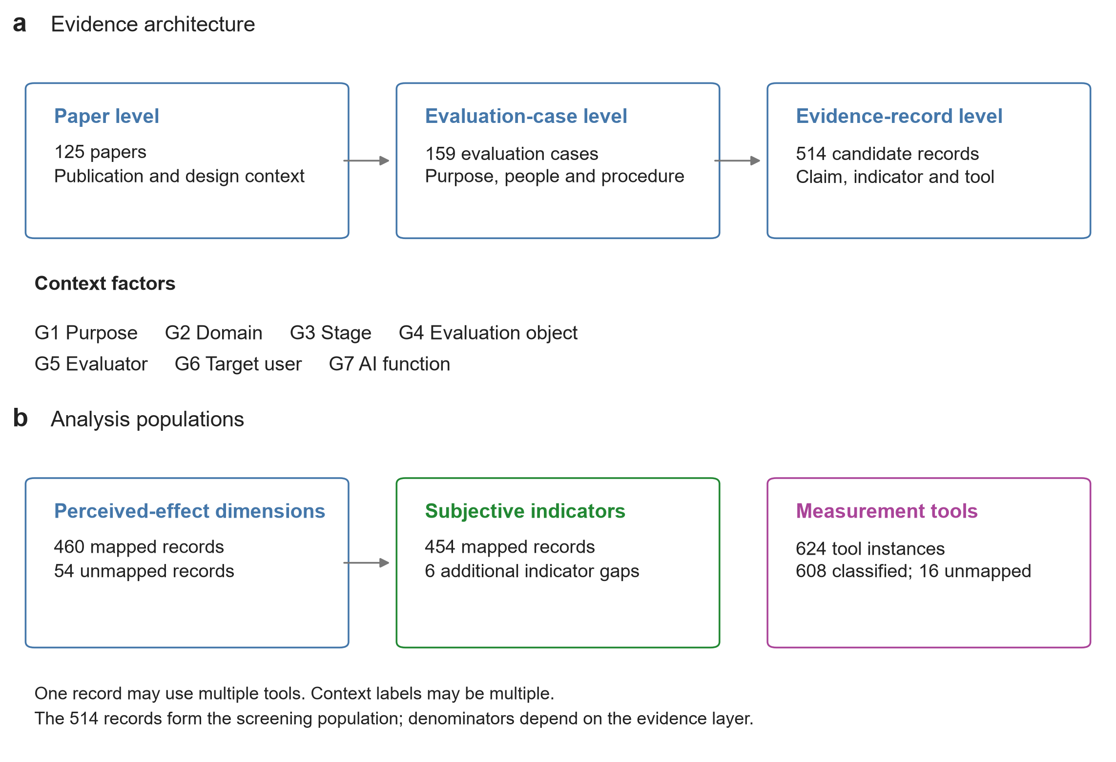
Figure 1. Analytical architecture and denominators. Paper and evaluation-case information is linked to each candidate evidence record. Of 514 records, 460 have a mapped perceived-effect dimension and 454 have a mapped subjective indicator. A record can use more than one tool, yielding 624 tool instances, of which 608 are classified. The diagram describes the available analytic corpus and is not a literature-search flow diagram.
Extraction retains the paper identifier, evaluation-case identifier, record identifier, original construct and instrument wording, claim description, available item or response-format information, source location, contextual codes, and assessment evidence. Original wording is retained alongside normalized categories. For example, an instrument described as a self-developed five-point questionnaire remains distinguishable from an established scale, even if both use numerical response options. Likewise, a participant’s report of experienced workload remains distinguishable from an observer’s rating of the feasibility of an artifact.
The analysis uses the latest supplement-enhanced dataset. An earlier version contained 490 candidate records, 432 mapped dimensions, 426 mapped indicators, and 600 tool instances. Evidence enrichment restored or added records, replaced incomplete placeholders, and produced a net increase of 24 candidate records. Supplement retrieval was incomplete: the audit records 113 publisher pages as blocked or restricted, 10 as accessible, and two with other HTTP errors. These access outcomes concern the supplementary retrieval audit and do not mean that all corresponding main articles were unavailable. We retain the earlier snapshot to assess sensitivity to enrichment.

3.4 Evidence and context codebooks
Perceived effects are organized into five dimensions: design outcome quality (A); design process quality (B); designers’ cognition, affect, and abilities (C); human–AI interaction experience (D); and social and contextual value (E). The codebook specifies 36 subjective-indicator categories, 35 of which occur in the mapped dataset. These categories are analytical groupings, not a psychometrically established scale structure. For example, novelty and feasibility describe different judgments within outcome quality; inspiration and self-efficacy describe different judgments concerning the designer; and control and trust describe different aspects of interaction with AI. The full indicator inventory appears in Appendix A.
Tools are grouped into five classes: named scales (M1), bespoke structured ratings (M2), qualitative verbal elicitation (M3), non-scale structured questionnaires or judgments (M4), and analysis of existing perceptual material (M5). M4 includes formats such as choices, comparisons, and rankings, where the essential response is not a multi-item scale score. M5 includes existing reviews or other text containing human judgments; automatic analysis of such material does not itself turn a computational output into a direct report of a newly experienced effect. Membership in M1 identifies a named instrument and does not guarantee that its particular translation, adaptation, or scoring procedure is validated.
The seven contextual groups describe evaluation purpose (G1), design domain (G2), design stage (G3), evaluation object (G4), evaluator (G5), target user (G6), and AI function (G7). Evaluation purpose distinguishes value elicitation and criterion construction, model supervision or calibration, formative feedback, and summative comparison. The evaluator is the person who supplies the judgment; the target user is the person for whom AI assistance is intended. An expert who rates an artifact and a designer who operates the system can therefore occupy different roles. AI functions include identifying needs, retrieving knowledge, generating proposals, realizing prototypes, providing evaluative feedback, and supporting iterative improvement. Context codes can be multiple-valued.
Table 2. Contextual factors used to describe Subjective Evaluation of Perceived Effects. The prediction analysis uses the recorded contextual fields described below; derived object and evaluator-role fields are excluded.
Factor | Operational meaning and categories | Analytic role
G1 Evaluation purpose | Value elicitation and criteria construction; model supervision and calibration; formative feedback and iteration; summative verification and comparison. | Contextual predictor; multiple labels permitted.
G2 Design domain | Visual communication; industrial/product; fashion; interior; service; UI/UX design. | Contextual predictor; multiple labels permitted.
G3 Design stage | Research; ideation; prototyping and testing; implementation. | Contextual predictor; multiple labels permitted.
G4 Evaluation object | Design output; task or workflow; AI system/interface; human state or capability; human–AI relationship. | Descriptive category; omitted from prediction.
G5 Evaluator | Professional designer/domain expert; student/novice; end user; public/crowdworker; client/stakeholder; researcher. | Original identity categories used for prediction.
G6 Target user | Direct workflow users: professional designer; design student/novice; nonprofessional creator. | Contextual predictor; distinct from the evaluator.
G7 AI function | Needs identification; knowledge retrieval; solution generation; prototype implementation; evaluation feedback; iterative optimization. | Contextual predictor; multiple labels permitted.
Multiple labels are permitted. G4 remains descriptive; predictive analyses use the original identity-based G5 categories.

3.5 Seven-standard reporting-support screen
We operationalize seven standards from the third edition of the JCSEE Program Evaluation Standards [12]: Relevant Information (U5), Valid Information (A2), Reliable Information (A3), Explicit Program and Context Descriptions (A4), Sound Designs and Analyses (A6), Explicit Evaluation Reasoning (A7), and Evaluation Documentation (E1). Table 3 describes their application to subjective evaluation. This is a research-specific adaptation of selected standards. It does not represent a complete JCSEE assessment, and the operational categories and eligibility rules are not official JCSEE scoring rules.
Table 3. Selected JCSEE standards and review-specific operational questions. These questions adapt the standards to published evaluation evidence; they do not constitute an official certification instrument.
Code and official standard name | Operational question
U5 Relevant Information | Does the reported information address the stated evaluation purpose and the Perceived Effects under investigation?
A2 Valid Information | Is the interpretation of the subjective indicator supported by a defensible connection among the Perceived Effects, operationalization, and measure?
A3 Reliable Information | Is the dependability or credibility of the information supported by evidence appropriate to the measurement and analysis?
A4 Explicit Program and Context Descriptions | Are the evaluation object, participants, task, and setting described sufficiently to interpret the findings?
A6 Sound Designs and Analyses | Are the evaluation design and analysis appropriate for the question and the strength of the reported claim?
A7 Explicit Evaluation Reasoning | Can the reasoning from collected information through analysis to the reported conclusion be traced?
E1 Evaluation Documentation | Are the measures, procedures, scoring, results, and source locations documented sufficiently for scrutiny?

Each record receives one of five operational labels: sufficient support (S), partial support (P), an explicit concern (C), not reported or not recoverable (NR), or not applicable (NA). These labels organize the evidence retained for each criterion. They concern support in the reported record rather than the inherent quality of a tool or the complete conduct of a study. For example, naming a scale does not by itself establish validity in a new task, and reporting a technical model’s reliability does not establish the reliability of a subjective indicator. Likewise, NR can reflect insufficient reporting or insufficient recoverable detail and is not equivalent to evidence that a procedure was omitted.
Applying the operational eligibility rules yields a strict analytical subset of 63 records and an expanded subset of 183 records. The expanded subset relaxes the reliability requirement to admit NR. Both exclude explicit concern labels and apply additional rules concerning mapped evidence and reported support. These subsets support sensitivity analysis of the association models; they are not certifications of methodological adequacy. The supplementary records retain the criterion labels, supporting text, and selection flags. We do not create a summed quality score, treat NR as proof of methodological failure, or replace an inapplicable reliability procedure with a missing-information penalty.

3.6 Descriptive synthesis and predictive sensitivity analysis
RQ1 uses counts and within-layer proportions. Dimension and indicator analyses use 460 and 454 mapped records, respectively; tool-class analyses use 608 classified instances. Unmapped observations remain visible in the accounting but are not silently included in category percentages. Domain and stage analyses expand multiple-valued context codes, so one record can contribute to more than one column. These distributions characterize reported evaluation choices, not the direction or magnitude of AI’s perceived effects. Heterogeneous constructs, instruments, and designs preclude a meaningful pooled effect-size estimate.
Temporal analyses use publication years harmonized against the Crossref published-date field for all 125 papers. The original analytical and screening year fields are retained for sensitivity analysis because online publication and issue assignment can lead to different annual classifications. We emphasize counts and denominators and do not interpret sparse annual fluctuations as developmental trajectories. The final year covers only publications available through September 25, 2026.
For RQ3, contextual predictors must be distinguishable from the categories being predicted. G4 describes an evaluation object whose coding partly depends on the dimension and indicator under investigation. It is therefore retained for conceptual interpretation and excluded from predictive estimation. For G5, models use the original identity-based evaluator categories, avoiding role assignments informed by the target category. G4 remains useful for clarifying the evaluand, but its stored coding cannot estimate an independent contextual contribution.
The analysis uses fixed L2-regularized logistic regression (C = 1, balanced class weights), binary encoding fitted within each training fold, and 10 repeated stratified partitions grouped by paper. All records from a paper remain in the same fold, addressing dependence among records from the same publication [16]. No model or hyperparameter is selected from the reported results. Classes require at least five records from three papers, and a task requires at least 30 records. The support filter defines the estimand using the full available dataset; consequently, estimates apply only to these retained classes. Depending on class support, the analysis uses four or five folds.
We compare a training-frequency baseline with context-only prediction. Indicator prediction additionally compares known dimension alone with context plus known dimension. Tool prediction additionally compares known dimension and indicator alone with their combination with context. The known-evidence conditions assume that a user has already selected the preceding evidence component; they are not end-to-end prediction results. Tool prediction operates on tool instances, not on complete multi-tool configurations.
Primary metrics are macro-F1 and top-two accuracy, pooled from out-of-fold predictions within each repetition. We report the mean and standard deviation across the 10 partitions; the standard deviation reflects partition sensitivity, not a population confidence interval. A sensitivity analysis gives each paper equal total weight when scoring. For each context group, a paired ablation computes ΔG = macro-F1(full model) − macro-F1(model without G), using identical partitions. Positive and negative values are retained. These are conditional predictive contributions, not causal effects or normalized influence weights. They remain conditional on the eligibility rules and on the retrospective coding.

4 RQ1: Distribution of Evaluation Evidence

4.1 Perceived effects span outcomes, designers, interaction, and context
Design outcome quality is the largest dimension, accounting for 144 of 460 mapped records (31.3%). Designers’ cognition, affect, and abilities account for 110 records (23.9%), followed by human–AI interaction experience with 97 (21.1%), social and contextual value with 66 (14.3%), and design process quality with 43 (9.3%). Thus, although outcome quality is the largest single category, most mapped records concern other aspects of the workflow. Subjective evaluation of perceived effects cannot be adequately represented by artifact quality alone.
At the indicator level, suitability is most frequent (39/454; 8.6%), followed by novelty (35; 7.7%) and enjoyment (29; 6.4%). Communication, coordination, conflict, and shared understanding account for 25 records (5.5%); feasibility for 23 (5.1%); and aesthetic quality for 21 (4.6%). Inspiration and sense of control each occur in 20 records (4.4%). These results show that frequent indicators concern both the properties of design outcomes and the experience of producing them. Figure 2 presents the overall distributions and the most frequent indicators.
Coverage is uneven within dimensions. Professional and organizational fit and environmental or sustainability value each occur in three mapped records; long-term use, governance, and responsibility occur in one. Handover efficiency, one of the 36 predefined indicator categories, has no mapped record. These are gaps in the coded corpus, rather than evidence that the corresponding perceived effects are unimportant or absent from AI-Assisted Design Workflows. They identify areas in which the present evidence map provides little empirical guidance.
Corpus examples illustrate why preserving the judgment’s referent matters. Wu and Li’s study of generative AI for knitted textile design examines human judgments of design attributes such as aesthetics, style, and fashionability [17]. Haisor uses judgments of rendered indoor scenes, including rationality and human affordance [18]. Such judgments concern representations of proposed outcomes; they do not establish the lived experience of using the eventual product or inhabiting the resulting space. In contrast, the study of hidden costs in AI-assisted ideation includes task-specific judgments concerning creative confidence [19]. These indicators address the designer and require a different interpretation from external ratings of the generated artifacts.

4.2 Tools combine structured judgments and interpretive evidence
Among 608 classified tool instances, bespoke structured ratings are most common (193; 31.7%), followed by qualitative verbal elicitation (138; 22.7%), non-scale structured judgments (115; 18.9%), named scales (97; 16.0%), and analysis of existing perceptual material (65; 10.7%). Sixteen additional instances could not be assigned to a tool class. Because a record can combine tools, these proportions describe instances rather than mutually exclusive study designs.
The distribution indicates that named scales are one component of a broader methodological repertoire. Qualitative elicitation can establish what participants mean by an experience and why an evaluation criterion matters; structured ratings can represent judgments on explicitly specified response dimensions; and comparisons or rankings can reveal preferences among alternatives. These tools address different inferential needs. A combination can be productive when each component has a defined role, such as using interviews to interpret divergent ratings rather than treating all favorable comments as confirmation of a quantitative result.
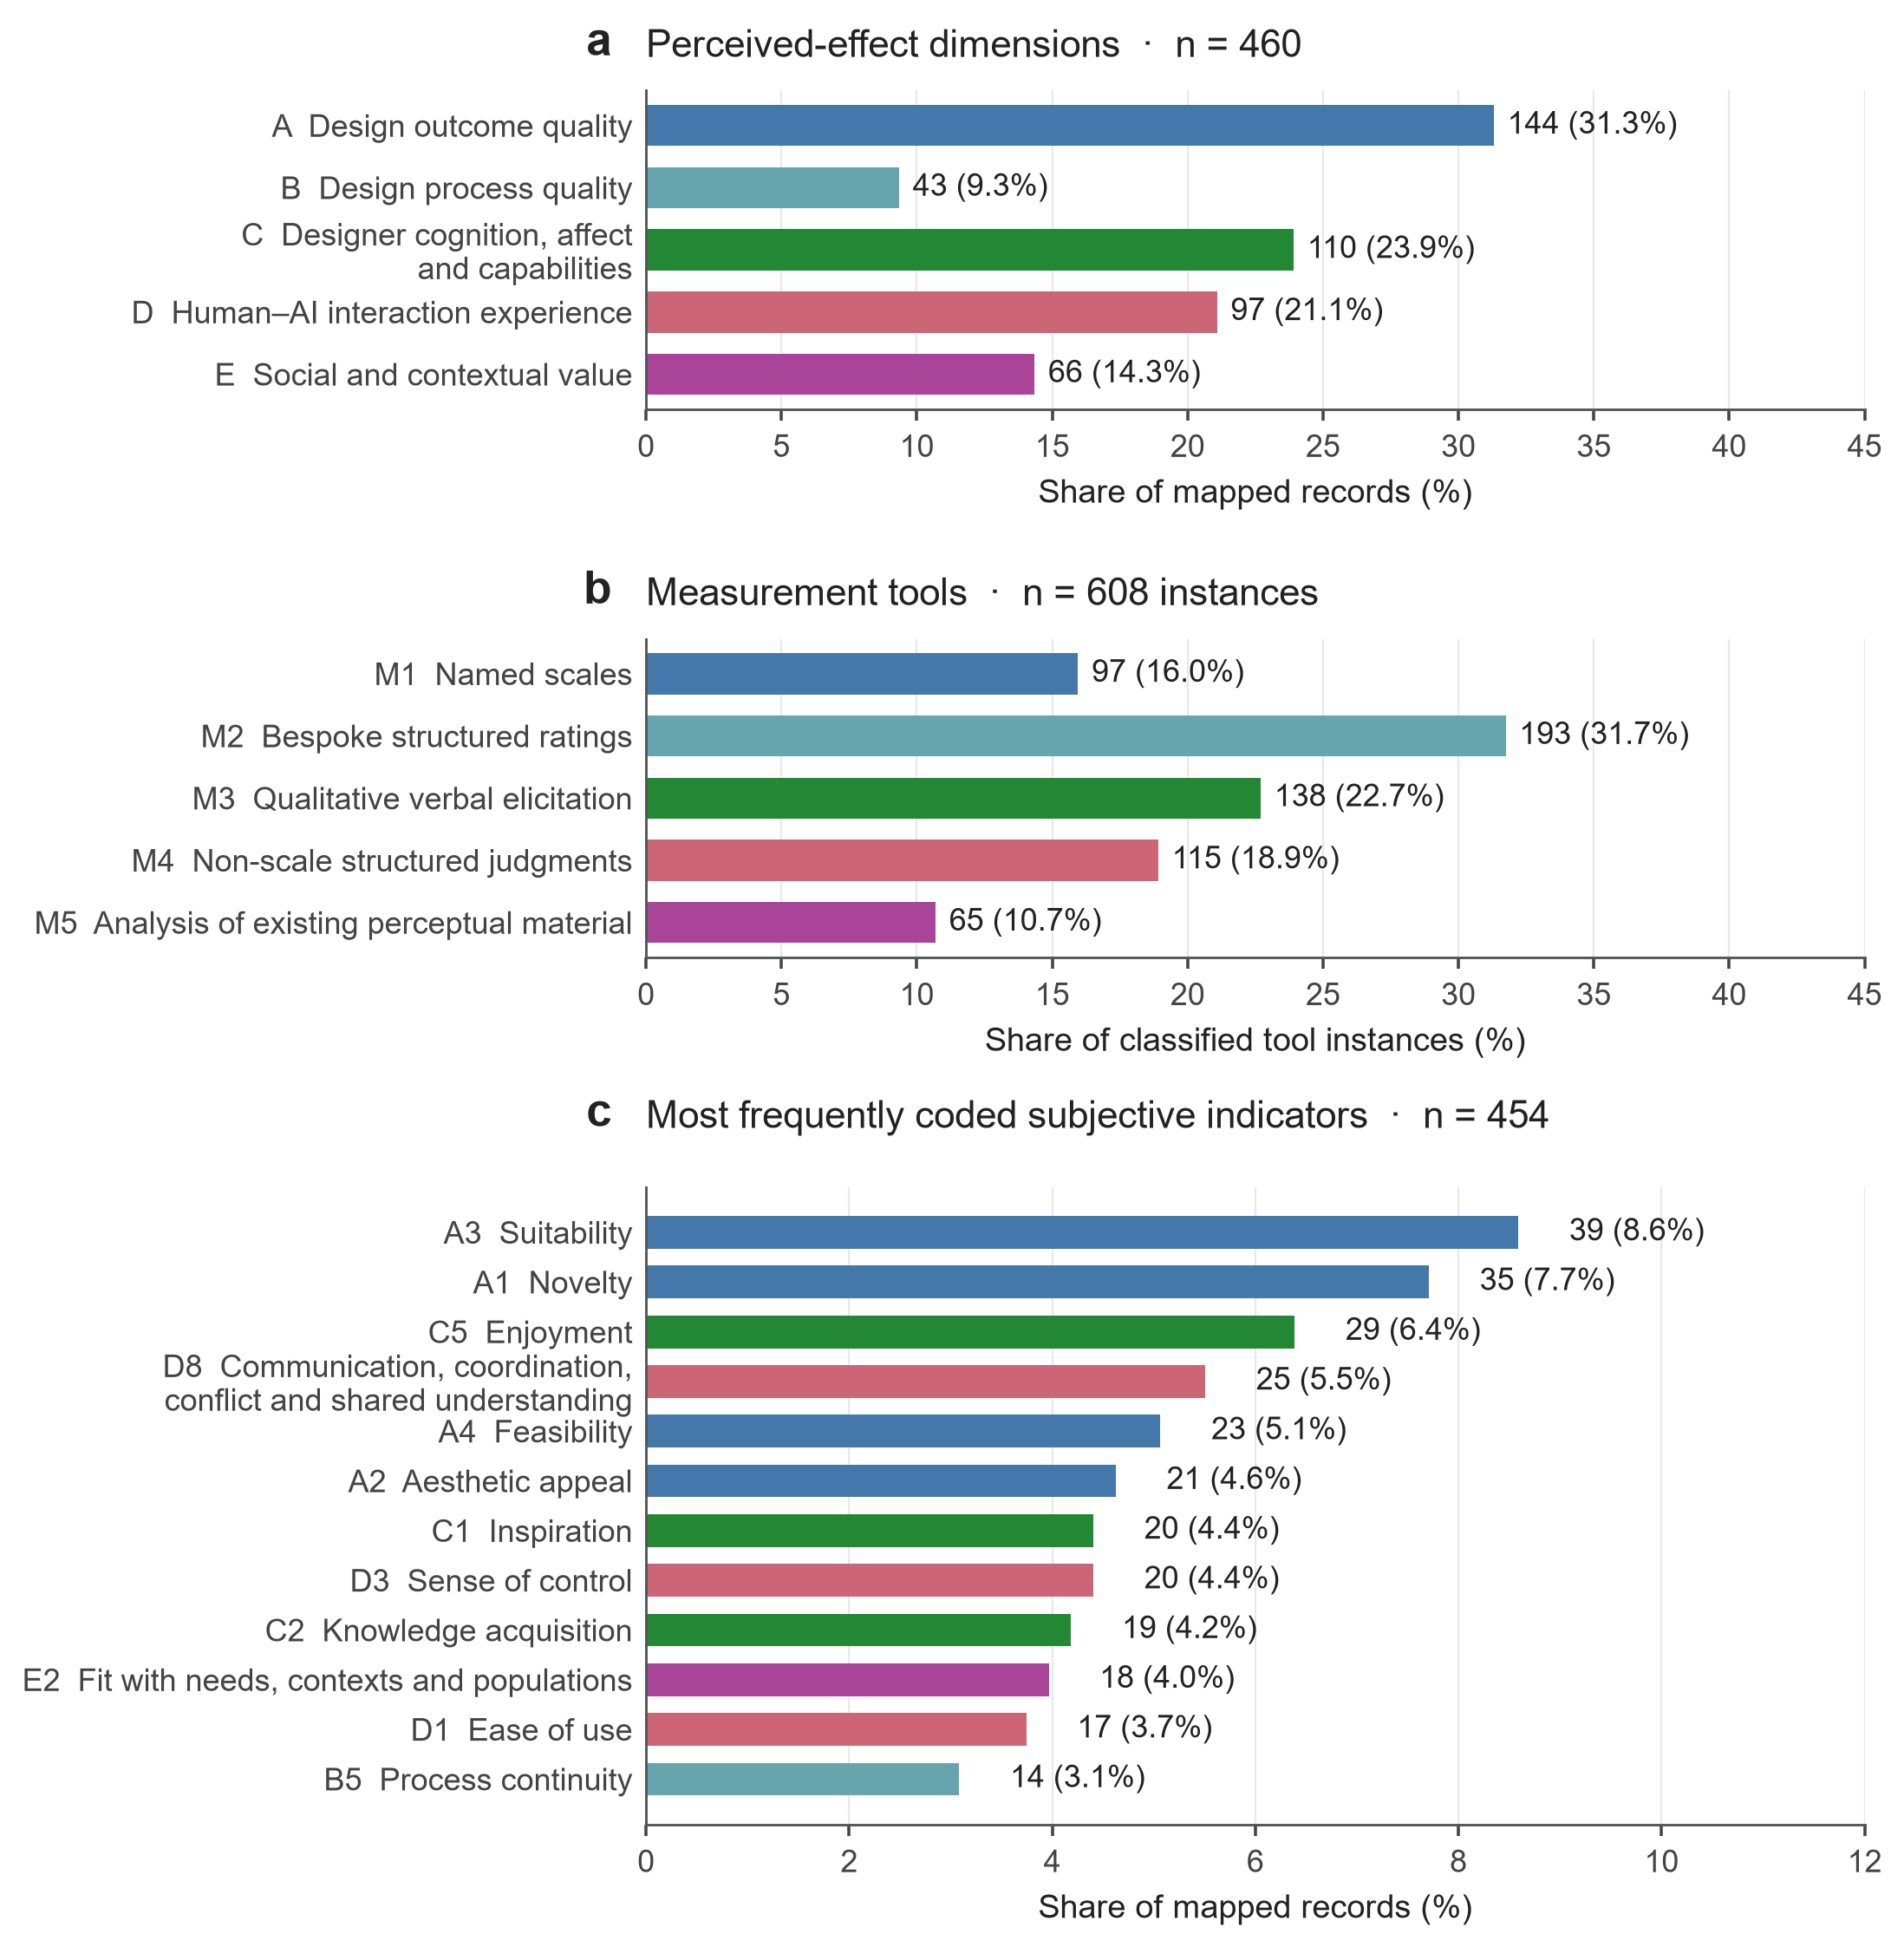
Figure 2. Distribution of evaluation evidence. (a) Perceived-effect dimensions among 460 mapped records. (b) Tool classes among 608 classified tool instances. (c) The 12 most frequent subjective indicators among 454 mapped indicator records. Labels show counts and within-layer percentages. Colour identifies dimensions in (a,c); tool colours in (b) identify tool classes. These distributions describe what the corpus evaluates, not the size or direction of AI effects.
For example, MemoVis examines feedback provision and interpretation in 3D design, distinguishing feedback providers from recipients with relevant design experience [20]. The evaluation context therefore includes more than one perspective on the same system-mediated exchange. Reference-based sketch extraction uses comparisons involving resemblance to a specified reference style [21]. Such a choice can support a fidelity-related interpretation, but should not be generalized to overall liking, creative value, or ease of use. The AiLoupe evaluation further illustrates the relevance of qualitative accounts for understanding designers’ interpretations of AI-supported activity [22].

4.3 Annual distributions reflect a concentrated contemporary corpus
Using harmonized publication years, the corpus contains 11 papers from 2022, 11 from 2023, 28 from 2024, 33 from 2025, and 42 from 2026. The corresponding dimension-mapped record counts are 11, 8, 131, 89, and 221; classified tool-instance counts are 14, 10, 151, 121, and 312. The difference between paper counts and record counts reflects both the presence of unmapped papers and variation in how many evaluative constructs each paper contributes.
Figure 3 shows annual composition rather than plotting raw counts alone. Outcome quality is the largest dimension in 2024 (43/131; 32.8%) and 2026 (70/221; 31.7%); in 2025, it is tied with human–AI interaction experience (25/89 each; 28.1%). The leading tool class also changes across the three later years: qualitative verbal elicitation in 2024 (43/151; 28.5%), non-scale structured judgments in 2025 (38/121; 31.4%), and bespoke structured ratings in 2026 (119/312; 38.1%). These distributions do not establish a simple monotonic shift in evaluation practice. The much smaller denominators in 2022 and 2023 make comparisons with the later years particularly sensitive to individual studies.
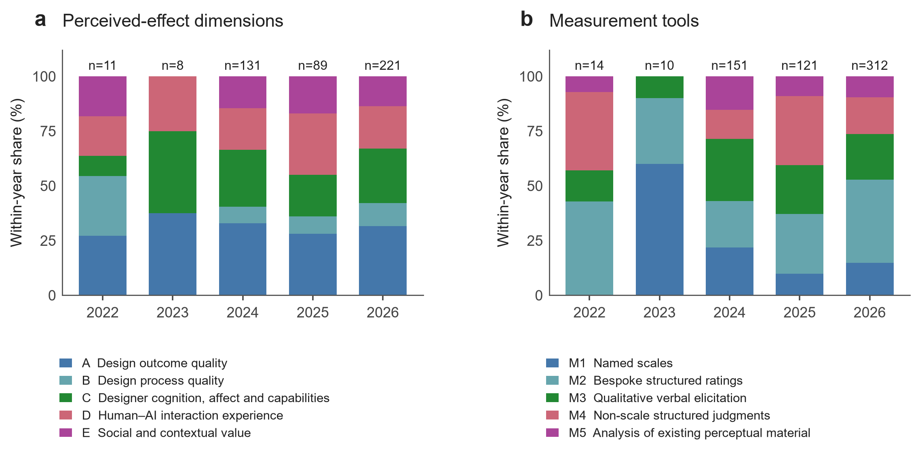
Figure 3. Annual composition of perceived-effect dimensions (a) and tools (b), using Crossref-harmonized publication years. Bars sum to 100% within each year; labels above bars give record or instance denominators. The 2026 period ends September 25. Small early-year samples limit comparison. Alternative year classifications are provided in the supplementary data.
The original analytical year field yields 11, 11, 20, 27, and 56 papers, whereas the screening catalogue yields 11, 13, 27, 35, and 39. All three classifications concentrate the corpus in recent years, but they differ materially in the apparent size of the 2026 increase. We therefore avoid interpreting the annual series as an estimate of the field’s growth rate. Publication-date sensitivity and partial coverage of the final calendar year further limit temporal inference. The supplementary source tables preserve the alternative annual classifications and the indicator-level series.

4.4 Domain and stage patterns suggest contextual diversity
Industrial and product design contributes the largest number of domain-tagged mapped records: 306, of which 104 (34.0%) concern outcome quality. Visual communication contributes 116 records, with designers’ cognition, affect, and abilities the largest category (33; 28.4%). The corresponding category is also largest in UI/UX design (22/67; 32.8%). Human–AI interaction experience is the largest category in fashion design (18/61; 29.5%). Service design has only 16 domain-tagged records, making its apparently larger share of social and contextual value (5; 31.3%) particularly uncertain. These are overlapping domain-tagged counts; they must not be added to estimate the number of distinct records.
Tool distributions also vary. Bespoke structured ratings account for 165/435 classified instances in industrial and product design (37.9%), whereas qualitative verbal elicitation accounts for 40/81 in fashion design (49.4%). Non-scale structured judgments account for 16/29 instances in interior design (55.2%). This variation is consistent with different evaluative tasks and forms of available evidence, although the review cannot establish that the domain itself causes a particular tool choice.
Across design stages, outcome quality remains the largest dimension: 79/267 research-tagged records (29.6%), 122/361 ideation-tagged records (33.8%), 65/199 prototyping-and-testing records (32.7%), and 81/253 implementation-tagged records (32.0%). Social and contextual value represents 17.6% of research-tagged records and 18.1% of prototyping-and-testing records, compared with 9.9% of implementation-tagged records. Since a paper or case can receive several stage codes, these patterns describe contextual membership rather than evidence gathered exclusively at that stage. In particular, an implementation label does not establish longitudinal deployment. Figure 4 presents the dimension and tool distributions across domains and stages.
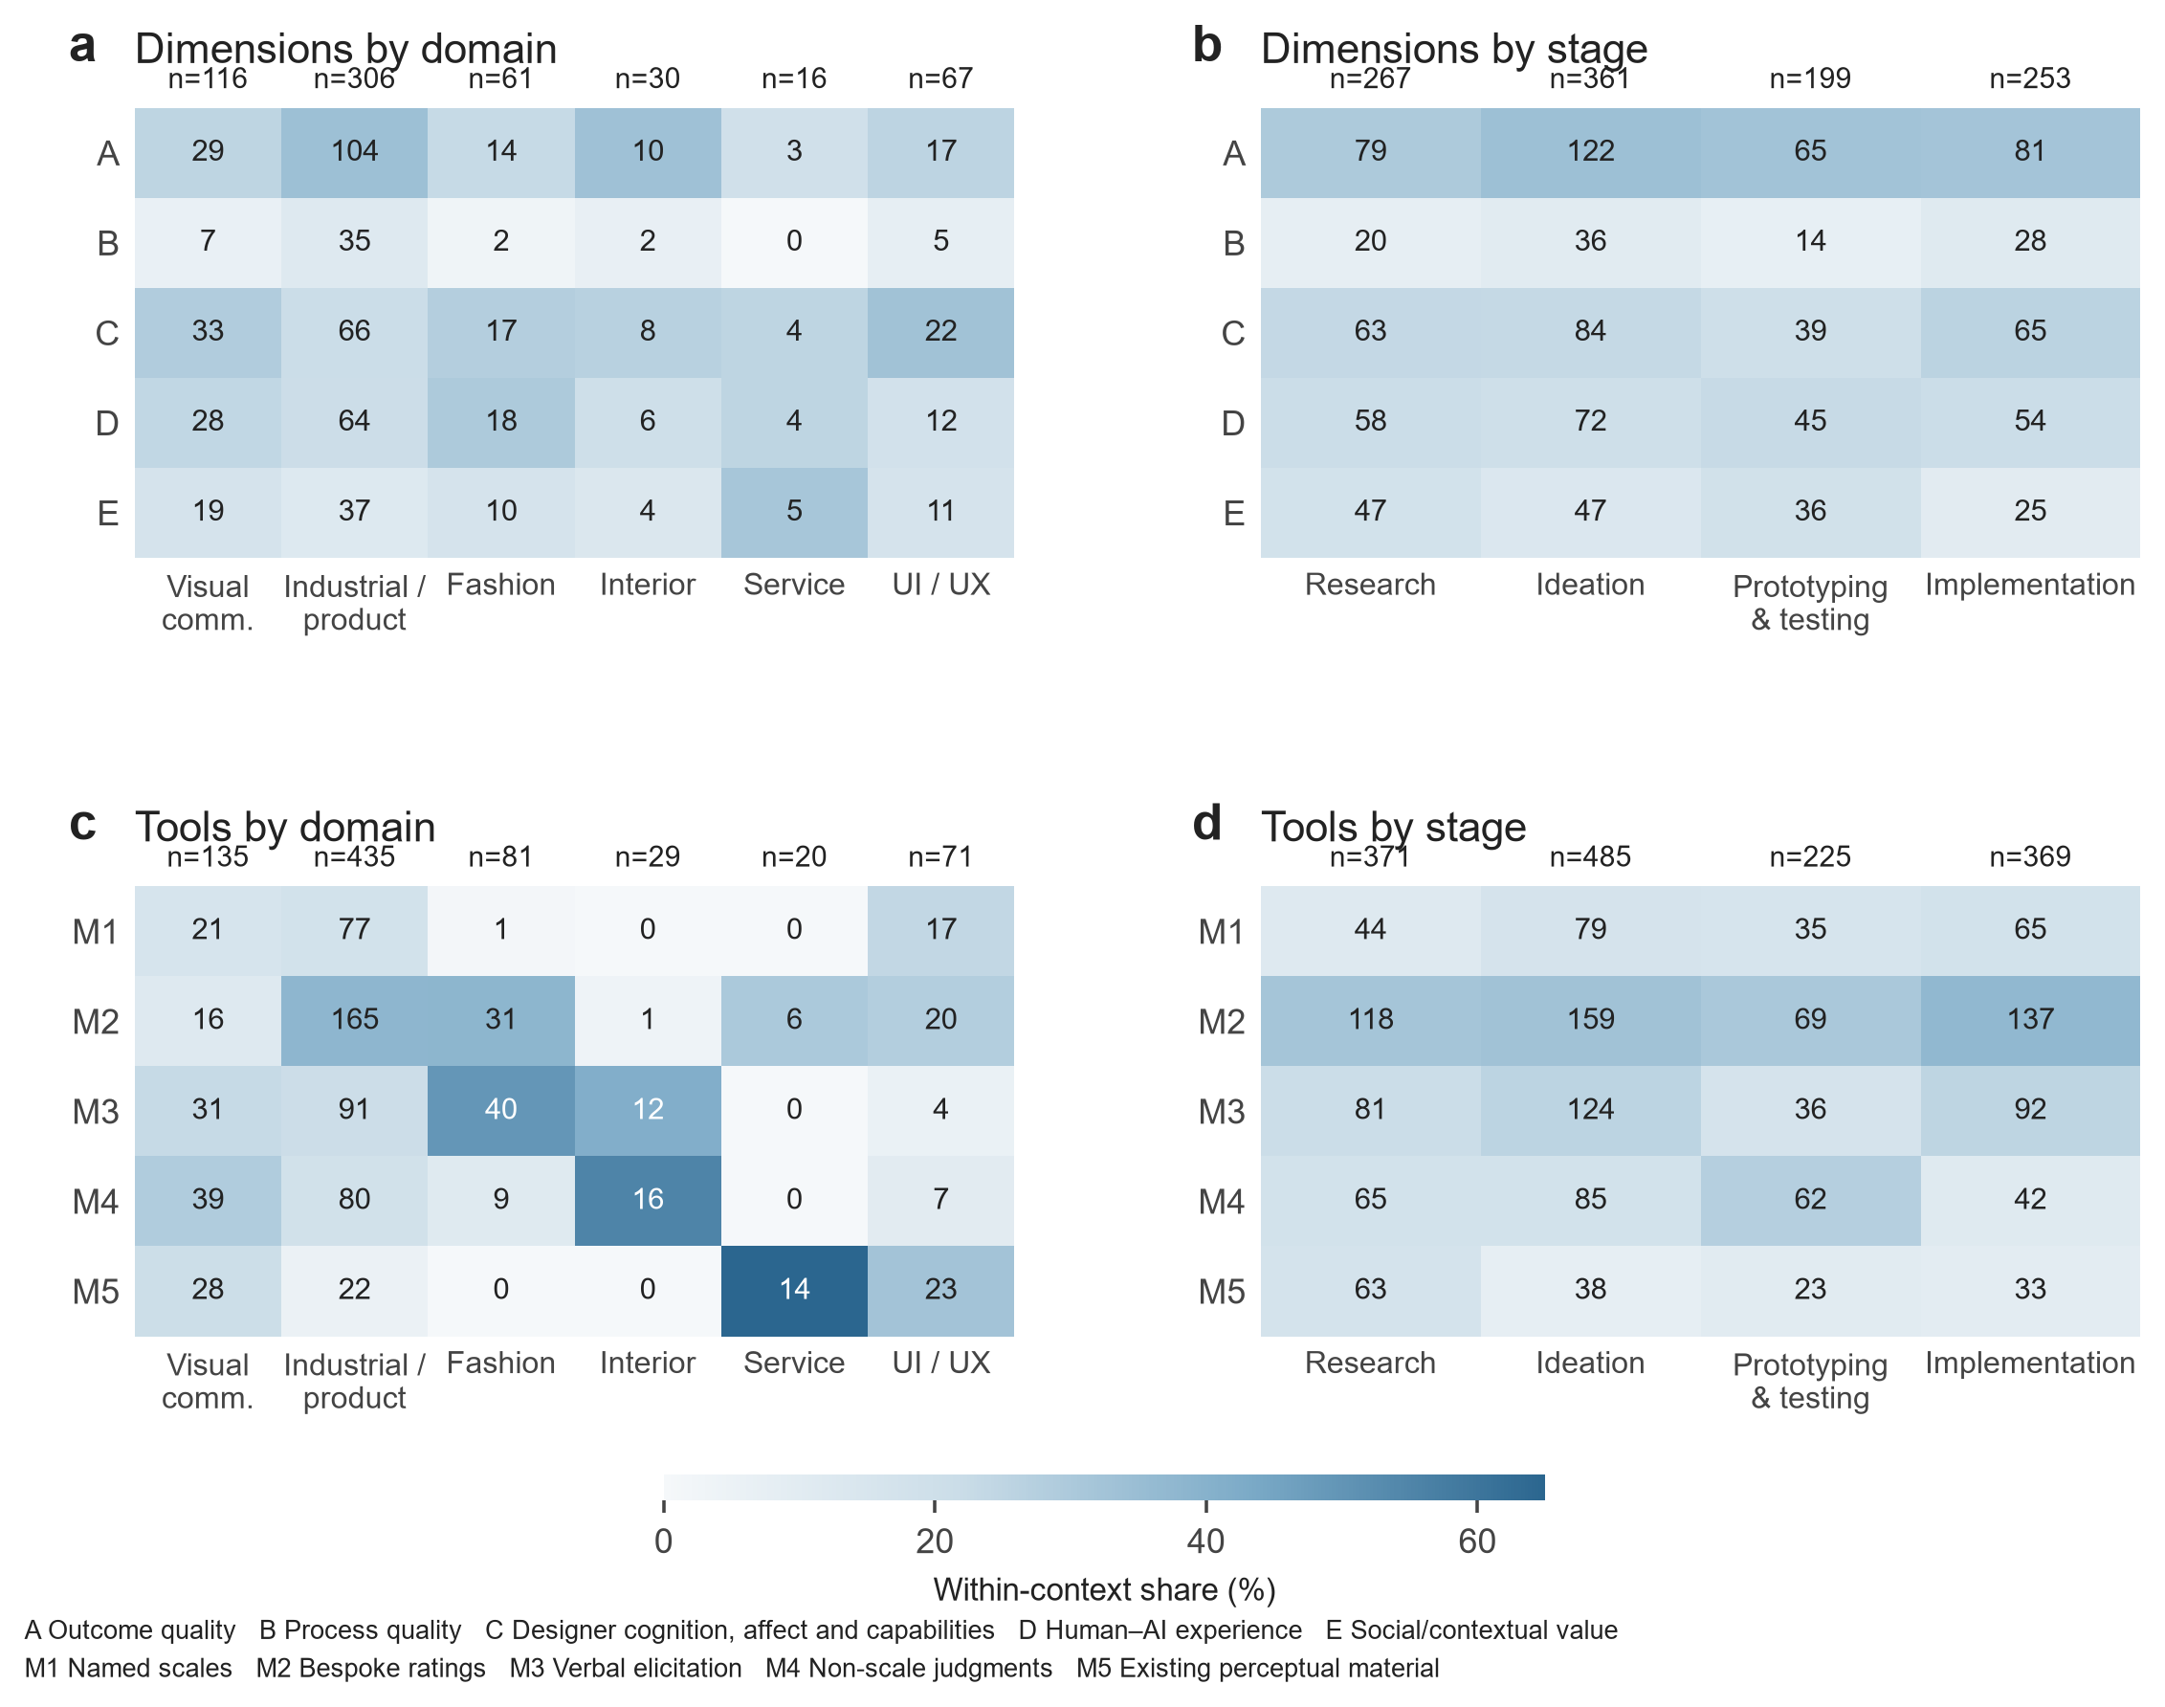
Figure 4. Contextual distribution of perceived-effect dimensions and tool classes. Colour shows the proportion within each design domain or stage; cell labels give raw counts and column labels give denominators. Records can carry more than one domain or stage, so counts across columns do not sum to the unique-record total. Domain and stage membership are descriptive context labels.

4.5 Sensitivity to supplementary evidence
Evidence enrichment increased the mapped dimension count from 432 to 460, the mapped indicator count from 426 to 454, and classified tool instances from 584 to 608. Aggregate proportions changed little: the largest absolute change was 0.53 percentage points for a dimension, 0.44 for an indicator, and 0.92 for a tool class. Dimension and tool ranks were unchanged, while the indicator-rank correlation was .995. The broad descriptive profile is therefore comparatively stable under this enrichment. This result concerns marginal distributions; it does not establish stability of record-level judgments, eligibility assignments, or contextual models.

5 RQ2: Reported Support for Subjective Evaluation

5.1 Reporting-support profiles differ across standards
The seven-standard assessment produces 3,598 criterion labels across 514 candidate records. Figure 5 and Table 4 summarize the recorded statuses. U5 contains the largest S category, with 446 records (86.8%), whereas A2 contains 44 S records (8.6%) and 405 P records (78.8%). A4 similarly contains substantially more P than S labels: 407 (79.2%) and 60 (11.7%), respectively. Thus, the operational classifications assign more complete support to relevance than to measurement interpretation or contextual specification.
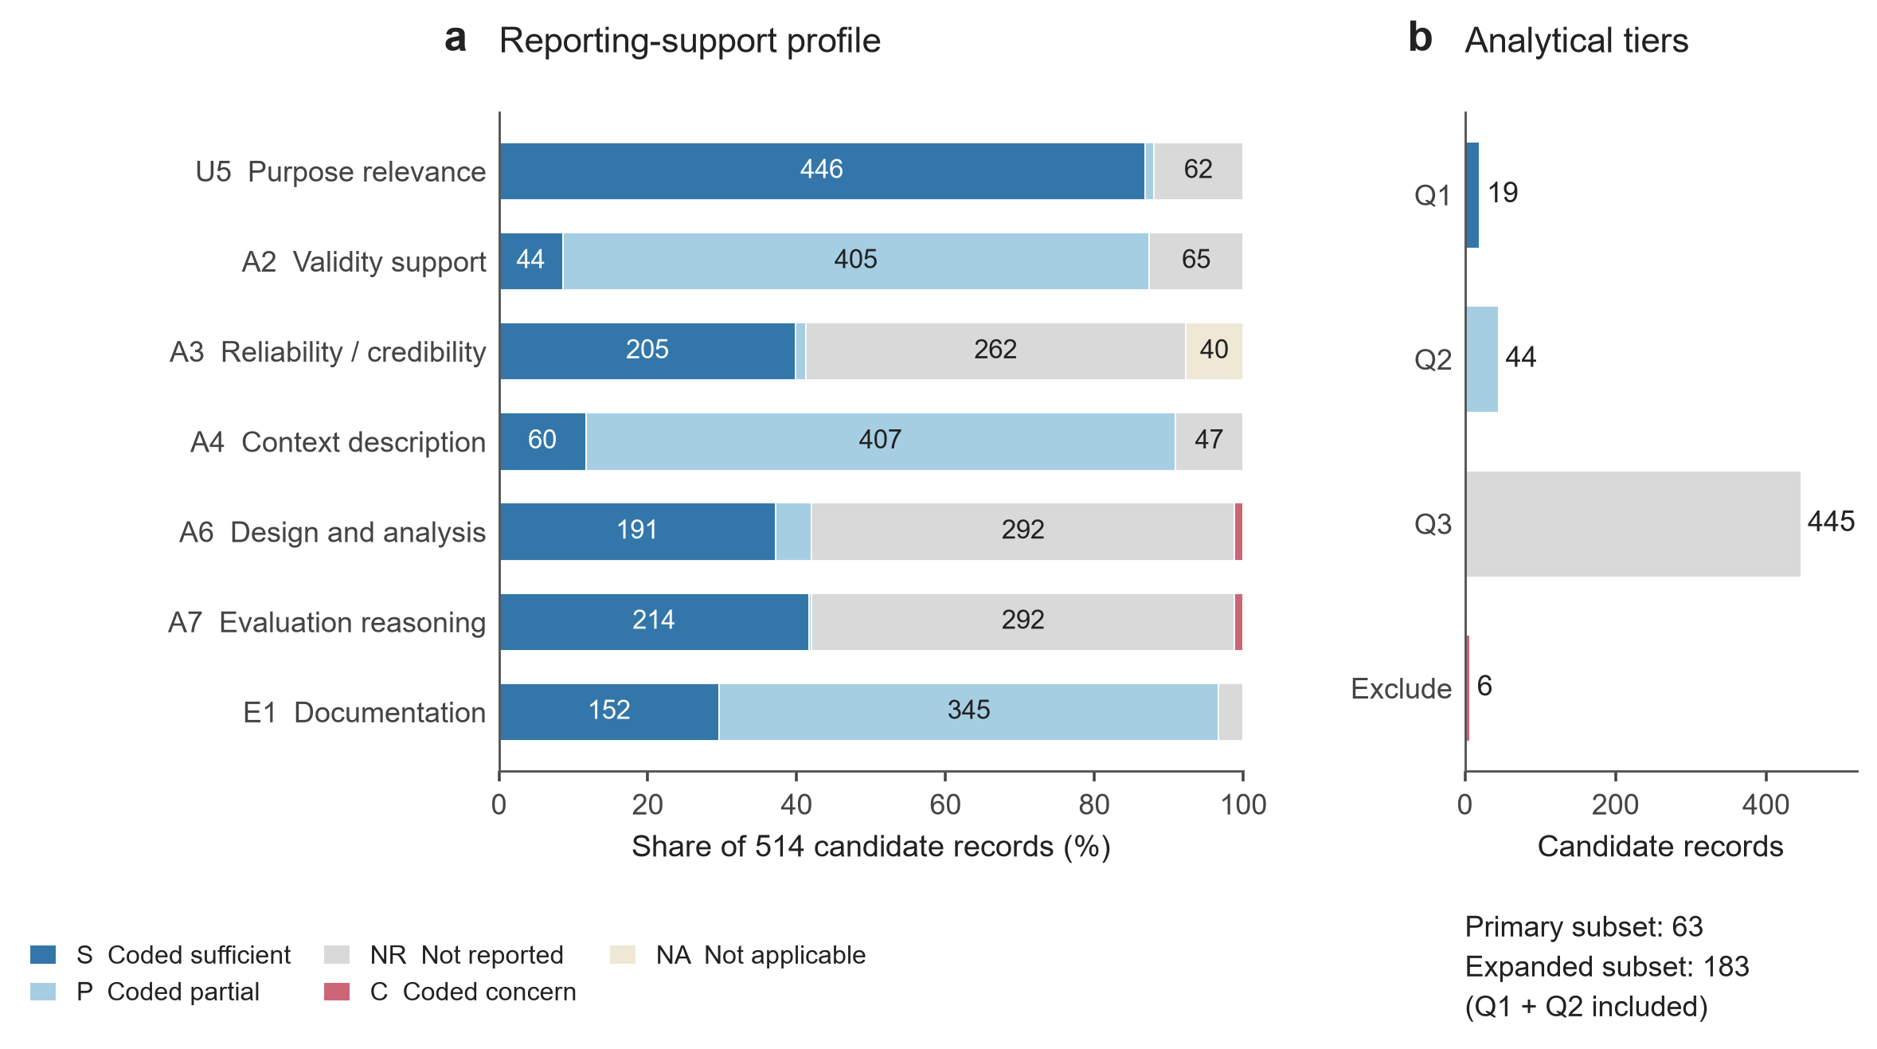
Figure 5. Distribution of operational reporting-support codes across 514 candidate records. (a) The seven JCSEE-informed criteria yield 3,598 criterion-by-record codes, including 40 records coded NA for A3. S, P and C denote coded sufficient support, partial support and concern, respectively. NR does not establish that a procedure was omitted in practice. Numbers identify segments large enough to label; exact counts are provided in source data. (b) Analytical tiers derived from the operational codes: the primary subset comprises Q1 and Q2 (63 records), and the expanded subset contains 183 records. Counts represent coded categories, not certification of study methodological quality.
Table 4. Criterion-level reporting-support classifications across 514 candidate evidence records.
Criterion | S | P | C | NR | NA
U5 | 446 | 6 | 0 | 62 | 0
A2 | 44 | 405 | 0 | 65 | 0
A3 | 205 | 7 | 0 | 262 | 40
A4 | 60 | 407 | 0 | 47 | 0
A6 | 191 | 25 | 6 | 292 | 0
A7 | 214 | 2 | 6 | 292 | 0
E1 | 152 | 345 | 0 | 17 | 0
S: sufficient support under the operational coding; P: partial support; C: explicit concern; NR: not reported or indeterminate; NA: not applicable. Every row totals 514. These codes concern the retained evidence record and do not certify the underlying study.
A3 includes 205 S, seven P, 262 NR, and 40 NA labels. Preserving NA is necessary: a procedure can be inapplicable to a given form of evidence, and this status should not be silently converted into missing data. For A6 and A7, 292 records (56.8%) receive NR on each criterion. Six records receive C on each, and these belong to a single paper rather than six independent publications. E1 includes 152 S (29.6%), 345 P (67.1%), and 17 NR (3.3%) labels. These counts describe the operational assessment categories and should not be interpreted as the prevalence of validated or invalid studies.

5.2 Evidential adequacy depends on the intended interpretation
The practical issue underlying the assessment is whether a reader can reconstruct the path from a judgment to a claim. Relevance alone is insufficient: asking about trust is relevant to an AI-assisted workflow, but the interpretation of a trust score still depends on the item wording, the object of trust, the timing of elicitation, and the conditions under which participants used the system. Similarly, a feasibility judgment requires a specified standard and an evaluator with an appropriate basis for making the judgment.
Validity and reliability require distinct evidence. A familiar instrument name can establish provenance while leaving open whether the instrument covers the intended perceived effects in a new task. Agreement among expert artifact raters addresses a different source of consistency from internal consistency among scale items. A reliability statistic for model annotations or extraction accuracy does not directly establish the reliability of a participant’s subjective indicator. The appropriate question is therefore whether the reported evidence supports the particular measurement interpretation, rather than whether a publication contains a general reference to validity or reliability [23] [24].
The same specificity applies to qualitative evidence. An interview can illuminate why participants experience a tool as supportive or constraining, but readers need to understand participant selection, elicitation, analysis, and the basis for the presented interpretation. Documentation is especially important when the same excerpts support several perceived-effect categories. Adequate reporting makes the relationship among those categories inspectable rather than treating each coded occurrence as independent confirmation.

5.3 Analytical eligibility narrows the available evidence
The strict eligibility rules retain 63 records from 22 papers, corresponding to 12.3% of the 514 candidate records. The expanded rules retain 183 records from 43 papers (35.6%). The strict subset comprises 19 records in the most restrictive tier and 44 in the next tier. The remaining records include 445 in a broader descriptive tier and six excluded by explicit concern codes. These tiers are study-specific selection devices and should not be interpreted as a standardized hierarchy of research quality.
The retained evidence is also concentrated. One paper contributes 15 of the 63 strict-subset records (23.8%), while the 19 records in the most restrictive tier come from only four papers. Consequently, filtering records cannot substitute for attention to the number and diversity of independent publications. This concentration motivates paper-grouped validation and the equal-paper-weight sensitivity analysis used for RQ3. It also limits the extent to which selected examples can support a general recommendation for a new design context.

6 RQ3: Contextual Associations and Predictive Contributions

6.1 Predicting evidence categories from context
The expanded subset supports three prediction tasks after class-support filtering: five perceived-effect dimensions across 183 records from 43 papers; 13 subjective indicators across 124 records from 31 papers; and five tool classes across 210 instances from 43 papers. The strict subset supports dimension and tool prediction, but does not provide enough retained indicator records to meet the minimum task size. Figure 6 and Table 5 summarize the expanded-subset models.
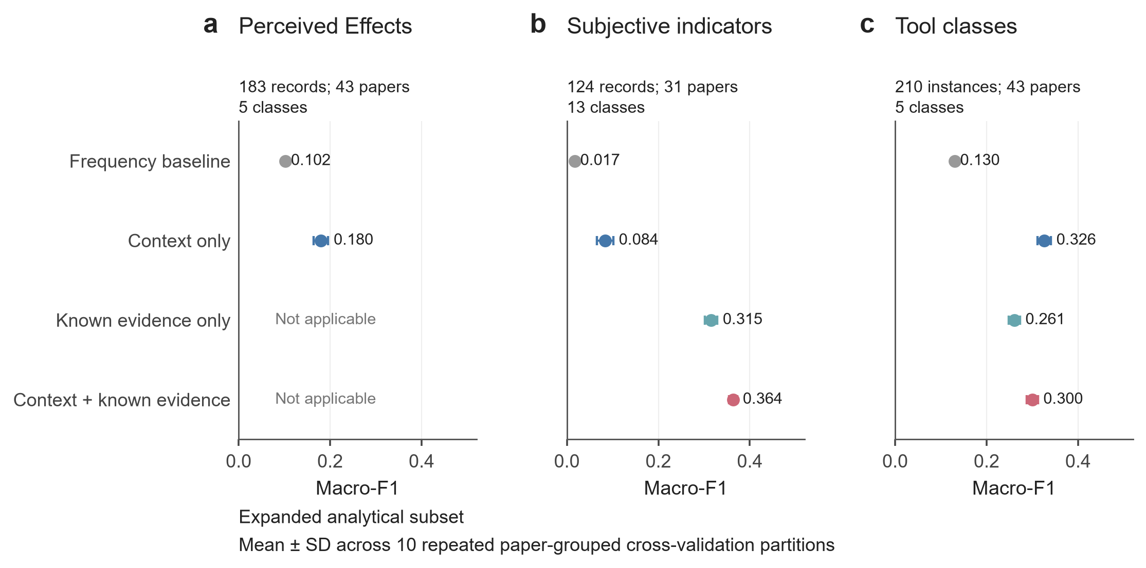
Figure 6. Predictive analysis in the expanded analytical subset. Results are conditional on the operational eligibility rules and coded records used in this analysis. Fixed, class-balanced L2 logistic regression uses fold-specific encoding, excludes target-derived G4 and uses original evaluator labels for G5. Panels report classification of (a) perceived-effect dimensions, (b) subjective indicators and (c) tool classes. Known evidence means the dimension for indicator prediction, and dimension plus indicator for tool prediction; it is inapplicable to dimension prediction. Points are mean pooled out-of-fold macro-F1 over ten repeated paper-grouped partitions; error bars are the SD across partitions, not confidence intervals for a population effect. Different target layers have different eligible samples and class counts.
Table 5. Expanded-screen conditional prediction results over ten repetitions of cross-validation grouped by paper. Macro-F1 is reported as mean ± SD across data splits; SD is not a population confidence interval.
Prediction target | Information supplied | Records | Papers | Classes | Macro-F1 | Top-2 accuracy
Perceived Effects dimension | Frequency baseline | 183 | 43 | 5 | 0.102 ± 0.000 | 0.515
Perceived Effects dimension | Context only | 183 | 43 | 5 | 0.180 ± 0.016 | 0.465
Subjective indicator | Frequency baseline | 124 | 31 | 13 | 0.017 ± 0.000 | 0.194
Subjective indicator | Context only | 124 | 31 | 13 | 0.084 ± 0.018 | 0.189
Subjective indicator | Known evidence only | 124 | 31 | 13 | 0.315 ± 0.014 | 0.672
Subjective indicator | Context + known evidence | 124 | 31 | 13 | 0.364 ± 0.009 | 0.745
Tool class | Frequency baseline | 210 | 43 | 5 | 0.130 ± 0.000 | 0.586
Tool class | Context only | 210 | 43 | 5 | 0.326 ± 0.015 | 0.512
Tool class | Known evidence only | 210 | 43 | 5 | 0.261 ± 0.012 | 0.537
Tool class | Context + known evidence | 210 | 43 | 5 | 0.300 ± 0.012 | 0.561
All non-baseline rows use the same fixed regularized logistic-regression specification. Known evidence is the selected Perceived Effects dimension for indicator prediction and the selected dimension plus indicator for tool prediction. G4 and derived G5 are excluded. Tool records are individual tool instances. Metrics are pooled over out-of-fold predictions within each repetition. Equal-paper-weighted scoring reverses the indicator ordering between known-evidence-only and context-plus-known-evidence (macro-F1 .321 versus .305), limiting claims of incremental contextual benefit.
For perceived-effect dimensions, context-only prediction achieves a mean macro-F1 of .180 (partition SD .016), compared with .102 for the frequency baseline. Its top-two accuracy is .465, below the baseline’s .515. Context therefore improves macro-averaged classification performance while reducing the proportion of observations for which the recorded category appears within the two highest-ranked choices. The distinction matters for a recommender: improved macro-F1 does not automatically establish improved shortlisting performance.
For subjective indicators, context alone yields macro-F1 .084 (SD .018). The known-dimension-only model yields .315 (SD .014), and combining the known dimension with context yields .364 (SD .009). Top-two accuracy is .672 with known dimension alone and .745 with the combined specification. Much of the gain depends on supplying the preceding evidence component. Since indicators are nested within dimension categories in the codebook, this result is partly a consequence of the evidence hierarchy rather than independent validation of its theoretical structure.
For tools, context alone yields macro-F1 .326 (SD .015), compared with .261 (SD .012) for known dimension and indicator and .300 (SD .012) for their combination with context. Adding known evidence therefore does not consistently improve the context-only model. The combined model’s top-two accuracy is .561, compared with .586 for the frequency baseline. These results motivate a design that makes tool candidates and their supporting records available for comparison; they do not establish that a learned ranking identifies an appropriate measurement tool for a new study.

6.2 Contributions vary across evidence layers
Paired group ablations show that contextual information contributes differently across tasks. In the expanded indicator model, retaining design domain (G2) improves macro-F1 by .026 on average, with a positive difference in all 10 repetitions. For tools, evaluation purpose (G1) contributes .040 on average, also positive in all repetitions; design stage (G3) contributes .019, positive in nine repetitions. For dimensions, the original evaluator group (G5) contributes .022, positive in eight repetitions. These results indicate model-specific complementarity between the target being predicted and the context supplied.
Several group contributions are negative. Removing AI function (G7), for example, improves macro-F1 in each of the three expanded-subset tasks under the specified model. This does not show that AI function is irrelevant to subjective evaluation. Sparse categories, correlated context fields, limited sample size, and variation among papers can make a conceptually important feature unhelpful for a particular predictive model. Likewise, the excluded G4 field remains central to specifying what is being judged, even though its dependence on the coded target prevents a separate predictive interpretation. The ablations are therefore retained as signed conditional differences rather than converted into percentages of causal influence.

6.3 Dependence on sample selection and publication weighting
The strict-subset dimension model yields macro-F1 .183 (SD .027), using 61 records from 21 papers after class filtering. Its tool model yields .493 (SD .032) with context alone and .367 (SD .017) with context plus known evidence, using 66 instances from 22 papers. These values are not directly comparable with the expanded models as evidence of better generalization: the retained classes, sample composition, and number of papers differ.
Equal-paper-weight scoring further qualifies the apparent benefit of contextual predictors. In expanded indicator prediction, the combined model’s macro-F1 changes from .364 under record-weighted scoring to .305 under equal-paper weighting. The known-dimension model scores .321 under equal-paper weighting, reversing the combined model’s apparent advantage. For tools, the equal-paper-weight scores of context alone and the combined model are almost identical (.267 and .265). A result that appears advantageous when records are equally weighted may therefore reflect publications that contribute many records.
Taken together, RQ3 supports a restrained interpretation. Context and previously specified evidence components can help organize candidate choices, but their value differs across evidence layers and is sensitive to corpus composition. The analysis does not establish stable universal influence weights, an optimal order of all contextual questions, or validated recommendations. It provides empirical grounds for a guided selection process in which the user confirms the perceived effects and examines the supporting records before choosing an indicator or tool.

7 RQ4: From Evidence Mapping to Progressive Guidance

7.1 Principles for selecting evaluation evidence
The review supports a sequence of decisions rather than a universal ranking of indicators or tools. Selection begins with an intended inference: what should be learned, whose judgment is needed, and what decision will use that judgment? The perceived effects then identify the relevant consequences, the subjective indicators specify what will be observed, and the tools establish how evidence will be elicited. Context informs these decisions, while documentation makes their alignment inspectable. Table 6 summarizes the resulting guidance.
First, distinguish evaluation purpose from evaluation outcome. Needs elicitation can identify valued consequences, calibration can connect human judgments to a computational representation, and formative feedback can support revision. None of these purposes alone establishes comparative benefit. If the intended claim concerns improvement, the evaluation should specify the comparison and the basis on which improvement is judged. This principle preserves the breadth of subjective evaluation while preventing upstream evaluative activity from being interpreted as downstream evidence of effectiveness.
Second, identify the evaluator and evaluation object before interpreting a score. Designers, domain experts, clients, and eventual users may make different judgments about the same workflow. A domain expert’s novelty rating can inform artifact assessment but cannot substitute for the designer’s report of control. A designer’s satisfaction with a generated concept cannot establish that the eventual user finds the realized product comfortable or acceptable. G4 is essential to this specification even though it cannot be used as an independent predictor in the present data. Its conceptual importance should not be reduced to a model-derived weight.
Third, select a manageable set of perceived effects that reflects the evaluation purpose. RQ1 shows that outcome quality is prominent, but cognition, affect, interaction, and contextual value collectively account for a larger share of mapped records. For a study of AI-assisted ideation, novelty may therefore need to be considered alongside inspiration, control, or fixation. This is a requirement to justify coverage, not to measure every category. Adding indicators without a reason increases participant burden and may obscure the claims that the study is intended to test.
Fourth, choose tools only after specifying the indicator and intended interpretation. A named scale is appropriate when its construct coverage, population, response format, and scoring are suitable for the study. A bespoke rating can be useful when the judgment is task-specific, provided the item, anchors, and interpretation are explicit. A ranking is suitable for a relative preference among presented alternatives, but does not by itself establish the absolute quality of any alternative. Qualitative elicitation can explain meanings and contextual dependencies that a rating leaves unresolved. Existing perceptual material can broaden access to judgments, while requiring attention to who produced it, under what circumstances, and with what selection biases.
Finally, make the support for each choice traceable. Reusable evidence includes the source study, original construct wording, evaluator and target-user descriptions, task, stimulus or artifact, item or elicitation prompt, response format, scoring or analytic procedure, and the reasoning connecting the result to the claim. Measurement justification should accompany adaptations rather than being inherited automatically from the original instrument. This principle extends the concern with implementation detail illustrated by reviews of established HCI instruments [11] to heterogeneous subjective evaluation across design workflows.
Table 6. Practical guidance for selecting evidence in Subjective Evaluation of Perceived Effects.
Decision | Evidence to establish | Interpretive limitation
Establish purpose | Specify whether judgments elicit criteria, calibrate a model, guide revision, or support comparison. | Criteria or calibration labels do not alone demonstrate downstream benefit.
Identify perspectives | State the evaluator, target user, evaluation object, and task conditions. | Artifact ratings do not establish the designer’s own experience.
Select perceived effects | Justify coverage across relevant outcome, process, designer, interaction, and contextual dimensions. | Frequency in the corpus is not a normative priority.
Specify indicators | Retain construct wording, intended interpretation, and relation to the selected perceived effects. | Shared names need not denote equivalent operationalizations.
Choose tools | Match the indicator to instrument content, elicitation format, population, and analysis. | Named scales and repeated use do not guarantee validity in a new context.
Document and review | Provide items or prompts, scoring or analytic procedures, evidence sources, and unresolved assumptions. | A recommendation is a starting point for a justified evaluation plan.
Guidance is derived from the evidence architecture and descriptive and predictive analyses; its effectiveness has not been established in a prospective evaluation.

7.2 A progressively disclosed recommender
We translate these principles into a recommender design with four connected stages (Figure 7). An exploratory interface in the project materials instantiates the progression from evaluation intention to perceived effects, indicators, and tools. The present contribution is the evidence-guidance structure and its decision logic. Neither the fitted models nor the interface establish that the resulting recommendations are optimal or improve researchers’ evaluation designs.
The first stage establishes the evaluation purpose and a minimal context: design domain, design stage, evaluator, target user, and AI function. The interface also asks the user to describe the evaluation object in plain language. Additional questions are disclosed when they clarify a choice, rather than requiring the complete contextual taxonomy at the outset. The ablations motivate attention to purpose and stage when discussing tools and to domain when discussing indicators, but do not justify a fixed universal question order.
The second stage presents candidate perceived effects with concise definitions, corpus coverage, and examples of the relevant judgments. The user confirms the dimensions that match the intended inference. Frequent categories are presented as common precedents rather than automatically preferred choices. Categories with sparse coverage remain visible, because a rarely studied perceived effect may be central to the current design problem. If the evidence does not support a useful shortlist, the interface should state that limitation and allow direct exploration of the taxonomy.
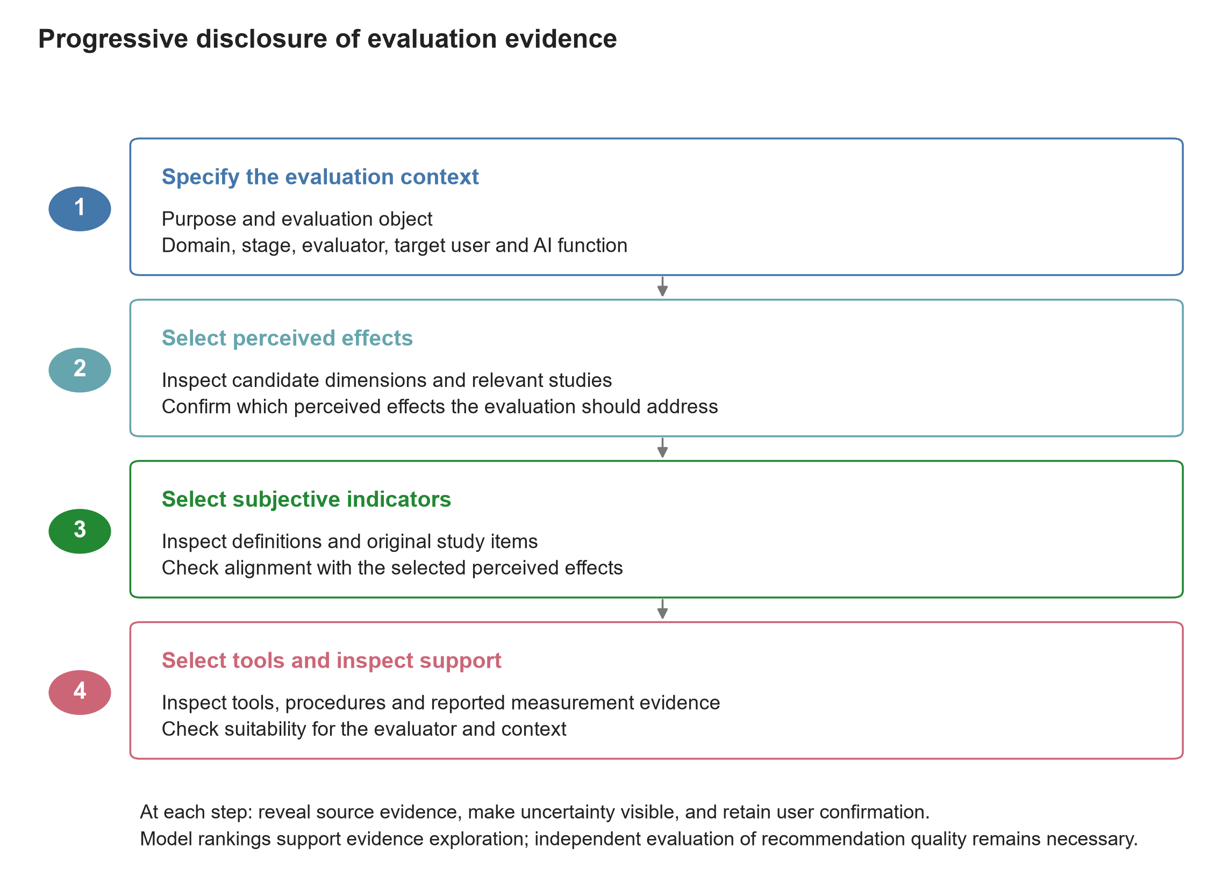
Figure 7. Proposed interaction structure for progressively disclosed evidence guidance. Users first specify context and then confirm perceived effects, subjective indicators and tools in sequence. Source records and reported support remain inspectable at every step. The diagram expresses the evidence-guidance design; it does not claim that ranking weights are causal, that the recommender is optimal, or that recommendation quality has been independently validated.
The third stage presents subjective indicators within the selected dimensions. Each indicator is linked to the original wording used in source studies, the evaluation object, and the evaluator. The dependence of indicator prediction on a known dimension provides a rationale for narrowing the candidate space in stages. However, the paper-weighted sensitivity result cautions against presenting contextual reordering as a stable improvement over the evidence hierarchy itself. A user should be able to inspect alternatives and retain an indicator on substantive grounds even when it is uncommon in the matched corpus.
The fourth stage presents candidate tool classes and, where available, specific instruments or elicitation formats. Each recommendation includes a rationale tied to the intended judgment, examples from the corpus, reporting-support information, and implementation requirements. The interface distinguishes a direct instrument use from an adaptation and a multi-item score from a single judgment. It should also expose combinations, such as a structured rating accompanied by an interview, without implying that the instance-level tool classifier has validated that combination.
At every stage, the proposed source panel provides the paper and record identifiers, source location, and retained evidence. An exportable evaluation plan should record the selected perceived effects, indicators, tools, contextual assumptions, and unresolved requirements, allowing the selection process to be reviewed and revised. A frequency or model score can help order candidate records, but should not be displayed as a probability that the proposed evaluation is valid.

7.3 Illustrative application and evaluation requirements
Consider a researcher designing a study of AI-assisted product ideation with novice designers. The intention is to understand whether AI supports idea development while preserving the designer’s involvement in the process. The researcher first distinguishes artifact judgments from the participants’ own accounts. Novelty and feasibility can concern the resulting concepts; inspiration, self-efficacy, and control concern the designer’s experience. The researcher then chooses which of these perceived effects are necessary for the intended claim, identifies appropriate evaluators, and inspects tools that match each indicator. The example is illustrative rather than a claim that this exact combination is empirically optimal.
For a formative study, interviews and task-specific judgments may help identify why participants accept, reject, or revise generated suggestions. For a comparative study, the plan additionally needs a suitable comparator, comparable task conditions, justified scoring, and an analysis that respects the study design. If an established creativity-support or workload instrument is selected, its dimensions and implementation should be checked against the intended claim rather than used as a generic substitute for all perceived effects [13] [14]. The exported plan should make these decisions explicit.
Future evaluation of the recommender should assess the quality of the resulting evaluation plans, not only interface usability or agreement with common corpus choices. Relevant outcomes include construct–indicator alignment, appropriateness of evaluator and tool, completeness of reporting, ability to identify missing evidence, and the burden of using the recommender. Comparisons with unguided planning and with a simple searchable catalogue would help determine whether progressive disclosure and contextual ordering provide additional value. Such evaluation is necessary before making claims about the recommender’s effectiveness.

8 Discussion

8.1 The unit of reusable knowledge is an evidence connection
The review suggests that a catalogue of perceived effects is necessary but insufficient for cumulative knowledge. “Trust,” “novelty,” or “workload” can each label substantially different judgments. Reuse depends on knowing what was judged, by whom, through which question or activity, and for what inference. The evidence connection among perceived effects, subjective indicators, and tools provides a practical way to preserve these distinctions while still supporting comparison across heterogeneous studies.
This perspective complements the broader mapping of creativity support and human–AI co-creativity [25] [6]. It also explains why tool popularity should not become a substitute for methodological justification. The most common tool class in the corpus is bespoke structured ratings, which may reflect the need to capture task-specific judgments. The relevant methodological issue is not that such tools are bespoke, but whether their content, response process, and interpretation are adequately established. Conversely, a named instrument can be poorly aligned with a particular claim despite having a strong history in another context [24].
Preserving the evidence connection also makes disagreement productive. Different evaluators may reasonably disagree because they attend to different consequences or occupy different roles. A designer may value a suggestion’s capacity to stimulate exploration while an expert judges the resulting artifact as less feasible. Collapsing these judgments into an overall favorable or unfavorable evaluation would erase the distinction that explains the result. Subjective evaluation becomes more informative when its categories preserve the perspectives and circumstances from which judgments arise.

8.2 AI-assisted design requires attention beyond immediate outcomes
The corpus’s emphasis on outcome quality coexists with substantial attention to designers’ cognition and human–AI interaction. This pattern is consistent with the fact that AI can alter both what is produced and how people participate in producing it. Frameworks of human–AI co-creativity foreground interaction and contribution [26], while research on design fixation and creative output demonstrates that different consequences can move in different directions [27] [28]. A study that examines only one favorable indicator may therefore provide an incomplete account of the workflow.
The review does not establish the direction of these trade-offs across the corpus, because it maps evaluation practice rather than pooling comparable effect sizes. It does identify the need for evaluation plans that articulate plausible relationships among indicators. A claim about time efficiency, for instance, may require attention to whether faster progress is accompanied by reduced control, less exploration, or additional verification work. These relationships should be specified and investigated rather than inferred from co-occurrence in the review.
Sparse coverage of long-term use, organizational fit, sustainability, and responsibility further suggests limits to what current evaluation patterns can inform. Implementation-stage coding does not guarantee evidence from sustained use, and judgments of a prototype do not establish consequences of deployment. Extending subjective evaluation into situated and longitudinal activity would make it possible to examine whether initial perceived effects persist, change, or acquire new meanings as people adapt their practices.

8.3 Context should guide interpretation without becoming an automatic prescription
RQ3 shows why associations between context and evaluation choices require careful interpretation. An evaluation object is conceptually connected to the perceived effect being judged; a coded object can therefore contain target information. A model that exploits this connection may predict accurately while offering little independent evidence about how researchers should choose an indicator. Separating conceptual specification from predictive estimation is essential when building tools from review data.
The comparison between record-weighted and paper-weighted results adds a second caution. A paper that contributes many records can strongly shape apparent relationships. Grouping papers during validation prevents records from the same publication appearing in both training and test data, but does not make the corpus representative of all design activity. Equal-paper weighting changes the estimand and can change which model appears preferable. The practical implication is to expose source diversity and coverage alongside any ranked suggestion.
These findings favor an inspectable recommender that supports judgment. Progressive disclosure allows users to clarify the intended perceived effects before navigating detailed indicators and tools. Traceable examples help users evaluate whether an apparent precedent applies to their setting. The recommender’s role is to make the available evidence easier to use and its limits easier to recognize. Establishing that it improves evaluation practice requires a separate empirical study.

9 Limitations and Future Work
The review is bounded by its source selection, retrieval coverage, and publication window. OpenAlex-based retrieval may differ from native searches of the intended publication databases. The post-search restriction to 2022 onward prioritizes contemporary activity and excludes earlier work that could inform evaluation methods. Although the main temporal analysis harmonizes publication years, alternative date conventions and partial coverage of 2026 limit strong temporal conclusions. Future extensions should broaden source coverage and examine whether the excluded earlier literature changes the methodological picture.
The synthesis depends on what publications and accessible supplementary material report and on the interpretation of heterogeneous constructs. The corpus contains 125 papers, but only 71 contribute mapped perceived-effect records. Candidate records with incomplete mappings are retained in the accounting rather than treated as complete evidence chains. Multiple records and tool instances from the same paper are not independent observations. These features restrict both coverage and the precision with which population-level claims can be made.
The seven-standard assessment is a selective adaptation of an evaluation framework rather than a complete or validated assessment instrument. Its operational categories are sensitive to the available evidence and to coding judgments. A criterion’s NR status does not establish that the underlying study omitted the corresponding procedure, and an S status does not certify the validity of every interpretation. Independent criterion-level verification and coding-agreement assessment would strengthen the assessment and the eligibility decisions derived from it.
The predictive analyses are exploratory and conditional on sparse selected samples. They use fixed models, paper-grouped partitions, and alternative scoring weights, but cannot eliminate publication bias, contextual confounding, or uncertainty in retrospective coding. Indicator prediction assumes that the dimension is already known, and tool prediction does not estimate the suitability of complete tool combinations. The results cannot be interpreted as causal influence weights or as proof of recommendation effectiveness.
Finally, the recommender is a translation of the review into an evidence-guidance design. Its usefulness, usability, and effects on evaluation quality require prospective investigation. Future work should test the recommendations against expert judgments and actual evaluation plans, examine underrepresented design domains and stages, and study whether source transparency helps users identify recommendations that do not fit their context.

10 Conclusion
Subjective evaluation of perceived effects is central to understanding what AI-Assisted Design Workflows mean for design outcomes, designers, interaction, and the contexts in which design is used. This review organizes a 125-paper corpus into linked perceived effects, subjective indicators, and tools. The mapped evidence spans five dimensions and 35 observed indicator categories, with substantial variation in tool use and contextual coverage. The reporting-support assessment and contextual analyses show why frequency, operational eligibility, and predictive association must not be treated as interchangeable evidence of methodological adequacy.
The resulting guidance connects evaluation purpose and context to the selection of perceived effects, indicators, and tools, while preserving the source evidence behind each choice. A progressively disclosed recommender can make these connections easier to inspect and apply. More cumulative subjective evaluation will depend on explicit measurement interpretations, traceable reporting, appropriate evaluator perspectives, and evidence that remains meaningful when transferred to a new design setting.

Data and Materials Availability
The accompanying research package contains the corpus catalogue, mapped evidence tables, criterion-level assessment records, figure source data, analysis scripts, and model outputs. Paper, evaluation-case, and evidence-record identifiers preserve links among these materials. Publisher articles are referenced by DOI and are not redistributed as part of the manuscript package. The package is supplied with this reference manuscript; no public archival deposit is claimed.

References
[1] Ayano Okoso, Keisuke Otaki, Satoshi Koide and Yukino Baba. 2025. Impact of Tone-Aware Explanations in Recommender Systems. ACM Transactions on Recommender Systems 3(4), 1-34. https://doi.org/10.1145/3718101
[2] Titus Schleyer, Brian S. Butler, Mei Song and Heiko Spallek. 2012. Conceptualizing and advancing research networking systems. ACM Transactions on Computer-Human Interaction 19(1), Article 2, 1-26. https://doi.org/10.1145/2147783.2147785
[3] Eryn Ma, Priya Dixit, Andy Han, Nicholas Marsano, Brooke Sparks, Ashley Sun, Lucas Tiangco, Tongyu Zhou, Jeff Huang and Alexandra Papoutsaki. 2025. EyeDraw: Investigating the Perceived Effects of Shared Gaze on Remote Collaborative Drawing. Proceedings of the ACM on Human-Computer Interaction 9(1), Article GROUP17, 1-24. https://doi.org/10.1145/3701196
[4] International Organization for Standardization. 2019. ISO 9241-210:2019. Ergonomics of human-system interaction — Part 210: Human-centred design for interactive systems. International Organization for Standardization. https://www.iso.org/standard/77520.html
[5] Marc Hassenzahl and Noam Tractinsky. 2006. User experience - a research agenda. Behaviour & Information Technology 25(2), 91-97. https://doi.org/10.1080/01449290500330331
[6] Mahima Ahsan, Wenfang Shi, D. Vaughn Becker, Gonzalo Ramos and Daricia Wilkinson. 2026. How do we measure creativity? A systematic review and taxonomy of evaluative methods in human-AI co-creativity. Human–Computer Interaction, 1-32. https://doi.org/10.1080/07370024.2026.2720237
[7] Samuel Rhys Cox, Helena Bøjer Djernæs and Niels van Berkel. 2025. Beyond Productivity: Rethinking the Impact of Creativity Support Tools. Proceedings of the 2025 Conference on Creativity and Cognition, 735-749. https://doi.org/10.1145/3698061.3726924
[8] Daniel P. Kidder, Leslie A. Fierro, Elena Luna, Heather Salvaggio, Amanda McWhorter, Shelly-Ann Bowen, Rebecca Murphy-Hoefer, Sally Thigpen, Dayna Alexander, Theresa L. Armstead, Euna August, Destiny Bruce, Seseni Nu Clarke, Cassandra Davis, Amia Downes, Sarah Gill, L. Duane House, Michael Kerzner, Karen Kun, Karen Mumford, Leah Robin, Dara Schlueter, Michael Schooley, Eduardo Valverde, Linda Vo, Donjanea Williams, Kai Young and CDC Evaluation Framework Work Group. 2024. CDC Program Evaluation Framework, 2024. MMWR. Recommendations and Reports 73(6), 1-37. https://doi.org/10.15585/mmwr.rr7306a1
[9] Michael Quinn Patton. 2008. Utilization-Focused Evaluation (4th ed.). SAGE Publications. https://in.sagepub.com/en-in/ind/utilization-focused-evaluation/book229324
[10] Christian Remy, Lindsay MacDonald Vermeulen, Jonas Frich, Michael Mose Biskjaer and Peter Dalsgaard. 2020. Evaluating Creativity Support Tools in HCI Research. Proceedings of the 2020 ACM Designing Interactive Systems Conference, 457-476. https://doi.org/10.1145/3357236.3395474
[11] Juyoung Lee, Thad Starner, Kai Kunze, Thomas Kosch, Maria Pospelova and Woontack Woo. 2026. NASA-Task Load Index in CHI: A Comprehensive Review and Subscale Meta-Analysis with Implementation Guidelines. ACM Transactions on Computer-Human Interaction 33(5), Article 52, 1-38. https://doi.org/10.1145/3837858
[12] Donald B. Yarbrough, Lyn M. Shulha, Rodney K. Hopson and Flora A. Caruthers. 2011. The Program Evaluation Standards: A Guide for Evaluators and Evaluation Users (3rd ed.). SAGE Publications. https://www.eval.org/About/Competencies-Standards/Program-Evaluation-Standards
[13] Erin Cherry and Celine Latulipe. 2014. Quantifying the Creativity Support of Digital Tools through the Creativity Support Index. ACM Transactions on Computer-Human Interaction 21(4), Article 21, 1-25. https://doi.org/10.1145/2617588
[14] Sandra G. Hart and Lowell E. Staveland. 1988. Development of NASA-TLX (Task Load Index): Results of Empirical and Theoretical Research. Advances in Psychology 52, 139-183. https://doi.org/10.1016/S0166-4115(08)62386-9
[15] Matthew J Page, Joanne E McKenzie, Patrick M Bossuyt, Isabelle Boutron, Tammy C Hoffmann, Cynthia D Mulrow, Larissa Shamseer, Jennifer M Tetzlaff, Elie A Akl, Sue E Brennan, Roger Chou, Julie Glanville, Jeremy M Grimshaw, Asbjørn Hróbjartsson, Manoj M Lalu, Tianjing Li, Elizabeth W Loder, Evan Mayo-Wilson, Steve McDonald, Luke A McGuinness, Lesley A Stewart, James Thomas, Andrea C Tricco, Vivian A Welch, Penny Whiting and David Moher. 2021. The PRISMA 2020 statement: an updated guideline for reporting systematic reviews. BMJ 372, Article n71. https://doi.org/10.1136/bmj.n71
[16] David R. Roberts, Volker Bahn, Simone Ciuti, Mark S. Boyce, Jane Elith, Gurutzeta Guillera‐Arroita, Severin Hauenstein, José J. Lahoz‐Monfort, Boris Schröder, Wilfried Thuiller, David I. Warton, Brendan A. Wintle, Florian Hartig and Carsten F. Dormann. 2017. Cross‐validation strategies for data with temporal, spatial, hierarchical, or phylogenetic structure. Ecography 40(8), 913-929. https://doi.org/10.1111/ecog.02881
[17] Xiaopei Wu and Li Li. 2024. An application of generative AI for knitted textile design in fashion. The Design Journal 27(2), 270-290. https://doi.org/10.1080/14606925.2024.2303236
[18] Jia-Mu Sun, Jie Yang, Kaichun Mo, Yu-Kun Lai, Leonidas Guibas and Lin Gao. 2024. Haisor: Human-aware Indoor Scene Optimization via Deep Reinforcement Learning. ACM Transactions on Graphics 43(2), Article 15, 1-17. https://doi.org/10.1145/3632947
[19] Louise Krajcer, Alice Schut, Pan Wang, Arnold-Jan Quanjer and Milene Gonçalves. 2026. The hidden costs of AI-assisted ideation: empirical findings on ChatGPT’s impact on novice designers’ creative confidence and design process. Design Science 12, Article e16. https://doi.org/10.1017/dsj.2026.10060
[20] Chen Chen, Cuong Nguyen, Thibault Groueix, Vladimir G. Kim and Nadir Weibel. 2024. MemoVis: A GenAI-Powered Tool for Creating Companion Reference Images for 3D Design Feedback. ACM Transactions on Computer-Human Interaction 31(5), Article 67, 1-41. https://doi.org/10.1145/3694681
[21] Amirsaman Ashtari, Chang Wook Seo, Cholmin Kang, Sihun Cha and Junyong Noh. 2022. Reference Based Sketch Extraction via Attention Mechanism. ACM Transactions on Graphics 41(6), Article 207, 1-16. https://doi.org/10.1145/3550454.3555504
[22] Lissy Hatfield, Chipp Jansen, Zhengtao Ma, Boyuan Tuo, Elif Ozden Yenigun and Sharon Baurley. 2025. An evaluation study of AiLoupe: An AI driven design tool to source and select textile materials. The Design Journal 28(6), 1195-1218. https://doi.org/10.1080/14606925.2025.2579120
[23] Lee J. Cronbach and Paul E. Meehl. 1955. Construct validity in psychological tests. Psychological Bulletin 52(4), 281-302. https://doi.org/10.1037/h0040957
[24] Jessica Kay Flake and Eiko I. Fried. 2020. Measurement Schmeasurement: Questionable Measurement Practices and How to Avoid Them. Advances in Methods and Practices in Psychological Science 3(4), 456-465. https://doi.org/10.1177/2515245920952393
[25] Jonas Frich, Lindsay MacDonald Vermeulen, Christian Remy, Michael Mose Biskjaer and Peter Dalsgaard. 2019. Mapping the Landscape of Creativity Support Tools in HCI. Proceedings of the 2019 CHI Conference on Human Factors in Computing Systems, 1-18. https://doi.org/10.1145/3290605.3300619
[26] Jeba Rezwana and Mary Lou Maher. 2023. Designing Creative AI Partners with COFI: A Framework for Modeling Interaction in Human-AI Co-Creative Systems. ACM Transactions on Computer-Human Interaction 30(5), 1-28. https://doi.org/10.1145/3519026
[27] Samangi Wadinambiarachchi, Ryan M. Kelly, Saumya Pareek, Qiushi Zhou and Eduardo Velloso. 2024. The Effects of Generative AI on Design Fixation and Divergent Thinking. Proceedings of the CHI Conference on Human Factors in Computing Systems, 1-18. https://doi.org/10.1145/3613904.3642919
[28] Anil R. Doshi and Oliver P. Hauser. 2024. Generative AI enhances individual creativity but reduces the collective diversity of novel content. Science Advances 10(28), Article eadn5290. https://doi.org/10.1126/sciadv.adn5290

Appendix A Subjective Indicator Inventory
Table A1 lists the 36 predefined indicator categories and their mapped record counts. Thirty-five categories occur in the corpus. Counts use 454 mapped indicator records and should not be interpreted as numbers of independent studies or as effect magnitudes.
Table A1. Distribution of the 36 subjective indicators across 454 indicator-mapped records. Counts reflect records, not independent papers or participants.
Code | Subjective indicator | Records | %
A1 | Novelty | 35 | 7.71
A2 | Aesthetics | 21 | 4.63
A3 | Suitability | 39 | 8.59
A4 | Feasibility | 23 | 5.07
A5 | Fidelity | 10 | 2.20
A6 | Comprehensiveness | 12 | 2.64
B1 | Time efficiency | 10 | 2.20
B2 | Workload | 11 | 2.42
B3 | Iteration efficiency | 1 | 0.22
B4 | Decision support | 7 | 1.54
B5 | Process continuity | 14 | 3.08
B6 | Handover efficiency | 0 | 0.00
C1 | Inspiration | 20 | 4.41
C2 | Knowledge acquisition | 19 | 4.19
C3 | Self-efficacy | 2 | 0.44
C4 | Engagement and immersion | 10 | 2.20
C5 | Enjoyment | 29 | 6.39
C6 | Reflection | 12 | 2.64
C7 | Fixation and dependence | 7 | 1.54
C8 | Capability expansion | 11 | 2.42
D1 | Ease of use | 17 | 3.74
D2 | Intention to use | 2 | 0.44
D3 | Sense of control | 20 | 4.41
D4 | Explainability | 7 | 1.54
D5 | Trust | 11 | 2.42
D6 | Agency | 3 | 0.66
D7 | Roles, division of labor, and contribution fairness | 11 | 2.42
D8 | Communication, coordination, conflict, and shared understanding | 25 | 5.51
E1 | End-user experience and acceptance | 13 | 2.86
E2 | Fit with user needs, contexts, and populations | 18 | 3.96
E3 | Fit with professional and organizational work | 3 | 0.66
E4 | Cultural, social, and public value | 9 | 1.98
E5 | Ethics, fairness, bias, and inclusion | 6 | 1.32
E6 | Environmental and sustainability value | 3 | 0.66
E7 | Business, brand, and market value | 12 | 2.64
E8 | Long-term use, governance, and responsibility | 1 | 0.22
Counts use 454 indicator-mapped records; six additional records map only to a dimension. Indicator codes are distinct from JCSEE criterion codes.

Appendix B Reproducibility and Analytical Decisions
The analysis preserves four distinct identifiers: paper, evaluation case, evidence record, and tool instance. Descriptive tables retain unmapped categories in the source data and state the applicable denominator when presenting mapped distributions. Contextual tables expand multiple-valued domain and stage codes. Primary annual tables use the Crossref published-year field, with the original coded and screening years supplied for sensitivity analysis.
The predictive specification uses L2 logistic regression with C = 1, balanced class weights, the lbfgs solver, and a maximum of 5,000 iterations. Ten repetitions use seeds 20261029 through 20261038. Stratified group partitions keep papers intact. Category encoding is fitted within each training fold, and previously unseen test categories are ignored. All 230 recorded fold splits have zero paper overlap between training and test data and include all retained target classes in training.
Class eligibility requires at least five records from three papers, and task eligibility requires at least 30 records and two classes. The strict indicator subset fails the task-size criterion and is not modeled. Primary metrics pool predictions across test folds within each repetition. Macro-F1 includes every retained target label, assigning zero where appropriate, rather than averaging over different sets of labels in different folds. The paper-weighted sensitivity gives every publication equal total weight at scoring; training remains record-based.
For indicator prediction, the known-evidence baseline uses the dimension category. For tool prediction, it uses both dimension and indicator. Contextual ablations retain these known components and remove one context group at a time. The same partitions are used for paired comparisons. Standard deviations quantify partition sensitivity only. The supplementary data preserve the full metric tables, retained class supports, per-partition results, and predictions for the first partition repetition.

Appendix C Search Concepts and Eligibility Criteria
The recorded search design connected an AI concept block with a professional-design concept block. The AI block comprised: artificial intelligence; machine learning; deep learning; neural network; reinforcement learning; natural language processing; computer vision; generative AI; large language model; diffusion model. The design block comprised: design; designer; design process; visual communication design; industrial design; product design; fashion design; interior design; service design; UI/UX design. Terms within each block were connected with OR and the two blocks with AND. These lists document the recorded search concepts rather than a verified verbatim log of every source-specific query.
EC1 excluded non-English publications, ineligible publication formats, secondary research, and studies whose focus was not the presentation or construction of an AI-Assisted Design Workflow. Ineligible formats included patents, preprints, technical reports, white papers, datasets, theses, editorials, reviews of books, posters, demonstrations, extended abstracts, and workshop summaries.
EC2 excluded studies outside the six selected professional design domains. EC3 excluded studies in which machine-learning-driven AI was absent, peripheral, or mentioned only as background. EC4 excluded studies principally concerned with designing AI systems, interfaces, datasets, or frameworks unless these were explicitly applied to support a professional design task within the selected domains.

