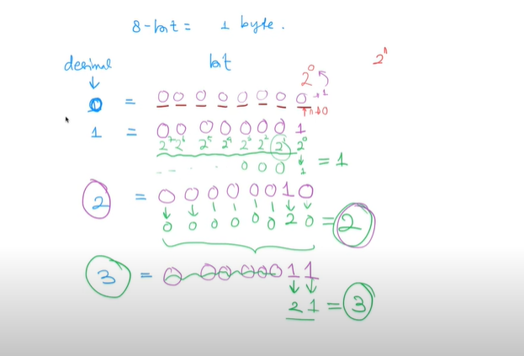

* Operator Bitwise

