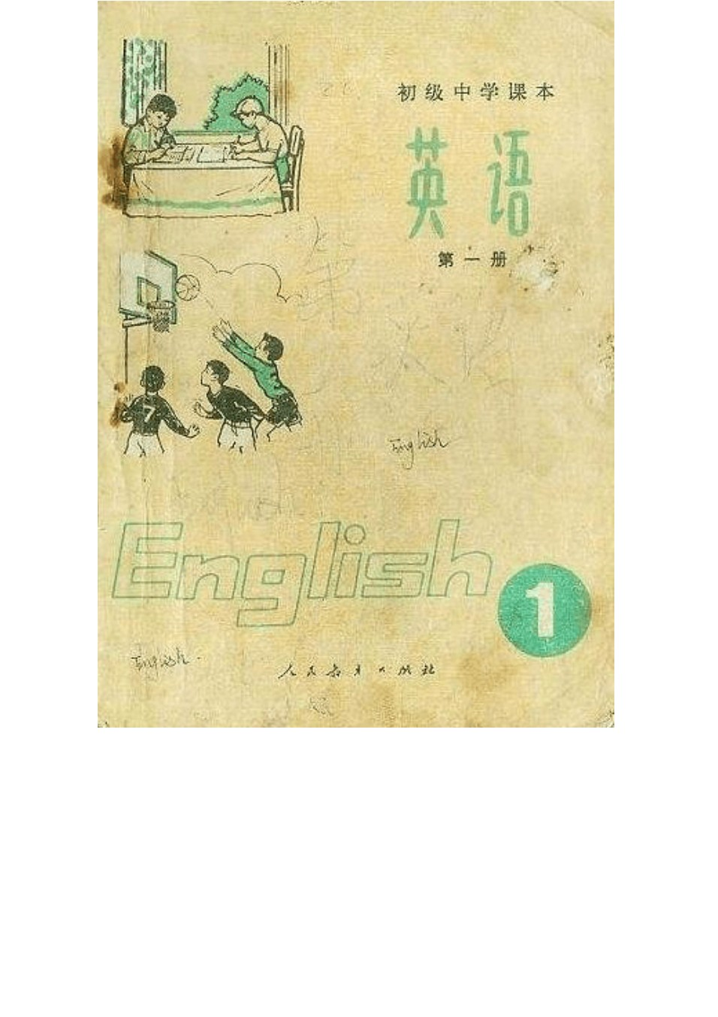

## 初中英语课本第一册

LESSON 1

Letters: A B C D E F G W ords: face, bag, bee, bed

LESSON 2

Letters: H I J K L M N W ords: bike, chick, cake, hand LESSON 3

Letters: O P Q R S T W ords: rose, dog, jeep, pen, knife, ship LESSON 4

Letters: U V W X Y Z

W ords: student, bus, plane, apple, sheep, egg, coat, orange LESSON 6

DRILLS （句型练习）

A

This is a book. That ’ This is a pen. That ’s a chair. B

What ’s this? It ’a cake.

What ’s that? It ’s an egg. What ’s that? It ’s an orange. LESSON 7

DRILLS （句型练习）

A

What ’s this? It ’s a bus. It ’s a red bus. What ’s that? It ’s a car. It ’s a blue car.

B

Is this a jeep? Y es, it is. Is it green? Y es, it is. C

Is this a ship? Y es, it is. What colour is it? It ’s yellow.

Is that a plane? Yes, it is. What colour is it? It ’s white. DIALOGUE （对话）

A ： What colour is this apple? B ： It ’s red.

A ： What colour is that banana? B ： It ’s yellow.

1. ： What colour is an orange?
2. ： Why , it ’s orange. An orange is orange LESSON 8

DRILLS （句型练习）

A

This is my cup. It isn ’t your cup. My cup is white.

Y our cup is yellow.

That isn ’t his bike. It ’

Her bike is green. Is this your desk?

Yes, it is. Is that your chair?

No, it isn ’t. It ’s his chair. Is this your rubber? Y es, it is. Is that your ruler? No, it isn ’t. It ’s her ruler.

DIALOGUE （对话）

Tom ： Kate! Kate ： Y es?

Tom ： Is this your knife? Kate ： No, it isn ’t.

* * *

Kate ： Tom! Is this your pencil-box? Tom ： Y es, it is. Thank you.

Kate ： That ’s all right. LESSON 9

DRILLS （句型练习）

A

one ship; two ships; three cakes; four coats; five beds;

six bees; seven bananas; eight oranges; nine buses; ten boxes;

B

These are apples. Those aren ’t apples. They ’re oranges. The apples are here.

These are desks. The desks are here. The tables are there. DIALOGUE （对话）

1. ： Look ， what ’s this?
2. ： It ’s a ship.

A ： No ， it ’s a sheep. These are all sheep. They ’re white sheep. What are those? B ：Why , they ’re sheep, too. They ’re black sheep.

A ： No, they aren ’t sheep. They ’re goats.

GRAMMAR （语法）

名词的复数形式（ The Plural Number of Nouns ）(Ⅰ) 1、一般在单数名词末尾加 -s ：

book-----books ruler-----rulers egg-----eggs student-----students

hand-----hands rose-----roses orange-----oranges 2、以 s 、 x 等结尾的词加 -es ：

bus-----buses box-----boxes

注：knife 的复数形式为 knives ，sheep 的复数形式和单数形式 相同。

LESSON 10

DRILLS （句型练习）

A

What are these? They ’re pigs. They ’re fat.

What are those? They ’re goats. They ’re thin.

B

Are these horses white? Yes, they are.

Are those cows white,too? No, they aren ’t. They ’re black and white.

C

Are those chicks? No, they aren ’t. Are they cocks? No, they aren ’t. What are they, then? They ’re hens. They are big, fat hens.

DIALOGUE （对话）

Kate ： What ’s in that box, Mum?

Mum ：Kate ： New shoes for me! Mum ：Guess. Kate ： Are they white?

Mum ：No, they aren ’t. Kate ： Are they red?

Mum ：No.

Kate ： Are they green, then?

Mum ：No. Look, they ’re blue.

Kate ：

LESSON 11

DRILLS （句型练习）

A B

C It ’s our room. It ’s small.

Whose books are those? They ’re new. DIALOGUE （对话）

Kate: Hello, Joan. Joan: Hello, Kate.

Kate: Joan, this is Mike. He ’s a new student.

Joan: Hello, Mike. Mike: Hello, Joan.

Mike: Whose seat is this? Kate: It ’s Joan ’s. Y LESSON 13

DRILLS （句型练习）

|  |  |  |  |
| --- | --- | --- | --- |
| A  Li Ping is a boy. He | ’s a Chinese boy. He | ’s twelve. He | ’s tall. |
| He ’s a student. |  |  |  |
| Li Ying is a girl. She She isn ’t a student. | ’s Li Ping ’s sister. She | ’s five. She | ’s short. |

Who ’s this man? He ’

Y es, he is.

Who ’s this woman? She ’No, she isn ’t. She ’s a worker. C

They aren ’t Chinese.

They ’re English. They ’re brothers. D

Are they English? Y es, they are.

Are they sisters? No, they aren ’t. They ’re friends. DIALOGUE （对话）

A: Look at this picture, Li Ping.

B: Oh, it ’s an old picture. Who ’s this man? A: He ’s my father.

B: Oh, your father?

A: Yes. He ’s a teacher. And this is my mother. B: Is she a teacher, too?

A: No. she ’s a worker. B: Who ’s this baby?

A: Guess!

B: Is it your brother? A: No.

B: Your sister? A: No.

B: Then it ’s you! Ha ha!

A: Yes, it ’s me. LESSON 14

DRILLS （句型练习）

A

I ’m a boy. Y ou ’re a girl. She ’s a girl. Y ou ’re girls. I’m a student. Y ou ’

What ’s your name? My name is Li Ping. How old are you? I ’m twelve.

C

Are you middle-school students? Y es, we are. No, we aren ’t. We ’re in Grade One.

Are you Young Pioneers? Y es, we are. D

Is your father a doctor? Y es, he is.

Is your mother a doctor, too? No, she isn ’t. TEXT （课文）

My family

I am an English boy. My name is Mike. I am twelve. My sister ’s name is Rose. She is fourteen. Rose and I are students. We

like school.

My father mother is a nurse. They work hard. My little brother ’s

name is Jack. He is only four. We all like Jack. GRAMMAR （语法）

II. 动词 be (Verb to be) 1、 I am W e are

Y ou are (not) a student. Y ou are (not) students. He is They are

She is

It is (not) a cock. They are (not) cocks.

2、 LESSON 15

DRILLS （句型练习）

A B

Where ’s Kate? She ’

s near the window.

Where ’s her bag? It ’s on the desk.

Where are her books? They ’re in the bag.

Where are her pencils? What ’s on the table? There ’s a glass on it.

What ’s under the table? There are two balls under it. What ’s on the chair? There ’s a bag on it.

What ’s in the bag? DIALOGUE （对话）

Mike: Where ’s my cap, Mum? Mum: Is it in your room?

Mike: No, it isn ’t. Mum: Is it on the desk? Mike: No, it isn ’t.

Mum: Why, Mike,

* * *

Grandma: Where are my glasses, Mike? Mike: Are they on the table?

Grandma: No, they aren ’t.

Mike: Are they in your bag?

Grandma: No, they aren ’t.

Mike: Why , Grandma, they ’re right on your nose! LESSON 16

DRILLS （句型练习）

A B C

Are there any flowers in front of the house? Y es, there are.

Are there any cows behind the house? No, there aren ’t any. What ’s behind it, then? Some sheep.

TEXT （课文）

Our classroom

This is our classroom. It is a nice big room. The windows are big and the walls are white. On the back wall there is a map. It

is a map of China.

is for the teacher. There are What is on the teacher ’s desk? There are some flowers. They are for our teacher. We like her.

She is a good teacher. LESSON 18

DRILLS （句型练习）

A

How many hours are there in a day? There are twenty-four hours in a day.

B

How many days are there in a week? There are seven days in a week.

How many days are there in a month?

There are thirty or thirty-one days in a month. C

How many months are there in a year? There are twelve months in a year. How many days are there in a year?

There are three hundred and sixty-five days in a year. DIALOGUE （对话）

A: How many people are there in your family, Wang Lin?

B: There are five, my grandpa, my father, my mother, my sister and I.

A: Is your grandpa a worker?

B: Oh, no. He ’s old. He ’s seventy.

A: Are there many students in his class? B: Yes. There are forty-six.

A: Is your mother a teacher, too? B: No. She ’s a doctor.

A: And your sister?

B: She ’s a driver, a bus-driver. A: How old is she?

B: She ’s twenty-three. GRAMMAR （语法）

I. There be 结构

“There is (are) + 某物（某人） + 某地（某时） ”这样一种句型，

大致相当于汉语 “某地（某时）有某物（某人） ”的说法。句子中 的is (are) 和后面所跟的名词在数方面必须一致。

1. There is a house in the picture. There are some trees near the house.
2. Is there a horse under the tree? Y es, there is.

No, there isn ’t.

There isn ’t a horse under the tree.

1. Are there any cows behind the house? Y es, there are (some).

No, there aren ’t (any).

There aren ’t any cows behind the house.

1. How many hours are there in a day? There are twenty-four hours in a day.

LESSON 19

DRILLS （句型练习）

Come here, please. Come to the blackboard. Please open the window. Please close the door. Let ’s read. Let ’s write.

DIALOGUE （对话）

An English Class

Li: Stand up, please.

Teacher: Good morning, boys and girls. Student: Good morning, teacher!

Teacher: Sit down, please. Li Ping? Li: Y es.

Teacher: Oh, Wei Fang, How are you today? Wei: I ’m all right, thank you.

Teacher: That ’Wang: Teacher: How many days are there in this month?

Wang: There are thirty-one.

Teacher: That ’s right. Come to the blackboard, Liu Ying. Write

“Monday ”and

“month ”on it, please. Teacher: Good. Now,

GRAMMAR （语法）

LESSON 20

DRILLS （句型练习）

A

What time is it? It ’s six thirty. Let ’s get up. We get up

What time is it? It ’s seven fifteen. Let ’s go to school. We go to school at seven fifteen.

B

What time is it? It ’s three fifty. We What time is it? It ’s five. Let ’s go home. We go home at five.

C

What time is it? It ’s seven thirty. Let ’s .

We do our homework at seven thirty in the evening. What time is it? It ’s nine. Let ’s We go to bed at nine.

TEXT （课文）

My Class

I am a middle-school student. My name is Wei Fang. I study . I an There are twenty boys and twenty-three girls in my class. I come to school at seven thirty. We study Chinese, maths, English and other lessons. We like maths. We like English, too. Some of us are good at it.We work hard. We study for the people.

GRAMMAR （语法）

特殊疑问句及其回答（ some special Questions and Answers ）

1. What ’s this? It ’s a bus. What are these? They ’re pigs.

What ’s your name? My name is Li Ping. What ’s your mother? She ’s a nurse.

What ’s under the table? There ’s a ball(There are two balls)under it.

What day is today? Today is Monday. What time is it? It ’s seven thirty.

What colour is your coat? It ’s red.

What colour are your new shoes? They ’re blue.

1. Who ’s this boy? He ’s Li Ping.

Who are these boys? They ’re Mike and Jack.

1. Whose room is this? It ’s our room.

Whose books are these? They ’re my books.

1. Where ’s the dog? It ’s in front of the house. Where are the cows? They ’re behind the house.
2. How old are you? I ’m twelve.

How many days are there in a week? There are seven days in a week.





初 级 『i,§/: 丰

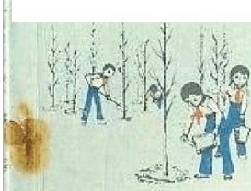

 

第 二 陪

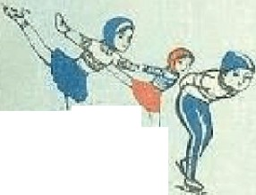

义；L

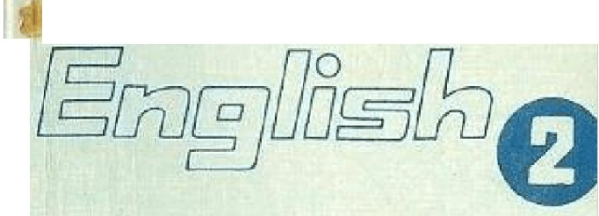

*A* -' *...rr* _. ‘ *fA: ll*

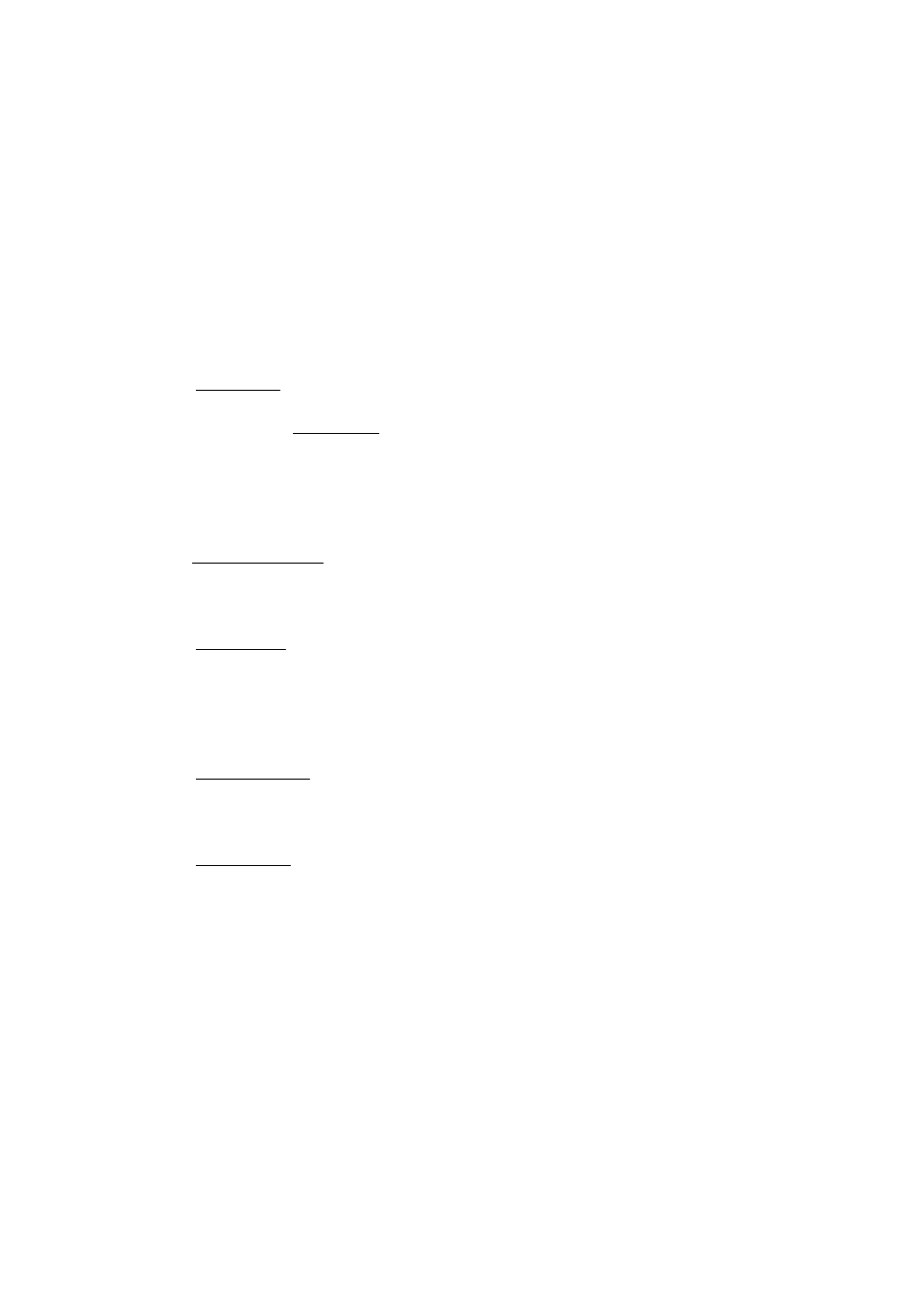

# 初中英语课本第二册

### LESSON 3

**DRILLS** （句型练习）

A

What’s in the room? There’s a table.

Are there any bowls on the table? Yes, there are. And there are some plates, too.

B

What’s on the two plates? There’s some fish on one plate. There’s some bread on the other.

What’s in the bowls? There’s some meat in this one. There isn’t any meat in that one. There’s some rice in it.

C

What’s in those glasses? There’s some water in them. Please pass me a glass of water.Here you are.

What’s in these cups? There’s some tea in them. Please give him a cup of tea. All right.

D

Are there any cups on the table? Yes, there are. Is there any tea in that blue cup? Yes, there is.

Is there any tea in that green one? No, there isn’t. There’s some milk in it.

**DIALOGUE** （对话）

SUPPER IS READY

Mum: Lingling! Ling: Yes, Mum?

Mum: Supper is ready. Ling: All right.

Dad: Hurry!

Ling: I ?m coming. Hello, Dad. Hello, Mum. Mum: Sit down. Lingling. Here?s your rice.

Ling: Thanks. Oh, there?s fish and chicken! Meat too!

And eggs！ Why so much, Mum?

Mum: It ?s your daddy?s birthday. Ling: Oh! Happy birthday, Dad!

Dad: Thank you, Lingling. Help yourself to some fish. Ling: Thank you.

**GRAMMAR** （语法）

可数和不可数名词（ Countable and Uncontable Noun）s



和不可数名词两类。

1、可数名词有复数形式，如： an apple two apples

a book three books

a car some cars 2、不可数名词一般没有复数形式，如：

water: a glass of water

two glasses of water some water

,英语名词分可数名词

rice a bowl of rice two bowls of rice some rice



### LESSON 4

**DRILLS** （句型练习）

A

We have a TV set.Have you a TV set? No, we haven’t. We have a radio.

haven’t = have not

B

Tom has a story-book. Has Jack a story-book, too? No, he hasn’t. He has some picture-books.

How many picture-books has he? He has four.

hasn’t = has not

C

Have you any ink? Yes, I have some. Give me some ink, please. Here you are. Thank you.

D

Has Mary any paper? No, she hasn’t. Pass her a piece of paper, please.All right.

**TEXT** （课文）

WHAT IS IT?

I have a good friend. It has a round face. On its face, it has three hands. One is short, the other two are long. It has no arms, but its hands turn round and round. It has no feet or legs, but it can go all day and all night.

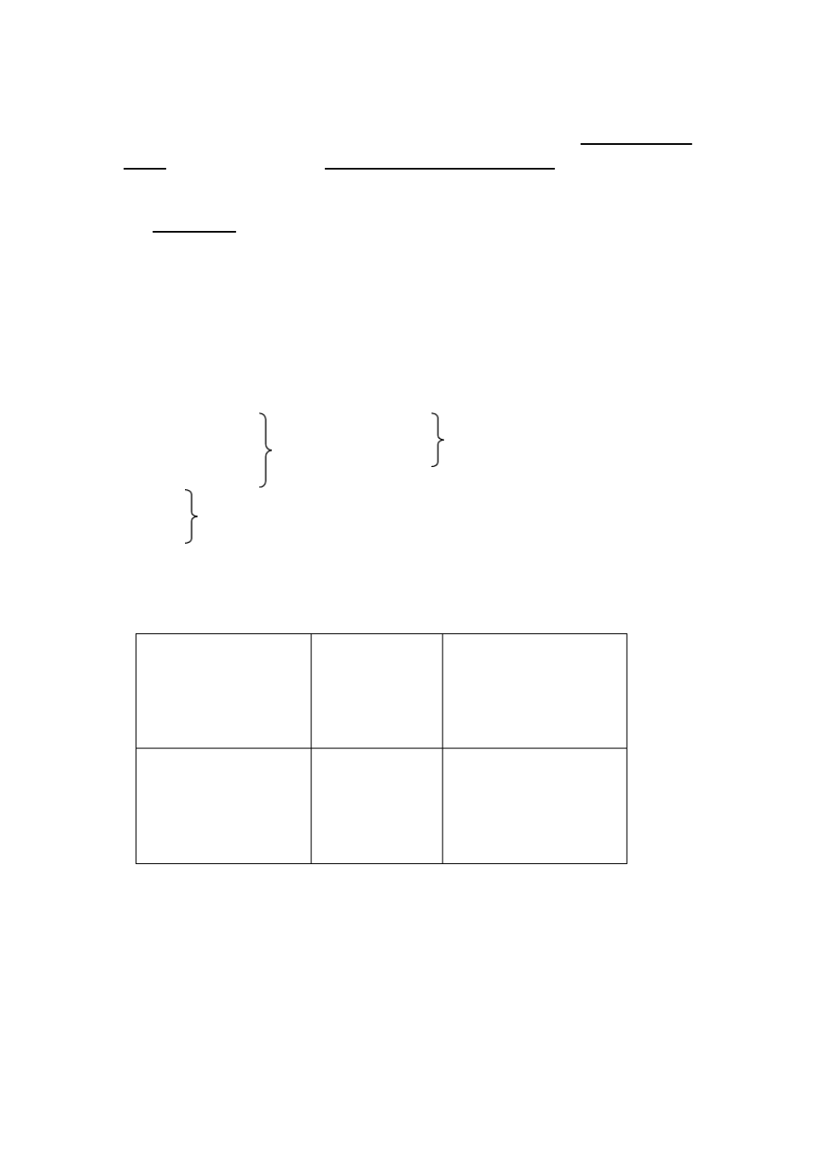

It has no eyes and no ears. It has no mouth, but it can talk. In the morning it can wake me up and tell me“, It ?s time to get up”.

What is it?

**GRAMMAR** （语法） 动词 have(verb to have)

|  |  |  |  |  |
| --- | --- | --- | --- | --- |
| 1、I  You He She It | have have  has | (not) | We  You have(not) They | |
| 2、 |  |  |  | |
| Have I ? | | | Have you ? | Has he (she, it) ? |
| Yes, you have. | | | Yes, I have. | Yes, he (she, it) has. |
| No, you haven’t. | | | No, I haven’t. | No, he (she, it) hasn’t. |
| Have we ? | | | Have you ? | Have they ? |
| Yes, we (you) have. | | | Yes, we have. | Yes, they have. |
| No, we (you) haven’t. | | | No, we haven’t. | No, they haven’t. |

### LESSON 6

**DRILLS** （句型练习）

A

Is this new shirt mine? No. It ’s your father’s. Oh, it’s his.

Is that one mine?Yes, tha’st

yours.



B

Whose jacket is this? It ’s Kate’s. Oh, it’s hers. Which one is yours? The white one.

C

Is this room yours? No. It ’s Mike and John’s. Oh, It’s theirs. Which one is yours?The next one is ours.

D

Are these cups yours? Only some of them. Which ones are yours? The blue ones are ours.

**DIALOGUE** （对话）

TWO YOUNG PIONEERS

Liu: Look, Zhang Ling. What ?s that? It ?s a watch, isn?t it? Zhang: Yes. What a nice watch!

Liu: It ?s quite new!

Zhang: Look, there?s a man over there. Perhaps it?s his. Liu: Let?s go and ask him.

Zhang: All right.

Liu: Excuse me, comrade. Is this watch yours? Man: No, it?s not mine.

(they see a woman nearby)

Liu: Excuse me, is this watch yours? Woman: No, it isn?t.

Zhang: Let?s go and give it to the policeman. Liu: OK.

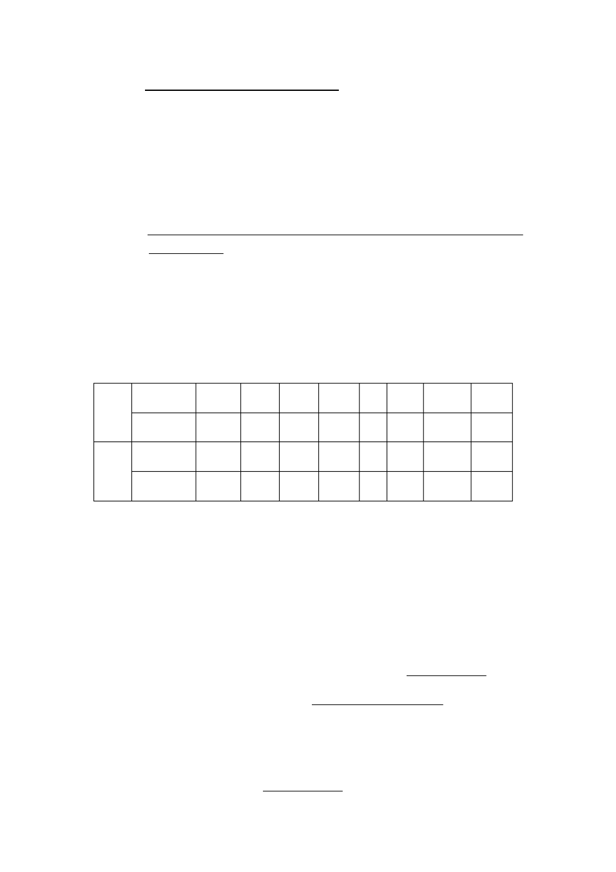

(they go to a policeman nearby)

Zhang: Excuse me.

Policeman: Yes? Can I help you?

Liu: Here?s a watch. We can?t find the owner. Can you find him and give it to him?

Policeman: Certainly. Thank you. You?re good Young Pioneers.

**GRAMMAR** （语法）

人称代词和物主代词（ Personal and Possessive Pronou）ns

人称 代词

|  |  |  |  |  |  |  |  |  |
| --- | --- | --- | --- | --- | --- | --- | --- | --- |
| 主格 | I | you | he | she | it | we | you | they |
| 宾格 | me | you | him | her | it | us | you | them |
| 形容词性 | my | your | his | her | its | our | your | their |
| 名词性 | mine | yours | his | hers | its | ours | yours | theirs |

物主 代词

### LESSON 7

**DRILLS** （句型练习）

A

I ’m talking. You aren’t talking. You’re listening to me.

We’re reading now. Tom and Mike aren’t reading. They’re doing exercises. Rose is writing. Jack isn’t writing. He’s looking out of the window

B

Close the door please, Alice.

What are you doing, Alice? I ’m closing the door.

Open the window please, Alice!



What’s she doing, Peter? She’s opening the window.

C

Read the text please, Joan and Rose.

What are they doing? They’re reading the text. Write down the new words, please.

What are you doing? We’re writing down the new words.

**TEXT** （课文）

ON A BUS

It is Sunday today. Wang Lin and Li Ping are going to the zoo. They are waiting for a bus.

A red bus is stopping at the bus stop. Wang Lin and Li Ping are getting on the bus.

“Here?s a seat for you, Wang Lin”.

“No, thank you. There?s another seat. I can sit over ther”e.

The bus is coming to the next stop. Now, an old woman is getting on the bus.

Wang Lin and Li Ping both stand up. Li Ping is saying:

“Here?s a seat for you, Granny. Please sit her”e.

Wang Lin is also saying:

“Please come here and have my seat, Grann”y.

“Mine is near the door. So take this seat, please, Grann”y.

“Thank you very much. It?s very nice of you”.

### LESSON 8

**DRILLS** （句型练习）



A

Are you cleaning your classroom? Yes, we are. Are they cleaning their classroom?

No, they aren’t. They’re cleaning the dinning-room.

B

Is Zhang Hong carrying water? Yes, he is. Is Liu Ying cleaning the window?

No, she isn’t. She’s cleaning the door.

C

Who’s taking down the old picture? Our teacher is. Who’s putting up the new ones? Our monitor is.

D

Who’s sweeping the floor? Some of the boys are.

Who’s cleaning the desks and chairs? Some of the girls are.

**TEXT** （课文）

PLANTING TREES

It is March now. Spring is here. It is time to plant trees.

Look! There?s a little child in front of the house. What is she doing? She is watering some flowers. Who are the man and the woman beside the house? They are the girl?s parent. What are they doing? They are planting trees.

Look at the children near the river. They are Young Pioneers. Are they playing or working? They are working. They are planting apple trees. Some are digging, some are planting. Some are carrying water, others are watering the trees. All of the children are busy.

On the hill there are also a lot of people. What are they doing? They are planting trees, too. Look at all the young trees on the hill.

How hard all these people are working! They are helping to make our country beautiful.

**GRAMMAR** （语法）

现在进行时 (The Present Continuous Tense)

1、现在进行时表示现在正在进行或发生的动作。如： We are reading the text now.

They are waiting for a bus.

也可以表示当前一段时期内的活动或现阶段正在进行的动作。如：

We are working in a factory these days.

2、现在进行时是有 am (is, are) + 动词的现在分词构成的。其肯定、否定和疑问 式如下：

I am We

|  |  |  |  |
| --- | --- | --- | --- |
| **You** | **are** |  | |
| **He** |  | **(not) working** | **You are (not) working.** |
| **She**  **It** | **is** |  | **They** |

Am I working?

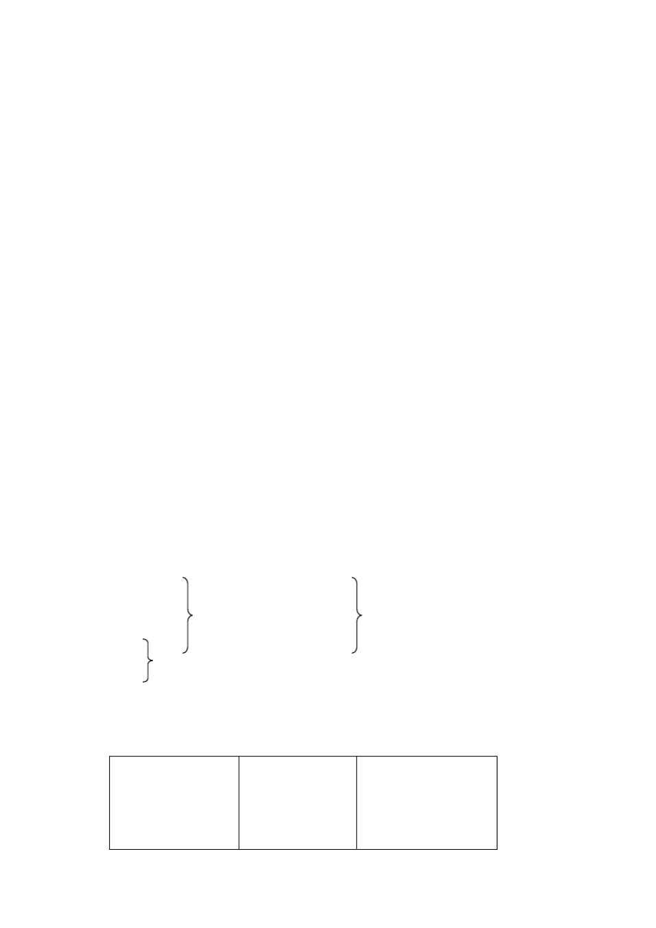

Yes, you are. No, you aren’t.

Are you working? Yes, I am.

No, I ’m not..

Is he (she, it) working? Yes, he (she, it) is.

No, he (she, it) isn’t.

Are we working?

Yes, we(you) are. No, we(you) aren’t.

Are you working? Yes, we are.

No, we aren’t.

Are they working? Yes, they are.

No, they aren’t.

3、现在分词的构成：

构 成 方 式 原 形 现在分词

一般在动词原形末尾加 -ing go ask play

going asking playing

以不发音字母 e 结尾的动词，先去

掉 e，再加 -ing

write close take

writing closing taking

以重读闭音节结尾的动词， 如末尾

只有一个辅音字母， 应先双写这一 字母，再加 -ing

dig put begin

digging putting beginning

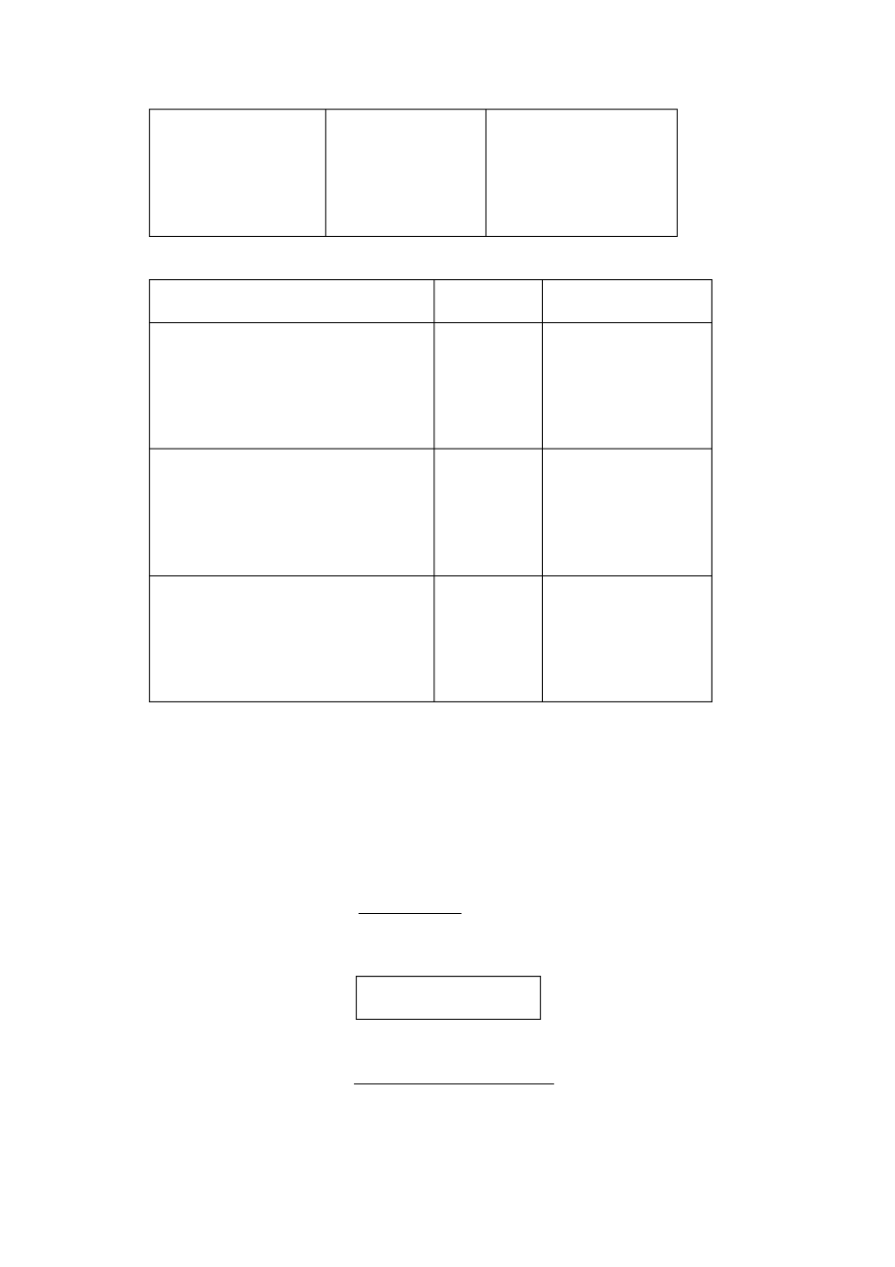

### LESSON 10

**DRILLS** （句型练习）

A

What’s the girl doing? She’s reading in bed.

What’s her mother saying to her? She’s saying:“Don’t read in bed.”

don’t = do not

B

What’s the boy doing? He’s drawing a plane on the wall.

What’s his sister saying to him? She’s saying:“ Don’t draw on the wall.”

C

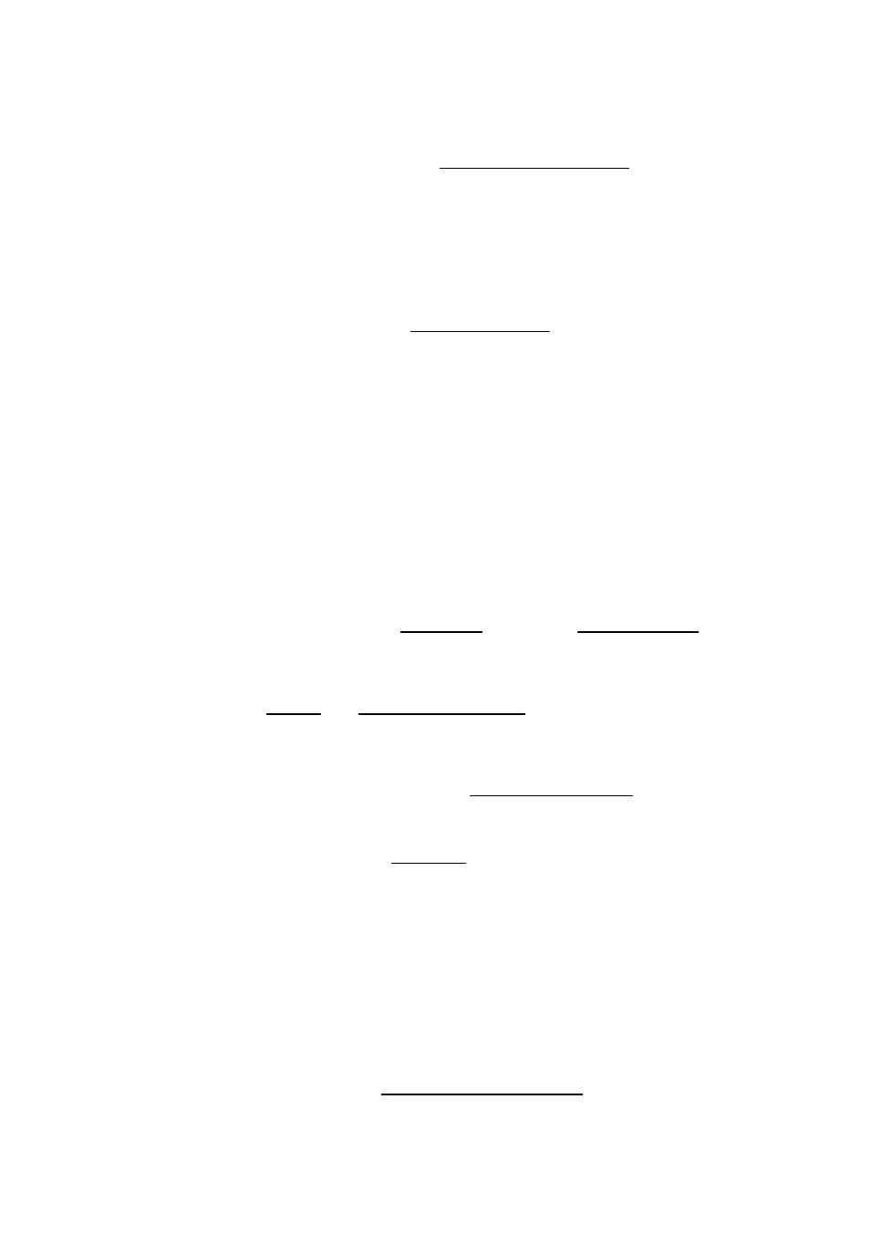

Where are the children walking? They’re walking in the tomato field. What’s the old peasant saying to them?

He’s saying:“Don’t walk in the tomato field.”

D

Where are the boys playing? They’re playing in the street. What’s the policeman saying to them?

He’s saying:“Don’t play in the street”.

**TEXT** （课文）

IN A PARK

It is Saturday morning. The sun is shining. A lot of boys and girls are playing in the park. They are having a good time. Some are singing and dancing under a big tree. Some are drawing by the lake. Others are climbing the hill.

What are Betty and Mary doing?

Betty: Mary, let?s sit here and read this picture-book. Mary: All right. What an interesting book!

Betty: Yes. Look at this picture. There are all kinds of birds in it. Aren?t they beautiful?

Mike: Hey, you two! Don?t read in the sun. I t?s too bright. It ?s bad for your eyes.

Betty: You?re right. Thank you, Mike.

Mary: Then let ?s go and sit there under the tree. Betty: OK.

Kate: Excuse me. Where?s Joan?

Mary: Look, there she is. She?s climbing the hill with Rose.

**GRAMMAR** （语法）

名词的复数形式（ The Plural Number of Nouns）(II )

可数名词的复数形式有以下几种情况：

1、规则变化

构 成 方 式 单 数 复 数

一般的名词在词尾加 -s: 在清辅音后读 [s] 在浊辅音及原音后读 [z] 在 t 后与 t 一起读 [ts] 在 d 后与 d 一起读 [dz]

book ball ear text word

books balls ears texts words

以辅音字母加 y 结尾的名词，

先把 y 变 i 再加-es，读 [z]

story country

stories countries

在 s, x, ch, sh结尾的名词

后加-es，读 [iz]

bus box watch

buses boxes watches

在 ce, se, ge 结尾的名词

后加 –s，也读 [iz]

orange oranges

以 o 结尾的名词后加 -es

或加-s，都读 [z]

tomato radio

tomatoes radios

以 f 或 fe 结尾的名词，

把 f 或 fe 变为 -ves，读 [vz]

knife knives

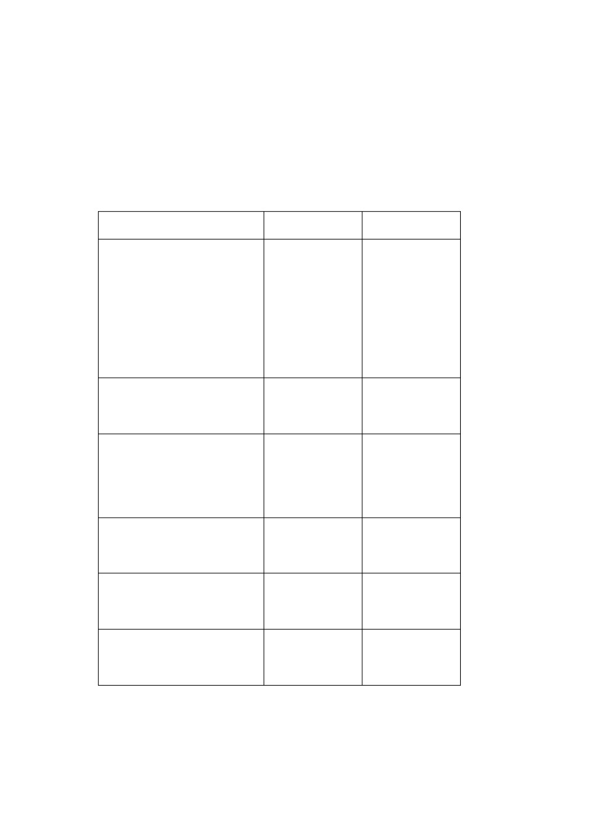

2、不规则变化

单 数 复 数

man woman child foot

men women children feet

### LESSON 11



**DRILLS** （句型练习）

A

I ’m doing my homework now. I do my homework everyday. They’re playing football now. They play football every Tuesday. Sometimes they play on Friday.

B

You speak Russian. I don’t speak Russian. I speak Chinese.

They know some Russian. We don’t know Russian. We know some English.

C

Are you writing to your friends? Yes, I am. Do you often write to them? Yes, I do.

Do your friends often write to you? Yes, they do.

D

Do you swim every day? No, I don’t. I only swim on Thursday. Do you play basket-ball every day?

No, we don’t. We play only on Wednesday. Do they watch TV every evening?

No, they don’t. they watch TV only on Saturday evening.

**TEXT** （课文）

A LETTER

May 2nd, 1983

Dear friend,

I am an American schoolgirl. My name is Alice Green. I am thirteen.

I have two brothers. One is Jack, the other is Peter. My brothers and Iare all at school. We go to school from Monday to Friday. We have no classeson Saturday.

My parents are both teachers. They often tell me about your country. They say China is a large and beautiful country.

I like drawing and reading. Now I am reading a book of Chinese stories. They are very interesting. My brothers like playing football. We all like watching TV. Do you often watch TV?

Let us be friends. Please write soon.

Yours, Alice Green

**GRAMMAR** （语法） 句子种类 (Kinds of Sentences)

英语的句子按照用途可分为下列四类：

1、陈述句（ The Declarative Sentenc）e

用来叙述一件事情。如：

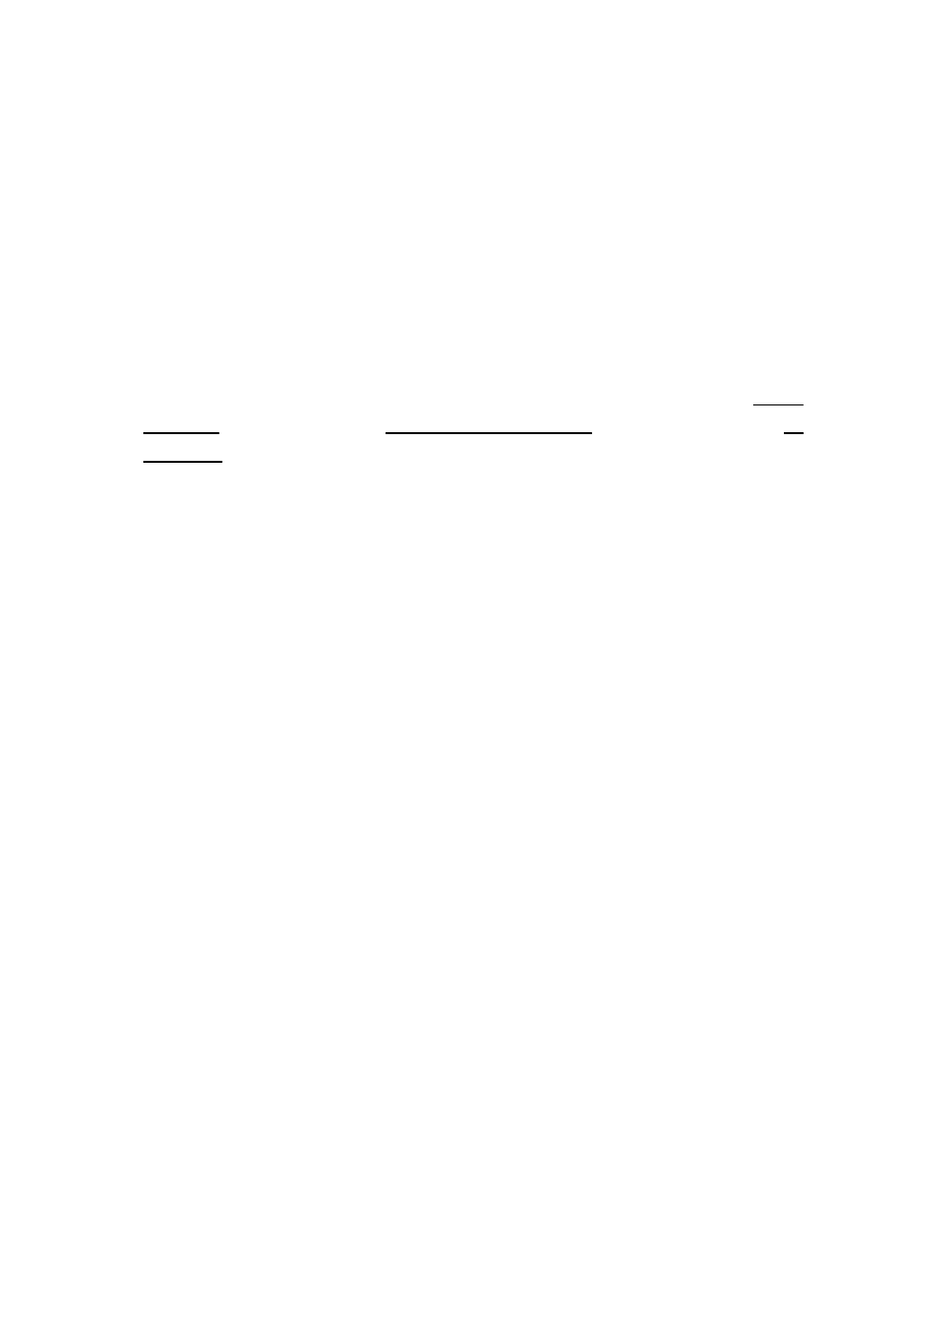

My parents are both school teachers. They are planting apple trees.

We aren’t workers.

2、疑问句（ The Interrogative Sentence）用来提出问题。如：

Have you any ink?



Do you swim every day? What are they doing now?

Are you in Class One or Class Two? Our classroom is bright, isn’t it?

3、祈使句（ The Imperative Sentence）用来表示请求、命令等。如： Write down the new words, please.

Look at the children near the river. Don’t draw on the wall.

4、感叹句（ The Exclamatory Sentence）用来表达强烈的感情。如： What an interesting book!

How hard all these people are working!

### LESSON 12

**DRILLS** （句型练习）

A

Li Ping gets up at half past six. His sister gets up at seven ’oclock. His mother goes to work at seven.

His father goes to work at ten past seven.

B

Tom sings well. Kate doesn’t sing well. But she dances well. Alice likes drawing. Peter doesn’t like drawing.

He likes making model planes.

doesn’t = does not



C

Does Li Ping’s mother have breakfast at home? Yes, she does. Does she have lunch at home?

No, she doesn’t. She has it at the factory.

Does his father have lunch at home? Yes, he does.

**TEXT** （课文）

THE COCK AND THE FOX

It is evening. An old cock is sitting in a tall tree. A fox comes to the tree and looks up at the cock.

“Hello, Mr Cock. I have some good news for yo”u,says the fox.

“Oh?”says the cock“. What is it?”

“All the animals are good friends now. Let?s be friends, too. Please come down and play with me”.

“Fine!” says the cock. “I ?m very glad to hear that.”Then he looks up.

“Look! There?s something over there”.

“What are you looking at?”asks the fox.

“Oh, I see some animals over there. They?re coming this way”.

“Animals?”

“Yes. Oh, they?re dogs”.

“What? Dogs?”asks the fox.“Well, well, I must go now. Good-bye”.

“Wait, Mr Fox, ”says the cock.“Don?t go. They?re only dogs. And dogs are our friends now”.

“Yes. But perhaps they do?nt know that yet.”

“Isee, I see”, says the cock. He smiles and goes to sleep high up in the tree.

### LESSON 13

**DRILLS** （句型练习）

A

What do you do on Sunday? I usually do some cleaning. What does your brother do? He plays football with his friends.

B

When do you go to school? I usually go to school at seven.

When does your father go to work? He goes to work at half past six.

When does your mother go to work? She usually goes to work at twenty to eight.

C

Where do you live? I live in Beijing.

Where does your grandpa live? He lives in Shanghai.

**TEXT** （课文）

A PRESENT

Today is June 4. It is Betty?s birthday. She comes home and sees a card on the table. It says: “There?s a present for you, Betty. Go and look for it in your room.”

Betty runs to her room. Her parents are watching her. They are smiling.

On her bed she sees a new red box. She thinks“: What ?s in the box?” She opens it. There is nothing but a card in it! Betty takes it out and reads:

“Dear Betty. I?m your present. My first letter is in the word‘ book?, but not in‘ look?. My second letter is in‘ ink ?, but not in‘ thank?. You can find my last

letter in both‘ink?and‘ book?. And my last letter is i‘n What am I? ”

sheep?, but not in‘ ship?.



Betty thinks hard. B-I-K-E. She smiles and says to her mother: “Aha, I know. But where is it, Mum? ”Her mother says: “Look at the back of the

card.”Betty turns it over and reads:“come and look for me in the garden”.

Betty hurries to the garden. There under a big tree she finds her presen–t a nice new bike!

“Happy birthday, Betty!”her parents say.

“Thank you, Mum and Dad!”

**GRAMMAR** （语法）

**I** 、一般现在时（ **The Present Indefinite Tens**）**e**

1、一般现在时表示经常的或习惯性的动作， 常常与 usually, often, sometimes, every day, every morning 等连用。如：

I do my homework every day.

Do you usually go to school at seven? He doesn’t speak Russian.

2、一般现在时的肯定、否定和疑问式如下：

|  |  |  |  |
| --- | --- | --- | --- |
| **II** |  | | |
| **You** | **go** | **You** | **do not(don?t) go.** |
| **We** |  | **We** |  |
| **They** |  | **They** |  |
| **He** |  | **He** |  |
| **She**  **It** | **goes** | **She**  **It** | **does not(doens?t)go.** |

Do I go? Yes, you do.

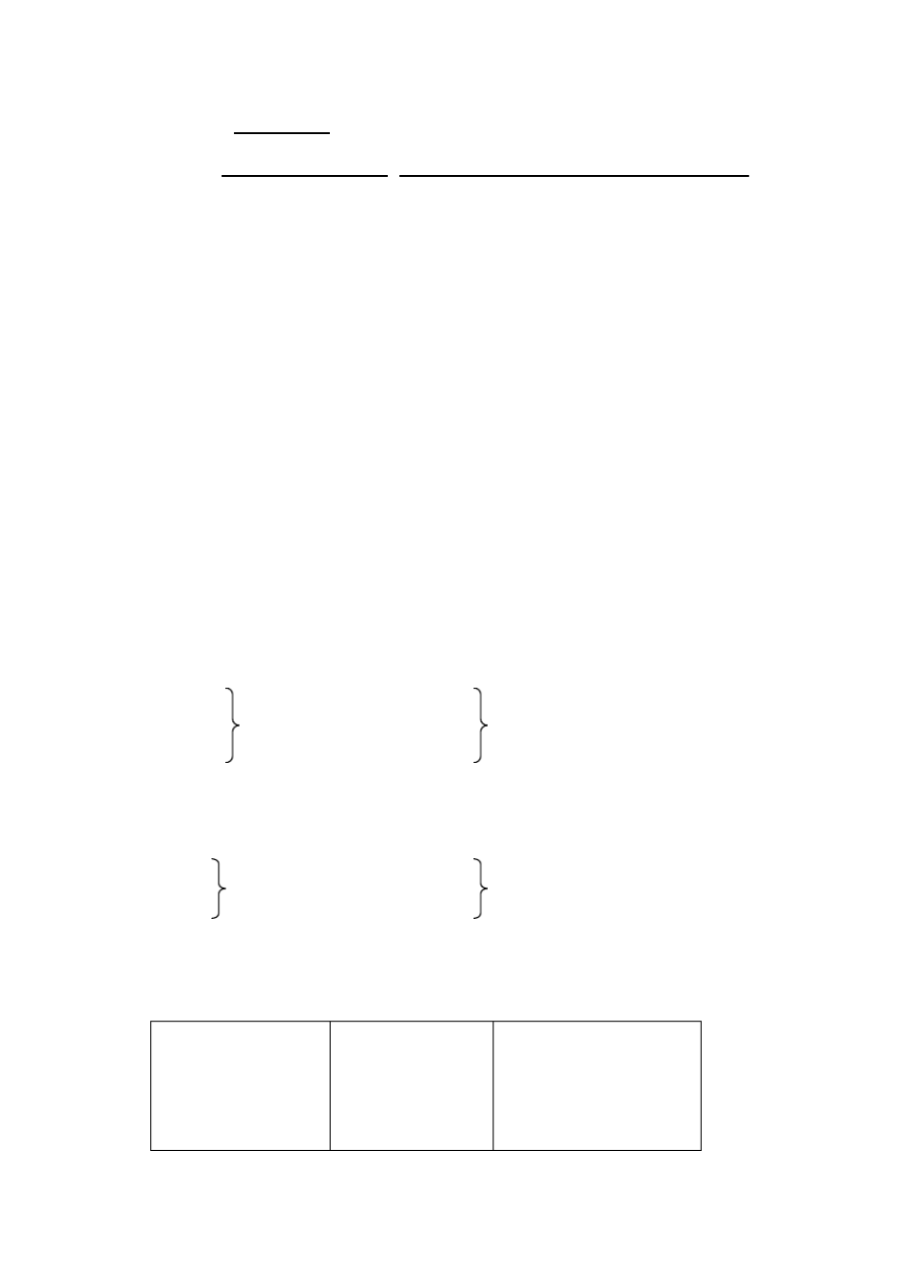

No, you don’t.

Do you go? Yes, I do.

No, I don’t.

Does he (she, it) go?

Yes, he (she, it) does. No, he (she, it) doesn’t.

Do we go?

Yes, we (you) do. No, we (you) don’t.

Do you go?

Yes, we do. No, we don’t.

Do they go?

Yes, they do. No, they don’t.

当主语是第三人称单数时，动词形式的几种变化：

一般的动词在词尾加 -s like read

play

likes reads plays

以字母 o, s, ch, sh 等结尾的

动词加 -es

do pass wash

does passes washes

以辅音字母加 y 结尾的动词，

先把 y 变 i 再加 -es

study carry

studies carries

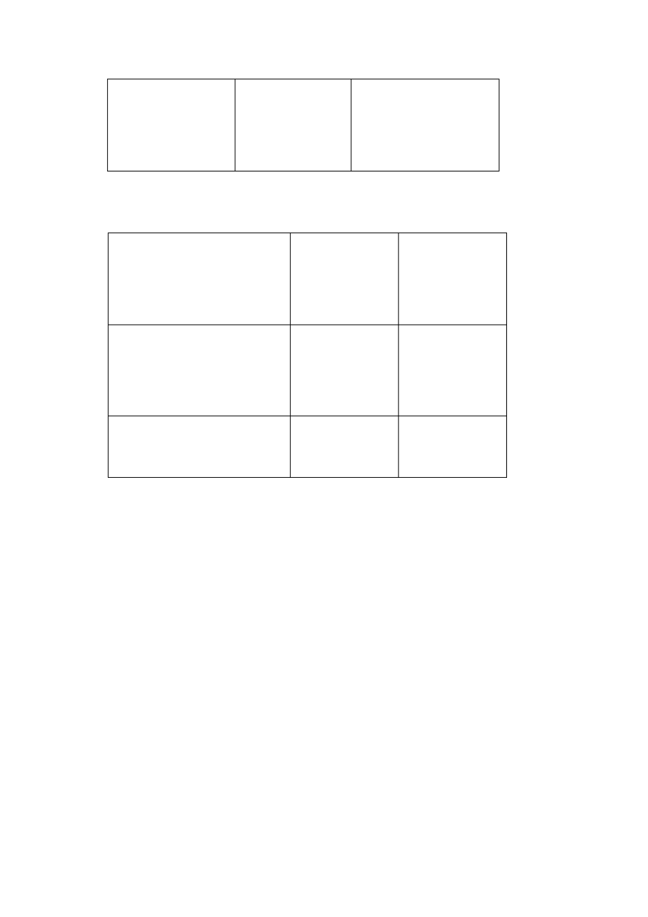

**II** 、序数词（ **Ordinal Numbers**） 序数词表示事物的顺序，往往与定冠词 the 连用。

first 1 st twentieth 20th

second 2 nd twenty-first 21th

third 3rd thirtieth 30 th

fourth 4 th thirty-ninth 39 th

fifth 5 th fortieth 40 th

sixth 6 th fiftieth 50 th

seventh 7 th sixtieth 60 th

eighth 8 th seventieth 70 th

ninth 9 th eightieth 80 th



|  |  |  |  |
| --- | --- | --- | --- |
| tenth | 10 th | ninetieth | 90 th |
| eleventh | 11th | hundredth | 100 th |
| twelfth | 12 th | one hundred and first | 101 st |

### LESSON 15

**DRILLS** （句型练习）

A

Rose is young. Mary is younger. Betty is the youngest.

A sheep is heavy. A horse is heavier. An elephant is the heaviest. Mary’s handwriting is good.

Betty’s handwriting is better. John’s handwriting is the best.

B

Which is bigger, the moon or the earth? The earth is bigger.

Which is the biggest, the sun, the moon or the earth? The sun is the biggest. Which is the smallest? The moon, of course.

C

Who’s younger, Mary or Rose? Mary is younger.

Who’s the youngest, Rose, Mary or Betty? Betty is the youngest. Who’s the oldest?Rose, of course.

**TEXT** （课文）

THE SEASONS

There are four seasons in a year: spring, summer, autumn, winter.

Spring is the best season of the year. The weather gets warmer, and the days get longer. The crops begin to grow. The trees turn green and flowers come out

（ 出来，生长 ） **.**

Summer comes after spring. It is the warmest season. It often rains and the crops grow fast. The best sport in summer is swimming in rivers and lakes.

Autumn is a busy season.The days get shorter and the nights longer. It is

harvest-time（ 收获季节 ）. The peasants are busy. They are getting in收(

割 ) the crops.

获，收

Winter is the coldest season of the year.Sometimes it snows and the fields are all white. Skating is the best sport in winter. Many boys and girls often go skating. But the peasants are still busy. They are getting ready for the next year.

**GRAMMAR** （语法）

形 容 词的 比 较级 和最高 级 （ **The Comparative and Superlative Degrees of Adjectives**）（**I** ）

大多数形容词有三个等级：

1）原级，即原形，如 big（大）；

2）比较级，表示“更 一些”或“较 ”的意思，如 bigger（更大， 比较大，大一些）；

3）最高级，表示“最 ”的意思，如 biggest（最大）。 I、形容词比较级和最高级的构成

1、规则变化（一般在单音节和部分双音节的形容词词尾加 -er 或-est） 构 成 方 式 原 级 比较级 最高级

一般的名词在词尾加 -er 或-est: tall long

taller longer

tallest longest

以字母 e 结尾的形容词，加 -r 或-st. nice nicer nicest

以重读闭音节结尾的形容词， 如末尾 只有一个辅音字母， 应先双写这一字

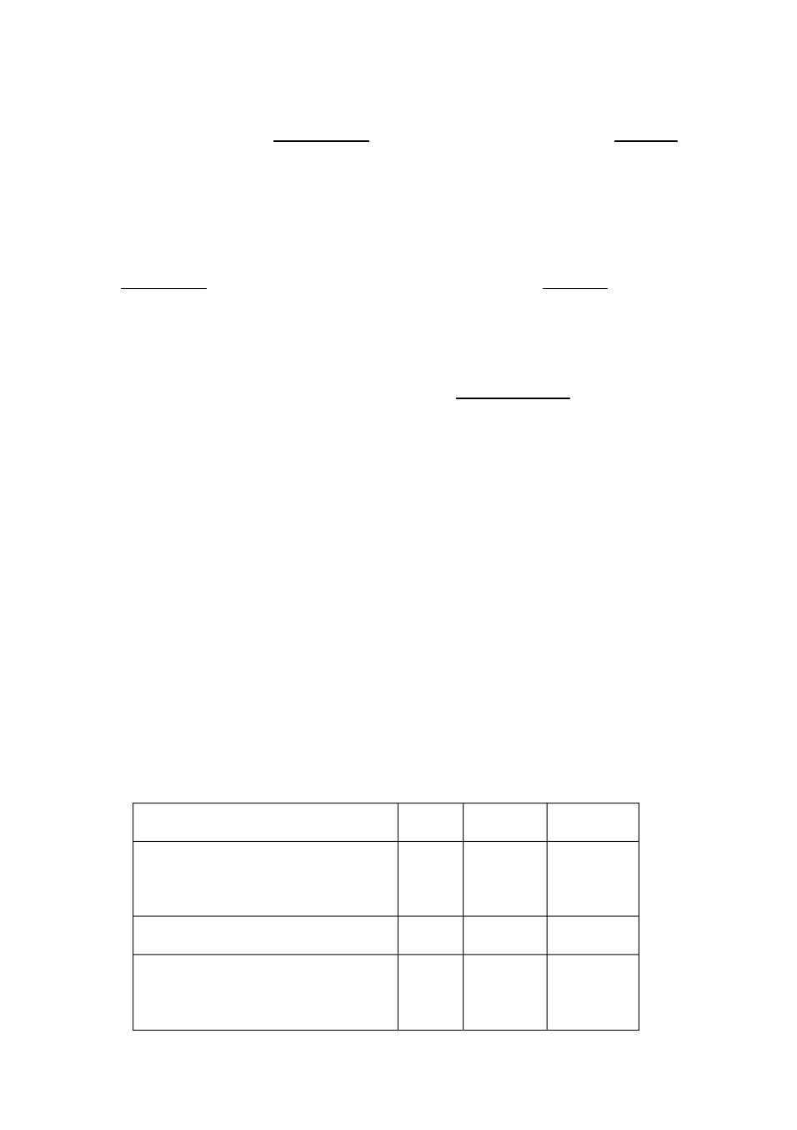

big thin

bigger thinner

biggest thinnest

母，再加 -er 或-est

以辅音字母加 y 结尾的形容词， 先把

y 变 i，再加 -er 或-est

happy heavy

happier heavier

happiest heaviest

2、不规则变化



good better best II、形容词比较级和最高级的用法

1、表示两者（人或物）的比较时，用形容词比较级。如： A sheep is heavy. A horse is heavier.

Who is younger, Rose or Mary? Mary is younger.

2、表示三者或三者以上（人或物）的比较时，用形容词最高级，最高级的前

面要加定冠词 the，后面可带 of（in）短语，来说明比较的范围。如： Which is the biggest, the sun, the moon or the earth?

The sun is the biggest of the three.

This elephant is the heaviest one in the zoo.

### LESSON 16

**DRILLS** （句型练习）

A

Tom is taller than Mike.Mike is taller than John. Who’s the tallest? Tom is the tallest.

My skirt is longer than yours. Betty’s skirt is longer than mine. Whose skirt is the longest? Hers is the longest.

B

Rose works hard. Joan works harder. Mary works the hardest.

Tom draws well. John draws better. Mike draws the best.



C

A truck goes faster than a bike. A car goes faster than a truck. Which goes the fastest? A car goes the fastest.

Mike comes to school earlier than Kate. Mary comes to school earlier than Mike. Who comes to school the earliest? Mary comes to school the earliest.

D

Who dances**the best**in your class?Kate**does.** Who runs the fastest in your class? John does. Who works the hardest in your class? Mary does.

**DIALOGUE** （对话）

WHO IS FASTER

T ---- Tortoise

H ---- Hare

T: Hello, Mr Hare!

H: Oh, it ?s you, Mr Tortoise. What are you doing? T: I ?m running.

H: Running ? Ha ha! You can?t run. Your legs are too short! T: Of course I can.

H: My legs are longer than yours.I?m sure I can run faster than you. T: Don?t be so sure.

H: Well then, let?s run to the tall tree over there. Le?ts see who gets there first. T: All right.

H: Ready? Go!

(Mr Tortoise goes very slowly. Mr Hare runs much faster. In a minute he comes to a small tree).

H: Where ?s Mr Tortoise? Aha! There he is. He?s far behind me. How slow he is! I?m much faster. Mmm, it?s hot! Ahh, here?s a tree. Let me have a rest under it. It ?s so nice and cool.

(Soon he is aslee)p

(Mr Tortoise comes up. He looks at Mr Hare and goes)on

H( waking up): Ah, what a good sleep! Now, where?s Mr Tortoise? Where is he? I don?t see him. (Runs to the tall tre)e

T( sitting under the tall tree) : Why, hello, Mr Hare! How are you? You?re very fast, aren?t you?

H: Yes, but

T: But, I?m here first. Now who is faster, you or me? H: Oh! ...

**GRAMMAR** （语法）

副词的比较级和最高级（ **The Comparative and Superlative Degrees of Adverb**）**s**

（**I** ）

I、副词和形容词一样，也有原级、比较级和最高级三个等级。规则变化和形容 词一样。如：

|  |  |  |
| --- | --- | --- |
| **hard** | **harder** | **hardest** |
| **fast** | **faster** | **fastest** |
| **high** | **higher** | **highest** |
| **early** | **earlier** | **earliest** |

不规则变化，如：

well better best

II、副词比较级和最高级的用法与形容词相似。如：

Rose works hard. Joan works harder.



以上两句也可以用一个句子表示：

Joan works harder than Rose. 形容词比较级也可用在带连词 than 的句子里。如： A horse is heavier than a sheep. 副词最高级前可以不加定冠词 **the**。 如：

Which goes (the) fastest, a truck, a bike or a car? A car goes (the) fastest of the three.

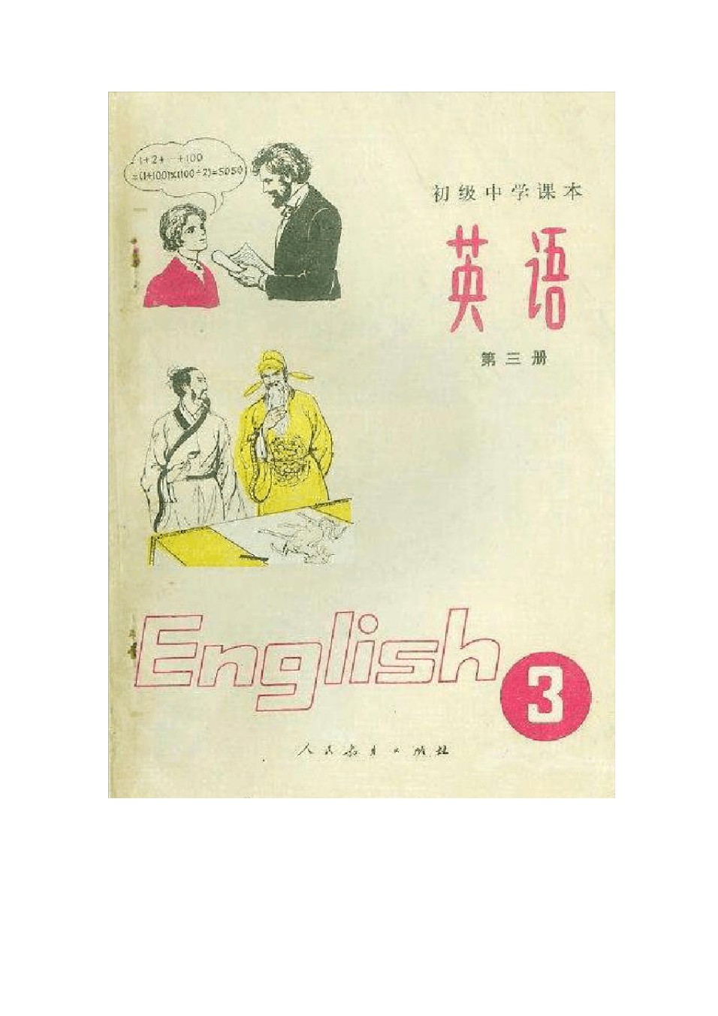

# 初中英语课本第三册

### LESSON 1

**DRILLS** （句型练习）

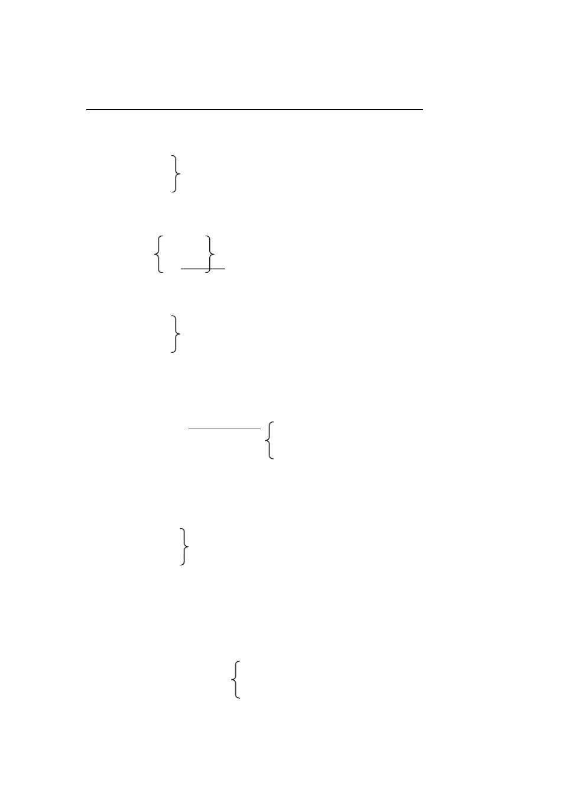

Are you going to have a swim?NoI,?m not. I?m going to play football.

A

A: Do you

Do they often go to the cinema? Does Mary

B: No, but I ’m

they’re going to see a film this afternoon. she’s

I ’m not

They aren’t going to have any lessons. She isn’t

B

A: Are you going to have geographythis year? this term?

next year?

B: Yes, I am. A: Is Kate

Are they going to have geography, too? Is your brother

B: Yes, I think so. (No, I don’t think so.)

C

A: What are you going to do this evening? this Sunday?

tomorrow?

B: I’m going to write some letters.



A: What’s Jane going to do?

B: She’s going to do her lessons.

play volleyball. play tennis.

**TEXT** （课文）

THE NEW SCHOOL YEAR

It ?s September, and w?ere back at school. It?s good to see all my teachers and friends again. They all look fine.

We?re in Grade Two this year. We?re going to have a new subject-physics. I hear physics isn?t easy.I?m going to work hard at it. I?m not very good at maths, but Wei Fang says sh?es going to help me. I think I can do better than last year.

I like English very much. I always work hard at it. This year I?m going to do more speaking. Zhang Hong likes English too, but he needs help. I?m going to help him.

This term I?m going to work for the wall-newspaper.My classmatessay I draw well, and my handwriting is good. I?ts interesting work, and I like it.

I?m going to do my best this year.

**GRAMMAR** （语法）

Be going to 结构

“Be going to + 动词原形”表示就要（即将） ，打算（做什么）或将要发生 的事。常与 tomorrow, tomorrow afternoon, next week, this year 等表示将来的时间 状语连用。如：

We’re going to have a new subject this year. Is Li Ping going to play basket-ball with us?

What are you going to do next Sunday? It ’s going to rain this afternoon.

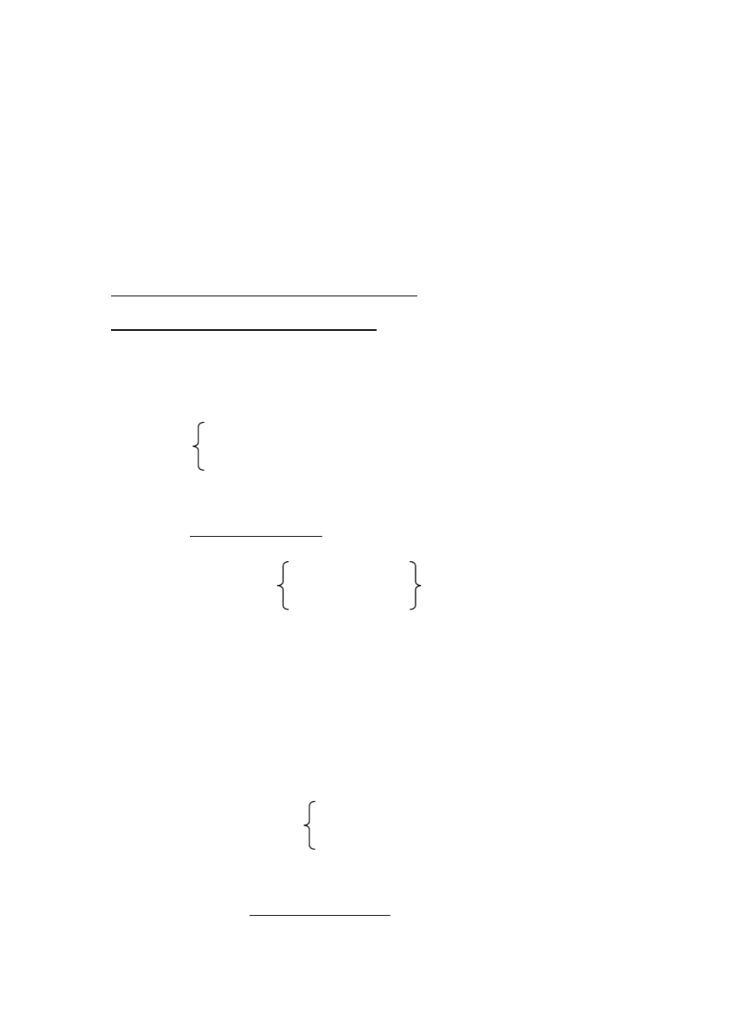

### LESSON 2

**DRILLS** （句型练习）

What ?s John going to do? He?s going to skate. Where?s he going to skate? In the park.

A

A: What are you doing over there?

Are you drawing a picture?

doing your homework? writing a letter to Grandpa?

B: No. I ’m reading the newspaper.

A: When are you going to draw the picture then?

do your homework write the letter

B: This evening.

B

A: What are they going to do the day after tomorrow?

this Sunday morning? next Saturday afternoon?

B: They’re going to have a volleyball match.

A: Where are they going to have it?

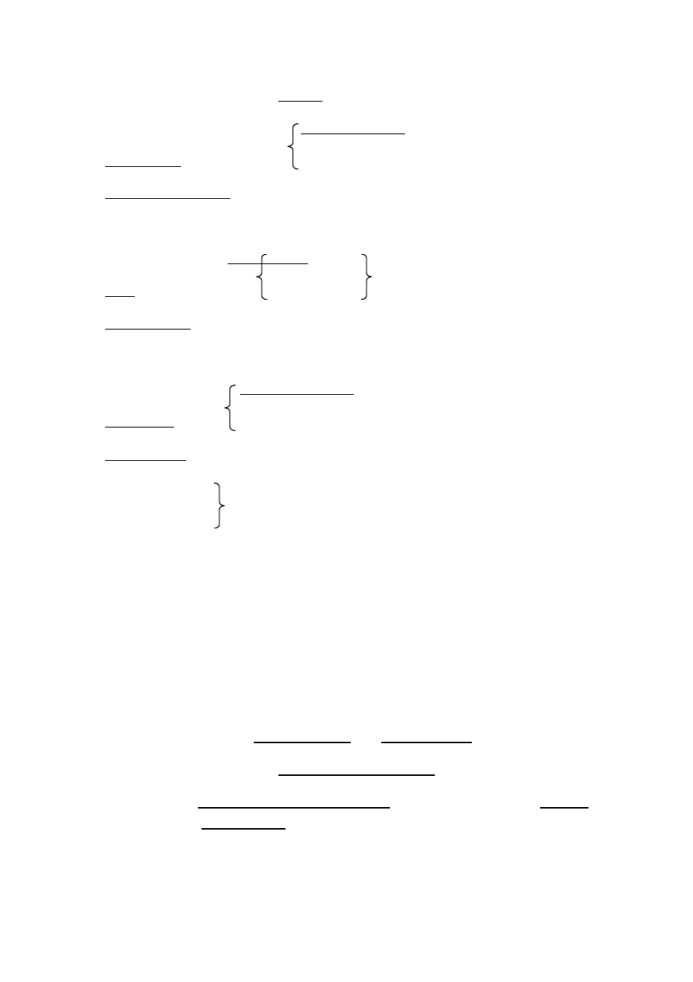

B: They are going to have it on the playground. in our school.

at the Children’s Palace.

C

A: Are we going to havea meeting this week? a talk

an English film

|  |  |  |
| --- | --- | --- |
| B: | Yes, we are. |  |
| A: | Who’s going to | speak at the meeting? |

give the talk? buy the tickets?

B: Our teacher is, I think.

Comrade Wu Li Ping

**DIALOGUE** （对话）

WHAT ARE YOU GOING TO DO TOMORROW?

Zhang Hong: It ?s Sunday tomorrow, you know. What are you going to do?

Wang Lin: I?m going to watch a volleyball match in the Capital Stadium. It?s between a Japanese team and a Chinese team.

Zhang Hong: That ?s great. What time is it going to be?

Wang Lin: At four o?clock in the afternoon. I have two tickets here. I can let you have one. You want to go, do?nt you?

Zhang Hong: Of courseI do, but I can?t. We?re going to have a table tennis match tomorrow afternoon.

Wang Lin: I see. Who are you going to play? Zhang Hong: A team from the No. 7 Middle School.



Wang Lin: Where are you going to have the match?

Zhang Hong: At the Children?s Palace.By the way, where?s Li Ping, do you know?

Wang Lin: He?s at home. Why?

Zhang Hong: He?s got my bat. I must get it back from him.

Wang Lin: His home isn?t far from here. I think you can find him at home. Zhang Hong: Right.I?d better go and look for him now. See you later.

Wang Lin: See you later.

NOTES:

I’d better = I had better, had better 的意思是“最好（做某事） ”，后面跟动词 原形。如：

You’d better write him a letter now.

**GRAMMAR** （语法）

句子的成分（ Members of the sentenc）e（I ） 组成句子的各个部分叫做句子的成分，即：主语、谓语；表语，宾语，宾语

补足语，定语和状语。

1、主语（ The Subject）和谓语（ The Predicate） 句子一般是由主语和谓语两个部分构成的。 主语表明句子里所谈的是 “什么

人”或“什么事物”。谓语说明主语“做什么” ，“是什么”或者“怎么样” 。如： 主语部分 谓语部分

**We** ‖ **work** hard.

**Betty** ‖ **likes** her new bike.

**My parents** ‖ **are** both teachers.

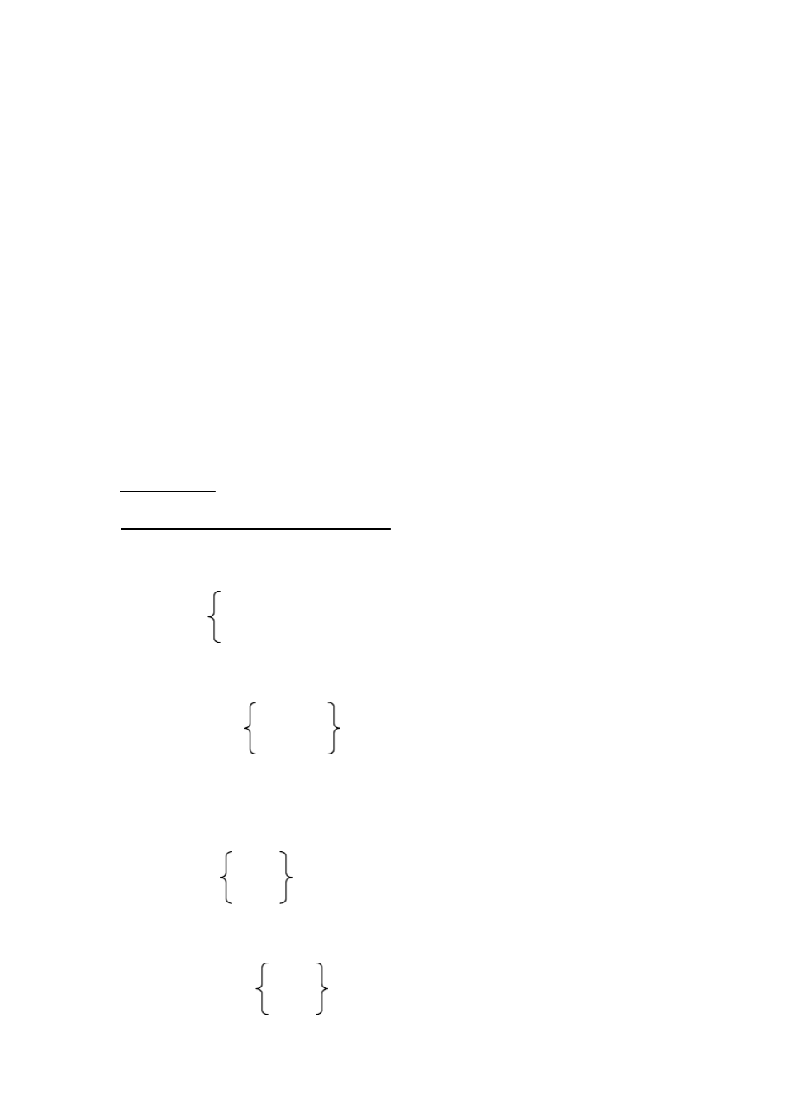

主语（主语部分里主要的词）常用名词、代词或相当于名词的词或短语等； 谓语（谓语部分里主要的词）用动词。

谓语和主语在“人称”和“数”两方面必须一致。如：

I am reading. We are reading.

You are reading. You are reading. He(she) is reading. They are reading.

### LESSON 3

**DRILLS** （句型练习） **Can you sing?**

Yes, I can and I can sing in English, too.

A

A: Can you skate?

dance?

answer this question? B: No, I can’t, but John can.

they

my sister

B

A: Can you be here at eight tomorrow morning?

ready back

B: Sorry, I can’t be here so early.

ready

back

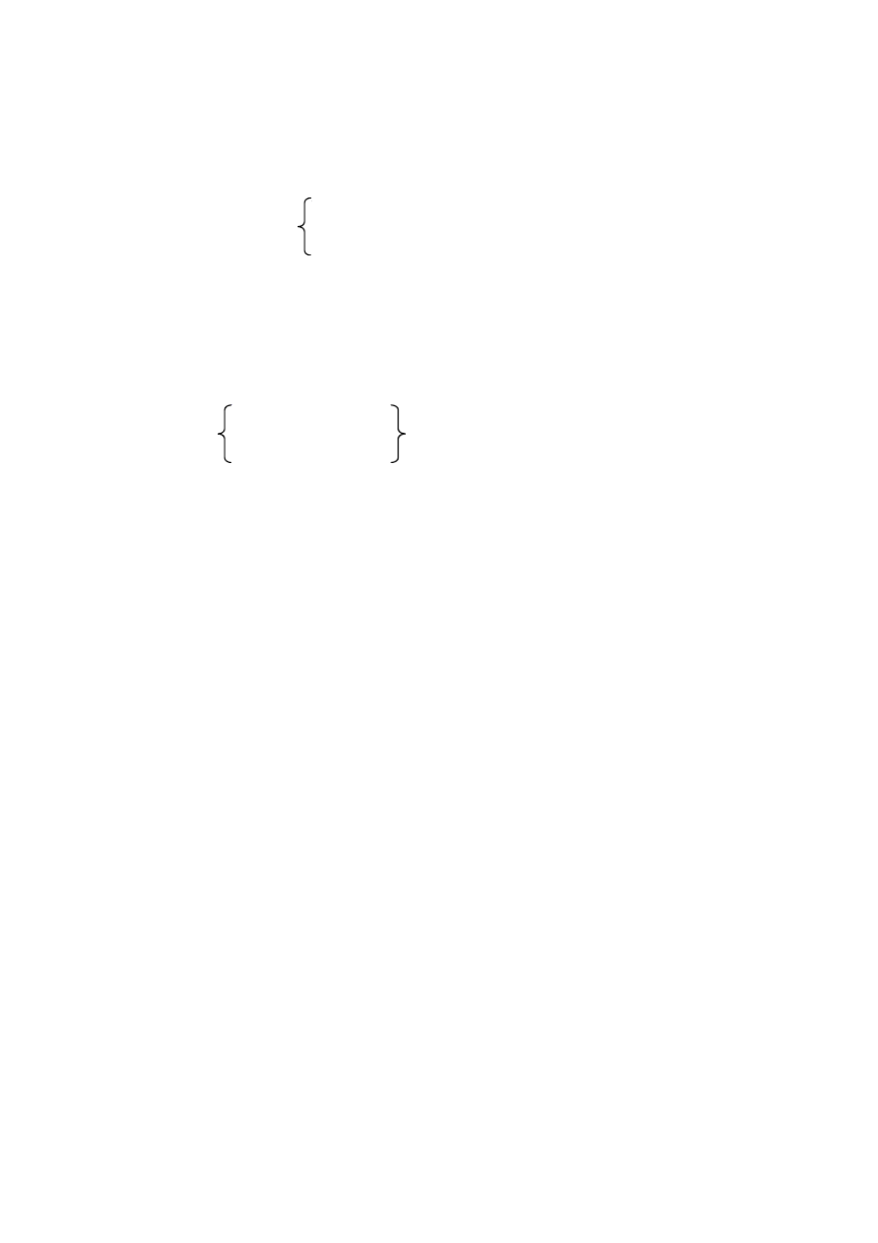

C

A: Excuse me, may I look at that book?

have a glass of wateh? use your pen?

B: Certainly. Here you are.

D

A: Must I finish my homework now? clean the room

stay here B: Yes, you must.

(No, you needn’t. You may go home now.)

**DIALOGUE** （对话）

AT THE LIBRARY

It ?s four o?clock in the afternoon. Liu Ying is at the library. She ?s going to the borrow some books. Sh?se speaking to the assistant.

Liu Ying: Good afternoon!

Assistant: Good afternoon! Can I help you? Liu Ying: Do you haveFrom Earth to Moon? Assistant: Let me see Ah, here it is.

Liu Ying: Thank you. How long may I keep it? Assistant: Two weeks.

Liu Ying: Can I keep it a little longer?

Assistant: Yes, you can. But you must come and renew it if you ca?tnfinish it in time.

Liu Ying: Must I bring the book back for that?



Assistant: Yes, you must. And you must?nt lend it to others.

Liu Ying: All right, I won ?t. May I look at some of the new books? Assistant: Certainly. They?re over there.

**GRAMMAR** （语法） 动词的种类（ Kind of Verbs）

动词是表示动作或状态的词，按其词义和在句子中的作用可分为下列四类：

1、行为动词，又称实义动词（ The Notional Verb）表示动作或状态，能独立做谓 语。如：

I ’**m reading**the newspaper now. She **has**some books.

They often **come**back early.

行为动词又可分为及物动词 （The Transitive Verb, 缩写为 vt.）和不及物 动词（ The Intransitive Verb, 缩写为 vi.）。及物动词后面带宾语。

2、连系动词（ The Link Verb, 缩写为 link v.）不能独立做谓语，必须与表语一起 构成谓语。最常用的连系动词是 be（是），另外还有 look（显得，看起来）， turn（变成），get（变得）， become（变得，成为）等。如：

His father **is**a teacher. They all **look** fine.

3、助动词（ The Auxiliary Verb, 缩写为 v. aux.）本身没有词义， 不能独立做谓语，

只能和主要动词一起构成谓语动词， 表示否定、疑问、时态或其它语法关系。 常用的助动词有 be, do, have等。如：

He **doesn**’**t speak**Russian.（表示否定）

They **are doing**their homework now.（表示进行时态）

**Do** you often **go** swimming in summer?（表示疑问）

4、情态动词（ The Modal Verb）本身有一定的意义，但不能独立做谓语，只能和

主要动词一起构成谓语动词，表示说话人的语气和情态。 情态动词没有人称

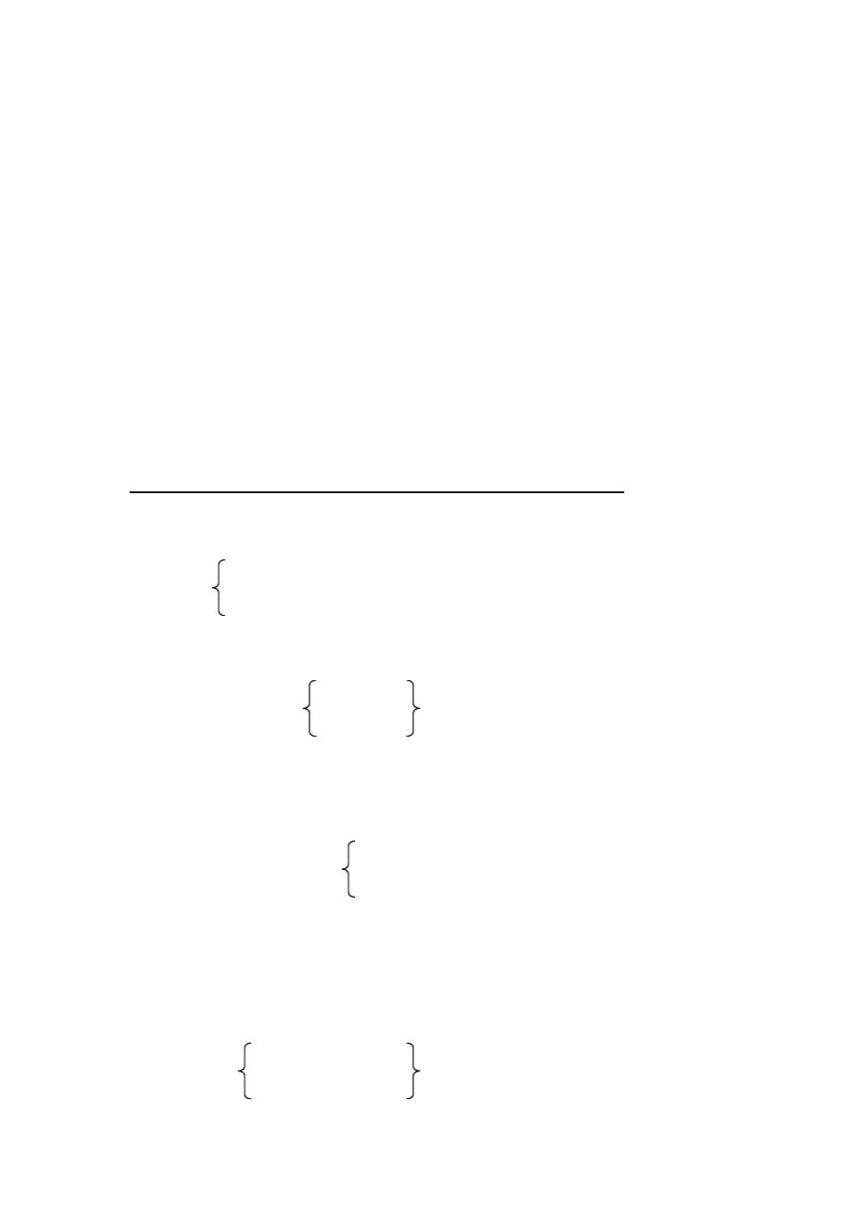

和数的变化 。常用的情态动词有 can, may, must, need等。如： I**can** speak a little English?

**May**I come in?

**Must** he go now? No, he **needn**’**t.**

**Can** he be at the zoo tomorrow morning?

### LESSON 4

**DRILLS** （句型练习）

You weren?t at school yesterday. Where were you?I was ill in bed.

A

A: Where is Mr Green? is Mary?

are Jack and Mike?

B: sorry, I don’t know. He was here a moment ago. She was

They were

B

A: Was your father at home yesterday morning?

yesterday afternoon? last night?

B: Yes, he was. (No, he wasn’t. He was at work)

C

A: Were they busy yesterday evening? Back at seven

Late for the meeting



B: Yes, they were. (No, they weren’t.)

D

A: When were you born?

B: I was born in January , 1969.

in February, 1970.

on April 2, 1969.

A: Where were you born? B: I was born in Wuhan. Guangzhou.

Tianjin.

**DIALOGUE** （对话）

A TELEPHONE CALL

Mrs Black: Hello!

Mary: Hello! May I speak to John? Mrs Black: Sorry, John isn?t in.

Mary: Is that Mrs Black speaking? Mrs Black: Yes. Who?s that?

Mary: This Mary, Mrs Black. I called at four thirty this afternoon, but nobody was in.

Mrs Black: Oh, we were all out. John wasn?t back then. Mr Black and I were at the cinema. Can I take a message for John?

Mary: Yes, please.John asked me to help him with lessonsthis evening.

I?m afraid I can ?t do that today. Mother is ill. I have to look after her at home.

Mrs Black: I?m sorry to hear that. Just stay at home and take good care of your mother. Don?t worry about John. You can help him later, can?t you?

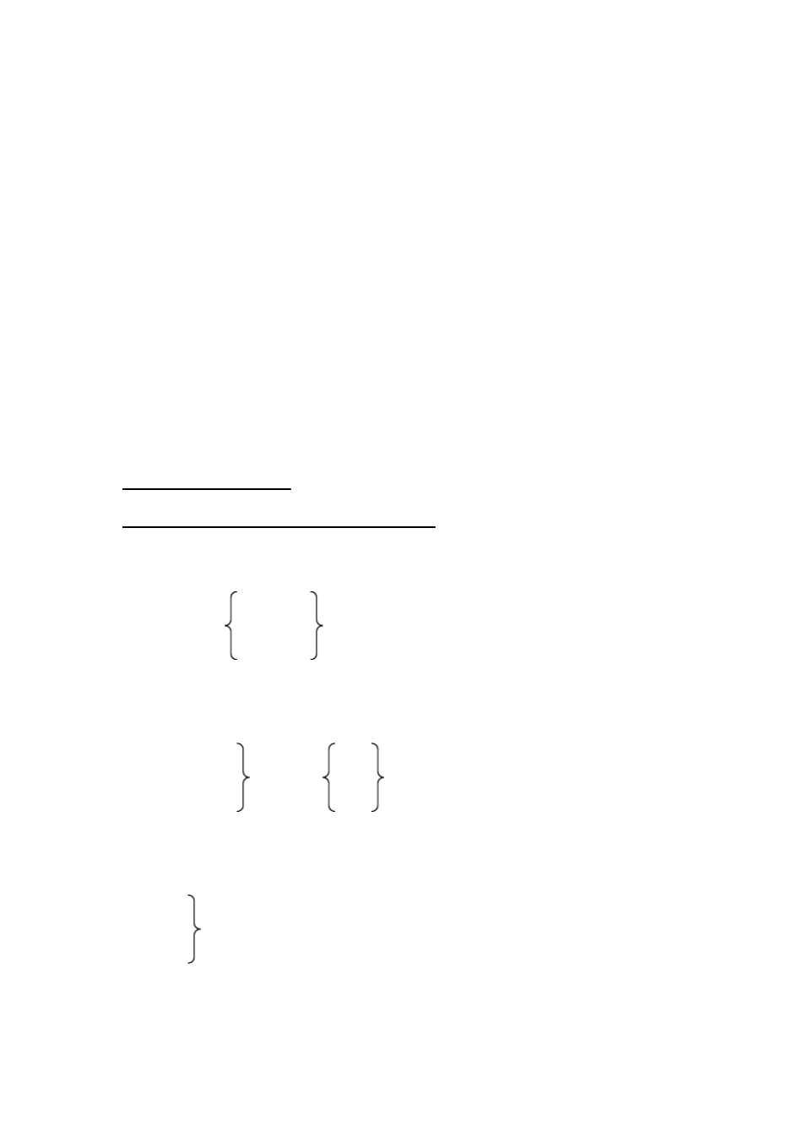

Mary: Yes. Please tell John about it. Mrs Black: OK.

Mary: Thanks a lot. Bye-bye! Mrs Black: Good-bye!

### LESSON 5

DRILLS （句型练习） Did you water the trees?

No, but I planted some flowers in the garden.

A

A: What time do you usually get up in the morning?

do they does he does she

B: I get up at six. But I didn’t get up so early this morning

They get up they

He gets up he

She gets up she

I got up at a quarter to seven. They

He She

B



A: Did your father go to work early yesterday? B: Yes, he did. He went to work at six.

A: Did he have lunch at home? stop work early?

come back early?

B: No, he didn’t. He had it at the factory.

stopped work quite late. came back quite late.

C

A: Did you have a meeting after school? B: No, I didn ’t.

A: What did you do?

B: I played the violin.

helped my brother with his biology. planted trees with my classmates. carried water for Grandpa Li.

**TEXT** （课文）

THE ARTIST

Long, long ago there lived a king. He loved horses.One day he asked an artist to draw him a beautiful horse. The artist said,“All right, but you must wait.” So the king waited. He waited and waited. At last, after a year he could

not wait any longer. He went to see the artist himself.

Quickly the artist brought paper and a brush. In five minutes he finished drawing a very beautiful horse. The king was angry. “You can draw a good horse in five minutes, yet you kept me waiting for a year. Why”?

“Come with me, please”, said the artist. They went to the artis?ts workroom.

There the king saw piles and piles of paper. On every piece of paper was a picture of a horse. “ It took me more than a year to learn to draw a beautiful

horse in five minutes”,

the artist said.



**GRAMMAR** （语法）

一般过去时 (The Past Indefinite Tense) 1、一般过去时表示在过去某个时间发生的动作或存在的状态，也表示过去经常

或反复发生的动作。常与 yesterday, yesterday afternoon, last year, in 1965, a

moment ago 等表示过去的时间状语连用。如：

**I got up** at five yesterday, but**I didn**’**t get up**so early this morning.

**Did** he **watch** TV last night?

**I was** in Grade One last year.

2、动词过去式的构成和读音。 规则动词 A、过去式的构成：

1）一般的词，加 -ed：

ask --- asked help --- helped 2）结尾是“”的词，加 -d：

dance --- danced love --- loved

3）末尾只有一个辅音字母的重读闭音节词 （注：重读闭音节中元音字母不 是发它本身的字母音， 而是发短元音 ) ，先双写这个辅音字母， 再加 -ed：

stop --- stopped

4）结尾是“辅音字母 +y”的词，改“ y”为“ i”，再加 -ed： carry --- carried study --- studied

B、过去式的读音

规则动词的过去式，其词尾 –ed 或 –d 的读音，依照下列规律：

1）在浊辅音后面读为 [d] 。 used called



在元音后面也读为 [d] 。 played answered 2 ）在清辅音后面读为 [t] 。 worked helped

3 ）在[t],[d] 音后面读为 [id] 。 wanted needed

不规则动词

am (is)--- was are --- were bring --- brought come ---came do --- did get --- got

go --- went have --- had keep --- kept make --- made run --- ran say --- said see --- saw take --- took tell --- told

### LESSON 6

**DRILLS** （句型练习）

What did Mike do this morning? He played tennis. Who did he play with? He played with his sister.

A

A: What day was yesterday? B: It was Tuesday.

A: What was the date? B: It was July 4th.

August 2nd.

November 3rd. December 1st.

B

A: How many classes did you have yesterday afternoon? B: We had two.

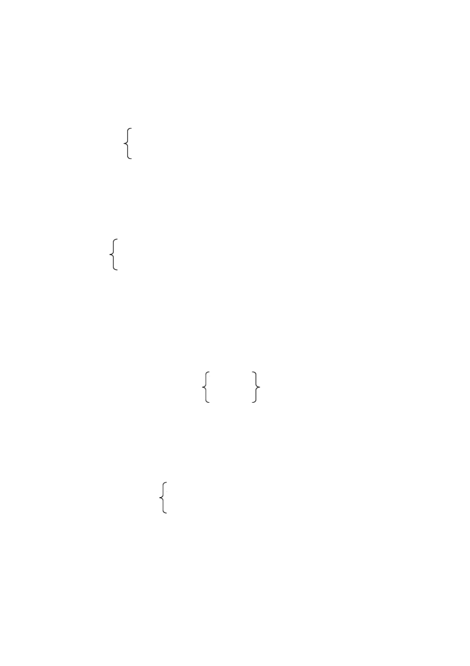

A: What classes did you have? B: We had history and politics.

P.E. and English. physics and biology.

C

A: What did Alice do the day before yesterday? B: She went to the cinema.

visited the History Museum. climbed the hills.

A: Who did she go with?

B: She went with her classmates.

D

A: What time did they get to the park last Monday?

zoo museum

B: At about nine.

A: How long did they stay there?

B: They stayed there for half an hour.

for three hours. for two hours

**TEXT** （课文）

“THE MOVING BLACKBOARD ”

More than one hundred years ago there was a great French scientistwith the name Ampere.



One day, Mr Ampere went out for a walk in the street. There were a lot of people and much noise there. But all this was nothing to him. He was thinking about a maths problem. He had no paper with him. How could he work it out?

Just then, he saw a blackboard in front of him. He ran up to it at once. He took out a piece of chalk and wrote his problem on the blackboard. Then he started to work on it. The blackboard moved a little, but he did not notice it. The blackboard moved on. Mr Apere moved with it. The blackboard started to move away faster and faster. Mr Ampere could not keep up with it any longer. He stopped to have a look.

What did he see? Why, the“blackboard”was NOT a blackboard. It was the back of a carriage!

**GRAMMAR** （语法）

句子的成分 (Members of the Sentence)(II)

2、表语（ The Predicative），宾语（ The Object）和宾语补足语（ The Object Complement）

表语、宾语、宾语补足语都是谓语里的组成部分。表语由名词、形容词 或相当于名词或形容词的词或短语等充当，和连系动词一起构成谓语，说明 主语是什么或者怎么样。如：

Her sister **is** a nurse.

**Are** you ready?

We **were**at homelast night.

宾语是动作行为的对象， 由名词、代词或相当于名词的词或短语等表示， 和及物动词一起构成谓语，说明主语做什么。如：

He **needs**help.

Tom **has** a story-book.

**Did** you **see**him yesterday?

有些及物动词可以有两个宾语， 一个指人，一个指物，前者叫间接宾语，

后者叫直接宾语， 合成双宾语 。如：

Our teacher**told**us an interestingstory. He **gave**me someink.

有些及物动词的宾语后边还需要有一个补足语，意思才完整。宾语和它

的补足语构成复合宾语（ The Complex Object）。如： Let me stay here.

John asked me to help him.

3、定语（ The Attribute）和状语（ The Adverbial）

定语是修饰名词或代词的。 可以作定语的处形容词外， 还有名词、代词、 数词、介词短语或相当于形容词的词或短语等。如：

This is a green**jeep.**

Winter is the coldest**season**of the year.

形容词作定语时通常放在被修饰的词之前， 而介词短语等则放在被修饰的词之后。 状语是修饰动词、 形容词或副词的， 有的修饰全句。 可以做状语的主要是副词和

介词短语或相当于副词的词或短语等。如：

They often**draw**in the park. You arequite**right**.

We **like** this picture very much.

简单句的五种基本类型：

谓 语 部 分

主语

谓语动词 表语 宾语 宾补

1 We (不及物动词 )work ----- ----- -----

2 I (及物动词 )study ----- English. -----

3 They (连系动词 )are Students. ----- -----

4

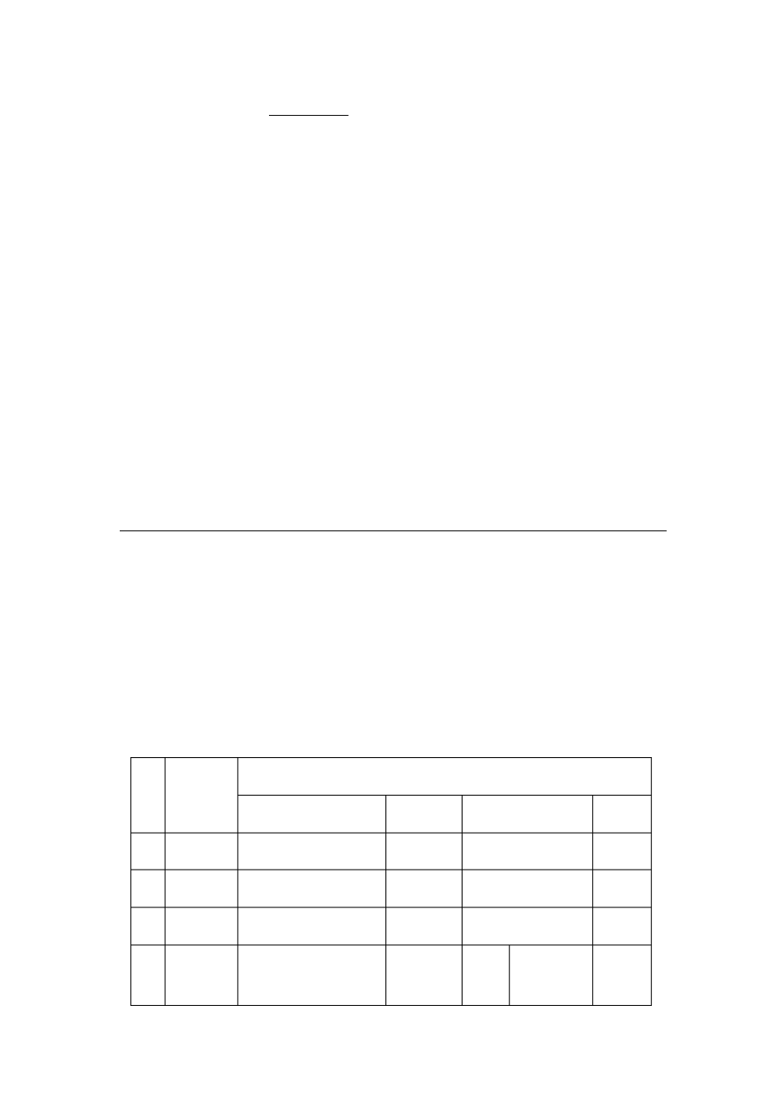

He (及物动词 )gave -----

间宾 直宾 some me milk

-----

5 Li Ping (及物动词 )made ----- the baby laugh.



### LESSON 7

**TEXT** （课文）

A PAGE FROM A STUDENT ?S DIARY

October 22nd, Saturday Cloudy

There were no classes this afternoon. My classmates all went to the Summer Palace. They had a good time, but I didn?t go.

After lunch Aunt Huang came in. she looker worried. “Grandma is ill, ”she said. “Imust take her to the hospital. But my baby, Ican?t leave her by herself.”

Mother and Dad were not at home. So I said, “Don?t worry. I can look after her,”

“Thank you, Xiao Ping. Thank you.”Then she left.

The baby was about ten months old. At first she was asleep. Half an hour later she woke up. She couldn?t find her mother and began to cry. “Don?t cry,”I said. I talked to her. But she looked at me and cried harder and harder. I turned

on the radio. She stopped crying and listened to the music. After a few minutes she started to cry again. “Listen to me,”Isaid. I started to sing. The baby watched and listened. She didn?t cry any more. Then I made faces and jumped

like a monkey. The baby laughed and laughed.

All that afternoon I jumped and sang and did all kinds of things. When Aunt Huang came back, I was tired.

In the evening Wang Lin came to see me. I told him the whole story. He laughed. “You?re great! I?m going to tell everyone.I?m going to tell them ,Bring your babies to Li Ping. He can take good care of your babie?s”.

### LESSON 9

**DRILLS** （句型练习）

John writes more carefully than Tom and Peter. Right. He writes the most carefully of the three.

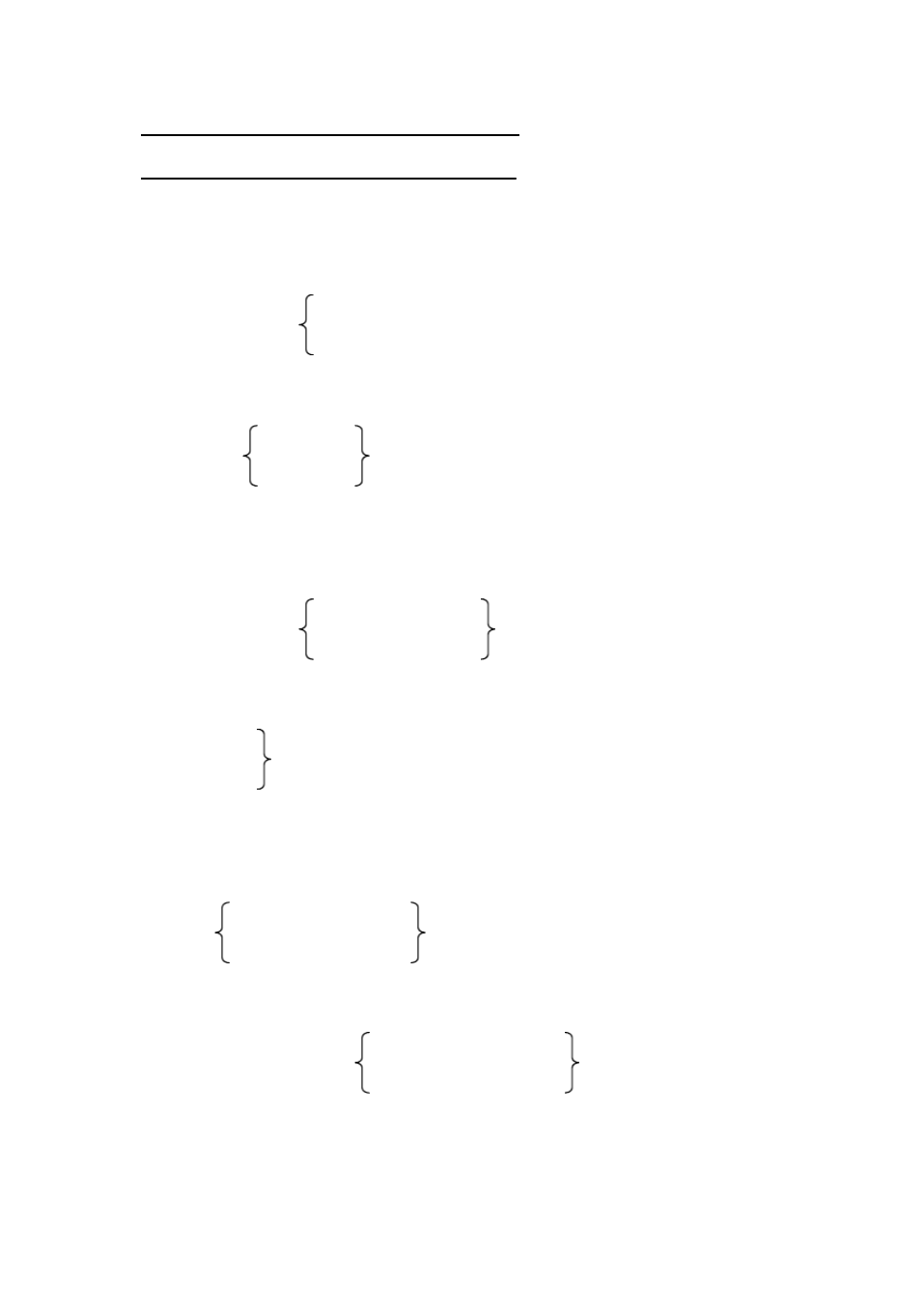

A

A: Which picture is more beautiful?

more interesting? more expensive?

B: The one on the left, I think.

on the right, on the left,

B

A: Which lesson is the most difficult in Book Two?

the most interesting the most instructive

B: Lesson 15 is. Don’t you think so?

Lesson 13

Lesson 6

C

A: Tom draws better than Peter. jumps higher

writes more carefully

B: You’re quite right. He draws the best in our class.

jumps the highest writes the most carefully

D

A: Is Joan as tall as Kate?



strong careful

B: No, she isn’t. She isn’t quite as tall as Kate.

strong careful

(Yes, she’s just as tall as Kate.)

**DIALOGUE** （对话）

THE MOON

Son: Look, Dad! How bright and near the moon looks tonight! Father: But it isn?t as near as it looka.

Son: I know it ?s far away from the earth.

Father: It ?s three hundred and eighty thousand kilometers away. Son: How far is that?

Father: Well, it takes more than three days to get there by spaceship. Son: A spaceship flies very, very fast, doe?stnit?

Father: Yes. It flies at about eleven kilometers a second. In 1969 two Americans got to the moon by spaceship.That was one of the most exciting moments of that year.

Son: They didn?t find any living things there, did they?

Father: No, they didn?t. I t?s too hot in the day and too cold at night. And there?s no air or water there. Nothing can live on the moon.

Son: I hear walking on the moon is more difficult. It ?s like jumping and flying. Is that so?

Father: Yes, isn?t that interesting! Everything is much lighter on the moon. You can jump much higher on the moon than on the earth.

Son: I wish I could fly to the moon in a spaceship one day. It must be great fun.



NOTES

It ’s three hundred and eight thousand kilometers away.它（月球）离我们有三 十八万公里。

1,000 以上的基数词的读法如下： 1,026 读作 one thousand and twenty-six

9,743 读作 nine thousand, seven hundred and fory-three 15,978 读作 fifteen thousand, nine hundred and seventy-eight

748,359 读作 seven hundred and forty-eight thousand, three hundred and fifty-nine.

**GRAMMAR** （语法）

形容词和副词的比较级和最高级 （The Comparative and Superlative Degrees of Adjectives and adverbs）(II)

1、多音节的形容词和副词在其前面加 more 或 most 构成比较级或最高级。如： 形容词：

difficult more difficult most difficult interesting more interesting most interesting

副词：

slowly more slowly most slowly carefully more carefully most carefully

不规则变化的形容词和副词的比较级和最高级：

|  |  |  |
| --- | --- | --- |
| 原级 | 比较级 | 最高级 |
| good | better | best |

well

bad ill

worse worst

many much

more most

little less least

far farther

further

farthest furthest

old older

elder

oldest eldest

2、多音节形容词和副词的比较级和最高级的用法。如：

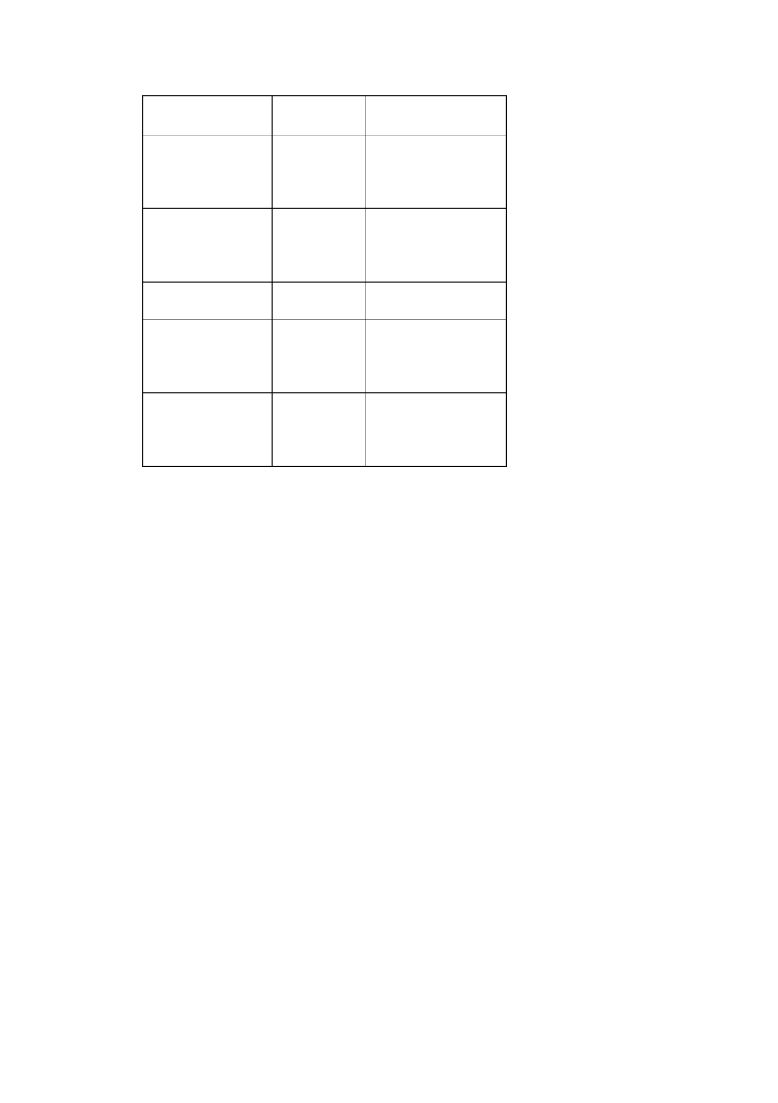

This story is **more interesting than**that one.

The third question is **the most difficult o**t**f**he three. He listens to the teachers**more carefully than**you. She writes**(the) most carefully of**the three.

在形容词和副词的比较级前，有时可以用 much, a little, still 等来修饰。如：

An elephant is **much** stronger than a horse. Mike is **a little** taller than John.

May I keep the book**a little** longer?

You can jump**much** higher on the moon than on the earth.

3、表示甲与乙在某一方面程度相同是，用“ as+形容词（副词）原级 +as”的句 型。如：

Joan is just as careful as Kate. Tom walks as fast as Mike.

表示甲在某一方面不及乙时，用“ not as (so) +形容词（副词）原级 +as”的句

型。如：

It is not as (so) warm today as yesterday. He did not come as (so) early as Wang Lin.

### LESSON 10

**DRILLS** （句型练习）

It was warm yesterday, wasn?t it?Yes, it was. But i?ts much colder today.

A

A: It was cold yesterday, wasn’t it?

hot sunny

B: Yes, it was. But It s’

much warmer today. much cooler

cloudy and windy

B

A: You were tired after **the sports mee**,**t**

weren’t you?

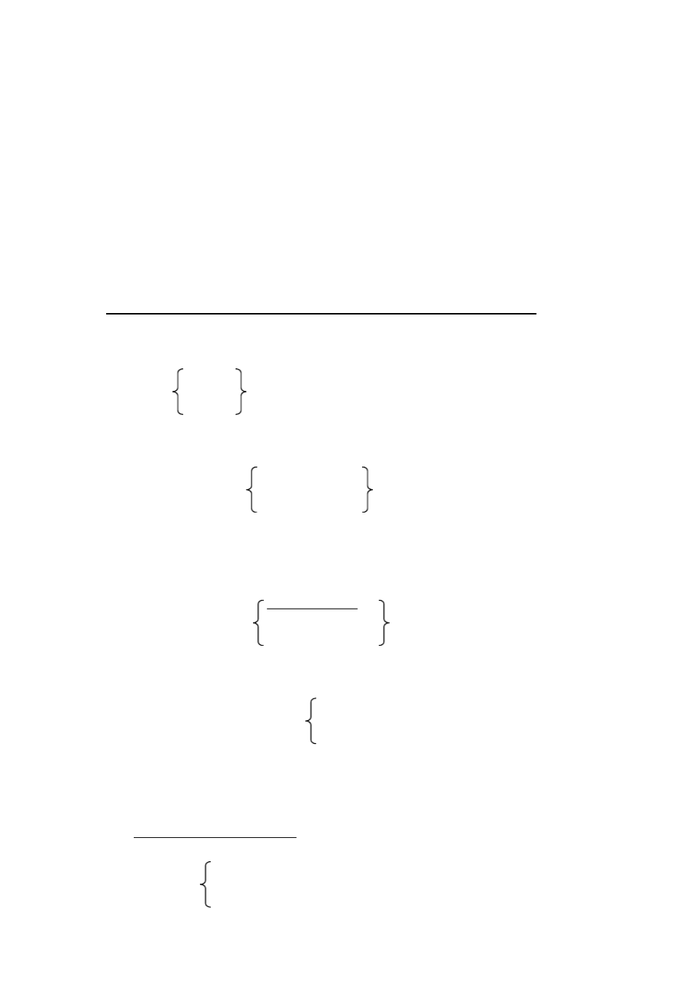

the football match, running,

B: Yes, but only a little. Now I ’m fine.

all right much better.

C

A: You don’t often go home late. But you went home late yesterday, did’nt you? B: Yes, I did. I helped Liu Ying with her English.

had a long talk with the teacher. waited for Wei Fang.

D

A: Your mother often goes to see your grandma. She went to see her last Sunday too, didn’t she?

B: No, she didn’t. She stayed at home and cleaned the house.

stayed at home and did some washing. took me to the park.

**TEXT** （课文）

A WAY OUT

AFrench student went to London for his holiday. He thought: “Iknow a little English. I think people can understand me”.

One morning he went to visit the Science Museum. At noon he was tired and hungry. He went to the nearest restaurant and sat down at the table. He wanted to have a cup of tea and some eggs. Soon the waiter came up to him and asked,

“Can I help you, sir?”

“A cup of tea and ”he could not remember the English word for eggs. He looked around him, but nobody was eating eggs.

Then he saw a magazine on the table next to him. There was a picture of a cock on its cover. He showed the picture to the waiter.

“ whats?the English for this?”he asked.

“A cock, sir”,

answered the waiter.



“What do you call a cock?s wife?”was the next question.

“A hen, sir”.

“And what do you call a hen?s children?” “Chicks, sir”.

“And what do you call chicks before thye?re born?”

“Eggs, sir”.

“Very well,”said the French student. “Bring me two eggs, two eggs and a

cup of tea, please”.

And he sat back with a smile on his face.

### LESSON 11

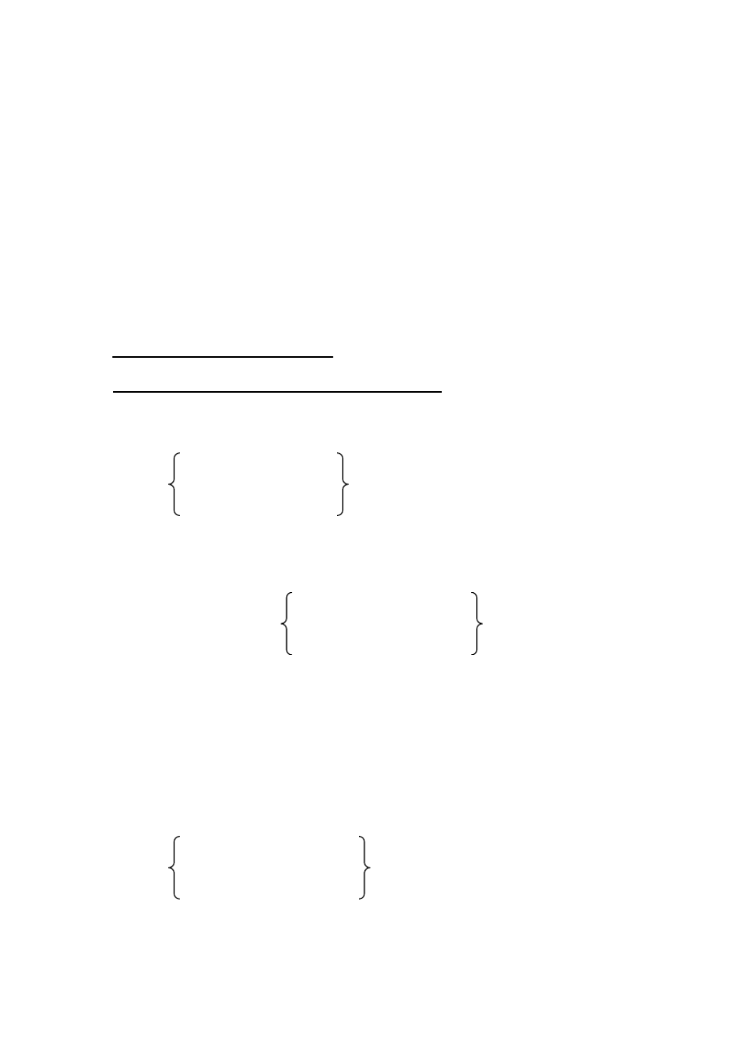

**DRILLS** （句型练习）

Will you be busy tomorrow, Dad?

No, I won?t. We can go to the Great Wall tomorrow.

A

A: You washed the clothes, didn’t you? answered the letter,

called Mr Green,

bought me a bottle of ink,

B: Sorry, I forgot! But I ’ll wash them after lunch. Answer it

Call him

Go and buy a bottle for you

B

A: Will you be here this afternoon? you help me with my maths

she come home

they have any lessons

B: Yes, we will. I



she they

C

A: Will you be free tomorrow?

B: No, I won ’t. But I ’ll be free the day after tomorrow. A: Will you go fishing with me?

Teach me Japanese? Help me repair my bike? Make me a kite?

B: Certainly. I ’ll be glad to.

**DIALOGUE** （对话）

SHOPPING

Alice: Mum, look at my coat. It ?s too short and too small. Will you buy me a new one?

Mrs Green: All right. I?m just going out to do some shopping now. Come on, dear.

(They go into a shop for clothes).

Shop Assistant: What can I do for you, madam? M: I ?m looking for a coat for my daughter.

S: Here, madam, here are coats for young people.

M: The red one on the right looks very niced, oesn?t it? Do you like it, dear? A: No, Mum, I don ?t like red very much. I like green better.

S: Green? Here?s a green one. How do you like this?

A: It ?s nice, isn?t it, Mum? M: Yes. How much is it?

S: Thirty pounds.

M: Thirty pounds? That?s too expensiveI,?m afraid.

S: What about the one next to it? It?s cheaper. It?s only twenty pounds. M: That ?ll be all right. Alice, please try it on, will you?

**A: Yes, Mum.** (She tries it on.)

M: It looks a bit large. Have you a smaller size?

A: I think it ?ll fit me quite well before long, Mum. You ?re always saying I?m growing so fast.

M: All right then. We?ll take it.

**GRAMMAR** （语法）

一般将来时 (The Future Indefinite Tense) 1、一般将来时表示在将来某个时间要发生的动作或存在的状态。

2、一般将来时由“ 助动词 **will+**动词原形 ”构成。在日常口语中， will 在名词或 代词后常简缩为 ’ll ， will not 常简缩为 won’t 。例如：

I ’ll go to your school tomorrow afternoon. We won’t have a meeting next Saturday.

注： 1）在书面语中，主语为第一人称 (I 及 we) 时，常用助动词 shall+动词原 形。例如：

I shall write you a letter next month. We shall be very glad to see you.

但在日常口语中，所有人称都可以用 **will.**

2 ) 在表示“带意愿色彩的将来”时，常用 will 。例如：

I will tell you all about it.

3）在问对方是否愿意，或表示客气的邀请或命令时，常用 will 。例如：

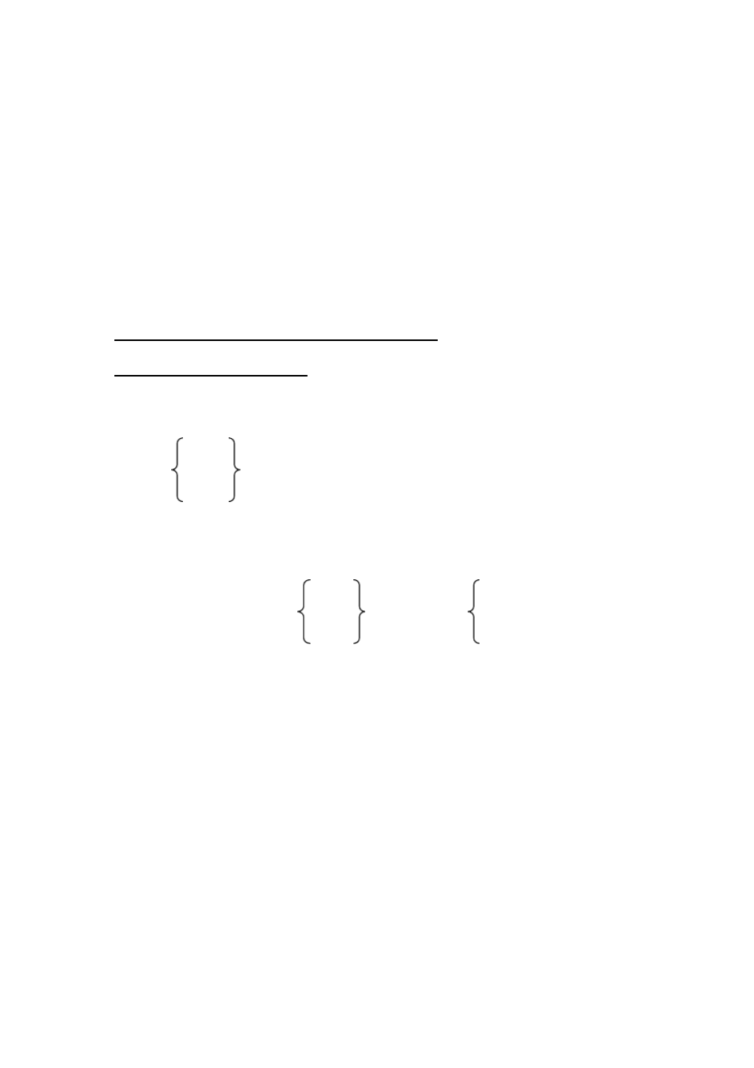

Will you go and see the film with me? Will you please open the window?

### LESSON 12

**DRILLS** （句型练习）

This problem is hard. It is. Do you need any help? No, thanks. I can do it myself.

A

A: Can you work out this problem? Jack

Mary

they

B: Yes. It’s not too difficult. I can work it out myself. He himself.

She herself.

They themselves.

B

A: What’s wrong with your clock/bike/watch/radio? B: It doesn’t work.

A: Can you repair it yourself?

B: I ’m afraid not. Can you help me? A: Certainly.

C

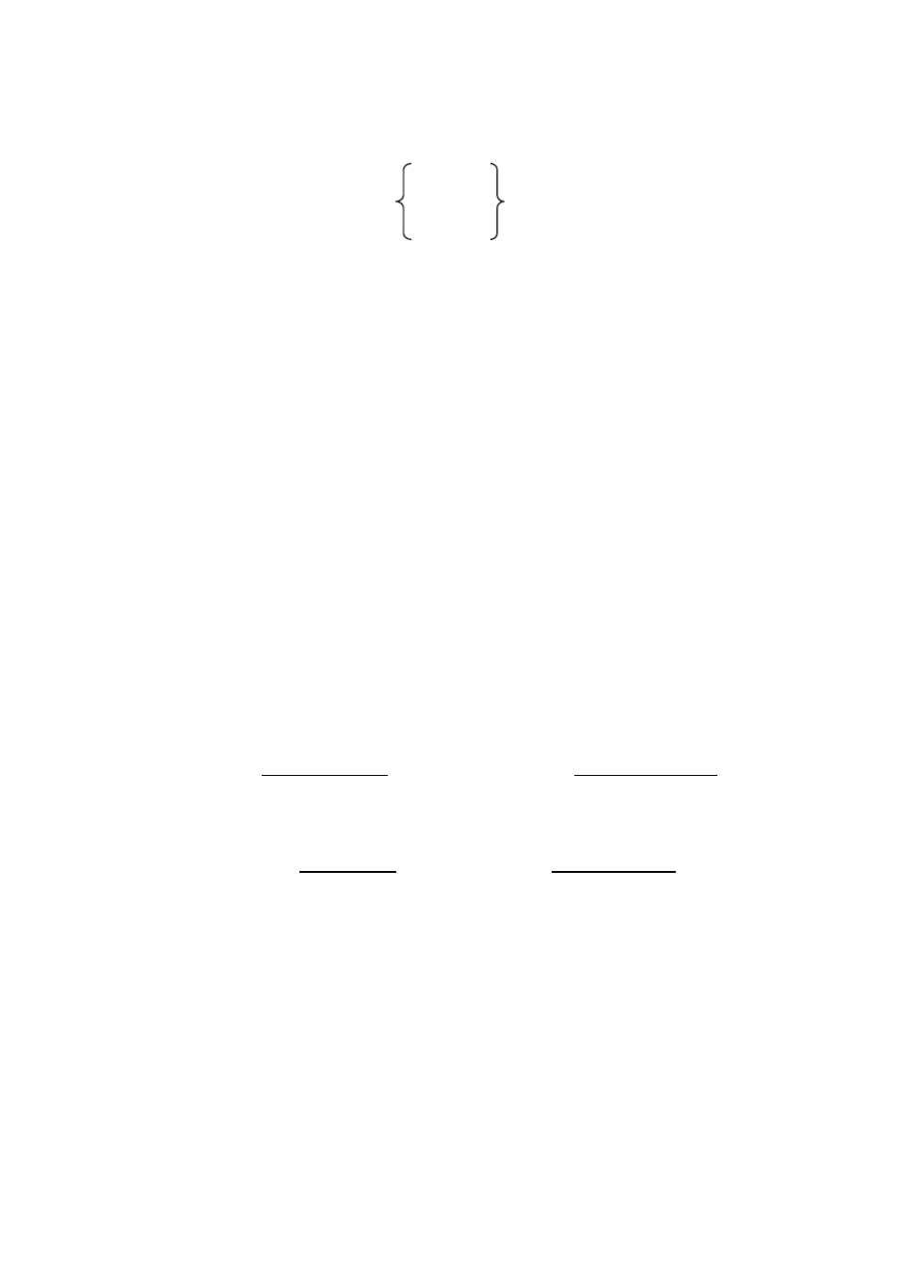

|  |  |  |  |
| --- | --- | --- | --- |
| A: | Hi, Mike! Where are you going? |  | |
| B: | To John’s. We’re going to have | Chinese | lessons together. |

French Japanese Russian

A: Who teaches you?

B: Nobody. We teach ourselves.

**TEXT** （课文）

TWO FRIENDS AND A BEAR

One day two young men were going through the forest. One said to the other, “We?re good friends. We must help each other. If any beast comes at yoI?ull, stay with you and help you.”The other friend said, “Iwill help you too, if any beast comes at you”.

They walked on.

After a while there was a great noise. It was a big bear. The young men ran away quickly. One of them got up into a tree. But the other was fat and could not climb up. So he threw himself at the foot of the tree. He thought to himsel“f,The bear will think that I am dead.”

Soon the bear came near. The bear looked at the fat young man, then it put its nose down and smelled him. The young man held his breath. The bear thought he was dead, so it went away.

The man in the tree came down. With a smile he asked his friend“,The bear put its mouth so near to your ear. What did it say to you”?

The friend answered,“The bear said,, Don?t trust your friend. He ran away from you when you needed his help most. Remember: A friend in need is a friend indeed.?”

**GRAMMAR** （语法）

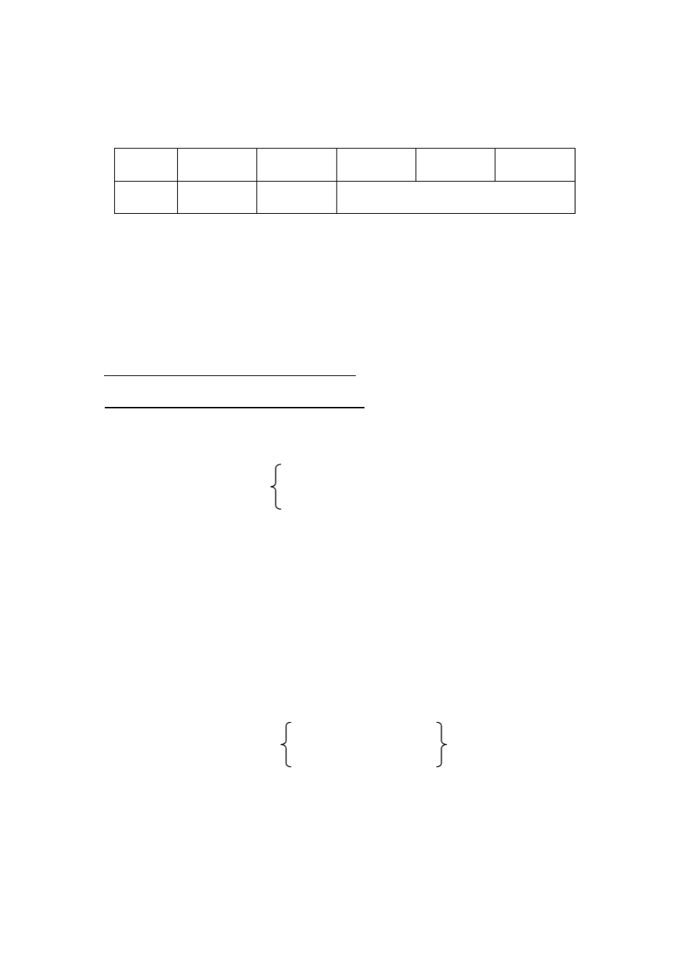

反身代词 (The Reflexive Pronouns)

|  |  |  |  |  |  |
| --- | --- | --- | --- | --- | --- |
| 单 数 | myself | yourself | himself | herself | itself |
| 复 数 | ourselves | yourselves |  | themselves |  |

### LESSON 13

**DRILLS** （句型练习）

Can you come out to play football with us? Sorry. I?ll have to finish my homework first.

A

A: Where’s Peter? I want to have a word with him

ask him a question. show him my new bike.

B: I don’t know. Perhaps he’s in the garden.

A: I ’ll go and find him.

B

A: Are you going to see Wei Fang today? B: Yes. I ’m going to her home right now.

A: Will you please ask her to call me tomorrow?

return my books

bring a map of the world

B: OK.

C

A: Can you come to see the film with me now?

fly my model plane skate in the park

B: Sorry, I can’t. I ’ll have to finish my homework first.

**TEXT** （课文）

LENIN AND THE GUARD

One morning Lenin was going to his office. At the gate a guard stopped him.

“Your pass, please”.

“Oh, yes, my pass”, said Lenin. “It ?s in one of my pockets”. He began to look for it in his pockets.

Just then a young man came up. This young man knew Lenin. He said to the guard: “Let him in.”

“No, I won ?t let him in if he has no pass. What ?s more, I want to see your pass, too”.

The young man became angry. “This is Comrade Lenin. Let him in, I tell you!”he shouted at the guard.

“Don?t shout at him,”Lenin told the young man.“He?s right. We must obey the rules!”

Lenin found his passand showedit to the guard. The guard looked at it carefully. Yes, it was Lenin himself.

“ **Im?**

you.”

sorry.”The guard said and his face turned red. “Ididn?t know it was



“But you did the right thing,”Lenin said.“You are a good comrade. You are strict in your work. We must all be strict in our work”.

**GRAMMAR** （语法） 动词不定式 (The Infinitive) (I)

1、动词不定式的基本形式是 “ to+动词原形”，有时可以不带 to。动词不定式 （或

不定式短语）没有人称和数的变化，在句子中不能做谓语。动词不定式仍保 留有动词的特点，即它可以有自己的宾语和状语。动词不定式同它的宾语或 状语构成不定式短语。如： to read the newspaper, to speak at the meetin等g 。

2、动词不定式具有名词、形容词、副词的特征，因此在句子中可以作主语、表 语、宾语、宾语补足语、定语和状语。 （用动词不定式作主语时，经常用 it 作形式主语，代替不定式，放在句子的开头，把动词放在谓语后面，但翻译

时 不 必 把 it 翻 译 出 来 。 To learn English is difficult but very interesting= It is difficult but very interesting to learn English ）

1）作宾语（如果两个或两个以上的不定式并列使用时， 后面的不定式常省去 to ） They began**to read and write.**

He wanted**to have a cup of tea.**

2）作状语

She went**to see her grandma herself.**

He stopped**to have a look**.

3）作宾语补足语

The teacher told us**to do exercises 1 and 2.**

Peter asked me**to help him with his lesso**.**ns**

We often heard them**sing**. Let me **help you**.

注： 在 let ， hear 等动词后面的复合宾语中，不定式都不带“ to ”。

### LESSON 14

**TEXT** （课文）

THE STORY OF LITTLE GAUSS

One afternoon some boys made a lot of noise in class. The teacher got angry.

He kept them in the classroom after school. He told them to add all the numbers from 1 to 100 together.

The boys took out their exercise-books.All of them began to write the numbers down except one boy. He was new in the school. He looked out of the window for a few minutes. Then he wrote a number in his exercise-book and put up his hand.

“May I go home, sir?”he asked.“Iknow the answer now”.

The teacher and the other boys were very surprised.

“Bring it here.”said the teacher.

The boy took it to the teacher. The answer was right, so the teacher had to let the boy go home.

The next morning, the teacher asked the boy“,How did you find the answer so quickly?”

“Well, sir,”he said, “I didn ?t want to stay here long. So I tried my best to find the answer quickly. Soon I found it. You see, if you add 100 to 1, you get 101, and 99 and 2 is 101. 98 and 3 is 101 too, and when you reach 51 and 50, you have

101 fifty times. That is 5050”.

After this, when the teacher gave the class exercises to do, he gave this boy different exercises.The boy?s name was Karl F. Gauss. When he grew up, he became a great scientist.

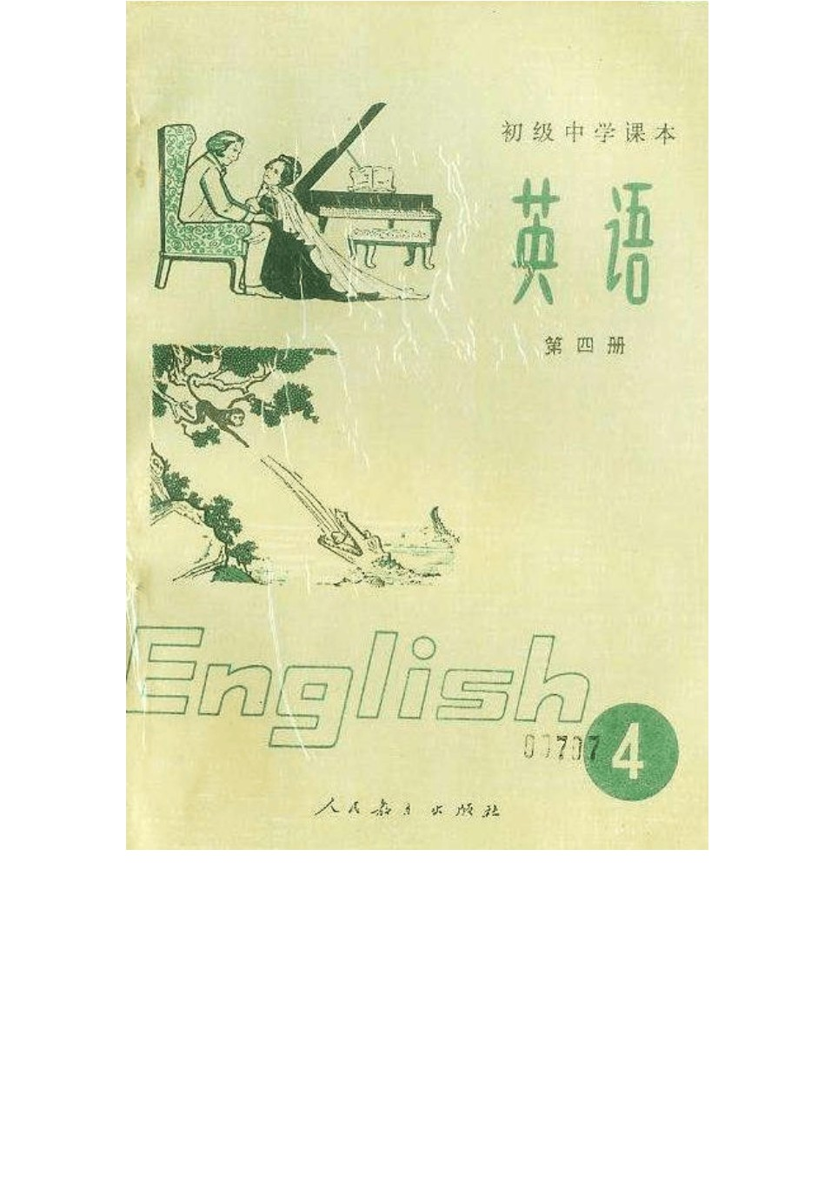

# 初中英语课本第四册

### LESSON 1

**DRILLS** （句型练习）

When shall we visit the Science Museum?Sometime next week.

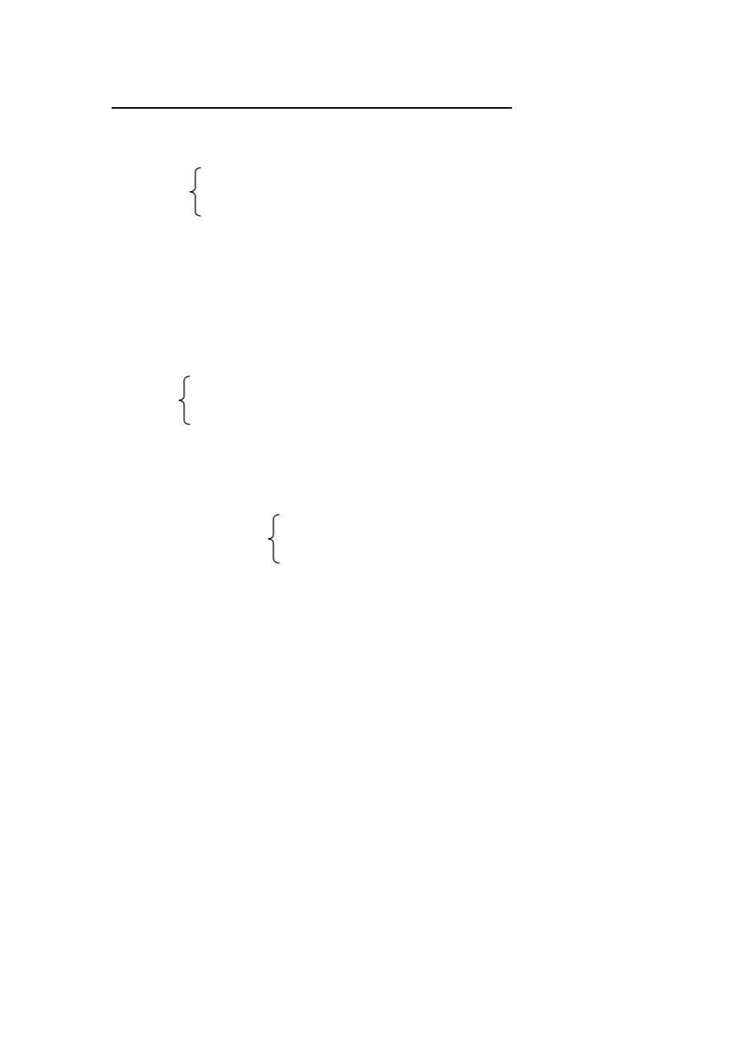

|  |  |  |
| --- | --- | --- |
|  | | **A** |
| A: | Shall I | get some chalk? |
|  |  | change the maps on the wall?  return these books to the library? |

B: Yes, please. (No, thanks. Let Li Ping do it)

B

A: What shall we do in our English class tomorrow? B: We’ll go over the new words.

have a test.

talk about some pictures.

C

A: When shall we have the class meeting?

the English evening?

the talk on the history of the party?

B: Next Wednesday afternoon. A: Where shall we have it?

B: In the meeting-room.

**DIALOGUE** （对话）

LET ME HELP YOU

W --- Woman

L ---- Liu mei

P ---- Policeman H ----Husband

(At a street corner.)

W (Looking very worried): Oh, dear! What shall I do?

(Liu Mei is on her way to see a film, but she stops.)

L: What ?s the matter, Granny? Can I help you?

W: I?m here to see my husband. He?s in hospital. He wrote the name of the hospital in his letter, but I can?t find the letter now. what shall I do?

L: It ?s not in any of your pockets? W: No.

L: Maybe you put it in your basket.

**W** (looking in her basket)**: Ah, yes, here it is!**(She shows it to Liu Mei.)

L: Yes, this is it.

W: How can I get there? I don?t know the way.

**L: I don ?t, either, Granny. I?ll ask the policeman.** (Runs to the policeman at the corner.)

L: Excuse me, which is the way to the East Street Hospital?

P: Go down this street, then turn right at the second crossing. At the end of the road you?ll find the hospital. It?s about half an hour?s walk. But you can get there by bus.

L: Which bus shall I take?

P: The No.3 bus over there. It?ll take you right there.

**L: Thank you.** (Runs back to the old woman.) **Granny, the hospital is a bit far from here. Shall we go by bus?**

W: All right.

(Twenty minutes later the old woman finds her husband. How happy they are to see each other!)

H: But how did you get here? W: This little girl brought me.

H: Which girl?

(They look around but Liu Mei is already gone)

W: What a good girl!

(Liu Mei is very late for the film, but she doesn’t mind.)

**GRAMMAR** （语法）

冠词 ( The Article)

冠词是一种虚词， 放在名词的前面， 帮助说明名词的含义。 冠词分不定冠词

（ The Indefinite Article ）和定冠词（The Definite Article ）两种。a(an)是不定冠词， a 用在辅音之前，如 a book, a man; an 用在元音之前，如 an old woman, an hour 等。 the 是定冠词。

1、不定冠词的用法

1) 指人或事物的某一种类。这是不定冠词 a (an) 的基本用法 。如：

I am **a** boy.

Pass me**an** apple, please.

2) 指某人或某物，但不具体说明何人或何物。如：

**A** boy is waiting for you.

He borrowed **a** story-book from the library.

3) 表示数量，有“一”的意思，但数的概念没有 one强烈。如： I have **a** mouth, **a** nose and two eyes.

4) 用于某些固定词组中。 如： **a** bit, **a** few, **a** little, **a** lot of, **a** piece of, **a** cup of,

**a** glass of,**a** pile of 等。

2、定冠词的用法

1) 特指某些人或某些事物。这是定冠词 the 的基本用法 。如：

Beijing is **the** capital of China.

**The** book on the desk is mine（. the desk 所限定。）



特指桌上的那本书。 注意名词 book 被短语 on

2) 指谈话双方都知道的人或事物。如：

Where is **the** teacher? （双方都知道指的是哪一位教师。 ）

Open**the** window, please. （双方都知道指的是哪一扇窗。 ）

3) 指上文提过的人或事物。如：

There was a chair by the window. On **the** chair sat a young woman with a baby in her arms.**The** baby was thin.

4) 用在世界上独一无二的事物前。如：

**The** earth is bigger than**the** moon, but smaller than**the** sun.

5) 用在序数词和形容词的最高级前。如：

Mr Green taught **the** first class. Alice is **the** tallest in her class.

1. 用在某些专有名词前。如： **the** Great Wall, **the** Summer Palace,**the** History

Museum, **the** Science Museum, **the** Capital Stadium, **the** Children ’s Palace,

**the** East Street Hospital,**the** Party 等。

1. 用在一些习惯用语中。如： in **the** day, in **the** morning (afternoon, evening), **the** day after tomorrow, **the** day before yesterday,**the** next morning, by **the** way 等。

3、下列情况中一般不用冠词

1. 在专有名词和不可数名词前。如： China, Grade Two, Class Three, science, chalk, ink, paper, water, tea, milk等。
2. 名词前已有做定语的 this, that, my, your, some, any等代词。如： The letter is in **her basket.**

Go down **this street**.

3) 复数名词表示一类人或事物时。如：

My father and mother are**teachers**. She likes reading**stories**.

4) 在节日、日期、月份、季节前。如：

Today is**New Year?s Day.**



It is **Sunday** (**Monday, Tuesday**, etc)

**March** 8 is **Women?s Day**. It is cold in **winter.**

5) 在称呼语或表示头衔的名词前。如：

What’s the matter,**Granny**? This is **Comrade Wang.**

6) 在某些习惯用语中的名词前。 如：at moon, at night, at first, at last, by bus, in bed, in time, in front of, go to school, go to bed等。

7) 在三餐饭和球类运动名称前。如：

He goes to school after**breakfast.** We are going to play**football.**

### LESSON 2

**DRILLS** （句型练习）

What were your parents doing at eight last night? Mum was sewing. And Dad was reading.

A

A: Were you at home yesterday evening? B: Yes. I was doing some cooking.

doing some washing. learning English on the radio.

Were you doing the same thing at that time? A: No, I wasn’t. I was doing my homework.

B

A: What were you doing this time yesterday? were Tom and Peter



was Jenny

B: We were copying the new text.

They were She was

**TEXT** （课文）

THE MONKEY AND THE CROCODILE

One day a little monkey was playing in a tall tree by the river. A crocodile was swimming slowly near the bank with her baby. She looked around for some food. Suddenlyshe saw the monkey. “Aha, there?s my meal,”she thought. She then turned to her son,“Do you love me, Son”?

“Why, of course, Mum!”the baby crocodile said.

“Well then, you catch that monkey and give me his heart to e”at.

“But how can I? ”the baby crocodile asked. “Monkeys can?t swim, and I can?t climb trees”.

“You needn?t climb the tree,”his mother said. “Use your head, then you?ll find a way.”

The baby crocodilethought hard. The he had an idea. He swam near the tree and shouted,“Hey, Monkey! Would you like some bananas”?

“Bananas! Mm! I love them,”said the monkey.“But where are they?”

“On the other side of the river. There are some banana trees there, and they have lots of bananas on themI?. ll take you there on my back”.

“Good,”the monkey came down and jumped onto the crocod?isleback.

(To be continued)

**GRAMMAR** （语法）



疑问句 ( **The Interrogative Sentence**)

英语的疑问句有四种： 一般疑问句、特殊疑问句、选择疑问句和反意疑问句。

1、一般疑问句 (The General Question)

用 yes或 no 回到的疑问句，叫做一般疑问句。这种疑问句通常是把动词 be 或 have，助动词或情态动词放在主语之前，说时用升调。如：

Is she a worker? Have you any paper?

Does he study English?

2、特殊疑问句 (The Special Question)

用 what，who，which 等疑问代词和 when， where，why ，how 等疑问副 词引起的疑问句，叫做特殊疑问句。这种疑问句不能用 yes或 no 回答，说时 用降低。如：

What’s this?

Who’s the boy over there? When do you get up?

3、选择疑问句 (The Alternative Question)

提出两种或两种以上的情况，要求对方选择一种，这种疑问句叫做选择 疑问句。它的结构是“一般疑问句 + or + 一般疑问句”，但常把后面一部分里 面和前一部分相同的成分省略。 说时 or 前面部分用升调， 后面部分用降调。 如：

Is her brother a doctor or a teacher?

Do you want a newspaper or a magazine? Shall we have a meeting this week or next? 4、反意疑问句 (The Disjunctive Question)

在陈述句之后附上一个简短问句，对陈述句所叙述的事实提出相反的疑 问，这种疑问句叫做反意疑问句。 如前一部分为肯定式， 后一部分用否定式。 反之，如前一部分为否定式，后一部分就用肯定式。说时，反意疑问句的前

一部分用降调， 后一部分， 在表示疑问时用升调， 在表示强调时用降调。 如：

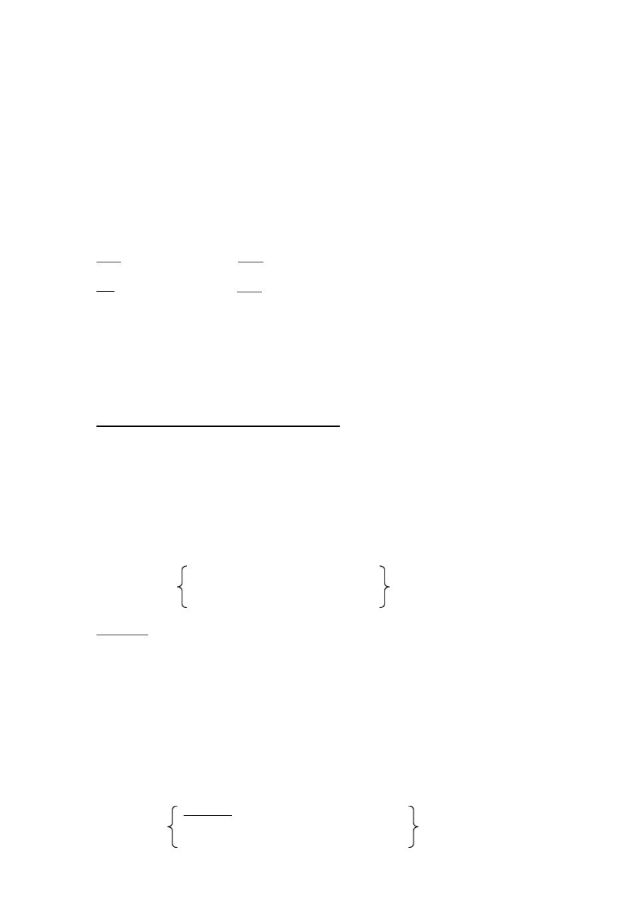

He’s a teacher, ↗ isn’t he? 他是教师，是不是？

She’s a nurse, ↘ isn’t she? 她是护士，不是吗？ 对反意疑问句的回答，不管问题的提法如何，若事实是肯定的，就要用

yes，事实是否定的，就要用 no。这和汉语不一样，应特别注意。如： He isn’t a worker, is he? 他不是工人，是吗？

Yes, he is. 不，他是工人。

No, he isn’t. 对，他不是工人。

### LESSON 3

**DRILLS** （句型练习）

I was cooking when she knocked at the door.

A

A: You saw the boys in the classroom just now, did’nt you? B: Yes, I did.

A: What were they doing?

B: They were doing maths exercises when I left. drawing a map of the world

putting up some pictures on the wall

B

A: Did you see your teacher in the office? B: Yes, I did.

A: Was she having a meeting? B: No, she wasn’t.

She was talking to some parents when I saw her.

going over our exercises



preparing the new lesson with other teachers

**TEXT** （课文）

THE MONKEY AND THE CROCODILE

(Continued)

Soon they were in the middle of the river. Suddenly the crocodile went down under the water. When he came up again, the monkey was all wet. “ Don?dt o that! ”the monkey cried.“Don?t do that again! I can?t swim, you know”.

“Iknow, but I have to, ”answered the crocodile.“My mother wants to eat your heart.”

The little monkey was clever“. Why didn ?t you tell me earlier?”he asked.

“My heart isn?t here with me. I left it in that tree over there”.

“Then we?ll have to go back for it. Mother doesn ?t want you without your heart.”The crocodile turned and swam back to the bank.

Soon they reached the bank. The monkey jumped off the crocodile at once, picked up a big stone and quickly climbed up the tree. The crocodile waited and waited. As he was waiting, he suddenly heard a voice from above:

“Hey, Crocodile!”

The crocodile looked up. The monkey was hanging from the tree by his tail and laughing.

“Here?s my heart. Come up and get it. Don ?t keep your mother waiting You can?t come up? Well, catch”!

With these words, he threw the big stone at the crocodile.

**GRAMMAR** （语法）

过去进行时 (The Past Continuous Tense)

1、过去进行时由“ was (were) + 现在分词”构成。

2、过去进行时的用法：表示在过去某一时刻或某一段时间正在进行的动作。这

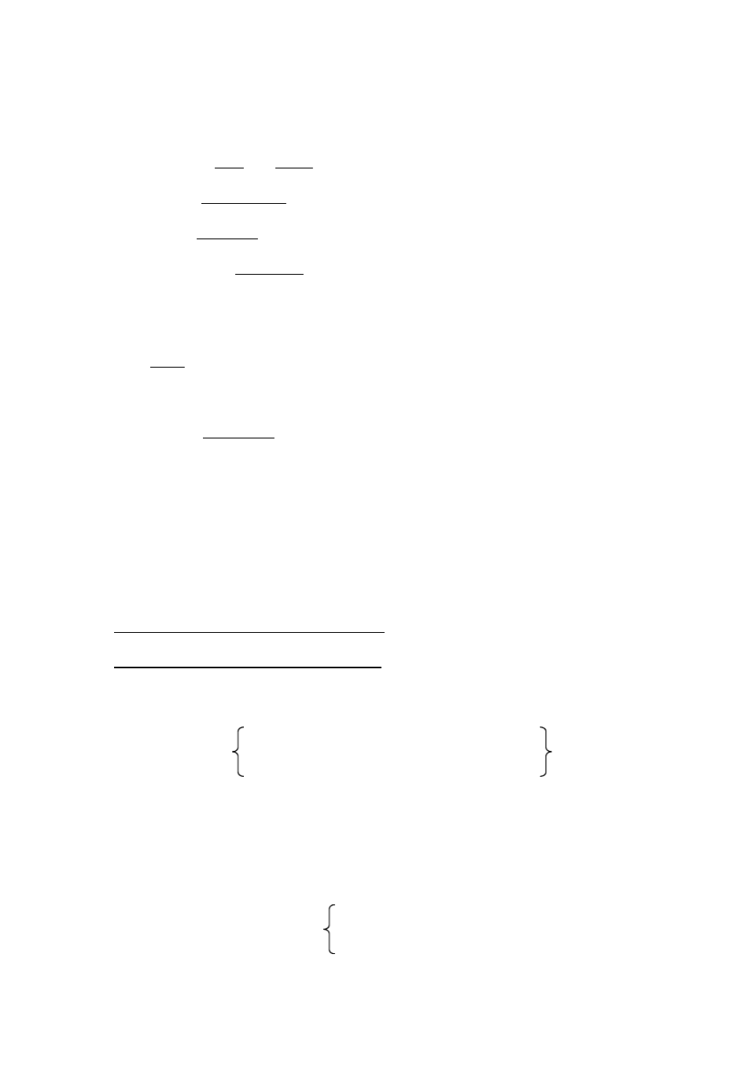

一特定的过去时间，除有上下文暗示以外，一般用时间状语来表示。如：

1）A: What were you doing **this time yesterda**?**y**

B: We were cleaning the classroom.

2）Mum was doing some washing**yesterday evenin**.**g**

3）The teacher was talking to some parent**w**s **hen I saw her**.

3、一般过去时与过去进行时用法比较：一般过去时表示在过去某个时间发生的 动作或存在的状态， 而过去进行时则表示过去某个时间正在进行的动作。 如：

Mary wrote a letter to her friend **last night.** 玛丽昨晚给她的朋友写了封信。 （信写完了） Mary was writing a letter to her friend **last night.** 玛丽昨晚一直在给她的朋友写信。 （信不一定写完）

### LESSON 4

**DRILLS** （句型练习）

When did you go go the Childre’sn Palace? I went there after I finished my homework.

A

A: Was it raining when you came to school yesterday? when school was over

when you took your grandmother to the hospital

B: Yes, it was. It was raining hard. （No, it wasn’t. But the ground was quite we）t

B

A: Where did your brother study before he became an artist?

before he went to college?

before he joined the army?



B: He studied at the No. 2 Middle School.

C

A: When did you go to bed last night?

B: I went to bed at about ten after I did my homework.

after I wrote a letter to my grandfather. after the TV play was over

**TEXT** （课文）

IT ?S UNFAIR

Jenny was a good girl, but she had one shortcoming. She was often late for school. One morning when she came in late, Mr Black, her teacher, got angry.

“ Il?l write to your father if you aren ?t here on time tomorrow,”he told her. Jenny didn?t want him to do that because her parents were very strict with her.

The next day she got up very early and went to schoolwithout breakfast.

When the bell rang, she was waiting in her seat. The door opened and the teacher came in. But it wasn?t Mr Black. It was Miss Green. Mr Black was ill, so she was taking his class instead. How disappointed Jenny was!

The next morning Jenny got up even earlier. After a quick breakfast she hurried to school. Just before shegot to schoolgate, she stopped.There was a wallet lying on the ground.

She picked it up.“Whose is this?”she wondered.

As she stood there, she heard the first bell. “What shall I do?”she asked herself. “ Il?l turn it in first, ”she decided. And so she did.

When she hurried into her classroom, Mr Black was already beginning his lesson.

“Jenny White,”he said as soon as he saw her“. Didn?t I tell you to be here on time?”

(To be continued)

**GRAMMAR** （语法）

句子的类型 **(Types of Sentences) 1**、简单句 **(The Simple Sentence)**

由一个主语（或并列主语） 和一个谓语（或并列谓语） 构成的句子叫简单句。

如：

I get up at six in the morning.

My sister and I go to school together.

2、并列句 (The Compound Sentence)

由并列连词 (如 **and, so, but, yet, or**等)把两个或两个以上的简单句连在一起 而构成的句子叫并列句。如：

I help him **and** he helps me.

Mr Black was ill, **so** she was taking his class instead. Zhang Ying likes English, **but** he needs help.

You can draw a good horse in five minutes**y**, **et** you kept me waiting for a year.

**3**、复合句 **(The Complex Sentence)** 由一个主句和一个或一个以上的从句构成的句子叫复合句。例如： I ’ll tell him **as soon as I see him**(**.**状语从句 )

**When the crocodile came up again**t**,**he monkey was all wet. (状语从句 ) I ’ll go to see you **if I have time.** (状语从句 )

I think **you can find him at home.**(宾语从句 )

### LESSON 5

**DRILLS** （句型练习）

Will you go with me to the zoo this afternoon? Yes, I will if the rain stops.

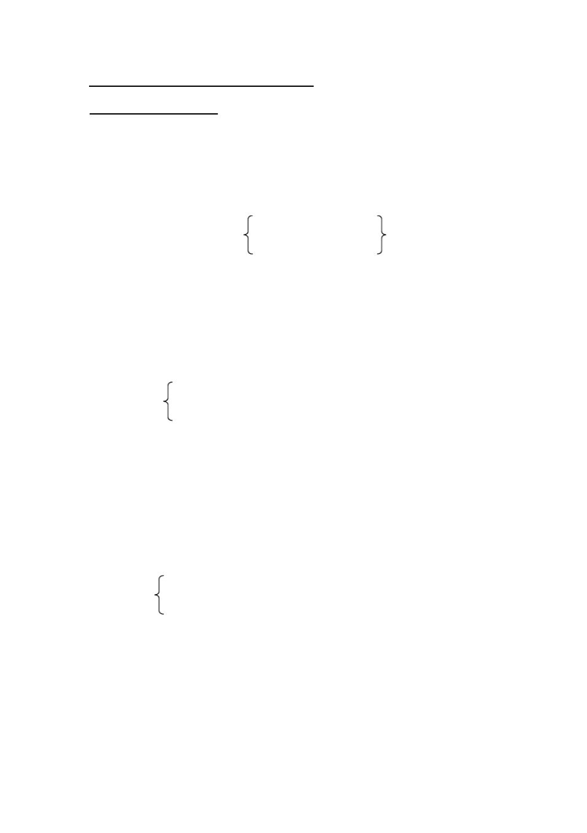

A

A: Will you please give this note to Tom?

B: Certainly. I ’ll give it to him as soon as he comes back.

as soon as I see him.

as soon as school is over. (Sorry, I won’t be able to see him today.)

B

A: Will you go with me to the cinema this afternoon? B: Yes, I will if I ’m fine.

if my mother lets me.

if we don’t have any homework.

C

A: Will the swimming pool be open today? B: No, it won ’t.

A: Why not?

B: Because they’re cleaning the pool.

they’re changing the water. they’re making repairs.

**TEXT** （课文）

IT ?S UNFAIR

(Continued)

“ **Im?**

sorry, sir”,

Jenny tried to explain.“I was late because I had to .”

“Iwill not listen to any excuse”,

Mr Black stopped her. “If you can?t get

here on time,I?ll have to write to your father”.

“But Mr Black, that ?s that?s unfair!”

“Unfair! How dare you say that?”Mr Black said angrily. “I ?ll report you to the headmaster”!

“Iwas only trying to do a good deed,”Jenny thought, “and now . ”She couldn?t keep back her tears.

As soonas the bell rang for the break, the door opened and in came Mr Smith, the headmaster.He was holding a wallet in his hand. “Excuse me, Mr Black,”he said,“but is this wallet yours?”

“Why, yes. It is mine”.

Mr Black was surprised. “Ididn?t know I lost it.”

“One of our girls found it and turned it in just before school started, ”Mr Smith said.

“Oh? Who was it?”Mr Black asked. “Imust thank her”.

“It was Jenny White.”

Mr Black ?s face slowly turned red. He looked at Jenny and said,“ Im? sorry, Jenny. I take back whatI said”.

very

“And I?m sorry, Mr Black. I?ll try not be late again,”Jenny said.

**GRAMMAR** （语法）

状语从句 (The Adverbial Clause)

在复合句中修饰主句中的动词、 形容词或副词等的从句叫做状语从句。 状语 从句根据它表达的意思的不同可分为时间、地点、原因、目的、结果、让步、比 较（或：方式）和条件等类。

1、时间状语从句 由 **when, before, after, as soon as, a**等**s** 连词引导。

Was it raining **when** you came to school yesterday? Where did your brother study**before**he joined the army?

I went to bed **after** the TV play was over.

I ’ll give the note to him **as soon a**I**s**see him.

**As** the crocodile was waiting, he suddenly heard a voice from above.

2、条件状语从句由 if 等连词引导

I ’ll go with you to the cinema this afternoon **if**I ’m free.

3、原因状语从句由 because等连词引导。

The swimming pool won’t be open today**because**they’re changing the water.

4、比较（或：方式）状语从句 由 than, as as, not as(so) as等引导。 The earth is bigger**than** the moon (is).

This story is **as** interesting **as** that one (is). Betty is **not as** tall **as** Rose (is).

### LESSON 6

**TEXT** （课文）

THE RAILS SING

This story is about a bright boy in a small village in Europe. He worked in a town far away. Every day he went there by train.

In thosedays, trains ran very slowly. Few people liked taking trains. But this boy didn?t mind because he enjoyed listening to the click, click of the rails.

One evening after work, the boy was going home on the train. He sat in his seat quietly. He was listening to the click of the rails. Suddenly there was a break in the singing of the rails.

“Something is wrong”, said the boy to himself. He stood up.“Stop the train!”he cried.

“Something is wrong with that boy”,someone said.

One man shouted at the boy“, Be quiet, boy!What?s the matter with you?”

Another man said,“Don?t be foolish, boy”!



But the boy would not be quiet. “Stop the train! Stop the train! There?s danger ahead!”he cried.

He went to look for the conductor of the train.

“Conductor,”he said when he found the man. “Please listen to the click of the rails. Something is wrong”.

The conductor listened. Then he said“,You?re quite right, boy. We must stop the train.”

The train stopped. The conductor got off and checked the rails.

When he got on the train again, he said to the others, “The boy was right. There?s somethingwrong with one of the rails about thirty metres ahead. He saved our lives”.

This boy later became a musician. Many people like his music. When you listen to one of his pieces,you can hear click, click, click. It soundslike the singing of rails.

### LESSON 8

**DRILLS** （句型练习） **Here, have an apple.**

No, thanks. I?ve just had one.

A

A: When are you going to renew the book?

post the photos? visit the farm?

B: I’ve already renew the book.

post the photos. visited the farm.

B

A: Have you returned the book?

borrowed any English magazines? bought an English-Chinese dictionary?

B: Yes, I have.I ’ve just returned it.

borrowed one. bought one.

C

A: Has Peter seen the doctor?

Has Jenny Have they

B: No, he hasn’t. But he’s going to see him this afternoon.

she hasn’t. she’s

they haven’t. they’re

**DIALOGUE** （对话）

WHAT ?S WRONG WITH TOM?

Tom was very quiet this morning. He said he feel sick. “Oh, ooh! I feel

terrible,”he said. “Mum, I can ?t go to school today”. see the doctor.

**(**At the doctor’s**)**

Mother: Good morning, Doctor.

So his mother took him to

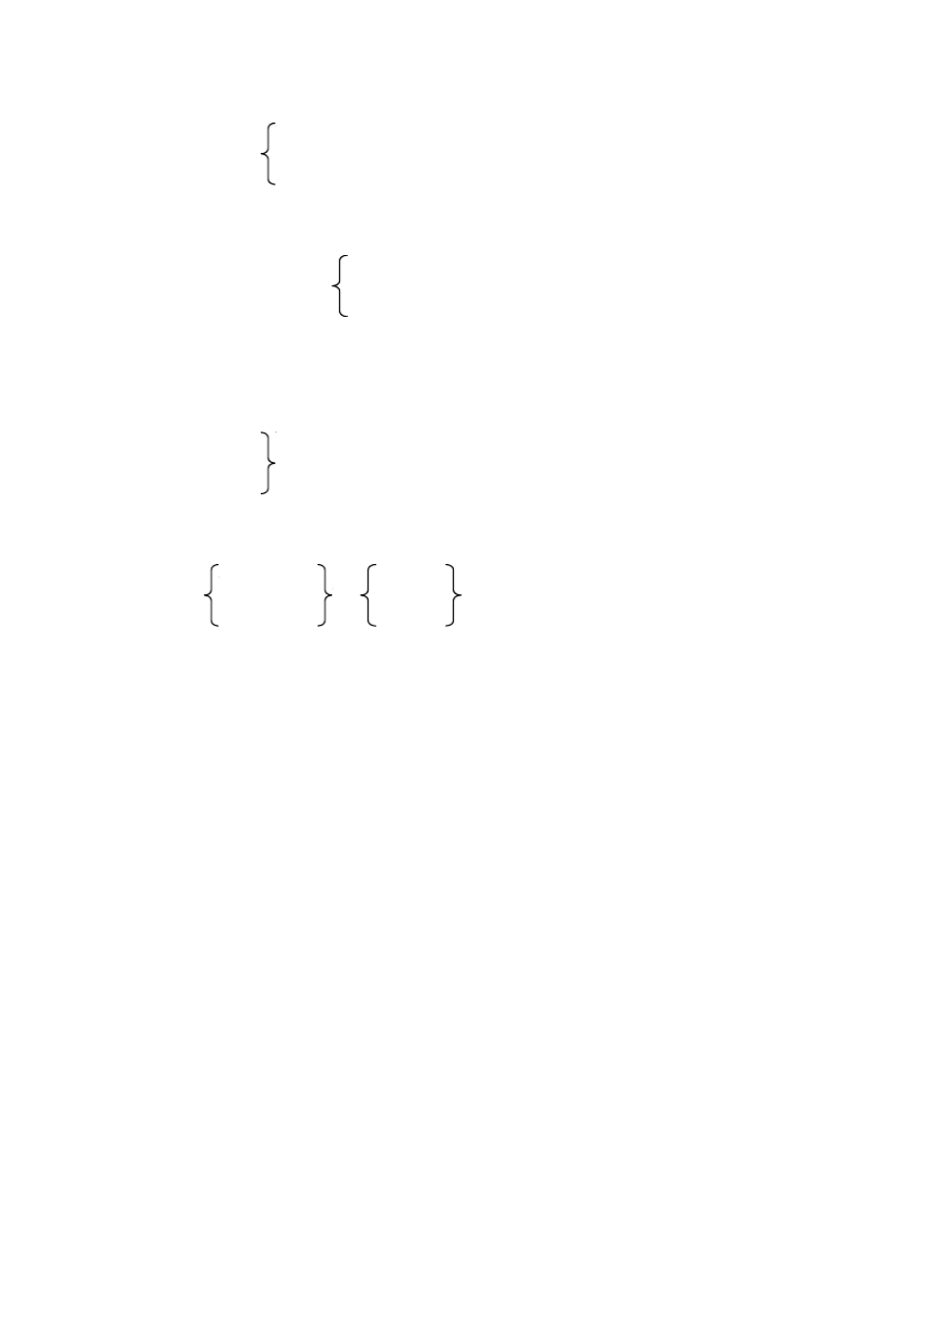

Doctor: Good morning, Mrs Brown. Good morning, Tom. What ?s your trouble, young man?

Tom: I I?ve got a headache and (Begins to cough.) M: Why, Tom, you?re coughing too!

T: Ooh Ifeel terrible!

D: Have you taken his temperature? M: Yes. I have. He hasn?t got a fever.

D: Tom, open your mouth and say“ahh”.

T: Ahh!

**D(**to Tom’s mother**): How long has he been like this? M: Ever since this morning.**

D: Has he had anything to eat?

M: He ?s had some bread, two eggs, a glass of milk and an orange. D: Did you give him any medicine?

M: No. He hasn?t had any medicine.

D: Mmm. How are you feeling now, young man?

T: Very bad, Doctor. In fact, I feel even worse, Ooh! Ooh! I think I?m going to die.

D: Die! You won?t die, Tom. You?ll be all right soon. M: So it?s nothing serious, Doctor?

D: No. Your son will be all right by supper time. Tom?s trouble is very common to boys these days. It comes and goes very quickly.

M: But I don ?t understand, Doctor.

D: This afternoon, the biggest football game of the year will be on TV. If your song feels well enough to watch TV by then, h?lel be fine after the game. You wait and see.

M: Oh, I see! Thank you very much, Doctor. Come along, Tom. D: Goodbye!

### LESSON 9

**DRILLS** （句型练习）

How many photos have you taken?Twelve.

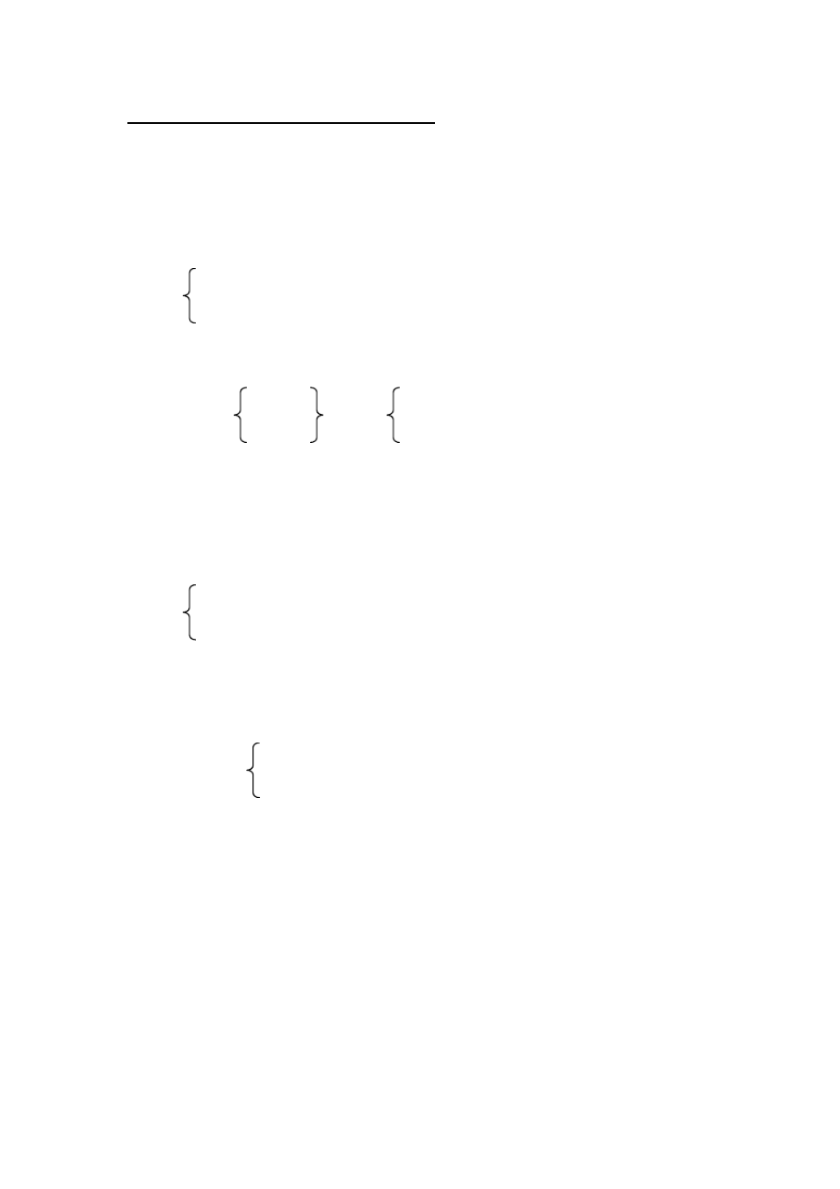

A

A: What are you doing?

B: I’m reading Snow-white and Rose-red. doing my geography exercises. making paper flowers.

A: How many pages have you read?

exercises done?

flowers made?

B: Five.

B

A: Has the plane arrived?

the ship left? the train gone?

B: Yes, it has.

A: When did it arrive?

leave? go?

B: Half an hour ago.

**TEXT** （课文）

I HA VE SUNG ALREADY

Once a rich woman invited Martin Brown, a famous singer, to her house. She wanted him to sing for her friends. But she didn?t invite him to have dinner with them. She told him to eat downstairs with the servants.

The singer was surprised. But he said nothing and went downstairs. After the meal he stood up and said to the servants:

“Now, my good friends, I shall sing for yo”u.

Of course, the servants were quite pleased. He sang them several songs. There was no piano in the room, but he didn?t mind. When they asked for more, he sang more.

At nine o?clock the rich woman asked the singer to come up to the sitting-room. When he came in the guestswere all seated and waiting for the concert.

“We are ready now, Mr Brown,”said the woman,“you may begin”.

“Ready for what?”asked the singer.

“For your songs of cours”e,she answered.

“But I have sung already,”said Mr Brown, “and I can ?t sing twice in one evening”.

“You have sung already”! said the rich woman in surprise.“But when? And where did you sing?”

“Just now, downstairs”.

“Impossible”!

she cried.



“But it ?s quite true, madam,”said the singer.“I sang for the people after I had supper with them, you know”.

And with a polite “Good night”, he left the rich woman?s house.

### LESSON 10

**DRILLS** （句型练习）

How long has Mr Smith taught in Hangzhou?For half a year.

A

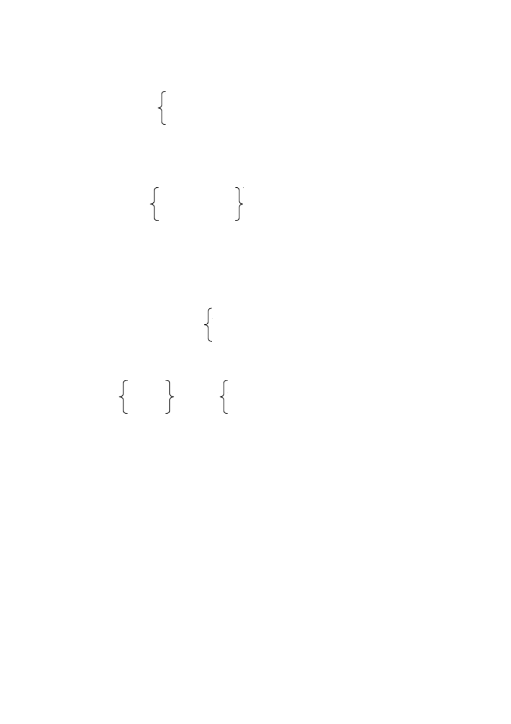

A: When did you get to know Jack?

begin to learn English? come to this school?

B: The year before last.

A: Then you’ve known each other for about two years.

learned English been here

B: That’s right.

B

A: How long has your uncle taught in that village?

lived in that street? worked on that farm?

B: He’s taught there since 1965

lived he came to this city.

worked he left the army.

**TEXT** （课文）

AN AUSTRALIAN BOY IN BEIJING

809 West Chang?an Street Beijing, China

December 21st, 1983

Dear Peter,

I?ve been here in Beijing for half a year now. Beijing is in the north of China, so it?s quite cold in winter. It has just snowed twice here. I?m going to have the first “White Christmas”in my life! It?s hard to believe, isn?t it ---- so warm in

Australia and so cold here?

Thank you for the wonderful stamp! I?ve collected over three hundred Chinese stamps since I came hereI?. m sending some Monkey King stamps to you. I think you will like them.

Now to answer some of your questions. YeIs?m,

learning Chinese. Chinese is



quite a difficult language for me. Last time Mum asked for some quilts in a shop. They showed her some cups. Dad and I had a good laugh over thatI.?ve learned about five hundred Chinese words. I can even write a little Chinese now. Have you looked at the words on the Christmas card? I wrote them myself!

No, I?m not swimming. Instead,I?m learning to skate on real ice!I?ve had so many falls that I?m black and blue all over. ButI?m learning fast.

I?ve traveled to several places in South China with Mum and Dad since we came to China. I?ve seen a lot of interesting things.I?ve made quite a few good friends, too.

I have to finish this letter now. Ask Uncle John and Aunt Alice to bring you, too, when they come in August. W?lel have a good time together then.

Yours, Mike

**GRAMMAR** （语法）

现在完成时 (The Present Perfect Tence)Ⅰ( )

1、现在完成时的构成

助动词 have (has) + 过去分词 (规则动词的过去分词的构成与动词过去式相同。 不规则动词的过去分词

见本书末《不规则动词表》

2、现在完成时的基本概念和用法

1）表示过去发生的某一动作对现在造成的影响或结果，如： I have already posted the photos.

我已经把照片邮寄了。 （“邮寄”是过去发生的动作，对现在造成的结果

是“照片不在我这里” 。）

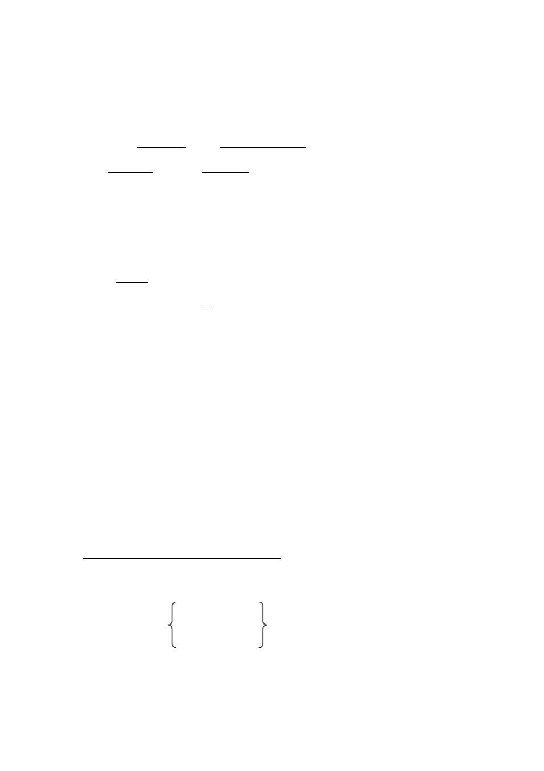

2）表示过去已经开始， 持续到现在的动作或状态， 往往和表示一段时间的状 语连用，如：

He has learnedEnglishfor about two years.

They have lived in Beijing since 1980. 3）和现在完成时连用的时间状语

现在完成时属于现在时态范围，因而不能喝表示过去时间的状语连用，

如 **yesterday**， **last week**，**three years ago**，**in 1960** 等，但可以和 **already**， **never**（从来没有），**ever**， **just**，**yet** 等状语连用，如：

He hasalready done his exercises. I haven’t learned the wordyet.

现在完成时还可以和表示从过去某时刻延续到现在 （包括“现在”在内） 的一段时间的状语连用， 象 **today**，**these days**，**since** ，**for a long time**等。 例如：

Have you seen her these days?

We have lived in that street for a long time. He has taught at this school since 1965.

### LESSON 11

**DRILLS** （句型练习）

Have you ever been to America?No, never.

A

A: Your brother is a solider, isn’t he?

a League member, in Guangzhou,

in England,

B: Yes, he is.



A: how long has he been a solider?

a League member? there?

there?

B: For about two months.

B

A: Have you ever been to the Great Wall?

Xi ’an?

England?

B: No, never. What about you? A: Yes, I have.

B: How many times have you been there? A: Only once.

**TEXT** （课文）

THE PIANO CONCERT

A young woman in a small German town was going to give a piano concert.

Her posters said she was a pupil of Franz Liszt, the great Hungarian pianist.

This was not true.

One day the woman learned that Liszt himself was in town. Now people would find out and she would never be able to give a concert again. What should she do?

Finally she went to see the famous man himself. She told him everything.

Her parents were dead and she was alone. She had to make a living. She decided to give piano lessons to rich children.But who would send their children to an unknown young woman? So she told people Franz Liszt was her teacher.

“I believe you,”Liszt said. “You?ve done wrong, but I can see you are truly

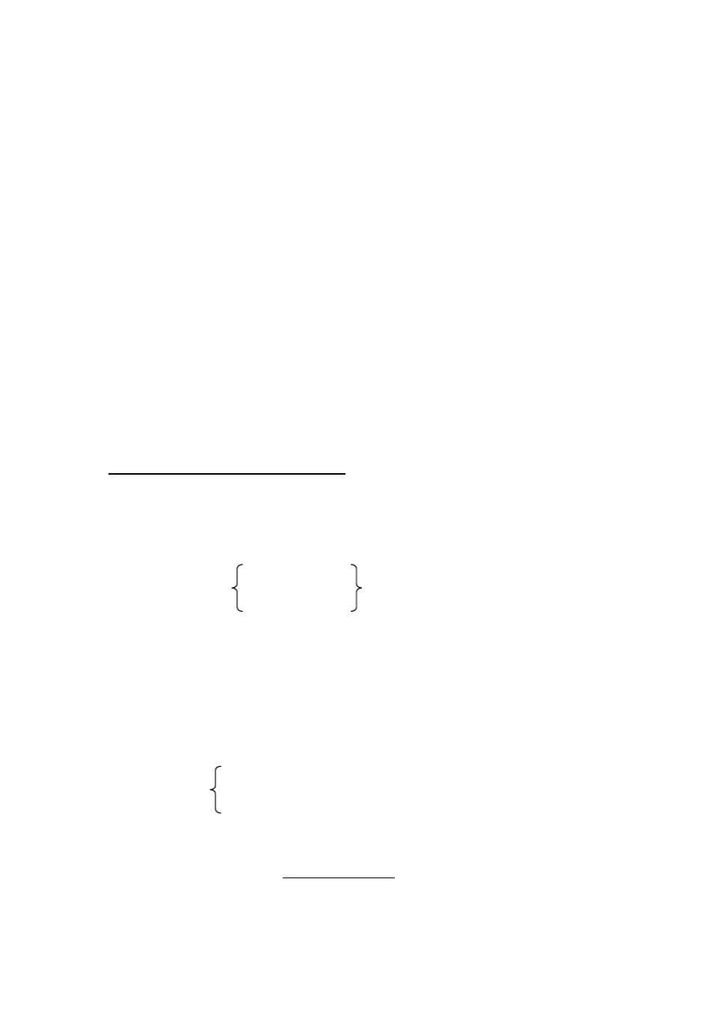

sorry about it. That?s enough. Now let me hear you pla”y.

The young woman was shy at first. But then she saw Liszt smiling. It made her feel better. Now she wans?t afraid any more. She started playing. She put her heart into it and she played wonderfully. Liszt was quite pleased.

When she finished, she turned to look at Liszt. There was a smile on his face. She could see he was pleased. Then Liszt gave her some advice. After he finished, he said,“Now you really are my pupil. Go ahead with your concert. And you can

add a note to the posters. Say that your teacher himself will be there. He will play the last piece”.

### LESSON 12

**DRILLS** （句型练习）

Where?s Mum?She?s gone to the bank.

A

A: Where have you been?

B: I’ve just been to the library. Did anybody ask for me?

the League office. the reading-room.

A: Yes, Li Ping did. He wanted his book back.

B

A: Where’s Wei Fang?

B: She’s gone to the shop.

the post office. the playground.

A: Please tell her to come to the teache’rsoffice as soon as she comes back.

B: All right. I ’ll do that.

**TEXT** （课文）

THE UNIVERSE AND MAN-MADE SATELLITES

When we talk about the universe, we mean not only the earth, the sun, the moon and the stars, but also all the things too far away to see.

In the past fifty years or so, scientists have been able to “see”farther and farther into the sky. They have found many “new”stars. Those stars are not really new. They have been there millions of years.

Of all the stars the sun is the nearest to the earth. Millions of other stars are even bigger and brighter than the sun. they look small only becausethey are much farther away. You can?t see them in the daytime. But if you go out at night, you?ll be able to see thousands of them.

The earth is one of the sun?s planets, and the moon is our satellite. It is our nearest neighbour in space, and men have visited it already. No man has traveled farther than the moon, but spaceshipswithout people have reached other planets.

Many countries have sent up man-made satellites to circle the earth. With their help, people have done much research in many fields of science.

Our country sometimesuses man-made satellitesto send and receive TV programmes. This has helped the people of China and other countries to understand each other better.

**GRAMMAR** （语法）

现在完成时 (The Present Perfect Tence)Ⅱ( )

4）现在完成时和一般过去时的区别：

现在完成时表示过去发生的某一动作对现在造成的影响或结果，强调的 是现在的情况， 所以它不能和表示过去时间的状语连用。 而一般过去时只单 纯表示过去的动作或状态，和现在不发生关系，它可以和表示过去时间的状 语连用。如：

I have seen the film.

我看过这个电影。（我了解这个电影的内容）

I saw the film last week.

我上星期看了这个电影。（只说明上星期看了这个电影， 不涉及现在的情

况）

He has lived here since 1972.

1972 年以来他一直住在这里。 （他现在还在这里住。 ）

He lived here in 1972.

1972 年他住在这里。（不涉及他现在是否还住在这里。 ）

5）“have (has) been”和 “have (has) gone”的区别

表示“曾到过某地”要用“ have (has) bee”n，不能用“ have (has) gone”。 比较下面的句子：

Where has he been?

他刚才到哪儿去了？（他已回来。 ）

Where has he gone?

他上哪儿去了？（他现在不在这里。 ）

She has been to Shanghai.

她到过上海。（她现在已不在上海了。 ）

She has gone to Shanghai.

她到上海去了。（她可能在去上海的路上，或者已到上海，总之，现在不 在这里。）

### LESSON 13

**TEXT** （课文）

MISS EV ANS

Have you ever heard the story about Miss Evans? It is a true story. Maybe many people have read about it.

One afternoon in April 1912, a new ship set off from England to America on its first trip. It was one of the largest and finest ships at that time and on it were over 2,200 people.

It was cold, but the trip was pleasant and people were enjoying themselves.

The next day was even colder. People could see icebergs here and there.

It was night. Suddenly the man on watch shouted, “Look out! Iceberg!

Iceberg ahead!”

It was too late. The ship hit the iceberg and came to a stop. There was a very big hole in the ship and water began to come inside. Slowly the ship started to go down.

People had to leave the ship. Women and children were the first to get into the lifeboats. Suddenly a woman shouted, “Please make room for me. My children are in that boat. I must go with them! Please”!

“There?s no more room here,”someone shouted back.The children heard their mother and began to cry.

A young woman was sitting near the poor children. She stood up. “Here,” she shouted“. Take my place!I?m not married and I have no children”.

She got out and the thankful mother joined her children in the lifeboat.

Soon after that, the ship went down. More than 1,500 people lost their lives.

Among those was the young woman.

Who was she? Her name was Miss Evans and she was going home to Boston.

But nobody knew more about her than that.

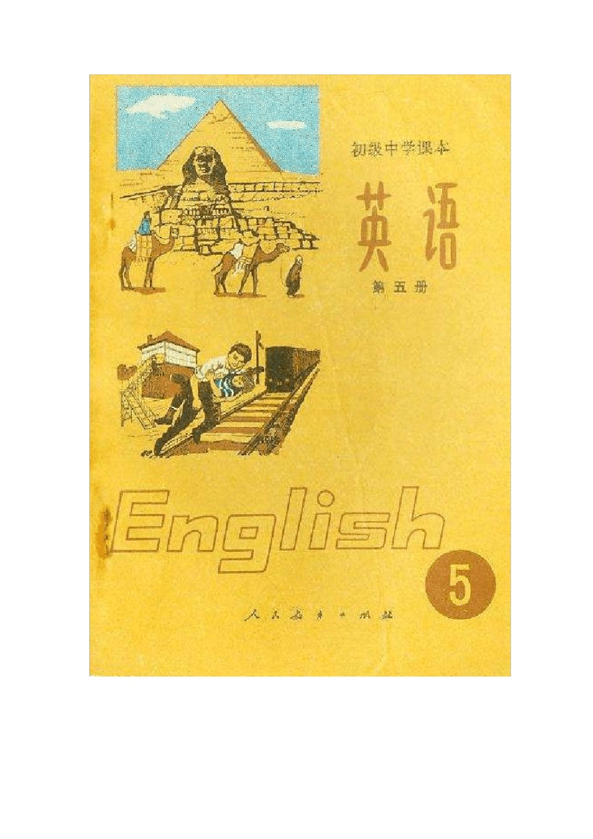

# 初中英语课本第五册

### LESSON 1

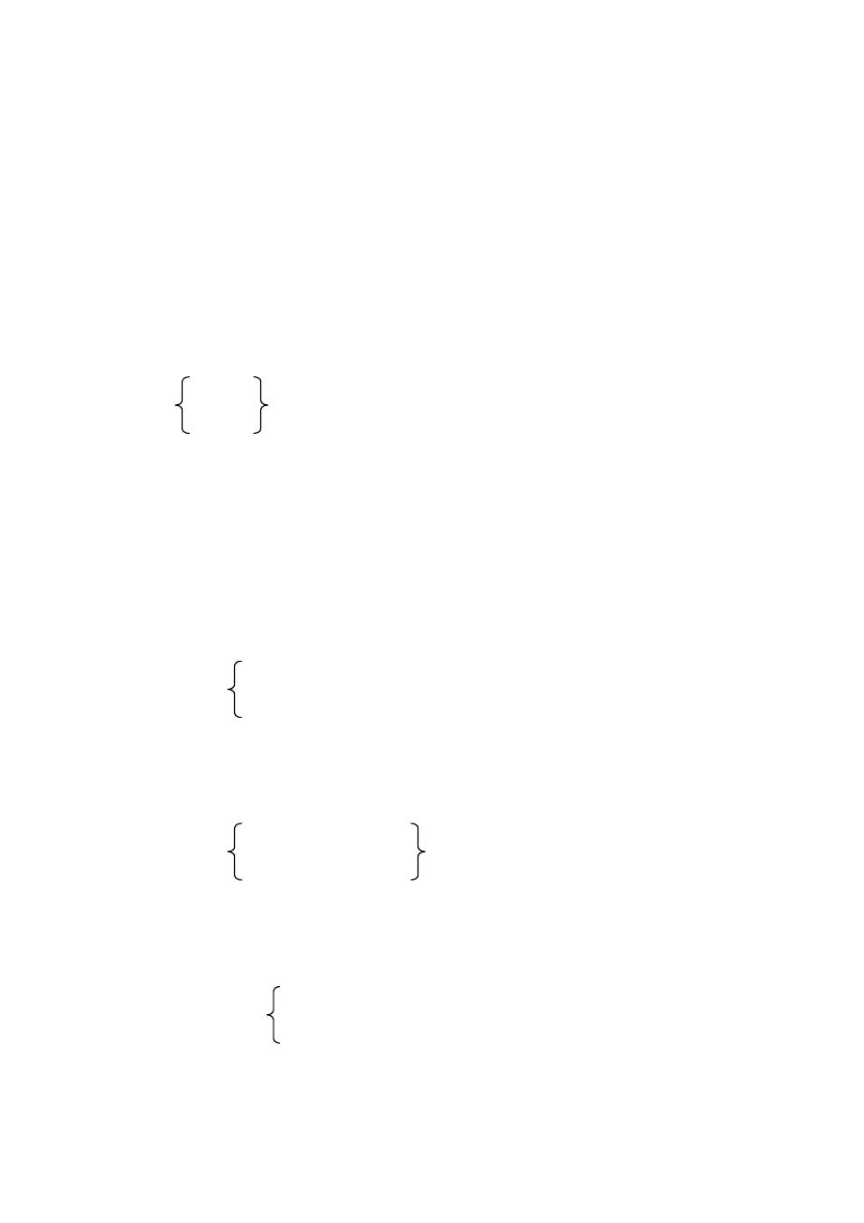

**DRILLS** （句型练习）

1

A: Where’s Mr Evans?

B: He’s gone to Washington.

A: When will he be back, do you know? B: I hear he’ll be back in a month.

think believe

2

A: Have you heard from Joan recently? B: Yes. She wrote to me only yesterday. A: What did she say?

B: She said she was much better than before.

she hoped to be back soon. she missed us very much.

3

A: They’re waiting for somebody, aren’t they? looking for something,

talking about a film B: Yes, they are.

A: Do you know who (whom) they’re waiting for?

what they’re looking for?

which film they ’re talking about?

B: Sorry, I don’t.

**TEXT** （课文）

WHY THE BAT COMES OUT ONLY AT NIGHT

Long, long ago, there was a war between the birds and the beasts. No one knows what they fought about.

The bat did not know whose side he should take. He thought and thought, then decided he must try to be on the side of the winners.

So he watched from far away. After a while, it seemed that the birds were going to win. He flew over to join them.

“What on earth are you doing here?”a bird shouted at him.

“Can?t you seeI?m a bird?”the bat said with a smile. “Look, I have wings, just like you.”

“Come along, then”,

said the bird.“Don?t hide behind others”.

But things changed soon. Now it seemedthat the beastswere winning. So the bat left the birds in a hurry and went over to the beasts.

“What are you doing on our side?”an animal called out to him. “Are you spying on us?”

“Don?t you knowI?m one of you?”asked the bat, showing his teeth.“Look.

Can?t you seeI?ve got teeth, too?”

“Who are you trying to fool?”said the animals.“We saw you fighting on the side of the birds just now”.

So the beasts drove him off. Of course the birds refused to take him back.

When the beasts and the birds saw neither side could win, they decided to stop fighting.

Neither beasts nor birds would have the bat as their friend, so he was afraid to leave his home. Ever since then, he comes out only at night.

### LESSON 2



**DRILLS** （句型练习）

1

A: What did the teacher ask?

B: He asked who could answer the question.

whose handwriting was the best. which exercise was the most difficult.

2

A: Excuse me, can you tell me where the No.3 bus stop is?

when the train will arrive? why the train is late?

B: Certainly. It ’s on the other side of the street.

It’ll arrive in half an hour. They’re repairing a bridge. A: Thank you.

B: That’s all right.

3

A: May we ask you some questions now, Mr White? B: Yes, please.

A: Could you tell us if (whether) it snows in winter in australia?

there’s plenty of rain in your country? you grow cotton in your country?

B: Yes, I ’m coming to that.

**TEXT** （课文）

NATHAN HALE

The young American stood quietly while the British guards searchedhis clothes. They found nothing. “If they don?t find the maps in my boot,” he thought, “maybe they will let me go. Then I?ll try to send the maps to General Washington.”

“Take off your boots”,

one of the guards ordered. The America?ns heart beat

faster. He took off his boots and handed them to the guard. The guard looked inside one boot, then the other.

“Use your knife, man”!

ordered the British officer nearby.

The guard brought out his knife and cut one boot open. He stopped suddenly and the American knew what it meant. The maps of the British army?s defence works!

The guards took the American to General Howe. The general looked at the maps. “I see you?ve made some drawings of our defence works”, he said. “This can only mean one thing”.

“Yes, sir”.

“Do you have anything to say for yoursel”f?

“No, nothing.” “What ?s your name?” “Nathan Hale.” “Rank?” “Captain.”

The general studied the maps a few more minutes.“Captain Hale, ”he said finally. “ Iv?e never seen such fine drawings. You know, we could use a man like you. Why not join us? You won?t have to worry about rank or pay”.

Nathan Hale looked straight at the general. “Nothing could make me turn against my country”!

“Then there?s only one thing I can do, you understand”?

“Yes, sir”.

“You will be hanged as a spy early tomorrow mornin”g.

* * *

Nathan Hale looked around as a British soldier put the rope around his neck.

“Now, Nathan Hale,”said the British officer. “Let?s hear what you have to say before you die”.

Nathan Hale took a last look at his beautiful country and said“, that I have but one life to lose for my country”.

Ionly regret

**GRAMMAR** （语法）

宾语从句 **(The Object Clause)**

宾语从句在复合句中作主句的宾语。宾语从句通常由下面一些词引导：

1、由连词 **that** 引导（ **that** 在口语或非正式文体中常常省略 ）

1）I hear (that) physics isn’t easy. 2）He said (that) he felt sick.

3）I think ( that) you will like the stamps.

4）She told people (that) Rranz Liszt was her teacher. 5）Can’t you see (that)I ’m a bird?

2、有连接代词或连接副词引导（ 这种宾语从句中的主、谓语次序不颠倒 ）

1. I take backwhat I said.
2. Do you knowwhich film they’re talking about?
3. I can’t tell who is there.
4. Do you know who (whom) they are waiting for?
5. He askedwhose dictionary this was.
6. Can you tell mehow I can get to the Summer Palac?e
7. Do you know how many pictures they’ve drawn?



1. Please tell mewhen we’ll have the meeting.
2. I don’t know why he hasn’t come ye.t
3. Can you tell mewhere he is?

3、有连词 **whether** 或 **if** 引导（ 口语中常用 **if**）

1. I want to know whether (if) he lives there.
2. He asked mewhether (if) I could help him.

### LESSON 3

**DRILLS** （句型练习）

1

A: Martin called you a moment ago. B: Did he? What did he say?

A: He asked if (whether) Mr Howe had come back.

you had met Mr Howe at the railway station. you had written to Peter.

your parents had bought a pair of boots for you.

2

A: You were late for the film yesterday, weren’t you?

B: Yes. The lights had already gone out when I got to the cinema. The newsreel had almost finished

The film had already begun

The film had been on for five minutes

**TEXT** （课文）

A QUESTION OF PRONUNCIATION

This happened in London. It was November and the weather was very wet and cold.

AFrenchman had caught a very bad cold. He coughed day and night. So he decidedto go and get somemedicine for his cough. As he did not know much English, he got out his dictionary and looked up the word “cough”. But the

dictionary did not tell him how to pronounce the word. He thought it over and remembered that he had learned the word“plough”. He remembered that it was pronounced [plau]. So he thought that c-o-u-g-h must be pronounced [kau].

Then he put on his coat and hat and went to a chemist?s shop. When the man in the shop asked him what he what he wanted, the Frenchman said:

“I want something for mycow, please”.

The man in the shop looked at him. Had he heard him correctly?

“I beg your pardon, sir?”he asked.

The Frenchman repeated:“Iwant some medicine for mycow.” “For your cow?”asked the man.“Are you a farmer?”

“A farmer? ”said the Frenchman in surprise. “What makes you think you think I?m a farmer? I come from Paris. I?m not a farmer.”

“Where?s your cow, then”? asked the man in the shop.

“It?s here!”replied the Frenchman. He put his hand on his chest and bean to cough.“Here it is!”he said.“ Iv?e a very badcow here.”

Then the man in the shop understood what the Frenchman meant. He wanted some medicine for his cough.

### LESSON 4

**DRILLS** （句型练习）

1

A: How many English songs had you learned by the end of last term?

stories read

parties had

B: Four.

2

A: How long had Comrade Wu lived in the south before he came here?

studied taught

B: For less than five years.

3

A: Did you give the chemistry book to Wei Fang yesterday?

B: No, I didn ’t, because she had already bought a copy for herself.

borrowed one from the library. gone back to her home town.

**TEXT** （课文）

THE ARAB IN THE DESERT

An Arab was walking alone through the desert when he met two men. The men looked worried. It seemed that they had lost something. The Arab went over to them.

“Have you lost one of your camels”?he asked them.

“**Yes**”**,**

they said.

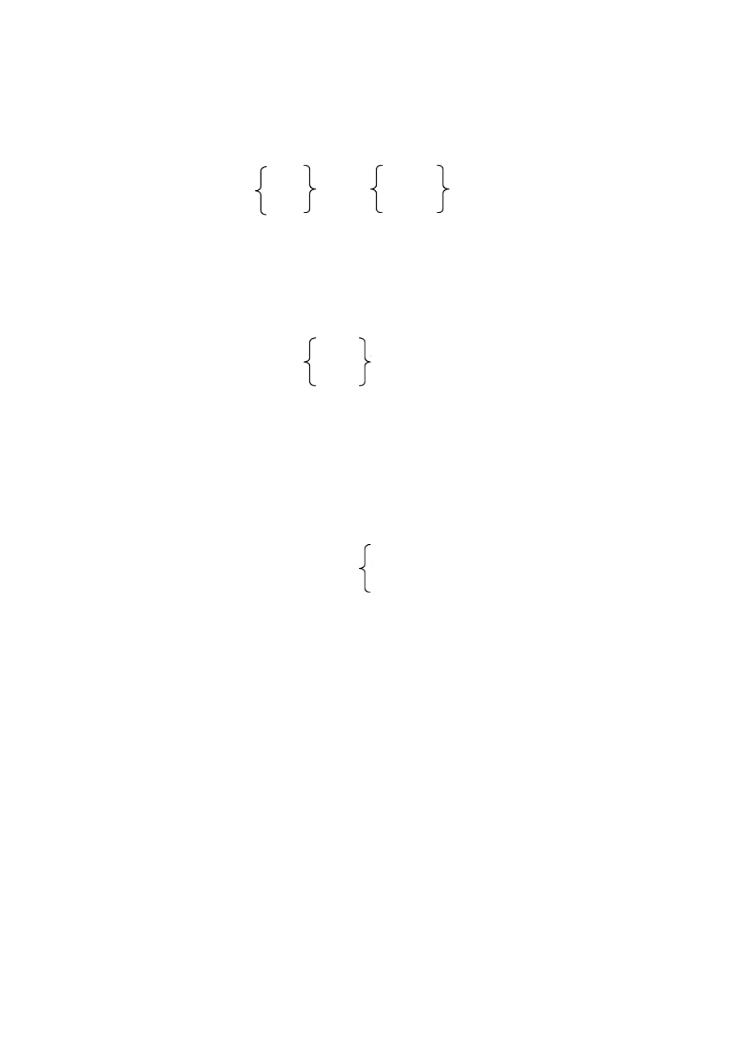

“Was he blind in the right eye and lame in the left foot”?asked the Arab.

“Yes, he was”.

“Had he lost a tooth and was he carrying corn”?

“**Yes**”**,**

said the men.“Please tell us where he i”s.

“I don?t know where he is”,

said the Arab. “I ?ve never seen such an anima”l.

“Did someone tell you about him”?

“**No.**”

The two men looked at each other in surprise. They could not believethe Arab?s words. Finally, they came up close to him, took hold of him, and shouted:

“Where?s the animal? And what have you done with our good”s?

The Arab insistedthat he had never seenthe camel. At last the men took him before a judge. They said that the Arab had stolen their camel.

“ Iv?e never seen their camel,”insisted the Arab. “But I?m a man of the desert, andI?ve learned to look carefully at everything I see. This morning I saw the tracks of a lost camel. I knew this because there were no man?s tracks near those of the camel. I also saw that the camel must be blind in the right eye,

because he had only eaten the grass on his left side and had not touched the grass on his right. The animal was lame becausewith one foot he left a track much lighter than any of the others. He had lost a tooth, because wherever he ate grass, there was always a small space left untouched. I also found groups of ants near the tracks of the camel. They were pulling pieces of corn. From these facts I was

able to tell what goods the animal was carryin”g.

The judge and the two men were satisfiedwith what the Arab had said.

Together the four men set out to look for the lost animal.

**GRAMMAR** （语法）

过去完成时 (The Past Perfect Tense)

1、过去完成时的构成

过去完成时由“助动词 had（通用于各种人称和数） +过去分词”构成。 2、过去完成时的用法

1）过去完成时表示在过去某一时间或动作之前已经发生或完成了的动作。 它 表示动作发生的时间是“过去的过去” 。表示过去某一时间常用以下几种方式：

a、用 **by**，**before** 等构成的短语

How many English films had you seenby the end of last term?

We had reached the stationbefore ten o’clock. b、用 **when**，**before** 等引导的从句

The film had already begunwhen I got to the cinema.

Wang Lin had checked the radiobefore his brother returned.

注：如果时间状语从句的动作发生在主句的动作之前， 则从句用过去完成时， 主 句用一般过去时。

When he**had finished**his work, he **left** his office. After I **had done** my home work, I**went** to bed. c、通过上下文表示

The Arabinsisted that he had never seen the camel.

The students started working in the fields at eight o’clock. The rain had stopped and the sun was shining.

2）过去完成时还可以表示，从过去某一时间开始，持续到过去另一时间的 动作或状态。往往和由 for 或 since引导的、表示一段时间的短语或从句连用。

He had worked in the northfor five years before he moved here.

I saw Li Ping yesterday. We had not seen each othesrince I left Beijing. By the end of last month, my brother had been on that shipfor two years.

注：当一个由 **before**，**after**，**as soon as**等连词引导的从句所表示的动作与主句

的动作前后紧接时， 由于连词本身已经说明两个动作发生的先后关系， 这两 个动作都可用一般过去时来表示。

Where **did** your brother **study**before he joined the army? After heclosed the door, he**left** the house.

As soon asthe bell rang for the break, the door **opened**and in **came** Mr Smith, the headmaster.

### LESSON 5

**TEXT** （课文）

THE SEAGULLS OF SALT LAKE CITY

Salt Lake City is a beautiful city in the west of North America. The name comes from a great salt lake nearby. The city lies in a valley with high mountains all around it. But long ago there was almost nothing in this place and there were very few people living here.

More than a hundred years ago, a group of men, women and children moved from the east to the west. They had traveled a long way. At last these brave people came to the great mountains by the salt lake. They crossedthe mountains and reached this quiet place. They decided to stay here, and so they built their homes and made their farms. This was where Salt Lake City now lies.

The people had to work hard on their farms, because their lives depended on their crops.

One day while they were working in the fields, some farmers saw something strange in the sky.

“What ?s that?”asked one of them. “Where?”asked another, as he stopped to look. “Over there,”was the reply.

They saw something like a cloud coming, but it was too low in the sky. As they watched, it came nearer and nearer. Suddenly a shout went up: “Locusts! Millions of them!”

The words put fear into the hearts of all, becausethey knew what locusts could do, and they had never seen so many of them before.

In no time the locusts came down and started eating everythin–gthe wheat, the corn, the grass and even the leaves on the trees.

The farmers brought out things to fight the locusts. They tried everything. But while they were killing the locustsin one place, millions more arrived in another. What could the farmers do?



Suddenly there was a great noise. As they looked up, they saw another cloud coming towards them. To their surprise, they saw not locusts this time, but seagulls. The farmers cried out“, They?ve come to eat what the locusts have le”ft.

But to their joy, they found that the seagulls had come to eat not the crops, but the locusts.They had seenor smelled the locustsand had come from the Great Salt Lake. Now they were eating the locusts! In a short while they ate up millions of them. The farmers?crops were saved!

The people were very thankful. They decided that from then on no one should ever kill a seagull. And today, if you go to Salt Lake City, you can see a monument with seagulls on top of it.

### LESSON 7

**DRILLS** （句型练习）

1

A: Kate asked me to give you a message. B: What is it?

A: She said she was going to spend her holiday with her parents in Egypt. she wasn’t going to be free this Saturday.

she was going to prepare for her trip.

B: Thanks for telling me.

2

A: Did you ask Kate whether they would fly to Egypt?

what they would do there? when they would return?



B: Yes. She said they would go there by air.

they would visit the pyramids.

they would return before the end of this month.

**TEXT** （课文）

THE PYRAMIDS

Thousands of years ago, the kings of Egypt built strong tombs for themselves.Over thesetombs they built pyramids. They thought their bodies would be well kept in these until they could come back to life. They also hoped the world would look on the pyramids as monuments to them and would remember them for ever.

There are around 80 pyramids in Egypt. But the Great Pyramid is the biggest of all. It is nearly 5,000 years old. It is about 137 metres high today, but it was oncehigher. It is made of 2,300,000 huge stones.Most of them are higher than a man and weigh about two and a half tons each. Some weigh as much as fifteen tons. It took more than 100,000 men twenty years to build the Great Pyramid.

When you look at the pyramids, you can?t help wondering how theEgyptians were able to build them thousands of years ago. How did they cut, carry and lift such huge stones? Each stone fits so well, yet they did?tnhave our modern machines! Scientists have studied the pyramids, but nobody can tell just how the Egyptians built them so long ago.

Inside the pyramids are the rooms for the bodies of the kings and queens. There are lots of wonderful treasures in the pyramids, too. Thieves have broken into some of the pyramids and taken away many of the treasures to foreign countries. They have even stolen the mummies. Today some of the mummies and treasures are on show in museums in different countries. When the kings had the pyramids built for them, they perhaps never thought this would happen.

*** *** *** *** ***

★ 2,300,000读作 two million three hundred thousand。

★can’t help doing 是“忍不住”、“情不自禁”的意思。

★had the pyramids built 这种“ have+名词（或代词） +过去分词”的结构，表示 “请或让人做某事”的意思。如：

I ’ll have my hair cut tomorrow. 我明天要理发（请人给我理发）

We had the machine repaired.我们请人把机器修理了。

**GRAMMAR** （语法）

过去将来时 (The Future-in-the-Past Tense)

1、过去将来时的构成

过去将来时由“助动词 would + 动词原形”构成。 would 常简缩为 ’d， 如 I ’d， you’d，he’d 等； would not 常简缩为 wouldn’t。

2、过去将来时的用法

过去将来时表示从过去某一时间看来将要发生的动作或存在的状态。过 去将来时常用在宾语从句中。

Betty said she**would visit** her uncle next Saturday.

Liu Ying asked me who **would give**the talk.

He told us where we**would have** the table tennis match. He said there**would be** a concert that evening.

I was sure (that) they**would do** that.

过去将来时也可以用“ was (were) going to + 动词原形”来表示。例如：

Betty said she**was going to visit**her uncle next Saturday. He said **there was going to be**a concert that evening.

I was sure (that) they**were going to do**that.



### LESSON 8

**DRILLS** （句型练习）

1

1. Mr Smith said, “John**is** a good worker”.

Mr Smith said that john **was**a good worker.

1. John said,“**I want** to forget the past”.

John said that**he wanted**to forget the past.

1. John said,“**I can** get on well with the people **here**.”

John said that**he could**get on well with the people **there**.

2

1. Mr Smith said, “John **told me**all about his past three weeks**ago**.”

Mr Smith said that John**had told him**all about his past three weeks**before**.



1. Bob’s wife said, “Bob, you **forgot your**wallet **this** morning.” Bob’s wife told him that he **had forgotten his**wallet **that** morning.

3

1. John said to Bob,“**I haven**’**t seen you**r wallet.” John told Bob that **he hadn**’**t seen his**wallet.
2. Mr Smith said to the workers, “John **has worked**very hard and **I want** him to stay.”

Mr Smith told the workers that John **had worked**very hard and that**he wanted**him to stay.

**TEXT** （课文）

ONCE A THIEF, ALWAYS A THIEF?

Mr Smith, the bossof a small factory, once hired a young worker called John Hill. On the first day, Mr Smith took John to one of his workshopsand introduced him to the other workers. The men introduced themselvesto John and showed him around the factory. Then John started to work.

John was good at his job. Soon he got a rise. And he got on well with his workmates. He hoped they would like him.

But one morning John noticed that his workmates were looking at him and talking in low voices. Then Bob, one of his workmates, came up to him and asked whether it was true that he had been a thief and had just come out of prison.

John?s heart sank. He had been afraid of this all along. He told them that he had been in prison, but he was no longer a thief and wanted to forget the past.

The workers went to Mr Smith and asked him to fire John. Mr Smith explained to them that John had told him all about his past when he asked for a job in his factory. That showed John was honest. Since a lot of people make mistakes in life, Mr Smith wanted to give John a chance. The workers went back and John stayed. But after that they were not as friendly to him as before.

One afternoon about a week later, Bob could not find his wallet. He went to

John and asked whether he had seen his wallet. But John said he knew nothing about it. When Bob tried to catch hold of his arm, John hit him in the face. Bob fell to the ground and blood ran down his nose.



Mr Smith came out to see what was happening. The workers again asked him to let John go. They said they would all leave if John stayed. Mr Smith knew what that would mean. So he had to give in and say sorry to John.

Just at that moment, in came a woman. It was Bob ?s wife. She called out, “Bob, you forgot your wallet when you left home this morning. I thought you would need it, so I brought it over to you”.

Everyone looked at Bob.

“John, I I?m sorry,”said Bob with a red face.

“John, I want to apologize–for us all,”said Mr Smith. “Please stay with us.

This is a lesson for Bob, for me, and for all of u”s.

**GRAMMAR** （语法）

直接引语和间接引语 **(Direct Speech and Indirect Speech)**Ⅰ**( )**

直接引述别人的原话， 叫直接引语。用自己的话转述别人的话， 叫间接引语。 间接引语在多数情况下构成宾语从句。 直接引语一般前后要加引号； 间接引语不 用引号。

直接引语： Mr Black said, “Im’busy.” 间接引语： Mr Black said that he was busy.

1、陈述句 直接引语如果是陈述句，变为间接引语是，用连词 that 引导（ that 在口语中常省略），从句中的人称、时态、指示代词、时间状语、地点状语等 要作相应的变化。

1）人称的变化

A） He said, “**I** like it very much.” → He said that**he** liked it very much. B）He said, “**I** ’ve left **my** book in **your** room.” →

He told me that **he** had left **his** book in **my** room.

2）时态的变化 如主句的谓语动词是一般过去时，直接引语变间接引语时，

从句的谓语动词在时态方面要作以下的变化：

直接引语 间接引语

一般现在时 现在进行时 现在完成时 一般过去时 过去完成时 一般将来时

一般过去时 过去进行时 过去完成时 过去完成时 过去完成时 过去将来时

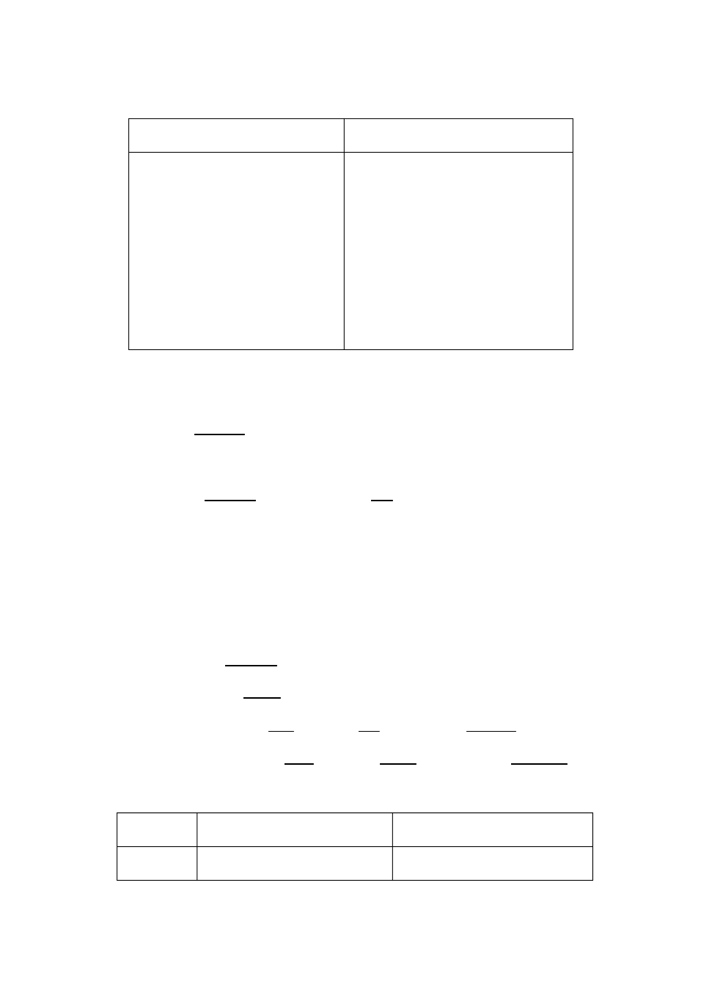

例如：

A） He said,“Isaw the film yesterday”. →

He said that he**had seen**the film the day before.

B）she said,“Ihave seen the film. It is good”. →

She said that she**had seen**the film, and that it **was**good.

注：直接引语如果是客观真理，变为间接引语时，时态不变。例如：

He said, “Light travels much faster than sound”. →

He said that light travels much faster than sound.

3）指示代词、时间状语和地点状语的变化 A） She said,“Iwill **comethis**evening.”→ She said that she would**gothat**evening.

B）He said, “My sister was **here** three days**ago**, but she is not**herenow**.”→ He said that his sister had been**there** three days**before**but she was not**therethen**.

现将这几种变化列表如下：

直 接 引 语 间 接 引 语

指示代词 this that

these those

now today tonight

this week (month, etc.)

then that day

that night

that week (month, etc.)

时间状语

yesterday

last week (month, etc.) three days (a year, etc.) ago tomorrow

next week (month, etc.)

the day before

the week (month, etc.) before three days (a year, etc.) before the next day

the next week (month, etc.)

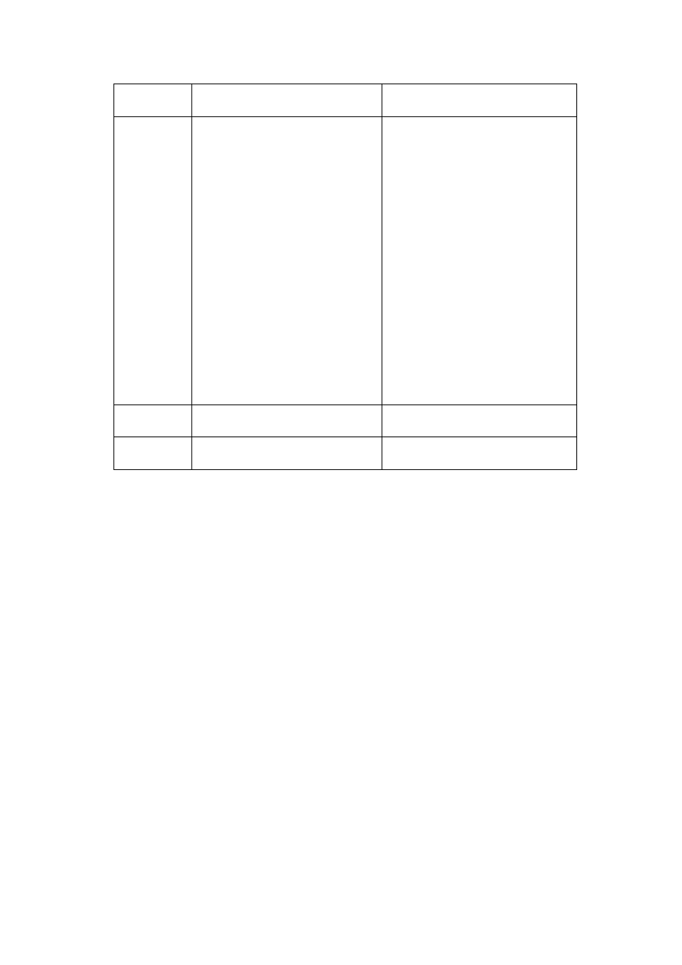

地点状语 here there

动 词 come go

以上这些变化， 要根据说话的实际情况来定， 不要机械照搬。 假如就在当地 转述， here 就不必改为 there。如果就在当天转述， yesterday，tomorrow 等时间 状语也不必改变。

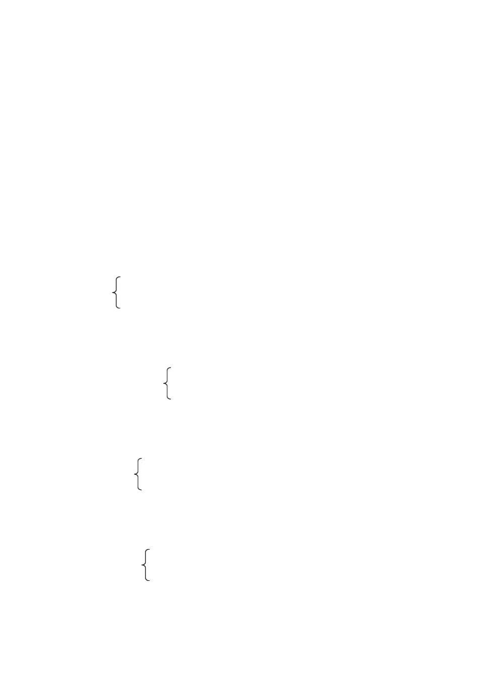

### LESSON 9

**DRILLS** （句型练习）

1

Mr Howe: Is your party going to start at 7 o’clock? Will all of you take part in it?

Are you preparing for it?

Mrs Brown(to Mary): Did you catch what he said?

Mary: Yes. He asked if our party was going to start at 7 o’clock.

if all of us would take part in it. if we were preparing for it.

2

Shop Assistant: What size dress do you wear, Madam? Which one do you like best?

What else would you like?

Mrs Hill: What did he say, Jack?

Jack: He asked what size dress you wore.

which one you liked best. what else you would like.

**TEXT** （课文）

EDISON ?S BOYHOOD

Thomas Edison was born in 1847. When he was a child, he liked t find out how things worked. One day when he was five, his father saw him sitting on some eggs, and asked what he was doing that for. Tom did not reply. Instead, he asked his father why he was not able to hatch chickens while hens could.

Young Tom was in school for only three months. During those three months, he asked a lot of questions. Most of them had nothing to do with his lessons. His teacher did not understand why the boy had so many strange questions. He told Tom?s mother that Tom was not bright and was not worth teaching. His mother took him out of school and taught him herself. The boy read a lot. He became very interested in science.

By the time he was ten, he had already built a chemistry lab for himself. He planted vegetables in his garden and sold them to buy what he needed for his lab.

Once his mother was ill and she sent for a doctor. The doctor said she needed an operation at once. But it was night and the lamp in the room gave poor light. Edison thought hard. Finally he had an idea. He collectedall the lamps in the house and put them on a long table. Then he placed a big mirror behind them. Now there was enough light, so the doctor could operate. Ediso?sn mother was saved.

At the age of twelve, Edison began selling newspapers on a train. When he was free, he printed a newspaper and sold copies to the railway workers.

One day in August, 1862, Edison saw a little boy playing on the tracks at a station. A train was coming near quickly, and the boy was too frightened to move. Edison rushed out and carried the boy to safety. The b?osyfather was so thankful that he taught Edison how to send messages by railway telegraph.Edison soon becamevery good at it and later he left home to work in different cities. This gave him a start in life. At that time he was just a boy of sixteen.

**GRAMMAR** （语法）

直接引语和间接引语 **(Direct Speech and Indirect Speech)**Ⅱ**( )**

2、疑问句 直接引语如果是疑问句，变为间接引语时，要把疑问句语序变为陈

述句语序（主语在谓语的签名） ，句末用句号。主语的人称、时态和状语等也



要做相应的变化。

1）一般疑问句 直接引语如果是一般疑问句，变为间接引语时，要用连词 whether 或 if 引导。主句中的谓语动词是 said 时，要改为 asked，没有间 接宾语的，可以加一个间接宾语（ me，him，或 us 等）。例如：

1. He said,“Are you ready?”→ He asked (us) if we were ready.
2. He said,“Did you see him last night?”→

He asked (me) whether I had seen him the night before.

2）特殊疑问句 直接引语如果是特殊疑问句，变为间接引语时，仍用原来 的疑问词引导。例如：

1. “What do you want?”he asked me.→ He **asked**me whatI wanted.
2. She said to Tom,“How are you feeling now?”→ She**asked**Tom how he was feelingthen.
3. She said,“Where have you been, Mike?”→ She**asked**Mike where he had been.



### LESSON 10

**DRILLS** （句型练习）

1

Teacher: Stop writing and listen to me.

Make sentences with these words. Speak a little louder.

Pay attention to your pronunciation Student A: What did the teacher tell us to do?

Student B: She told us to stop writing and listen to her.

to make sentences with those words. to speak a little louder.

to pay attention to our pronunciation.

2

Granny: Don’t play with the cat any more.

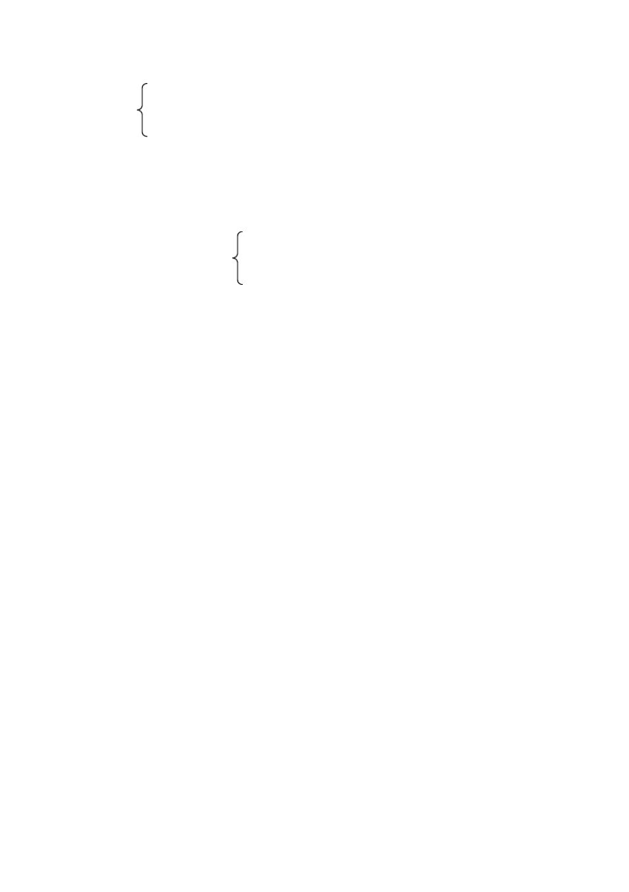

Don’t be late for school, Xiao Hai. Don’t drink this water.

Don’t get your hands dirty.

Xiao Hai: What did Granny say just now?

Yu Lin: Granny told you not to play with the cat any more.

not to be late for school. not to drink that water.

not to get your hands dirty.

**TEXT** （课文）

DR BETHUNE

It was late on the night of October 20, 1939, when Dr Bethune was busy working in a field hospital. An Eighth Route Army man riding a horse came from the front. He told Dr Bethune that the front was in great need of medical workers. Immediately, Dr Bethune set off with a medical team.

On their way, they met a group of wounded Eighth Route Army men. They took the wounded soldiersinto a small temple at once and Bethune began to operate on them.

Dr Bethune went on working throughout the night. When someoneasked him to have a rest, he just went on working. To him, the most important thing was to save lives. He had no time to think about rest.

The next day while an operation was going on, a young man ran in and said to the doctors, “Several hundred enemy soldiersare coming.”Soon they heard the sound of guns. But Dr Bethune still went on with his work.

Twenty minutes later, when Bethune was operating on the leg of the last soldier, the guns sounded much closer. Again the young man rushed in and told Dr Bethune not to go on operating any more“.Comrade Bethune, you must leave now!”he cried.

“Let me go on with the operation”,

right now, Dr Bethune. Hurry!”

said one of the doctors“. You must leave

“Please go, Doctor,”begged the wounded soldier himself. “It ?s not a bad wound. Take me with you, or leave me here, but pleasego before the enemy comes”.

“Never mind, my boy, it won?t take long,”said Dr Bethune.“If I spend a few more minutes on it now, I can save your leg. But if I do?tn, you?ll lose it.”

The guns sounded still closer now, but Dr Bethune worked on. He and the other doctors did not leave until the operation was over.

By that time the Japanese were already very near. As Bethune and the other doctors were climbing the hills, they could see the enemy entering the village in the valley below.

**GRAMMAR** （语法）

直接引语和间接引语 **(Direct Speech and Indirect Speech)**Ⅲ**( )**

3、祈使句 直接引语如果是祈使句，变为间接引语时，要用 tell (ask, order) someone (not) to do something 这个句型，就是把动词原形变为动词不定式， 并在动词不定式之前用 tell， ask， order 等动词及其宾语。如果祈使句为否 定式，在动词不定式的前面加 not。

1. She said to us,“Please have a res”t.

→ She asked us to have a rest.

1. He said,“Go away.”→ He ordered him (me, her, the boy, etc) to go away.
2. One of the doctors said,“Let me go on with the operation, Dr Bethune”. →

One of the doctors asked Dr Bethune to let him go on with the operation.

1. He said to Dr Bethune,“Don’t go on operating any more”. →

He told Dr Bethune not to go on operating any more.

### LESSON 11

**TEXT** （课文）

THE FISHERMAN AND THE GENIE

Once upon a time there was an old fisherman. He went fishing very early every morning, but he never cast his net more than four times a day.

One morning, he went out early to the sea. He cast his net for the first time, and drew in the body of an animal. He cast it a second time, and drew in an old basket full of sand. He cast it a third time, and drew in a lot of stones. It seemed he would have nothing to take home that morning.

Day had now broken, and he cast his net for the last time. After some time, he began to drew the net in. He found it was very heavy. But there were not any fish in it. Instead he found a jar with a lid. He shook the jar, but could hear nothing. So he took off the lid and looked inside. He could see nothing. After a while a light smoke came slowly out of the jar. Then little by little, the smoke grew heavier and thicker until finally it turned into a terrible Genie!

“Get down on your knees”, said the Genie,“for I?m going to kill you”.

“Why? Didn?t I set you free from the jar?”

“That?s whyI?m going to kill you, butI?ll let you choose how yo?ure going to die.”

“But why?”

“Listen, and I will tell you my story”.

“Iwas one of the spirits in heaven. But I did not want to obey Solomon?s orders. So one day, he put me in this jar and threw it into the sea.

“During the first hundred years of my stay in the sea, I made a promise that if anyone set me free I would make him very rich. But no one came. During the second hundred years, I promised that if anyone set me free I would show him all the treasures in the earth. But still no one came. During the third hundred years,

I promised that if anyone came to set me free, I would make him king over the earth.

“Still no one came. Then I became very angry, and decided that if anyone should set me free I would kill him at once. Now you have come and set me free. So you must die, but I will let you say how you want to di”e.

The fisherman was not frightened. He said: “Since I must die, I must. But before I die, answer me one questio”n.

“All right, but be quick.”

“Were you really in the jar? You are so big and the jar is so small that it could hardly hold one of your fee”t.

“Of course I was in the jar. Don?t you believe me?”

“No, and I won?t until I?ve seen you in the jar with my own eye”s.

When he heard this, the Genie changed again into smoke. Slowly the smoke went back into the jar. When all of it was in the jar, the fisherman quickly put

the lid on and threw it back into the sea.

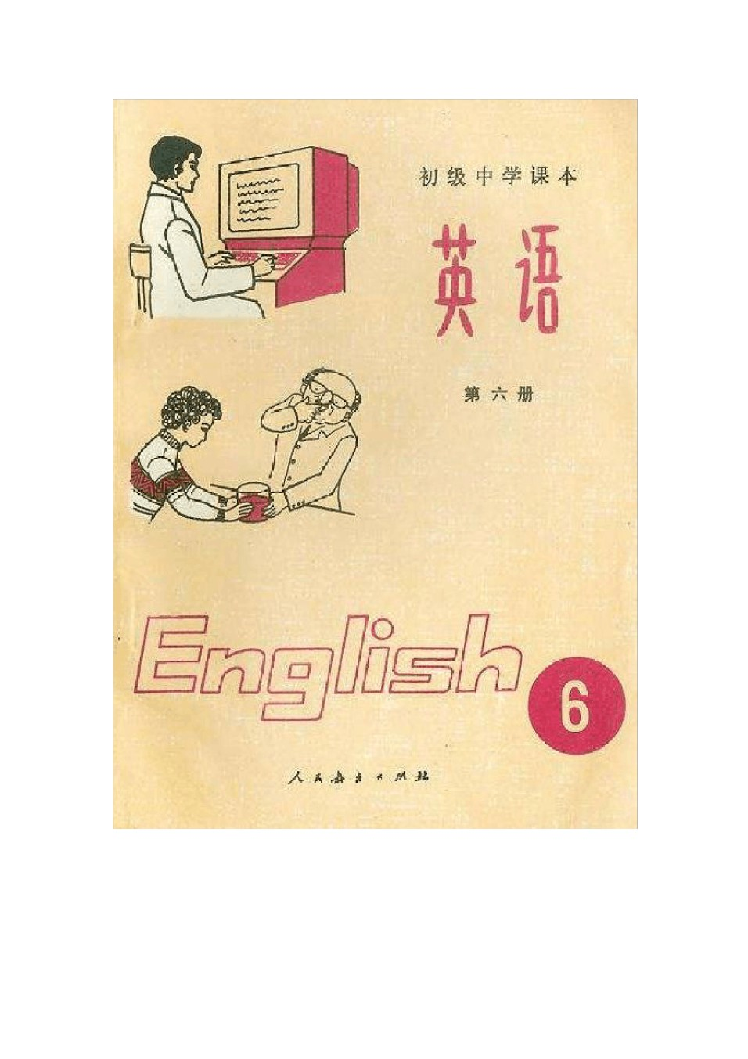

# 初中英语课本第六册

### LESSON 1

**DRILLS** （句型练习）

1

1. Many people speak English. English is spoken by many people.
2. We often use a recorder in our English class. A recorder is often used in our English class.
3. They show slides once a week in their class. Slides are shown once a week in their class.
4. They publish English textbooks in that publishing house. English textbooks are published in that publishing house.

2

A: Is this kind of telephone

bicycle TV set recorder

made in Guangzhou?

B: No, it isn ’t.



A: Where is it made?

B: I t ’s made in Shanghai.

**DIALOGUE** （对话）

ENGLISH IS WIDELY USED

Ping: Dad, I got a “C”in English again. I tried my best.

Dad: Well, don?t give up. English may be hard, but i?ts so useful. Ping: How widely is English used?

Dad: Very widely. English is one of the working languages at international

meetings. It ?s probably the most widely used at those meetings.And do you know most international business letters are written in English?

Ping: Really? Is English understood by people outside England and the United States?

Dad: Yes. I spoke English when I was in Japan. Many people understood me. Ping: How about other countries?

Dad: Well, I know that in Sweden and France a lot of people understand English.

Ping: Is English the language spokenby the largest number of people in the world?

Dad: No.

Ping: Then Chinese must have the largest number of speakers. Dad: Right. But Chinese is spoken by few people outside China. Ping: Dad, did people in China study English a long time ago?

Dad: Not so very long ago. In China the first English textbooks were published in the late nineteenth century.

Ping: Did many people in China study English at that time?

Dad: No, not many. But by and by, more and more people began to study English. Later, English was required for study in many schools.

Ping: It ?s required in our school now. But, Dad, English is so hard!

Dad: It is hard, but when you ?ve learned it, you?ll find it a bridge to so much knowledge. And you?ll find you can enjoy so many more books, if you know English.

Ping: Well, I?ll try harder.

**GRAMMAR** （语法）

被动语态 **(The Passive Voice)**Ⅰ**( )**

1、主动语态和被动语态

英语动词有两种语态，即主动语态（ The Active Voice）和被动语态（ The

Passive Voice）。主动语态表示主语是动作的执行者，被动语态表示主语是动 作的承受者。例如：

Many people speak English. （主动语态） English**is spoken**by many people. （被动语态） 2、被动语态的构成

被动语态由“助动词 be+及物动词的过去分词” 构成。助动词 be 有人称、 数和时态的变化，其变化规则与 be 作为连系动词时完全一样。现将动词 ask 的一般现在时被动语态的肯定式、否定式及疑问式列表如下：

肯 定 式 否 定 式 疑 问 式

I am You are

|  |  |  |  |  |  |  |  |  |  |
| --- | --- | --- | --- | --- | --- | --- | --- | --- | --- |
| He | is | asked | He | is | not asked | Is | he |  | |
| She |  |  | She |  |  |  | she | asked | ? |

I am You are

Am I Are you

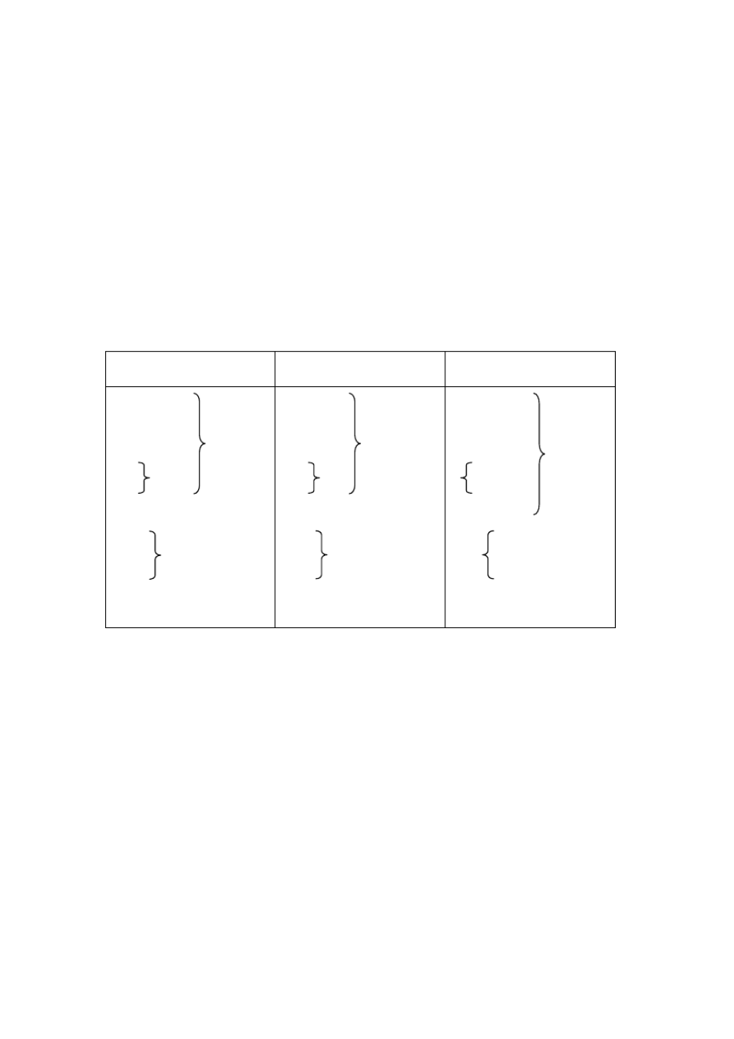

|  |  |  |  |  |  |
| --- | --- | --- | --- | --- | --- |
| We |  | We |  |  | we |
| You | are | You | are | Are | you |
| They |  | They |  |  | they |

3、被动语态的用法

被动语态常用于下列情况：

1）当我们不知道谁是动作的执行者， 或者没有必要指出谁是动作的执行者时。 例如：

1. Letters **are collected**from this post-box at 7:30 every morning.（主要说明每天早 晨七点半钟开邮筒收集信件，至于是谁来收集信件，没有必要说明。 ）
2. Colour TVs **are sold**in that shop.（主要说明彩色电视机在那个商店出售， 至于由谁售货，没有必要说明。 ）

2）需要强调动作的承受者而不是执行者时。例如：

1. This kind of bike **is** not **made**in our factory.
2. Football **is played**in most middle schools. 4、主动语态变为被动语态的方法

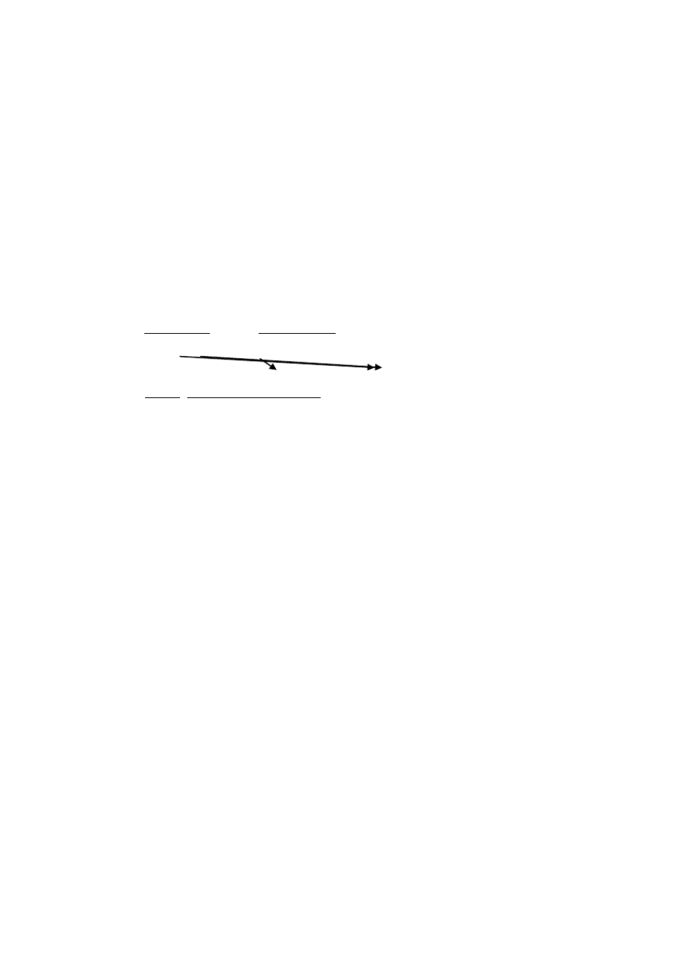

把主动结构改为被动结构时，要作如下变动：

1）主动结构的宾语变为被动结构的主语；

2）主动结构的谓语动词有主动语态变为被动语态；

3）主动结构的主语变为介词 by 的宾语，组成介词短语，放在被动结构中谓 语动词之后。 在动作的执行者无须说明或不必强调时， by 短语可以省略。 例如：

Many people speakEnglish.

Englishis spokenby many people.

B) We often use a recorder in our English class.→

A recorder **is** often **used**(by us) in our English class.

### LESSON 2

**DRILLS** （句型练习）

1

1. The PLA liberated my home town in 1949. My home town was liberated in 1949.
2. The villagers built some new houses themselves. Some new houses were built by the villagers themselves.
3. Joe Hill led a strike in Salt Lake City in 1915.

A strike was led by Joe Hill in Salt Lake City in 1915.

1. The pianist gave the pupils some advice.

The pupils were given some advice by the pianist.

2

A: When was the Chinese Communist Party

the Chinese People’s Liberation Army the people’s Republic of China

founded?



B: It was founded on July 1, 1921.

August 1, 1927.

October 1, 1949.

**TEXT** （课文）

JOE HILL

You may know the song about Joe Hill. But do you know that the song was written about a real person?

Here is the story of Joe Hill.

He was born in Sweden in 1879. When he was in his twenties he went to the

United States and became a worker. At that time, things were hard for the workers. Joe took an active part in( 积极参加 ) the workers?struggles for better pay and better conditions. He helped to form trade unions. He spoke at meetings

and organized strikes.

Joe was a good musician and at the meetings he sang and played the piano. He himself wrote the words and music of the songs. Many of these songs called on( 号召 ) the workers to take up the struggl(e从事斗争 ) .

Joe Hill was a tall, thin, good-looking man. He had fair hair and blue eyes. His comrades liked him, but the bosses hated him, because they were afraid of

his work among the workers and afraid of his songs. He was a fearless fighter for the working class.

In 1915 Joe Hill led a strike in Salt Lake City. The bosses knew that Joe was the soul of the strike and decided to get rid of( 除掉，去掉 ) him. They need an excuse and they soon found one. One day a man was murdered. The bosses then brought out( 提供，推出 ) a man who said that Joe was the murderer. Joe was tried and sentenced to death. He was shot on November 19, 1915.

Even while he was in prison, Joe Hill went on writing songs to keep (u坚p 持； 不使斗志等低落 ) the workers?fight. Just before he was killed, he sent a message to his comradesall over the country. These were his last words: “Don?t waste time mourning. Organize.”

On the day he was killed, a speakerat a big meeting said: “Joe Hill isn?t dead! He will never die!”To this day( 直到今天 ) his name is remembered by fighting workers in the United States.

**GRAMMAR** （语法）

被动语态 **(The Passive Voice)**Ⅱ**( )**

5、一般过去时被动语态的肯定式、否定式和疑问式（以动词 ask 为例）

肯 定 式 否 定 式 疑 问 式

I was You were

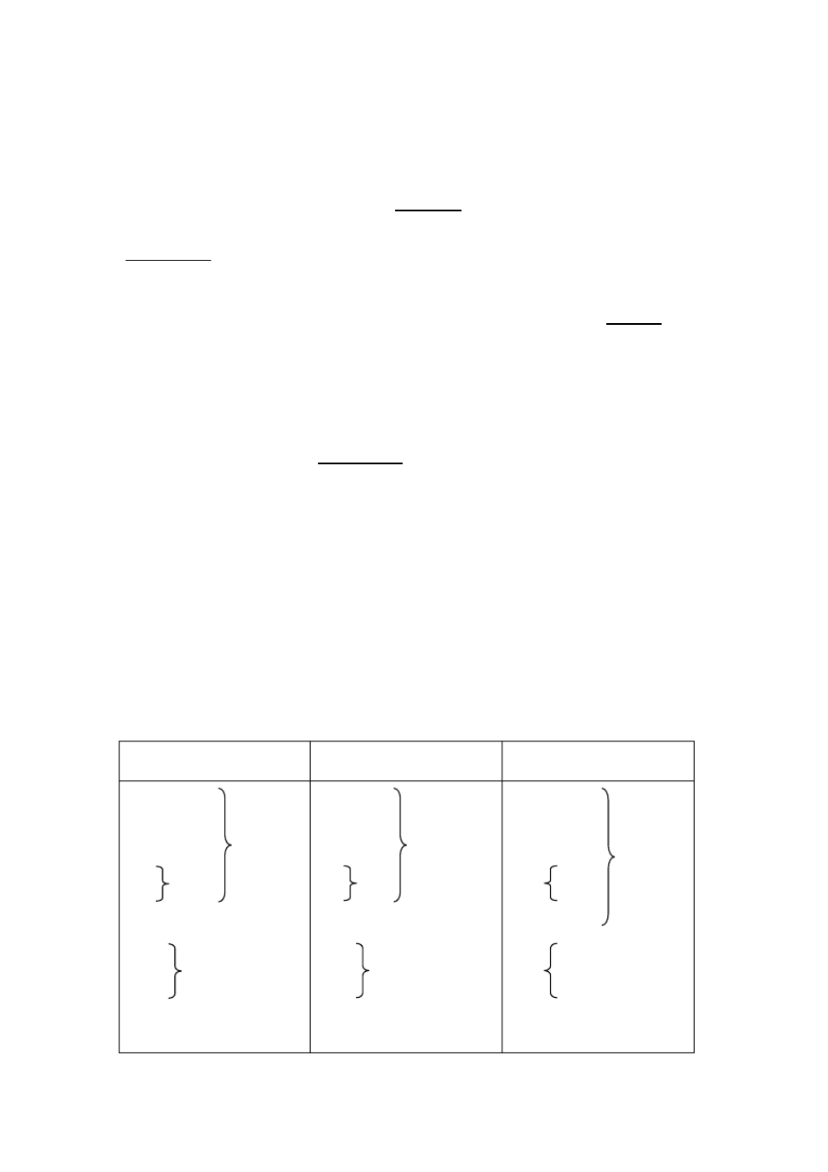

He was asked She

We

You were They

I was You were

He was not asked She

We

You were They

Was I Were you Was he

she asked ? we

Were you

they

6、含有直接宾语和 的主动结构变为被动结构时， 可以将其中一个宾语变为主语，

另一个不动。一般是主动结构的间接宾语变为被动结构的主语。例如：

The pianist gave the pupilssome advice.→

(间接宾语 )（直接宾语）

The pupils**were given**some advice (by the pianist). Some advice**was given**to the pupils (by the pianist)

### LESSON 3

**DRILLS** （句型练习）

1

A: You’re just back from your home town, aren’t you? B: Yes.

A: How are things there?

B: Excellent. Great changes have taken place the last two years.

A new school A big building A new road

has been opened

put up built

in my home town

2

A: Has the play

this programme this song

been put on at this theatre? shown on TV?

taught on the radio?



B: Yes, it was put on last week.

shown taught

A: Will it be put on

shown taught

again?

B: Yes, I think so. (I ’m sorry I don’t know.)



**TEXT** （课文）

DUSTMEN ON STRIKE

It is Thursday morning. No dustmen come to the Turners? road. They are still on strike. And the rubbish has not been collected for weeks.

The Turners are sitting at the breakfast table. Mr Turner is reading the newspaper. It is time for Robert to go to school.

Robert: I?d better be going.?Bye.

Mrs Turner: Oh, Robert, take the bag of rubbish out to the dustbin, please. Robert: But where can I put it? The dustbin is full, Mum.

Mrs Turner: Hasn?t it been emptied yet? Well, just put it near the dustbin, then.

Robert: All right. ?Bye.

Mrs Turner: This really is too bad. The dustbins haven?t been emptied for three weeks.

Mr Turner: Hm?

Mrs Turner: All the dustbins are full, and there are bags of rubbish everywhere.

The whole street has been turned into one big rubbish dump. It smells terrible.

Mr Turner: And it can bring more trouble. Mrs Turner: More trouble?

Mr Turner: Yes, we?ve been warned to be careful of rats. Mrs Turner: Aren?t the dustmen going back to work yet?

Mr Turner: No, they aren?t. Look, there?s a report here in the newspaper, with pictures.I?ll read it to you.

**(**reads**)**

STRIKE GOES ON

Things are getting worse. No rubbish has been collected since the dustmen went on strike three weeks ago. Dustbins are full, and plastic bags full of rubbish have been piled in the streets. The smell is terrible. In some places rats have even been seen, and people have been warned to be careful.

The public wants to know: why hasn’t anything been done to end the strike? The dustmen say they are badly paid and they want more money. They are not going back to work until they get it. But that is not all. They want to make it clear to the public

that they do an important and necessary job.

Mrs Turner: That?s true. Their job is important and necessary to us all. Mr Turner: Something must be done to end the strike.

**GRAMMAR** （语法）

被动语态 **(The Passive Voice)**Ⅲ**( )**

7、一般将来时和现在完成时的被动语态

1）一般将来时 I will (shall) You

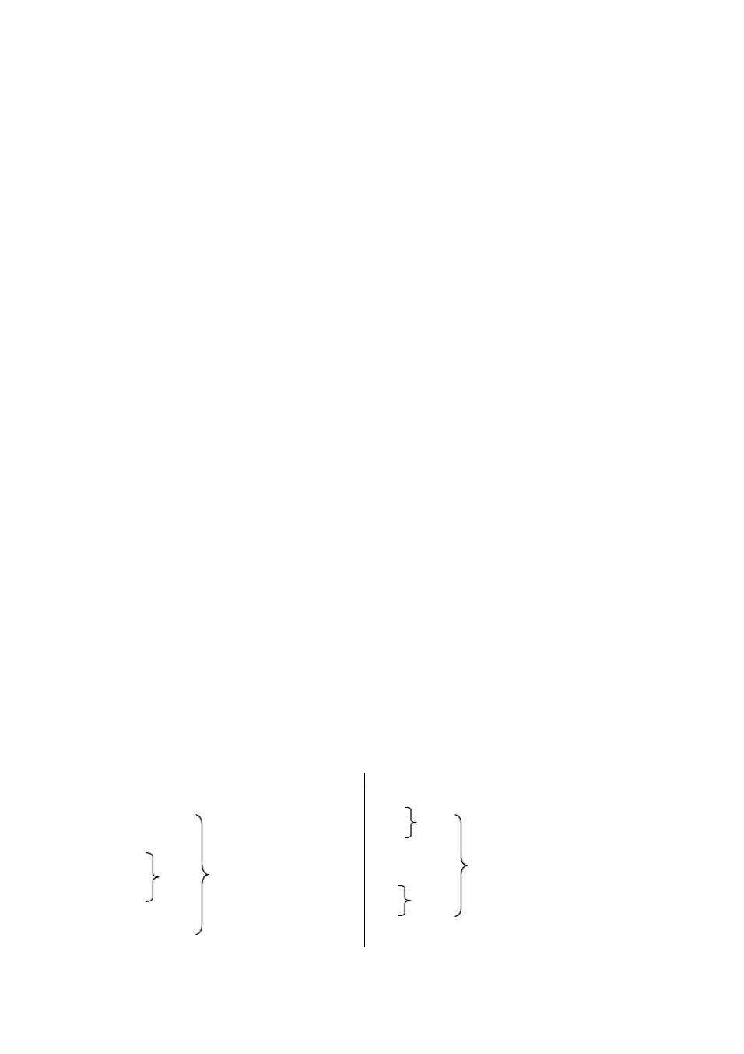

He will

She be asked

2）现在完成时 I have

You

He has been asked She

We will (shall) You

They will

We

You have They

8、短语动词的被动语态

一般来说，只有及物动词才有被动语态，因为只有及物动词才可能有动 作的承受者。但有许多由不及物动词加介词构成的短语动词，相当于及物动 词，可以有宾语，因而也可以有被动语态。但应注意：短语动词是一个不可 分割的整体，在变为被动语态时，不可丢掉构成短语动词的介词或副词。例 如：

1. The workers have put up a big building in my home town. → A big building **has been put up**in my home town.
2. They took good care of the children. →

The children **were taken good care o**. **f**

### LESSON 4

**DRILLS** （句型练习）

1

A: Can this lock

this kind of key this radio

be repaired made fixed

here?

B: Yes, it can be repaired



made

in two days. ten minutes.

fixed three days.

2

A: When must the composition

the drawing

the money for the tickets

be handed in?



B: It must be handed in after class.

five days before the exhibition. sometime before Friday.

**TEXT** （课文）

WATER, STEAM AND ICE

We have all played with snow and ice. When a piece of ice is taken into a warm room, it becomessmaller and smaller, until in the end it disappears completely. Where has it gone? It has been turned into water by the heat.

In winter, when clothesare washed, they don?t dry easily. They are often hung up near a fire. Soon steam can be seenrising from the wet clothes. The water in them is being turned into vapour, and they get drier and drier. When no more steam comes out, they must be taken away from the heat of the fire, or they might get burnt.

If you hold a mirror close in front of your mouth and blow on it, you will find the glass covered at once with little drops of water. The warm water vapour

in your breath has been changed into water on the cold glass. Now stop blowing, and soon you will find the glass clear again –the little drops of water have disappeared because they have again been turned into vapour by the warm air

around them.

Leave a basin of water outside in freezing weather, and it will soon be covered with ice. If it is not taken inside the room, sooner or later the whole basin of water may be turned into a block of ice.

Most matter has three states: solid, liquid and gas. Solids can usually be turned into liquids and liquids into gasesif we raise their temperatures high enough. On the other hand, gasescan often be turned into liquids and liquids

into solids if they are made cold enough.

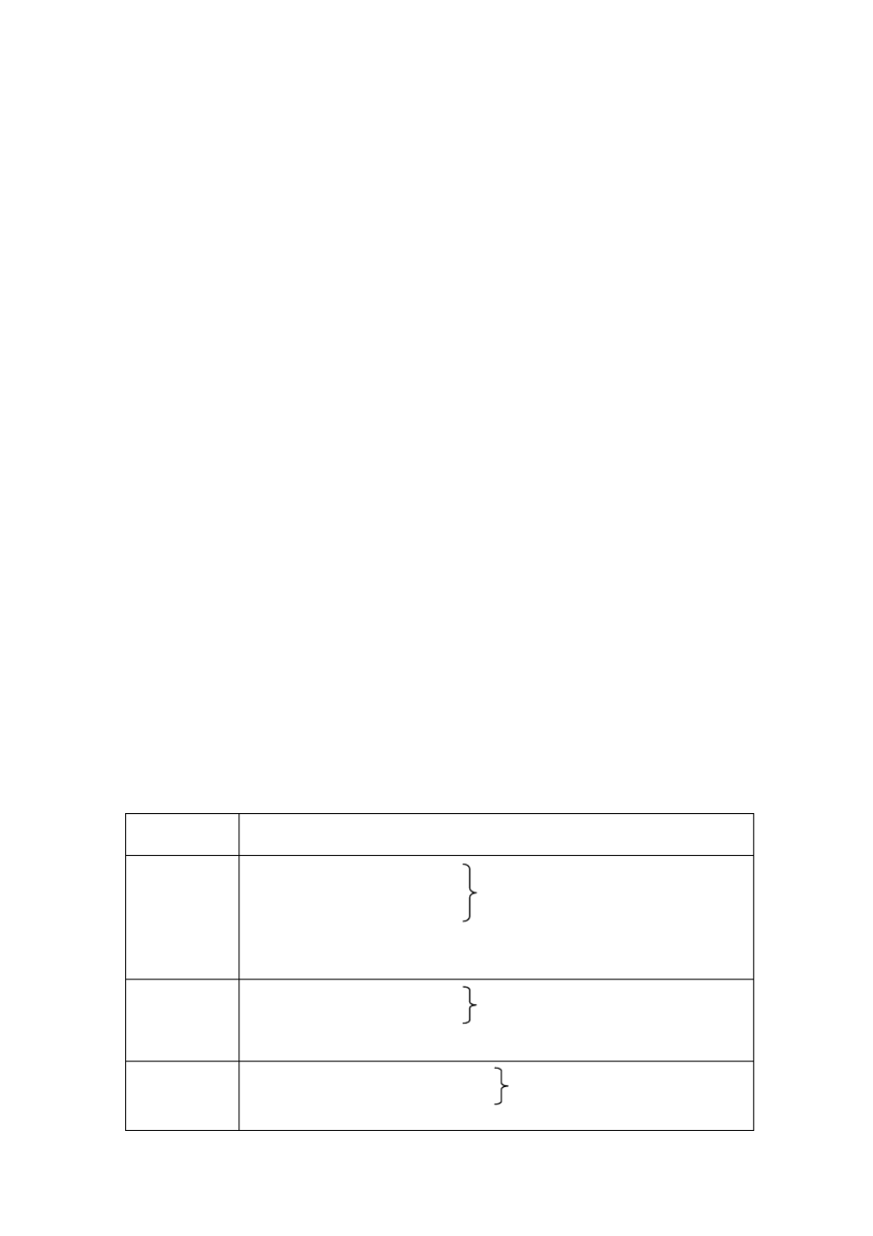

This change of state is a physical change and not a chemical one. If a piece of wood is heated to a high temperature, it begins to burn. Light and heat are sent out, together with heavy smoke, and soon only black charcoal is left. That is called a chemical change.

**GRAMMAR** （语法）

被动语态 **(The Passive Voice)**Ⅳ**( )**

9、现在进行时的被动语态

现在进行时的被动语态由“助动词 be + being + 及物动词的过去分词” 构成。例如：

The water is being turned into vapour. 10、含有情态动词的被动语态

含有情态动词的被动语态是由“情态动词 + be + 及物动词的过去分词” 构成。例如：

* 1. This lock can be repaired in two days.
  2. The composition must be handed in after class.
  3. A basin of water may be turned into a block of ice in freezing weather. 11、被动结构小结

时 态 被 动 结 构

一般现在时 I + am

He (She) + is + p.p. * (+ 介词或副词 )

You (We, They) + are

一般过去时 I (He, She) + was + p.p. (+介词或副词 )

We (You, They) + were

一般将来时 I (We) + will (shall) + be + p.p. (+介词或副词 ) You (He, She, They) + will

情态动词 can

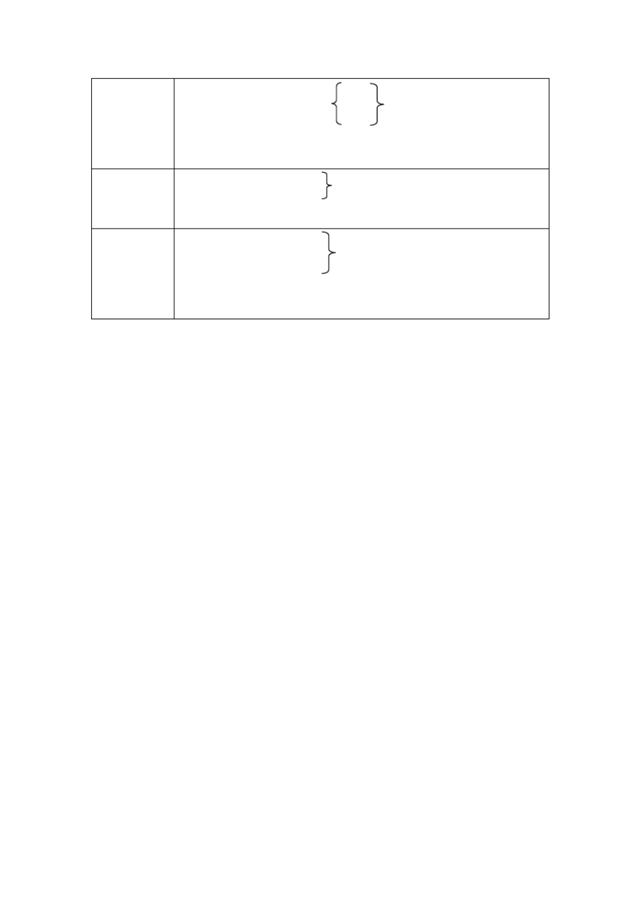

I (He, She, We, You, They) + may + be + p.p. (+介词或副词 ) must

现在完成时 I (We, You, They) + have + been + p.p. (+介词或副词 )

He (She) + has

现在进行时 I + am

He (She) + is + being + p.p. (+介词或副词 ) You (We, They) + are

* p.p. = past participle 过去分词

### LESSON 5

**TEXT** （课文）

COMPUTERS

The computer is a wonderful machine. It is the most important invention in many years. Today it is used a great deal in many ways. By the year 2,000 the computer will probably touch the lives of everyone, even people in faraway villages.

The oldest kind of computer is the abacus, used in China centuries ago. In

the seventeenthcentury an adding machine was invented, but the first large, modern computer was built in 1946. A computer then could do 5,000 adding problems in one second. Now computers can work millions of times faster.

Today most computers have a memory. That means information can be stored in them and be taken out anytime needed. Computers are getting smaller and smaller, and computing faster and faster. Even in a large computer, the part that does the computing is now only about as big as the end of a finger.

Computers can do many kinds of work. For example, when someone buys something in a big shop, information about the sale is put into a computer. During the night the computer works on the information from all the sales that day. The next morning, the manager has a report on everything that was sold and also on everything that will soon be sold out.

In research about the moon, a lot of information is put into computers. A scientist can then“ask”the computer questions, and the computer“answer”on the screen. It is almost like talking to another scientist.

Another computer programme has information about different illnesses.A doctor can talk to the computer and explain what is wrong with a person. The computer will then tell what to do. If the doctor asks why, the computer goes through its memory and gives the reason.

In somelarge factories there are very few people. Robots do most of the work. For example, in a car factory, when a different type of car comes along the line, the robot changes its work, just as a human would do. How does the robot

know this? A computer“tells”it what to do.

In the last few years there have been great changes in computers. They now can do most of the things people can do, though most scientistsagree that computers cannot completely take the place of humans. Who knows what the computers of tomorrow will be like? Will they make life better, or will they bring suffering to people? The studentsof today will have to decide how to use the computers of tomorrow.



### LESSON 7

**DRILLS** （句型练习）

1

A: Have you seen Zhao Hai today? B: Yes, I have.

A: Do you know why he isn ’t coming this evening?

B: He told me he had an important meeting to attend.

some exercises to do. a composition to write.

several letters to answer.

2

A: Have you started writing your composition yet? B: No, I really don ’t know what to write about.

which topic to choose. how to begin.

**TEXT** （课文）

A LESSON FROM NATURE

Not many years ago, some farmers were worried because hawks were taking many of their chickens. The farmers did not know what to do. Finally they went to the officials and asked for help.

“Kill the hawks,”the officials said. “We?ll even pay you for them.”So the farmers began to think of ways to kill hawks.

The farmers killed many hawks. Before long they didn?t have to worry about their chickens. Btu they now had a new worry. Field mice were eating up a lot of the farmers?grain.

How did this happen?

Hawks eat not only chickens but also field mice. They eat more field mice than chickens. But the farmers did not know this. When they killed a lot of hawks, they changed the balance of nature.

When people move into a new place, they often destroy many wild plants.

Many of these plants are food for the animals. If the animals cannot find enough plants to eat, they will starve or have to leave the place.

In one part of the United States, for example, the deer there like to eat a certain kind of wild rose. The mountain lions there eat the deer. The number of deer, mountain lions, and wild roses does not change much if people leave things as they are.

But people killed many mountain lions in order to protect the deer. Soon there were so many deer that they ate up all the wild roses. Then the deer began to eat the green leaves of young trees. These trees were important to the farmers. So the farmers thought of ways to protect their trees. Now the deer had nothing to eat, and many of them died. This was another lesson from nature.

It is important for us to keep the balance of nature. This is the lessonwe should remember.

**GRAMMAR** （语法）

动词不定式 **(The Infinitive)** ( Ⅱ) 1、动词不定式（或短语）的用法（续）

动词不定式（或短语）具有名词、形容词和副词的特征，因此，在句子 中可以做主语、表语、宾语、宾语补足语、定语和状语。在第三册第 13 课已 归纳过动词不定式作宾语、宾语补足语和状语的用法，本册继续归纳动词不 定式作定语、主语和表语的用法。

1）作定语

1. He said he had an important meeting**to attend**.
2. Do you have anything **to say for yourse**?**lf**
3. The fisherman had nothing**to take home**that morning.
4. The farmers thought of ways**to protect their tree**.**s**
5. Dr Bethune had no time**to think about res**.**t**

**It** 的用法 （ **The Use of**“**It** ”）

1、代词 it 可用来指除人以外的一切生物和事物。例如：

1. Where’s the dog?**It** ’s in front of the house.
2. Is this jacket yours? Yes,**it** is.

2、代词 it 在某种情况下也可以指人。例如：

1. Who is **it**? **It** ’s me.
2. “ Im’sorry,”the guard said to Lenin.“ Ididn ’knot w’**it** was you.” 3、代词 it 有时不特指某件东西，而代表前面提到的整个事情。例如： Don’t read in the sun. It’s too bright. **It** ’s bad for your eyes.

4、代词 it 可以指时间、距离和自然现象，在句子中作主语。例如：

1. What time is **it**? **It** ’s six o’clock.（指时间）
2. **It** ’s September, and w’ere back at school（.

指时间）

1. **It** ’s not far from here to the bus stop（.

指距离）

1. **It** ’**s** cold today, isn’t it?（指自然现象）
2. I hope **it** will be fine tomorrow. （指自然现象）
3. **It** was raining when I got to school yesterday（.

指自然现象）

1. **It** did not snow much last winter.（指自然现象）

### LESSON 8

**DRILLS** （句型练习）

1

A: Do you get up early in the morning? B: Why, yes!

A: What do you usually do after you get up?

B: I do morning exercises.

some reading aloud. some cleaning.

It’s good to have plenty of exercise. to read aloud often.

to help with the housework.

2



A: What are good manners in your country? B: It ’s good manners to wait in line.

to eat quietly.

not to shout in public.

A: I see. But what are bad manners?

B: It ’s bad manners to be rude to people



to spit in public.

to come late to class or a meeting.

**TEXT** （课文）

GOOD MANNERS

Manners are important to happy relations among people. Everyone likes a person with good manners. No one likes a person with bad manners.But what are good manners? How does one know what to do and what not to do?

Well, here are some examples.

A person with good manners never laughs at people when they are in trouble. Instead, he tries to help them. He is always kind to others. When people are waiting for a bus, he takes his turn. He does not push to the front of the line. On the bus he gives his seat to an older person or a person with a very young child. If he knocks into someone, or gets in his way, he sa“yEsxcuse me”or “ I?m

sorry”.

He says “Please”when he asks for somethingand “Thank you”when he receives something. He stands up when he is speaking to an older person, and he doesnot sit down until the other person takes his seat. He doesnot interrupt other people when they are talking. He does not talk too much. He does not talk loudly or laugh loudly in public. When he is eating he does not speak with his mouth full of food. He uses a handkerchief when he sneezes or coughs. He does not spit in public.

As a student, it is bad manners to come late to class. If you are late you should make an apology to the teacher either at the time or after class. It is also bad manners to keep silent when the teacher asks you a question. If you do not know the answer, say so immediately. If you do know, answer in a loud enough voice so that all the class may hear. It is polite for the students to help the teacher. Sometimes students can help their teachers to clean the blackboard, to close or open the door or windows. Sometimes there are papers to collect or to hand out.

This kind of help is always appreciated.

Ideas of what are good manners are not always the same in different

countries. But in all countries it is important to be kind and helpful.

**GRAMMAR** （语法）

动词不定式 **(The Infinitive)** ( Ⅲ) 1、动词不定式（或短语）的用法（续）

2）作主语

**To learn a foreign language**is not easy.

在现代英语中， 更为普遍的是用 it 来开始一个句子， 作形式主语， 而 把真正的主语动词不定式（或短语）放在后面。例如：

1. It’s not easy**to learn a foreign language.**
2. It’s good **to see all my teachers and friends ag**.**ain**
3. It took me more than a year **to learn to draw a beautiful horse in five minutes.**

3）作表语

1. His wish was **to become a scientist.**
2. To the doctor, the most important thing was**to save lives.**

2、动词不定式的否定形式

由 not +动词不定式构成

1. Tell him **not to be late.**
2. I’ll try **not to read in bed.**
3. The policeman told the boys**not to play in the street.**

3、动词不定式和疑问词连用

动词不定式可以和疑问词 what，which ，how，where，when 等连用，构 成动词不定式短语，在句子中作主语、宾语、表语等成份。

1. **How to use the compute**is**r**

the question（.

主语）

1. A computer tells the robot**what to do**（**.**

宾语）

1. The question is**where to get a compute**（**r.**表语）

### LESSON 9

**TEXT** （课文）

LOOK CAREFULLY AND LEARN

My friend Carl will never forget a certain professor. This professor taught him chemistry at the university. He was an ordinary-looking little man with thick glasses,but he had a strange way of making his classeslively and interesting.

And the lessons he taught were not easily forgotten.

Carl remembers one of his first lessonsfrom this professor. After the studentswere all in the chemistry lab, the professorbrought out three bottles. One was filled with kerosene(煤油 ), one with castor oil, and one with vinegar.

“Now watch carefully,”said the professor.“Pay attention to everything that I do.”

He then filled a cup with some of the kerosene, some of the castor oil and

some of the vinegar. As the students watched with fascination, he mixed the three together. After that, he held up one of his fingers and showed it to the class. He

then dipped it into the cup. After a few secondshe took his finger out. “Now

watch,”he said.“ Remembe, ryou must do everything that I do”.

He put a finger in his mouth and sucked it. He nodded with a smile. Then he handed the cup around the class of students. Each student dipped a finger into the mixture and suckedit. Each immediately made a face. The mixture tasted horrible.

“ **Im?**

When the cup was at last returned to the professor, he shook his head sadly. sorry,”he said to the class“, but none of you watched carefully enough. Yes,

I sucked a finger, but the finger I put into my mouth was not the one I had dipped into the cup”.

It was their first important lesson as students of chemistry and they never forgot it.