**Nucor-Relay for Life (website)**

**Technical Manual**

**for IT Support Services**

Prepared by: Adam Moses

**Revision Sheet**

|  |  |  |
| --- | --- | --- |
| **Release No.** | **Date** | **Revision Description** |
| Rev. 0 | 12/5/2016 | Technical Manual Created |
|  |  |  |
|  |  |  |
|  |  |  |
|  |  |  |
|  |  |  |

**TECHNICAL MANUAL**

**TABLE OF CONTENTS**

Page #

1.0 GENERAL INFORMATION 1-1

1.1 System Overview 1-1

1.2 Acronyms and Abbreviations 1-1

2.0 SYSTEM SUMMARY 2-1

2.1 Website Development 2-1

2.2 Database Overview 2-1

2.3 User Access Levels 2-1

3.0 GETTING STARTED 3-1

3.1 Setting up MySQL 3-1

3.2 Create the database 3-4

**1.0 GENERAL INFORMATION**

# GENERAL INFORMATION

## 1.1 System Overview

The Nucor-Relay for Life website is set up to be user friendly and easy to navigate as well as allow for public viewing of Nucor’s progress with their American Cancer Society Relay Teams. The website consists of the following pages: Home, About Us, Relay Teams, Leader Board, Events, and Photo Gallery.

The Administrative website utilizes an intuitive user interface that makes imputing and editing attributes and entities fast and efficient. There are two administrative categories, Admin user(s) and Super Admin; depending on permissions each can perform their granted duties.

This system is designed with intentions of utilizing a virtual machine instead of a physical server. During development of this system the XAMPP (Apache distribution) package was used. NOTE: The XAMPP package is for developing purposes only.

**2.0 SYSTEM SUMMARY**

# SYSTEM SUMMARY

## 2.1 Website Development

The following were used in the development of the Nucor-Relay for Life website.

* XAMMP package 7.0.13 for Windows (utilizes Apache and MySQL servers for testing as localhost/)
* Bootstrap 3.3.7 (front-end web development)
* NotePad++ (for writing source files)
* GitHub (project repository)
* Languages – HTML, PHP, JavaScript, MySQLi, CSS

## 2.2 Database Overview

The backend database was designed with MySQLi and the “phpmyadmin” application. The following ERD shows the entities, attributes and connectivity.

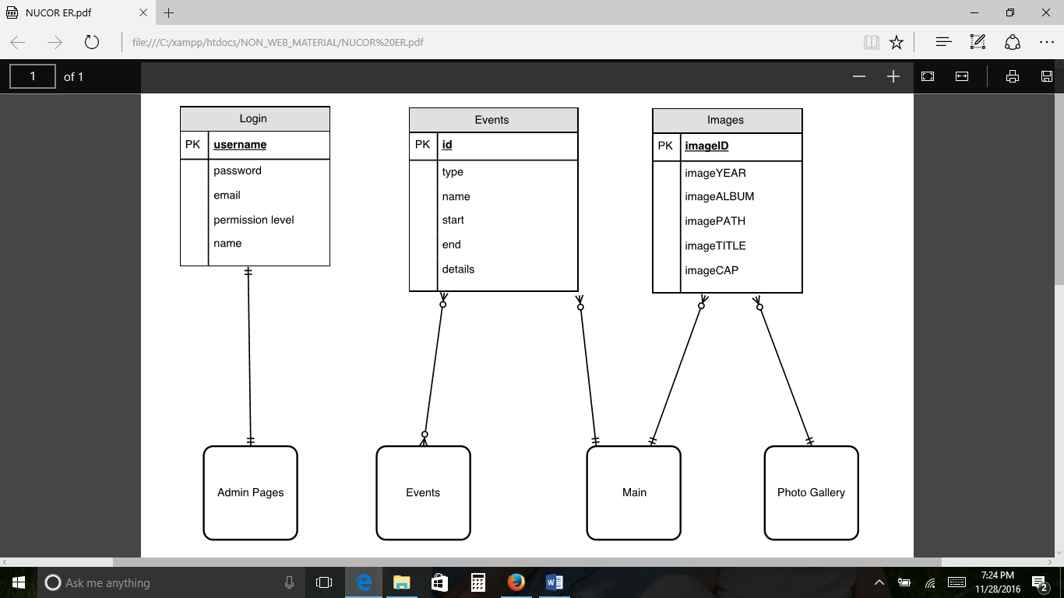

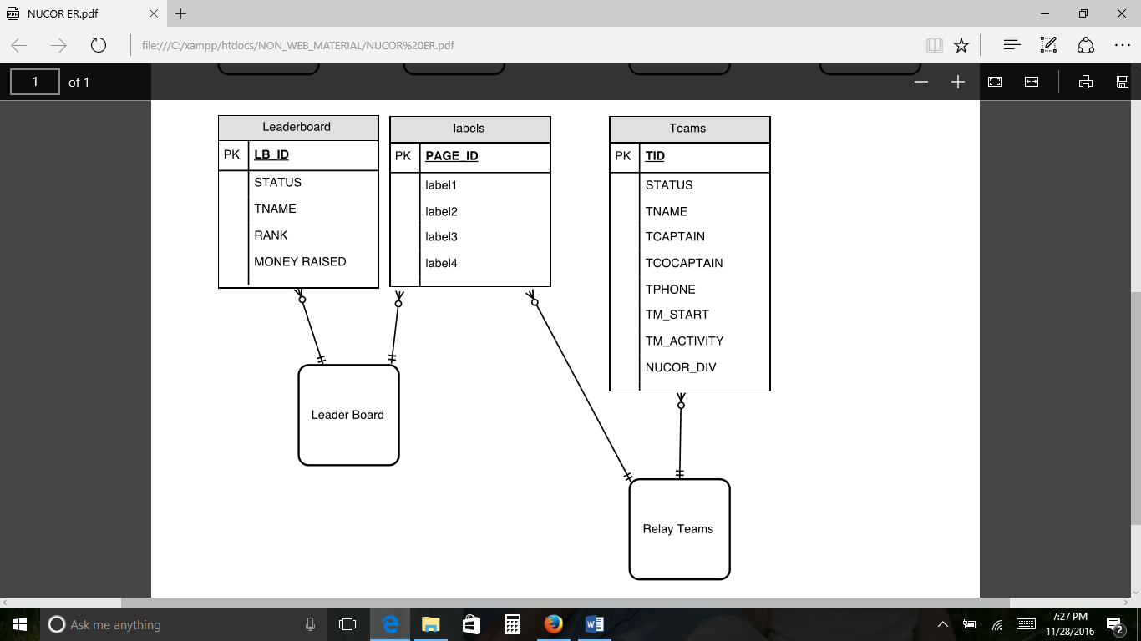

## 2.3 User Access Levels

**Machine/localhost**

There are three different types of users as depicted in the image above. Public are public viewers who can view the Nucor-Relay for Life website pages such as Main, About Us, Relay Teams, Leader Board, Events, and Photo Gallery. Admin Users are Nucor employees who have authority to view and change/update their info, calendar events, and photos within the database. The Super Admin User(s) will have full control of all database manipulation from importing and exporting data to updating data as needed. *Special Note: It is Nucor’s responsibility to appoint the Super Admin User role.*

**3.0 GETTING STARTED**

# GETTING STARTED

## 3.1 DOWNLOADING XAMMP AND SOURCE FILES

1. Begin by downloading the “XAMPP 7.0.13 package” for Windows contained in the Nucor-Relay for Life content CD/DVD
2. After successful installation of XAMPP package, locate the “Nucor_Relay” folder from CD/DVD and download content to the “htdocs” folder located inside “XAMMP” folder

## 3.2 Create the database

The following are steps for creating a database named “nucor”

1. Start by locating/opening the “XAMMP Control Panel”
2. Click the “Start” button of both the “Apache” and “MySQL” shown in pic

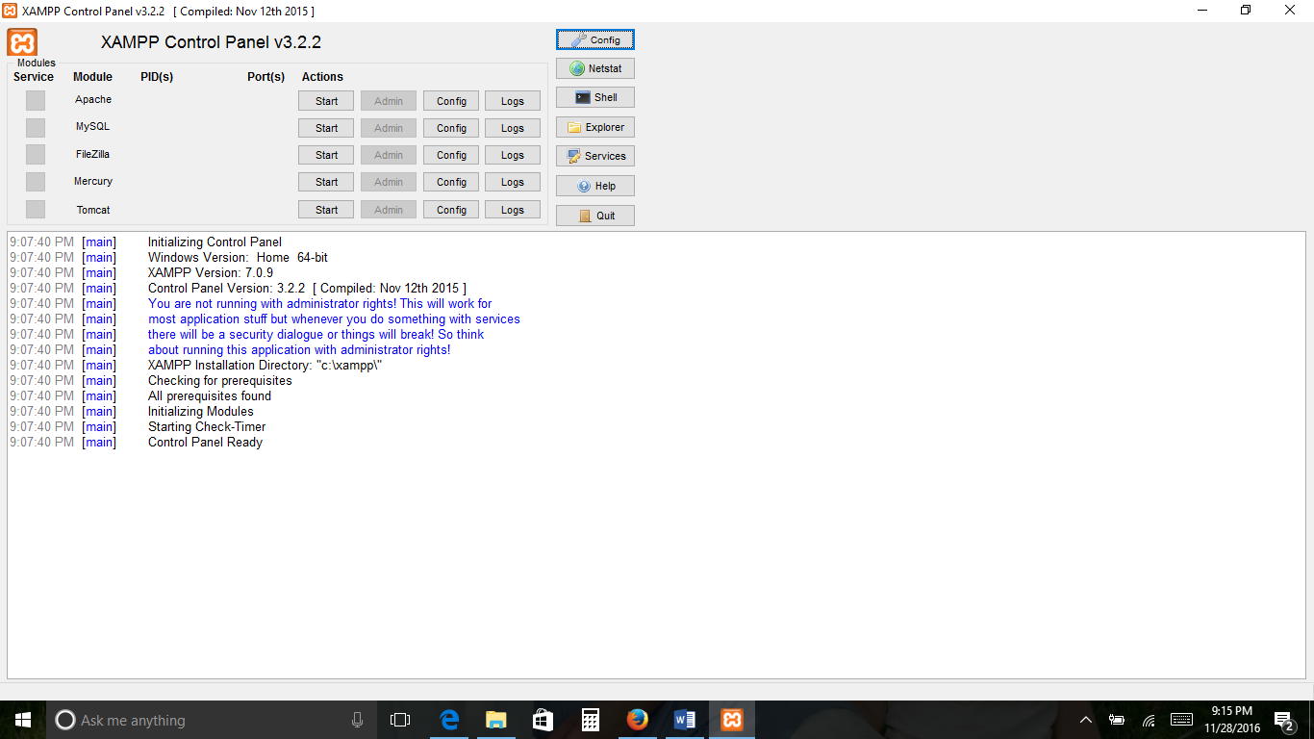

1. Open your favorite browser and type the following text “localhost/phpmyadmin” inside the address text box
2. This should launch the phpMyAdmin application, now click the “New” tab as pointed out in picture

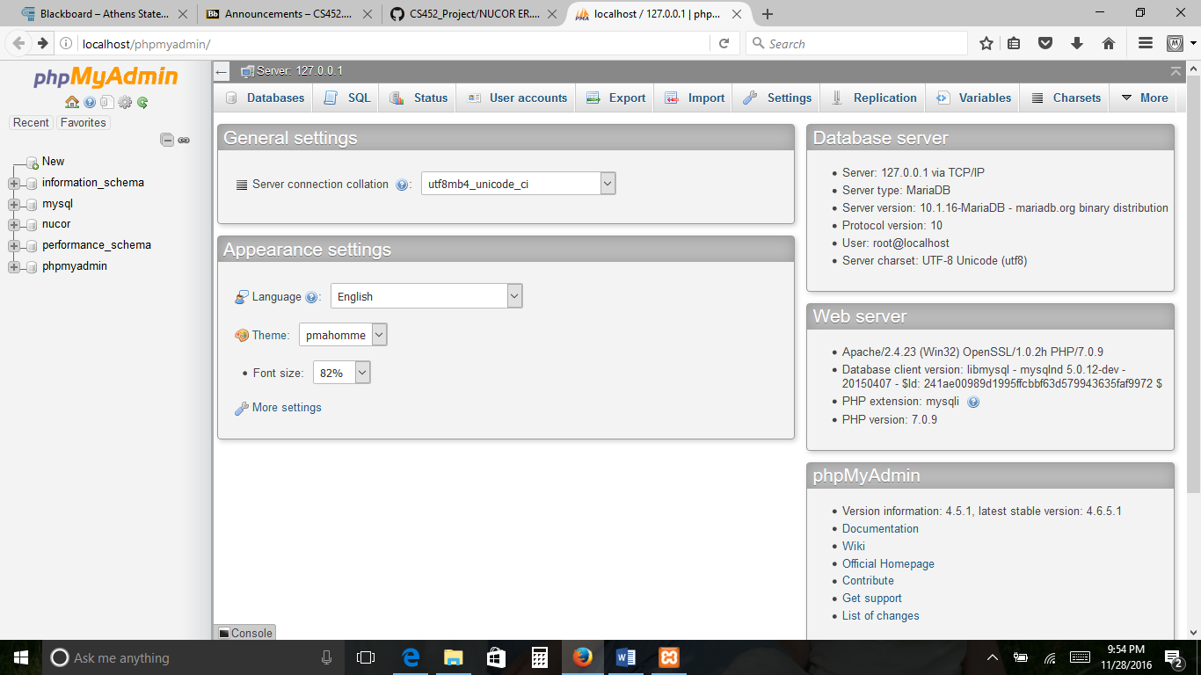

1. Type the following text “nucor” inside the Database name text box, then click the “CREATE” button as pointed out in picture

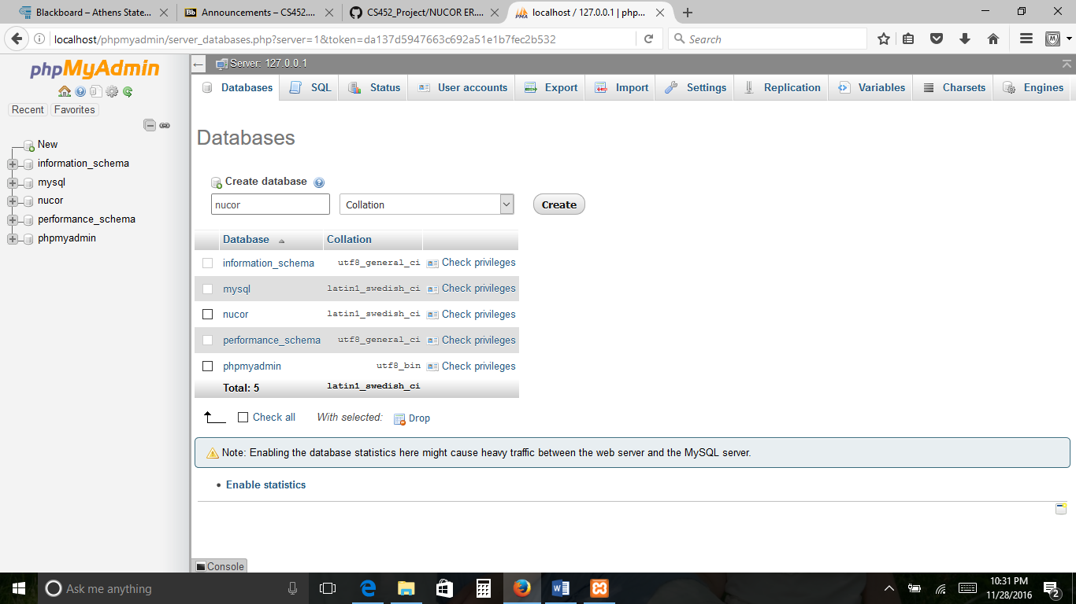

1. Locate the “htdocs” folder -> “mysql” folder -> and open the “nucor.txt” file
2. Right-click and COPY the content inside the “nucor.txt” file
3. Go back to the “phpMyAdmin” application from your browser and click on the SQL tab as pointed out in the picture

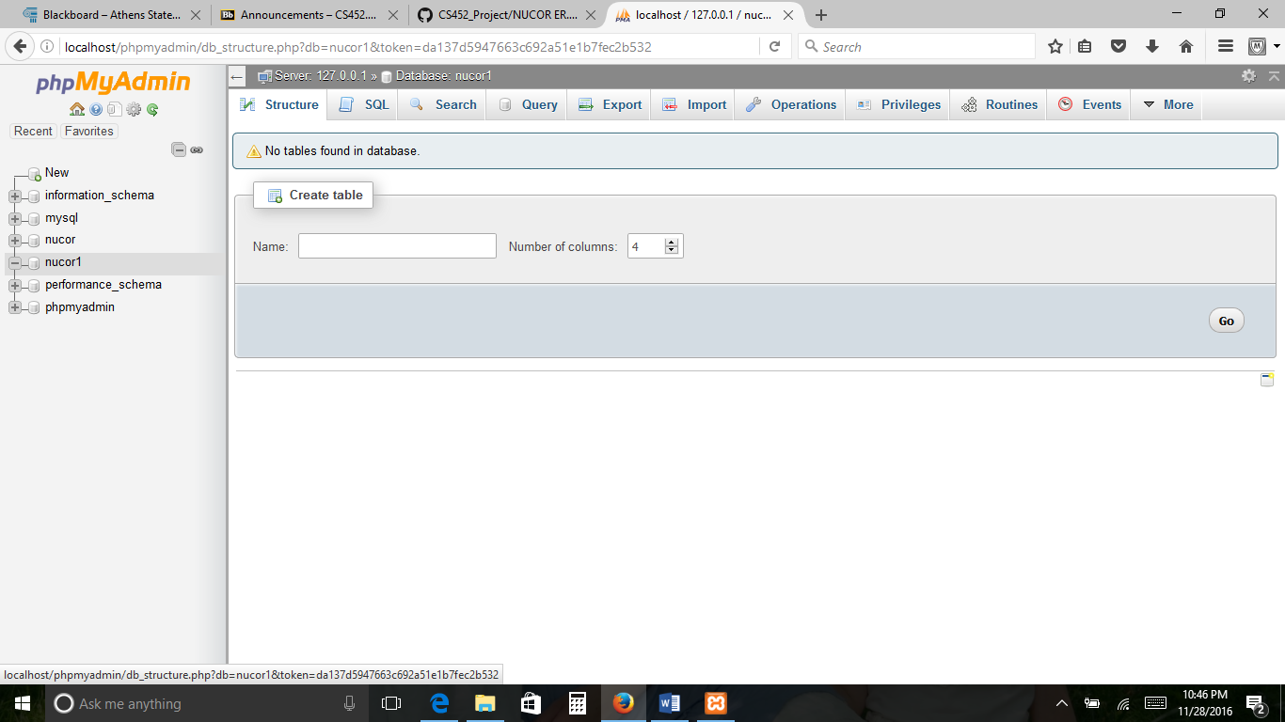

1. Right-click and paste the “Nucor.txt” content inside the query text box as pointed out in the picture

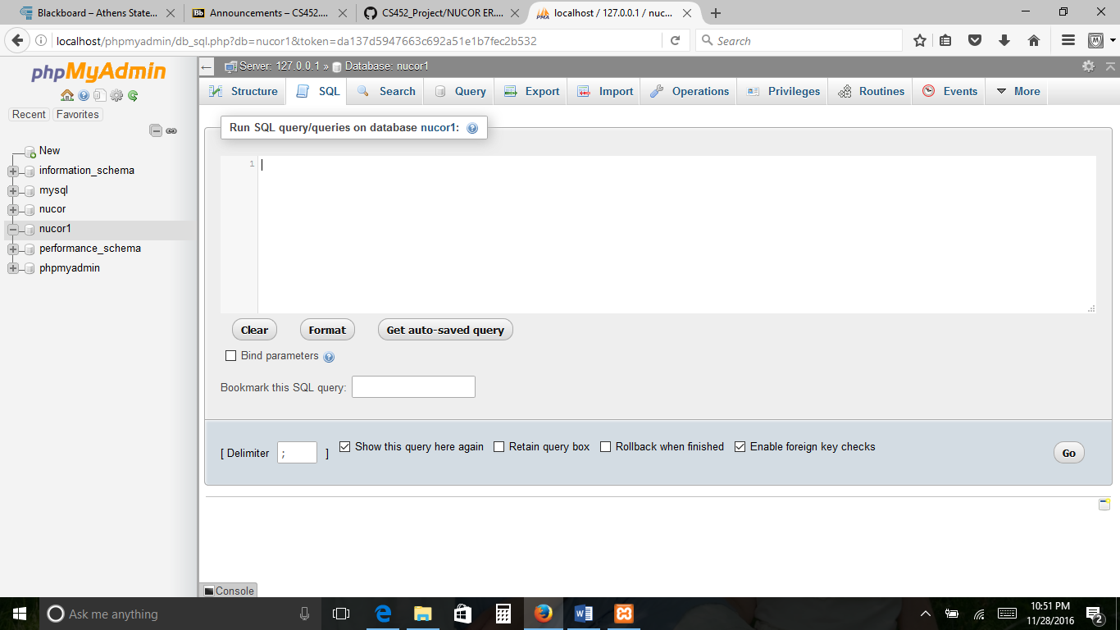

1. Now the back-end database named “nucor” with the needed tables are created as pointed out in the picture

